CHILDREN’S SERVICES

Research in Practice and Research in Practice for Adults Tailored support

Group Case Supervision: Guidance

Introduction

Background

Group Case Supervision (GCS) was introduced in 2015 as an integral part of the Family Safeguarding model of social work. These multi-disciplinary sessions support shared ownership, risk management and decision making.

This guide

This guide covers:
- the purpose of GCS
- the underpinning principles of GCS
- the functions of GCS

- how GCS fits with other forums and
- practicalities for running GCS.

Each section of this guide contains
- signposting to the evidence base on which GCS has been developed
- specific guidance to support the implementation and practice of GCS in
Surrey County Council’s Family Safeguarding Service

The guide also contains appendices with templates and tools. It finishes with further reading and references that may be useful to those wishing to develop further in this area.

Document last reviewed: November 2023
Reviewed by: Kasey Senior – Service Manager, Practice Standards
Next review date: June 2024

Research in Practice – Group Case Supervision Page 1 of 30

CHILDREN’S SERVICES

Purpose of group case supervision

Evidence

Any model of reflective supervision must be adapted to fit the organisation, the skills of the supervisor and the needs of supervisees. When thinking about what model or approach to adopt within an organisation, it is helpful to consider purpose (Earle et al 2017). Supervision supports innovative practices and service developments where teams work collectively to deliver contracted services that are focused on delivering specific outcomes (Carpenter et al 2012).

There is a hypothesis that GCS is about ensuring good decision making to manage risk.
Kemshall (2003) identifies the following criteria for defensible decision-making:
- All reasonable steps are taken
- Reliable assessment methods are used

- Information is collected and thoroughly evaluated

- Decisions are recorded and carried through
- Agency processes and procedures are followed

- Practitioners and managers are investigative and proactive.

Guidance

The purpose of GCS is to enable the best outcome for the child and family by identifying how to work with the family to enable them to make changes that benefit the child. By ‘benefit the child’ we mean that there is a reduction in harmful impact on the child.

In GCS we therefore aim to make good decisions about what to do. Good decisions include:
- Clear direction
- Timeliness

- Risk management & sharing of risk with other professionals

- Prioritisation of core issues
- Including both the adults and child’s voice

- Shared decision making

- Identifying the contribution from other agencies –within and outside FSH
- Critical reflection and discussion
- Identifying progress in reducing harmful impact
- Analysis of information & identify what we do not know about the family

Showing our decision making is part of our accountability.

There are additional benefits when GCS works well:
- Support for the adults in the family
- Support for individual practitioners through shared accountability and increased confidence in decisions

- Other agencies feel more included

- Use resources in the best way possible

- Identify learning and ways to improve

- Shared knowledge & experience

Research in Practice – Group Case Supervision Page 2 of 30 June 2019

CHILDREN’S SERVICES

Principles of group case supervision
Evidence

Group supervision usually involves practitioners from a variety of different professions who have professional concerns or tasks in common. Potential benefits of group supervision include the opportunity to:
- Reflect in depth on complex problems
- Pool and apply knowledge and skills
- Challenge individual perspectives (a group’s diversity in terms of gender, age, ethnicity and experience will provide different perspectives)

- Explore the skills, processes and dynamics needed in work with children and families and to influence organisational culture from the
‘bottom up’
- Provide a safe space to share feelings

- Build relationships and reduce isolation

- Develop a shared language, values and culture

There are potential pitfalls, however. Without confident facilitation, groups can lose focus and lack challenge (e.g. lapsing into ‘group think’) or be dominated by a few loud voices. Groups can amplify dysfunctional team processes – such as anxiety about speaking out – and confuse boundaries of responsibility and structures. And time for individual needs or cases to be explored will be limited. (Earle et al 2017)

Group discussion benefits from:
- Diversity

- Equality
- Hypothesising
- Use of analysis and intuition

- Emotional intelligence
- Accountability
- Recognition of disguised compliance

Decision making can be undermined by power and identity issues.

Guidance

The principles of GCS are:
- We keep the child at the centre

- We evidence the journey and progress of the family
- We have a shared commitment to the purpose and principles of GCS

- We see GCS as a priority
- We take responsibility for making it work – we prepare, we provide information, we attend when appropriate

- Everyone feels safe in GCS
- We respect professional views

- We strive to understand each other’s roles, cultures and identities
- We create an open and honest environment that allows challenge
- We develop shared goals – we discuss disagreements, we reach consensus as far as possible, we accept that the manager has ultimate accountability

- We have one voice and one messages for families
- We are open-minded and flexible

- We record what is needed in order to be accountable and to empower children

- We see GCS as an opportunity to share and develop learning.

Overall, we strive to ensure that the way we behave and work together in GCS reflects the way that we want to work with families in Family Safeguarding.

Research in Practice – Group Case Supervision Page 3 of 30 June 2019

CHILDREN’S SERVICES
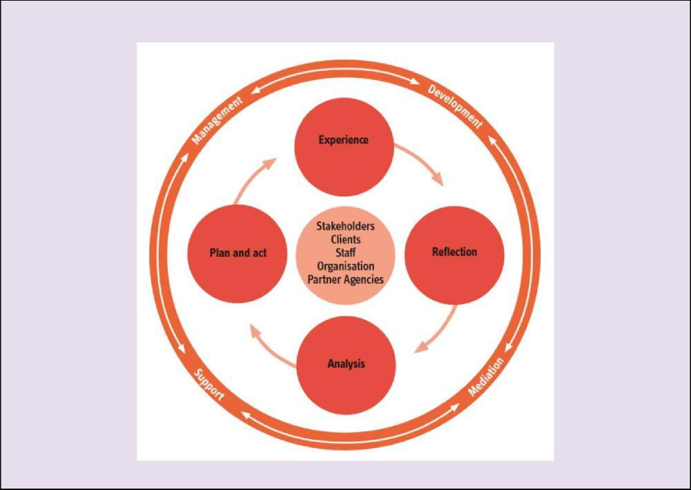

Functions of group case supervision

Evidence

RiP’s Change Project (Earle et al 2017) made the following observations about good supervision:

- Supervision needs to flow between addressing four main functions – management, development, support and mediation.

- Supervision is a valuable means to surface and share good practice – a space in which to unpick the behaviours and interactions that support positive outcomes

- Supervision supports accountability

- Supervision acts as a buffer between staff experience and organisational demands.

Supporting reflective practitioners requires the provision of:
  - Containment for practitioners’ emotional responses to direct practice experience

  - A space in which practitioners can build their capacity to think and analyse complex situations, which may be dominated by anxiety about risk

- A means for practitioners to engage and make use of their own experience and develop awareness of how their experience informs their practice. (Morrison, 2001; Sheppard, 1998)

The 4x4x4 model of supervision sets out the main functions of supervision around the outside, with critical reflection as a cycle at its heart. This model underpins supervision in Surrey Children’s Services.

Research in Practice – Group Case Supervision Page 4 of 30 June 2019

CHILDREN’S SERVICES

Guidance

The following areas are the important functions of GCS:
- Decision making and risk management

- Multi-agency work
- Identifying progress made in achieving outcomes.

These relate to the stakeholders in the 4x4x4 model, the reflective cycle at its heart, and the management function.

These 3 key functions directly support:
- Accountability

- Sharing of good practice
- Understanding what are the behaviours and interactions that support good practice

These 3 key functions directly support:
- Accountability
- Sharing of good practice
- Understanding what are the behaviours and interactions that support good practice

Other functions of supervision fit more with one-to-one personal supervision:
- Identification of support needed for staff (practitioners and managers)

- Identification of learning and development needs and opportunities
- Identification of challenges in our work and organisational learning.

These areas may be identified in GCS and in this case they will be noted by the team manager and taken into other forums (see below).

Research in Practice – Group Case Supervision Page 5 of 30 June 2019

CHILDREN’S SERVICES

Fit of group case supervision with other areas of work

Evidence

Group supervision is the use of a group to implement part or all of the responsibilities of supervision. This is what distinguishes it from other group activities such as team meetings. It can be used to complement one-to-one supervision or on its own. It is important to recognise that individual and group supervision are complementary practices; one should not take place at the expense of the other (Gibbs et al, 2014)
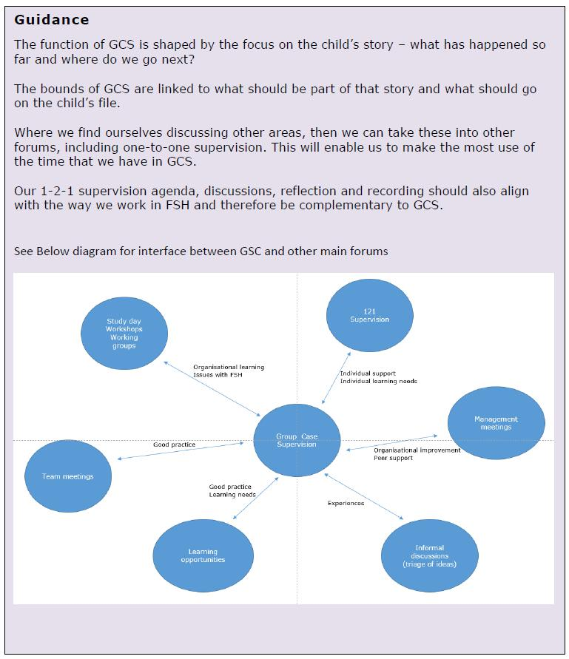

Research in Practice – Group Case Supervision Page 6 of 30 June 2019

CHILDREN’S SERVICES

Group case supervision recording

Evidence

The RiP Change Project on Reflective Supervision identified Key principles for recording methods – specifically that they should be:

- fit for purpose
- described in policy

- in use and understood by all involved

- Succinct, which is not the same as being limited to a number of words or pages (Earle et al 2017)

Guidance

Recording in GCS aims to support the purpose of GCS. It, therefore, aims to demonstrate:
- Our workings out for decisions
- The decisions that were made
- The progress that we have made to carry out these decisions
- What the impact of the decisions has been.

Recording will support:

- Process and accountability - it will show how we have done what is reasonably expected of us

- Empowerment – it will provide the child with a record of what happened and why, to help them make sense of their story.

The principles that we follow in recording are:
- Accountability
- Transparency
- Accuracy
- Clarity
- Proportionality.

Records will usually be recorded by the support officer. They will be based on contributions by all GCS participants. They will be signed off by the team manager.

The GCS record for each case will include:
- Who was involved in the discussion
- When the discussion took place

- A summary of the discussion – the main points made and who they were made by

- What decisions were made and why

- A plan for what will happen next – actions, expected outcomes, dates and who will carry out the actions. (What has happened with the plan is then discussed at the next GCS.)

The record will reflect any disagreements and the outcome reached by the team manager.

The amount recorded in the discussion will be proportionate to the complexity of the situation.
More will be recorded if the situation is more complex. Complexity depends on:
- How many things are happening

- How many people are involved

- The probability and severity of risk

- The likelihood of change
- The amount of conflict.
The manager will advise the support officer on how complex the situation is

Research in Practice – Group Case Supervision Page 7 of 30 June 2019

CHILDREN’S SERVICES

Practicalities for group case supervision

Evidence

Decision making is undermined by inaccurate/ incomplete information, poorly defined situations, time pressures, and heavy workloads (Saltiel 2016).

Work done by RiP based on Gibbs et al 2010 focuses on the key areas that support good supervision:

- Clarity of purpose - is helped by agenda, tools and approaches, focus on outcomes

- Right membership - is helped by clear expectations, an agreement
- Clear activity and focus - is helped by a model, a set duration
- Clarity about authority - is helped by clear roles, recording, a way of dealing with conflict.

Guidance

The main practical elements that are needed for GCS are:
- A room that is accessible and suitable
- IT that works consistently

- A support officer to take minutes, who is skilled and supported, has had a briefing with the team manager, and has a de-brief as needed afterwards

Also needed are:
- The facilitator – Team Manager
- The social worker
- Other practitioners involved in the case Commitment needed includes:

- Staff to complete monthly summaries prior to GCS
- Staff to attend on time for relevant parts of the meeting, undistracted
- Other staff not to interrupt.

Things that will help to achieve this are:
  - Everyone applying the GCS guidance
  - An agreement that everyone commits to (see appendix 2)
  - Dates planned in advance – agreed with staff, communicated to staff, put in calendar, room booked in advance

  - Dates to be crosschecked by managers in the same office to avoid clashes as much as possible
  - Team manager and support officer to meet before first GCS to agree how they will work, including; how support officer will raise any concerns or questions or ask for a break, and how support officer will be supported with emotional impact

  - Email reminder to staff to do summary
  - Support officer to log in and check IT in advance

  - Adult workers’ cases to be discussed first

  - Workbook to be prepared and worker to finalise (on iPad) once the case discussion has taken place
  - Support officer to aim to directly record minutes on to LCS system.

All of these areas may not be possible all of the time. The first solution to this is to recognise that we are all doing the best that we can.

Suggested ways of managing the impact of practicalities not being in place are:

- No support officer – Senior support officer to identify alternative support, if not available team manager to make notes and either write up or another support officer write them up afterwards and enter onto the system

- No social worker or team manager – rearrange the GCS as soon as possible
- Adult social worker not able to attend – dial in if possible
- All cases not covered – mop up session to be arranged as soon as possible
- Urgent work impacting on someone present – arrange for practitioner or manager to support with that work while GCS is going on.

Research in Practice – Group Case Supervision Page 8 of 30 June 2019

CHILDREN’S SERVICES

Additional Guidance for all workers involved in Group Case Supervision.

- The expectation is that all support officers will minute group case supervision.

- All social workers must ensure that the involvements on LCS are up to date in order for support officers to invite the correct workers to GCS.

- If an adult worker is not currently involved or is required to join the GCS on a consultation basis or with the possibility of being involved in the case to do a specific piece of work, it is the responsibility of the social worker/team manager to inform the support officer who else should be invited.

- Support officers will invite those Family Safeguarding Workers (social worker, children’s practitioner, domestic abuse officer, domestic abuse practitioner, recovery worker, mental health worker, and psychologist) as appropriate as indicated in involvements or as directed by social worker or team manager.
- Support officers will invite the appropriate workers using electronic diaries.

- Support officers should book GCS for their team manager at least 3 months in advance (6 or more where possible). This will enable all members of the team to know what days GCS takes place, and be able to book the rooms in advance. (It is recommended that team managers from the same site do not book the GCS on the same day, to ensure there is support officer cover).

- Service managers to agree with their team managers days on which GCS will take place.

- As adult workers are now working across several teams it is important that they are made aware of the days GCS takes place for each manager.

- Where a worker is unable to attend it is essential that they finalise their summary for that month so the team manager has their contribution for the discussion at the GSC meeting. (Adult workers if unable to attend due to other priority visits should explore dialling into the GCS session if possible).

- Support officers should all now be recording GCS directly on to the GCS form on LCS.

- GCS minutes should be ready for the team manager for finalisation within 5 days.

- Team managers should finalise group case supervision minutes within 5 days.

- If in exceptional circumstances GCS needs to be cancelled it is the Team Managers responsibility to inform the support officer who will then be required to cancel the meeting and inform the participants using the electronic calendar. In these circumstances the team manager will need to identify an alternative date and time to enable the support officer to resend invites.

- If a support officer is absent when GCS is due to take place the senior support officer will aim to identify an alternative support officer to cover, if this is not possible the team manager will liaise with the senior support officer to agree a solution.

- GCS template should be used for all cases CIN, CP & CLA cases.

Research in Practice – Group Case Supervision Page 9 of 30 June 2019

CHILDREN’S SERVICES

Appendix 1: Model of group case supervision

Evidence

Research points to a reliance solely on professional judgement or solely on actuarial tools not being as helpful as the use of both, i.e. risk scoring plus judgement equals structured professional judgement (De Bortoli and Dolan 2015).

While there are many approaches to group supervision in use by different professional disciplines and in multi-professional casework, they tend to have more similarities than differences.

Important elements include:
- a mutually agreed purpose

- focus and structure
- trusting relationships between participants and facilitator
- strong facilitation by someone with an understanding of the group processes being used

- The facilitator modelling curiosity, respect, clarity and authority. (Gibbs et al, 2014).

- a well-articulated case dilemma is absolutely crucial for focusing and containing a case discussion.

The main model that underpins reflective models in supervision is Kolb’s cycle (1984). The four parts of the cycle focus on concrete facts, reflection on feelings, analysis and planning for action.

One of the core strengths of Kolb’s cycle is that it brings cognitive (thinking) and affective (feeling) aspects of experience to bear on understanding experience and planning for action. Morrison’s (2005) application of the Kolb learning cycle articulated how, by using focused and open -ended questions to draw practitioners through the learning cycle, supervisors can interrupt the inclination to jump straight into solutions and actions without reflection or analysis.

Morrison (2005) advocates using the cycle both in supervision and in direct practice. It can help practitioners understand how children and families make sense of the world by considering experiences in their lives, what these experiences may be like for those involved, the meaning of these experiences and how families see the future as a result (Gibbs et al, 2014).

Research in Practice – Group Case Supervision Page 10 of 30 June 2019

CHILDREN’S SERVICES

Guidance

The Kolb cycle is also the model for reflection and decision making in GCS. This is reflected in the template (see appendix 3).

The areas of discussion are:

Experience

Case synopsis

Feedback from professional interventions

Reflection

Evidence of change
Reflection on impact

Analysis

Analysis
Judgement of risk

Pl anni ng

Management decisions and case direction

Manager authorization

The purpose of each area of discussion is to understand how we progress the child’s story.
The one-to-one record reflects the same cycle .

Learning from one-to-one discussions may be brought into GCS to inform our discussion. Elements that are identified in GCS that impact on staff may be further explored in 1-2-1 supervision.

The reflection element where it relates to individual responses, emotional impact and support needed fits more closely with one-to-one supervision.

However, it is important to acknowledge emotion as information. This allows the analysis to be informed by our emotional intelligence and helps to prevent emotion from clouding our judgement.

CHILDREN’S SERVICES

Appendix 2: Group Case Supervision agreement

This agreement should be signed by the Supervisor and Supervisee. The aim of the agreement is to:
- Clarify expectations and responsibilities
- Support a good working relationship
- Enable any disagreements to be managed.
- Agree duration and frequency of supervision sessions

- Agree venue and resources required(consider privacy and aim to ensure no interruptions, access to case files and recording

- Agree jointly the content/agenda of supervision

For Group Case Supervision as set out in the GCS guidance
- Do my best to help achieve the purpose of GCS
- Act according to the principles of GCS
- Follow the model of GCS

As a participant in Supervision, I will:

- Prepare by completing and preparing any documents that are needed for discussion

- Attend on time, and not be distracted
- Follow up on actions that are agreed in or outside of supervision

- Complete a record of supervision to be placed on supervisee’s file and give copy to supervisee

- Ensure casework decisions are placed on child’s electronic file. (Where discussions and management decisions occur outside of formal supervision these will be recorded as a case note with reason for decision).

We have agreed that supervision will take place:
(INSERT session details - frequency and duration)

If either party cannot attend supervision they will let the other know as soon as possible.

If I have any concerns or questions about Supervision I will raise them with my supervisor in the first instance.

The agreement should be reviewed at least every year.

Date for review……………………………………………………………..

Supervisor Supervisee

Name: Name:

Role: Role:

Date: Date

Research in Practice – Group Case Supervision Page 12 of 30 June 2019

CHILDREN’S SERVICES

Appendix 3: Group Case Supervision template

Group Case Supervision Template

FAMILY SAFEGUARDING GROUP CASE SUPERVISION
- Forms can be cancelled if created in error
- Consolidation to be enabled to support family working

Child’s Name Prepopulated |  |  |  |  |  |  | Date of Birth Prepopulated
Date of FS Group Case Supervision
Attendees
CP |  | CIN |  | CLA |  | PLO |  |  | CARE PROCEEDINGS

Actions/Updates from previous GCS

Experience element of the Kolb reflective cycle

Case Summary (This will not be a pull through) This information should be in case summary/workbook summary

Points to consider:

- What is the current situation/level of professional involvement? Date current plan commenced?
- Key dates/visits? E.g. court filing dates, ADM dates.

- Dates child(ren) last seen/seen alone?

- Dates family last seen?

Person recording should indicate where the above information can be found.
E.g. See workbook summary, or see case summary.

Outcomes and Analysis (From all Family Safeguarding Workers involved)

(Text box which will bring through the child’s workbook summary(outcomes & analysis) information from all FS workers involved.

Observations and Feedback

Feedback from professionals not in Family Safeguarding

Points to consider:
- What are the strengths? Evidence?

- What are the areas for further work? Evidence?

- What tools are being used as part of the intervention?

- Views of adults including absent fathers

- Has a Permanency Planning Meeting taken place?

Research in Practice – Group Case Supervision Page 13 of 30 June 2019

CHILDREN’S SERVICES

- Has a Family Group Conference taken place?

Child/ren Observation (incorporating the voice of the child)

- What is life like for them living in the home?

- Parent- child relationships, sibling relationships?

- Childs Self-esteem, ability to build relationships with peers

Reflection element of the Kolb reflective cycle

Evidence of Change
Points to consider:
- Evidence of engagement?

- Evidence of barriers/challenges?

- Views of family members?

- New partners/significant others?

Outline how Equality and Diversity areas are being addressed
- What is the family culture, what is important to them as a family

- What are these areas and why are they important

- What impact are these areas that impact on the family

Reflection on impact
Points to consider:
- What is the impact on the child (what is it like for the child?)

- What is/has worked well with the family?

- What is not working well for the family?

Analysis element of the Kolb reflective cycle

Analysis
Points to consider:

- From the information gathered and shared, what does this mean?

- The views of all involved workers need to be considered

- How does it impact on the child?

Research in Practice – Group Case Supervision Page 14 of 30 June 2019

CHILDREN’S SERVICES

- Evidence where the parents are at relating to the cycle of change? Are there any barriers/challenges? Are they ready to make the changes? If yes how? If no, why?
- What progress and outcomes have been achieved?

Judgement of Risk
Points to consider:
- Relevance to each individual child needs to be considered?

- Risk factors (increasing/decreasing)

- What do we need to know more about? What don’t we know?

- What does this mean for the immediate safety of the child(ren)?

- Are there any grey areas we need to know more about?

Planning element of the Kolb reflective cycle Management Decisions and Case Direction Points to consider:

- Plan for future period of work

- Timescales

- Evidence to support this decision-making

Overall RAG Status

Red | Amber | Green
1-2-3 | 4-5-6-7 | 8-9-10

Frequency of Supervision Based on RAG rating. (Picklist with values to be based on rag rating selected.)

User Choose field to allow completing worker to choose which manager will receive the form to authorise it.

(AUTHORISATION STAGE TO BE ADDED WHEN THE FORM HAS BEEN COMPLETED) Manager Authorisation

Form authorised? Yes/No (radio buttons)
Date of decision (Date field)

Additional Information/Comments Text box for additional information/comments to be recorded with regards to the decision

Research in Practice – Group Case Supervision Page 15 of 30 June 2019

CHILDREN’S SERVICES

Appendix 4: Tools

Group supervision areas to discuss
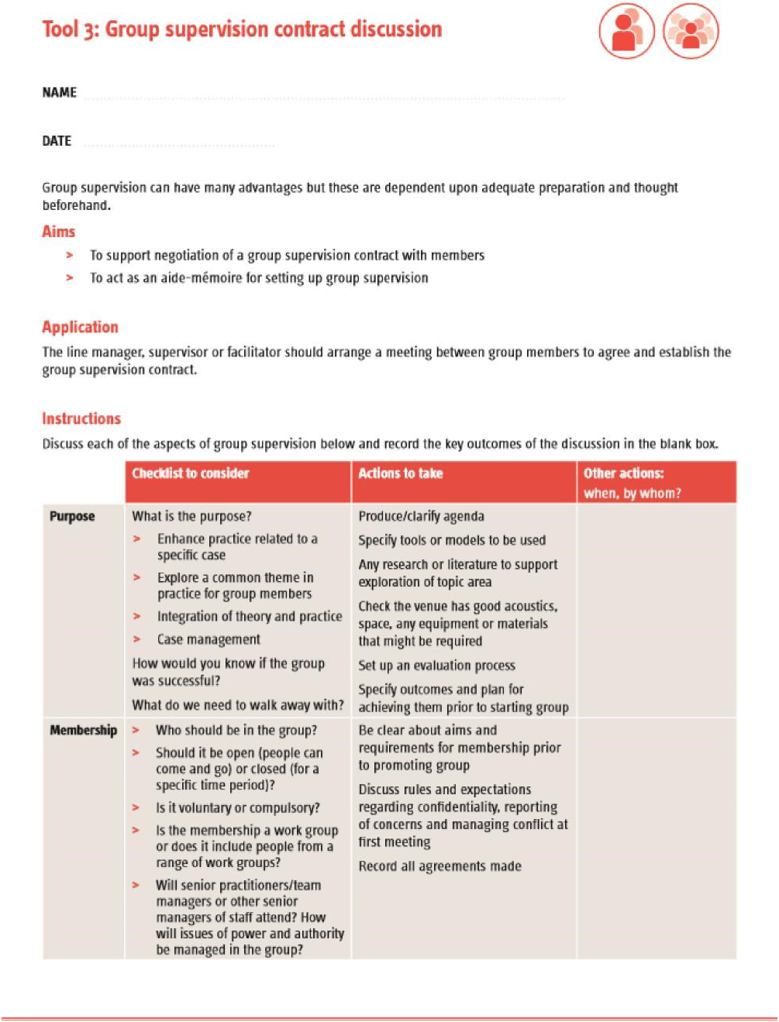

Research in Practice – Group Case Supervision Page 16 of 30 June 2019

CHILDREN’S SERVICES
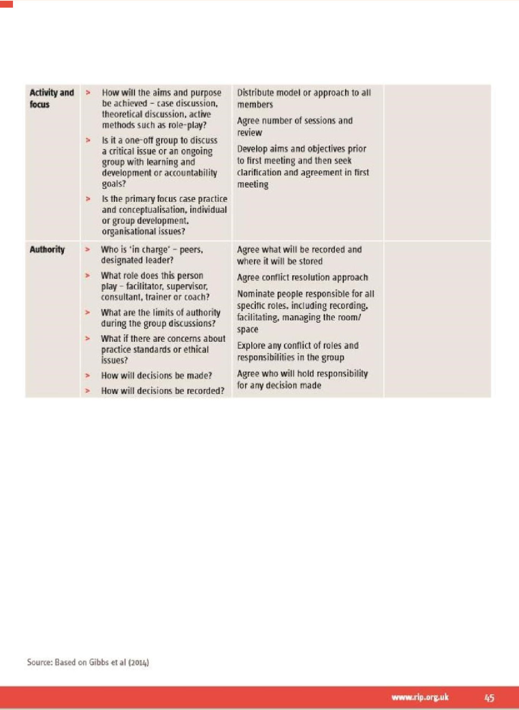

Research in Practice – Group Case Supervision Page 17 of 30 June 2019

CHILDREN’S SERVICES

Appendix 5: Reflective discussion based on MI principles

The reflective element in a GCS case discussion could take place in accordance with Motivational Interviewing principles.

The discussion will follow the DEARS model

Develop Discrepancy - clarifies the client’s goals and values and reveals how behaviour is in conflict with them. Behaviour is more likely to change if he or she can see the conflict between current behaviour and personal goals. Your task is to ensure that there is an honest discussion about the consequences of not changing as well as changing.

Express Empathy – practitioner is able to put themselves in the clients place and view things form their perspective. When people feel understood, they are more likely to share their experience, which makes us more able to determine where they need support

Amplify Ambivalence - about recognising and verbalising where the client is “of two minds” (opposed to one another). Ambivalence to change is normal, the “to-ing and froing” between the two poles can paralyse clients, causing them to remain stuck. As you bring the ambivalence out into the open and explore the two sides the client is dealing with, the client is enabled to work through it, opening the door to change.

Roll with Resistance – resistance to change is normal – encourage clients to come up with their own solutions to their situation as they define it. Asserting control or lecturing a client will make matters worse – empathy and allowing personal choice and control over their problems can help to minimise resistance.

Support Self-efficacy - one of the goals of motivational interviewing is to increase confidence, which helps to enhance self-efficacy: the person’s belief that they can achieve their goal. Clients must believe that change is possible and that they are capable of making the changes necessary to improve their situation.

Research in Practice – Group Case Supervision Page 18 of 30 June 2019

CHILDREN’S SERVICES

Appendix 6: Socratic questions – to promote reflective and analytical thinking
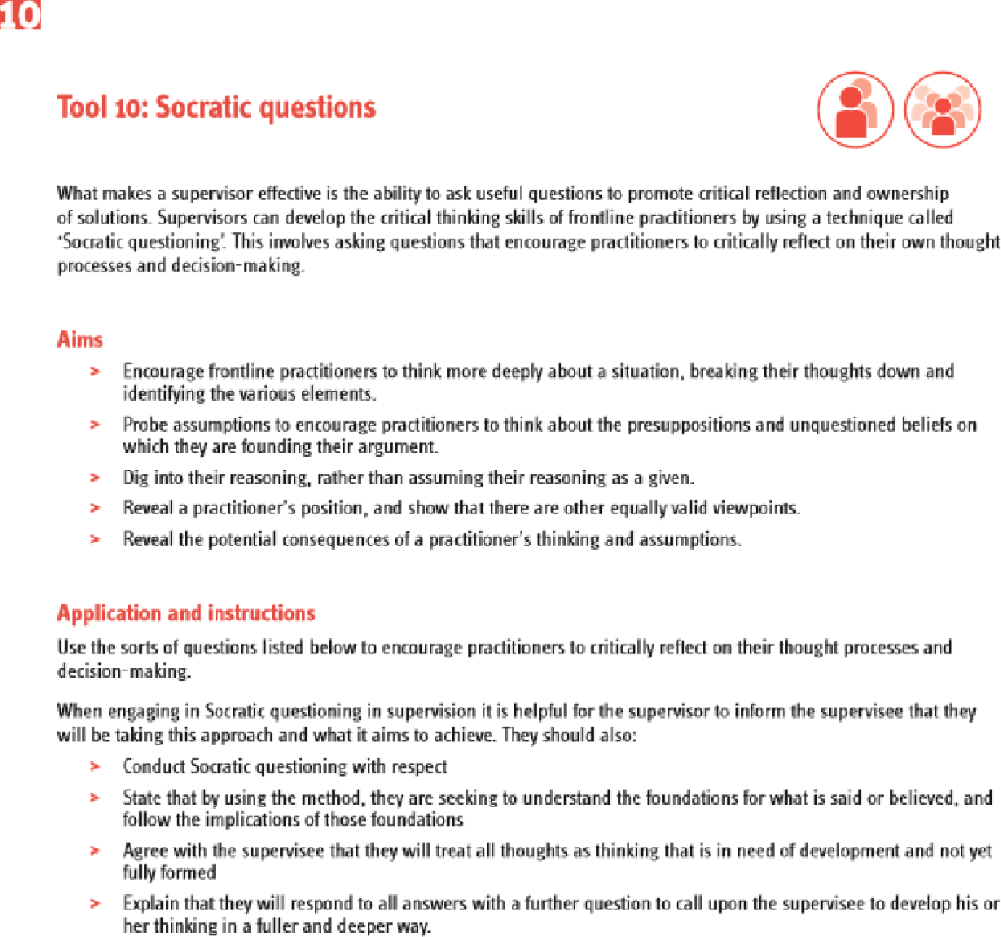

Research in Practice – Group Case Supervision Page 19 of 30 June 2019

CHILDREN’S SERVICES

1 0

Conceptual clarification questions

Support practitioners to think clearly about what exactly they are asking or talking about. Probe the concepts behind their argument. Ask basic iell me move' cue-shoos vo encourage practitioners to think more deeply. Why are you saying that?

What exactly does this mean?

How does This relate to what we have been talking

about? What is the nature of...?

What do we already know about this?

Can you give me an example?.

Are you saying ... or ...?

Can you rephrase that, please?

Can you help me understand more clearly?

Probing assumptions

Challenge supervisees to think about the presuppositions and unquestioned beliefs on which they are founding their arguments.

What else could we assume?

You seem to be assuming...?

How did you choose those assumptions?

Please explain why/how...?

How can you verify or disprove that assumption?

What would happen if ..?

Do you agree or disagree with...?

Probing rationale, reasons and evidence

People often use poorly thought-through or weakly understood rationale for their arguments. Dig into the reasoning a supervisee gives for a hypothesis or argument.

Why is that happening?

How do you know this?

Show me...?

Can you give me an example?

What do you think causes...?

What is the nature of this?

Are these reasons good enough?

Would h stand up in court?

How might it be refuted?

How can I be sure of what you're saying?

Why is…. happening?

Why? (Keep asking this question if you need to)

What evidence is there to support what you're saying?

On what authority are you basing your argument?

winnociip.am.uk 65

Research in Practice – Group Case Supervision Page 20 of 30 June 2019

CHILDREN’S SERVICES
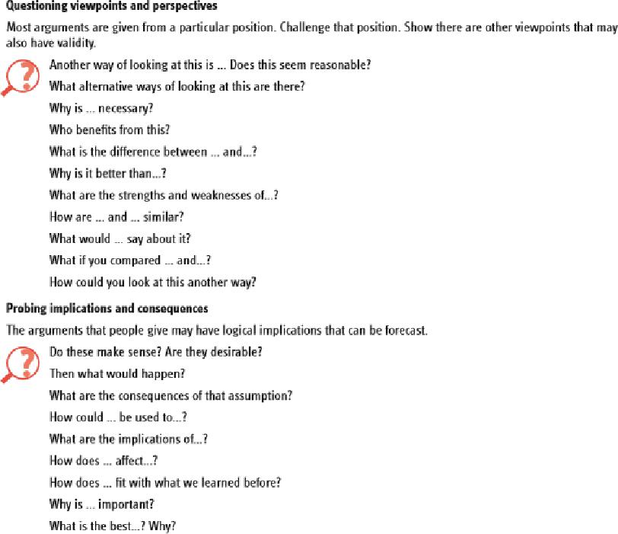

Research in Practice – Group Case Supervision Page 21 of 30 June 2019

CHILDREN’S SERVICES

Appendix 7: Problem tree – identification of core problem to work on

It is important to define the problem before making any decisions or plans. This tool simply enables you to sort out causes and effects of a focal problem.

Start by putting the problem in the centre. Put in the causes that you have identified or hypothesise, and the effects that you see or hypothesise.

You may find that the focal problem changes as you do this.

Once you have the problem mapped out, you can identify how to reduce or manage the causes, and how to minimise or manage the effects.
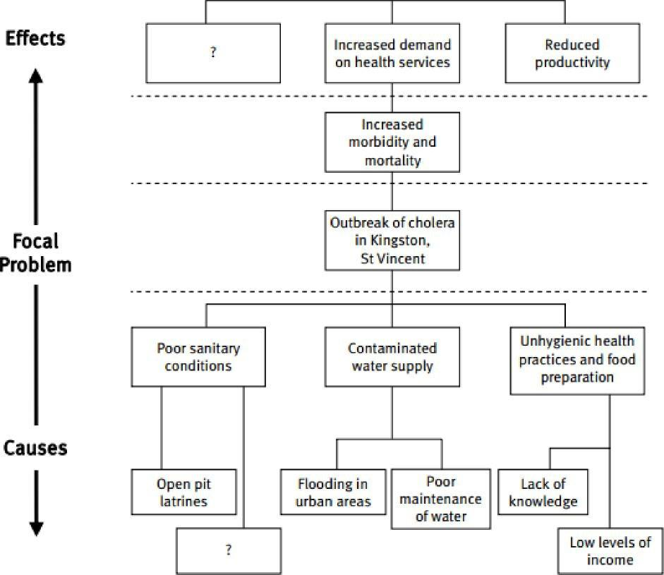

Research in Practice – Group Case Supervision Page 22 of 30 June 2019

CHILDREN’S SERVICES

Appendix 8: Decision tree – identification of risk associated with different options
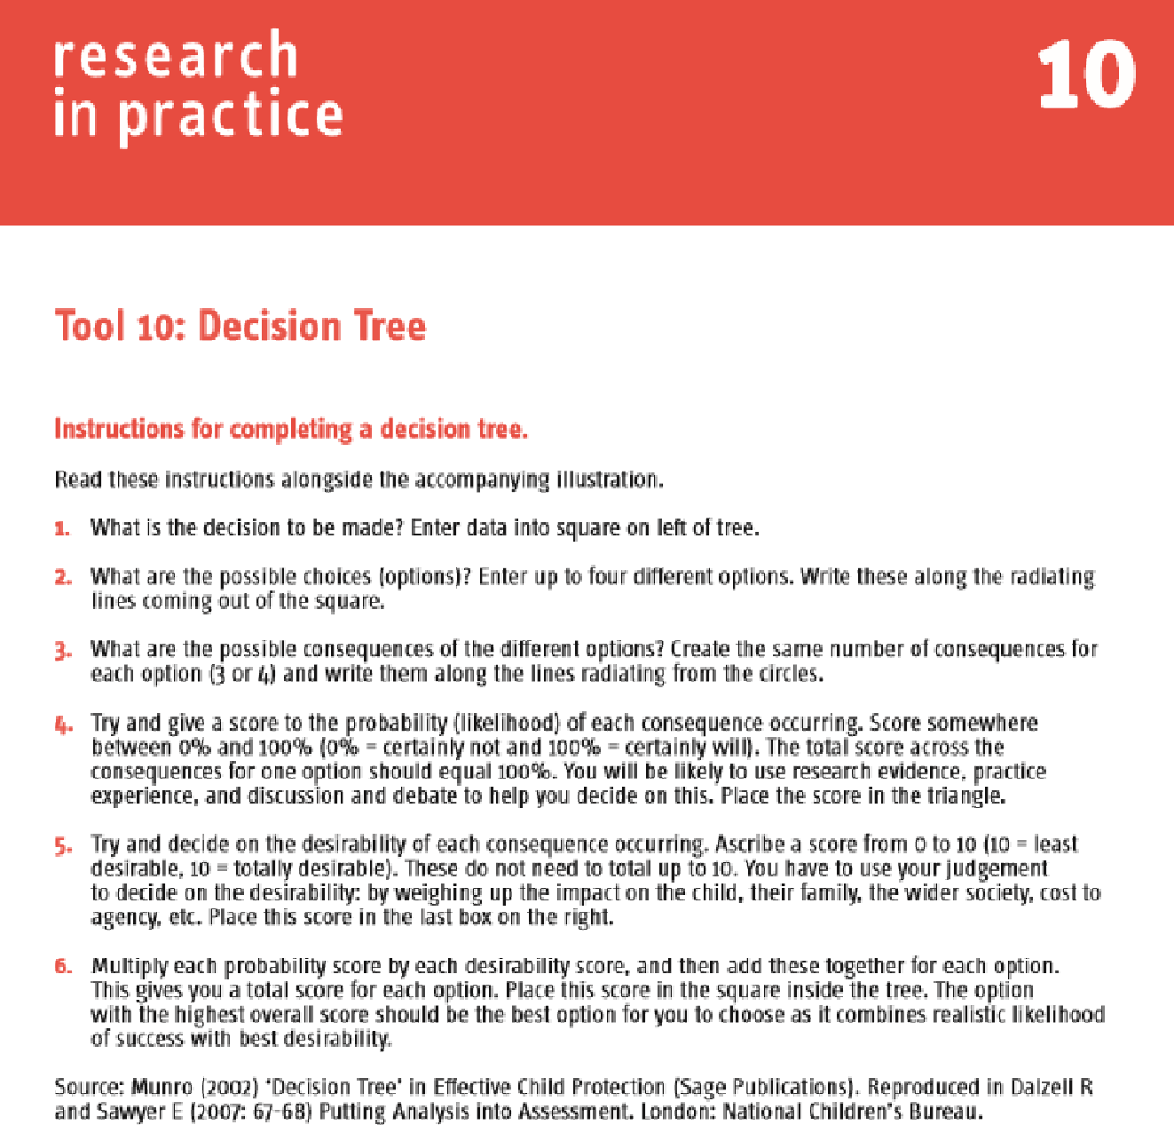

Research in Practice – Group Case Supervision Page 23 of 30 June 2019

CHILDREN’S SERVICES
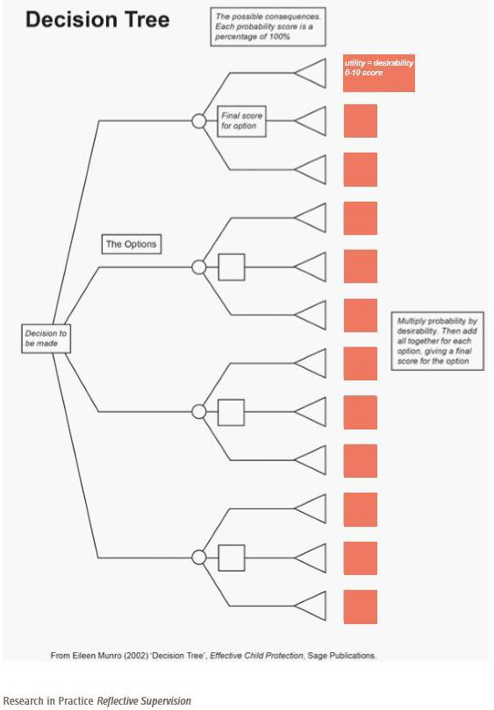

Research in Practice – Group Case Supervision Page 24 of 30 June 2019

CHILDREN’S SERVICES

Appendix 9: Discrepancy matrix – identification of gaps in our thinking and of assumptions
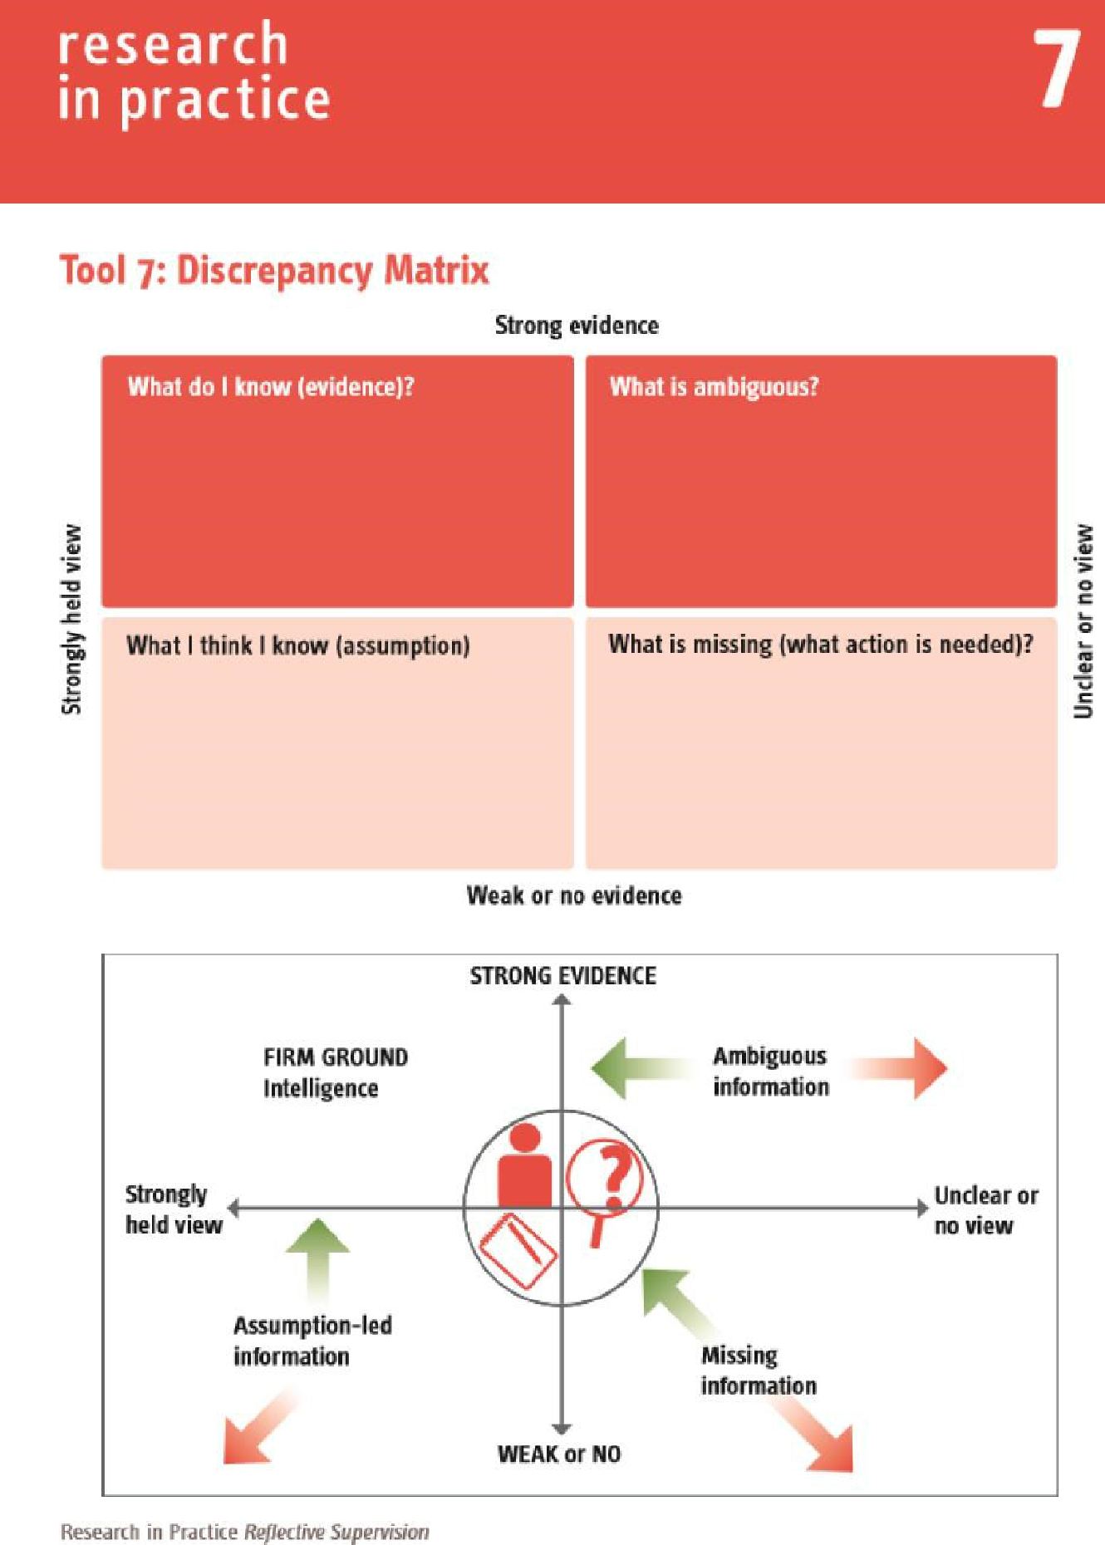

Research in Practice – Group Case Supervision Page 25 of 30 June 2019

CHILDREN’S SERVICES

How to use this matrix

This matrix can be used in individual and group supervision to clarify the nature of the information being used to inform practitioners' understanding of a case, Analysing information across this matrix supports the supervisor to help the practitioner think critically about the information upon which they are basing their decision-making.

The practitioner is supported to tease out the information they hold into four types: evidence, ambiguous, assumption. and missing.

Step One: The case⁻holding practitioner tells their story briefly fib mins). The supervisor or group members then begin to support the practitioner to sort the information they have been told into each of the boxes. Questions such as

- How do you know that ...?

- What other evidence do you have that this is true?

- How often have you felt like that even though you have no evidence it is true?

- When do you feel that most strongly? Why?

- If you had this piece of information what might it make you do differently?

Step Two: The information is sorted into the four areas as the practitioner answers the questions_

- What do I know? For something to go into the 'evidence• category. It needs to be proven and verified (In other words, come from more Than one source as a fact). It will also include knowledge about legal frameworks and roles and responsibility under the Children Act as well as research. This category provides the strongest factual evidence for analysis and decision making.

- What is ambiguous? This relates to information that is not properly understood, is only hearsay or has a different meaning or context, or is hinted at by others but not clarified or owned.

- What I think I Imam? This allows the practitioner to explore their own practice wisdom and also their own prejudice to see how it is informing the case. Emotion and values can also he explored in this area and the self-aware practitioner can explore how they are responding and reacting to risk.

- What is missing? These are the requests for information coming from the people listening to the story (supervisors. peers. other agency staff) that prompt the practitioner to acknowledge there are gaps In the information. The gaps then have to be examined to see if the lack of information might have a bearing on the decision making in the case. If so, then it needs to be explored.

Step Three: Once the exercise is complete the practitioner is then asked:

- What has changed about what you know?

- What do you still need to know?

- What does this mean for the child/family?

- What do you want to do next?

Source: Adapted with permission from Morrison and Wonnacott (2009) in Wonnacott (2014).

Research in Practice Reflective supervision

Research in Practice – Group Case Supervision Page 26 of 30 June 2019

CHILDREN’S SERVICES

Four plus one - identification of service user’s view of where we are and where we go next
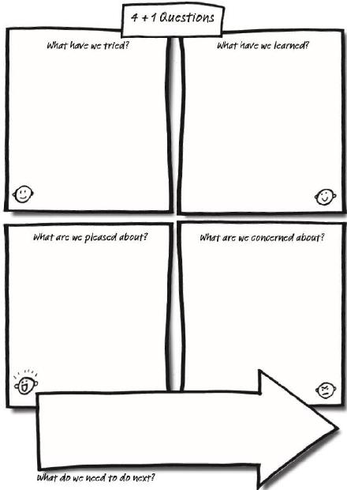

Research in Practice – Group Case Supervision Page 27 of 30 June 2019

CHILDREN’S SERVICES

De Bono’s hats - use of different viewpoints to avoid group think
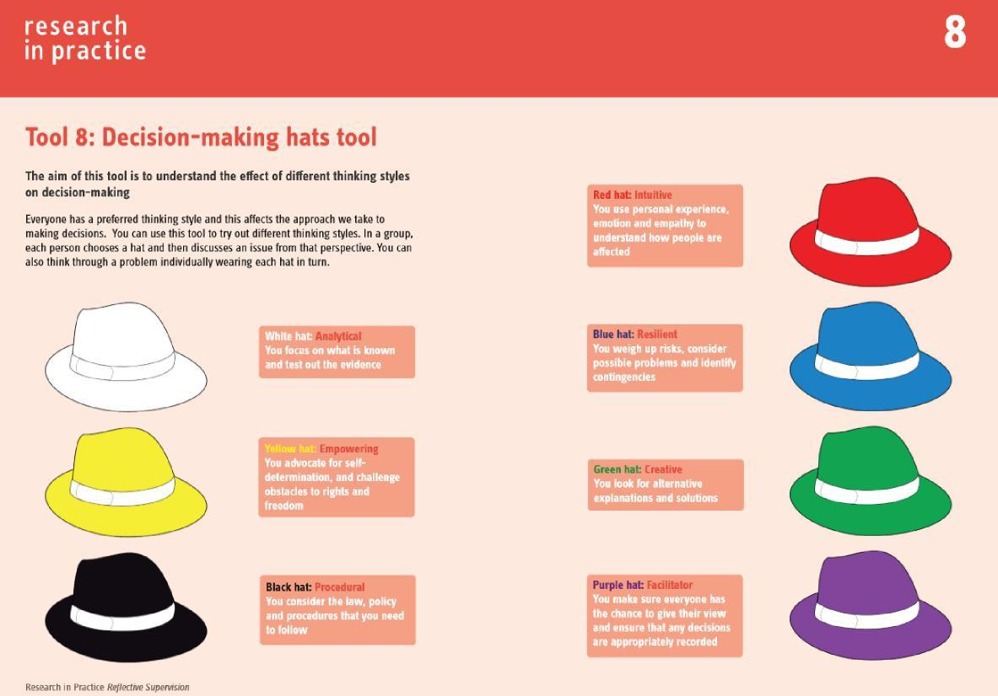

Research in Practice – Group Case Supervision Page 28 of 30 June 2019

CHILDREN’S SERVICES

References and further reading

The Research in Practice Reflective Supervision Resource Pack is a primary resource for GCS. This contains evidence about supervision as well as tools (including many of the tools that are included in this guide).

Earle F, Fox J, Webb C and Bowyer S (2017) Reflective Supervision Resource Pack, Research in Practice, Dartington

https://www.rip.org.uk/resources/publications/practice-tools-and-guides/reflectivesupervision-resource-pack-2017

Other references and further reading

British Association of Social Workers (2011) UK Supervision Policy. London: BASW.

Brown L and Turney D (2014) Analysis and Critical Thinking in Assessment. (2nd edition.) Dartington: Research in Practice. Available at: www.rip.org.uk/ACTA.

Carpenter J, Webb C, Bostock L and Coomber C (2012) SCIE Research Briefing 43: Effective supervision in social work and social care. London: Social Care Institute for Excellence.

de Bono E (1985) Six Thinking Hats: An essential approach to business
management. New York: Little, Brown, & Company.

De Bortoli L and Dolan M (2015) Decision Making in Social Work with Families and Children: Developing Decision-Aids Compatible with Cognition, British Journal of Social Work 45, 2142–2160).

Department for Education (2015) Knowledge and Skills Statements for Practice Leaders and Practice Supervisors. London: DfE. Accessed 03 December 2015 https://www.gov.uk/government/uploads/system/uploads/attachment_data/file/478111 /

Knowledge_and_skills_statements_for_practice_leaders_and_practice_supervisors.p df

Gibbs G (1988). Learning by Doing. A guide to teaching and learning methods. Oxford: Further Education Unit, Oxford Polytechnic

Gibbs J (2001) ‘Maintaining Front-line workers in Child Protection: A case for refocusing supervision.’ Child Abuse Review, 10 323−335

Gibbs J, Dwyer J and Vivekananda K (2014). Leading Practice: A resource guide for

child protection leaders. Melbourne: Child Protection Victorian Government Department of Human Services

Hawkins P and Shohet R (2006) Supervision in the Helping Professions. (3rd edition.) Maidenhead: Open University Press. Health and Care Professions Council (2012) Standards of Proficiency – Social Workers in England. London: HCPC.

Research in Practice – Group Case Supervision Page 29 of 30 June 2019

CHILDREN’S SERVICES

Kolb D (1984) Experiential Learning: Experience as a source of learning and development. New Jersey: Prentice Hall Lambley S and Marrable T (2013) Practice Enquiry into Supervision in a Variety of Adult Care Settings where there are Health and Social Care Practitioners Working Together. London: SCIE.

Morrison T (2001) Staff Supervision in Social Care: Making a real difference for staff

and service users. Brighton: Pavilion. Morrison T (2005) Staff Supervision in Social

Care. Brighton: Pavilion.

Munro E (2002) Effective Child Protection. London: Sage. Munro E (2008) Effective

Child Protection. (2nd edition.) London: Sage Publications.

Munro E (2011) The Munro Review of Child Protection: Final report. A child-

centred system. London: The Stationery Office.

Reivich K and Shatte A (2002) The Resilience Factor: 7 essential skills for

overcoming life’s inevitable obstacles. New York: Broadway Books.

Ruch G (2000) ‘Self and Social Work: Towards an integrated model of learning.’ Journal of Social Work Practice, 14 (2) 99112.

Ruch G (2013) ‘Relationship-based Management in Social Work: Where have all the feelings gone?’ Presentation at Heikki Waris Institute, Helsinki, delivered March 2013.

Saltiel D (2016) Observing Front Line Decision Making in Child Protection, British Journal of Social Work 46, 2104–2119)

Scaife J (2010) Supervising the Reflective Practitioner: An essential guide to theory
and practice. London: Routledge.

Schön D (1991) The Reflective Practitioner: How professionals think in action.

Aldershot: Ashgate.

Sheppard M (1998) ‘Practice Validity, Reflexivity and Knowledge for Social Work.’ British Journal of Social Work, 28 (5) 763781

Social Care Institute for Excellence,Overview of practice issues identified through an

analysis of 38 Serious Case Reviews

http://www.scie.org.uk/children/safeguarding/casereviews/learning-from-case-

reviews/index.asp

CIE Guide 50: Effective Supervision in a Variety of Settings. London: SCIE.

Accessed 20 March 2015

http://www.scie.org.uk/publications/guides/guide50/files/guide50.pdf

Wonnacott J (2013) ‘Supervision: A luxury or critical to good practice in times of austerity?’ Paper delivered at National Centre for Post Qualifying Social Work Conference, Bournemouth University, 28 June 2013. Available at: http://www.in-trac. co.uk/news/supervision-in-times-of-austerity/

Wonnacott J (2014) Developing and Supporting Effective Staff Supervision.
Hove: Pavilion.

Research in Practice – Group Case Supervision Page 30 of 30 June 2019

