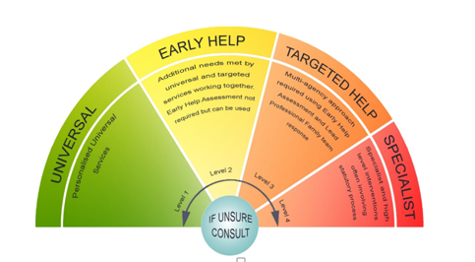

Children’s Single Point of Access
Operational Guidance

‘In Surrey, we all believe that every child should have the opportunity to reach their potential and that children are best supported to grow and achieve within their own families.
By working together, we will develop flexible services which are responsive to children’s and families’ needs and provide the right level of help at the right time. This will shift focus away from managing short-term crises, towards effective help and support for children, young people and their families at an earlier stage.'

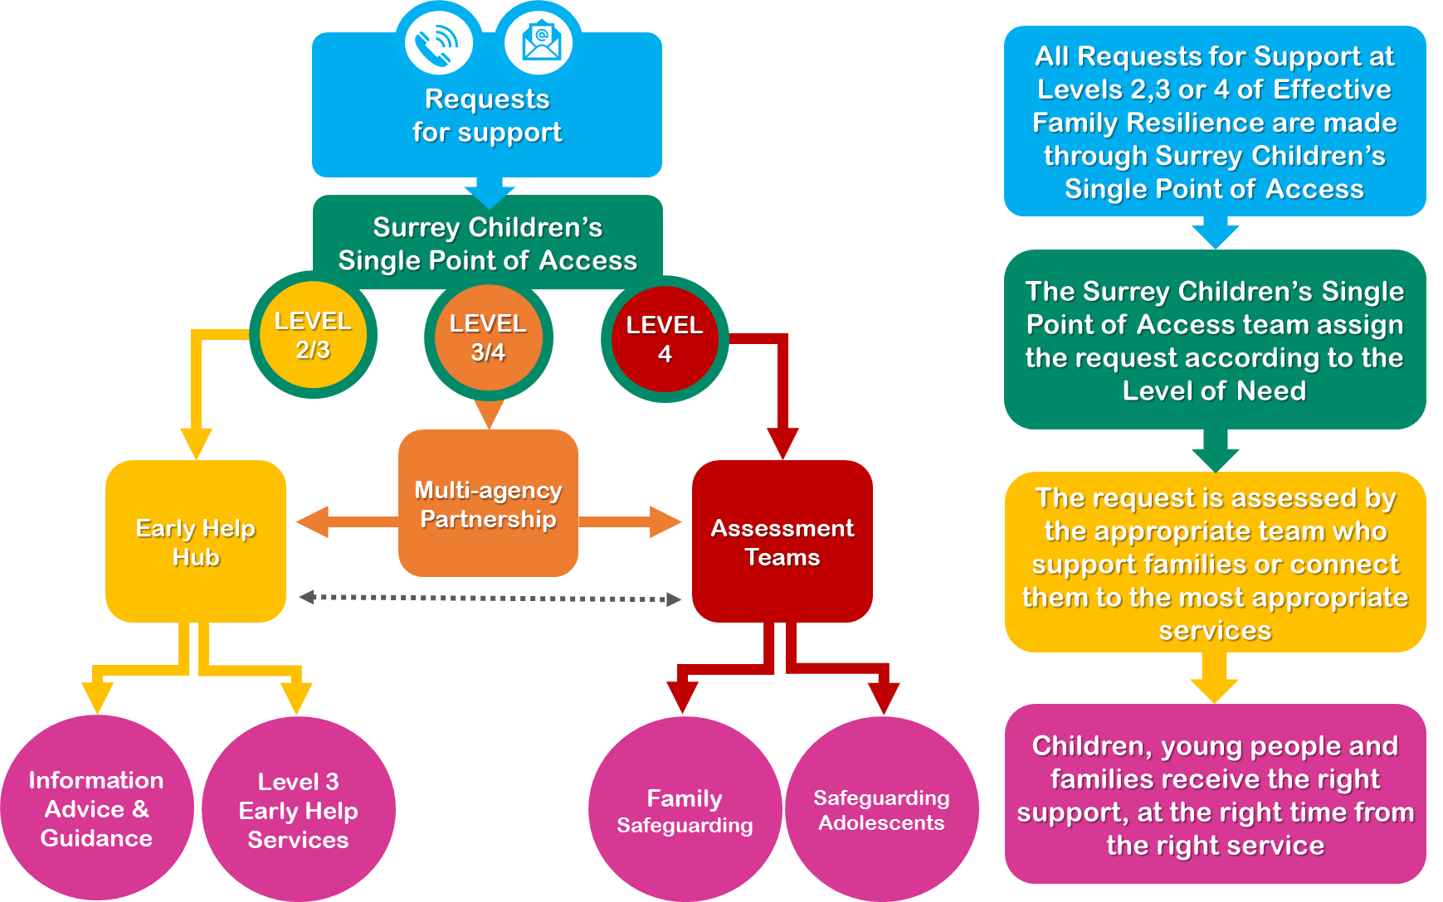
A Partnership Approach to Pathways for Children, Young People and Families Living in Surrey
Why are we making changes?
We know that approximately 20% of families will require additional support at some point and we know that getting to the top of waiting lists means families present in crisis.
We know nationally that late intervention comes at a large cost – estimated by the early intervention foundation as £17 billion pounds a year.
We know the ‘MASH’ was under pressure because of large number of referrals and we know that children and their families experience repeat assessments and interventions across our services.
The way forward will focus on how we work together to ensure a child or young person’s journey is coordinated to identify need and vulnerability; provides appropriate service responses at the earliest stage; and reduces risk. This will require co-production with our community and partners at all levels; to produce a ‘wraparound service’ that offers the building blocks to self-reliant and resourceful families and communities. It is about offering the right service at the right time; but making this more than just a catchy slogan by providing professionals with easy to navigate pathways to support which are child centred and family focussed.

What does that look like for me as a ‘contributing partner?’
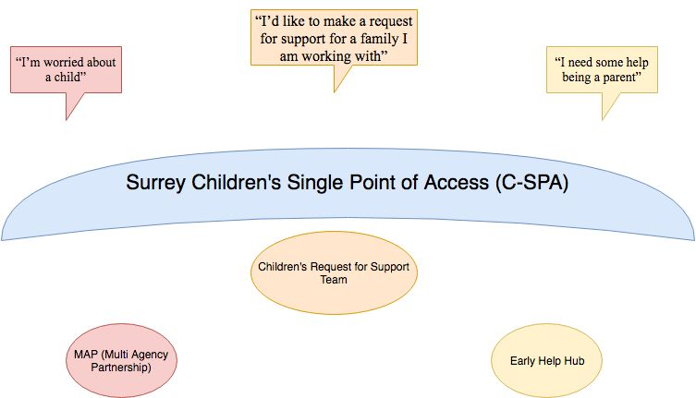
The needs of children and families in Surrey will be met through early access to help and support; guided through clear pathways to services within a clearly articulated partnership offer of support. This will achieve better outcomes for children and reduce the demand on the front door and statutory services. To compliment changes in approach and culture, and to build further on a commonly shared partnership narrative this paper proposes the following structure and branding.

Surrey Children’s Single Point of Access (C-SPA) > The C-SPA will act as the umbrella term to describe the point of entry for all Requests for Support.
What happens to my ‘Request for Support’?
Children’s Request for Support Team > this team respond to all requests for support i.e. calls, emails, letters and faxes. They will apply the Effective Family Resilience Levels of Need and send to either:
- Level 4 > will go straight to the Assessment teams meaning swifter response times for families.
- Level 3 / 4 ‘grey areas’ > will pass to the Multi – Agency Partnership (MAP) for further information gathering between Police, Health, Children’s Services and Education.
- Level 2 / 3 > will pass to the Early Help Hub where a multi-agency team will review the needs identified and offer support be this to a professional or to the family directly.
The process for requesting and receiving a service is set out below:

How are we going to work together to ensure we respond to the needs of our community?
Surrey levels of need document, Effective Family Resilience, was agreed by Surrey Safeguarding Children Board. All partners will be invited to refer to this document when requesting support from Surrey Children’s Single Point of Access (C-SPA).
Surrey Police will triage SCARFs so that only those at Effective Family Resilience levels 3 and 4 will be sent through to either the Early Help or the Family Safeguarding Hub. We will support Surrey Police to triage by providing a senior admin worker to check against our systems when it is unclear what level of response, if any, is required.
What are the key ingredients needed to make this work?
- Advice – will be offered through the consultation line to professionals.
- Gathering and Analysing Information – new systems will support professionals to do their job well and this will be quality assured with partners.
- Sharing Information Well – information that can and should be shared will be. Information Governance will be robust but will not present a barrier to working together to support children and their families.
- Contextualising Families Strengths and Risk – Historical factors have to be taken into account to understand strengths and risks. A proactive approach is required, any incidents or events must be considered in context if we are to build resilient families.
- Using Early Help Effectively – the Early Help Hub will act to ensure the right help and support is offered quickly to build resilient and resourceful families – the hub will not be a gatekeeper to services.
- Child Centred – there will be an unshakable culture that places the welfare of the child at the centre of all that we do.
- Valuing Professional disciplines and expertise – The C-SPA will be staffed virtually or co-located with partners who have specialist knowledge, it will be clear what their role is and how this compliments others.

Family Resilience and Safeguarding
In Surrey, our approach to safeguarding is changing. We aim to focus on the duties laid out in the Children Act 1989 and wherever possible, to work in true partnership with families and provide them with the help and support they need so that children can remain living safely within their families.

We will do this by ensuring:

- Everyone knows how to access help for children and their families, with families’ consent;

- Children with additional and complex needs are identified early, they and their families are offered help at the earliest opportunity;

- The majority of children’s needs will be met without statutory intervention;

- Children and their families are subjects of statutory assessment and support only when it is evident children are at risk of significant impairment to their health or development or significant harm as a result of care given/not given to them by their families;

- Adults are provided help to meet their own needs and this will enable them to have a better focus on parenting;

- Children and their families move on from statutory services as soon circumstances have been improved and when they are no longer at risk of significant harm. Those children who are unable to remain with their birth families move on to live with substitute families wherever possible;

- Children and their families are helped to become resilient so that they can manage future life challenges independently;

- Children and their families’ needs are met by confident practitioners trained in Motivational Interviewing and who use evidence based interventions; and

- The children’s workforce is aligned to meet demand across the levels of need.
We have developed a model of practice and we have called this ‘Effective Family Resilience’ the document which sets this out can be found on the Surrey Safeguarding Children Board website. This describes what Effective Family Resilience means for everyone who works with children in Surrey.
This document describes the child’s journey through our practice model within Surrey County Council.

SURREY CHILDREN’S SINGLE POINT OF ACCESS (C-SPA)
The Surrey C-SPA is the umbrella term for the front door to support, information and advice for residents, families and those who work with Surrey Children. The C-SPA is the conduit for access to services at levels 2 and 3 of Effective Family Resilience, it also provides direct information, advice and guidance to residents and people who work with children in Surrey about where and how to find the appropriate support for families.
We are committed to children and their families receiving the right help at the right time and our C-SPA will better enable us to fulfil this commitment.
The way to contact the C-SPA has not changed.
• Phone: 0300 470 9100
• Out of hours phone: 01483 517898 to speak to our emergency duty team.
• Email: emails are dealt with during normal office hours
For concerns for a child or young person: email csmash@surreycc.gov.uk
The success of our new model is based on having strong relationships with families and we have to start this relationship in an open and transparent way. We are asking for everyone who seeks support for a family via the C-SPA to have express consent from the parents (or GiIllick competent young person) when submitting that request. There will be some exceptional circumstances whereby to speak to the parents would likely cause harm to the child and we would not expect consent to be sought. The multi-agency referral form (MARF) has been withdrawn and has been replaced with a form called ‘request for support’. When people request support it is implicit that the family is not being handed over but that the request is for children’s services to join the existing network around the family.
All requests for support and contacts with the C-SPA will be directed through the contact centre to the Children’s Request for Support team. The team is based in the corporate contact centre. Operating from a detailed guidance document and with support from a qualified social worker, the team will perform initial triage on all contacts from members of the public and professionals. Where there are information requests, they will deal with these direct. Where contact details clearly indicate that a response is required from a specific team they will send the service request to the appropriate team to respond. The team is trained in motivational interviewing so that they can begin that positive relationship between service user, partner and Surrey County Council from the outset.
Requests for support that reach level 4 of Effective Family Resilience will be sent straight to the Quadrant Assessment Teams. The duty manager will assess and record whether the needs of the child require assessment under s.17 Children Act 1989 or if a strategy meeting is required to determine whether the assessment should be under s.47.
Requests for support up to Level 3 of Effective Family Resilience will be directed to the Early Help Hub. The Early Help Hub is staffed by advisors from early years, family information service, SEND, youth homeless, education, Surrey Police and early help. The Early Help Hub will offer information advice and guidance to residents and those working with children in Surrey. All of the Early Help Hub staff will be trained in motivational interviewing and they will assist families to seek help using the online Family Information Service (FIS), will offer advice to those working with families about how best to support them and connect them to other people or services who can join them to support a family.
The Early Help Hub will act as the main conduit for support for families at Level 3 of Effective Family Resilience. Surrey County Council commissions targeted support for children up to the age of 11 through Family Centres. The Family Centre Model will be effective from September 2019, in the meantime they work with families up to the age of 5 offering a range of support at levels 2 and 3 of Effective Family Resilience.
From September there will be 21 Family Centres based in communities with the greatest need offering a range of evidence based interventions for children up to the age of 11 at levels 2 and 3 of Effective Family Resilience. The Centres will provide outreach to families who do not live nearby. Family Centres will have access to EHM from September and will undertake Early Help assessments, plans and reviews for level 3 families.
The Family Support Programme (FSP) will also support families with children aged 5 – 18 and is delivered by 6 teams covering the 11 Districts and Boroughs. The FSP staff are trained in evidence based interventions and will undertake early help assessment and plan and will also move to recording on EHM this year.
Support from the Targeted Youth Support Service will also be accessed through the Early Help Hub.
CAMHS and SEND will be co-located in the Early Help Hub. Both services will have their front door triage co-located with partners in the Hub, including our SEND advice and advocacy service (SSIAS). The plan is to move toward a fully integrated Hub from September 2019. We know that children can be referred to multiple agencies and sometimes they may be referred to the wrong service but wait for an assessment or to be directed to a different source of help. Working with our partners in SEND and CAMHS we will have an integrated initial response whereby we are able to determine which service is best placed to meet that child’s needs. This will provide a swifter service and prevent multiple assessments.
The Family Group Conference Team (FGC) are located in the Early Help Hub as we are keen to deploy this service early in the presentation of a problem, of course we will continue to offer a FGC service to children who are subjects of formal child protection processes and in pre-proceedings.
The Multi-Agency Partnership (MAP) receives requests for support when it is unclear if the need is at level 3 or 4 of Effective Family Resilience. The MAP is a multi-agency team, staffed by qualified social workers, education advisors, police and 0-19 public health nurses. The team is supported by MAP officers and administrators. The MAP will research and analyse information about a child in order to determine whether this is a level 3 or level 4 need.
Schools and Settings Consultation line. Most of our young people in Surrey are in schools and early years settings and we are committed to supporting colleagues who work in this sector. We are providing a dedicated consultation line whereby they can access advice from a qualified social worker to support the school or setting to help the child and family or decide whether they need to discuss with the family that a request for support to children’s social care is submitted. Formal requests for support cannot be made through this service it is for consultation only.

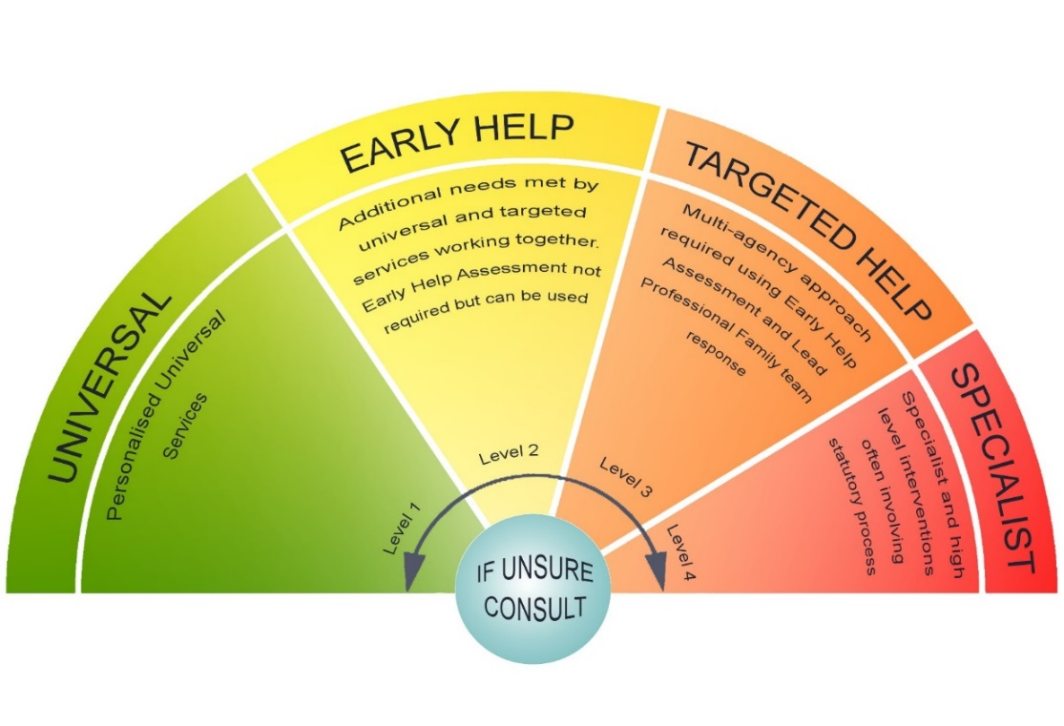
Using the Surrey Effective Support Windscreen in the C-SPA
The Children’s Single Point of Access Service will ensure a consistent response to children’s needs and support the embedding of this model into practice through the following actions:-
- All staff will use the Effective Support Windscreen to aid threshold decision making at all times
- We will model the use of the framework in our conversations, consultations and recording helping to embed the model into day to day practice.
- We will ensure that decision making within the framework is evidenced based focused on the needs of the child and family
- We will help partners consider how the service they offer fits within the levels of need
- We will continue to be curious exploring strengths and vulnerability.
- We will ensure that we pay attention to complexity of information considering accumulation of need at a lower level that indicates a higher level of need for children.
This model and windscreen is a simple way of developing a shared understanding and explaining the Surrey approach across all our services and partnerships, ensuring a consistent approach is applied by all. The model illustrates how we will respond to the requirements of children and families across four levels of need (Universal, Early Help, Targeted Early Help and Specialist). The windscreen is a visual tool to help us share a common language to describe risk and needs.
We will actively work with children and families to meet their additional needs and aim to prevent them escalating. We recognise that each child and family member is an individual, and each family is unique in its make-up, so reaching decisions about levels of needs and the best response requires discussion, reflection and professional judgement.
The windscreen cannot replace professional curiosity, judgement or decision making and should not be used as a checklist or an assessment of need. The indicators of need are suggestions of the types of need a child and family may have. Sometimes their needs may include indicators from each of the levels, however combined, they may cause additional strain on the family and following discussion with the family may indicate a higher level of support needed. Equally, there may be family strengths that are mitigating factors for the indicators.
Families’ positions on the windscreen will change as their circumstances change and therefore will not be a fixed position. All practitioners should consider which needs take priority when identifying the appropriate level

Consent
Requests for Support for Children’s Services MUST be made with the knowledge and agreement of the family members being referred, exempting in exceptional circumstances (see below).
Parents MUST be aware that Children’s services may need to share information with, and to seek information from other agencies to help them decide if additional services are needed.
Members of the Public
It is not an expectation that members of the public will have gained consent from the child/parent, or at least one person with parental responsibility (PR), to make contact with the Request for Support Team/C-SPA
Professionals
Best practice dictates that when professionals make contact with RFST with a ‘Request for Support’, they will have already gained the explicit consent of the child/parent, or at least one person with parental responsibility to do so. If the professional is requesting family/targeted support (Level 2/3- Early Help/Targeted Help) or a s.17 ‘Child in Need’ assessment (L4 – Specialist Service) and do not have consent, C-SPA may ask the professional making contact to discuss the matter with the child/family, before they will accept the contact.
In essence:
A Contact CANNOT be progressed to the Early Help/Targeted Support Services, and the MAP without consent. Such Contacts should be sent back to the referrer advising them to seek consent prior to progressing.
A Contact for L4 – Specialist S.17 Child In Need Assessment should not be progressed to the Assessment Service without Consent.
If it has not been possible to get consent and/or there are potential safeguarding concerns, it is expected the professional will have informed the child/parent, or at least one person with PR that they are making contact with C-SPA with a ‘Request for Support’.
Basic Screening Checks
Consent from child/parent or person with Parental Responsibility is not required for screening checks, because no sensitive information about the child or family is being shared in this circumstances.
The purpose of screening checks are to identify which Services are or have been working with the family, to prevent any duplication of activity. Basic screening checks involve conducting a set of multi-agency database checks to establish:
- What agencies are currently involved with the child/family e.g. name of the School the child attends
- The contact details of professional/s involved e.g. Name, telephone number, address of Health Visitor
- Any immediate hazards associated with the household and its members e.g. Record of a dangerous dog in the household.
Accepting Contacts without Consent
Obtaining consent for information sharing is best practice, and professionals should always attempt to obtain the explicit consent from the child/parent or at least one person with PR, before making a request for service to Surrey Children’s Services, unless specific criteria apply as below.
“The key factors in deciding whether or not to share confidential information are necessity and proportionality, i.e whether the proposed sharing is likely to make an effective contribution to preventing the risk and whether the public interest in sharing information overrides the interest in maintaining confidentiality”
Information Sharing: Guidance for practitioners and managers. DCSF p21

There are some circumstances where sharing information without consent will be justified in the public interest. These are:
- When there is evidence of reasonable cause to believe that a child is suffering, or at risk of suffering significant harm; or
- To prevent significant harm to a child, including through prevention, detection and prosecution of serious crime.
When there is justifiable public interest, there are some circumstances where consent can be overridden, furthermore there may also be times when it is also NOT appropriate to inform the child/parent or person with PR that the information will be shared. If to do so would:
- Place a person at increased risk of significant harm; or
- Prejudice the prevention, detection or prosecution of a serious crime; or
- Lead to an unjustifiable delay in making enquiries about allegations of significant harm to a child
Where a RFST officer determines that a contact be accepted without consent, this decision must be agreed with a RFST Manager/SW on rotating duties at the RFST.

Document last reviewed: November 2023
Last reviewed by: Fardowsa Ga’al
Next review date: December 2024

