Practice Guidance for Working with an Interpreter

Why is it important to work with an interpreter?
Effective communication is central to safeguarding and supporting the children and families we work with. As professionals, we may find ourselves working with people where there is no shared language between us. In the 2021 Census, 880,000 people across England and Wales described themselves as being unable to speak English well, a further 161,000 people described themselves as being unable to speak English at all. People who require interpreters may face barriers to accessing services due to not being aware of the support available to them. The importance of breaking down these barriers in order to keep children safe is something which has been highlighted within both national and local case reviews.

In 2013 a Serious Case Review was undertaken in relation to the death of Daniel Pelka, who was murdered by his mother and step-father following a period of abuse. Daniel and his family were Polish and the review highlighted failures through not working with an interpreter to speak with Daniel about his injuries and his experiences of living at home. Interpreters were not consistently engaged when communicating with his mother and it also raised concerns around Daniel’s sister – who was only 2 and a half years older than him – being used inappropriately to interpret. Working with an interpreter effectively can promote equality and help to empower the service user, it is also key to anti-oppressive and anti-discriminatory practice.
Who can interpret?
Children should NEVER be used as interpreters.
Where possible, always use a professional interpreter. Avoid using family members, carers or friends to interpret as this may lead to a conflict of interest, lack of impartiality, inaccurate interpreting or be a safeguarding risk, e.g. an abusive partner distorting information.
If a colleague speaks the service user’s language during a meeting you are chairing then they should not be asked to interpret for all attendees. While it would be acceptable for the worker to speak with the service user in their preferred language during their own communications, the professional interpreter should be used to interpret these conversations with the fellow participants of the meeting.

How do I book an interpreter?
To book an interpreter, email L2L@dudley.gov.uk to request the type of booking you require; interpretation face to face, over MS Teams and the telephone, written translation, and alternative formats, such as audio, easy read and large print. The relevant referral form will then be sent out for you to complete.

What do I need to think about before booking an interpreter?
Plan the amount of time you will need for the visit, interview or meeting. Remember that all questions and answers will need to be repeated by the interpreter.
Find out what language the service user speaks. Be mindful of any specific dialect requirements they may have, if there is a preference for some region or country of origin for the interpreter or if there are any cultural considerations.
Does the sex of the interpreter matter? For example, consider if a female victim of domestic abuse feels comfortable speaking with a male interpreter or if there are any cultural issues to consider.

What should I do before starting the interview/meeting?
Meet the interpreter alone before the interview. If you are working with a telephone interpreter, ensure you speak with the interpreter separately before the service user joins the call.
Explain the context and purpose of the interview. Check whether the interpreter is familiar with the potential subject matter and language/terminology which may be used. Make sure they are aware of any potential challenges to communication; e.g. mental health, abusive language, learning disabilities.
Agree an interpreting style. Ask that your words are interpreted verbatim – interpreters should not be adding anything additional to what you are saying as this may obstruct your conversations and reduce your understanding of the situation. Likewise, ask that they interpret everything the service user says – even if they are swearing.
Ask the interpreter to tell you if they don’t understand. Ask the interpreter to let you know if they don’t understand what the service user is saying – this may be because the service user is under the influence of substances or suffering with poor mental health. If the interpreter is unsure how to translate a particular word or phrase, ask them to tell you so you can rephrase the sentence.
Speak up if they know the service user. Ask the interpreter to let you know immediately if they personally know the service user – the interpreter should be independent to ensure neutrality and confidentiality and avoid any conflicts of interest. Therefore, the visit or meeting will have to be re-arranged with another interpreter present.
Sit facing the service user. Make sure that you and the service user are facing each other when seated, this will help you to build a rapport and control the dialogue. Ask the interpreter to sit close to both yourself and the service user, but not in a position which breaks your line of sight.

Top tips for communicating effectively
Complete introductions and explain the interpreter’s role. Introduce the interpreter to the service user and check that they can understand each other.
Explain that:
- the interpreter will interpret your words verbatim.
- the interpreter is bound by confidentiality.
Speak clearly and in the first person.
- Speak directly to the service user when asking or answering questions, e.g. “I would like to talk to you about…” rather than, “could you ask her about…”. Remember the service user is the main focus within the conversation – even when the interpreter is speaking.
- Avoid using jargon and professional terms which the service user and interpreter may not know. Be mindful that some words we use, like ‘Social Worker’ and ‘looked after’ may not translate into non-European languages. Consider preparing your own explanations for these terms, rather than relying on the interpreter to do this. E.g. “I am going to be your Social Worker. That means it is my job to make sure that we make a plan for you to live somewhere you feel happy and safe / help your mum and dad to look after you”.
- Remember to pause regularly to allow the interpreter to relay your words to the service user in manageable chunks – consider delivering one or two sentences at a time.
If the interpreter and service user engage in non-directed dialogue – STOP! Don’t be afraid to stop any conversations which you feel aren’t being directed by you – if a conversation seems to be taking place between the interpreter and service user which isn’t being interpreted back to you, ask the interpreter to stop, remind them of their role and relay this to the service user.
Complete regular check-ins with the service user. At regular intervals throughout the interview/meeting, check that the service user understands what you are saying, e.g. “Could you explain what I’ve just said back to me please?”.
One speaker at a time. If you are chairing a meeting or there are other family members present during a visit, it is important you only let one person speak at a time or it will become difficult for the interpreter to follow the line of conversation.

How do I end the interview?
Make time for questions. Make sure you leave enough time for the service user to ask any questions. Ensure they have a good understanding of what was spoken about and what the actions / next steps are.
Check-out with the Interpreter. Is there anything they left out during the interview, e.g. abusive language, observations of the service user or any cultural knowledge or observations?
Provide feedback to the interpreter.

Direct Work Tools
Below are some direct work tools that you could do with children and young people where English is not their first language:

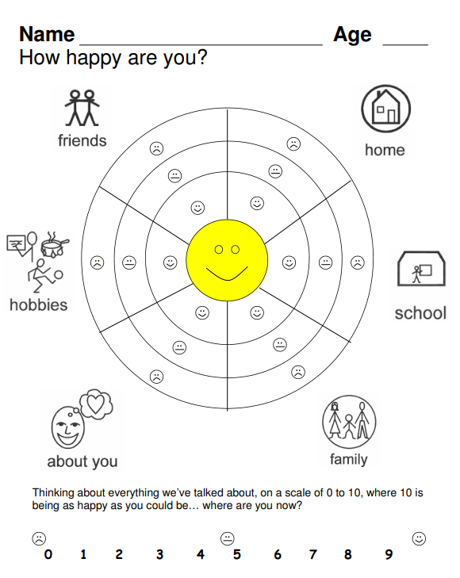

Picture Cards – ‘Get to Know Me!’

Using the different picture cards, learn about the child or young person by encouraging them to choose pictures that capture things that are important to them or that they do and don’t like.
You can do this with them, so they learn about you as well! You can make two columns of likes and dislikes, or you can put the child’s name in the centre and put their cards around them to indicate what is important to them. The images are not labelled so children can attach any meaning or name to the pictures.
Please add to these images, considering the interests of children and young people and build upon them as part of your practice.
There are a few ways to use these picture cards. They can be used:
- With children or young people with disabilities;
- To effectively communicate with children in circumstances where English is not their first language;
- To build a relationship where the practitioner and the child learn about each other.

Tip: You can either print, cut and laminate the cards so you can reuse them in your visits, or you can bring them up on your laptop and copy and paste the pictures on to paint or a word document for a more interactive session.

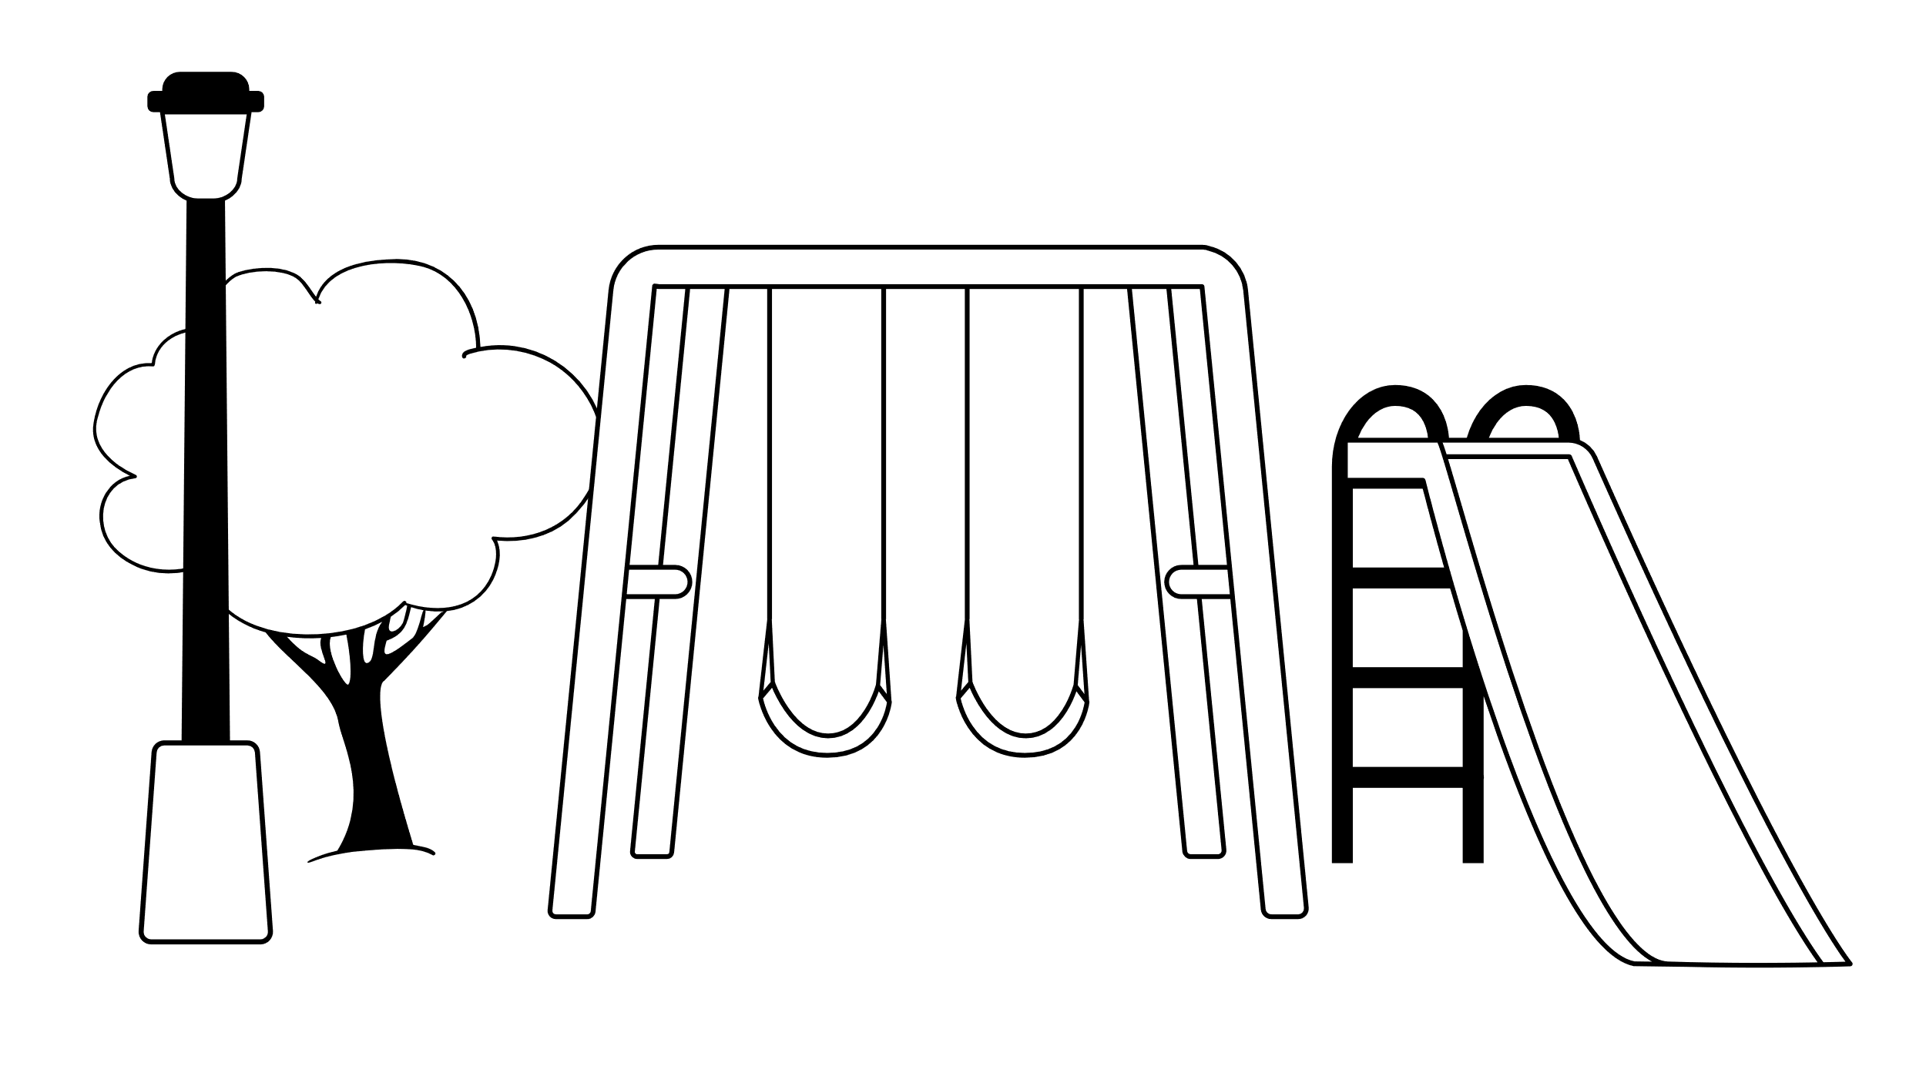
Create your own picture cards! | Create your own picture cards!

