Dudley Safeguarding and Review Service
Top Tips Guide to restorative and child and young person centered Child in Care in Care Review Meetings

Top Tips guide for Foster Carers:
RESTORATIVE PRACTICE
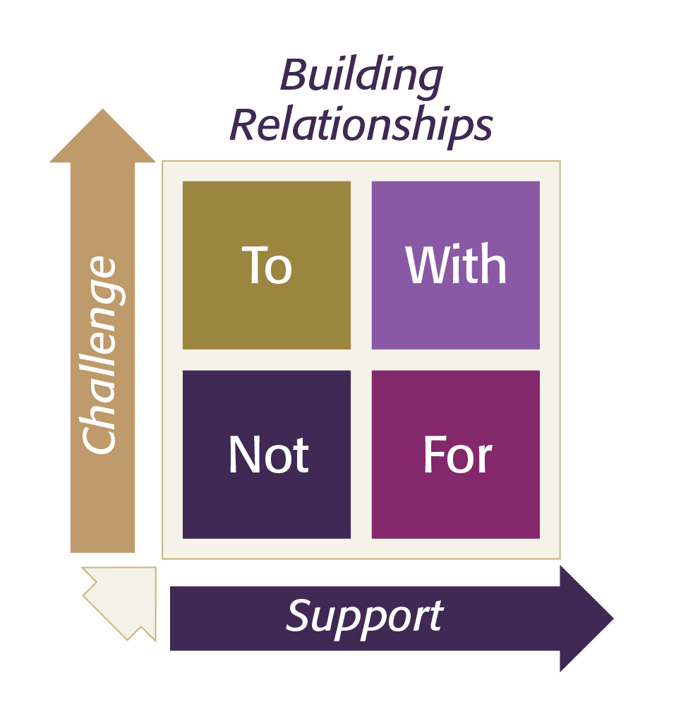
All contact and work received by families from Dudley Children’s Service are based around restorative practice principles. This is to ensure we improve the life outcomes for all children, young people, and families we work with. In Dudley we intend to use restorative principles and behaviours with colleagues as well as children and families, to help develop positive working relationships.

This guide summarises the good practice standards required within Children in Care s review meetings. The Safeguarding and Review Service are committed to ensuring all children in the care of the local authority are protected from harm, have care and pathway plans that ensure their needs are fully considered and met, and that their holistic developmental outcomes are promoted in order they have every opportunity to reach their optimum outcomes. Our Service has a strong focus on Restorative Practice working closely with parents, carers, and our partner agencies to achieve best outcomes.

The principles underpinning all our work:

- The child’s welfare must be paramount, and this overrides all other considerations.
- Children have the right to be heard, to be listened to and to be taken seriously. Taking account of their age and understanding, they should be consulted and involved in all matters and decisions which may affect their lives.
- Parents/carers have a right to be respected and should be consulted and involved in matters which concern their families.
- All agencies involved with a child or young person must work together in the best interests of children and their families.
- Wherever appropriate and possible to do so, children will be invited to attend their review meetings or should be helped to participate and share their views in an alternative way according to their expressed choice and preference.
We will best achieve this by working together by:
- Confirming your attendance at the review meetings as soon as possible given your contribution is important to understand the role and support you provide. If you are unable to attend, a report should be provided and if you are unable to attend a face-to-face meeting, the option of joining virtually can be discussed and agreed with the IRO.

- Making sure the information you plan to share is relevant to the child’s care planning and that you have considered how this will be delivered and received when heard by the child. This means considerations should be given to the language used which needs to be should clear and easily understood and include a balance of what is working well and any areas of worry or concern you may have. Please advise the IRO should you wish to share sensitive information which may be upsetting to the child or young person in advance of the meeting.

- If you are assisting a child’s attendance or speaking on the child’s behalf at their review meeting, you may wish to speak to the social worker or your supervising social worker to ask how best this could be achieved, for example, sharing views via letter, sharing the child’s views and helping to organise where and how the meeting may take place, for example, if the child would prefer hybrid, face to face or video; or, arranging for the child to speak to the IRO separately.

- Our restorative approach to chairing meetings and working together means we value your time and contribution to help produce a need led and meaningful care plan with and for the child after every review meeting and that we all take responsibility for fulfilling the role or tasks agreed within the agreed plan.

- It may be helpful to ‘check in’ with the IRO should you have any queries about any part of the agreed care plan, to assist you to speak with the child after the meeting to ensure they fully understand their care plan.

- It is important we all work together to maintain a ‘safe space’ for the review meeting to progress well, therefore ensuring we allow each other to speak and be heard, avoid interruptions, and allow the chair to manage any potential conflict or difference of opinions within the meeting forum is important. Should the child’s preference for attending their meeting includes having any additional preferences, for example, snacks, or drinks, we ask you to please inform the IRO at least week before the meeting to agree together, how a request may be met.
- Our commitment and focus are to improve and find better ways to work together, with our Children in care and their families, foster carers and partner agencies, I therefore thank you for the important part you take within this process.

