Step up and Down

January 2023

What is the process?
The TEAMS channel includes the 3 MAP team managers and MAP advanced practitioners (AP), FC and FSP Managers. The TEAM channel name is FC/FSP Step Up Requests.
Managers, seniors and/ or DSL (if no senior) who provide management oversight from both the FC and FSP will receive an invite to join this team, please accept. This channel is for managers/seniors only as there should be clear Management Oversight for any step-up decisions recorded on file before the request is submitted. If a senior/DSL is case holding the service manager should have overseen the decision to step-up.
If a FC/FSP manager has identified that a family’s needs have escalated and may require Specialist/Level 4 support, please consider the below prior to requesting a consultation via the TEAMs chat facility on the group chat. In this request you should include:
- Has there been at least one indicator identified at Specialist/Level 4 ( Effective Family Resilience & Levels of Need document ).
- If the indicator ‘situation could reduce the child’s safety’ is being used, this needs to be also accompanied by at least 1 other Specialist/Level 4 factor
- Ensure management case supervision has been sought through your own organisation at /DSL/senior Leaders and that this is clearly recorded
- Is there clear evidence of the concerns for the family/young person with the impact recorded clearly,
- Record clearly all the above on EHM with the rational for requesting a Step Up

In the request you should include:
- your name/email
- service
- if the child is at imminent risk of harm and you require a faster response mark as Urgent
- Do not include the EHM number

As this is a shared chat to ensure we comply with GDPR no personal details of the family should be included. A MAP team member will acknowledge the message and will ask for the EHM number, where the management oversight is recorded, and the managers/seniors best contact number to be sent by email to them and confirm they will call back. Please note this channel is used by all services so keep information on here to a minimum.
After your email has been received in MAP, team manager/AP dealing with that step-up will then check EHM and contact you to discuss within 24 hours. The Map team will liaise with the manager/senior not the FSW to discuss the family. They will either confirm and agree the escalation to progress to the assessment team or confirm the needs remain with the FC/FSP service and would offer guidance on next steps.
All step-up requests will be overseen by a qualified social worker in MAP (i.e., Team Manager or AP) and using the threshold document, they will confirm whether a statutory intervention is required.
The maximum response time is 24 hours however if you believe that a child is at risk of significant harm, and you have not had a response before the end of the working day then the MAP team managers can be contacted directly. Please note that it may be worth tagging the Team Managers/AP to your message in the chat to alert them to this. This channel is part of a duty system so it will be covered by a different team manager each week.

Map Managers
- Bukky Oginni Bukky.Oginni@surreycc.gov.uk
- Clara Masenda Clara.Masenda@surreycc.gov.uk
- Rachel Doncaster Rachel.Doncaster@surreycc.gov.uk
Advanced Practitioners
- IIze Streicher Ilze.Streicher@surreycc.gov.uk

Recording of the outcome of the discussion
The MAP TM/AP will create a contact if the Step up is agreed otherwise the decision will be recorded via case notes. These will include the contact phone number for the relevant CS Assessment team. The Assessment team (Level 4) and the FC/FSP (Level 3) to liaise to confirm the next steps, i.e., close on EHM or continue with FC/FSP (Level 3).
FC/FSP must NOT close EHM record until area team confirms.
Area team contacts: Report a concern about a child or young person - Surrey County Council (surreycc.gov.uk)

Disagreements and escalations
If there was to be a dispute regarding the outcome of the consultation, in the first instance another MAP manager will review the decision and confirm whether the family require a statutory intervention.
If an issue cannot be resolved at team manager level, then this can be raised at service manager level by the relevant managers already involved with the consultation.
Service Manager for CSPA Paul Cooke paul.cooke@surreycc.gov.uk
Service Manager for Early Help partnerships (interim) Sue Turton sue.turton@surreycc.gov.uk

Review
This process will continue to be reviewed within meetings and regular communication between the management teams. Please direct feedback to Team Manager for Early Help Partnerships (interim) Jane Chappell janechappell@surreycc.gov.uk
Step-up consultation flow-chart
Significant or imminent safeguarding concern
Yes

No
Report to Police if welfare check or Police involvement is needed

Request step-up consultation using the step up process via teams– ensuring there is relevant management oversight / supervision record available for review by MAP TM/AP

Alert MAP TM’s if there is no response and if the request is urgent
Request urgent step-up consultation. *Alert TM if no response by end of day
Await response within 24 hours

Discussion / Email response will be had.
(TM/AP records outcome on EHM)

outcome
Threshold met - Step-up to Level 4 agreed
Threshold not met

TM/AP completes a contact including FC/FSP contact information and will transfer to area team.
TM/AP records outcome on EHM (under general notes) including the contact number for the relevant CS Assessment Team.

L3 service to continue working with the family

Assessment Team (Level 4) and FC / FSP (Level 3) to liaise to confirm next steps, i.e., close on EHM or continue Level 3.
FC/FSP must NOT close EHM record until area team confirms.

Families stepping down from statutory children’s services
When the CSPA receive step down from area social care teams to a family centre they will transfer the child and family records to the appropriate service that has been identified to support the family. Prior to step down the area team should have planned for the Family Centre or Family Support Team to accept the step down and put in place a TAF meeting. CSPA are unable to check that this has been put in place. If a family centre/FSP is allocated a step down from their area team without a consultation in place, the service should not return the allocation to CSPA but contact the area team directly to agree a plan of action directly with the ‘stepping down’ team.
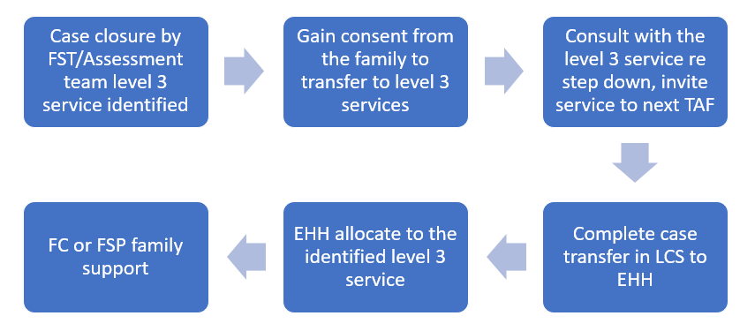

Document last reviewed: November 2023
Reviewed by: Jackie Clementson
Next review date: April 2024

