Promoting Stability Team

Children don’t get traumatised because they are hurt.
Children don’t get traumatised because they are hurt. They get traumatised because they’re alone with the hurt.
Dr. Gabor Maté
They get traumatised because they’re alone with the hurt.
Dr. Gabor Maté

Why Trauma Informed Practice…

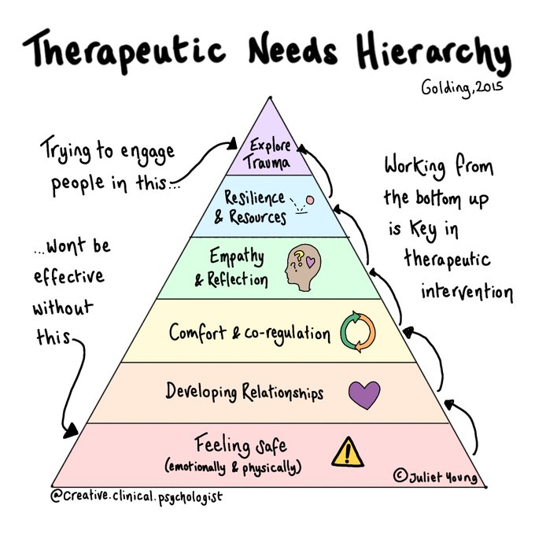
Children who have experienced trauma find it extremely difficult to trust in the good intentions of foster carers who are trying their best to support them. Our children have learnt to develop survival behaviours to keep themselves safe, they show us through their emotional responses, their behaviour, and the way in which they manage relationships.
Supporting our children to be able to trust is a careful journey of patience, acceptance and empathy. There are no quick fixes or short cuts. Our children need to be gently invited into new relationships that offer nurture, safety and security, that will ultimately support them to safely experience the pain of the past and receive the comfort they need from caregiving relationships. Therapeutic parenting goes beyond love and care for a child to helping a child heal from past hurts and trauma.
Our hope is to give every child the opportunity to heal from their trauma and explore the world around them, through the safety of relationships, which offers them the stability of a loving home and family
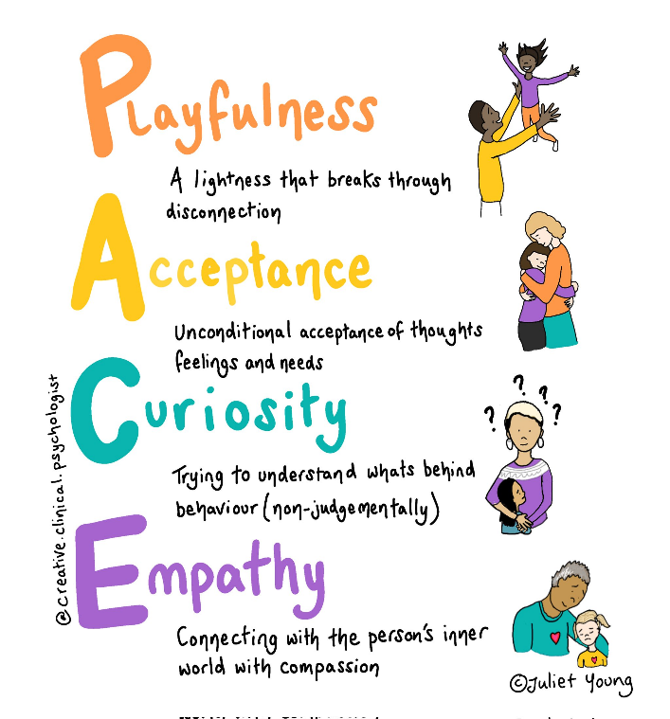
What We Offer…

DDP informed practice (Dyadic Developmental Psychotherapy) underpins our approach, supporting foster carers in responding to our children’s distress. Collaboratively we make sense of and understand what is behind the behaviour by responding with PACE to emotional and physical safety needs. We explore therapeutic parenting and aim to provide an open, safe, non-judgemental and reflective space for carers, helping to understand and explore any barriers to parenting our children therapeutically. This support is regularly reviewed, to ensure we are meeting all needs and remain focussed on stability within the foster family.

Theraplay and sensory attachment principles are a focus within our work. A reflective space is offered to the foster carer to encourage understanding of how their child’s experiences may have impacted on the development of emotional safety and an ability to regulate emotions. Together with the carer and child, we encourage and facilitate building sensory activities into daily attachment time to regulate emotions. Our aim is to strengthen emotional safety within the child and carer relationship, deepening attunement and connection, and to gain further understanding of the needs of each child.

How to refer...
The child’s social worker, supervising social worker or a foster carer, can refer to PST if there is instability or a risk of instability developing within the foster family. In all cases, a PST intervention can be more impactful when we identify challenges early and work in a preventative way, so please get in touch if you feel we can help.
Relationships within foster families can feel difficult and can be a barrier to children receiving attuned and responsive care. PST can help to think about building connection and understanding for everyone in the home. Family time or difficulties at school can increase stress, and PST can support and offer a reflective space.
During calmer times, a foster carer may benefit from a space to think about understanding the needs of the child in their care.
Some situations may need urgent attention, PST are part of the Fostering Support Duty Line which is available from 12-10pm every weekday to provide advice and support. There is a duty worker to provide telephone advice only on a weekend from 11am-8pm.
For a discussion about a family or child you could contact the Fostering Support Duty Line on 01392 381491, or email PST at promotingstabilityteam-mailbox@devon.gov.uk. There is a short referral form to complete and return to the mailbox.
Our focus is on the carer to hold their confidence in caring for the child. Being trauma informed we don’t ask ‘what’s wrong with you?’ but rather ‘what’s happened to you?’ This is what leads to increased stability within our foster families.

Additional responsibilites
• Provide a 2 week referral for children who have moved suddenly or are new into care.
• Support assessments of prospective foster carers, along with the delivery of training on Skills to Foster.
• Delivery of the 6 week Foundations for Attachments Training, this is mandatory for all new foster carers within 18 months.
• Availability to offer support at designated foster carer support groups.
• Transition support that includes narratives and focuses on the child’s emotional wellbeing.
• Provide consultation to the professional network to support trauma informed practice.
• Time limited support to Independent Fostering Agencies.

Feedback from young people and foster carers and Professionals
• “We would not hesitate to use the Promoting Stability Team again. At times, it was the ‘glue’ that held the placement together” - Foster Carer
• “I found it all very helpful and found (worker) a reliable, helpful, friendly and approachable person” - Young Person
• “I greatly appreciated that we were never made to feel we were getting things wrong while seeking advice on how to try different approaches” - Foster Carer
• “It is my firm belief that as a service, this is one of the most important services we have in DCC Fostering at the moment” - Supervising Social Worker

