Devon Children’s Social Care:
Quality Assurance, Learning and Improvement Framework
2023-2025
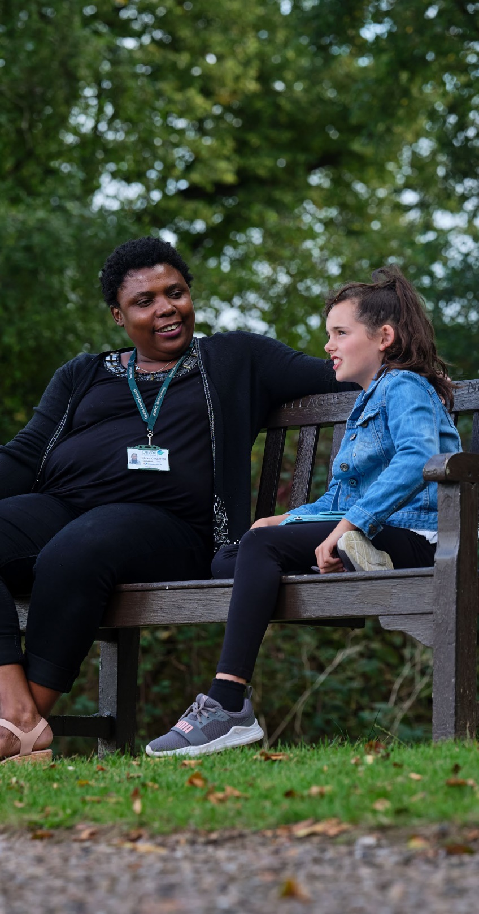

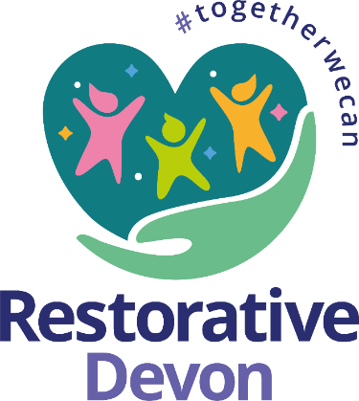

Contents

Introduction…………………………………………………………….3

Quality Assurance and Restorative Values…………………………4

Our Approach………………………………………………………….5

Our Six Quality Assurance Methods……………………….………..6
- Complaints, Compliments and Feedback………………………..6
- Practice Observations……………………………………….......7
- Monthly Collaborative Auditing Cycle and Thematic Activity……..8
- Research, Knowledge and Best Practice Examples……………12
- Devon SCP QA, CSPRs and Rapid Reviews…………………...12
- Internal Learning…………………………………………….………13

Equality, Diversity and Inclusion……………………………………14

Learning, Improvement and Measuring Impact…………………..15

Introduction
This Quality Assurance, Learning and Improvement Framework sets out our ambition to achieve consistently good practice for all vulnerable children in Devon. It outlines how we will use quality assurance as a method to drive a culture of continuous development and improvement. The framework sets out our ambition to increase quality assurance activity at every level of the organisation to create a whole system culture where making a difference in children's daily lives is central to all we do. Every transition point in a child’s journey of support, protection and care is seen as an opportunity to pause, reflect, and hold ourselves and each other accountable for the difference we are making.
This approach, combined with our Restorative Practice Framework Devon's Restorative Practice Framework (sharepoint.com) and Practice Standards practice-standards-november-2023 (1).docx will demonstrate how we check, measure, and evaluate progress for children to ensure they get the right help, the first time they need it, in a sustainable way. Our approach is both responsive and structured; responsive to ensure we focus on emerging areas of concern, quickly identifying and addressing gaps in practice, and structured so that what we learn from our quality assurance work will inform our learning and development offer, in a cycle of continuous improvement.
This framework is an essential part of our approach to improving the quality of our Social Work practice, Leadership, and organisational culture, by modelling and leading a culture of professional curiosity and accountability, supporting staff across the organisation to create an environment in which good Social Work can flourish through a restorative and relationship-based approach.
The Quality Assurance Framework consists of 6 strands of activity/practice that support our practitioners and the organisation as a whole to understand the quality of our practice and which contribute to improving practice by informing the Social Work Academy offer, partnership training offer, bespoke learning events, communications and performance management processes.
This framework takes an approach which brings together a range of quantitative information (how much, how many) with qualitative data (how well?) about practice from across our services on a regular basis. We will evaluate what it tells us about the quality of our practice, whether we are achieving the standards and outcomes we have set out across our service and whether our work is making a difference to the lives of the children, young people and families we are working with (so what? what impact?). In this way we can identify good practice where it is being achieved, evaluate whether improvements are being made as needed and take action where we find they are not.

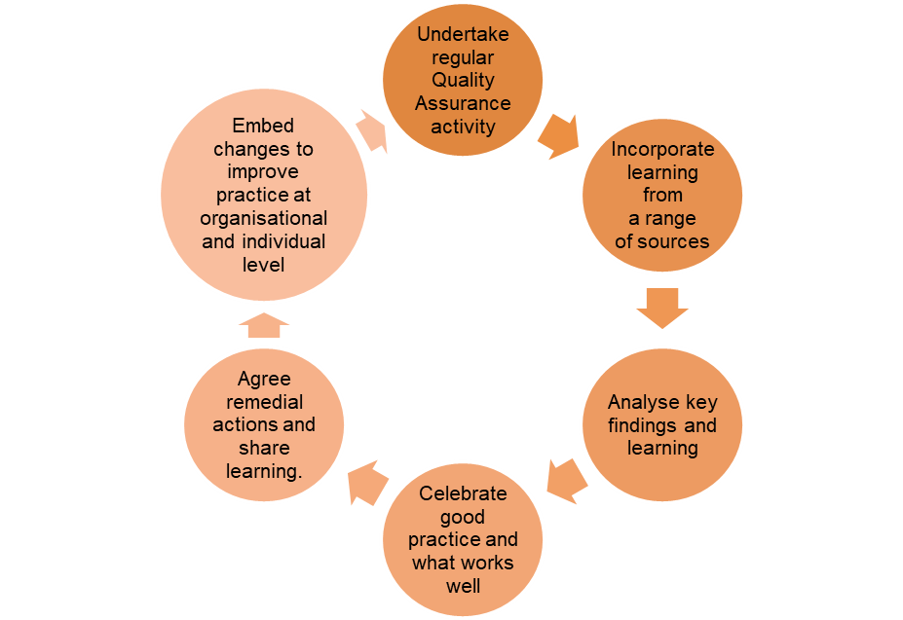

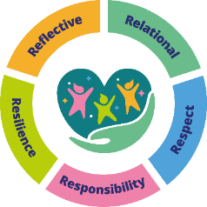
Quality Assurance & Restorative Values
Our quality assurance principles align with the 5 R’s
of our Restorative Practice Framework:

Relational
- Quality Assurance work is an opportunity to strengthen relationships between practitioners and Managers. Our work is complex and challenging, but through audits and practice weeks we think together about how to strengthen child-centred practice. A goal for 2023 – 25 is to increasingly bring the voice of the child and family, and their lived experience into this framework and our quality assurance work.
Responsibility
- Auditing and reviews are undertaken with staff rather than done to them. Everyone is invested in creating good practice and improving outcomes for children in a culture of continuous improvement. We are all part of a system that continually challenges professional practice to promote the best outcomes for children and their families. Leaders and Managers take responsibility for creating the conditions for good practice to thrive in a culture of shared accountability. Intelligent use of data supports our understanding of practice and enables us to attend to emerging themes or patterns at an early stage.
Resilience
- A strengths-based approach to quality assurance encourages improvement, and a culture of learning and development. Practitioners know that their efforts are recognised, their challenges are shared, and this gives them courage to be creative in their work. This supports resilience across the system of help, protection, and care, because practitioners feel safe to offer each other support but also challenge each other to get the best for children.
Respect
- This framework models high standards and expectations for children – and will drive forward learning and improvement work until together we achieve them consistently. We ensure that we use what we have learnt from the analysis of findings to drive ongoing improvement.
- Reflective
- We will use quality assurance to evaluate what is different for children as a result of our intervention and feed this learning back into strategic and development planning.

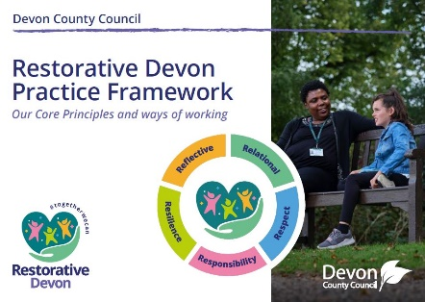
For more information and to see Devon’s Restorative Practice Framework, click here.

Our Approach
The six strands of our Quality Assurance Framework are as follows:
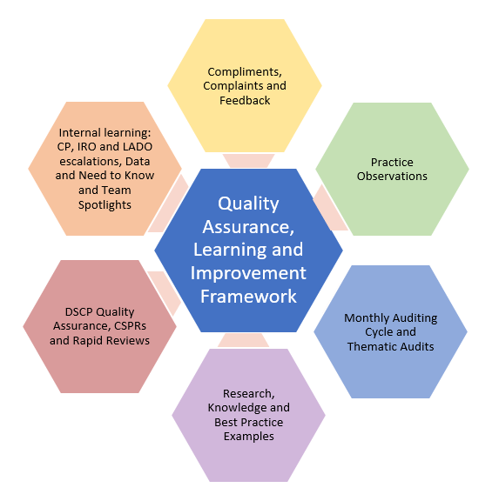
Our quality assurance is both routine; regularly reviewing practice against core practice standards, and thematic; focusing on a specific issue to evaluate our response on a specific issue. It is both single agency and planned with partners through the Devon Safeguarding Children’s Partnership Quality Assurance Workforce Delivery Group (QAWDG)

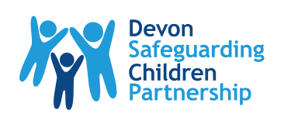
The Devon Safeguarding Children Partnership (Devon SCP)

Our Six Quality Assurance Methods

Compliments, Complaints and Feedback

Children’s Services receive feedback about our practice and the impact that we have on the lives of Children and Families who access our services through several different routes:

- The Single Feedback Form (two forms, one for children aged under 13 and one for children, their families, carers and professionals aged over 13).
- Complaints
- Standalone feedback via email
- The Mind Of My Own (MOMO) app

The Single Feedback Form – returns from the single feedback form are received by the Quality Assurance Team who access the form and send it to the relevant practitioner or Team Manager. The Team Manager acknowledges the feedback with the practitioner in supervision and highlights good practice/feedback to the Senior Manager/Head of Service. If the form indicates that the person completing the form would like a conversation about the contents of the form then the Team Manager will try to have a conversation with the sender and explore the outcomes that they would like as a result of their feedback. If the sender wishes to make a formal complaint, the form will be sent on to the Customer Relations Team (customer.relations@devon.gov.uk) along with any additional detail obtained during the conversation with the sender for logging and processing as a complaint.
The practitioner will add the received single feedback form to the relevant child’s Eclipse record (if the child’s details are known). This way, feedback can be reviewed by anyone who needs to access the child’s Eclipse record and can be considered when undertaking Auditing activity.
The Quality Assurance Team will collate and analyse key themes in the information coming through in the Single Feedback forms received and a quarterly report of the information and findings will be produced and shared with the service as a whole. Learning identified from the feedback received will be considered in monthly meetings between the Service Manager for the Quality Assurance Team and Social Work Academy with colleagues from the Participation Service ensuring that learning is addressed with the organisation either through an update to the current training offer, a bespoke training event or additional communications across the organisation.
Complaints - the Head of Service for QARSS, Principal Social Worker and Customer Relations Manager for Children’s Services will meet on a quarterly basis to undertake a review of all finalised complaints to identify key themes and learning. This information will be collated in the Customer Relations Quarterly Report for Children’s Services which will be presented to QPRM by the HOS for QARSS (and the Customer Relations Manager where possible). Collectively QPRM will agree any necessary actions and learning will be embedded within our Training and Development Offer via the Principal Social Worker liaising with the Social Work Academy Service Manager. This can include included information/learning in current training packages, development of additional training packages and one-off learning events. The Principal Social Worker will be responsible for ensuring that key messages are disseminated each quarter to the workforce within their Principal Social Worker newsletter.

Standalone Feedback via Email – any feedback received via email that is not a complaint or through the single feedback form process should be recorded on the relevant child’s Eclipse record (where the identity of the child is known). All feedback should be responded to acknowledging the feedback received.
Where the feedback does not relate to a specific child, the correspondence should be sent to the Service Manager and Head of Service for the specific service area and also to the Principal Social Worker who will work with the QA Team Data Analyst to ensure that there is a clear log of all feedback received from outside of any formal process. The Principal Social Worker will be responsible for ensuring that any themes and learning from feedback is collated and shared with the Service Manager for the Academy and Quality Assurance Teams as well as ensuring that themes are highlighted celebrating good practice within a celebration event during Practice Week.
The Mind of My Own (MOMO) App – supports a dialogue with children and young people. Use of the MOMO app gives children and young people a sense of independence and puts them in control of their information, emotions and feelings. Hearing directly from children and young people using the app helps to make our practitioner with vulnerable young people impactful and in turn achieves better outcomes for children and families.
All frontline workers will introduce all children and young people to MOMO as a way for them to participate and have their voice heard. All frontline workers will help young people set-up their own Once account to use independently if they are able to. All frontline practitioners working with children and families will have their own worker account and must use this during direct work with children and young people where appropriate. IROs and CP Conference Chairs will speak with children and young people before all reviews and conferences, reminding and encouraging them to use the MOMO app as a means of participation.
When a child’s statement is assigned to any practitioner they must download the PDF statement, respond to the child immediately and check the PDF is saved to the child’s Eclipse record (the latter will be completed by Business Support practitioners when it is received via the portal).
Once a month the Participation Team Leader collates a report that summarises the responses received from children and young people who have used the MOMO app. This report is sent to the Head of Service, Service Manager and Team Manager for the Quality Assurance Team and findings are included in the Head of Service report to QPRM. Themes in learning are discussed and actions in response to these themes agreed by the representatives present from the whole service within QPRM.

- Practice Observations

All Team Managers, Social Workers and Family Practitioners within statutory children’s services should participate in two observations of practice each year. For practitioners, at least one practice observation should include the observation of direct work with a child or young person. Practice Observations should be undertaken by the practitioner’s line manager, however it is an expectation that Heads of Service also undertake observations for practitioners within their service throughout the year. All Team Managers and Service Managers should also have an observation of their Supervision once a year. Team Manager supervision should be observed by their Service Manager and Service Manager supervision should be observed by their Head of Service.
Practice Observations should be undertaken in a collaborative way, be a positive learning experience for all involved and any learning identified from the observation should be recorded on the child’s Eclipse record if the learning is child specific so that this can be reviewed and followed up in Child Specific Supervision or the line manager for the practitioner should be made aware of practitioner specific learning and development identified for follow up in their personal supervision.
 | Family Practitioner | Social Worker | Team Manager | Service Manager
Month 1-6 | Direct work with a Child | Direct work with a child | Supervision | None
Month 6-12 | Other (meeting, conference, assessment visit etc) | Other (meeting, conference, assessment visit etc) | Other (meeting, conference, assessment visit etc) | Supervision
By Whom? | Advanced Practitioner | Team Manager | Service Manager | Head of Service

All Practice Observations should be recorded using the Collaborative Practice Observations Record - Collaborative Practice Observation Record.docx . This record should be sent to the Quality Assurance Team Inbox for storing - business.qualityassurancepracticeevaluation-mailbox@devon.gov.uk.
All Supervision Observations should be recorded using the Supervision Observation Record – Observation of Supervision Record. This record should not contain any child specific information and should be attached to the manager’s personal supervision record in i-trent.
- Monthly Auditing Cycle and Thematic Audits

The Monthly Auditing Cycle continues to feed into the Social Work Academy Offer, findings and key headlines continue to be disseminated throughout the organisation to all practitioners and examples of good practice are identified. All documents linked to the Monthly Auditing Cycle can be found here : Audit Framework - Monthly Auditing Documents and Tools

By February 2024 every Team Manager and Service Manager from the following services will undertake a collaborative audit with a practitioner each month:
- MASH
- Assessment and Intervention
- Children and Families
- Permanence and Transition
- Disabled Children’s Services
- Independent Reviewing and Safeguarding Service

The Monthly Auditing Cycle uses a Collaborative Audit Record to record the audit findings and the quality of practice under each of the 7 Pillars of Practice is evaluated. The auditing process is completed collaboratively with practitioners, seeks feedback from both children and their families and people that are important to them, and considers Restorative Practice expectations and practices.

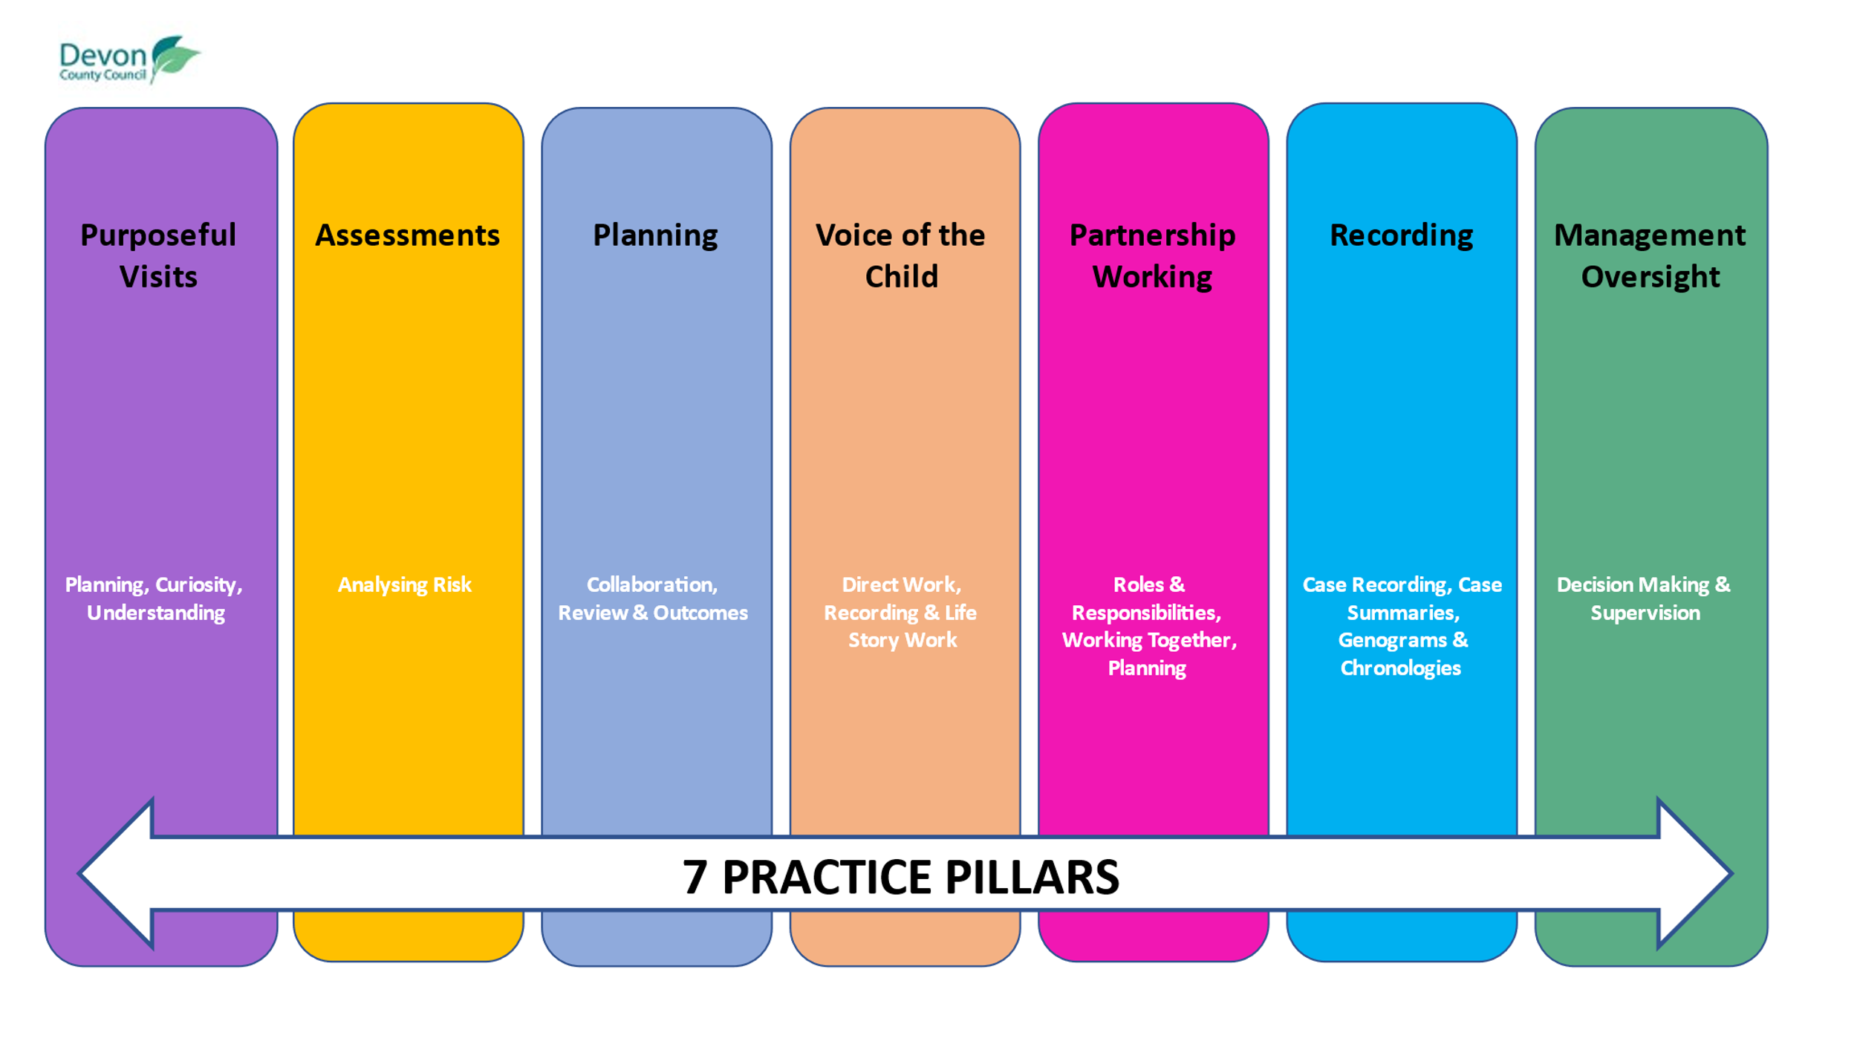
Our Monthly Auditing activity provides us with an overview of quality across our service and allow us to identify trends and themes within particular services that require targeted support and/or enable us to learn from areas of good practice. It also ensures that the organisation is able to really know our practice and ensures that for OFSTED inspections we have a pool of recent audits to select various cohorts of children from.

It is the responsibility of the Service Managers each month to identify the child’s record that is going to be audited. Service Managers will need to consider a mix of CIN, CP, CIC and children subject to court proceedings for teams where there are several levels of intervention for the children with whom they work.

The Quality Assurance Team will moderate each Collaborative Audit Record received and the moderation grade will be the final grade awarded to that audit.

Benchmarking will take place once a month by the Heads of Service and Deputy Directors where five moderated audit tools are considered for their quality and accuracy and any changes to gradings made by the Benchmarking group will be the final grade awarded for that audit.
As part of the Audit Cycle outlined above, a report is created each month providing an overview of the quality of practice for those children who’s records were audited and collating key themes in terms of practice improvement and strengths. Key Headlines are presented at QPRM and the report is circulated to all Heads of Service and Service Managers. An “info-graphic” sheet is created from these findings and circulated to all practitioners and Team Managers to ensure that all practitioners across the service understand key audit findings as well as ensuring our workforce has an understanding of the quality of the work that we are undertaking with children and their families, our areas of strength and the areas of practice that require greater focus on improvement.

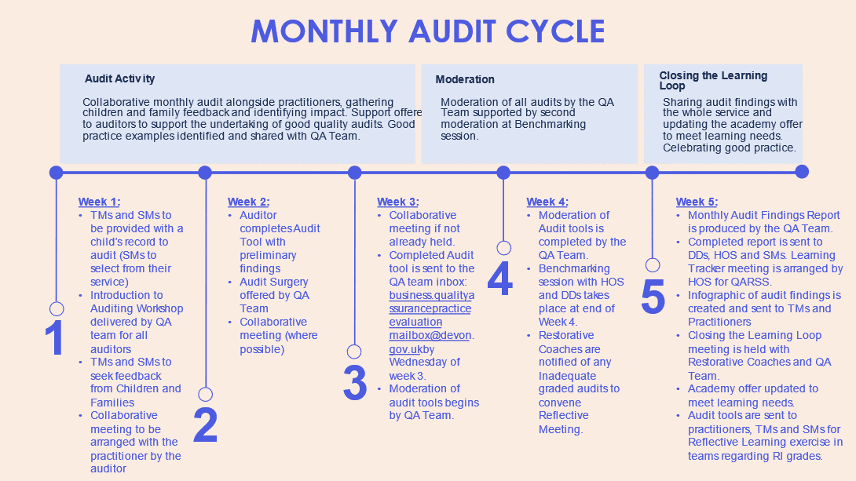

A Closing the Learning Loop meeting is held monthly following each audit cycle by the Service Manager for the Quality Assurance Team and Lead for Restorative Practice with the Restorative Coaches and the practitioners in the Quality Assurance Team to understand learning about the audit process itself, but additionally to ensure that learning for the workforce is recognised and that support is put in place to meet this learning need.

Good practice examples will be identified and highlighted to the Head of Service for QARSS throughout each month’s auditing cycle which will be used to create an “exemplars” resource and for celebration during Practice Week.
Inadequate and Requires Improvement Collaborative Practice Audit Process

The Inadequate and Requires Improvement Process is designed to be a supportive, collaborative and restorative process to aid practitioners to develop their skills and build on the strengths in their practice.

By creating a positive and inclusive learning culture, this process will support practitioners to understand where the strengths in their practice are, and how they can further enhance and elevate their practice in developing their work to a good quality.

When inadequate work is identified within the auditing process, there is often a need to ensure that swift and responsive action is taken to ensure best outcomes for the children with whom we work, but additionally coaching and support for the practitioner to enable them to understand and undertake urgent actions (For the Inadequate Process Flowchart see Appendix 1)

In addition, as part of Devon’s improvement journey, where work is graded as Requires Improvement, support from Team Managers, Service Managers and Restorative Coaches will be essential in supporting practitioners to learn, develop their skills further and build on strengths in practice.

It is the responsibility of the Team Manager to review, in supervision with the practitioner, the plan to strengthen our practice and to ensure that this is reflected in the forward plan. It is also important that a reflective discussion is facilitated by the Team Manager with the practitioner considering ways of improving practice and understanding where practice may have fallen below “good”. The Team Manager can consider any developmental needs identified for the practitioner and can advise them about training and development opportunities on offer from the Social Work Academy and/or identify learning opportunities for the practitioner within the service.

The audit may also identify learning and development needs for the Team Manager and discussions should take place between the Team Manager and their Service Manager regarding developmental opportunities for the Team Manager and any additional support that may be required for them.

The Team Manager may also consider it would be appropriate to hold a team reflective learning activity, such as a reflective circle or appreciative inquiry, anonymising the practitioner’s details to explore further collectively the learning identified within the auditing process so that all practitioners can benefit collectively from the learning identified.

If, upon receipt of the audit records across their service area the Service Manager identifies themes in the strengths of practice or areas of practice that require improvement, they may want to hold a service wide reflective learning event. Restorative Coaches can be contacted to support such an event and facilitate the reflective activity.

Team Managers and Service Managers will be responsible for updating the QA Team as to the reflective activities that they have undertaken either with the practitioner, the team or the service so that this can be logged on a tracker by the QA Team, thus evidencing that we are learning from audits and “closing the learning loop”.

Thematic Dip Sample Activity

Complimenting the monthly audit cycle, 2 x Thematic Dip Samples are undertaken by the Quality Assurance Team focussing on specific cohorts of children and areas of practice. These are undertaken by the Quality Assurance Advanced Practitioners and corresponding summary reports are created and circulated to all Heads of Practice and Service Managers. A Learning Action Meeting is held by the Head of Service for QARSS with the relevant Heads of Service and Service Managers who are responsible for children’s records considered in the Dip Samples to input into the Learning Action Tracker with actions relevant to their service and across the organisation to address areas of learning identified within the activity, as well as promoting areas of strength.

Key Headlines from the Thematic Dip Samples are also shared each month at QPRM which ensures that all leaders within Children’s Services are aware of the themes in terms of strengths and learning as well as any organisational learning identified within the auditing process, to ensure swift and effective decision making by the leadership team in terms of adapting process and responding to organisational learning promptly.

Thematic Dip Sample Activity Yearly Schedule (for 2024)

- IRT Threshold and Decision Making – January 2024
- Management Grip, Oversight and Quality of Supervision – January 2024
- Re-referrals – February 2024
- Early Help: Levels of Need and interface with MASH – February 2024
- CP planning that ends for children at the first review – March 2024
- Children subject to CP Planning for over 18 months – March 2024
- Emergency Action and EPOs – April 2024
- Pre-birth Assessments – April 2024
- Plans, their Impact and Outcomes – May 2024
- Strategy discussions and S47 Investigations – May 2024
- Children subject to the PLO – June 2024
- Children subject to CIN planning for over 9 months – June 2024
- Contextual Safeguarding: our response to Children at risk of Exploitation and our adolescents at risk – July 2024
- Quality of Assessments – August 2024
- The Lived Experience of the Child: The quality of our direct work with children, our relational practice with children, the voice of the child and keeping children central to decision making – September 2024
- Permanency -September 2024
- Equality, Diversity and Inclusion, exploring our work to understand children's uniqueness and diversity – October 2024
- TBC – October 2024
- TBC – November 2024
- TBC – November 2024
- TBC – December 2024

- Research, Knowledge and Best Practice Examples

The Principal Social Worker will be responsible for ensuring that current research in practice is shared across the workforce, that links are forged with Research In Practice (RiP) colleagues to support the training and development offer from the Social Work Academy and that Best Practice Examples are collated and shared with all practitioners. In addition, learning from a range of sources from throughout the year will be collated and showcased within Practice Week each year. Included within Practice Week will be a celebration event showcasing good practice and strengths in our practice supporting practitioners to know what good looks like and understanding how to elevate their practice to good.

The Principal Social Worker is also responsible for ensuring that our Practice Standards practice-standards-november-2023 (1).docx are kept up to date and that all polices and procedures are available to practitioners on TriEx Devon's Children and Families Procedures Manual (proceduresonline.com)

Our Social Work Academy offer is being aligned with the 7 Pillars of Practice and within each pillar a resource pack of direct work tools, current research and knowledge and the training packages on offer to support practice under each of the Pillars of Practice will be available to all practitioners across Children’s Services to access. The Social Work Academy page can be found here : Welcome to the Academy (under construction) (sharepoint.com)

- DSCP Quality Assurance, CSPRs and Rapid Reviews

The Devon Safeguarding Children’s Partnership has a clear plan for Quality Assurance work being undertaken each year. This includes Thematic Reviews which form part of an ongoing partnership approach to Quality Assurance. Thematic Reviews include (but are not limited to), Multi-agency Audit activity, interviews with Senior Leaders, Interviews with Children and Families, Data Analysis and Appreciative Inquiries focussing on a particular topic or area of risk. Children’s Services are represented by the Head of Service for QARSS within this work who co-chairs the Quality Assurance and Workforce Delivery Group (QAWDG) with the Head of Service for Public Health Nursing. The learning from Thematic Reviews is summarised in a Final Report which is available on the DSCP website (see below). The DSCP will arrange partnership training events following each finalised Thematic Review Report and the Head of Service for QARSS will ensure that these multi-agency learning events are attended by Children’s Services practitioners and managers.
Safeguarding Practice Reviews - Devon Safeguarding Children Partnership (devonscp.org.uk)

Child Safeguarding Practice Reviews (CSPRs) and Rapid Reviews (RRs) are coordinated and completed by the DSCP when a serious incident has occurred for a child or young person. The collation of information and the resulting meetings have multi-agency representation present and contributing to the findings and the final reports that are written and submitted to the National Panel. For RRs a Briefing Report is always produced. The Principal Social Worker will be responsible for ensuring that learning from CSPRs and RRs is disseminated to the workforce but additionally that they work with their Social Work Academy colleagues to ensure that learning that is identified is incorporated into existing training or that new or bespoke training is developed for delivery. The Principal Social Worker will also be responsible for working with the Head of Service for QARSS to ensure that our Thematic Auditing Work continues to take into account findings from CSPRs and RRs but additionally, that it continues to assess and understand the impact of training and development opportunities offered to the workforce as a result of CSPR and RR findings.

6) Internal Learning: CP and IRO escalations, Data and Need to Know

Child Protection Chairs and Independent Reviewing Officers - are responsible for Quality Assurance and compliance with expected standards in our work with individual children. They have a clear “Resolving Professional Differences” process which includes the informal and formal escalation of professional concerns when children are not receiving the expected service from Children’s Social Care services. Tracking of escalations takes place and is monitored and overseen by the Team Managers and Service Manager for the Independent Reviewing and Safeguarding Service. On a monthly basis a report is completed highlighting themes in escalations and this is shared at QPRM by the Service Manager. In addition, monthly meetings are held with the Service Manager for the Quality Assurance and Academy Service and overseen by the Head of Service for QARSS to ensure that any themes in learning or development are captured and addressed within the training and development offer for the workforce.

Quality and Performance Meetings - undertaken fortnightly with all Heads of Service and led by the Deputy Director for Children’s Social Care ensures that performance data in line with our Key Performance Indicators (KPIs) is reviewed frequently and consistently ensuring that any areas of declining performance are identified and addressed across the service and areas of practice where we are succeeding and maintaining good performance are recognised and celebrated.

The Need to Know process - ensures that any significant incident for a child or young person is reported to senior leaders. This ensures a swift response and decision making to serious incidents. The Need to Know process can, at times, trigger a multiagency discussion to determine if a notification needs to be made to the National Panel and whether a Rapid Review should commence as a result of the information – this links to our Devon SCP work as outlined above. In addition, the Service Manager for our Quality Assurance and Academy will collate a quarterly report looking at key themes from Need to Know notifications and ensure that learning is disseminated and considered within the Academy offer.

Team Spotlights - are an opportunity for a service or team to review the quality of work, a team or service culture, management oversight and supervision and to highlight strengths in practice and areas where our practice can be improved through a variety of activities which includes working alongside practitioners, dip-sampling and quality assurance activity and data analysis. The process is done with rather than done to and is designed to provide helpful insights into our work so that we can really “know ourselves”. All of the work undertaken is collated into verbal feedback provided promptly during the Spotlight Event and in a report written after the event which is evidence based and collates all relevant information and work undertaken.
Each Spotlight Team is made up of Advanced Practitioners, Team Managers, Service Managers and a Head of Service who are peers of the service/team being focussed on, as well as a Lead Practitioner who is identified to lead and coordinate the activity. Any Team or Service where a Spotlight activity is planned is given notice of the date on which the Team Spotlight will commence and preparatory meetings and information sharing takes place.
Team Spotlights not only benefit the team or service for whom the Spotlight is for, but the practitioners undertaking the Spotlight activity have an opportunity to learn from and understand services other than the one that they current practice in. Shared learning and understanding has significant benefits in supporting an open learning culture within our organisation.
Any recommendations made as a result of the Team Spotlight activity will collaboratively be considered by senior leaders, managers and practitioners to contribute to their Service and Improvement Plans. All Service and Improvement Plans are tracked, reviewed quarterly and evidence of impact is clearly recorded.

Equality, Diversity and Inclusion

The consideration and understanding of Equality, Diversity and Inclusion permeates through all of our Quality Assurance Framework.

Our monthly Collaborative Audit Record asks specific questions about children’s uniqueness and assesses the quality of our work with children and families in relation to our understanding of protected characteristics as well as the social GGRRAAAACCEEESSSS:

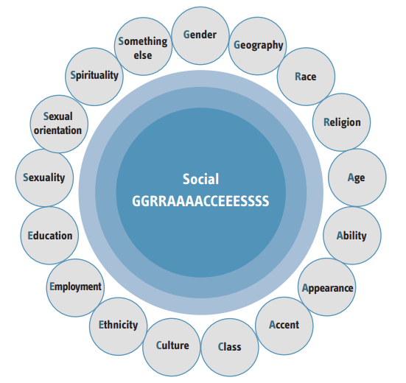
adultsdp_tools_1-6.pdf (researchinpractice.org.uk)

We have specific Thematic Dip Sample activity factored into our annual schedule focussing on our practice considering our work with Diversity, Equality and Inclusion as well as considering and listening to the views of the children and families that we work with through our seeking of feedback via MOMO, the Single Feedback Form and the collation of themes from our Complaints.

The learning that we achieve from our Quality Assurance activity will directly impact our Social Work Academy offer which strives to ensure that robust training regarding anti-discriminatory practice and working with the protected characteristics as defined in the Equality Act 2010 is developed and delivered to all practitioners in 2023-2025.

Learning and Improvement cycle
Learning from activity carried out as part of this framework will be used proactively to bring about continuous development and improvement in practice to ensure we improve outcomes for children, young people and their families.
It is also vitally important that we understand the impact of our work, particularly for areas of practice that have changed or been developed. We need to understand that any changes or progress we are making in practice are having a positive impact on the children and young people that we work with.
There are a number of ways in which we undertake Quality Assurance outlined above, however we need to measure and understand the impact of all of this activity and ensure that the learning process is continuous and not standalone.

Child’s Voice- MOMO
Thematic / Bespoke Dip Sample Activity
Analysis of Data
IRO’s- escalation, challenge, and themes
Learning from RRs and CSPRs
Practice Observations
Child and Feedback – Single Feedback Form
Monthly Audit Cycle
Team Spotlight Events
Devon SCP Quality Assurance Activity
Learning from Complaints and Compliments
Annual Self-Assessment and Development Plans
Improvement Plan driving Continuous Improvement
Culture of Learning with sharp focus on outcomes for Children
Collating Learning:
- Monthly Audit Cycle Report
- Monthly Thematic Dip Sample Activity Report
- Quarterly Complaint Themes Report
- Quarterly Single Feedback Form Report
- Monthly MOMO Report
- Rapid Review Briefings
- QARSS QPRM Reports
- Need to Know Quarterly Thematic Report
- Practice Observation Records
- Devon SCP Quality Assurance Reports
- Team Spotlight Reports
Closing the Learning Loop:
- Inadequate and Requires Improvement Process from Monthly Auditing Cycle
- Closing the Learning Loop Meetings with Restorative Coaches following each Monthly Auditing Cycle
- Monthly Audit Infographics
- Learning Action Meetings and Learning Action Tracker (reviewed quarterly for progress)
- Practice Week
- Bespoke Learning Events
- Workforce Briefings
- Principal Social Worker Newsletter
- Academy Offer updates
- Recommendations from Team Spotlight Events

Research and Knowledge
Need to Know Process
Good Practice Examples
Measuring Impact
- Themes from Complaints, Compliments and Feedback
- Data Analysis
- Audit gradings
- Practice Observation gradings
- Repeat cycle of Thematic Dip Sample Activity
- Ofsted feedback

Appendix 1 : The Inadequate Process Flowchart