**Beds and Luton CAMHS – October 2023 – monthly compliments**

**IST**

C & D

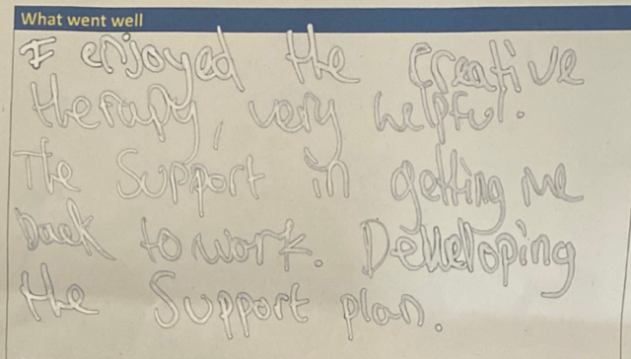

**IST & Crisis**

 L, M, N, J, J, C & C

' ______ expressed that she was thankful for IST and crisis support and explained that her suicidal thoughts had reduced in recent days due to the caring nature of the staff that had been in contact with her.'

C & C

During an initial assessment patient expressed that despite the difficult topics they found it easy to engage with both staff due to the approach used. SW teacher later said that they were worried about C & C meeting with the patient prior to the assessment, but could see it had gone well and thanked both for their support.

**CEDS**

NW

Thank you so much for all the help and support we have received from you and the wonderful team at CAMHS. We could not of got to where we are now without the kindness and support. We are all sad to be leaving the service but also immensely proud of M and her progress. Fingers crossed we stay heading in the same direction. Thank you again and I hope you are a wonderful day.

DM

Received a card

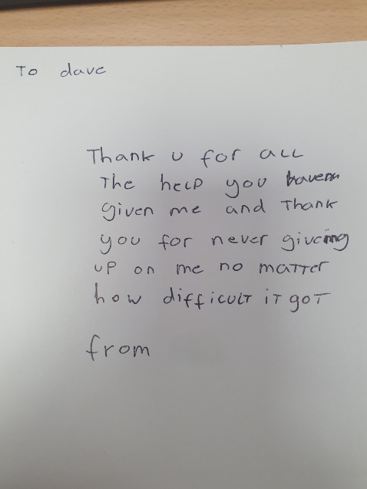

SW

Received thank you card

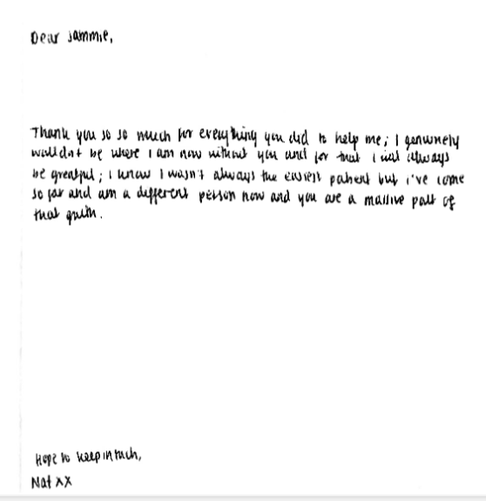

**Participation**

'I would just like to say I have enjoyed working with you N & your team in Service participation & excited for the young people that I referred who are benefitting from being a part of this wonderful initiative'

S

I just wanted to say a massive thank you for the amazing training you provided our forum last week. Thank you for creating a space for us all think and learn about how we support trans young people

J & M

I would also like to extend my gratitude to Jay and Molly for such a brilliant piece of work. This is excellent well done! A big thank you to you, J and M

M

I am a new member of staff and so this was the first time I have seen the Chameleon Magazine, and just wanted to say what an amazing piece of work this is! It was really lovely to read the pieces by previous service users ☺

**H**

From Luton Admin team- A big thank you to H for being such a great addition to the senior management team, she was always approachable, kind and always had time for her colleagues. She was always quick to address any issues and concerns. We wish her all the best in her future endeavours!

**North Beds Outcomes**

I want to thank our Outcomes team for their hard work, especially when I have sent out dozens of emails with ROMS in one day.

I’d like to also say - Rosemary, your patience, kindness and support has helped EB3 achieve their Outcomes goals consistently in the past 6 months. I know there is a lot of work going into putting together weekly/monthly reports for us and your help is greatly appreciated.

North Beds AMHT, Crisis & Home Treatment

M

From a parent-“…Good afternoon M,

 I hope this reaches you.  I just wanted to say a huge thank you for your contribution to the meeting today.  The social workers wanted this meeting to be with just me so I insisted on CAMHS and education being involved.  I was so pleased to see so many people from CAMHS there and, in particular you, for speaking out for F, and for the safety of future cyp being placed.  You echoed my feelings precisely…”

During an initial assessment, the patient mentioned that they had previously received support from M which they described as “brilliant”.

S N

Received a gratitude stone and card from a client and family.

September 2023 compliments:

**IST**

C L

From a parent regarding LDA award- The article really emulates what you guys do in often, let’s face it, emotionally charged situations! We are forever great full for the kindness you’ve shown us as a family 😊 Congratulations on your award, you’ve definitely earned it.

M V T

I received a card from a patient we recently discharged saying the following:

“Thank you M for helping in my sessions and for being such a caring and lovely person. Your thoughtfulness means a lot"

**LAC**

C

Feedback following consultation with EB2 and Social Care colleagues-  'Ah, thank you C, much appreciated. Some positive feedback from X regarding the way you positioned yourself, she described you as very gentle and caring’

FD

Feedback I received this morning from a residential home manager and then a mother of a young person I have been working with

*Mother of a young person*

*😪 there are no words I pray there is still a relationship between you all who have been involved*

*I know X she will miss you guys too. I can see regardless of how hard it’s been for her to adjust as myself too you’ve all become a great people in her life you became like family members who contribute the best support possible to her In consistence. I pray we can all stay in contact and j can still receive your passionate support over the coming years. We will never forget any of you, I’m so grateful to you all for your works. Thank you*

*Residential home manager- Thank you so so much i'm  going to miss working with you when X leaves us, you have truly been so amazing for her and she adores you, I added the flask and Enfield alongside Bedford and thank you again for your continuous support to us and X We all think you are amazing 😊*

**CEDs & ED HIT Team**

I cannot praise the HITT service highly enough, as a parent it can feel isolating and overwhelming supporting a child to eat, when the illness is at its worst.

Having members of this wonderful team visit my daughter during her recent hospital admission was invaluable. The ladies had a wonderful approach and undoubtedly helped her to start eating after many days of refusing food. I also really appreciated their support in passing on my concerns, as to how triggering and condescending my daughter was spoken to by some of the doctors, things improved after this and hopefully future patients will also benefit. Once discharged, visits to home continued until she was once again able to eat without their support.

I have really appreciated that when my daughter has been at her lowest, at weekends and bank holidays, we have had check in phone calls from CAMHS and members of HITT have in the past come in on their days off to support a hospital admission and provide support at home. This really sums up the level of care and dedication provided by HITT, I feel incredibly lucky that my daughter and I have received their support. I'm not sure how we would have got to this stage without it -thank you.

This is going to be a hard letter to write but I feel you all need to know the enormity of the journey we have been on with you and the huge levels of gratitude we feel towards each and every member of your Team... In walked E, kind, cheerful, no nonsense, positive, upbeat, straight talking, honest glorious E, we sat in a tiny little room and she talked, she knew exactly where M was at, where we all were at and what was needed, she asked the right questions she knew what M would say, and we all sat there stunned, she saw the monster that lurked inside our daughter and she had a plan. I think in those early days as a family what you so desperately need is to feel that someone knows what is going on,  and you need to feel confidence that they knows what to do,  for us that person was E.  I would do different but today our daughter is well she is 15, she is a normal sassy grumpy adorable teenager and we have the Bedford CAMHS ED Team to thank, you are the people who have helped us save our daughter, you saved our family, you do this as a job and you do it every day with humanity and compassion.

E

Thank you for your huge, huge kindness for your calm pragmatic genuine compassion, for your brilliant professionalism and for being the first person we spoke to who actually made sense, you knew what to ask and how our daughter was feeling, you held our hand and lead us through the maze, I really hope that one day I bump into you in the future when this is all behind us and I can take you out for a meal lunch dinner tea coffee whatever and we can just talk about you, and how you are, and how you are feeling and what is going on in your life.  We owe you so much and I doubt we will ever be able to repay any of it, I’m really, really glad we got on your boat, Thank you xxxxxx

M

Thank you for guiding us through the scary world of drugs, for being firm when you needed to and for getting M onto and then more importantly off of what were for us a really helpful selection of drugs. Thank you for answering our questions and tolerating my fears and mummy lion behaviour. Your professionalism and knowledge was hugely appreciated and will be remembered long after I can remember what drugs we talked so long about.

Dr B

We met sporadically mostly with masks or on-line and your advice was always delivered with kindness and understanding it must be so hard to know what needs to be done and then watch parents fumbling around making mistakes, I thank you for all of your patience and your advice.  I know we never saw 90 percent of what you do, the meetings the planning sessions the running a department under the most hideous pressures but thank you for all of it, your formula works, we are the proof.

B

B you are just great, I know the meal support didn’t really work but I don’t think it was ever going to work for M, I think you showing up was what she needed, people on her team willing to fight for her and you were there in spades, you taught us that humanity and humour still happens even in the middle of an eating disorder thank you forever. Lanyard on or off whatever!

Huge love and thanks to the whole ED team you are all bloody amazing!

At a time where we knew nothing E was calm, kind, confident, professional and instilled confidence in us. The whole of the ED team were amazing but special mention need to be made for E and B who were spectacular.

E has been supported beautifully. We have been supported as a family as well. Thank you so much for everything. E is back to being the person she was before her illness.

M was amazing. She cared and looked after me. I wouldn't be where I am now without her and all the team. Big thank you from me from me. I wouldn't be here without you!

**Rachel Overton and wider business support colleagues**

R O and wider business support colleagues – who diligently supported a desk top RIO audit in a very short time frame. I really appreciate the input from everyone involved and Rachel’s commitment to support this piece of work in such tight time scales showed great determination

Amazing team work ☺

**North Schools Pathway**

I would like to thank all of this team (A, B, J, L, J and A) for being such a kind and supportive bunch of people. I have enjoyed working with them over the last year so much and will miss them very much. I know how hard they all work to provide vital Mental Health support to Schools, Early Help and, most importantly, Young People. Big up you guys!! ❤

**North SPOE**

Can I please give a shout out to NORTH SPOE Admin Team. They are doing a good job managing referrals coming in, answering any queries posed to them. Nothing is too much trouble for them. They are a hardworking bunch and just wanted them to know that we appreciate all the work 🙂

**North Beds Early Years’ Service**

K R

‘I want to thank you for the help you’ve provided me with these past several months, I found it very helpful being listened to’.

Thank you for the offer of an appointment but I don't feel I need any more help with this.

 I'd just like to take the opportunity to say thank you for all of your help.’ very accurately drawn hand-made Good Girl Star sticker awarded to K R by a 5-year-old patient.

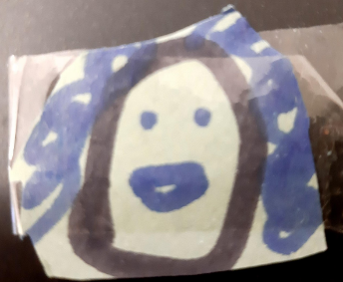

**North Beds PCAS & Discovery College**

I just wanted to message to say a big big thank you for attending today. Without your support and giving up your valuable time, we wouldn't have been able to have such a successful event.

**North Beds AMHT, Crisis & Home Treatment Team**

Crisis and AMHT teams

From a parent - I just wanted to thank you for all the recommendations and advice you gave in the meeting today.

I appreciate you and your Bedfordshire colleagues, including Lisa, J and also G for everything you are doing and all your contributions to meetings too which I value highly.  It is so refreshing to hear from well informed people who are open and honest with me.

C N

He was positive about most of them but him and his mum were particularly complimentary of C from your crisis team, sharing that he was really down to earth, B felt understood by him and that he in general was easy to talk to and connect with, both as a young person and a parent. They named him as the best professional they have had contact with over recent months.

G N, K C and Dr S N

S gave verbal feedback to G N, Kit Chand and Dr S N, for their hard work and support with a young person during a difficult time. Compliments from deputy home manager S.

G N and R K

Verbal feedback given during formulation and care planning meeting for proactive interventions being in place in preparation for the young person transitioning into adult care. Stated it was a great example of how the process should be done and was lovely to see

K C

*Lovely to see you as well and thank you so much - F says she feels very comfortable with you and says your very warming and friendly face'*

**Bedford Reception**

E S

Just wanted to say a big thank you to E S from reception for supporting some of our youngest patients and engaging in such a warm, welcoming, and playful way whilst they feel anxious and wait for the clinician.

Received a card

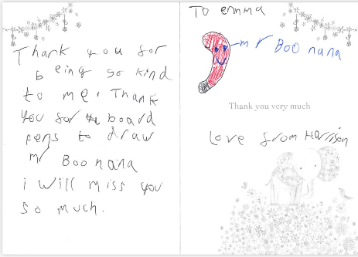

**EB2**

E M

I had my last appointment with a young person on Tuesday and they said that my report was ‘spot on’. Made me smile

Dr A Y

A parent shared with me how helpful Dr Y had been and gave her hope for her daughter’s future.

**EB3**

From recent trainee clinical psychologist - I just wanted to say a huge THANK YOU for accepting me into your team and truly making me feel part of it. It has been an honour working with you all and I have learnt so much from you. Each and every one of you is inspiring and I will not forget the care and dedication you put into your work and the YP - this is something I will take forward with me.

**Dunstable EB**

D P

WE DID IT!! Thanks so much for the help, I’ve finally been accommodated for properly. Wouldn’t have been able to do it without you <3 thanks so much D : D x Have a great day!

L K

 It was a lovely session and bitter sweet as J is definitely in a better place but was sad to have come to an end with you both. We wish u every success in the future in your career path u choose. We are sure u will be successful in all you do. Many thanks again for your work with us and the empathy u showed throughout, it did not go unnoticed.

**Leighton MHST**

N W

'Hey! Sorry to get back to you so late, over the holidays i figured a lot of stuff out and worked on myself i'm actually doing a lot better now so i won't be needing the support, thank you for listening to what i had to say and helping me

**Luton Home Treatment Team**

E M & Team

**From a parent -** 'as a mum of a child that thought taking his own life was the only answer THANK GOD for YOU and the team .You were there day and night you were not only there for J but also us as a family . House visits ,phone calls and weekly sessions helping J understand what was hoping on in his head and showing him in c.b.t. sessions that it was OK not to have me as a security  blanket  . I cannot thank you enough for the great start and support you gave him on his journey to recovery before he turned 18 and was passed over to the great Mr P K. I would also just like to say thank you to you and your service your team was second to none ....from a very grateful mum. Before I went into my first c.b.t. session I already knew Liz from home visits and I said I don't want to do this how is it going to help me .....I was so wrong Liz explained things to me in a simple way in which I could understand ....I came out of that first session and couldn't wait for the next session the following week ....THANK YOU LIZ

**Luton EB**

C D

My first experience with CBT therapy started this year. I’ll be honest i was quiet hesitant at the start because no I’m in my family or community or anyone i knew had any experience with therapy. The attitudes around therapy that i was around, were usually quite negative which put me off seeking for it earlier. I had no idea what CBT was, but i was quilt explained by therapist C. At the start i was feeling very suicidal, i was worrying constantly, my sleep was pattern was horrible and i just had anxiety over everything. I wasn’t in the best state of mind, mentally or emotionally. However as the year has gone through, I have gotten better and i have taken much on board from the therapy as much as i can, even if it was the littlest things; I tried to keep an open mind because I realised, i never wanted to return to that point. My therapist C was lovely and very attentive, even though we had a quite few differences, which did make me hesitant at the start, she was able to help me and always listen and communicate with me effectively. Even if I was resistant to any sort of treatment or plan she was there to help me and guide me.  The thing with CBT, most of it is done by yourself, which in my case is my very important for me. The main issue i was struggling was that i had lost any motivation to do anything, even if it was important or enjoyable. So making sure i was the one putting the effort in and making sure I was actively trying to be better was effective for me and my journey as whole. I started techniques like manifestation and rumination which was totally new to me, however it has proven quite effective with me and is something i try to implement in my daily routine and is helping me get better. Honestly, being discharged is still quite a scary thought, i have realised i have gotten a lot better: I am worrying less, my sleep is better, and I don’t have any suicidal thoughts. Overall, I am happy with CBT therapy and how has it been conducted and I am thankful for my therapist C.

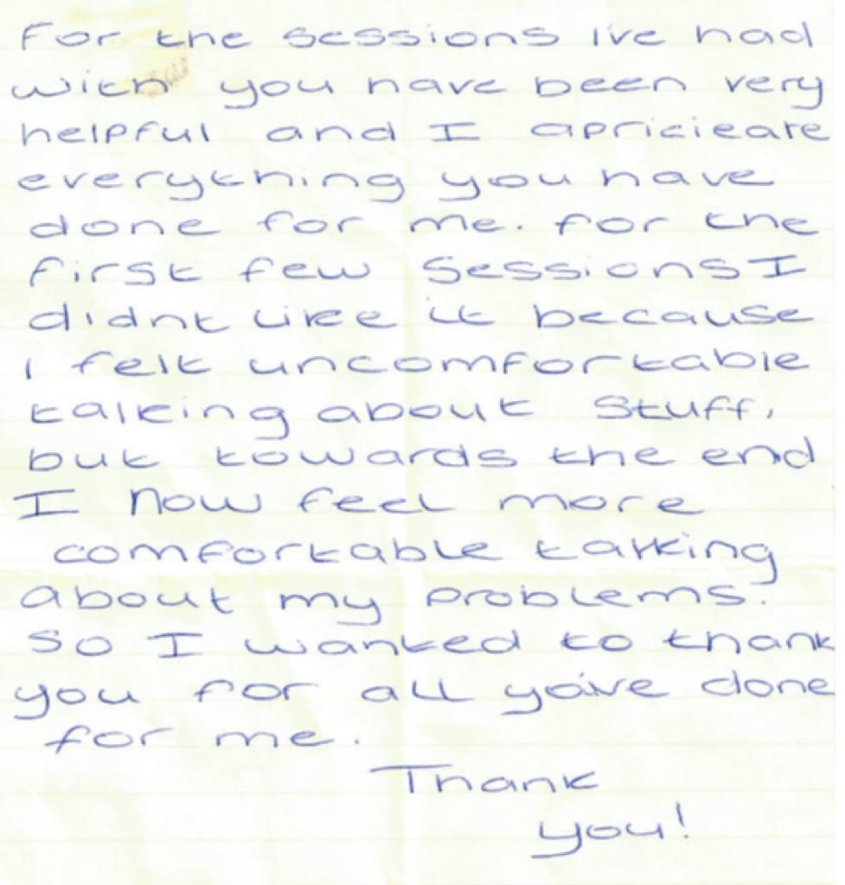

Dr M K

From 2 medical students-

'Thank you for taking the time to teach us - it was genuinely very useful, and a good overview of CAMHS. I really enjoyed learning about the differences with adult psychiatry, and the ways in which the struggles which are unique to CAMHS can be managed.'

'I, along with a second student, attended a placement day in CAMHS. Dr K was keen to involve us and help us make to most of the day despite, unfortunately, there being no patients to see that day. We spent the majority of the day in discussion around the key aspects of paediatric psychiatry. I liked the way our discussion was structured around child and adolescent mental health history-taking whilst allowing room for us to go down tangents of discussion on areas we found more interesting. We covered many topics and illnesses; and I feel that I left with a better understanding of how child and adolescent mental health should be approached. I want to specifically mention the friendly atmosphere I noticed at CAMHS. I was made to feel very welcome by all staff and I noticed good relationships between the staff themselves. It was a lovely environment to be in for the day.'

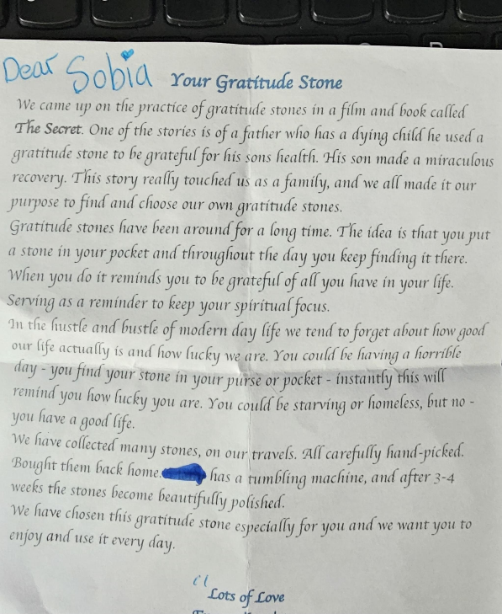

S, S & M

Patient reported to colleague that although they were finding a recent transition difficult, they were hopeful for their future because of the continuous support they have received from AMHT which they reported being very thankful for.

**EBT3**

D D

From a student nurse - 'I just wanted to just express my thanks and my appreciation for everything that you did for me during my brief placement with you guys. Right from the very first moment I arrived you made me feel very welcome and comfortable, I really appreciated all of the advice you gave me and I have taken it all on board. I can tell that you are a fantastic nurse and a role model for myself as a student, you clearly have a profoundly positive impact on the lives of the young people you work with.

**EBT2**

E M

'A went to her OT assessment appointment yesterday, which I found very interesting and helpful.”

D J

“A young person I am working with who hasn’t been able to go to school or leave the house without Mum, came for a 30 minute walk with me. They were also able to put their own plan together with support from me of how they felt they could work towards the next steps…… Mum also spoke with Karen and said “she hasn’t seen her daughter like this for months” and was really happy ☺”

**South SPOE**

T P

I wanted to thank you for your call last week regarding E, It felt very supportive and encouraging to discuss my concerns for her.

**South IT**

D P

From Leighton Buzzard MHST- *Our MHST would like to thank D for transforming our office at Whichello's Wharf on Friday, his ability to multitask and get things done is admirable and we are most grateful for the work he put into setting up our IT equipment. Thanks so much!*

South Beds AMHT, Crisis & Home treatment

*L G*

‘Fantastic work Lee on championing the Special Educational needs of a young person open to the AMHT. Your application for an Education, Health and Care needs assessment was excellent with the voice of the young person and his family at the centre of the application. Your persistence with the Luton SEND Assessment Team resulted in the assessment being agreed.’

A S

I was praised by ML' mother for our CAMHS crisis support worker sessions. She told me there has been a major improvement in M's behaviour at home; particularly her relationship with the mother and twin sister 'not a single argument since working with you, not sure what magic you have done but I have seen a huge difference in my daughter which I'm ever so grateful for'.

*LO - From yp*

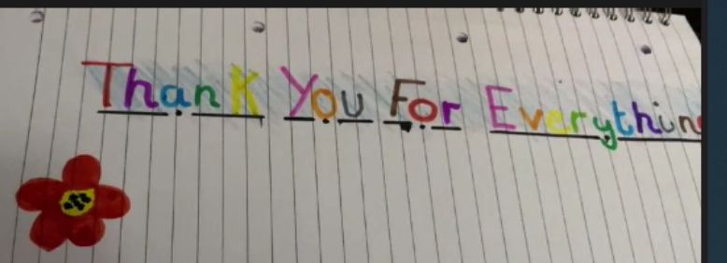

**Luton EB**

C C

I wanted to take a moment to express my and the Shared Carer’s team sincere gratitude and appreciation for your presentation on NVR. Your time, expertise and willingness to share your knowledge were invaluable to our Shared Carers and we are grateful to the insights you provided.

The knowledge  you shared will benefit not only our Shared Carers but also us Supervising Social Workers in our roles as well as in our personal lives. Your presentation has equipped us with a valuable framework and we look forward to applying these “relationship based” principles in our personal and professional journeys. Once again thank you for your time and dedication in delivering such a valuable presentation and please note that your presentation has left a lasting impact and we are grateful for your support.

**Luton CSLT**

C S

While talking to our Students, C has presented with broad therapeutic interpersonal skills and comprehensive medical knowledge. Her empathetic approach allowed some of the young people to open their mind and to talk about their mental health without hesitance, in fact, four of them come back later on and asked for therapy in house.  Please send my great gratitude towards Chelsie professionalism and her humanistic approach to our Students.

I wanted to comment to state how impressed I am with the amount of work which is currently being completed by CAMHS. I have been kept informed of the all the supportive work which has been underway since the start of term and I am sure you'll agree, it has been a hive of activity, with significant levels of support being arranged and delivered by yourself, in collaboration with the school. Thank you, for all the existing and ongoing support you have and continue to provide our staff and students.

T S

Feedback from a SEND audit-

The advice was graded as Outstanding with the following narrative: *Excellent advice, very clear, voice of YP shines through, PfA outcomes. Tells story clearly of her experience with CAMHS and return to school.*

*Luton MHST*

*A T*

*from a parent I just completed LI CBT  Parent-Led Anxiety protocol-*

“I have really benefited from the sessions A has organised and taught, she has helped with my understanding of anxiety and the methods in which will help k deal with her own feelings. K seems like she is doing a lot better with tackling ways to cope with anxiety and comes across like she doing well. A has made me feel really comfortable throughout our sessions and has listen and took on board the things I've mentioned. I think she's a wonderful lady.”