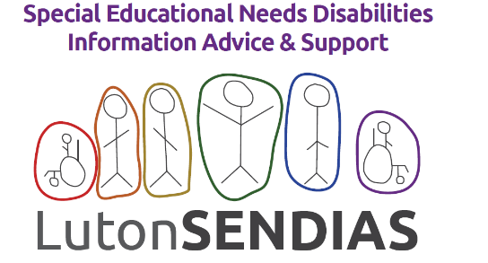

SENDIAS Service 2023: Quarter 3 data summary

Who is using the service?
Table 1 provides a summary of the different types of enquires the SENDIAS service responded to during quarter three.

Table 1:0 Summary of the number of new enquiries to the service for 2023 Q3.
Enquiry Type | July | Aug | Sep | Total for quarter
New enquiries (previous users & new families) | 51 | 16 | 70 | 137
Existing open casework | 93 | 108 | 58 | 259
New families/ CYP to SENDIAS | 16 | 6 | 26 | 48
Total number of enquires this month (New & existing casework) | 144 | 124 | 128 | 396
Professionals (Health) | 1 | 1 | 0 | 2
Professionals (Education) | 5 | 0 | 6 | 11
Professionals (Social Care i.e FPS) | 0 | 1 | 0 | 1
Professionals (Other) | 3 | 0 | 1 | 4
Calls / Emails for SENAT | 13 | 12 | 16 | 41
Calls / Emails transferred to Central Bedfordshire SENDIAS | 1 | 0 | 1 | 2

Figure 1 provides a comparison of both of new enquiries and existing enquiries to the service between 2020 to 2023 quarter three.

Figure 1:0 Summary of the number of new enquiries and existing enquiries to the service 2020 to 2023 Q3.

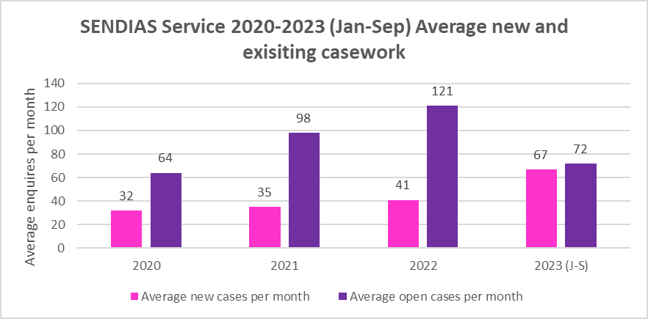

For enquires to the service by age group for quarter three 2023, see figure 2.

Figure 2:0: SENDIAS 2023- new service users by age group
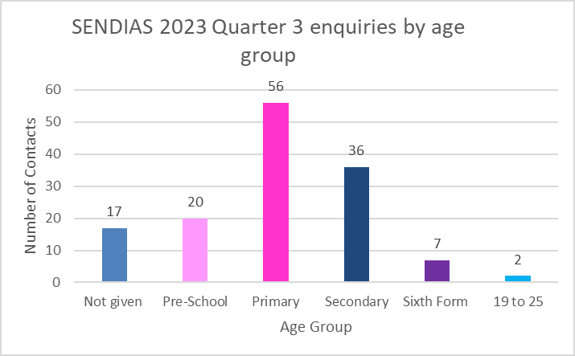
Table 2:0 provides a summary of the main Special Educational Needs and/or Disabilities (SEND) identified by the service user for all new enquiries during quarter two. Below are the categories currently available on our data system. The main presenting SEN is recorded in relation to what the service user identifies as the main presenting need. Additional SEN is also recorded.

Table 2:0 2023 - new referrals by main SEN.
Number of New Referrals By Main SEND 2023 | Number of referrals
ADD/ADHD | 22
Autism | 7
ASD | 27
Behavioural (SEN) | 1
Cognition and Learning | 3
Communication and Interaction | 4
Complex Needs | 2
Developmental Delay | 6
Dyslexia | 1
Global Delay | 3
Hearing Impairment | 3
Language and Learning Difficulties | 1
Medical - Brain Injury | 1
Medical - Cerebral Palsy | 1
Medical - Irlen Syndrome | 1
Medical - Multiple | 4
Medical - Spina Bifida | 1
Medical - Other (not listed) | 4
SALT - Delayed Speech | 5
SEMH | 3
SEMH - Anxiety | 8
Sensory and / Physical | 2
Tourette's / Tics | 1
Unknown | 27

Table 3:0 provides a summary of new referrals received to the service during quarter two 2023 by ethnic groups. The ethnic groups below represent the current ethnic groups that service users currently identify themselves as. At the start of 2022 changes to the services data reporting were introduced, therefore comparable data for contact to the service by ethnicity isn’t available.

Table 3:0: New referrals by Ethnic Group quarter 3 2023.
Referrals By Ethnic Group | Number of Referrals
African (Black) - Ghanaian | 2
African (Black) - Nigerian | 3
Black or Black British - Caribbean | 2
Black or Black British - UK | 2
Any Other Mixed Background | 7
Mixed White / Black African | 2
Mixed White / Black Caribbean | 4
Mixed White / South Asian (Bangladeshi, Indian, Pakistani etc) | 5
South Asian or Asian British - Bangladeshi | 6
South Asian or Asian British - Indian | 3
South Asian or Asian British - Pakistani | 31
South Asian - Sri Lankan | 1
Any Other Asian Background | 2
White - British | 37
White - Eastern European | 1
White - Irish | 1
White - Other | 1
White - Polish | 2
White - Romanian | 1
Unknown/ Not stated | 22
Preferred not to answer | 1
Any other Ethnic Group | 2
African (Black) - Ghanaian | 2
African (Black) - Nigerian | 3
Black or Black British - Caribbean | 2

Figure 3 provides a summary of new enquires during quarter three by gender.

Figure 3:0 SENDIAS 2023 Q3 - new enquires by gender
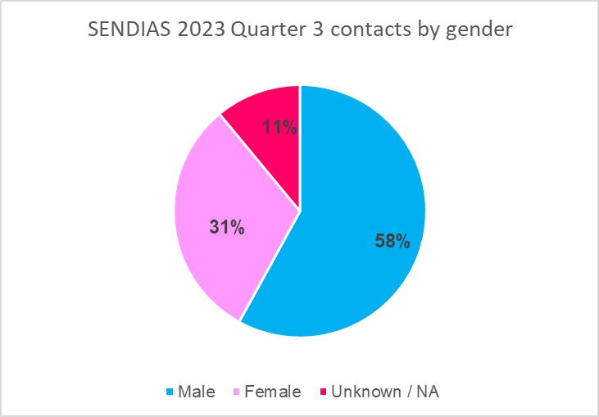

Table 4:0 provides a summary of the referral source of new enquires to the service during quarter two. This is based on the options currently available on our reporting system. New sources are reviewed and added to reduce the potential number of unknown/other source reported.

Table 4:0 Quarter 3 new referrals source of client
Referral Source of Client | Total number of referrals
Admissions (Local Authority) | 1
CAMHS | 4
Edwin Lobo | 7
Family Partnership Service | 1
Family Worker - School | 1
Family Worker - External | 1
Friend | 5
Google | 6
GP/Doctors Surgery | 1
Known - not yet listed | 1
LA/Council team not stated | 6
More than one source | 1
Other LA SENDIAS Services | 1
Other Parents | 1
SALT | 1
School SENCO | 5
School | 6
SENAT | 4
Service Leaflet | 1
Social Media | 1
Social Worker | 2
Transition Team | 1
Used Service Before | 62

From 2023 the service will monitor and report waiting times for new referral received. The service’s Service Level Agreement currently indicates a response time of 2-3 working days. Response times reported are for the length of time it takes for a service user to speak to a trained SENDIAS advisor. Please note that not all enquires require the involvement of an advisor due to the nature of the initial enquiry.

Table 5:0 SENDIAS service waiting times for new referrals for quarter 3.
Month | Total number of enquires with a waiting time of more than three days | Average waiting time for an appointment with a SENDIAS Officer
July | 15 out of enquires 54 | 6 days (r= 0 -9 days)
August | out of enquires | 5.3 days (r= 0 -8 days)
September | out of enquires | 4.9 days (r= 0 -10 days)

From 2023 the service intends to review enquires in relation to postal district to assist the service future development. Comparable date for previous years doesn’t currently exist.
Table 6:0 SENDIAS service new enquires for quarter three by postal district.
Postal District | Total number of referrals
Barnfield | 6
Beech Hill | 4
Biscot | 8
Bramingham | 6
Central | 5
Challney | 11
Crawley | 0
Dallow | 2
Farley | 7
High Town | 5
Icknield | 0
Leagrave | 6
Lewsey | 10
Limbery | 0
Northwell | 10
Poets | 5
Round Green | 5
Saints | 3
South | 3
Stopsley | 10
Sundon Park | 4
Vauxhall | 5
Wigmore | 9
Out of Area i.e. Central Bedfordshire Council | 2
Unknown/ not provided | 12

What type of support is required?

The intervention service levels for cases, are recorded following the IASS national guidelines to monitor the demand for different types of support regionally and locally.

There are 4 intervention levels. Figure 5 shows the levels of casework and intervention type undertaken by the service during the first two quarters of 2023 for new referrals compared to previous years.

Level 1 work accounted for 46% of new casework which is providing advice and support, signposting towards other services or interpreting information relating to special educational needs (SEN) and enabling service users to apply it to their own situation.

Level 2 work accounted for 33% of our service’s work. This relates to work that enables service users to understand or complete documentation, support in communicating with school and the LA and other services. It centres around providing detailed and personalised guidance on following SEND or exclusion procedures.

Level 3 work accounted for 15% of new casework and involves providing detailed, continuing assistance and guidance with statutory processes or assistance in overcoming serious breakdown in communications with school/LA/other services over a period of months.

Level 4 work accounted for 6% of new casework and involves any or all of Levels 1, 2 and 3 plus providing detailed and continuing assistance and guidance with preparation and support during: First Tier Tribunal (SEND) and complaints. This low figure could be attributed to the fact that our service is able to support families to reach early resolutions via other channels.

Figure 4:0 SENDIAS 2020-2023 Q3 - new enquiries by Intervention level
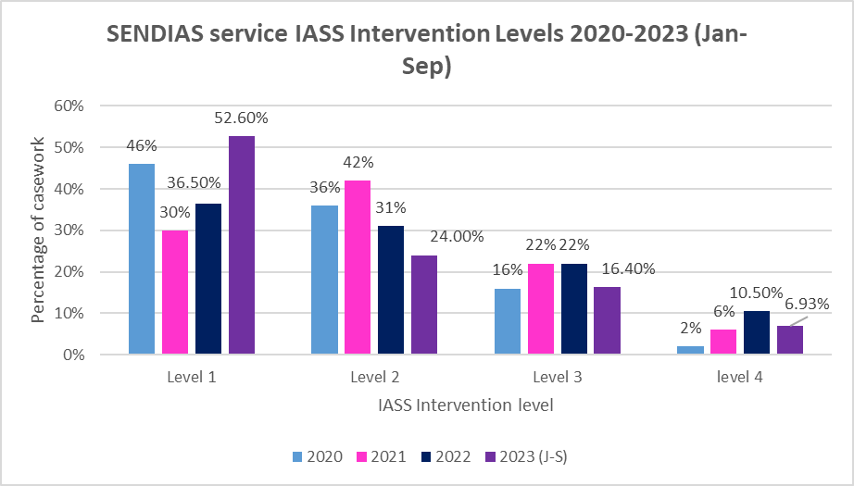
Table 7:0 provides a summary of the different types of casework undertaken by the service. This represents both new and existing casework. During quarter two the SENDIAS service continued to provide advice and support through a variety of methods, telephone, email, website and attendance at virtual/face to face meetings.

Table 7.0 Total number of different types of casework undertaken for quarter three.

Type of casework undertaken | Number of contacts
Number of Contacts By Phone | 475
Number of Contacts By Email | 277
Attending Group Meeting | 0
Virtual Meeting | 1
Message | 17
Office Visit | 14
Professionals Meeting | 0
Report review | 1
Text | 3
Telephone - No Answer | 0
Unspecified | 188

Table 8:0 provides a summary of the reasons that service users with a current Education Health Care Plan (EHCP) approach the service during quarter two.

Table 8:0 Reason for service users with EHCP’s contacting the service during 2023 Q3.

EHCP Reasons for enquiry | Number of enquiries.
Admissions | 6
Annual Review Support | 6
Attendance | 1
Complaints school | 2
EHCP appeal | 1
EHCP content/placement | 9
EHCP placement advice | 1
EHCP requests/needs assessment | 4
EHCP review | 6
Emotional Based School Non Attendance | 5
Exclusions | 1
Health | 1
Mediation support | 1
Mental Wellbeing | 1
Reduced timetable (part-time timetables) | 2
Setting not following EHCP | 3
Signposted to Health | 1
Signposted to LA Services | 7
Signposted to LA Services -Social Care | 1
Signposted to PCF | 1
Signposted to Support Groups | 3
Social care | 1
Transition | 6
Transport | 7

Table 9:0 provides a summary of the reasons why service users without an EHCP approach the service for support during quarter two.

Table 9:0 Reason for service users without an EHCP’s contacting the service during quarter 3 2023.

No EHCP Reasons for enquiry | Number of enquires
Admissions | 5
Benefits Advice | 4
Bullying | 1
Complaints School | 1
Disability discrimination | 1
EHC needs assessment | 40
EHCNA- refusal | 6
EHCP co-ordination support | 4
EHCP draft review/advice | 4
EHCP placement advice | 1
Emotional Based School Non Attendance | 9
Exclusions | 2
Health | 3
Mediation Support | 2
Reduced timetable (part-time timetables) | 2
SEN Support | 32
Signposted to Health | 3
Signposted to Support Groups | 7
Social care | 2
Transition | 5
Transport | 2
Tribunal Support- Advice EHCNA | 7
Tribunal Support- Advice EHCP | 1

To address these key areas of need within our service we have developed Frequently Asked Questions (FAQ’s) to further supplement our existing resources on our website relating to these key themes. In addition we have produced an animated short video to explain SEN Support in schools and co-produced a webinar on Education, Health Care Needs Assessment requests which is available on our website.

2023 - SENDIAS service website
Alongside our direct support for service user, the service also has a standalone website. The content and design is maintained and developed by Luton SENDIAS staff. There is a wide range of resources available for service users on the website.
Figure 5 provides a summary of the number of views the service’s website for each month of quarter two.

Figure 5:0 Summary of the SENDIAS service website use per month for 2023 Q3.

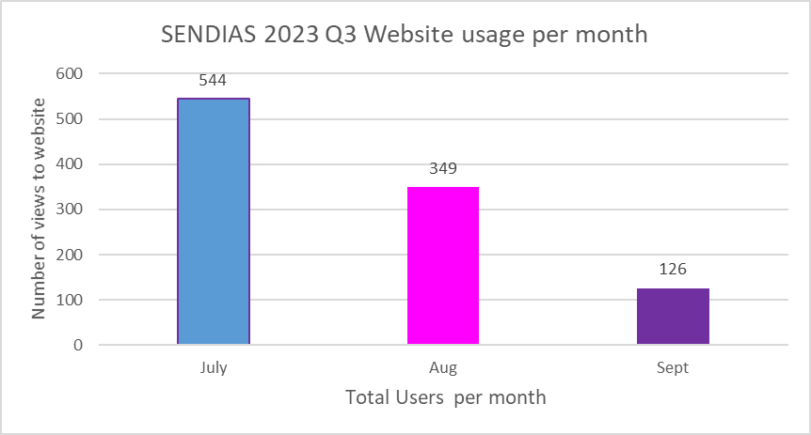

Figure 6 provides a comparison of the average use of the service’s website between 2020 to 2023 quarter one.

Figure 6:0 SENDIAS service website average use per month 2020 to 2023 quarter three.
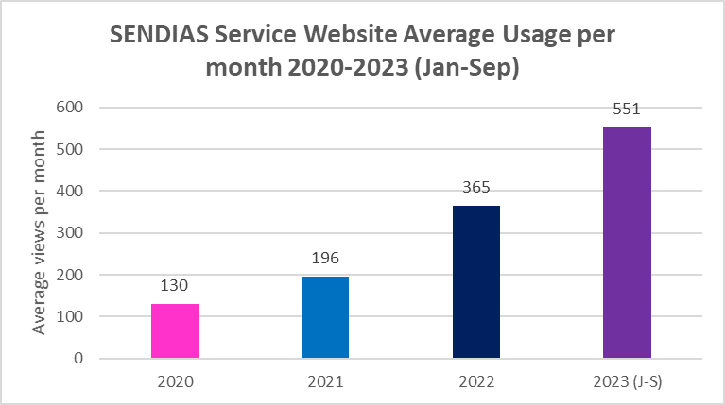

Table 10.0 provides a summary of the most frequently used pages of the website during quarter two.

Table 10:0: Top ten pages viewed on the SENDIAS website during 2023 Q3.
Website Most Popular Pages viewed 2023 | Total Number of Views
Landing page | 755
Support for parents & carers - EHCP | 177
Support for parents & carers | 151
Support Groups | 137
Contact Us | 128
What We Do | 119
Support for parents & carers - EHCNA | 119
Support for children | 109
Useful Information | 101
Useful Information - EHCP | 99

Additional accessibility software, Reach Deck, was added to the website in November 2020 which includes a translation service to help assist reaching the wider community of Luton. Table 11 provides a summary of the functions used by service users during quarter one.

Table 11:0 Summary of the functions used on the accessibility software during 2023 Q3.
Accessibility Analytics | Total Numbers
Speech | 3
Toolbar | 99
Translate | 23
Picture Dictate | 1
TOTAL | 126

During 2022 there were similar trends reported in relation to the functions used on the Reach Deck software with the use of the translate function being the most used function. Figure 8:0 provides a further breakdown of the translation function on the website and the languages accessed by service users during quarter two.

Figure 8:0: Languages used on the translation function on the SENDIAS service website during 2023 Q3.

2023: Social Media.
Our service launched a Facebook page back in February 2021 with the initial focus of signposting to local services, support groups and local events for children, young people and families. In addition, local and national news stories will be shared.
The initial launch of our social media was achieved through word of mouth promotion. As our social media presence was new to the service in 2021, we intend to continue to review the data and evaluate our service user’s interaction with our social media accounts. This will help inform how we can evolve our use of social media, for the benefit of our service users’ needs and interests. Figure 7 below provides a summary of the top five posts and their total reach for quarter two.

Figure 7:0: SENDIAS service Facebook 2023 - Top 5 Posts.

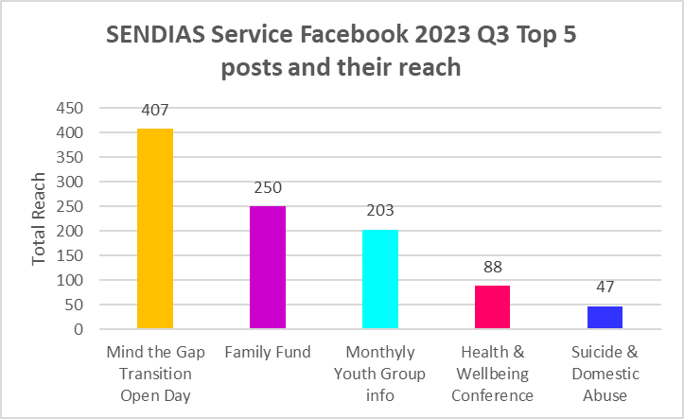

The total reach of our Facebook account for each month of quarter three is summarised in figure 8.

Figure 8:0: SENDIAS service 2023 Q3 - Facebook total reach.

The average total reach of our Facebook account from 2021 to 2023 quarter three is summarised in figure 9.

Figure 9.0: SENDIAS service 2023 Q2-Facebook average usage per month 2021 to 2023 Q3.
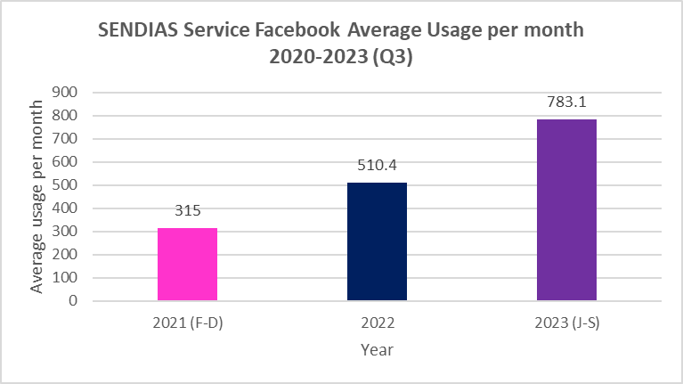
SENDIAS services Instagram account total reach for quarter two is summarised in figure 10.

Figure 10:0: SENDIAS service 2023 Q3 - Instagram total reach.
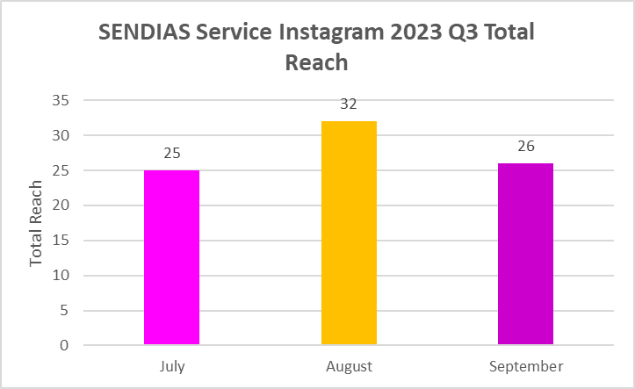

The average use per month of the SENDIAS services Instagram account since launch in 2021 to quarter two 2023 is summarised in figure 11.
Figure 11: SENDIAS service’s Instagram total reach from 2021 to 2023 Q3.
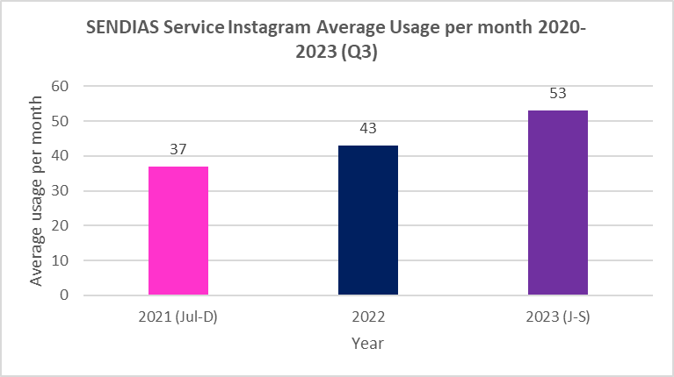

If you would like to speak to someone from the team, please call:
01582 548156
SENDIAS@luton.gov.uk
Appendices:
A: Levels of Service

Appendix A
Levels of Service

Level 1

• information and advice about SEND matters, such as: the legal framework, local SEN processes and procedures, support groups, particular special educational needs or disabilities, funding arrangements, local services, web based resources, national organisations

• phone or email support – tailored to the particular circumstances of the service user

Outcome; Service user confirms that their information and advice needs have been Met and/or Service user is signposted elsewhere. The service user feels confident to access further information and advice and/or to pursue matters independently or with support from other agencies or services.

Level 2

Any or all of Level 1 plus:
• help to understand or complete documentation, support in communicating with school, the LA, other services, etc. detailed and personalised guidance on following SEND or exclusion procedures, assistance in accessing services

• phone or email support over a period of time, research and provision of specialised advice and information, home visit by SENDIAS or office visit by service user, provision of support at/for meeting, liaison with other agencies

Outcome; Service user confirms that their information and advice and support needs have been met. Service user feels confident to continue without further support from SENDIAS or with support from other agencies or services.

Level 3

Any or all of Levels 1 and 2 plus:
• detailed and continuing assistance and guidance with statutory processes, complex multi-agency needs, assistance in overcoming serious breakdown in communications with school/LA/other services, requires intensive support due to personal circumstances (e.g. low literacy levels, learning or sensory difficulties, English as an additional language)

• provision of support at/for a series of meetings over a period of months, ongoing support and guidance through statutory processes (EHC needs assessment, disagreement resolution, mediation etc.), assistance with preparation for an exclusion appeal and support at the appeal meeting, SENDIAS undertakes key working role with other agencies

Outcome; Service user confirms that support has enabled them to participate in processes.

Level 4

Any or all of Levels 1, 2 and 3 plus:
• detailed and continuing assistance and guidance with preparation and support during: First Tier Tribunal (SEND), including Disability Discrimination Act complaints to Tribunal, Complaints to Ombudsman, Judicial Review and Disputes about Child Protection

• provision of intensive support for the service user(s) during the legal processes. This may include assistance with preparation for the legal process and support at, for example, a Tribunal hearing

Outcome; Service user confirms that support has enabled them to participate in processes.

