Assessment Practice Guidance

Contents

The Purpose of an Assessment | Page 3
What is a Good Assessment | Page 3
Planning for an Assessment | Page 5
Professional Curiosity | Page 6
Exploring Child and Family Relationships and Support Networks | Page 7
Genograms | Page 7
Genogram Symbols | Page 8
Ecomaps | Page 9
Engaging Fathers in Assessments | Page 9
Chronologies | Page 10
Holistic Assessments | Page 11
Assessment Framework | Page 11
What does this mean in the context of a child? | Page 12
Assessment Models and Tools | Page 16
SHARE: Develop Empathy in Assessments | Page 16
Restorative Questions | Page 17
Diclemente’s Model of Change | Page 18
Prosci’s ADKAR Model | Page 19
Motivational Interviewing | Page 19
Assessment Analysis | Page 20
The 5 Anchor Principles | Page 20
Descriptive Vs Analytical Writing | Page 23
Confirmation Bias | Page 23
The Hypothesis Tree | Page 24
Functions of Supervision | Page 25
Assessment Timescales | Page 26

Supporting Guidance

Cultural Competence in Assessment Guidance
Neglect Practice Guidance
Pre-birth Assessment Guidance
Pre-Birth Assessment Guidance Tool
Risk Assessment Guidance
Risk Assessment – Offending Behaviour Example
Risk Assessment – SCODA Drug Use Example
Using Pre-Meeting Reports for Statutory Meetings as an Updating Child and Young Person Assessment
Early Help Assessment Guidance

The Purpose of an Assessment

At all stages of a child’s/young person’s life, they will have identified needs. Most children will have these met routinely by parents, carers and universal services and will never come into contact with more targeted or specialist support services, however, a percentage of children and young people, will have identified needs that are based on parental disadvantage or problems that may impact on general parenting capacity, impairing health and development or exposing a child/young person to significant harm.

Additionally, some children may be identified as having a range of additional needs because of complex health needs, an Education, Care and Health plan, life limiting illness or disabilities, or contextual harm, that will need to have careful coordination and supportive services.

Assessments are pivotal in identifying family need and the impact of these needs on the child/young person’s health and development. It is only once need and impact are identified that effective and targeted support can be delivered, through robust care planning. It is therefore important that assessments are holistic, factual, robust and capture the child’s/young person’s experience of life.

What is a Good Assessment?

An assessment is an ongoing process which the service user participates in. The purpose of an assessment is to understand people in relation to their environment, it is a basis for practitioners to plan what needs to be done to maintain, improve or bring about change in a person, their environment or both (Coulshed and Orme, 1998).

A key question to ask when undertaking an assessment is:

What does the child, young person or family need in order to maximise their wellbeing in all key areas of their life?

When completing an assessment, it is important to be clear from the outset why it is necessary. Having a clear sense of purpose and good preparation is key to producing a good quality analysis for planning and interventions to be based on.

The principal approach to assessment and intervention within Dudley Children’s Services is a restorative, strength-based approach. If we work with families in relational ways, keeping children at the heart of decisions that affect them, we can enable families to solve their own problems earlier and more effectively; providing the right amount of support, for the right children, for the right amount of time. Therefore, ensuring that intervention in family life only occurs when necessary but is timely, appropriate and proportionate. Taking this approach allows practitioners to work with family members, whatever the concerns, with respect, and recognises that children and families are the experts in their own lives.

Working alongside the family, the practitioner can agree what the issues are and what must be done to address them. Where we have concerns and worries, these are expressed clearly, simply and in a way that is understood by everyone, checking that children, families and practitioners have an appropriate and shared understanding.

The assessments we produce must tell a family’s story in a way which is transparent and balanced, looking at strengths, assets, opportunities and providing a clear analysis of risk. Practitioners should work ‘WITH’ families on a high challenge high support basis, respecting their identity, supporting them to gain control and make good decisions for their children. Focus should be on the issue, not the person, and practitioners should avoid using language that blames, creates shame and builds barriers. It is important that practitioners are clear about what changes and outcomes are to be achieved, and that parents are empowered to take ownership of, and responsibility for their choices and decisions.

A good assessment will: -

- Capture the views, wishes and feelings of the child and family members – including fathers. Children and young people should be seen and spoken to alone where possible to ensure their voice is central to assessments and plans;
- Consider a family’s history and analyse how this may impact upon their current situation;
- Be evidenced based and critically reflective, with hypotheses which can be tested against the evidence;
- Consider information from multiple sources (e.g. lateral checks with health, education, police etc) and record this accurately and concisely;
- Be holistic, not solely focused on the most visible or presenting problem;
- Be informed by a good knowledge and understanding of child development;
- Where appropriate, take into account motivation to change;
- Provide a clear understanding of both the strengths and difficulties within the family and where there are risks of harm, identify proportionate and balanced recommendations in response;
- Be transparent – families should not have to wait until the end to know the outcome of an assessment, it should be shared with them and their views recorded.
- Be timely.

Planning for an Assessment
Below are some questions to support practitioners when planning for assessments: -
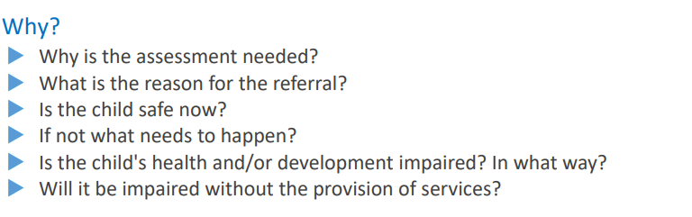

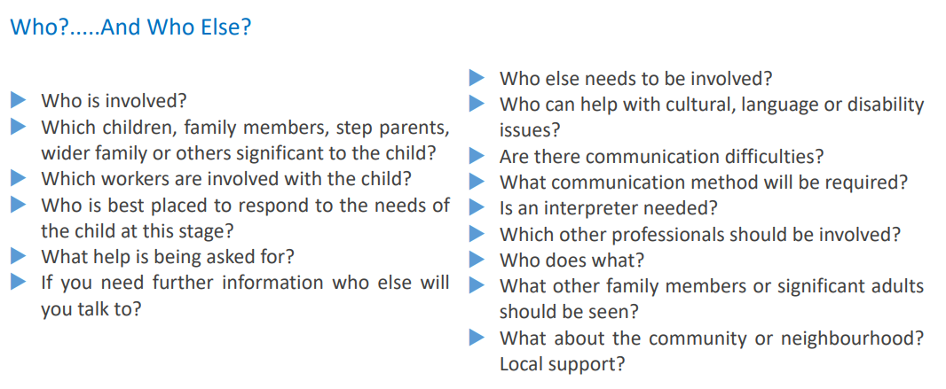

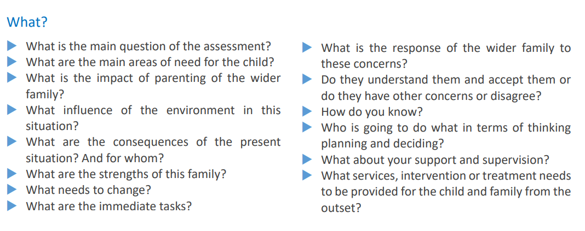

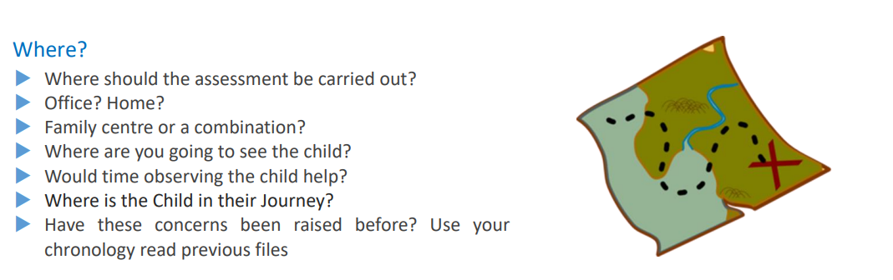

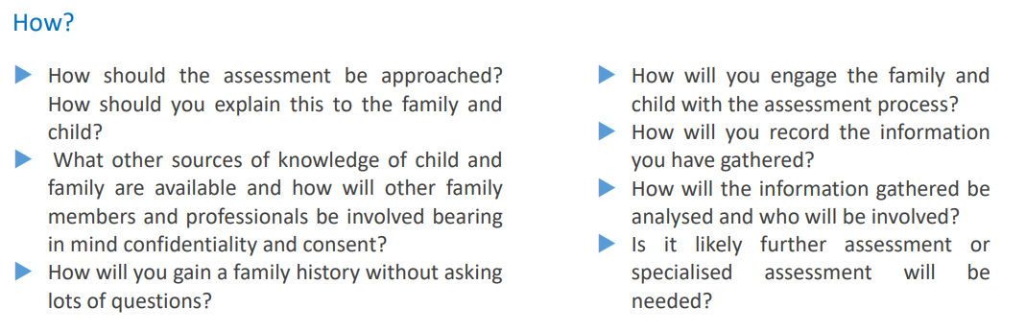

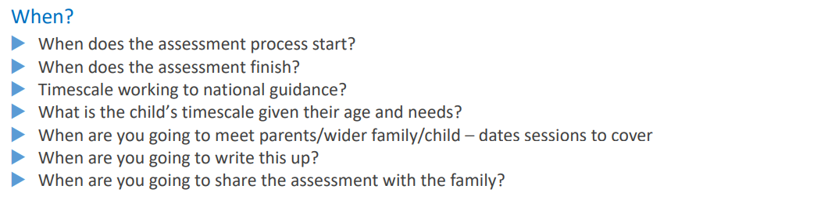

Professional Curiosity

Professional curiosity allows a practitioner to explore and understand what is happening with a person or family, rather than making assumptions or taking single sources of information at face value. It requires the practitioner to look, listen, ask questions, reflect and check out information that doesn’t feel right.

Below are some ways a practitioner can become more professionally curious: -

- Question why someone is behaving in a certain way – what could these behaviours mean?
- Find out more about someone’s personal circumstances - assess their behaviour in light of what you know about them and their situation.
- Question the motives of anyone who is with the person - Why are they there? What is their relationship to the person? Do they appear controlling? Do they dislike leaving the person alone? Even if they appear kind and supportive, could this be a way of hiding their role in harming the person?
- Recognise when someone is reluctant to provide a full or accurate account of events or is pretending to cooperate to avoid raising suspicions.
- Think outside the box - consider the person or situation from the viewpoint of other professionals. What might they look out for and notice? What would they think about the situation?
- Maintain an open mind - avoid making assumptions, taking information at face value and jumping to conclusions. Take account of changing information and different perspectives and consider if you need to adapt your views.
- Ask questions and challenge what you believe to be untrue.
- Notice if you or someone else starts to doubt that someone is a victim – consider the reasons for these doubts. Are they fair?
- Trust your instinct and raise concerns if something about someone’s behaviour or situation doesn’t feel right.
- Think vulnerability and exploitation – be actively aware of how anyone you come across may be vulnerable and could be experiencing exploitation.

Exploring Child and Family Relationships and Support Networks
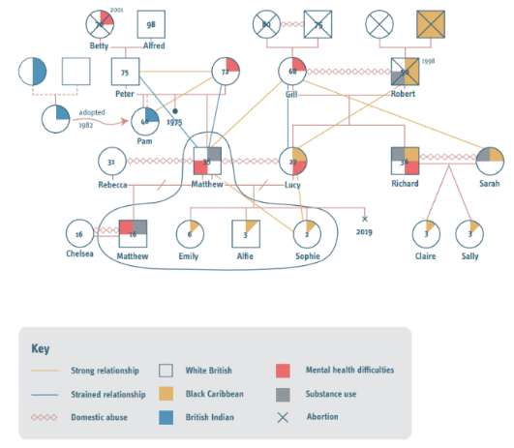
Genograms

A genogram is a specific way of drawing a family tree and is a tool which can be used to engage individuals or whole families in a collaborative exercise. This can potentially reveal a great deal of information and understanding about complex, intergenerational relationship and/or behaviour patterns. Genograms require the full name, DOB or written age of a person. Where possible, practitioners should aim for it to be three-generational.

A genogram should always be included as part of an assessment as it allows the practitioner to explore all family members, rather than focusing on a child in isolation. A genogram can also support practitioners to gain a greater understanding of a family’s challenges and strengths, which in turn will support them in formulating their analysis.

Genogram Symbols

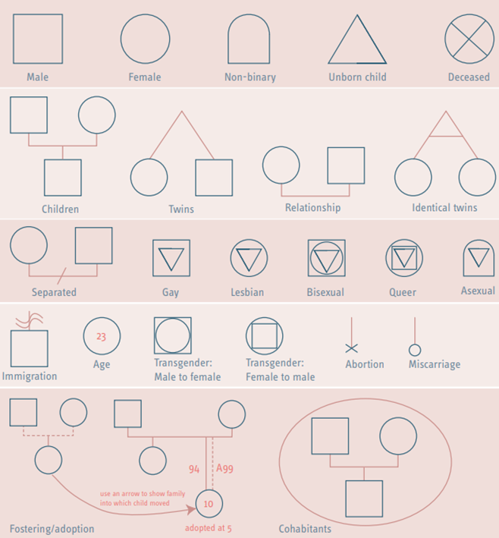

Further information about genograms can be found in here.

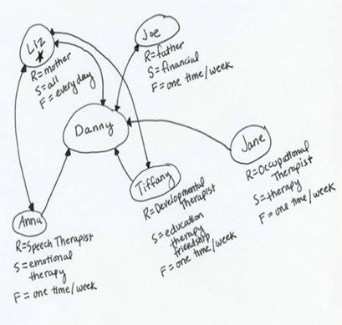
Ecomaps

Ecomaps (or ecograms as they are sometimes referred to) can be used to map a child’s support network. An ecomap focuses on relationships with family members and significant others, such as friends, pets, school staff and hobbies. This helps the practitioner to identify what relationships are supportive or stressful. As relationships are constantly changing, this is not a one off exercise and can be done at different periods through the assessment and review cycle.

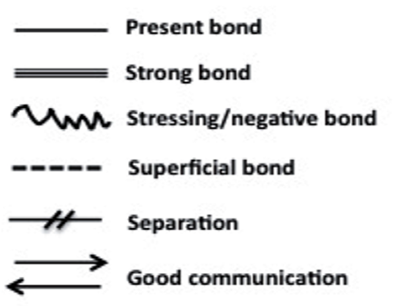
When drawing an ecomap, make sure that the child/young person is placed in the centre and draw circles to represent important people, organisations, professionals, hobbies etc, placing those the child has the closest relationship with next to them in the centre and moving further away as the relationships become less strong. Link the relationships with a line, line style will depend on the nature of the connection.

Further information about ecomaps and a template can be found here.

Engaging Fathers in Assessments

Audit activity within Dudley Children’s Services, and research, identifies that assessment, planning and intervention for children often has an absence of the father’s views, involvement and engagement. If fathers are not contacted, or are included minimally within intervention, this could ultimately result in potential safeguards or support for children being missed.

The views, wishes and feelings of fathers should be obtained and included within all assessments and plans for children, where possible and appropriate. Not including fathers can result in additional support or safeguarding opportunities for children being missed, i.e. the father
and paternal relatives not being considered within Genograms, Viability Assessments, and other Court processes. Where possible, we should be engaging with father’s from the beginning of our intervention, actively seeking contact details at the earliest opportunity.

In circumstances where parents may have separated, be explicit with mother about the importance of speaking to the father and why he should be included in the assessment process, while also ensuring that she will not be put at risk. When gathering information for the assessment it is important that we don’t rely solely on self-reporting from mother, where possible we should be speaking with father separately to gain his views. It may be necessary to also inform the child that father will be contacted and included in the assessment and why; recording any views they share in response to this.

Chronologies

In basic terms, a chronology is a list of significant events which have taken place for a child or their family, recorded in date order. A chronology can help a practitioner to study previous events and identify patterns of behaviours or concerns. Chronologies are an essential part of any good assessment. They are not simply a list of events, but rather a narrative of the major changes and significant events in the life of a child and their family, and the impact that this has had on the child/young person.

Chronologies lay out events in order, enabling an understanding of the child’s journey and the impact of changing events and experiences, both immediate and cumulative. They should be used as a tool to capture and build a foundation for analysis, and develop an understanding of the patterns and trends within a child’s life, in the context of their family functioning, emerging needs, and risks and strengths.

Chronologies help to:

- Gain an overview of events in the life of the child and their family, helping us as practitioners to understand their journeys, and navigate through their lives.
- Provide evidence of cumulative harm/changing needs/strengths, to inform an assessment of a potential change of care plan.
- Support the identification of patterns and trends to inform an assessment of the child’s need, both immediate and cumulative. This is particularly useful in situations where there may be no single incident, i.e. neglect.
- Support practitioners to understand the impact of changing events and experiences upon the child and their family;
- Support the identification of resources and further interventions to understand what has worked in the past and what has already been tried - this understanding prevents repeated interventions which may not be effective or in the best interests of the child or their family.
- Strengthen working with children and families and support them to make sense of their journeys e.g. through recognising patterns of behaviours with parents struggling to sustain change; starting life story conversations with a child or young person leaving care, supporting them to make sense of their experiences and the reasons behind decisions made by the Local Authority.

Further information about Chronologies can be found here.

Holistic Assessments

Assessment Framework

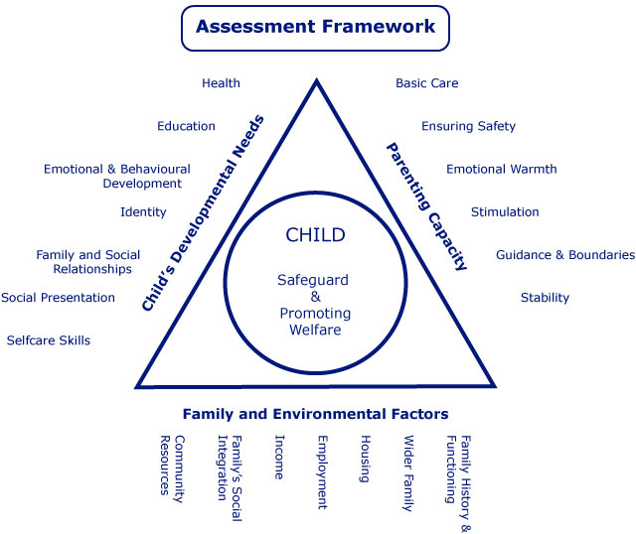
The Assessment Framework has been developed as a guide to help practitioners across all disciplines to assess concerns or support families asking for help. The Assessment Framework is made up of three domains which represent the key aspects of a child’s inner and outer world:

- a child’s developmental needs
- the capacity of parents to respond appropriately and meet the needs of the child
- the impact of the wider family and environment on a child and their parent.

The three sides of the assessment triangle focus on different aspects of a child’s life and experiences, when practitioners explore all of the identified areas it supports a holistic assessment of the family – rather than focussing on one singular area of potential concern.

For a Summary of Protective and Resilience Factors in Safeguarding Using the Assessment Framework see here. For a blank template of Protective and Resilience Factors see here.

What does this mean in the context of a child?
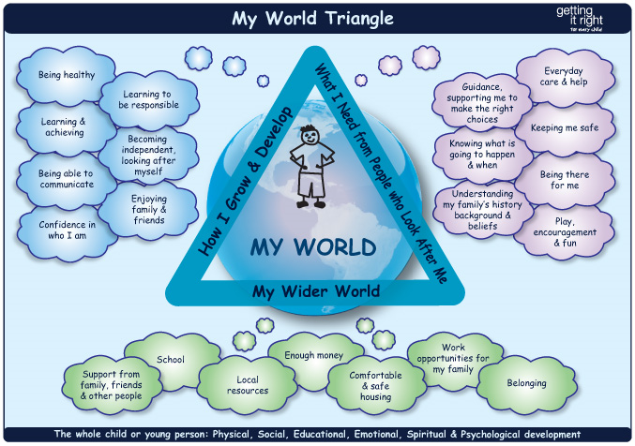

How I Grow and Develop

Being Healthy
Include information about all aspects of the child’s health and development, link this to developmental milestones and where appropriate include details about any major illnesses, hospital admissions, impairments, disabilities or conditions which affect development and health. Also consider areas such as nutrition, physical and mental health issues, sexual health or substance abuse.

Learning and Achieving
Include information about cognitive development from birth, learning achievements and any skills or interests the child has and could be nurtured. If there are additional needs, how are these being supported? Record education and social development milestones, if there are education and learning plans in place then state what support is being offered or still needs providing. Is the child’s educational progress in line with age related expectations? Where appropriate, provide information about further education or training needs and any potential employment opportunities.

Being able to Communicate
Include information about a child’s development of communication and language as well as their ability to express thoughts, feelings and needs. Where English is not the child’s first language, record what their preferred language or method of communication is and if they require any aids for communication.

Confidence in Who I Am
Include information on the child’s temperament and characteristics. Comment upon the quality of attachments of the child, emotional and behavioural development and resilience and self-esteem. Consider a child’s confidence in managing challenges and difficulties appropriate to their age and stage of development. Include information about a child’s sense of identity, ethnic and cultural background, gender, sexuality and religious beliefs.

Learning to be Responsible
Include observations of a child’s behaviour and social skills. Reflect upon their values and sense of right and wrong, consideration for others and their ability to understand what is expected of them and act upon this. Explore how the child responds to key influences on social and emotional development at different ages and stages, i.e. collaborative play in childhood and peer expectations when older.

Becoming Independent, Looking After Myself
Include observations around a child’s confidence and skills to do things independently, especially when they are at an age to begin transitioning from dependence to independence. When younger, include observations of practical skills such as dressing, feeding themselves etc. If the child has a disability, what impact does this have on their ability to meet their own care needs and what additional support may they need.

Enjoying Family and Friends
Explore the child’s relationship with others in their family and wider social networks and what opportunities they have to form significant lasting relationships. Consider if the child is encouraged to develop skills in friendship making and if they are able to take account of the feelings and needs of others and behave accordingly.

What I Need from the People who Look After Me

Guidance, Supporting Me to Make the Right Choices
Explore the parent/carers values, guidance and boundaries and what impact these have on the child. Are guidance and boundaries appropriate to the child’s age and understanding and are sanctions consistent and constructive? Is the child treated with respect and encouraged to take social responsibility? Are there areas of parenting capacity which may need support and intervention?

Knowing What is Going to Happen and Why
Is the child’s life stable and predictable, with appropriate routines and expectations? Explore other family members and people important to the child. Can parents/carers be relied upon to be honest and open about family relationships, needs and involve the child in matters which affect them?

Understanding my Family’s History, Background and Beliefs
Explore the family and cultural history, spirituality and faith. Is the child’s racial, ethnic and cultural heritage given prominence by the parent/carer? Do those around the child respect and value diversity?

Everyday Care and Help
Explore a parent/carers ability to nurture the child – what does the day to day physical and emotional care look like, including food, clothing, housing? Are the child’s health and educational needs being met and is independence being appropriately promoted? Is the child listened to and responded to appropriately, are they able to respond to a child’s likes and dislikes? Is any support required around parenting or meeting the child’s needs?

Keeping Me Safe
Is the parent/carer able to keep the child safe within and outside the home? Are their appropriate safety features within the home, e.g. fireguards, stairgates and is the home environment clean and free from hazards? Is the parent/carer able to consistently and effectively protect the child from physical, social and emotional harm and access appropriate support for issues such as bullying, mental health needs, violence or offending behaviour? Is there oversight of the child’s friendship groups and online presence? Where necessary, are parents/carers aware of the signs and risks of Child Sexual Exploitation and Criminal Exploitation and where concerns are being raised, are they listening to these?

Being There for Me
Include observations of love, emotional warmth, attentiveness and engagement from a parent/carer to a child. Is the child listened to and are their emotional needs being met? Who does the child have a bond with? Are their attachment issues with a parent/carer? What is the quality of relationship between the child and their siblings/members of the household? Where there are issues between parents, does this impact upon their ability to parent the child?

Play, Encouragement and Fun
Is there stimulation and encouragement for the child to learn and play? Who spends time with the child, how do they communicate and interact with them? Is the child supported and encouraged to engage in after school activities, pursue hobbies?

My Wider World

Support from Family, Friends and Other People
Include family and social support networks – where appropriate, look at what support grandparents, aunts, uncles, extended family and friends provide. Are there any tensions or negative aspects involved in the family’s social networks? Who are the significant people in the child’s wider environment?

School
Include feedback and observations from pre-school and nursery onwards. What is the child’s experience of school and peer relationships? What aspects of learning does the child enjoy or find important? What aspects of learning do they find difficult and what support could be identified to support this area? Is the school able to appropriately meet the child’s educational needs?

Local Resources
What resources does the child access for leisure, faith, sport etc? Is the family aware of the local resources regarding health, childcare, specialist services etc?

Enough Money
Do the family have enough income to meet the day to day needs of the child? Do problems of poverty and disadvantage affect opportunities for the child or family? Are parents/carers able to budget appropriately, do they have any debts they are struggling with? Are they in receipt of all entitled benefits?

Comfortable and Safe Housing
Is accommodation suitable for the needs of the child and their family – where necessary, are adaptations included to meet needs? Is the location in a safe and child friendly neighbourhood? Is the property safe and well maintained? How long have the family lived there for – have there been frequent moves?

Work Opportunities for My Family
Are the parents/carers in employment? If not, are there local opportunities for training and employment? Where appropriate, explore cultural and family expectations of work and employment. Is there support and encouragement for a young person’s career aspiration?

Belonging
Does the child feel included and valued in the community? What opportunities are available to the child to take part in activities outside the home, e.g. playgroups, after school clubs, youth clubs, faith groups. Are there local tensions which may affect the child’s ability to fit into the community?

Assessment Models and Tools

There are a number of different tools/models that support with assessment. Some of these have been identified below:

SHARE: Develop Empathy in Assessments

- The word SHARE for the model is important as it links to the importance of taking a partnership approach with children and families, as well as the importance of information sharing with other agencies.
- The components can be covered in any order.

A practitioner will need to consider ‘SHARE’ in the following way: -
Seeing – Who have they seen? Who with? What have they seen? Who haven’t they seen? How might they draw on observations in the assessment? What might they have lost sight of?
Hearing – What have they heard? Who from? Whose voice have they privileged? Why? Who else do they need to hear from?
Action – What action has been taken? What impact has this had? What actions have others taken?
Reading – What have they read that they may draw on in the assessment? This may include research, theory, legislation, assessments from others or case notes/chronologies.
Evaluation – How is the evidence being evaluated? Is there conflicting evidence – i.e. what was seen and what was heard?

Restorative Questions

Restorative questions – What? So What? Now What? – are designed to support a person to reflect and analyse what might have happened. Asking the children, young people and family members these questions can help practitioners to gather information for the assessment while providing families with an opportunity to reflect on incidents they’ve been involved with. Below are some example questions you could ask: -

What?
‘What?’ questions help to explore a person’s individual perspective:

- What happened?
- What were you thinking?
- What were you feeling?

So What?
‘So what?’ questions help to explore how thoughts and feelings can influence behaviours:

- Who has been affected?
- What is the impact on them and on you?
- How do you feel now?

Now What?
‘Now what?’ questions help with identifying solutions from individual perspectives:

- What needs to happen?
- What does that look like?
- What and who can help you?

For further information about Restorative Practice, see here.

Diclemente’s Model of Change
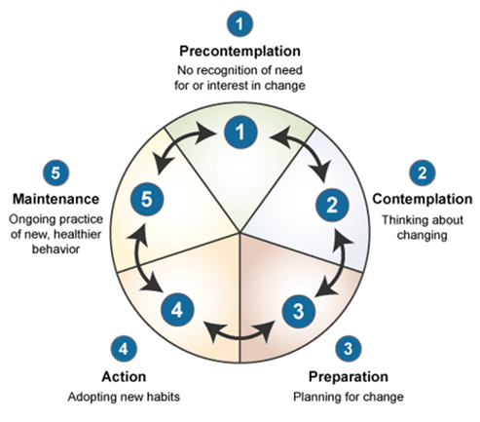
Practitioners can use the Cycle of Change to support their service users in understanding the process of change. It can help individuals to assess which stage of change they are currently in and enable them to plan strategies to support positive changes.

The cycle consists of: -

- Precontemplation: This is the stage where a person may not be aware there is a problem, or they have no intention of changing their behaviour e.g. they like to binge drink but they don’t see this as a concern.

- Contemplation: At this stage, a person becomes aware there is a problem and acknowledges there is a need for change. As yet though, they have not made any commitment to take action e.g. they understand they are drinking too much alcohol and must reduce or stop this, but currently, they haven’t done anything to change.

- Preparation: A person is motivated to take action at this stage and will actively plan and prepare to address their problem e.g. they will stop buying alcohol to store at home and will plan other activities to do with friends, rather than meeting at the pub.

- Action: At this stage a person is actively implementing the changes they have planned and is modifying their behaviour e.g. they are no longer storing or drinking alcohol at home and meeting friends outside of the pub.

- Maintenance: At this stage, a person will see sustained change occur and will find that the old behaviour starts to be replaced by the new one e.g. meeting outside of a pub becomes the normal routine, they start to see a positive difference in their health and wellbeing. This stage can be harder to maintain as the praise and recognition received can be less than in the earlier stages and maintenance requires more effort. In these circumstances, or if the person experiences a setback, Relapse may occur and the cycle of change begins again.

Often families enter our services at a precontemplation stage where they are often in denial or unaware of issues. Sometimes, our assessments and interventions can make families rush through into the action stage which means they haven’t had opportunity to understand consequences of their actions and explore what their options are - that change is possible. Practitioners should not just focus on the action stage, as this is normally when interventions and support is at it’s highest, it is about families maintaining this without the support and putting in place strategies around this.

Prosci’s ADKAR Model

The ADKAR model can be used by practitioners when supporting family members with change. ADKAR stands for:

Awareness – the practitioner must ensure that an individual or family has a clear understanding about the need to change, i.e. where they currently are and where they will need to get to.
Desire – the practitioner must support families to understand why these changes will have a positive impact on their child/children and family members. This is because people are more likely to change when they want to.
Knowledge – the practitioner should ensure that the individual or family have all the knowledge they will need to make changes, i.e. do they fully understand what change is needed and how to action this?
Ability – will individuals or families have the skills to make these changes and if not, what support will be needed? How can the identified support be provided effectively?
Reinforcement – to support ongoing change, regular reinforcement of the above will be needed.

Motivational Interviewing

Motivational interviewing is also another tool which can support practitioners when working with service users around change. Motivational Interviewing requires practitioners to have an empathic and non-confrontational approach and key aspects of the technique include:

- Educating individuals or families about the current situation they find themselves in.

- Supporting the service user to identify the benefits and costs or their current situation or lifestyle. The service user should also identify benefits and costs of the alternative behaviours, should they make these lifestyle changes.

- The practitioner should explore any barriers to change and support the service user to understand that while there will be difficulties, these barriers can be overcome.

- Where a service user may have already tried unsuccessfully to change, the practitioner will need to re-frame these past experiences. An example of this could be when someone who has an addiction to drugs and has tried many times to give up, instead of focusing on the times this has failed, the practitioner should instead focus on the service users continuing determination to try and stop using drugs and it is clearly a heartfelt goal of theirs to give up.

To find out more information about Motivational Interviewing and how to download the Motivational Interviewing App, click here.

Assessment Analysis

There are a number of different tools/models that support with the writing of analysis. Some of these have been identified below:

The 5 Anchor Principles

The ‘Five Anchor Principles’ were devised to inform assessment planning and discussion, supporting practitioners with analysis and critical thinking throughout the assessment process (Brown, Moore and Turney, 2014). The Principles can be used at any stage of an assessment or as a framework for discussion in supervision. The Principles underpin good assessment practice and encourage practitioners to reflect upon their practice and develop their understanding of a child’s story, their lived experiences, and the impact of Children’s Services intervention upon their lives.

‘The problems in assessment seem to lie in the move from the collection of data or information to its use in practice to support judgement or decision-making… [Practitioners] are generally good communicators and skilled at gathering information about families and their circumstances… then have difficulty in processing the material they have collected. The difficulties seem to lie in synthesising and analysing the data, evaluating it and drawing conclusions.’ (Turney, 2009 in Brown, Moore and Turney, 2014, p2)

The Five Anchor Principles are:

What is the assessment for?
This helps the practitioner to consider what they are assessing and what they are involved in the family’s life for. This question enables practitioners to demonstrate reflection from the beginning. Initial work may involve constructing or reading a chronology of the family history, identifying what a practitioner already knows from observations of the family or drawing upon research/experience a practitioner may have on a particular presenting issue.

Some questions to consider are:

- What are we worried about?
- What might the family/child be worried about?
- What skills and support might the practitioner need to complete the assessment?

What is the story?
These are the relevant facts, circumstances and events. This question supports a practitioner to consider the journey of a family and the lived experience of the child. Thinking about a family’s story is an integral part of analysis. Gathering this information allows the practitioner the chance to work in partnership with the child and family, to decide what is and isn’t relevant to their story. This may lead to different perspectives emerging between what practitioners and family members perceive to be relevant parts of the story.

Some questions to consider are:

- Can the practitioner tell the story from the viewpoint of the child?
- How has the practitioner used the story to make sense of the child’s life?
- How does the story make the practitioner feel, and has the practitioner thought about how their own past experiences influences the story?

What does the story mean?
At this stage, the practitioner will begin to analyse the story using their own practise wisdom, research and expertise about the family. This is the principle whereby you will ‘show your workings out’.

Hypothesise – make suggestions about what could be happening and how we know this.
Test – is all or part of the hypothesis correct? Interviews and observations of the family could be included as part of this.
Reflect – what do we know about this child and family? Are there any gaps in the story about the child and family? How can we find further information? Are there other hypotheses which need testing?
Plan – how do we take the evidence-informed hypothesis forward?

Some questions to consider are:

- What is your assessment of the strengths in the family on offer to the child?
- What is your assessment of risk and need?
- What is the impact of the story upon the child?
- Imagine the child is in this room – what would they say about the meaning being made of their life?

By the end of this phase, the practitioner should have gained a detailed picture of the child, their abilities, needs and vulnerabilities.

What needs to happen?
Plans are now starting to emerge and solutions are being suggested. Practitioners should focus on the needs of the child or family, rather than purely describing an action, i.e. ‘the child needs to be in a safe environment where there is no domestic abuse’, rather than ‘referral to domestic abuse service’.

Some questions to consider are:

- What would have to happen for this child for the practitioner to stop being involved with the child and family?
- What does the practitioner think will be the best outcome and why?
- How will this be helpful to the child’s current situation?

Identified plans should be clearly linked to the analytical assessment of the situation (as identified in Principle 3), and to the views of children and families.

Following on from the analysis, our assessments need to conclude with a clear statement. Children and families need to be explicitly clear about the needs we have identified, the proposed plan of support and, at what level this will be completed. This allows for transparency, an opportunity to gain consent for further work and reflects the needs and purpose of the assessment.

How will we know we are making progress?
Practitioners are encouraged to consider what things need to look like in order to be encouraged that the child is safe and their needs are being met. We should consider what ‘good’ looks like in the life of a child and how we will know the family have achieved that.

Some questions to consider are:

- What would the child/family say?
- Does the practitioner have a plan to challenge family or other professionals involved, should there be no change for the child?
- How will we know the family is making progress? What steps will we see along the way? How will we measure these changes?

When the assessment/plan is reviewed, it may be helpful to reflect upon these questions:

- Has the action been achieved? If not, why not?
- Was the analysis flawed?
- Has the hypothesis been disproved?
- Is there an alternative hypothesis?
- Has new information emerged?

Descriptive Vs Analytical Writing

When writing an analysis it is very important that the information recorded is analytical rather than descriptive. This ensures that practitioners are not just telling the story, but also breaking that down into what it means for the child/young person.
Descriptive Writing
- States what happened
- States what something is like
- Give the story so far
- States the order of events
- Explains a theory
- Explains how something works
- States options
- Gives information

Critical Analytical Writing
- Identifies the significance
- Evaluates strengths & weaknesses
- Weighs one bit of information against the other
- Makes reasoned judgements
- Shows why a theory is relevant
- Indicates why something will work best
- Gives reasons & rates each options
- Draws conclusions

Confirmation Bias

Confirmation bias is a thought process which can change the way a practitioner seeks, views and uses information within the assessment process and can have a significant impact on decision making. For example, if someone believes that men are better drivers than women, they may assume that all poor drivers they see on the road are female and they will recollect more examples of women driving badly than that of men. Within assessments, a practitioner must be careful that they don’t only seek out information which confirms their initial hypothesis. While being aware of confirmation bias is a positive start, this will not be enough to mitigate it, therefore tools such as Supervision are vital, as they can help practitioners to view families circumstances from a different viewpoint.

The Hypothesis Tree

Forming and testing a hypothesis is key to undertaking good assessments. A hypothesis is a testable proposition, it involves offering ideas about why things may be happening for a child or family and then testing these ideas to support and inform our analysis. A tool to assist with this is the Hypothesis Tree – an example of which can be seen below.

A presenting issue or concern will be identified, leading to several hypotheses being formed by the practitioner; for each hypothesis, opposing and supporting evidence is identified and next step actions are created to further test/explore each hypothesis.

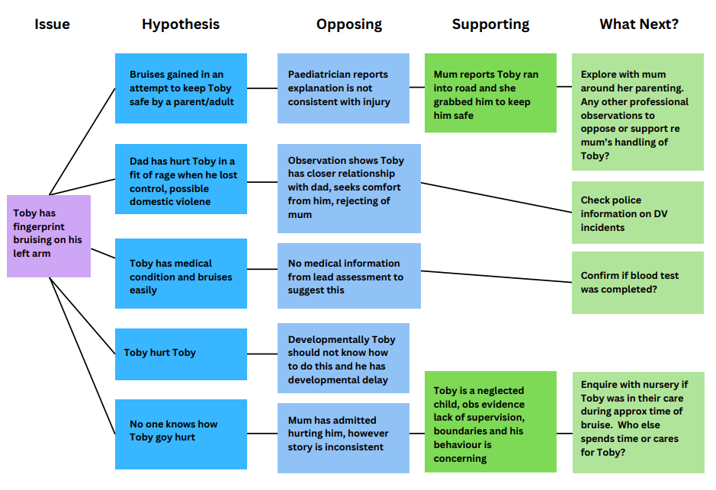

Functions of Supervision

Supervision should allow a practitioner to leave feeling less anxious and with a clearer view of what is required for the child, their family and the organisation, giving them an understanding of what actions may produce the best results and SMART actions of what to do next. Reflective supervision provides a practitioner a safe space to think, explore possibilities, look for meaning in what is happening and find ways to best support the children and families they are working with.

Morrison (2005) outlines four objectives to social work supervision: -

- Ensure competent accountable practice – Space to discuss work, reach decisions with guidance, create a level of shared decision making and clearly agreed accountability.
- Encourage continuing professional development – Opportunity for reflective discussion about practice to enable learning and development, space to discuss learning objectives and career development.
- Offer personal support to practitioners – Personalised support regarding challenges of the role, space to discuss the emotional context of practice.
- Engage the individual practitioner with the organisation – Understanding of professional role and clarity of responsibilities in the organisational setting.

An important part of supervision is the ability for the practitioner and manager to make shared decisions. For this to happen, the practitioner must present an analysis and recommendation to the manager, rather than just presenting the facts and expecting direction to be provided. Using the SHARE model (Maclean, Finch and Tedam 2018) as part of reflective supervision can support shared decision making. While working with a family, the practitioner will maintain an open and curious perspective, drawing upon what they See, Hear, do (Action) and Read. They will then Evaluate this and bring their hypothesis to discuss in supervision – leading to shared Decision making.

- Seeing – Draw on observations; e.g. family environment, family interactions, children’s behaviour. What hasn’t been seen? Reflect on what a good outcome for the family looks like?
- Hearing – What do the children and families say? What do other professions say? Who hasn’t been heard? Who’s voice is being privileged and why? Is the child’s voice central throughout?
- Action – What has the social worker done? What have others done? What impact has this had? Why?
- Reading – Has the chronology or previous case notes been read? Is there relevant theory or research to use?
- Evaluation – Using the first four components a social worker can understand what is happening by drawing on evidence gathered. The evaluation enables the social worker to develop a hypothesis about what is happening, what needs to happen and what would be helpful in moving towards this.
- Decision Making – The social worker should take a clear case hypothesis to supervision. This should be open to discussion and debate to address issues of individual bias in decision making.

More information about supervision can be found at Research in Practice, to access their guidance which includes a practitioners Preparation for Supervision Tool (Tool 5, page. 47) click here.

Assessment Timescales

There are many different types of assessments which practitioners undertake within their work with children, young people and families. While this guidance is unable to provide information for all of these, below you will find completion timescales for some of the most common assessments undertaken: -

Type of Assessment | Timescale for Completion
Child and Young Person Assessment (CYPA)  Pre-Birth Assessments | - The CYPA should not exceed 45 working days.  A timescale for completion of the assessment should be agreed between the Social Worker and Team Manager, depending on the urgency of the situation and the needs of the child.  - On the 8th day a management direction will be recorded, inclusive of a decision about whether the assessment will be completed in 15 days, or the next review point if it will be longer.  - Additionally, the Team Manager should provide oversight at the point of allocation and conclusion of the assessment.
Child Protection Enquiry Assessment (Sec.47) | - The ‘Record of Outcome of Sec.47 Enquiry’ must be complete within 15 days of the strategy meeting taking place.  - If CYPA is the outcome of the Sec.47 The CYPA should not exceed 45 working days. A timescale for completion of the assessment should be agreed between the Social Worker and Team Manager, depending on the urgency of the situation and the needs of the child.
Review Child Protection Conference Reports | - Reports for Review Child Protection Conferences are an updated assessment and therefore should address the child or young person's circumstances and needs holistically.  - The report should be made available 3 days ahead of Conference to be shared with parents and professionals.  - The report should be inclusive of management sign off.
Children Looked After Review Reports  Pathway Needs Assessment | - Reports for statutory review are an updated assessment and should address the child or young person's circumstances and needs holistically.  - Pathway Needs Assessments should be completed no more than 3 months after the young person's 16th birthday or after the young person becomes Eligible or Relevant if this is later. The Assessment should be updated every 6months in line with the CLA review process.
Early Help/Targeted Assessment | - Early Help Assessments (EHA) should be completed in 10 working days from the point of referral.

Assessments should always be completed in the identified/agreed timeframe, this is inclusive of the quality assurance process, management oversight and sign off. Practitioners need to complete assessments allowing time for manager oversight, amendments and obtaining/recording family’s views on the assessment. It is therefore good practice to set a date for a draft assessment, usually 2 days ahead of the final completion date, to allow for the quality assurance process.

