Finding a Home Form

Step by Step Eclipse Guidance

How to Complete a Finding a Home Form on Devon County Council Children’s Services Case Management System Eclipse

January 2024

Step by Step Guidance

Creating a Finding a Home Form
- One the child’s record, select Forms from the list down the left-hand side of the page as highlighted below:
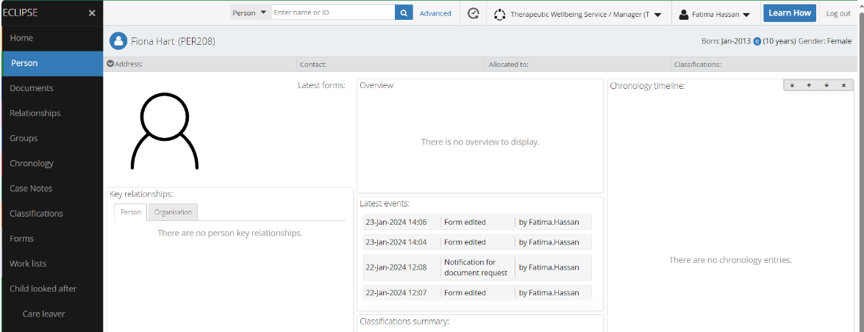

- On the next screen, click on the blue add icon near the top right of the screen and select the ‘Finding a Home form’ from the list presented (if the does not show in the list, you can click on the blue filter icon and enter Finding a Home form in the search bar which will bring up the form)

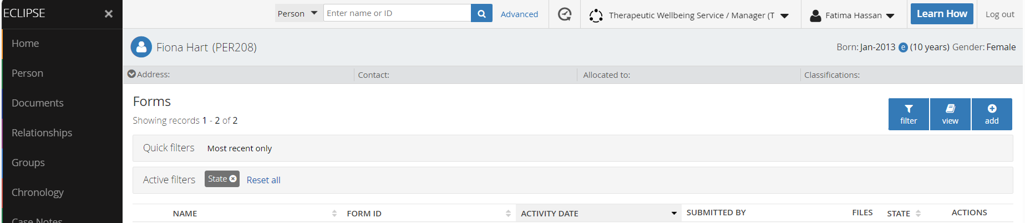

- Select the ‘Child: Finding a home’ from the list of forms presented by clicking the green add icon
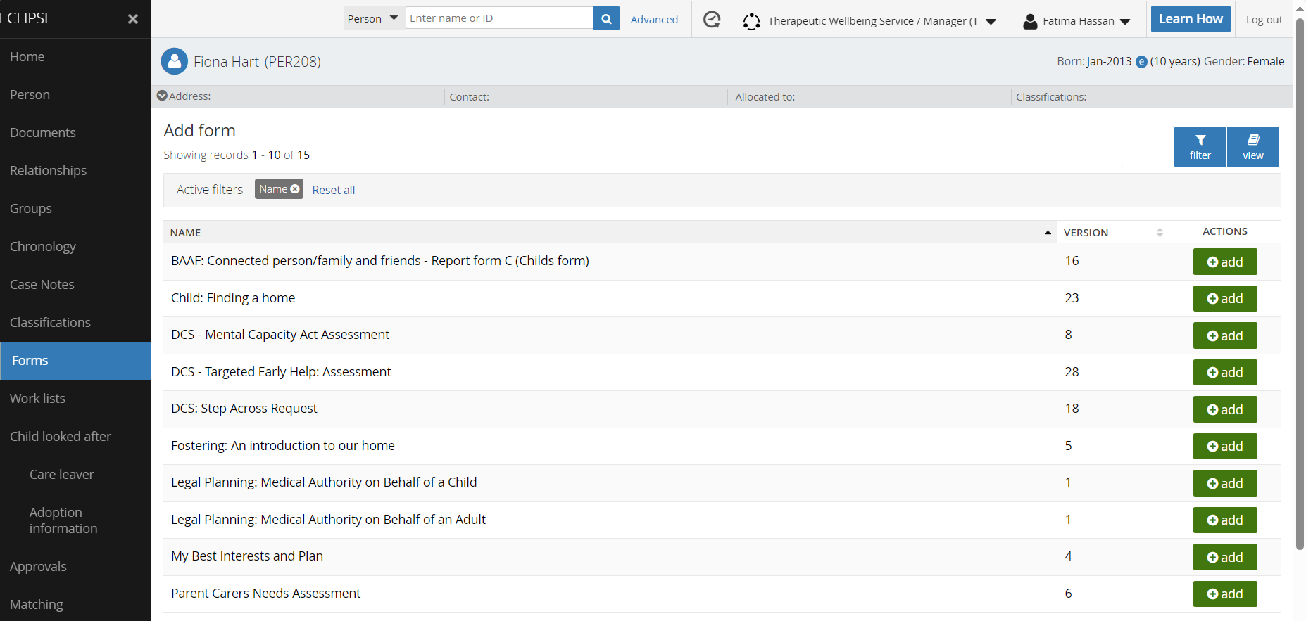

- Once the form has been added to the child’s record (you will find it in ‘Forms’ which you can access by clicking Forms on the left-hand side of your screen as demonstrated in step 1), select the form and you will then be presented with the questions in the form to complete.

- The finding a home form first presents guidance around completing the form and the power of the language we use to frame a child. It also reminds social workers to attach evidence of approval to carry out a search. Please note that without this approval, the Home Finding team will be unable to progress the form.

[N.B. For each section in the Finding a Home form, you need to click the edit icon to be able to complete the answers]

Emergency or Planned?
- The very first section of the form then asks if this is an emergency or planned search, please select the appropriate radio button as shown in diagram below.

- The next question asks what type of request this? Click on the down arrow in the answer box and select the appropriate answer (i.e. child coming into care, change to current home or respite)

- If your search is for a respite home, you will be asked if the respite if from care (i.e. from a child’s current foster home) or if it is respite from home (i.e. the child’s family home).

Where respite is selected, you will be presented with the respite form and the following steps in this document do not apply as they form for respite is much shorter and simpler.

- To complete this section, click on save and next.

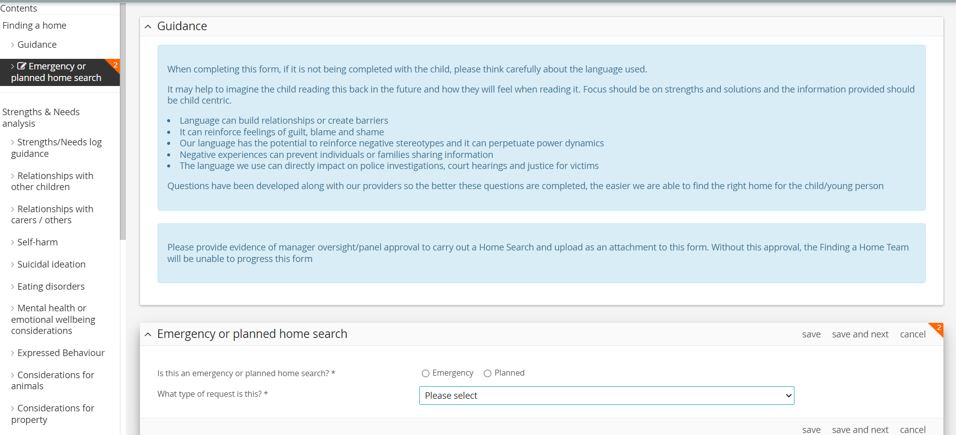

Child/young person’s Details
- This will take you through to the ‘Child/young person details’ section. The child’s name, date of birth and age will be prepopulated. You will need to select the child’s pronouns by clicking on the appropriate radio button and then enter create the child’s profile which is a free text box. Once you’ve completed the child’s profile, click save and next.
This section is critical to making what is essentially a 2D form into a 3D vison of who the child is. This is always best written by or with the child. Where it is not possible for the child to write this or contribute, the social worker will need to use their insight (along with feedback from others supporting the child) into how the child presents. If the social worker has not known the child for long enough, they will need to speak to those that have supported/worked with the child such as school, their family/carers, other professionals.

The profile should provide a strengths based and person centred overview of how the child presents with information on what they need to help them thrive. It is important to keep in mind the audience of this information, i.e. potential future carers and provide a balanced view of the child or young person.

The language we use and how the child is framed has huge impact on how a child is first perceived by readers of the form. Where a child is unable to contribute to the form, to get the framing right it often helps to imagine the child reading the form back in the future and how it will make them feel.

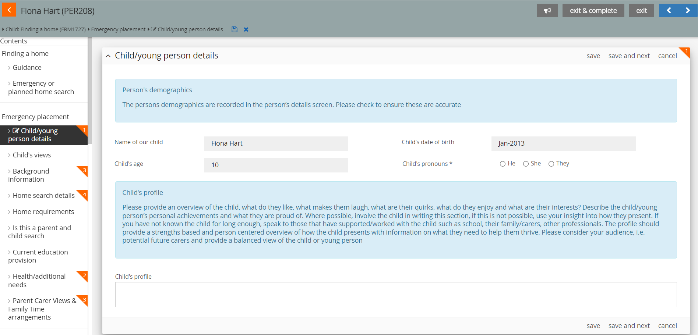

This is best written with the child. If the child is unable to contribute, ensure the profile is strengths based and uses restorative language. Once complete, read the profile back whilst putting yourself in the child’s shoes imagining that you are reading this back in the future. How would this profile make you feel. Is it positive and does it provide a reflection of who the child is and a vision of what can be achieved with the right support?

Child’s View
- This will take you through to questions within the ‘Child’s view’ section. Once these questions have been completed, click on ‘save and next’ to move to the next set of questions.

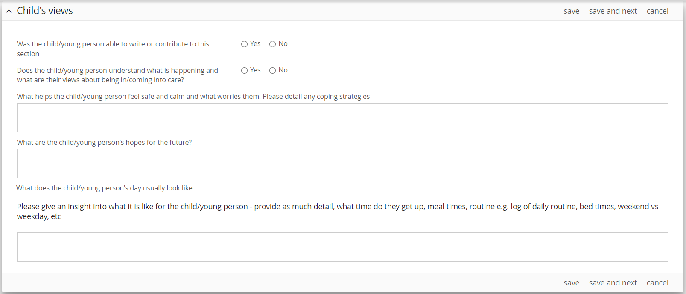
Where possible, it is important for the child to be involved in completing this form especially for the child’s profile and the child’s views

Background Information
- You will then be presented with the questions within the ‘Background information’ section. The first question asks for a brief summary of the child/young person’s history, childhood experiences and how they became looked after. Please enter you answer in the free text box.
When providing this information, think about what information you would find useful if you were the carer, what you help you understand the child’s journey, their needs and what they may need to support them.

The language we use and how the child is framed has huge impact on how a child is first perceived by readers of the form. Where a child is unable to contribute to the form, to get the framing right it often When providing this information, think about what information you would find useful if you were the carer, what you help you understand the child’s journey, their needs and what they may need to support them.
helps to imagine the child reading the form back in the future and how it will make them feel.

Provide information that will help the carer understand the child’s journey, and the context around their needs
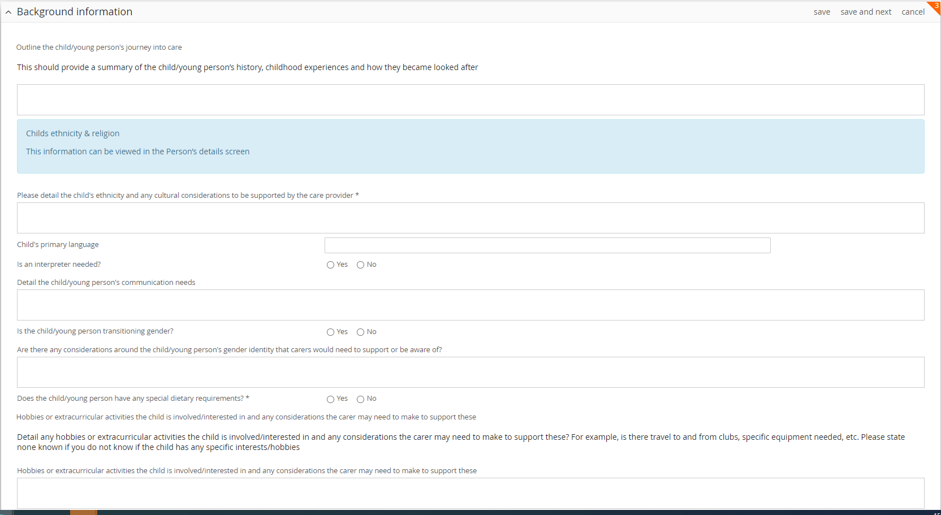
Are there activities the carer will need to support?

Home Search details
- You will now be presented with questions relating to the home search details.

‘What type of carer is preferred?’ is a new question that has been introduced. This will help guide the home search and will inform the carer chosen for the child however the current climate and limited number of foster carers available does mean that this preference is not always possible to meet.

Once all the questions in this section have been answered, click save and next.

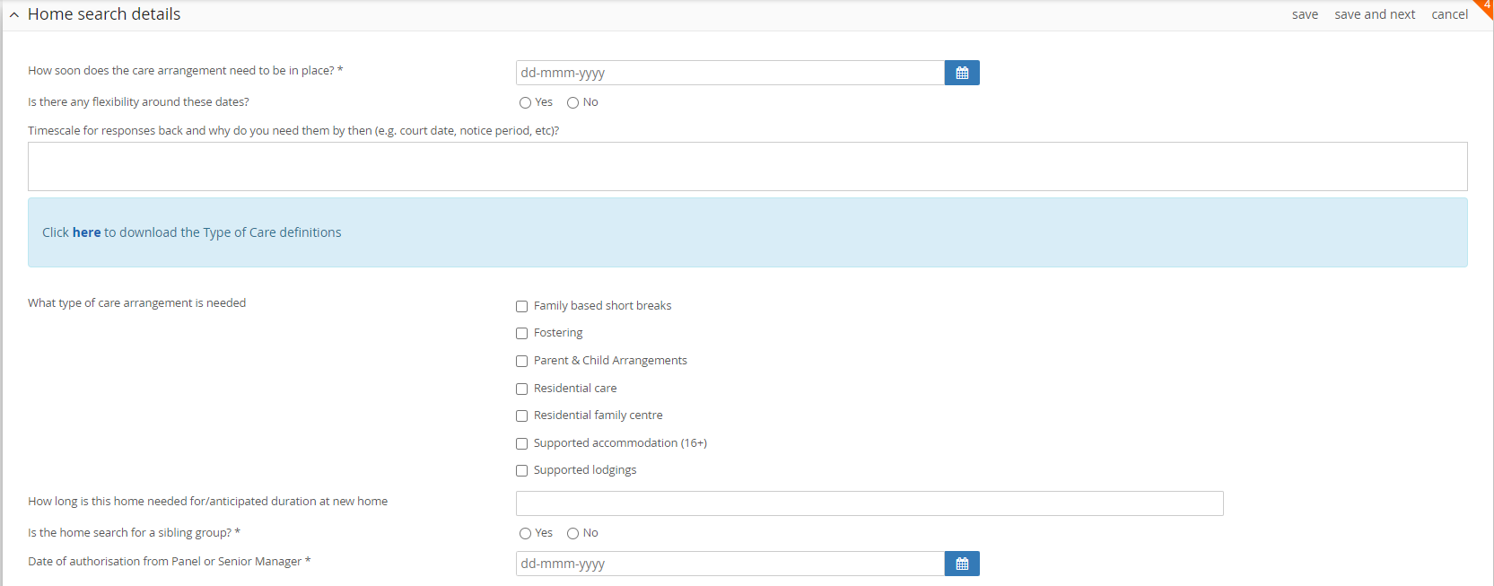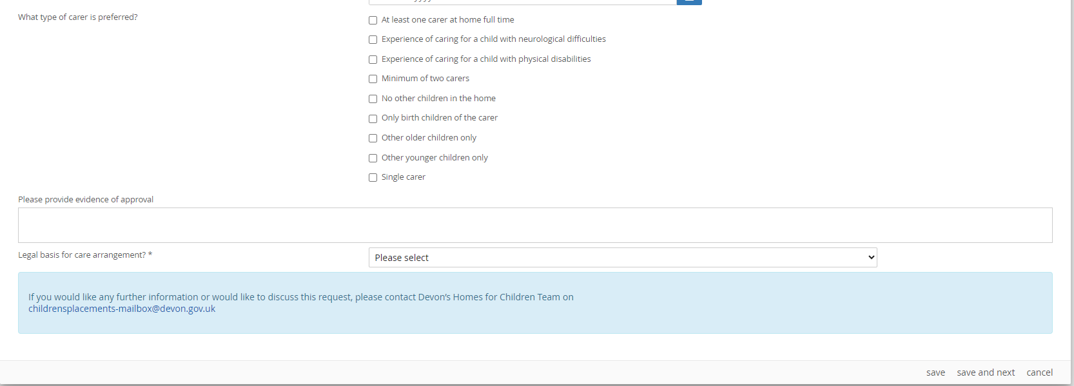
These preferences will inform the search but cannot be guaranteed
Multiple home search types can be selected
If the search is for a sibling group, additional question relating to if they should be together and if they can share a room will appear.

Home Requirements
- Next you will be asked questions around the home requirements, i.e. what is the intended outcome/LA plan, preferred search area, etc.

Once all the questions in this section have been answered, click save and next.
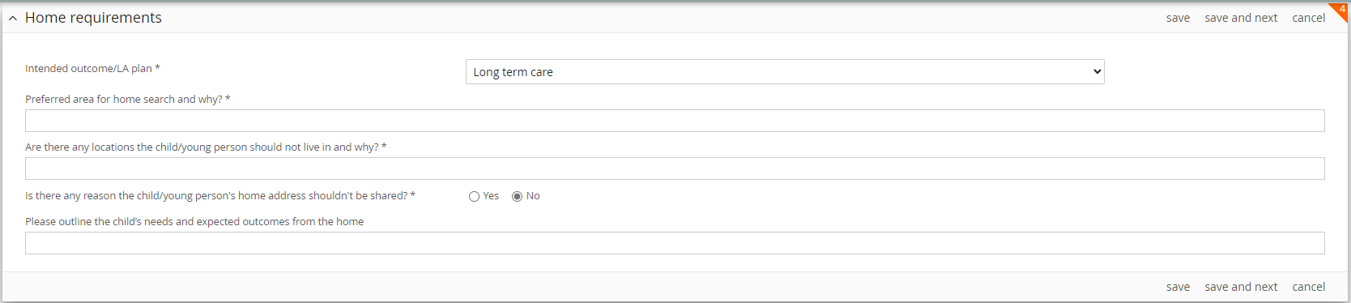
Here it is important to detail what the expectations are on the home to meet the child’s needs and how a child’s progress will be measured. This information will form part of the provider/carers agreement with DCC and will be used by SWs and IROs to assess if a child’s needs are being met
Select answer from drop down options
If you select yes, you will also be asked to provide some detail

Parent & Child Search
- The next section will ask if the home search is for a parent and child home. If you select no, you do not need to answer any further questions in this section and and can ‘save and next’ to take you to the next section.

If you selected yes, you will be asked to detail the type of home search needed (i.e. fostering/residential) and if the search is for one or both parents. The child’s parents details will be pulled automatically from the child’s Eclipse record and you are able to select the appropriate parent(s).

Once all the questions have been answered, click ‘save & next’

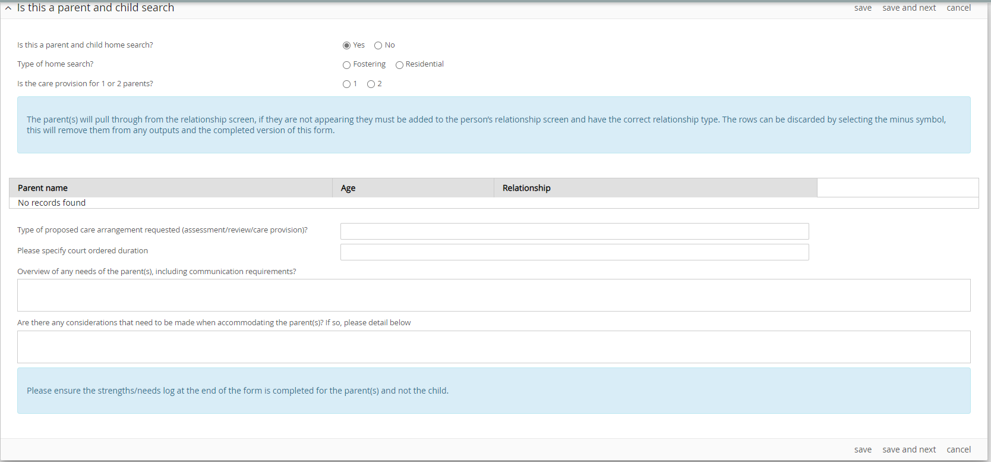
Parents details will be pulled automatically from the child’s record and show here. You will be able to select/remove as appropriate.

Current Education Provision
The following section requests details around the child’s current education provision.

Once all the questions have been answered, click ‘save & next’

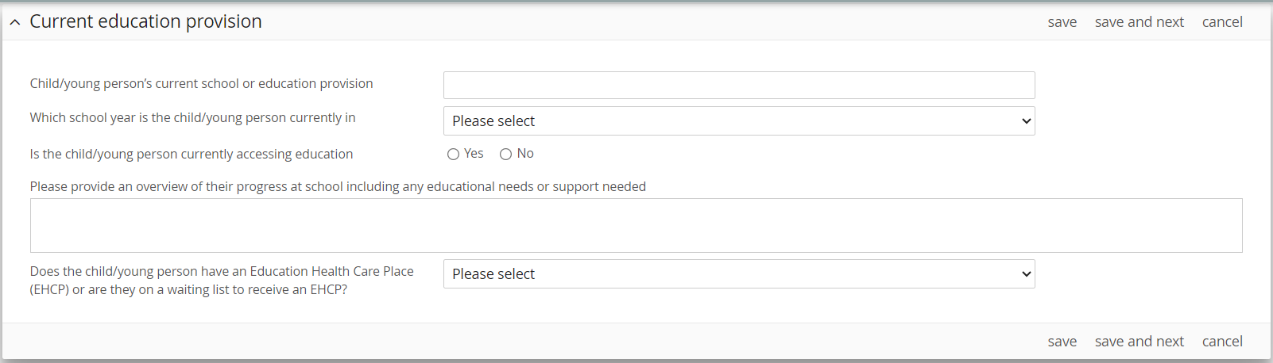
Here please detail how the child is engaging with school and what support is in place or needs to be in pace for the child

Health/addition Needs
- This section asks about the child’s health needs. Most of these questions are yes/no answers however where you answer ‘yes’, please provide additional detail.

Once all the questions have been answered, click ‘save & next’
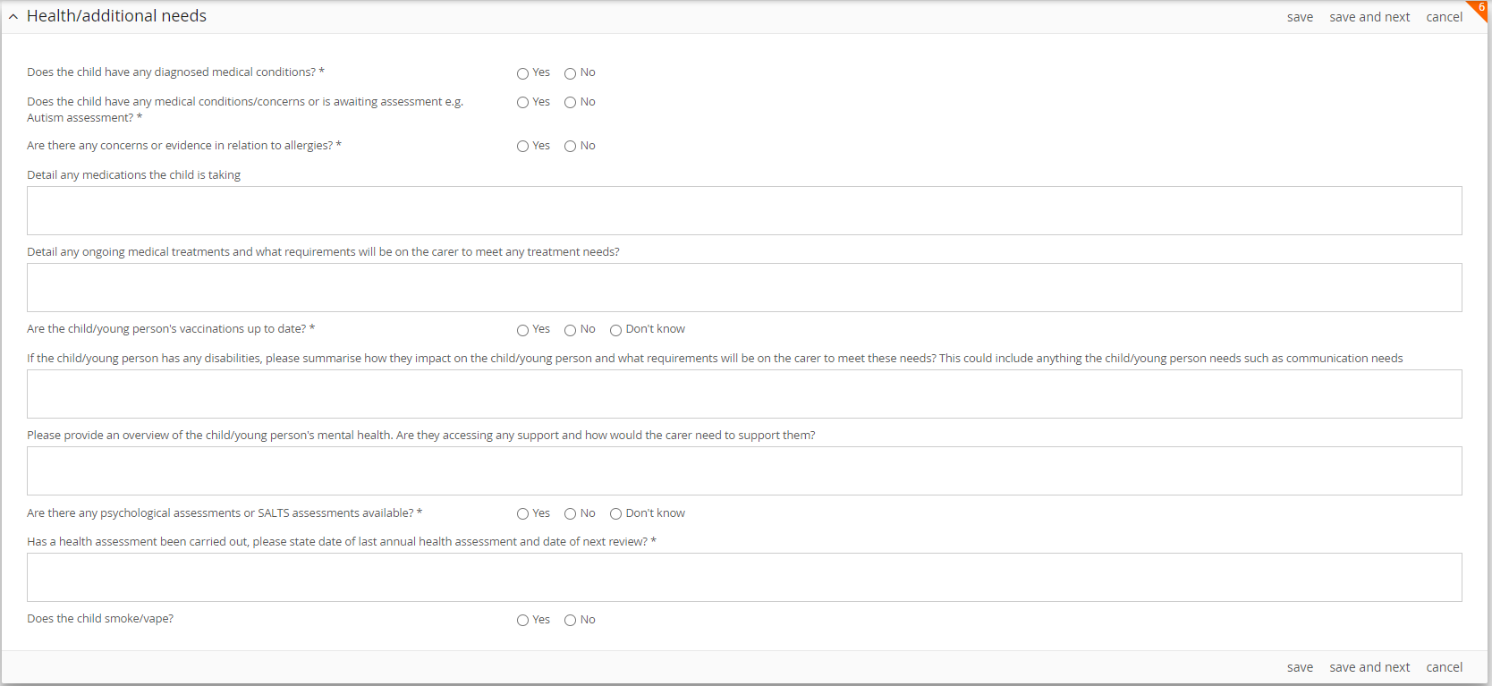
If you answer yes to the 1st two questions, a box will appear where you can record the necessary details

Parent Carer Views & Family Time Arrangements
- Here you will be asked for details around consent, parent/carer views and about family time.

Once all the questions have been answered, click ‘save & next’

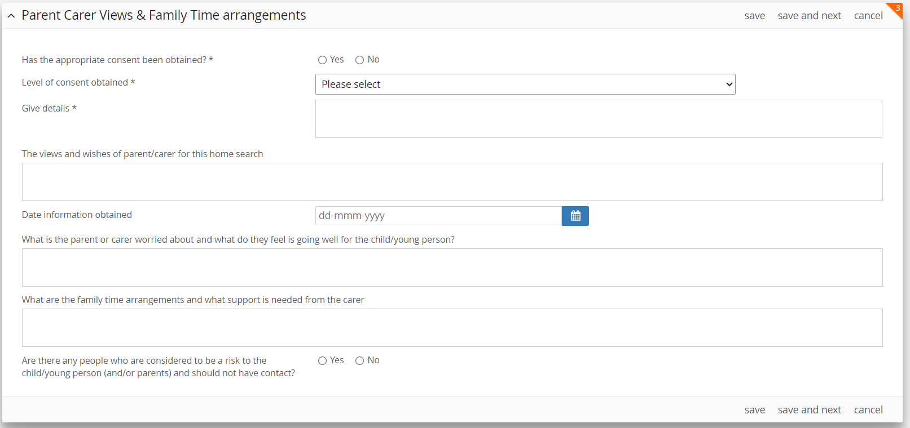
If ‘Yes’, a box will appear for you to enter relevant information and detail around who the child should not have contact with
As well as the logistics of family time, please provide any information available that will allow the carer to support the child, e.g. does the child need reassurance or alone time before or after visits, where do visits normally take place, are their any behaviours the carer should be aware of prior to or following family time
Please provide any limitations around consent, e.g. mother has given consent but not been able to contact father

Strengths & Needs Analysis
- This section replaces the ‘Risk Log’. Each area highlighted within this section was covered in the risk log but to support our thinking and the way we speak about our children, care has been taken to use words that enable us to record both things that we feel future carers should be aware of as well as strengths that have worked well for the child to regulate their behaviours.

Where a question within the strengths & needs analysis does not apply to a child, you can select no and move on to the next question.

Where a question does apply to a child, you will need to detail the context and background for the concern you have identified along with, any strengths i.e. what worked well to support the child to regulate; any triggers and how often significant incidents occurred and the date of the last incident.

- The first question in the strengths & needs analysis relates to the child’s relationships with other children. This was previously termed ‘risk to other children’.

Once all the questions have been answered, click ‘save & next’

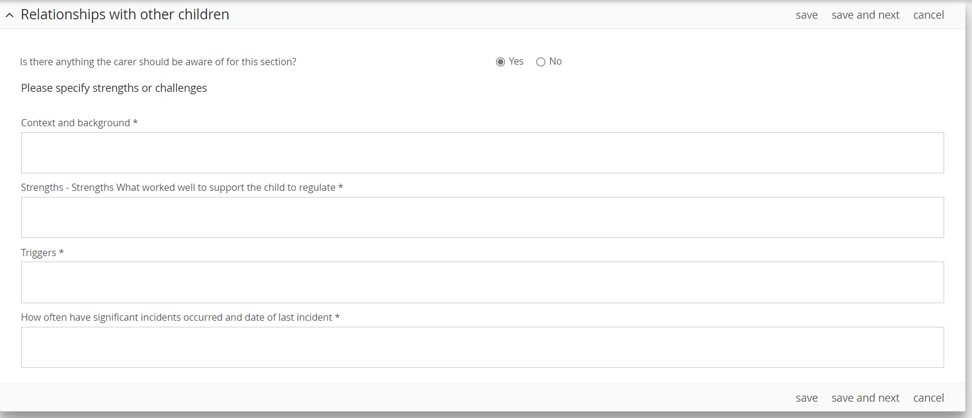
If you select ‘No’, the subsequent questions will not appear and you can click ‘save & next’ to move to the next question. If the answer is ‘Yes’, you will need to provide information on the context, what worked well to regulate previously, any triggers, how often incidents occur and the date of the last significant incident

- Similar to the format illustrated above, the following questions in the strengths and needs analysis ask about:

- Relationships with carer/others (if this applies, it is really important to highlight what worked well to manage this situation previously).

- Self-harm (if applicable, please detail frequency - daily, weekly, monthly, infrequent)

- Suicidal ideation (if applicable, please detail frequency - daily, weekly, monthly, infrequent)

- Eating disorders (if applicable, please specify considerations and details if an eating disorder has been diagnosed)

- Mental health and emotional wellbeing

- Expressed behaviour (if applicable, what does this look like and what is the frequency? Include responses to request as well as potential violence/aggression. Is this a trauma response? Trauma and distress affects behaviour in many ways, often in unsafe and concerning ways. If so please describe how the child’s trauma history may impact their responses?)

- Considerations for animals (if applicable, how has this been managed in the past?

- Considerations for property (e.g. is there anything the child/young person needs or does the carer need to be made aware of previous incidents where property has accidentally/intentionally been damaged and the extent of damage, e.g. fire setting, flooding etc.)

- Any relevant contact with the Criminal Justice System

- Problematic sexual behaviour (Problematic sexual behaviour involves one or more children engaging in sexual discussions or acts that are inappropriate for their age or stage of development.)
- Vulnerable to exploitation (if applicable, please provide detail around type of exploitation, e.g. county lines, sexual exploitation, modern-day slavery, etc.)

- Missing episodes (A missing episode is anyone whose whereabouts cannot be established and where the circumstances are out of character or the context suggests the person may be subject of crime or at risk of harm to themselves or another. A missing episode does not include a person who is not at a place where they are expected or required to be and there is no apparent risk.)

- Excessive substance/alcohol use (if applicable, please provide context, e.g. was this a one off occasion or is this habitual, smoking, vaping, drinking, drugs. If drugs, please specify which drug, e.g. cannabis, cocaine, etc.)

- Any other areas carer/provider need to be aware of? (e.g. climbing tall building, running into roads, eating soil, internet access, etc.)

- The last question in the strengths and needs analysis asks if a separate risk assessment has been completed, e.g. Safer Me Assessment, Toolbox, Forensic or Mental. If you select yes, you will be asked when this was completed and if it needs to be shared with potential carers. You are also reminded to attach it to the child’s Eclipse record.

Once this section is complete, click ‘save & next’

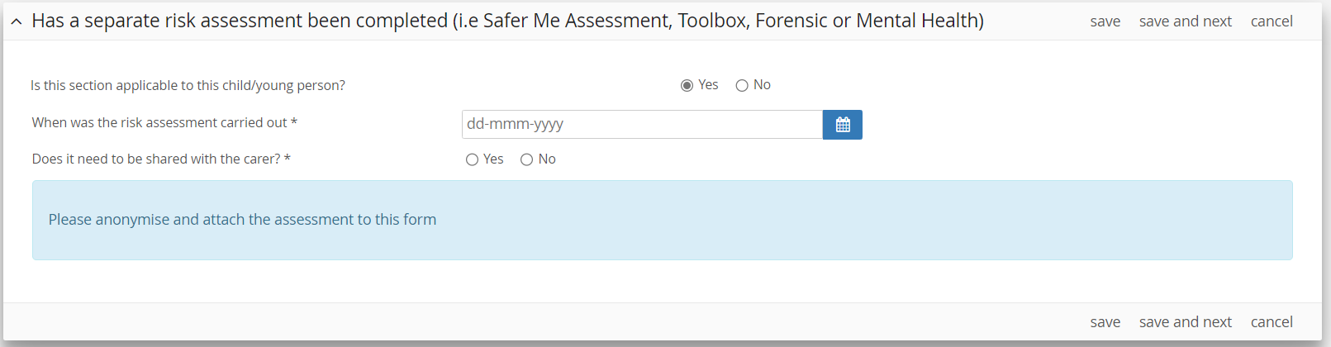

- This will take you through to the final section of the Finding a Home form where you can detail how the form has been completed. The first question in this section will ask if the form was completed with child/family/others?

If you select yes, you will need to detail who the form was completed with.
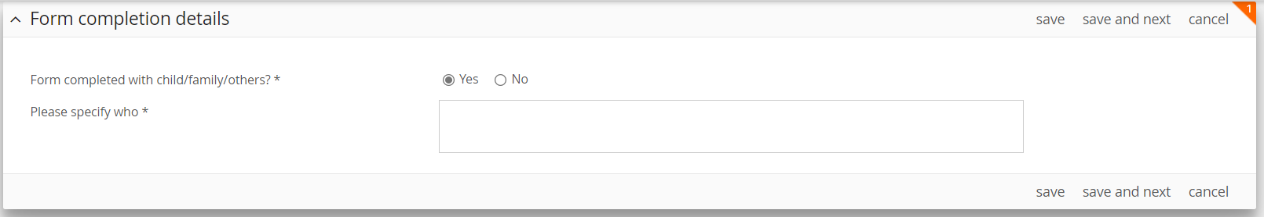

If you select no, you will need to detail why the form was not completed with the child/family and if the completed form has been shared with them.
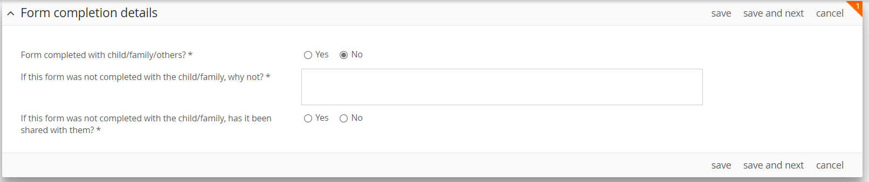

Once this section is complete, click ‘save & next’

- To complete the Finding a Home form click ‘exit and complete’ at the top right side of the page and the form will automatically be submitted to the Home Finding Team (previously known as the Placements Team) inbox.

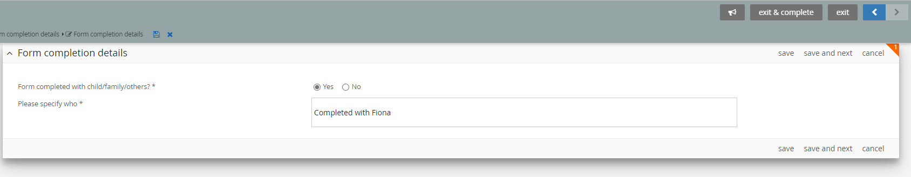

Please ensure that evidence of panel/manager approval to carry out a home search is attached as the Home Finding Team will be unable to progress without it.

