West Berkshire Council Children and Family ASYE HANDBOOK

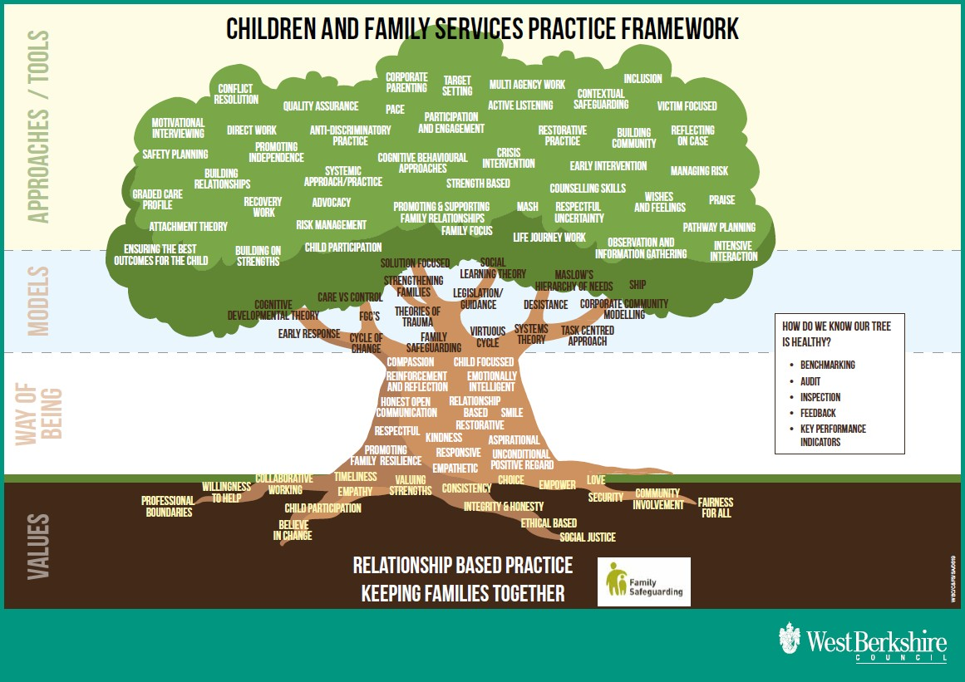

Newly Qualified Social Workers in their Assessed and Supported Year of Employment

Updated: November 2023

TABLE OF CONTENTS
Chapter one
- Introduction | 3
- Overview of the ASYE programme | 3-6
- ASYE timeline | 7
Chapter Two
- The Professional Capability Framework | 9
- Measuring Progress – level descriptors within the PCF | 10
- The Knowledge and Skills Statement | 11
Chapter Three
- Portfolio evidence | 13
- Portfolio Structure | 14
Record of Support and Progressive Assessment | 15
Chapter Four
- Key Players and their responsibilities | 16
- Work Based Supervisor | 16
- Practice Educator | 17
- NQSW | 17
- Buckinghamshire New University, Social Care Training, ASYE Panel | 18
Chapter Five
- Internal Moderation Panel | 22
Chapter Six
- Governance (what you need to know) | 24-30
Appendix | 31-35

CHAPTER 1: Introduction

Welcome to the West Berkshire Council Assessed and Supported Year in Employment (ASYE) programme. The ASYE is a 12-month Continuous Professional Development Programme, which aims to improve Newly Qualified Social Workers’ (NQSW) quality of practice with children and families in West Berkshire.

Firstly, congratulations on becoming a Newly Qualified Social Worker (NQSW) and welcome to a remarkable profession where you will have the opportunity to make a real difference to the lives of children, young people, and families in West Berkshire. We are pleased that you have chosen to start your social work career with us.

The ASYE supports NQSWs during their first year in employment, helping them to develop their skills, knowledge, and professional confidence.

This handbook is a practical guide for Newly Qualified Social Workers (NQSWs), Practice Educators (PE), Work Based Supervisors (WBS) and any professionals associated with the ASYE in West Berkshire Council.

Overview of the ASYE

- Why do we have the ASYE programme?

The ASYE has been designed to help NQSWs develop their skills, knowledge and capability and strengthen their professional confidence. It is a single scheme across children and adult services. It is aligned with the Professional Capabilities Framework (PCF), the Professional Standards of Social Work England and the Knowledge and Skills Statements (KSS) criteria. The KSS is also referred to as the Post Qualifying Standards, the PQS.

Employers now have the responsibility of deciding whether a NQSW has completed the ASYE successfully.

The key objectives of ASYE are to:

- Help NQSWs improve their skills, competence, and confidence as a social worker in a systematic manner during their first year of practice.
- Enable employers to provide NQSWs with focused supervision, support, and guidance.
- Improve NQSW job satisfaction and their enthusiasm to work as a social worker.
- Improve the quality of social work practice by ensuring the first year of employment provides an effective bridge from initial training to working effectively with children and families by developing professional competence.

Who is eligible to undertake the ASYE programme?

The ASYE was endorsed in 2012 by the Social Work Reform Board. Employers see ASYE success as evidence of a new social worker’s ability to apply learning in their employment.

All NQSWs are eligible to be registered by their employer for an ASYE programme within two years of successfully completing a recognised social work programme. Qualified social workers will be eligible if they have been working in another occupational area and it is less than two years since they qualified.

The Council may choose to support existing employees, whom it has supported to qualify as social workers, to undertake the ASYE, even if they are not employed in a qualified social worker role. In these circumstances, opportunities must be provided for the NQSW to undertake work that enables them to demonstrate competence to meet the PCF and KSS/PQS at ASYE level. This will be agreed between the social workers’ line manager, the Work based supervisor (WBS) and Practice Educator (PE).

NQSWs who qualified outside of England will be eligible if they have completed a recognised social work degree no more than two years before the start of ASYE.

NQSWs will also need to be registered with Social Work England.

Benefits of the ASYE programme

The ASYE is a framework to promote and sustain best practice in social work. The year aims to ensure that NQSWs are afforded a good induction into their roles and organisations. This includes protected caseloads with incremental increases at different points. Professional development is an essential feature of the first year in practice and these measures are key to best practice.

The support and assessment tasks during the year may be delivered in a variety of ways in the workplace. The practice educator (PE) collates evidence to assess the NQSW’s progress in achieving the expected social work standards as well as undertaking a minimum of one observation of practice. The practice educator also has an educational role – enabling the NQSW to reflect on social work practice, knowledge, skills, and values.

NQSWs will work within a professional development plan (PDP), which is developed together with input from the work-based supervisors (WBS) and practice educators (PE). This plan will target individual learning needs. NQSWs will receive weekly supervision from their Work based supervisors for the first 6 weeks of employment. This will then reduce to fortnightly for the first 6 months and then to

monthly supervision thereafter. Supervision dates will need to be recorded by the NQSW. If sessions are cancelled the reason for these sessions being cancelled will also have to be recorded. This record will be placed in the ASYE portfolio.

Currently, West Berkshire Council has agreed to an additional six group reflective supervisions over the year, facilitated by a practice educator. These sessions are mandatory as they provide a peer support group for learning and reflection.

The ASYE assessment process

NQSWs will be assessed against the PCF in a holistic way to ensure they have reached the expected standards of service delivery by the end of the ASYE.

NQSWs will also be assessed against the KSS/PQS (Knowledge and Skills Statement for Social Workers for Child and Family Social Work, 2018). These statements apply to all frontline practitioners. They also form the basis of the National Assessment and Accreditation System for Approved Child and Family Social Workers.

It is expected that the NQSW will have the opportunity to experience all social work tasks pertaining to their team and role. Evidence demonstrating progression will be collected and used to monitor individual progress. Part of this evidence will include a critical reflective log which the NQSW will produce for each review.

Professional development is considered at four formal reviews (3-month, 6-month, 9-month and 11-month reviews). At these reviews the NQSW’s progress is assessed, and the next phase of their personal development plan (PDP) is considered. These meetings are intended to monitor both the NQSW’s development and consider support in place.

Throughout the ASYE programme the NQSW will be accountable to the work-based supervisor (WBS) for their day-to-day practice. The work-based supervisor will enable the NQSW to reflect on case management and promote a culture of questioning and evaluating practice in partnership with the NQSW. They will have a significant role in contributing to the support and assessment of the NQSW. They will arrange the induction, undertake file audits and one observation of practice. The work-based supervisor will provide input about NQSW work performance into all reviews and into the final assessment report.

During the year, NQSWs will build an evidence record/portfolio which is highlighted in the ASYE Timeline table on page 7. Templates for this are provided in WBC’s Children’s Services Procedures Manual.

West Berkshire works in partnership with Buckinghamshire New University (BNU) and for those NQSWs not undertaking their MA studies with Frontline, there will be three mandatory workshops to support with consolidation of practice, provided by a BNU lecturer during the ASYE. One assignment will be submitted to BNU with a formative assessment provided and will form additional evidence of the NQSW’s progression.

Practice observations provide good learning opportunities and NQSW practice will be observed formally on a minimum of four occasions. Three of these will be undertaken by a practice educator and one by a work-based supervisor.

Feedback from professionals and service users is essential to the assessment process. NQSWs will need to provide feedback from a minimum of three service users including children, young people, or families the NQSW has worked with. Additionally, feedback from three colleagues and/or other professionals needs to be provided. Finally, the work-based supervisor may decide to seek other feedback from others such as family or professionals, and will share this with the NQSW individually, and with the practice educator in reviews.

Evidence collected over the year will be considered by an employer appointed internal moderation panel, which will comprise of at least two members who will be social work managers. A decision will be made as to whether the NQSW has achieved the expected standards of practice. The practice educator will provide a final report giving their view as to whether the NQSW should be recommended as passing the ASYE.

In all cases involving a tentative fail decision and in borderline pass situations, the evidence will be referred to an external quality assurance panel. This panel will comment to the employer on whether there is a fit between the assessment decision and the evidence used to justify this decision, as well as on the process of the assessment and the support made available to the NQSW throughout the ASYE. A range of evidence, which has been “passed” by the internal moderation panel, should also be referred to the external quality assurance panel.

The employer retains responsibility for decision making. NQSWs may formally appeal any fail decisions.

Successful completion of the ASYE will conclude your probation period at which time pay grades and any incremental rises will be in line with the WBC pay policy: Employees are entitled to a pay increment each 1st of April until they reach the top of the grade, subject to at least 6 months in the post, and to satisfactory performance.

(Source: WBC Pay Policy: http://intranet/index.aspx?articleid=31843)

ASYE Timeline

Month one

NQSW Induction process starts supported by the work-based supervisor.

NQSW completes KSS/PQS self-audit tool.

Interprofessional development meeting takes place (NQSW and practice educator)

NQSW, WBS and PE consider learning needs identified within NQSW final placement report, Interprofessional development meeting and the KSS/PQS self-audit tool to create NQSW personal development plan.

Support and Assessment Agreement meeting held.

PDP agreed between NQSW, PE and WBS.

NQSW starts logging evidence.

Three months- Foundational Review

NQSW to prepare supporting information for the first three months:

Update KSS/PQS audit.

1 Direct observation, 1 x Service user feedback and 1 x Professional feedback.

1 x work product/ or file audit.

Foundational Review of Progress meeting (PE, WBS and NQSW)

PDP updated

Six Months- Interim Review and Assessment of Progress

- NQSW to prepare supporting Information for the first six months:
- Update KSS/PQS skills audit
- 1 Direct observation, 1 service user feedback, 1 professional feedback
- 1 Work product and/or file audit
- Interim review and assessment of progress meeting (PE, WBS and NQSW)
- PDP updated and agreed between NQSW, PE and WBS
- Buckinghamshire New University- Critical reflection on decision making (please see course details for date this should be completed, it may not be completed and marked by the 6-month stage)

Nine Months- Progressive Development Meeting

NQSW to present to WBS/ PE and ASYE lead on a piece of work they have completed/ or professional dilemma (date to be agreed/ around 9-month stage of ASYE programme).

Presentation guidance for NQSWs (skillsforcare.org.uk)

NQSW to update KSS/PQS skills audit.

1 Direct Observation, PDP update and agreed between NQSW, PE and WBS.

Eleven Months -Review of Progress and Final Assessment

NQSW to prepare supporting Information for the final progress assessment

1 Direct Observation, 1 Service User feedback, 1 Professional feedback

1 Work product and/or file audit

NQSW update KSS/PQS Skills audit

Final report written by the PE with WBS input

Update Final PDP

Twelve Months

Portfolio submitted to ASYE panel.

NQSW to attend panel and feedback on their experience of the ASYE

NQSW notified of Pass, Fail or Deferred (with reasons)

Chapter 2: The PCF and KSS – What is the NQSW being assessed against? Assessment Against the Professional Capabilities Framework (PCF)

NQSWs will be familiar with the Professional Capability Framework, which was developed and published in 2012. The PCF is the profession-owned backbone of social work education and professional development in England.

Since 2012, the PCF has been reviewed and refreshed through a process of extensive consultation during 2017-2018. As a result, BASW in conduction with Research in Practice have produced an updated version of the 2012 PCF. The new version of the PCF hopes to ensure that the most important and useful domains are maintained.

It will be important for NQSW, PE and WBS to be familiar with the changes to the PCF and more detail can be found at the following web address:

https://www.basw.co.uk/system/files/resources/PCF%20Final%20Documents%20Ov erview%2011%20June%202018.pdf

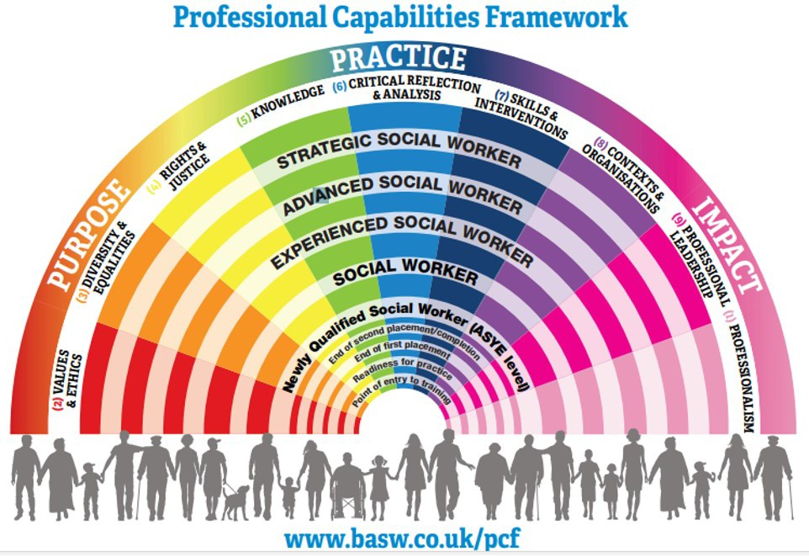

Measuring Progress – level descriptors within the PCF

By the end of the Assessed and Supported Year in Employment (ASYE) social workers should have consistently demonstrated practice in a wider range of tasks and roles, and have become more effective in their interventions, thus building their own confidence, and earning the confidence of others. They will have more experience and skills in relation to a particular setting and user group and have demonstrated the ability to work effectively in more complex situations. They will seek support in supervision appropriately, whilst starting to exercise initiative and evaluate their own practice.

Therefore, the NQSW will need to have demonstrated the following: to manage complexity, risk, ambiguity, and greater autonomous decision making across a range of situations. This can be demonstrated by:

- Level of confidence, underpinned by practice experience, reflection and deepening understanding

- The increasing ability to work independently and to collaborate on equal terms with members of other professions

- The quality of the judgments made, and the level of ability to explain and justify them

- Efficacy of the work undertaken, and the outcomes achieved, including opportunities for preventive work

- The ability to take initiative, form constructive alliances and to act as a change agent

- The ability to engage effectively with situations of increasing complexity and challenge, for example those with
  - multi-agency input
  - complex family / organisational dynamics
  - serious hostility and conflicts of interest
  - multiple problems / disadvantages
  - multiple / significant risk factors
  - need to consider the public interest

- The appropriate use of authority and challenge

- The ability and commitment to educate and provide professional supervision to others

- Demonstration of leadership, management, and research

Assessment against the Knowledge and Skills Statement (KSS, May 2018)

The KSS/PQS describes what social workers should know and be able to do at the end of their first year in practice. The statements support the use of the PCF as the generic standard for all social workers. The KSS/PQS does not reiterate all the PCF capabilities because they were designed to contextualise, not replicate, the PCF. The PCF is the overarching standards framework intended to be applicable to all social workers in whatever role or setting.

The KSS/PQS for social workers in child and family social work will help you to understand the specific knowledge, skills and responsibilities that are required of every social worker working in a child and family setting.

Through the reflective process the social worker, over the course of a year, is expected to develop a combination of evidence-based practice that draws on knowledge, including legal literacy and practice experience to understand, assess and work with children and families. Central to this is the recognition of potential harm and risk, and the importance of developing skills in this area. There is an expectation that the social worker will demonstrate the ability to lead investigations into allegations of significant harm, albeit in consultation with others.

The KSS/PQS provides a list of core knowledge requirements, including an understanding of child development, the impact of mental health, substance misuse and domestic abuse on children and families. The list is not exhaustive, and you will need to identify the knowledge requirements that are specific to your employment setting.

Support for and demonstration of progressive development over the year is linked to a cycle of critically reflective logs and reviews.

Post-qualifying standard: knowledge and skills statement for child and family practitioners

May 2018

Knowledge and skills for child and family practitioners cover the following ten areas in relation to practice for child and family social workers:

- Relationships and effective direct work

- Communication

- Child development

- Adult mental ill health, substance misuse, domestic abuse, physical ill health, and disability

- Abuse and neglect of children

- Child and family assessment

- Analysis, decision-making, planning and review

- The law and the family and youth justice systems

- The role of supervision

- Organisational context

This link will take you to the full statements:

https://www.gov.uk/government/publications/knowledge-and-skills-statements-for- child-and-family-social-work

Chapter 3: ASYE Supporting Evidence

NQSWs are expected to start collecting evidence for their ASYE portfolio from the start of their ASYE journey. Figure 1 identifies the main sources of evidence for NQSWs to demonstrate their progress throughout their ASYE. NQSWs must ensure that all evidence presented is anonymised; with due regard to confidentiality rules.

Service users’ feedback and professionals’ feedback, as well as the direct observations of practice, are to be included in the ASYE Portfolio. NQSWs will need to include at least 3 sets of each type of evidence in their portfolio.

It is no longer required to include professional documentation within the ASYE portfolio as the Practice Educator will need to provide work product feedback (Professional Document template) for every review and it is only this feedback that should be included in the portfolio.

Additionally, critical reflective logs, PDP’s and the two BNU assignments or the Frontline equivalent, will also form part of the portfolio evidence.

PROFESSIONAL
DOCUMENTATION
SUPPORTING
EVIDENCE
ASYE
portfolio
FEEDBACK
OBSERVATION OF
PRACTICE

Figure 1

Record of Support and Progressive Assessment

The Record of Support and Progressive Assessment (RSPA) is one of the core documents for the ASYE journey

Responsibility for the overview and completion of the record of support and progressive assessment lies with the PE. The PE will be responsible for completing a holistic assessment of your practice. This template includes:

- the support and assessment agreement
- three and six-month reviews and the 9-month review
- the final recommendation and assessment outcome.

The Pen Picture and guide to completing the CRLs are available on the West Berkshire Children’s Services Procedures Manual – Practice Guidance – Professional Development pathways https://www.proceduresonline.com/westberks/cs/local_resources.html

Portfolio Templates are available on the Skills for Care website:
ASYE templates (skillsforcare.org.uk)
CHAPTER 4: Key players and their responsibilities

The figure below illustrates the key players who may be involved with NQSWs in their ASYE Journey.

Practice Educator

Work Based
supervisor
Universities
BNU
Winchester Oxford Brookes
NQSW
Service Users
Frontline
WBC panel
Multi-agencies

Additionally, some key players have key roles as summarised below:

Work Based Supervisor

The main responsibilities for Work Based Supervisor are in assessing and supporting NQSWs in their ASYE journey in child and family social work:

Work Based Supervisor is expected to:
- Be accountable for the NQSW’s day to day practice including day to day support and assessment of the NQSW.
- Undertake individual supervision in line with WBC policy to address both case load and professional development including opportunities for reflective practice
- Identify and allocate appropriate work to the NQSW
- Provide case guidance and support to the NQSW.
- Conduct file audits to be completed prior to formal reviews and provide feedback to both the PE and the NQSW. The audit will consider all aspects of case management by the NQSW (e.g., quality of recording, meeting expected timescales, etc).
- Suggest work for consideration by the PE in assessing the NQSW’s progress.
- Conduct at least one formal observation of practice and provide a report.
- Attend formal review meetings and provide input into the reviews and final assessment report
- Liaise with the PE and Principal Social Worker and HR about the NQSW’s progress, especially if there are concerns.

Practice Educator

The main responsibilities for Practice Educator working with NQSWs:

Practice Educator is expected to:
- Hold overall responsibility for coordinating holistic assessment of the NQSW’s progress
- Convene meetings with WBS and the NQSW to develop the Record of Support and Progressive Assessment and finalise and circulate the agreed document
- Write final report clearly indicating a recommendation for pass or fail, to be submitted to the internal panel
- Check that the portfolio contains all the required information prior to submission to panel
- Co-ordinate the review meetings and produce notes.
- Conduct at least one formal observation of practice and provide a report.
- To provide a minimum of 3 reflective supervisions during the ASYE journey (one of these will be the interprofessional development meeting).
- Support the NQSW embedding knowledge (legislative, policy, theory, and evidence-based knowledge), values and skills to practice.
- Provide guidance and support to the NQSW to gather evidence to meet the requirements of the portfolio and provide feedback on the evidence
- Raise any concerns as soon as they arise to the WBS or Principal Social Worker regarding any factors that are affecting the NQSW’s ability to meet agreed targets e.g., stress levels, appropriateness of caseload, support within the team

WBC has agreed for the following additional support to be provided by the PE:

- X 1 extra observation (therefore a total of x3 observations undertaken by the PE)
- X 6 group reflective supervision sessions (provided over the ASYE year)

Newly Qualified Social Worker

The main responsibilities for NQSWs in their ASYE journey through West Berkshire Council

Newly Qualified Social Worker (NQSW) are expected to:
- Complete the ASYE programme within 12 months (there are only exceptional circumstances permitted for an extension).
- Work with the WBS and PE to regularly plan and review their ASYE journey.
- Take responsibility for producing a portfolio of evidence of support and development with due regard to the required structure and evidencing working to timescales.
- Prepare for and attend supervision sessions and to take responsibility for identifying his/her own learning needs and take proactive action to promote own development.
- Use supervision sessions constructively to develop learning and to reflect on and evaluate practice. This includes an active participation in corporate and team’s induction and any other learning opportunities.
- Ensure that allocated children are safe and there is a SMART multiagency child centered plan aiming to meet their identified needs according to threshold for services in WBC.

- To consistently deliver basic standards of social work practice across their caseload. This includes effective work with professionals, children and their families; to complete a timely self-audit on each case on allocation; keep up to date case records; use basic SW tools (Genogram, ecomap, chronology, timeline) ; use research and/or standardised tools for assessment; ensuring that all their children have up to date analytical assessments underpinning their care plan; visiting children within timescales and use a variety of tools to ascertain their wishes and feelings with due regard to age, understanding and stage of development.

Bucks New University, WBC training, ASYE panel

The table below contains the main responsibilities for other key players such as Buckinghamshire New University (for those ASYEs undertaking modules), our training department as well as West Berkshire ASYE Panel.

Bucks New University is expected to:
- Deliver non-accredited module which will provide underpinning knowledge and skills to support NQSWs’ reflective practice and to provide evidence to meet the required standards.
- induction/enrolment half day and three one-day workshops.
- Provide formative feedback on 1 critically reflective assignment
West Berkshire Council is expected to:
- Commission and arrange payment to PE
- Work according to Skills for Care Guidance to organise and deliver the ASYE program in West Berkshire.
- Coordinate the registration of NQSWs and apply for funding to support the delivery of the ASYE program from Skills for Care/Department for Education
- Coordinate the registration of NQSWs and pay funds to Buckinghamshire New University for the ASYE course modules
- Convene an internal moderation process which will be accountable (on behalf of the employer) for the assessment decisions.
- Organise ASYE launch day and ensure all NQSW understand the expectations of the ASYE programme in West Berkshire
- Organise and coordinate West Berkshire Council ASYE panel
- Facilitate informative sessions for PE, WBS and other involved in the assessment and support of NQSWS
- Organise and facilitate learning and development sessions for ASYE’s as part of the Social Work Academy.
- Organise Principal Social Worker reflective forums for NQSW’s
- Provide ASYE certificate on successful completion of programme.
- Seek feedback from all ASYE stakeholders to monitor and improve the ASYE programme.
- Regularly review the ASYE program in West Berkshire and develop and improvement plan.
West Berkshire Council’s ASYE panel is expected to
- Be responsible for internal moderation of all NQSW portfolios
- Complete internal moderation template
- Inform the NQSW in writing within 3 working days of the Panel’s decision. This includes informing NQSWs of their right of appeal.
- Seek feedback from NQSW about their experience of the programme.

CHAPTER 5: The End of ASYE Journey: Internal Moderation

The ASYE panel is responsible for the internal moderation process of your ASYE portfolio. The ASYE panel will make the pass/fail decision.

WBC training department will convene the ASYE panel for both adult and children’s services at least twice a year depending on demand. A minimum of 2 people should participate in the internal moderation decision-making. Assessment decisions should be reviewed by a registered social worker who should aspire to meeting practice development educator capabilities.

The Internal Moderation Template has been developed by Skills for Care and supports transparency in the internal moderation process and provides a record of the moderation decision. 1

Review and scrutiny of the ASYE assessment decisions

The panel must consider whether you have met the requirements of the KSS, considering the recommendation of the assessor.

The assessor’s recommendation should be:

- Accurate - Consistent with the expectations of the KSS and PCF ASYE capabilities.
- Valid - Based on evidence that reflects the breadth of the NQSW’s work throughout the year and their progression.
- Robust - Based on evidence that is checked and consistent and leads to a defensible judgement.
- Sufficient - Based on a sufficiently broad and varied range of different types of evidence.

The ASYE Panel should ensure that confirmation of the assessment outcomes is based on:
- a scrutiny of all ASYE assessment decisions made in the organisation
- a full reading of the evidence/material submitted by each NQSW and assessor (except professional documentation which will be verified by the assessor). Each set of evidence/material is read and reviewed by at least one other person

The purpose of reading the evidence for internal moderation of the assessment outcome is:

1 / Moderation (skillsforcare.org.uk)

- to ensure that the requirements of the ASYE have been met (e.g. protected caseload, supervision etc.) and that the evidence/material submitted is sufficient (e.g. the correct number of direct observations have been completed). This element will be recorded in a Quality Checklist. This can be assessed by any member involved in the process.
- to ensure the assessment judgement made by the assessor is accurate, valid and robust, and in line with the PCF ASYE capabilities and Knowledge and Skills Statement. This element will be recorded in a review of the assessment decision checklist. This can only be assessed by a registered social worker.

Reviewing the Assessment Decision

If the internal moderators do not agree with the assessor’s judgement or deem that there is not sufficient evidence to support the assessor’s decision, agreed action should be taken within a given timescale.

In relation to the NQSW, this may take the form of:
- a request for more evidence
- a reassessment with a view to bringing the assessment up to the expected standard
- a request that a second assessor reassesses the evidence and makes an assessment decision on behalf of the organisation
- in relation to the assessor, this may indicate a learning and development need. Agreed action to support the assessor’s development should be planned and enabled.

Completion of ASYE

Completion of the ASYE year will be dependent on the successful submission of a portfolio by the NQSW to the internal ASYE panel by the stated submission date.

The panel will decide about whether the ASYE has been successfully completed by the NQSW and written confirmation will be sent to the NQSW within 3 days of the panel date.

The decision will be that:

- The NQSW has successfully completed ASYE

- Further evidence is required for the panel to decide. A request must be responded to within the timeframe agreed by panel who will review the additional evidence and then advise the NQSW of its final decision

- The NQSW has not met the standard required and has not achieved ASYE.

CHAPTER 6: GOVERNANCE

Extracts taken from the WBC Assessed and Supported Year in Employment Procedure (Social Workers) ref: HRASYE 2012

Applicability

This procedure applies to:
- All NQSWs employed as qualified social workers, or, at the discretion of the employing organisation, others with social work qualifications working in social care positions.
- Anyone with responsibility for line management and supervision of NQSWs
- Anyone involved in the process of assessing NQSWs as part of the ASYE

Core Roles and Responsibilities

- WBC as the employing organisation will benchmark and review its ASYE against other ASYE programmes regionally through the established regional Social Work Education Group to identify and share best practice.
- WBC will ensure its programme follows national guidance provided by Skills for Care.
- WBC will continue to monitor and review its ASYE programme to ensure continual improvement can be identified and implemented.
- The Head of Children and Family Services has overall responsibility for ensuring that procedures for the NQSW are managed appropriately in accordance with agreed standards and that an ASYE programme is delivered across the Service.
- The Principal Social Worker is responsible for overall management of the ASYE assessment process. [Their responsibilities may be delegated to the Children and Family Services Workforce Development Officer.]
- Principal Social Worker and Work Based Supervisors are responsible for implementing and managing the NQSW during their ASYE in accordance with these procedures.

National Policies, Guidance and Support

Resources are available electronically from Skills for Care to support the ASYE. See website ASYE (skillsforcare.org.uk)

Eligibility Criteria for the ASYE (see page 4 for full details)

Timescales

Most full time NQSWs will complete their ASYE within one year.

It may be possible to extend the ASYE beyond twelve months where the NQSW is unable to demonstrate achievement of the necessary standards within the timescale due to circumstances outside their control. This would require negotiation with the WBS and approval by the Team Manager, in discussion with HR/Senior Managers as appropriate.

Timescales for completion of the ASYE can be adjusted to consider the working hours of NQSWs who are employed part time.

Team managers may agree to defer the final assessment of NQSWs in cases such as maternity leave or long-term sickness.
If a NQSW joins WBC having already partially completed their ASYE, they do not need to start the ASYE again. Their WBS, PE and Team Manager should decide on the sufficiency of evidence the NQSW presents for ASYE assessment, including any statements from previous employers about how they have progressed, and the standard already achieved and use this information to inform their decision to continue with the ASYE. The timescale for completion of the ASYE within WBC will consider the period already completed, and the total time will not be less than one year.

Where it is agreed that the ASYE will be longer than twelve months, it cannot take longer than, or be extended beyond, 2 years, irrespective of the circumstances.
NQSW’s not completing within 2 years will not be able to achieve a “pass”.

Induction and Probation

The probationary period for newly appointed NQSWs on the ASYE will normally be one year (or the alternative period agreed for the assessment in the case of part time workers). The probationary period may be extended if the NQSW has a period of maternity leave or long-term sick leave.

If, at any point during the probationary period, there are serious concerns about the NQSW’s potential to complete the ASYE successfully, these must be addressed as soon as possible. The WBS should convene a meeting with the NQSW and PE to discuss the concerns and the action that will be taken to try to address them. The concerns raised at the meeting and action plans arising from it should be confirmed in writing to the NQSW as soon as possible after the meeting.

Where the concerns continue, and are not addressed by the remedial action agreed, the matter will be dealt with under the terms of the probationary procedure (for employees during their first year of employment) or the capability procedure (for all other employees).

Newly appointed NQSWs are not required to complete the Induction Standards for people working in adults’ or children’s social care. However, WBS should check that the NQSW’s knowledge meets these basic standards and the online assessments

provided through http://cis-assessment.co.uk/ should be used to check NQSW’s knowledge and contribute towards the identification of areas for Professional Development.

All other aspects of the induction programme must be completed for all new employees.

Caseload and study leave

NQSWs’ caseload is protected in line with the Skills for Care requirements which stipulate that NQSW caseload should not exceed 90% of that of an experienced worker. This provides NQSW’s with the opportunity to access development opportunities, consolidate their learning and critically reflect on their practice.

- For the first three months- up to ten children to be introduced gradually to the NQSW
- Up to six months- up to 15 children to be allocated to the NQSW.
- Nine to 12 months- with the Practice Educator and WDO’s agreement, NQSW’s caseload can increase to 19 in preparation for the end of the ASYE year.

NQSW’s caseload is recorded at each of the review meetings. If the NQSW caseload exceeds the above recommendations, the WBS will be expected to address this immediately or justify caseloads which exceed recommended protection to the Principal Social Worker and Workforce Development Officer to get this agreed.

NQSW’s will not independently case manage CP cases or undertake S47 enquiries within the first 6-months of the ASYE programme, they are however able to shadow or work on a CP case or S47’s alongside an experienced social worker.

Before NQSW can start independently being responsible for CP cases the WBS will complete a risk assessment (see TRI-EX) which will be submitted to the Principal Social Worker to sign off.

All NQSW will spend one day a week protected in the Academy for the first six weeks of the programme.

For the remainder of the programme NQSW will be entitled to study leave of half a day per month, which can be taken at a time to meet the needs of the NQSW and the team, with the agreement of their line manager.

This protected time may include attendance at the BNU module workshops, to meet with their Practice Educator or to attend other training or learning activities.

It may also include setting aside study days to work on the BNU assignments and prepare for the nine-month presentation. NQSWs are expected to contribute some of their personal time to completion of ASYE programme, which is in line with WBC policy on all staff undertaking professional development.

Supervision and support

Within the first month of ASYE the NQSW, Work Based Supervisor and Practice Educator meet to agree and complete the Support and Assessment Agreement (which forms part of the RSPA), which will describe how the NQSW will be supported.

Each NQSW will be supported by a PE who will work with the NQSW and WBS to facilitate holistic assessment and to participate in the review of the records of evidence.

Reflective supervision during the ASYE journey is shared between the PE and WBS. Supervision with the WBS will be at least weekly for the first six weeks of employment, fortnightly until the worker is six months in post, and a minimum of monthly thereafter.

Supervision must follow WBC’s corporate standards and be recorded and shared with the NQSW.

NQSWs will also have reflective supervision with their Practice Educator (3 x individual sessions and 6 x peer supervision sessions)

First six weeks of employment | Weekly supervision takes place.  This can be formal or informal supervision, but the dates and times will need to be recorded
Week seven – six-month review | Fortnightly supervision (formal and informal) by the WBS who will provide case supervision.  Supervision will also be provided by the PE though group and 1:1 supervision.
Following six-month review | Practice Supervision will be provided by WBS on a monthly basis.  Supervision will also be provided by the PE though group and 1:1 supervision.

All NQSW will be invited to attend six peer group supervisions facilitated by the PE.

.

Holistic Assessment Process

ASYE promotes holistic assessment as a shared responsibility between the NQSW, WBS and PE. Critical reflection is required as part of the development of the NQSW’s professional judgement and expertise. The WBS must ensure suitable and sufficient opportunities are provided to enable this.

The key principle for assessment is that different types of evidence are gathered from a range of work that is sufficient to demonstrate how the NQSW has met the nine Capabilities Statements at ASYE level in the PCF. The NQSW will be required to pass each of these. Additionally, the NQSW will need to ensure the KSS are also being met.

The PCF is designed to support social workers throughout each stage of their career, beyond the Social Work England Professional Standards Professional standards - Social Work England which provide standards of what social workers should know, understand and be able to do.. set out what a social worker must know, understand and be able to do following the completion of their social work degree.

Evidence will be submitted by the NQSW from their everyday role to the PE showing how they have met the nine professional capabilities in the PCF. How they are working towards the KSS is also important as part of the NQSW’s professional development. Evidence will include supervision records, direct observations, work products, critical reflections and feedback from other professionals, people who use

2 https://www.hcpc-uk.org/resources/standards/standards-of-proficiency-social-workers-in-england/
services, their carers and their families. The evidence can be varied to consider the situation and environment. The emphasis will be on quality not quantity with partnership and early planning playing a critical role.

Critical reflection will be required as part of the development of the NQSW’s professional judgement and expertise. The WBS will need to ensure that suitable and sufficient opportunities are provided for this during the ASYE. The NQSW will be required to undertake critical reflective work/assignments linked to the PCF and KSS and submit these to be included in the reviews.

Evidence will be collected through the employment process as a part of normal and everyday work requirements. Templates can be found in the ASYE Handbook and intranet.

Assessment and Outcomes

Robust judgements about NQSW’s performance must be undertaken by an appropriately qualified and experienced registered social worker (the PE) whose judgement is central in making a recommendation about the quality of performance.

A formal assessment of progress will follow the council’s probation procedures and use the MyView IT system, the same as with all other employees. The only exception to these procedures is that formal reviews take place on 4 occasions during the ASYE programme: at three (3) months; six (6) months; nine (9) months and the final one at eleven (11) months. These will involve the NQSW, the WBS and PE. The Critical Reflection Log is used to facilitate the review of progress against the PCF and KSS at each meeting and will summarise the discussion, record progress and set out the action plan with new targets/milestones for the next review period.

The expectation is that all NQSWs complete ASYE within 12 months and extensions can only be agreed in exceptional circumstances such as maternity leave or a period of long-term sick leave (four weeks or more). Any request for an extension must be made to the WBC Principal Social Worker who will make the final decision after consultation with the NQSW, PE and WBS/team manager.

If the NQSW has any concerns about the support, guidance, or opportunities for development, these should be raised in the first instance with the PE or WBS. If the NQSW is not satisfied with the response, they should raise this with the Principal Social Worker/ Academy Manager.

Right of Appeal

If the decision of the panel is that the NQSW has not successfully completed ASYE, the NQSW has the right to appeal this decision. The request to appeal together with a summary of the grounds for appeal should be submitted in writing to the Head of
Children’s Services within seven days of receipt of the written confirmation of the panel’s decision.

The Head of Service will meet NQSW to consider the appeal as soon as possible. The NQSW may be accompanied and represented by a trade union official (if subscribed with trade union) or a work colleague at this meeting. The Head of Service will consider all the evidence available and either confirm the panel decision or determine that the evidence shows that the ASYE has been completed successfully.

Failure to complete ASYE

If an NQSW fails to complete the ASYE successfully, the WBS will be required to follow the latest guidance from Social Work England with respect to formal confirmation and notification.

An NQSW who fails their ASYE cannot continue to be employed at WBC in a qualified social worker role and steps will be taken to terminate employment in accordance with WBC’s Probationary Procedure.

Where the NQSW is an existing employee in a non-social work role and they fail the ASYE, they will not be able to use the title ‘Social Worker’. As long as there are no other concerns regarding their capabilities in their existing role then they will remain in this role and no action will be taken to terminate their employment

If requested by the NQSW, before a hearing is convened to consider termination of employment, a period of up to six weeks will be allowed during which time the NQSW will be supported to seek appointment to an alternative job role within WBC.

ASYE Handbook Appendices
PORTFOLIO TABLE OF CONTENT

 | Evidence | Self-Checklist |  | Signed
1 | Pen picture | Yes | No | Yes | No
2 | Confidentiality statement | Yes | No | Yes | No
3 | Record of Support & Progressive  Assessment (including Support and Assessment Agreement) | Yes | No | Yes | No
4 | Review reports from PE including final  review document | Yes No |  | Yes No
5 | Feedback from Critical reflections (BNU assignment and 9-month presentation) | Yes | No | Yes | No
6 | Observation x4 (Minimum of x3 observations) | Yes | No | Yes | No
7 | Professional Document: Work product feedback form ( x3) | Yes | No | Yes | No
8 | Professional and service user/carer feedback (x3 each) | Yes | No | Yes | No
9 | Table with all supervision dates and  learning activities (documented in the review paperwork by NQSW) | Yes | No | Yes | No
10 | Examples of Supervision records (Minimum of x6 examples). | Yes | No | Yes | No

NQSW |  | Submission  Date

PEN PICTURE

Newly qualified social worker |  | Team

Instructions
In this section the NQSW will introduce the reader to the portfolio on the following
- Briefly summarize your Social Work training and placement details.
- Share any relevant past experiences which have aided your learning and development
- Describe your current team role and Line Manager details
- Remember to update this summary at any time during the ASYE program if anything changes, i.e., change of role; change of Line Manager/Supervisor, Practice Assessor.

Pen Picture
Name |  | Date

