

MY EARLY YEARS PERSONAL EDUCATION PLAN

PEP PART 1

Date of Birth |  | Boy  | Girl 
Ethnicity |  | First Language

Playgroups, Pre-schools/Nurseries and Reception classes I have attended  (include address and LEA) | From (date) | To (date)

DATE COMPLETED / UPDATED: ……………………………………………………….



PEP PART 2 Essential Information & Contact Details
Name:

Current Early Years Setting | Name:  Address: | Contact No:
Designated Practitioner/  Designated Teacher | Name:  Address: | Contact No:
Social Worker | Name:  Address: | Contact No:
Social Work Team Manager | Name:  Address: | Contact No:
Legal Status
Date first in public care
Foster Carer
Placement Address
Name(s) of parent or person(s) who have parental responsibility

Other Key Contacts
Role | Name | Address | Contact No

Supervising Social Worker (foster carers’ SW)
General Practitioner
Health Visitor/School Nurse
Other Key Medical Professionals
Pre-school Support
(where involved)
Educational Psychologist
(where involved)

PEP PART 2

Essential Information & Contact Details

Who to contact when
Name & Contact Details | Name(s)
Who should be called in case of an emergency?
Who will receive and respond to communications from pre-school/school, including reports?
Who will attend reviews/meetings?
Who will give permission?
(e.g. for photographs/visits)
Who will contribute to the cost of trips etc?
Who will sign home/pre-school or school agreements?
Who takes responsibility on health
(e.g. medication etc)?
If medication is required who administers?
Are there any specific medical needs
(e.g. allergies)?
Are there any issues concerning contact, including persons who should not be involved?
What position should the pre-school/school take if contacted by the above person?
(e.g. Contact the social worker)

Special Needs
Early Years Action | Early Years Action Plus | Statutory Assessment | Statement
Is there a Learning Support Plan (LSP) in place ?
Key information about my needs:

PEP PART 3

My Early Learning Plan
Name of Child:

Record of Review Meeting on (Date)
Placing Authority
Early Years Setting

Please confirm whether the pre-school /school has received or completed PEP2: Essential Information & Contacts | Yes  | No 
Please confirm whether the carer has received, signed and returned the early years setting agreement | Yes  | No 

 | Name | Present | Consulted
Child |  |  | 
Foster Carer |  |  | 
Social Worker |  |  | 
Parents(s) |  |  | 
Designated Practitioner/Teacher for LAC (DP/DT) |  |  | 
Early Years Co-ordinator |  |  | 
Pre-school Support Teacher |  |  | 
Health Visitor/School Teacher |  |  | 
Health Visitor Other Health/CAMHS Representatives |  |  | 
Educational Psychologist |  |  | 
Other |  |  | 
If transferring to new pre-school /school receiving Designated Practitioner/Teacher |  |  | 

PEP PART 3 My Early Learning Plan

My progress since last review (see short term goals from last review)
ATTACH EARLY YEARS FOUNDATION PROFILE
Also LEARNING JOURNEY and LSP as APPROPRIATE.

My strengths and interests are:

Strategies that help me to learn?

What helps me cope with change?

Issues for consideration
Attendance |  | Progress/Specific Issues or Needs |  | Cultural /Religious Needs | 
Library Activities |  | Special Educational Needs |  | Personal/Social Emotional/Behavioural | 
Health & Well being |  | CAMHS |  | Language Needs | 
Change of Key Worker |  | Placement Transfer Nursery/School |  | Change of Home Circumstances | 
Any action required, including ways of supporting my development at home or need for links with other agencies/referrals?

By Whom:
PEP PART 3 My Early Learning Plan

Short-term Goals. Actions based on identified areas for development.
The responsibility of Social Workers, Foster Carers, Parent(s), Pre-school representative and others should be clear.

Goals | Action | By Whom | By When

Longer-Term Plans
Goal | Action | By Whom | By When

Has my nursery or reception place been applied for? Yes  No 

If not, who will do this?

When?
Name of nursery/reception place applied for?

Has an adult responsible visited the nursery/reception? Yes  No 

If not, who will do this?

When?
Who is the contact person at the new nursery/reception?

Any other action required?

Date of next PEP Review
Date of next LAC Review

Signed Parent(s)

Signed Carer(s)

Signed Designated Practitioner/Teacher

Signed Social Worker

My Name

Copies need to be sent to: all invited /or who attended the meeting.
A copy should be kept for the child for future reference
and another sent to: The HEART Team,
Triangle House, 305-313 Green Lanes, London, N13 4YB
0208 379 8266

PEP PART 4 My Views About My Learning

What I think of my Pre-School/Reception



What I like doing there?


My friends are?

Some things I might worry about at Pre-school/Reception?
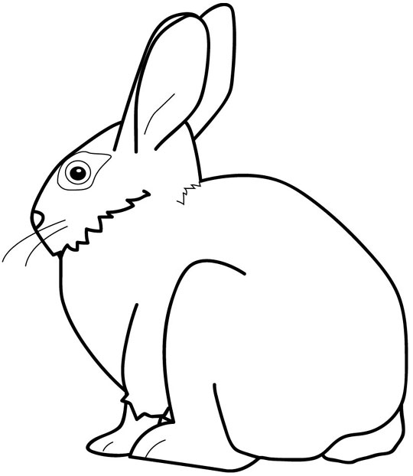


At home I enjoy?

If I need help or if I am upset I can go to..

They can make me feel better by….

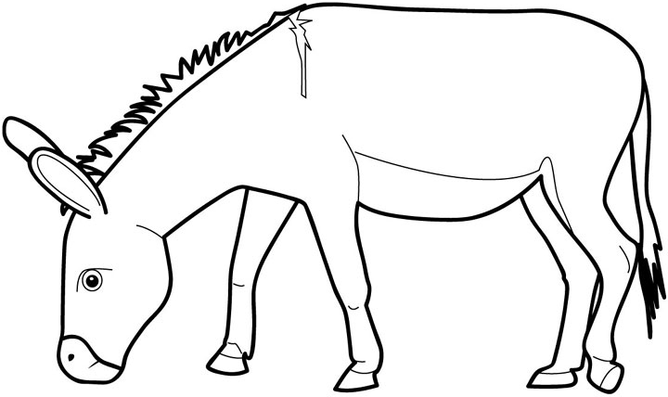

I am helped at home by…….

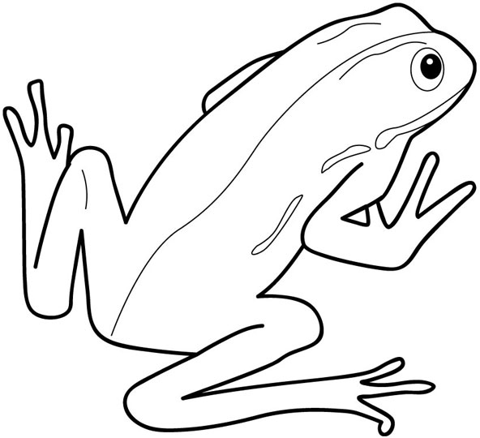

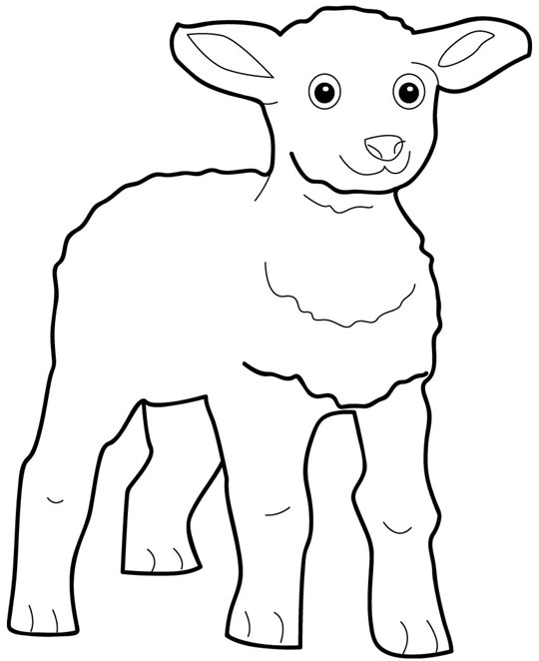
I would also like you to know……

