



**LAC Health Service**

**Initial and Review Health Assessments**

Includes guidance on the IHA and RHA process and completing BAAF, Consent and YOI Consent forms

If you have any questions regarding this guidance, please do not hesitate to contact the LAC Health Service on 020 8132 0354 / 0357 or email [LAC.Health@enfield.gov.uk](mailto:LAC.Health@enfield.gov.uk)

**Looked After Children Process**

Child becomes Looked After

Social Worker completes process on Liquid Logic and informs LAC Service Admin

Social Worker informs LAC Health by email that child is Looked After

LAC Service emails BAAF and Consent forms to SW (cc LAC Health) along with a copy of this guidance

Social Worker returns completed and signed forms to LAC Health within 4 working days or sooner if requested by LAC Health

LAC Health opens referral on RiO (local community health system), alerts relevant health professionals, and collates all available health information relating to the child / young person)

LAC Health allocates an IHA appointment with either a Consultant Paediatrician or Paediatric Registrar

LAC Health sends IHA appointment to FC / KW and emails SW with appointment details and reminder to book an interpreter if required. An Outlook calendar ‘invite’ is also sent to the SW.

Social Worker books interpreter if required and sends confirmation to LAC Health

LAC Health rings FC/KW prior to appointment to confirm they are able to attend

The allocated Social Worker is required to attend the IHA with the child/YP and FC/KW. It is the Social Worker’s responsibility to invite the birth parents if appropriate.

**PLEASE NOTE**

The Social Worker must inform LAC Health if the child/YP ceases to

be looked after or moves placement before the IHA takes place

**Initial Health Assessments**

To fulfil regulatory requirements, each looked after young person must have a holistic, comprehensive health assessment – Initial Health Assessment (IHA) - and Health Care Plan (HCP) in place prior to the first LAC review, i.e. within 20 working days of the child coming into care. In Enfield, the IHA is performed by either a Consultant Paediatrician or Paediatric Registrar. IHAs take place at either Chase Farm Hospital or Triangle House.

Before the IHA can be undertaken, the Allocated Social Worker must ensure there is appropriate consent for the IHA to take place, and that the LAC Health Service has consent to share the subsequent report (i.e. the young person’s health information) with professionals involved in their care. This is provided by the BAAF and Consent forms, which should be completed by the Social Worker, and signed by either the child or young person themselves (if they are aged 16 or over and have capacity to consent), or by the Social Worker or birth parent depending on whether the child is accommodated under Section 20 or a care order. However, it is always good practice to obtain consent from a birth parent where possible. Please see pages 4 and 5 for how to complete the BAAF and consent forms.

The completed and signed BAAF and Consent forms must be returned to [LAC.Health@enfield.gov.uk](mailto:LAC.Health@enfield.gov.uk) within 4 working days, or sooner if requested by LAC Health, e.g. if the IHA has been booked at short notice. **If the child has had a CP Medical, this report should also be sent to LAC Health to further inform the IHA.**

It is good practice for the Social Worker, and birth parent/s where appropriate, to attend the IHA, as well as the carer or the young person’s support worker, thus ensuring that the paediatrician has up-to-date information on the young person’s background and family and personal history, and is able to receive directly any comments regarding the young person’s health.

If the Allocated Social Worker is unable to attend the IHA, they should arrange for another Social Worker to attend on their behalf. This Social Worker should be fully briefed and able to pass on any health concerns that the Allocated Social Worker may have regarding the young person.

It is the Social Worker’s responsibility to invite the birth parent/s if appropriate, and prepare the young person, parents and carer for the assessment. If the young person or carer is not already in possession of their Personal Child Health Record (red book), the Social Worker should obtain it from the parents and ensure it is brought to the IHA.

The Social Worker must ensure that arrangements are made for an interpreter to be present if required. Confirmation should be sent to [LAC.Health@enfield.gov.uk](mailto:LAC.Health@enfield.gov.uk) prior to the date of the assessment.

An IHA checklist has been produced which may be used by the Social Worker to ensure all necessary processes have been completed (see page 10).

**Guide to the BAAF Form**

The BAAF form gives consent for the IHA to take place. There are two versions of the BAAF form: **Form IHA-C** (for children from birth to 9 years) and **Form IHA-YP** (for young people aged 10 years and over). LAC Service Admin will email the Social Worker **Part A** of the version appropriate for the age of the child (see example below) as soon as they are notified that a child/young person becomes looked after.

**Part A** contains important demographic, social and legal information which is required by the paediatrician prior to the assessment and must be completed in full by the Social Worker.

If the young person is aged 16 or over and has capacity to consent, the young person may do so by signing the consent section at the start of **Part B** of this form at the time of the health assessment (the paediatrician will ask them to do this before they begin the IHA). The Social Worker should advise LAC Health if this is what has been arranged.

If the child / young person is **Section 20**, a birth parent needs to give consent for the IHA. Consent may already have been given by the birth parent signing the LAC documents at the time of placement; these should be sent to LAC Health with Part A. Alternatively the birth parent may give consent by signing the consent section, circled in red below, at the end of Part A. The only exception would be if the child is a UASC and/or the birth parent/s cannot be contacted.

Where the local authority has parental responsibility/ies under a court order, the Social Worker may sign Part A (electronic signatures are acceptable).

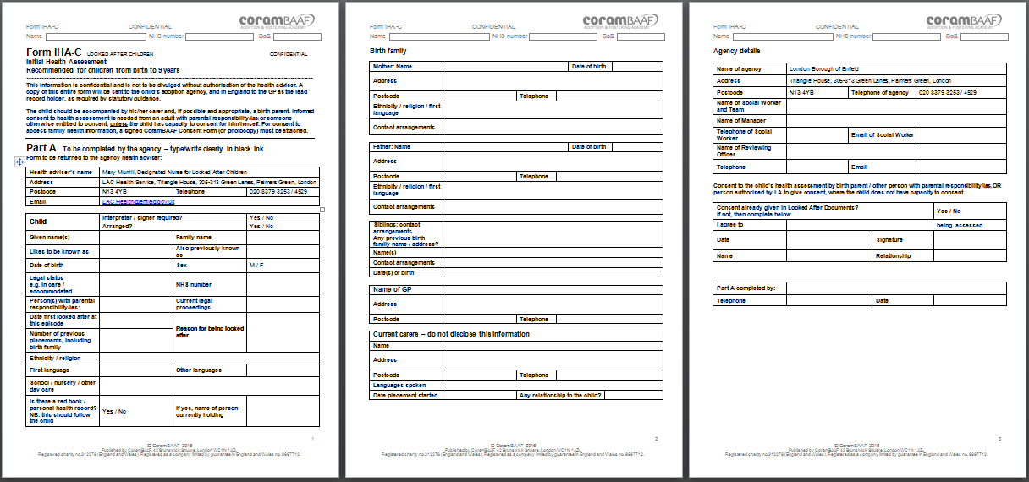

Social Worker or birth parent to sign BAAF form depending on who has parental responsibility

**PLEASE NOTE:** a separate BAAF form must be completed for each child; siblings cannot be put on the same form.

The completed and signed BAAF form must be emailed to [LAC.Health@enfield.gov.uk](mailto:LAC.Health@enfield.gov.uk) within 4 working days, or sooner if requested by LAC Health, for example if the IHA has been arranged at short notice.

If the form has been signed by hand, it will need to be scanned and emailed to LAC Health. **Please ensure the BAAF and Consent forms are scanned as two separate documents.**

Please contact the LAC Health Service on 020 8132 0354/ 0357 or email [LAC.Health@enfield.gov.uk](mailto:LAC.Health@enfield.gov.uk) if you have any questions regarding completion of the BAAF form.

**Guide to the Consent Form**

In order to complete a comprehensive and holistic health assessment and health care plan (HCP), it may be necessary to access the child’s and the birth parents’ health records, or contact relevant health professionals. Informed consent is needed to obtain health information from these sources. Once the IHA and HCP are completed, they are shared with other health professionals, Social Workers and others planning the care of the child or young person, and with their carers.

The Consent Form is used to obtain consent to **access and share** health information relevant to a Looked After Child and their birth parent. **It is not used to obtain consent to carry out the health assessment.** A separate form must be completed for each Looked After Child in the family.

A copy of the Consent Form must accompany a request for completion of Forms **M** (mother), **B** (baby), **PH** (parental health), **IHA-C**, **IHA-YP**, **RHA-C** and **RHA-YP**.

The Consent Form consists of four parts. The sections which need to be completed depend on whether the consent relates to information needed about the birth parent or the child/young person, and who will be giving consent.

**Part A: information about the child / young person**

**Part A** contains important demographic information, including contact details, and must be completed in full by the Social Worker.

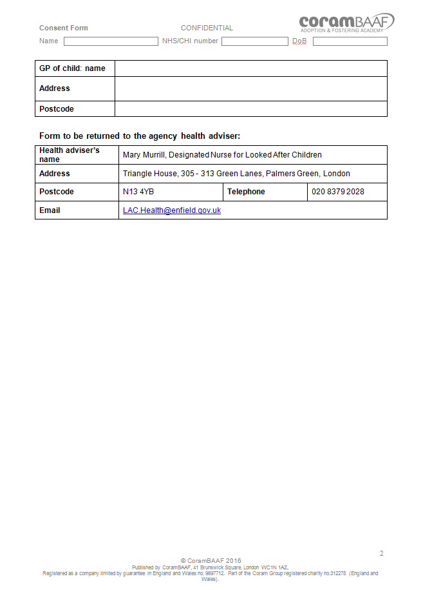

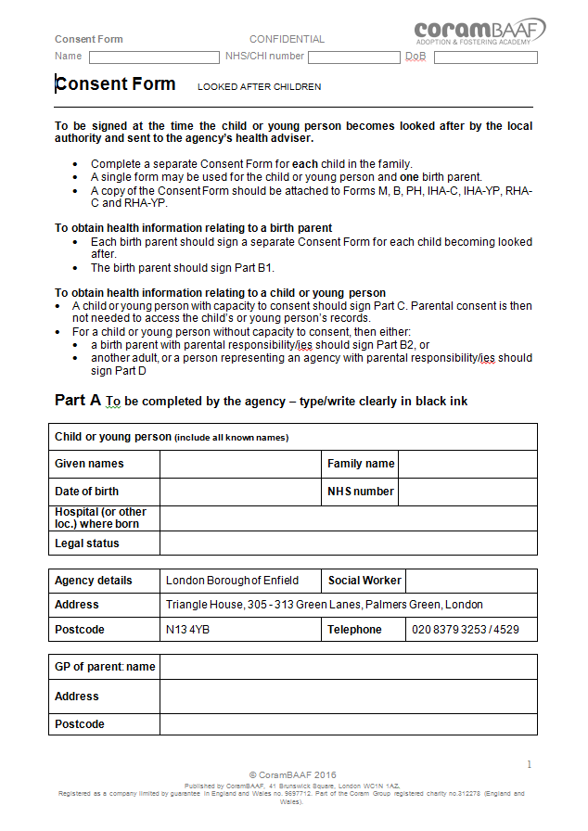

**Part B: Parental consent**

If the young person is **Section 20**, and *does not* have capacity to consent on his/her own behalf (see **Part C**), one of the birth parents needs to sign ‘**Parent’s consent regarding child’s health information’** and the Social Worker needs to sign as witness in the box below.

If the child is under 5 years of age, the child’s mother is also required to sign ‘**Parent’s consent regarding his/her own health information**’. This is to enable LAC Health to apply to the birth hospital (via forms M and B) for the mother’s obstetric report and child’s neonatal report. This enables the paediatrician to conduct a more comprehensive IHA.

**NB:** if the long-term plan for the child is adoption, the Adoption Medical Advisor will request the obstetric and neonatal reports from the Social Worker. As these reports can take some weeks to obtain, it is advisable to apply for them at this early stage. If Part B is not signed by the mother prior to the IHA, there is a risk that she will disengage in the future and refuse to sign, thus preventing professionals being made aware of any health concerns that may affect the young person later in life.

Informed consent rests on the individual having the capacity to understand the implications of consenting. The Social Worker should explain why health history is required and also that relevant health information will need to be shared, and with whom.

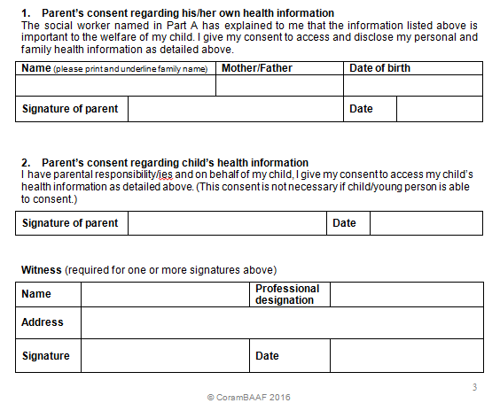

Birth mother to complete and sign

Birth parent to sign

Witness (Social Worker) to complete and sign

**Part C: Child/young person’s consent**

**Part C** should be completed and signed by the young person if they are 16 years of age or over and have capacity to consent. The Social Worker will need to explain the same issues as outlined in Part B to the young person, taking care with language so that they can understand.

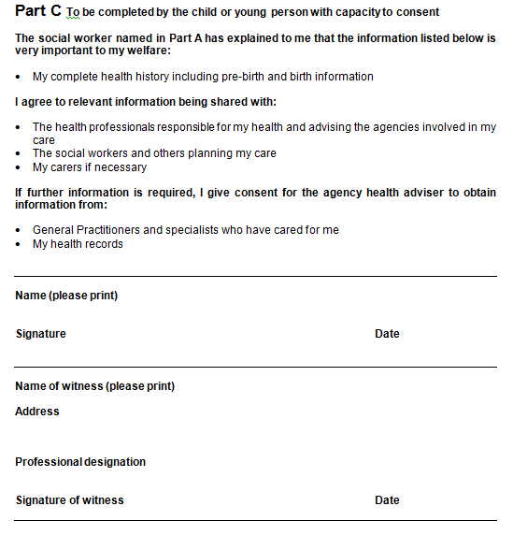

Young person to complete and sign

Social Worker or other appropriate professional to complete and sign as witness

**Part D: consent by non-parental adult with parental responsibility/ies, or agency representative (when neither B nor C is able to be completed)**

**Part D** should be completed by an adult with parental responsibility/ies or an agency with parental responsibility/ies (i.e. the local authority), under a court order. The birth parent should not complete part D. Part D should **only** be completed if neither parts B or C have been signed by a birth parent or the young person with capacity to consent.

Where the child / young person has a legal guardian, they may sign this consent at D1. The Social Worker or other appropriate professional should witness the signature in the box below.

When the local authority has parental responsibility/ies under a court order, the Social Worker should complete and sign the consent at D2.

**D1** to be completed and signed by another adult with PR

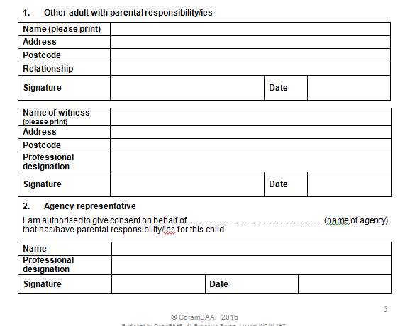

Social Worker to complete and sign as witness if another adult with PR signed D1 above

**D2** to be completed and signed by the Social Worker if neither parts B, C or D1 have been completed.

Please also ensure that the child/young person’s name, NHS number and date of birth are entered in the header at the top of each page.

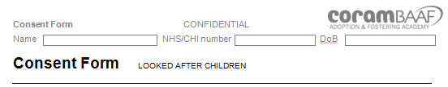

**Consent Form Reminder**

**Part A:** to be completed by the Social Worker

**Part B:** to be completed and signed by a birth parent if the young person is under 16 years of age and they are accommodated under Section 20 **OR** if the child is under 5 years of age and accommodated under either Section 20 or a care order

**Part C:** to be completed and signed by the young person if they are aged 16 or over and have capacity to consent

**Part D:** should only be completed if neither parts B or C are applicable. Part D to be completed and signed by an adult with parental responsibility/ies or an agency with parental responsibility/ies (i.e. the local authority), under a court order.

If the young person is 16 years or over and is signing the Consent Form on the day of the IHA appointment, please inform LAC Health so that a form can be made available for them to sign.

Once the Consent Form has been completed and signed, it should be returned to [LAC.Health@enfield.gov.uk](mailto:LAC.Health@enfield.gov.uk). If the forms are to be scanned and emailed, please ensure the BAAF and Consent forms are scanned as separate documents.

Please contact the LAC Health Service on 020 8132 0354/ 0357 or email [LAC.Health@enfield.gov.uk](mailto:LAC.Health@enfield.gov.uk) if you have any questions regarding completing the Consent Form.

**Initial Health Assessment Checklist**

* Complete **BAAF** and **Consent** forms according to legal status
* If child or young person is Section 20, ensure birth parent signs appropriate sections of **BAAF** and **Consent** forms
* If child is under 5, ask birth parent to complete and sign part B of the **Consent** form to enable LAC Health to apply for the obstetric and neonatal reports
* Return completed and signed **BAAF** and **Consent** forms to [LAC.Health@enfield.gov.uk](mailto:LAC.Health@enfield.gov.uk) **within 4 working days**, or earlier if requested by LAC Health
* Send CP medical report to LAC Health if available
* Book interpreter if required and send confirmation to LAC Health
* Invite birth parent/s ***if appropriate***
* Ensure Foster Carer / Key Worker is aware of time, date and location of IHA and is able to attend
* If allocated Social Worker is unable to attend, ensure another Social Worker attends on their behalf. This Social Worker must be fully briefed on the case and able to pass on any health concerns to the paediatrician
* Advise LAC Health if there is a change of placement / address before the IHA takes place.

**Out of Borough Initial Health Assessments**

For a child or young person placed outside the London Borough of Enfield, the same BAAF and Consent forms are required. If the child or young person has been placed in a neighbouring authority, or is placed close enough to be able to travel to Enfield for their health assessment, the same procedures will also apply.

If the child or young person is not able to attend an IHA in Enfield, LAC Health will apply to the LAC Health Service in the authority in which they are placed to undertake the IHA on Enfield’s behalf. The IHA will usually be undertaken by the child’s GP.

In such instances, the Social Worker will still be expected to attend the IHA if possible, and ensure the young person, carer and birth parent/s (if appropriate) are prepared for the assessment and that the carer has the red book and Health Passport (see page 12).

**After the Initial Health Assessment**

Following the IHA, a copy of the full report will be sent to the Allocated Social Worker, LAC Service Admin, and the Head of the Looked After Children’s Service, who will identify those children and young people who have a significant substance misuse problem from the responses provided

A copy will also be sent to the child / young person’s GP surgery, and to their Health Visitor or School Nurse if applicable. A copy may also be sent to CAMHS if the young person is already under their care, and to the LAC Health Service in the authority they have been placed (if not in Enfield).

A copy of the Summary Report and Health Care Plan will be sent to the Foster Carer / Support Worker, and to the young person if they are aged 16 or over and have capacity to understand the content.

The Social Worker, health professionals and carers will be expected to complete any actions allocated to them. The Social Worker should regularly review ***all*** actions to ensure completion and discuss at each LAC Review.

**IHA Refusals / DNAs**

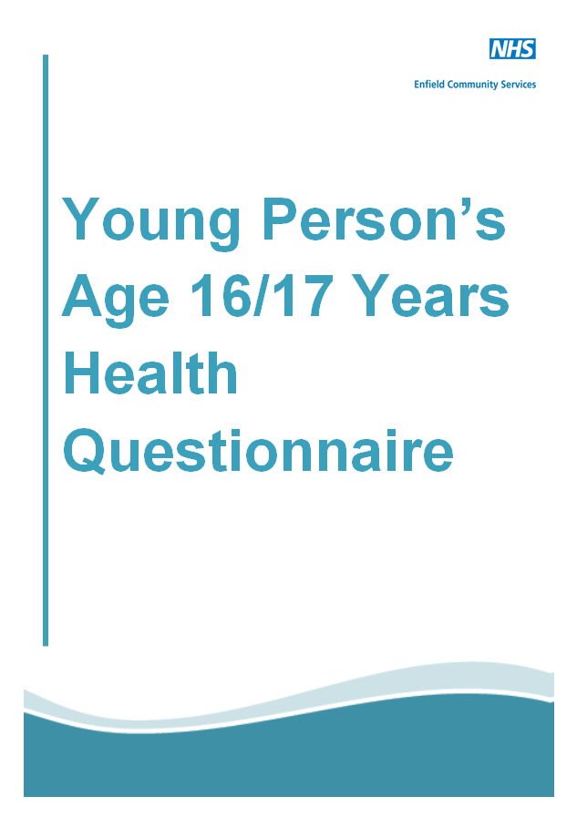

If the young person does not attend their IHA appointment, one further appointment will be offered. If they continue to refuse their health assessment and are aged 16 or over, the Allocated Social Worker will be asked to complete a Health Questionnaire with the young person.

The questionnaire has been created by the Designated Nurse for LAC and broadly covers the same areas as those included in the IHA. The answers given must be the young person’s own and the Social Worker

should ensure the young person signs the questionnaire giving their consent to sharing the health information they have provided with relevant professionals.

On completion of the Health Questionnaire, the Consultant Paediatrician will produce a Health Care Plan from the responses provided. The circulation list remains the same as for an IHA (see above).

**Health Passport**

The requirement for Care Leavers to have health passports; that is, information about their health history, comes from specific recommendations from the **NICE Public Health Guideline 28: Looked After Children and Young People** which states the need to ‘conduct a comprehensive health consultation when young people move on to independent living’. Ofsted links in with this guidance and requires all ‘care leavers have access to and understand their full health history’Care leavers, particularly if they have experienced unstable placements or have been placed out of borough, are vulnerable to not having sufficient information about their own health as well as



having limited information about their family and any significant medical history. The Health Passport was introduced as a means to provide a concise account of their health and any significant issues.

In Enfield, the Health Passport was designed with the help of the children and young people of KRATOS, Enfield’s Children in Care Council, and is an easy-to-reference record of the young person’s medical and healthcare history. The Health Passport has pages to record personal health information including childhood immunisations, allergies, health conditions, medical referrals and operations.

The Health Passport is completed following their last RHA and given to the young person and a copy is shared with the social worker.

**Young Offenders Consent Form**

When a young person is remanded to a Young Offender Institution (YOI), LAC Health requests their reception health screen from the YOI. The young person must give their consent for the YOI to share this report. LAC Health will send parts A and C of the **Consent** form to the Social Worker – Part A to be completed by the Social Worker, Part C to be completed and signed by the young person. There is no need to complete a BAAF form.

The reception health screen, or First Night Screening, serves as the Initial Health Assessment. On receipt, the Paediatrician will use the report to formulate a health care plan for the young person.

It is recommended that the Social Worker takes the Consent form to the first visit at the YOI. If this is not possible, the form should be sent to the allocated YOI Social Worker / Support Worker who should get the form signed and emailed back to the LBE Social Worker. The Consent form should then be returned to [LAC.Health@enfield.gov.uk](mailto:LAC.Health@enfield.gov.uk).

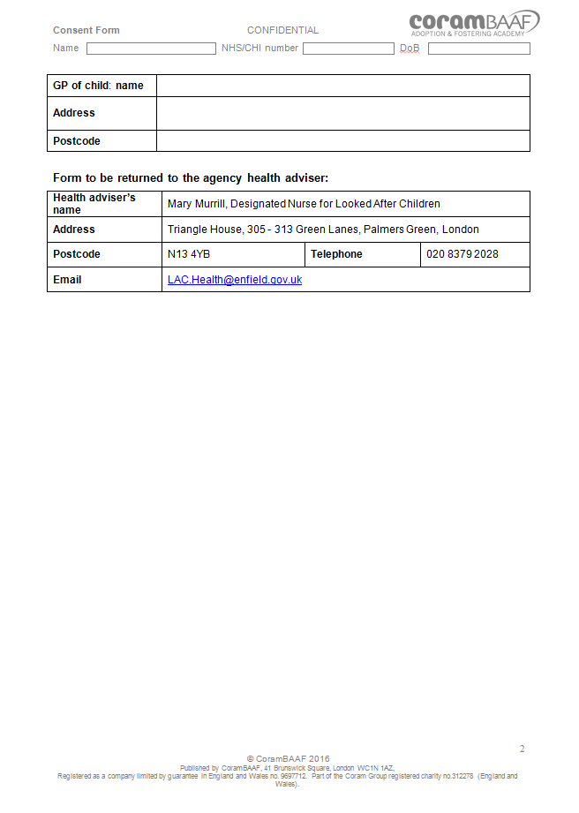

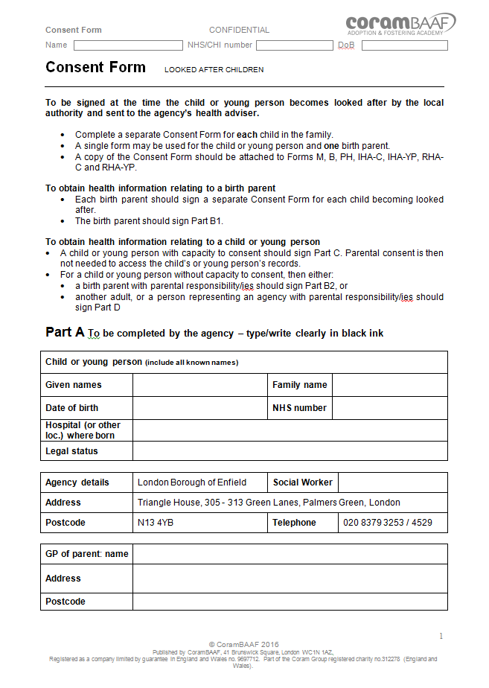

Name, NHS number and DOB to be entered on each page

Part A to be completed by the Social Worker

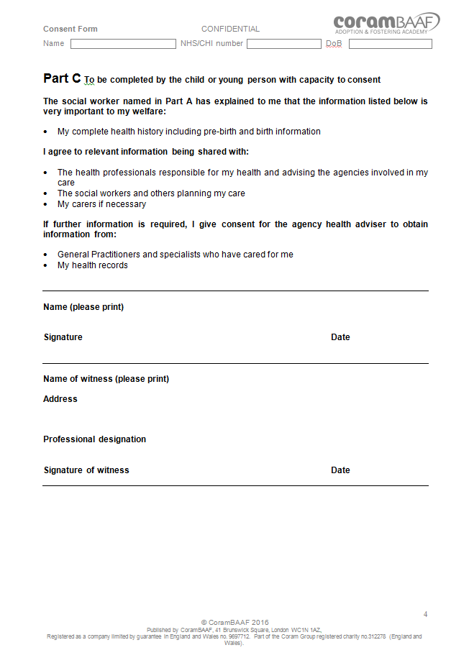

Young person to add name and date, and sign

Details and signature of witness (Social Worker / Allocated YOI Social Worker / Support Worker)

Please contact the LAC Health Service on 020 8132 0354 /0357 or email [LAC.Health@enfield.gov.uk](mailto:LAC.Health@enfield.gov.uk) if you have any questions regarding completing the Consent form.

**Review Health Assessments (RHAs)**

Review Health Assessments provide a holistic review of the health and development of looked after young people and take place every 6 months for children aged 0 - 4 years and annually for young people aged 5 and over. In Enfield RHAs are undertaken by our Specialist Nurses for Looked After Children. They will determine whether previous health care plans have been carried out, identify new issues and provide a written summary health report that will be used to formulate the health recommendations for the child care plan.

Review Health Assessments provide an ongoing opportunity for discussion with the young person about their health concerns, including physical and emotional development, relationships, sexual health, use of tobacco, drugs and alcohol, and to encourage them to begin to assume responsibility for their own health. They also offer the carer an opportunity to discuss any particular concerns they have about the young person’s health care with a health professional. The RHA also focuses on health promotion appropriate to the age and development of the young person.

When a young person’s RHA is due, one of the Specialist Nurses will email the child’s Social Worker to enquire about any new health concerns that may have arisen since the last health assessment and any related referrals that have been made. The Social Worker will also be sent an RHA consent form which should be signed and returned prior to the assessment. The Enfield LAC Health Service keeps a record of when each child’s RHA is due but the Social Worker should also be aware of the due dates in the unlikely event that an assessment is missed.

Following the Review Health Assessment, the nurse will produce a report, health summary and health care plan which will be shared with the Social Worker. The recommendations are also shared with the child’s foster carer (or Key Worker), GP, and School Nurse or Health Visitor if applicable.

**Out of Borough RHAs**

Enfield’s Specialist LAC Nurses will undertake RHAs for children and young people within a 20 mile radius of Triangle House. Young people placed outside this area will have their health assessments undertaken by a health professional in the authority in which they are placed. These RHAs have to be requested a number of weeks before the assessment is due as the authority’s LAC Health Service will need to arrange them around the health assessments for their own authority’s Looked After Children.

For children and young people placed outside the 20 mile radius, the Social Worker will be asked to complete BAAF and Consent forms rather than the simpler consent slip requested for RHAs to be completed by our own nurses. These forms must be returned to the LAC Health Service **within 4 working days of receipt**.

Following the RHA, the LAC Health Service in the host authority will forward the report to Enfield LAC Health Service for distribution.

**Form PH: report on health of birth parent**

The purpose of Form PH is to provide a family health history that will contribute to the care of the child’s health, both currently and in the future. It offers an opportunity to discuss with birth parents the health history of their extended families that, in view of increasing genetic knowledge, could prove to be of importance throughout their child’s life and possibly for their children as well. It can also demonstrate to the child later on that their birth parents gave thought and consideration to their child’s future welfare.

Form PH should be completed for all children and young people becoming looked after, preferably shortly after they come into care, to prevent valuable information being lost to them and their carers. The information on Form PH is essential to the completion of a comprehensive Initial Health Assessment (IHA) and Health Care Plan, especially if the birth parents are unable to attend. It also enables a carer, or the child or young person when they reach adulthood, to provide a health professional with information about the child’s family history that may be essential to the making of an accurate diagnosis.

It should also be noted that if there is a possibility that the eventual plan for the child will be adoption, the Adoption Medical Advisor will ask the Social Worker for Form PH. Therefore the Social Worker is advised to ensure this form is completed soon after the child comes into care to avoid delay and possible disengagement by the birth parent/s.

The Social Worker must ensure that parents understand the purpose of the form and appreciate that the information they give about their own and their families’ health history is of great value to the current and future welfare of their child.

The Social Worker should also indicate whether or not a parent has a learning difficulty. This information is essential for the child, and may affect the parent’s ability to understand and complete the form. If a parent is unable to read or write, the Social Worker should complete the form in the parent’s presence. People who speak English fluently may have difficulty in writing it and will need help.

Where there are difficulties in obtaining information from a birth father, the social worker may be able to obtain information from other sources, such as the other birth parent or a family member, e.g. grandparent. Although even limited information is of value to a child, the form should make clear that the information recorded is second-hand; the name of the source and their relationship to the birth parent should be included on the form.

**Part A**

Part A contains important demographic information and should be completed in full by the Social Worker

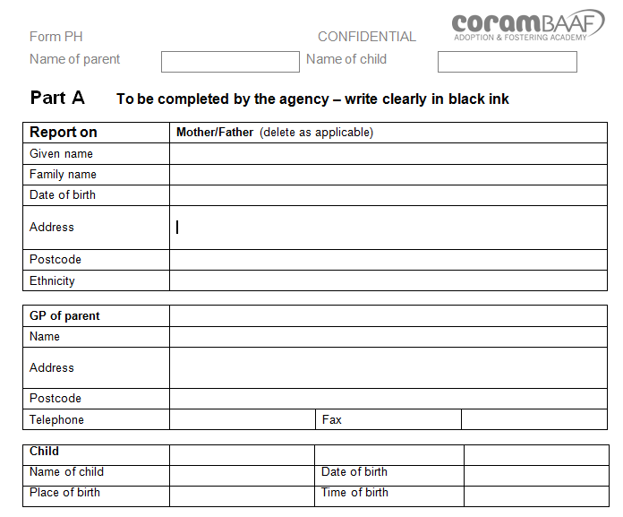

**Part B**

Part B should be completed by the birth parent, with the Social Worker

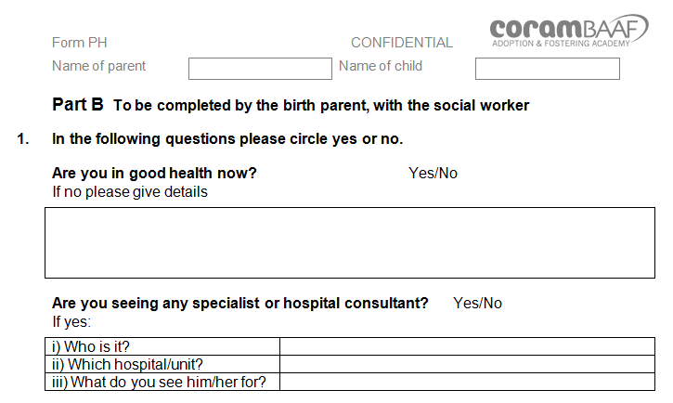

**For further information and advice regarding Initial and Review Health Assessments and the completion of BAAF and Consent forms, please contact the LAC Health Service on 020 8132 0354/ 0357 or email** [**LAC.Health@enfield.gov.uk**](mailto:LAC.Health@enfield.gov.uk)**.**