There are many more feelings which you will experience as you get older. Child’s name and Natalie have only named and acted our a few.

Sometimes the feelings all mix up with each other, a bit like the colours of a rainbow can

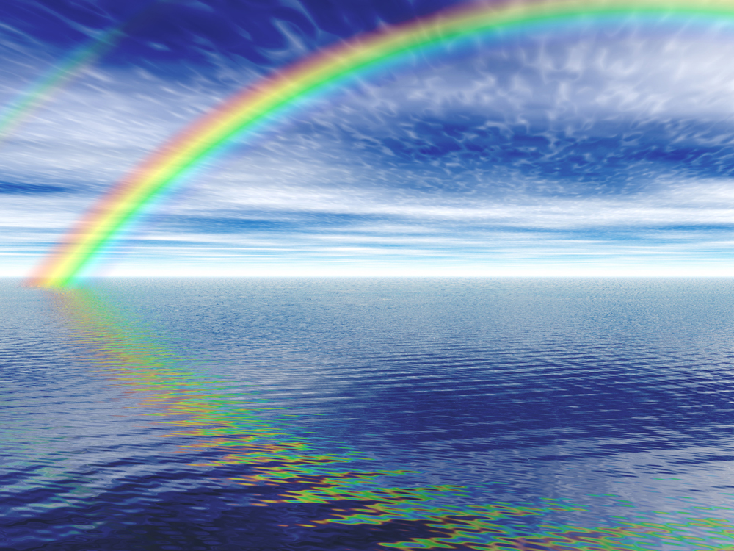

Everyone feels all these feelings at different times and the thing about feelings is that they never stay quite the same.

Here are some pictures of faces with feelings.

Happy is when you feel very smiley!

Great is when you feel fine.

Sad is when you feel like crying.

Guilty is when you wish you had not done something.

Jealous is when you want something that someone else has got.

Surprised is when you see something new like presents on your birthday!

Angry is when you feel red inside and want to shout and hurt something or someone.

Puzzled is when you feel muddled.

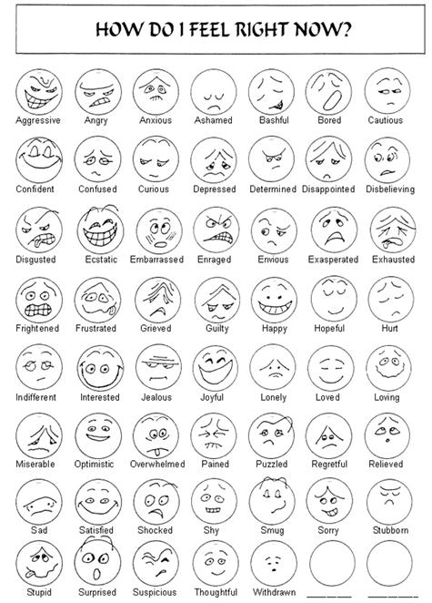

Do you want to put some colour in these faces?

Here is a picture of a volcano I have drawn!

Here are some faces with feelings I have made!

Here is a mask with an angry face and a happy face!

[Take photos of the pictures if they are too big for the book!]

