DOCUMENT

Delayed Discharges from CAMHS Inpatient Beds
A joint health and local authority approach to promote timely discharge

BRIEF OUTLINE OF THE DOCUMENT

The aim of this paper is to outline how we in Surrey will aim to facilitate the discharge process as smoothly as possible, given all the pressures on social care and health resources.

Version Number | 1.1
Approving Committee | Surrey Heartlands Provider Collaborative T4 CAMHS Partnership Board
Date Approved | 25th April, 2023
Next review date | February 2025

Version Control List
Version | Date | Author | Comment

Delayed Discharges from CAMHS Inpatient Beds
A joint health and local authority approach to promote timely discharge

Context
Approximately 40 to 50 most vulnerable young people who are the responsibility of Surrey are admitted to psychiatric inpatient units each year. The two main health services involved are the Hope Service and the Children’s Eating Disorders Service (CEDS), both part of Surrey and Borders (SABP) Children and Young People’s Services (CYPS). These teams manage high risk young people in the community and take responsibility for admission decisions, in collaboration with others.

Inpatient psychiatric units were previously commissioned by NHS England but the responsibility has been progressively devolved to NHS Trusts. For Surrey, this responsibility is held by the Surrey Heartlands Provider Collaborative (SHPC), whose staff are employed by SABP.
In Surrey we have been very successful in keeping admissions to a minimum and promoting shorter lengths of stay. We hope that the new inpatient unit in Surrey will further help with this. Our success has come through investment in community services, reducing the need for admission and by also facilitating earlier discharge.
We consider a return to the community for a young person to be a positive move as it reduces dislocation from family and local services. We are also acutely aware of the effects of longer stays in hospital which can instil unhelpful habits, broadly as a consequence of institutionalisation. Promoting safe and successful discharge as early as possible is a key part of our priorities, both for the young people using services and for families and the wider population as it allows for better use of resources.
This paper specifically looks at occasions where it is deemed inappropriate for a young person to return home and a new placement option needs to be explored prior to discharge. The aim of this paper is to outline how we in Surrey will aim to facilitate this process as smoothly as possible, given all the pressures on social care and health resources.
All young people admitted to psychiatric units have complex problems and finding solutions is often challenging. Effective joint understanding and joint working is essential, therefore.
Purpose
To ensure all young people admitted to a psychiatric hospital have a comprehensive multiagency assessment and support package. We aim to promote early detection of support needs which would facilitate support in the community and reduce length of stay and institutionalisation. Further, if a change of living arrangement were being considered, processes need to be effective in finding timely solutions.

Young people in need
Most young people are discharged home. The processes described here relate to those admitted to inpatient units, and refer to a subgroup of young people where there is a non-home placement need prior to discharge from psychiatric hospital. This accounts for somewhere in the order of 5 to 10 young people per year.

Outcome aiming to achieve
A multiagency delayed discharges working group, held in early 2022, identified the following outcome requirements.

Outcome area | Outcome detail
Timeframe standards | Discharge planning should begin as soon as a young person is admitted to hospital.  A decision about whether a placement is to be found, should take place within 1 month of a new request being made/proposed.  Once that decision has been made, placement finding and funding agreements should be completed within the next two months, so that the young person is ready to transition out of hospital.
Successful discharge | The discharge placement attends to the young person’s safeguarding and developmental needs whilst being agreeable to the young person and family. Successful discharge also means that there is no placement breakdown within 3 months.
SMART processes | Health, social care and education services understand the respective processes and timeframe pressures that each agency needs to follow, and these are mutually understood in outline. There are also easy, swift mechanisms for clarifying missing steps or fractured processes, if these become apparent.
Confident interagency responses | Each agency is confident of the others’ respect of pressures, response to requests and problem solving approach to difficulties. This needs to be built on clear responsibilities, accountabilities and timely information sharing as well as robust escalation processes when needed.
A positive experience for young people and families | The placement decision making and placement finding experience is smooth, transparent, joined up and timely for the young person and family.

Outline processes
These are described diagrammatically in the appendix. The diagrams give a simplified description of the steps along the way and therefore possible processes and pinch points. The diagrams are intended as summaries of existing processes rather than outlining anything new.

Common pitfalls include uncertainty about own agency procedures, uncertainty about other agency procedures, miscommunication about risk, fractured opinions given the number of professionals involved, numerous steps involved in the process providing many opportunities for delays. Therefore, good communication, good procedural knowledge with confident authorisation and good problem solving with child outcome focussed practice, should help smooth the process.

Linked policies and procedures
All existing policies and procedures need to be followed in the usual way from a Health, Social Care and Education point of view.

Linked policy includes the updated section 117 agreement which advises on interagency funding agreements for those who have been detained under section 3 of the MHA.

Keyworking programme for LDA children with complex health needs, led by Surrey Heartlands ICB

A joint education/health interface document is being prepared by Jim Nunns, Julie Beckett and others but is in draft mode as at the time of writing at the end of 2022.

Additional procedures to minimise risk of delayed discharge
- Social care referral for all those admitted for inpatient care
The purpose is to complete a child and family assessment for all those admitted so that future supports can be provided. Further, any subsequent alternative placements proposals can be responded to in a timely and well-informed way.
Procedure
- Hope and EDS to gather consent from young person and family about referral.
- Hope and EDS to complete a referral using the ‘SCC Support Request Form’ and send via C SPA. The referral needs to state that it is because the young person is an inpatient in a psychiatric hospital.
Referencing Surrey’s threshold of need document is important with criteria for ‘level 4 specialist input’, as follows:
Mental health needs resulting in high-risk self-harming behaviours, suicidal ideation and
inpatient admissions.
- When considering needs, Social care colleagues are asked to consider support needs bearing in mind the extreme pressures that mental health problems can create on families.
- Once Child and Family assessment is complete, feedback will be provided to family and referrer in the usual way. Child in need status may be the typical outcome.
- If parents decline an assessment there may be a need to help with understanding the possible benefits with information being provided from the health team or other sources.
- There is no expectation that care would remain open to social care throughout the admission period.

Any disagreements or misunderstandings about assessment or plans will be handled through discussion with the allocated social worker, with contributions from the team manager as required.
Matters may be escalated to the Assistant Director for assessments as needed (currently Nicole Miller). Any other operational matters will be directed to the Operational Director of C SPA.

- Children Looked After/Children who may become Children Looked After

2a. Owning of time frames and ambitions to achieve them
- 1 month for a new placement decision
- A subsequent 2 months for placement finding – will be owned at Area Director level and communicated to teams as needed.

Procedure
- Given the occasional nature of requests, all parties will work to remind each other of time frames and ambitions, bearing in mind the desired outcomes as outlined earlier in this document.

Reporting and accountability will be in line with tracking as below.
2b. Tracking and chasing of placement finding
In order to minimise procedural pitfalls, fortnightly tracking will take place guided by the Assistant Director of Resources. This can be in case specific meetings set up for the individual in question or dealt with through pre-existing meetings such as Monday handover meeting or fortnightly risk call meeting.
Procedure
- The Assistant Director of Resources will be notified by Hope or EDS of relevant cases who are at risk of a delayed discharge. Email record of notification to be recorded on Systm1.
- A plan of action will then be identified to work out the appropriate tracking next steps.

Any disagreements or misunderstandings about assessment or plans will be handled through discussion with the Assistant Director of Resources, with contributions from the allocated social worker and/or team manager as needed. Matters may be escalated to the Area Assistant Director as needed.

2c. Gateway form commentary for CLA or CYP who may become CLA
This procedural element applies to those who are in an inpatient facility, and to those who are not.
Procedure
- Once the social worker has completed a gateway form outlining a placement request, the social worker will send to the Hope / EDS for commentary. This can add accuracy to risk assessments in particular. Hope service or EDS will respond with comments within the week.

- Education placement finding or EHCP processes
Completing an EHCP or finding a suitable school, be it residential or not, may have an impact on discharge planning. Most education processes are statutorily determined, but it is important to keep communication flowing in the same way as above. Where possible, the plan would be to reintegrate a young person into their current school and S117 could be used to support this if it applies to the young person. Staff at hospital schools can share information with Case Officers regarding the young person’s education in the hospital school to help inform decision-making. It would generally aim to take 2 months for a young person with an existing EHCP (an Annual Review would be needed), although this is dependent of availability of onward placements. This could be prioritised with early multi-agency planning being essential, pre-empting the formal Annual review processes. For a young person without an EHCP, the process would take at least 20 weeks (making an application for an EHCP, decision making regarding the EHCP and identifying a school placement).
Procedure
- The allocated case officer will communicate with the health care coordinator on a fortnightly basis.
- Any procedural uncertainties or blockages will be tackled with the help of others as necessary.
Any disagreements or misunderstandings about assessment or plan progress, will be handled through discussion with the allocated case officer with contributions from the team manager as needed. Matters may be escalated to the Assistant Director (AD) Inclusion and Additional Needs for each Quadrant. Further escalation to Jim Nunns (NW AD) and or Julie Beckett (Education and Inclusion Service Manager NW). Matters can also be escalated to Liz Mills (Director of Education and Lifelong Learning).

- Funding decision making
Funding decision making is channelled through the Joint Commissioning Panel and the Governance panel. This includes decision making using section 117 agreements.
Procedure
- Agreement for S117 funding for children and young people should be sought through the Joint Commissioning Panel (JCP). If appropriate for S117, sign off would then go the S117 After Care Panel.
- If S117 funding does not apply then it may be that additional support is still required which will need discussion through the Joint Commissioning Panel. The Assistant Director of Resources for social care will be able to help with linking into the panel.
- When a young person is approaching 18th birthday, it will be important to involve adult linked professionals to promote a joined up view of the application

Any disagreements or misunderstandings about decision or plan progress, will be handled through approaching the Associate Director – Children and Young People’s Commissioning at Surrey Heartlands ICS.

- Tracking and reporting
Referrals of inpatients to social care colleagues will be overseen by the PC hub with input from the C-SPA Operational Lead, with a view to problem solving any difficulties.

Discharge progress is tracked through the fortnightly Clinical Activity Panel meetings and overseen by the PC hub and operational group.
Delayed discharges are monitored by the PC and reported to the Provider Collaborative Programme Board - a multiagency meeting. Reporting also goes to the ICS and NHSE (including weekly Sitrep Meetings) using the definitions outlined in the Appendix and the timeframes listed in this document.

Appendix 1. Outline process flow charts

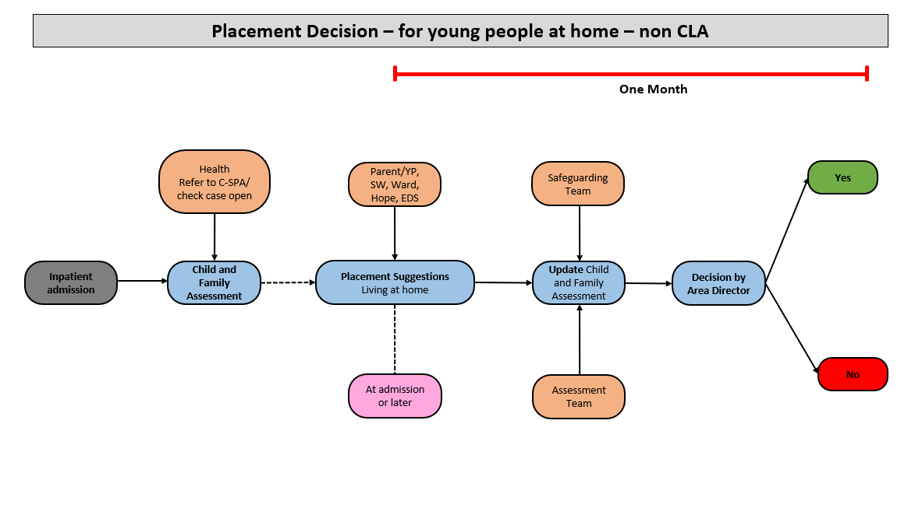
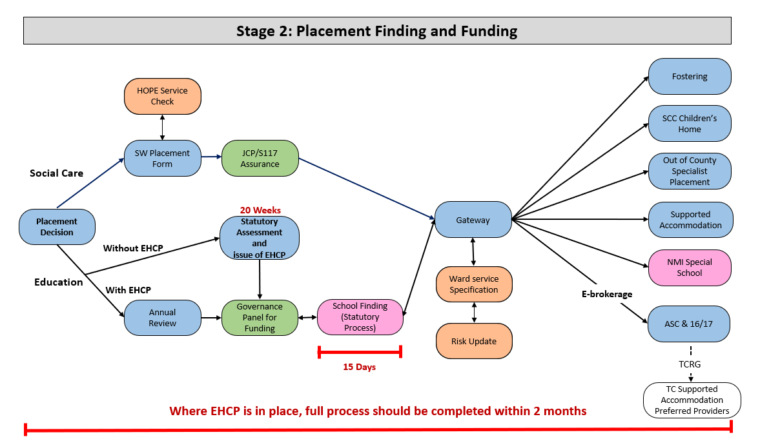

Appendix 2

Discharge Planning – Provider Collaborative Processes
Discharge planning begins as soon as a young person is admitted to hospital. It forms an integral part of the Clinical Activity Panels, which are held with providers every two weeks, and CETR reviews if the young person is on the LD/ASD programme.

Alongside the quality and environmental checks undertaken by the Provider Collaborative, length of stay is closely monitored throughout a young person’s admission. Estimated dates of discharge are regularly reviewed taking into account a young person’s presentation and treatment progress. Any blockages or barriers to discharge would be escalated through additional discharge planning meetings to identify course of actions by the Provider Collaborative.

As part of the discharge planning process, any social care or health support required on discharge is identified and preliminary discussions had with relevant agencies to begin planning. During the admission it will be identified whether the young person:
- may need to transition to adult mental health services as they are nearing their 18th birthday,
- may need a residential social care or education placement if they are unable to return to their usual place of residence, or
- may be discharged to the community with support from HOPE or CEDS.

Delayed Discharges
NHS England definition
“A delayed discharge occurs when a patient, clinically ready for discharge, cannot leave hospital because the necessary care, support or accommodation for them is not readily accessible and/or funding is not available.”
A delayed transfer of care from a Tier 4 unit occurs when a young person is ready to depart from such care and is still occupying a bed.
A young person is ready for discharge/transfer when they reach 18 years old, or
- a clinical decision has been made that the young person is ready,
- a multi-disciplinary team agrees with the decision that the young person is ready, and
- the young person is safe to discharge/transfer.
The multi-disciplinary team (MDT) should be made up of different professionals, including social workers where appropriate, with the skills and expertise to address the young person’s ongoing health and social care needs. The fundamental function of the MDT is to timely discharge the young person and to ensure the young person’s wellbeing.
- The date the clinical team agrees the young person is clinically fit for discharge or transfer must be recorded.
- The date the multi-disciplinary team agrees the young person is ready for discharge or transfer should be recorded and identified as the date the delayed discharge begins.
If there is any concern that a delay has been caused by the actions or inactions of a local authority, they should be represented in the MDT.

Admission and Discharge Process
Responsibility for the young person’s journey from Tier 4 admission through to discharge is held collectively, with participation from:
- Social Care
- Education*
- The Hub team within the Provider Collaborative
- The Responsible Clinician (inpatient) (RC)
- Community Consultant Child and Adolescent Psychiatrist
- The Care Co-ordinator
- Keyworker*

*depending on support requirements and whether the young person is on the Dynamic Support Register

Throughout the journey risk management decisions are collaborative, with the RC holding ultimate responsibility.

Responsibilities
Social Care
- works with stakeholders to assess the young person’s social care needs,
- identifies and delivers any ongoing social care needs,
- follows process to identify post-discharge needs, including decisions regarding the need for a potential placement,
- identifies and agrees a placement,
- works with Education to ensure educational needs are met.
Education
- ensures EHCP is in place/updated, as appropriate
- works with Social Care and other stakeholders to ensure the young person’s educational needs are met.
The Provider Collaborative:
- maintains oversight of the quality and delivery of Tier 4 services, from the point of admission to discharge, working alongside the RC and other stakeholders,
- supports the discharge process and works to unblock any barriers,
- supports care co-ordinators to link with colleagues out of area where there are complexities around geographical boundaries,
- leads the escalation process if timescales are not being met.
The RC (inpatient):
- is responsible for clinical risks and clinician to clinician dialogue,
- plans discharge in collaboration with the Hub,
- liaises with adult services regarding young people who will reach the age of 18 whilst admitted.
The Community Consultant Child and Adolescent Psychiatrist:
- assists RC in planning discharge with the Provider Collaborative,
- collaborates on decision-making regarding appropriate post-discharge treatment,
- supports referral process to other community mental health teams.
The Care Co-ordinator
- is responsible for seeking consent for the Child and Family Assessment, exploring further if consent cannot be obtained,
- refers young person as a Child in Need if not known previously to social care,
- links with out of area colleagues where there are complexities around geographical boundaries,
- leads the discharge process,
- ensures appropriate treatment post-discharge is arranged.
Keyworker
- Where a young person is on the LDA Pathway/Dynamic Support Register, they will have a Keyworker allocated to support them and the process.

