

**SUPERVISION POLICY**

**February 2024**

This document outlines Birmingham Children’s Trust policy on supervision and is applicable for **all staff** in the Trust.

1. Introduction

A core element of the Trust’s practice model ['Connections Count'](https://intranet.birminghamchildrenstrust.co.uk/info/20307/practice_model/1176/practice_model_2023/2) is ‘how we be’, which outlines the importance of relationships. An essential foundation for connection, support and leadership is in the supervisory relationship. It is a fundamental belief within the Trust that our staff are our most important asset in fulfilling our responsibility to provide a quality service to all who use our services.

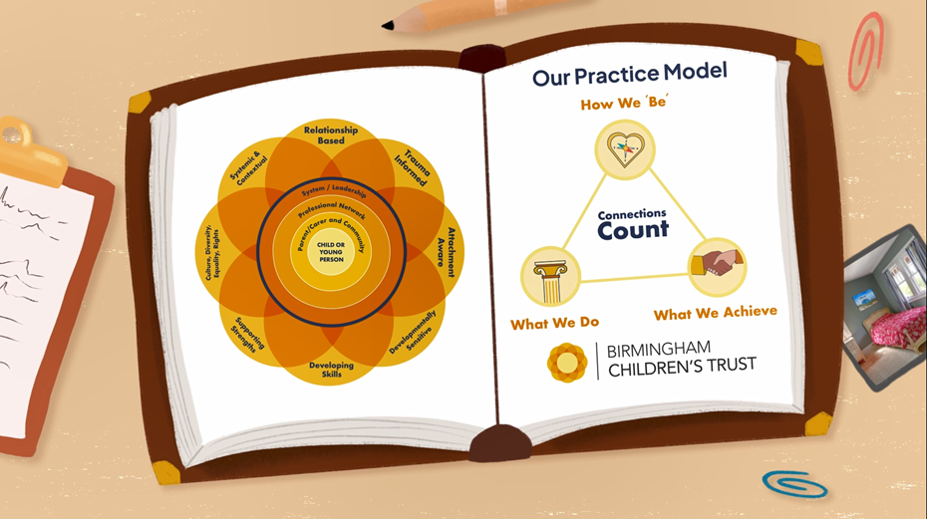

In the Trust, there is a commitment that all staff, no matter their role, will receive regular formal **one-to-one** meetings with their supervisor; the functions of which are:

* Management – Ensuring competent/accountable practice and performance;
* Development – Facilitating continuous professional development;
* Support – Understanding personal and emotional support needs of staff;
* Mediation – Communication between management and worker about organisational issues.

(Morrison, 2005)

For the purposes of this document all 1:1 meetings between supervisor and supervisee will be referred to as supervision.

Our bottom lines:

* All staff deserve access to good quality supervision.
* Those to whom we offer support (children and families, carers and victims of crime) deserve a good quality service driven by the managerial oversight supervision offers.
* The sections of the policy which are a must read for all staff are set out in pages 2- 6, setting out; what we mean by the term ‘supervision’, to whom this policy applies, frequency of supervision and roles and responsibilities. Additional resources and further reading are available from page 7 onwards.

1. Types of Supervision

Supervision takes several forms, including formal one-to-one supervision, informal/ad-hoc supervision and group supervision. The type of supervision that is primarily referred to in this document is a formal one-to-one meeting between worker and manager.

Informal, or ad-hoc supervision often occurs in between formal supervision (one-to-one) sessions when particular issues have arisen and discussion/guidance or a decision is required to progress matters.

Group supervision involves a group of staff, meeting to discuss issues about their work, this may be a shared task or one member of group exploring an issue they are grappling with.

Peer supervision may take the form of a discussion or guidance from a more experienced worker on specific issues.

Some staff may also experience clinical supervision, which aims to support learning and develop competency related to a specific clinical task.

1. Formal One-to-One supervision

One-to-ones are a meeting between the supervisor and supervisee in order to meet organisational, professional, and personal objectives. Sessions should be pre-arranged, regular and take place in a confidential space, wherever possible this should be face-to-face. They must be prioritised; they should be moved or cancelled only in exceptional circumstances. Agreed use of tools can support reflection. Before any one-to-one relationship commences there should be a one-to-one agreement. A template and guidance for one-to-one agreements in the Trust can be found in appendix ii.

It is expected that that the one-to-one supervision will consider the supervisee’s wellbeing, what they have done well and what areas for development they may have and set out actions to support continuous professional development. The frequency must be mutually agreed, and this agreement recorded in the initial 1:1 meeting. A suggested template for one-to-ones can be located in appendix iii.

1. Responsibilities

Supervision should be based within **anti-discriminatory principles of equality and diversity.** All managers and practitioners* should use one-to-ones and supervision to reflect on their work in the context of their own personal/professional identity and values and explore the Trust’s values, set out in ‘Connections Count’.

Both supervisees and supervisors have a responsibility to agree and set the agenda for supervision, to prepare for supervision and ensure adequate time is given to the process.

For further detail about the responsibilities of supervisors and supervisees please see appendix iv

*\* Practitioners in this document are workers/staff within the trust*

1. **Frequency of supervision**

The minimal frequency of formal one-to-one supervision will vary, according to roles and responsibilities. It is expected that supervision will occur at **no less** than **every two months** but that some people may require supervision at more frequent intervals, depending on their role. This may be supplemented by ad-hoc/informal supervision and/or group supervision.

**Social work practitioners** will have a formal supervision meeting with their line manager **at least once per month**. The Trust expects managers to drive child-centred plans to improve children’s situations. Through supervision, managers must assure themselves that the plan is improving the child’s situation and, if not, consider and agree what needs to happen. To that end, **all children** we are supporting **must** be discussed at least **once every three months,** in line with our **practice standards.**

**Some children, due to their situations will require managerial oversight via supervision at different frequencies dependent upon their situation. The table below sets out the Trust’s minimum requirements regarding supervision for children in specific circumstances. The below is not an exhaustive list and there will be times where professional judgement about the frequency of supervision needs to be made based on the needs of the child and their circumstances.**

|  |  |
| --- | --- |
| **Situation of those we are supporting** | **Minimum Frequency** |
| Children and young people who have an Early Help Plan | At least once every two months |
| Children open to ASTI | Every month |
| Children with a Child in Need Plan | At least once every two months |
| Children with Child Protection Plans / in Pre-proceedings / in Care Proceedings | Every month |
| Children in Care | At least once every three months, ***unless*** we are still planning for permanence or concerned about the child’s safety or stability, in which case each month. |
| Young people in the Care Leavers’ Service | At least once every three months |
| Children living in unregulated provision | Every month |
| Foster Carers with children on a short-term basis | At least every 6 weeks |
| Foster Carers with children on a long-term basis | At least every 12 weeks |

The table below sets out additional expectations determined by the worker’s role/ length of career/responsibilities:

|  |  |
| --- | --- |
| **Staff member** | **Minimum Frequency** |
| Support Services | 6 weekly |
| Early Help Practitioners | Monthly |
| Rights, Participation, and Corporate Parenting staff | Monthly |
| Family Support staff in locality Teams | Monthly |
| Newly qualified social workers in their  Assessed and Supported Year in  Employment (ASYE) | Weekly for the first 6 weeks  Fortnightly up to the 6-month review  Monthly thereafter  SPED supervision is in addition to the above |
| Social Workers (Non ASYE, inc in Adoption Services) | Monthly |
| Supervising Fostering Social Workers | Monthly |
| Adoption Panel and Post- Adoption Support workers | Monthly |
| Independent Reviewing Officers or Principal Officers | Monthly |
| Team Managers | Monthly |
| Family facing Heads of Service | Monthly |
| Project Officer and Workers | Bi-monthly individual supervision and bi-monthly group supervision |
| New Youth Offending Service (YOS) Staff | Weekly for first month, fortnightly for next 3 months |
| YOS Staff who provide a supporting/developmental role (not working directly with children/caregivers/victims) | Every 6 weeks |
| Members of the YOS Senior Leadership Team | Every 6 weeks |

Appendix v sets out specific frenquencies for supervision for those receiving support from YOS and staff employed by YOS not covered by the above table.

It is important to note that the frequency of supervision in the tables above, is a *minimum* requirement and that in some instances, professional judgement from the manager will be required to determine supervision frequency.

In respect of those who provide supervision of other staff and those such as IROs or Principal Officers, they are jointly responsible with their supervisor/line manager for exercising professional judgement about choosing which people we are supporting to discuss in their own supervision.

1. Recording

For supervision related to work with those who whom we provide a service (for example, children and families) whether this happens in formal one-to-one session, ad-hoc/informal supervision or in group supervision it is important that supervisors ensure that a summary of the discussion and any decisions made are recorded on the electronic case management system for the person/family we are supporting.

The manager and worker should reflect on the assessment of need and progression of the plan with a view to identifying strengths in practice, areas for further developments and actions to assist and safeguard the people we support.

Supervision and discussions about staff employed by the Trust will be recorded by the supervisor and stored ***only*** within the relevant electronic record for that individual (Oracle).

1. **Confidentiality**

Although private, supervision is a management process. Issues raised within supervision may need to be shared with other managers and staff when they concern adult or child protection and risk management, performance issues, sickness absence, disciplinary procedures, bullying, harassment or discrimination, staff safety or policy development and may need to be shared with the inspectorate or regulator in their work.

Other issues may be shared with the agreement of both the supervisor and supervisee. Supervisor and supervisee should be aware of their responsibilities in relation to the protection and use of client information. If there is any uncertainty about what should/should not be shared the supervisor’s line manager should be consulted for advice.

Supervision records will be stored securely. Unjustifiable breach of confidentiality may result in disciplinary action.

Senior managers have the right to audit and inspect supervision records to ensure that they are taking place in line with the policy requirements.

When the supervisor changes, the records will be transferred to the new supervisor.

In social work (or any role where the worker is family facing), when a supervisee leaves the Trust, the HR records should be retained for six years after the member of staff has left and then deleted.

1. **Further reading**

Appendix vi sets out addition resources for supervision, including the ‘golden threads’ of Connections Count

Appendix I – Functions of supervision

In the Trust, supervision is considered an essential foundation for connection, support and leadership. It is how managers ‘model the model’ and demonstrate our behaviours, or ‘how we ‘Be’.

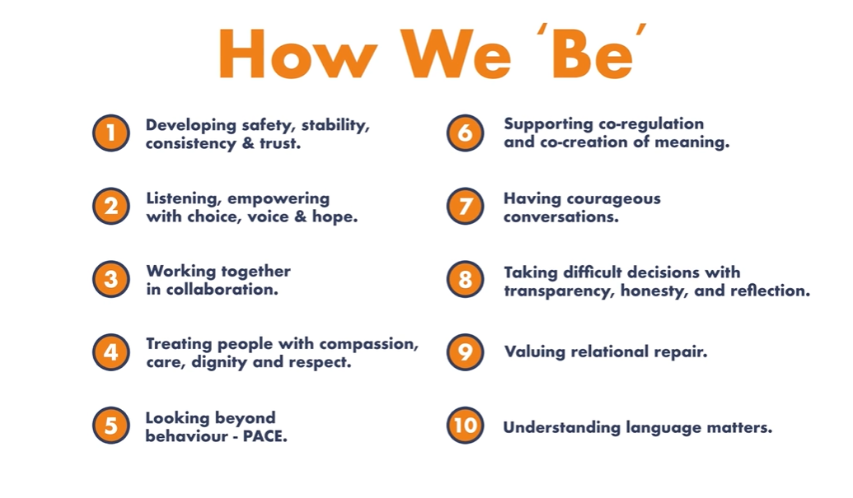

Regardless of role, supervision provides a forum for line managers and supervisors to model the behaviours of ‘how we be’ and explore with the supervisee how they have considered ‘Connections Count’ in their work and behaved in line with the practice model.

Supervision should benefit the 4 stakeholders: those who use our services, staff, the organisation and partner agencies.

Management – This function of supervision is to ensure that the performance of staff is competent. To do this, supervisors may wish to explore:

* That the supervisee is carrying out the requirements of their role,
* That the supervisee understands key policies and procedures and can access these and that these are being followed,
* That workloads are appropriate to role/experience,
* That records are up to date, in line with policy,
* That actions set out in previous supervisions are being followed,
* That the practice model ‘Connections Count’ is being used to frame practice
* That the supervisee is clear as to the limits and use of their personal, organisational and statutory authority.

Development – This function of supervision is to facilitate continuous professional development. To do this supervisors may wish to explore:

* The supervisee’s learning and development needs and how these can be met, including the manager’s assessment of the worker’s needs and the supervisee’s own goals,
* The supervisee’s experiences of learning/training/development sessions. What did they learn? How will they put this into practice?
* The worker’s value base in relation to race, gender and sexuality, etc and exploring its impact on their work,
* the supervisee’s ability to reflect on their work and interactions with other stakeholders (including those who use our services, if applicable).
* The supervisee’s own appraisal of practice and consider feedback from others.

Support – This function of supervision is to consider the physical and emotional support needs of staff and any potential impact upon their work. To do this, supervisors may wish to:

* Explore the supervisee’s current health and well-being and work-life balance,
* Consider the impact of working with those who have experienced trauma, conflict and high stress,
* Explore experiences of and attitudes towards discrimination,
* Encourage the worker to access further support outside of the supervision, which may include the [Employee Assistance Programme](https://intranet.birminghamchildrenstrust.co.uk/info/20292/occupational_health_and_wellbeing_service/704/employee_assistance_programme_eap).

Mediation – This function of supervision is to support communication between management and the worker about organisational issues. To do this, supervisors may wish to:

* Brief supervises about key events and organisational developments,
* Explore the supervisee’s experiences of supervision and working for Birmingham Children’s Trust
* Negotiate between the supervisee and other stakeholders, helping supervisees resolve difficulties in workplace or stakeholder relationships,
* Provide regular and constructive feedback to the supervisee on all aspects of their performance.

These functions are supported by the 4 stages of the supervision cycle:

1. Experience (understanding what happened?)

2. Reflection (what was it like?)

3. Analysis (what does this mean?)

4. Action Plan (what next?)

These stages of supervision are captured in the diagram below and help frame discussions with practitioners about their work. This is not limited to those working directly with children and their families.

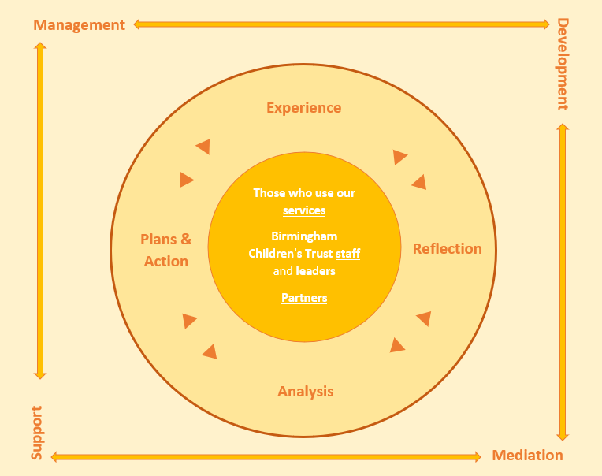

Adapted from ‘Supervision: Now or Never Reclaiming Reflective Supervision in Social Work (Morrison & Wonnacott, 2010)

# Appendix ii

**Supervision Agreement: Guidance**

Why is a supervision agreement important? A supervision agreement emerges from a discussion between supervisors and supervisees about what is important for you to know about each other if you are to work together effectively. Supervision agreements help to:

* set out the expectations you have of one another in how you conduct the supervisory relationship
* encourage a discussion about your priorities
* make clear what is negotiable and what is not
* clarify the expectations from Birmingham Children’s Trust as well as the regulatory bodies, where applicable.
* underline the importance of supervision and clarify expectations about why you are meeting and what is likely to happen as a result
* establish expectations about the emotional aspect of working (directly or indirectly) with children, young people and families – who will sometimes be highly distressed – that make it easier to manage emotionally distressing or difficult conversations should they arise in the future.

Negotiating a tailored agreement, emphasises the importance of your relationship. This could include core values, world views and aspects of social identity such as ‘race’, ethnicity, culture, disability, sexuality etc. This is good modelling for how staff negotiate agreements with stakeholders, including children, and families they are working with, too. Importantly, using the language of an agreement, rather than a contract, shifts the onus on to each party to recognise the significance of their role in the relationship to make supervision effective. For a supervision agreement to be successfully negotiated, there needs to be discussion between supervisor and supervisee(s) about what matters to each of them, as well as what is important for other stakeholders (children and families, the organisation, multi-disciplinary colleagues and so on). It gives supervisees as well as supervisors an essential voice in what happens in supervision, and models the importance of being collaborative and respectful, in line with our practice model, Connections Count, as a method of learning to trust each other. Supervision agreements are often negotiated at the start of a supervisory relationship, with a shared commitment to review the agreement to ensure it remains purposeful. That said, should this not happen for any reason, agreements can also be developed at any point after you and your supervisee begin to work with each other

# 

# Supervision Agreement

**This Supervision Agreement is made between:**

|  |  |
| --- | --- |
| **Name of Supervisee:** | **Job Title:** |
| **Name of Supervisor:** | **Job Title:** |
| **Date of Agreement:** | |

The purpose of this Supervision Agreement is to underpin the development and maintenance of a good supervisory relationship.

**Frequency of Supervision**

* We will meet at least once every ..... weeks for a session. This should only change in the event of annual leave, sickness or emergency situations.
* Formal supervision sessions will be for …. hours each.
* If there is a need to meet outside of this arrangement for work related issues this will be respected, explored and accounted for as informal supervision.
* We should book the dates for supervision, any probationary period, and appraisal in advance, confirming the next appointment at the end of each session and arranging to meet at a mutually convenient place and time.
* If the arrangement needs to be changed, the onus is on the person who needs to make the change to notify the other, giving as much notice as possible.

**Interruptions**

Interruptions should be kept as a minimum. These will occur in emergency situations only.

The supervisor is responsible for arranging a meeting space.

**Recording of Supervision**

We agree follow the guidelines as laid down in the Supervision Policy document with regard to confidentiality and standards for note and record keeping.

The supervisor will take responsibility for maintaining a record of supervision discussion relating to the supervise on Oracle. A copy will be sent to the supervisee.

All discussions relating to children from Supervision should be recorded directly onto the child/family file on Eclipse/ECINS/YOS records/Charms.

**Content of Supervision**

• **Management** – decision-making and reflection, consider performance, strengths, successes and areas of development and workload management;

• **Development** – continuous professional development;

• **Support** – welfare discussions

• **Mediation** – Line management and organisational accountability

At the end of each session we will agree any action points necessary; we will review the effectiveness of our sessions every 12 months.

**Responsibilities**

The Supervisor will endeavour to provide the following:

* Consistency
* Professional experience
* Sensitivity

In addition:

* The supervisee will follow plans as agreed during supervision sessions and work to meet timescales set.
* Both supervisor and supervisee will maintain a commitment to equal opportunities in relation to both service-users and staff.
* It is the responsibility of both the supervisor and supervisee to recognise, respect and value people’s differences via promoting equality of opportunity.
* The supervisor is responsible for recording the themes from discussion, key actions and target dates for completion.

**Supervisee’s expectations of the supervisor:**

|  |
| --- |
|  |

**Supervisor’s expectations of the supervisee:**

|  |
| --- |
|  |

**Are there any factors to acknowledge as relevant to the development of the supervisory relationship** (e.g. race, culture, gender, sexual orientation, impairment, including learning difficulties)?:

|  |
| --- |
|  |

**How might we recognise when the supervisory relationship is not working effectively?**

|  |
| --- |
|  |

**What methods will we use to resolve any difficulties in working together?**

|  |
| --- |
|  |

**Any other relevant issues?**

|  |
| --- |
|  |

**We have read, understood and agree with the content of the Supervision Policy and this Supervision Agreement.**

**Supervisee Signature: ……………………………………..**

**Date: ……………………………………………………………**

**Supervisor Signature: ………………………………………**

**Date: ……………………………………………………………**

Appendix iii – Suggested Supervision Templates

|  |  |  |
| --- | --- | --- |
|  | **Supervisee:** |  |
| **Supervisor:** |  |
| **Date:** |  |

Standing Agenda:

1. Check in and wellbeing – to include individual support needs and matters arising in relation to equality diversity and anti-discriminatory practice – is there anything I want my supervisor to know?
2. What does the supervisee want to talk about. Does the supervisor have matters to outline?
3. Administration – annual leave requests, sickness absence, flexi, mileage etc
4. Reflections on practice, successes and outcomes achieved since previous supervision, areas of development – to include feedback and practice evaluation/ audit feedback and meeting performance objectives and consideration of the [Connections Count](https://intranet.birminghamchildrenstrust.co.uk/homepage/297/connections_count_-_our_relationship-based_practice_model) practice model.
5. Learning and development / CPD – to include reflections on areas of need and how these needs could be met, what the supervisee wants to achieve and how training recently completed has been implemented.
6. Review of previous actions /matters arising – where agreed actions have not been completed, provide an overview of why this is: i.e., workload pressures, barriers, any absence from work
7. Review of work completed: Where this involves those who use our services critical reflection, relating to the practitioner should be recorded here. A summary and actions should be recorded in the electronic records for those person/persons.

|  |
| --- |
| **1. Check-in and well-being:** |
|  |
| **2. Agreed Agenda Items:** |
|  |
| **3. Administration:** |
|  |
| **4. Practice Reflections (please refer to supervision records on file):**  **Record reflections on how the practitioner has implemented ‘Connections Count’** |
|  |
| **5. Learning and development / Continuous Professional Development** |
|  |
| **6. Actions from Previous Supervision** |
|  |
| **7. Review of work completed** |
|  |
| **8. Actions Arising** |
|  |

**YOS Practitioners’ Supervision Record**

|  |  |
| --- | --- |
| **Name of Supervisor:** |  |
| **Name of Supervisee:** |  |
| **Date:** |  |

**Please remember to review and reflect on actions from the previous supervision and record the outcome or progress.**

1. **How Am I?**

*How am I doing generally? How am I feeling? Is there anything I would want my supervisor to know? Is there anything I want to reflect on and explore?*

1. **Recap of Our Last Session**

*Review of last supervision including actions*

1. **Work with I’d Like to Discuss**

*Opportunity for work with people I am supporting to be discussed and reflected on. Remember to include any new orders since we last met.*

|  |  |
| --- | --- |
| Young Person (name/age) |  |
| Involvement with us? |  |
| What’s going well? |  |
| What am I worried about? |  |
| Where am I stuck? |  |
| What feelings is this situation bringing up for me? |  |
| What needs to happen next? |  |

1. **How Am I Doing in Work?**

*What’s going well? What am I worried about? What needs to happen? Opportunities for reflection and feedback.*

1. **What Can You Do for Me?**

*What do I need from my manager?*

1. **My Performance and Objectives**

*What do I see my goals as? What are the Service and my priorities? Opportunities for reflection and feedback on practice, performance, referrals to and use of specialist services*

1. **How am I Progressing with Appraisal Objections?**

*How am I feeling about where I am with these? What progress am I making? Do I need any support to meet my objectives?*

1. **My Opportunities to Learn and Grow**

*Are there any areas I want to work on and improve? What support do I need? What learning and development opportunities have I identified?*

1. **Time Out**

*What leave/flexi have I got left? What time out have I got booked? Think about self-care, work life balance.*

|  |  |  |  |
| --- | --- | --- | --- |
| **Date and time of our next session:** |  | | |
| **Signed by Supervisee** |  | **Date** |  |
| **Signed by Supervisor** |  | **Date** |  |

|  |  |  |  |  |  |
| --- | --- | --- | --- | --- | --- |
| **Supervisee:** | |  | **Date:** | |  |
| **Supervisor:** | |  | **Relationship to Supervisee:** | | Line Manager |
| **Check-in and well-being:** | |  | | | |
| **Agreed Agenda Items:** | |  | | | |
| **Performance and development opportunities:** | |  | | | |
| **Review of previous actions:** | |  | | | |
| **Reflections using Connections Count:** | |  | | | |
| **Area of Work / Project**  Update | | **Refection and Analysis**  What’s has been the progress? What are the next steps?  Challenges and barriers and how do we address these? | | **Agreed Actions / Outcome**  What? Who? When by? | |
| 1. |  |  | |  | |
| 2. |  |  | |  | |
| **Any other business** | |  | | | |
| **Signed by Supervisee** | |  | | | |
| **Signed by Supervisor** | |  | | | |

Suggested template for support services.

Appendix iv – Responsibilities for Supervision:

**Organisational Responsibilities**

* Organisationally supervision will be prioritised as an important activity.
* Managers will ensure that all staff have a named supervisor who also has line management responsibility for their work and welfare.
* To make provision to support staff wellbeing.
* Training and ongoing development opportunities will be provided for supervisors, including coaching and mentoring.
* Appropriate space will be provided for one-to-one meetings.
* The frequency and quality of supervision being provided will be evaluated through performance information, audits, feedback, and observations.

**Responsibilities of Supervisors**

* To prepare for supervision and identify issues which require attention.
* To complete a supervision agreement with individual staff they supervise.
* To ensure that actions agreed at the previous supervision session are reviewed
* To ensure that they book an appropriate room/space to enable confidential and sensitive discussions
* To ensure, as far as possible, that supervision is uninterrupted**.**
* To ensure that a schedule of meetings is set up for each employeeand make contact with the supervisee should a supervision meeting need to be rearranged in order that any urgent issues can be discussed and a new meeting date agreed as quickly as possible.
* To ensure that agenda-setting is a two way process.
* To ensure that supervision is recorded, in an accessible format and SMART (specific, measurable, achievable, relevant and time-bound) actions are agreed.
* To ensure that decisions and actions agreed in regard to a child, caregiver or victim are recorded on their individual electronic record.
* To ensure that a signed copy of the supervision record is provided for the employee and a copy of the record is retained on a confidential file.
* To make supervision a restorative process and that employees are supported and given feedback in a constructive manner.
* To ensure that issues concerning the supervision process which cannot be resolved by the supervisor or supervisee are communicated to a more senior manager.
* To maintain confidentiality within the requirements of the policy.
* To challenge practice which is discriminatory and which does not conform to the Trust’s policies.
* To examine supervision records of employees they are responsible for, to ensure the policy is being followed.
* To tackle under-performance/conduct issues positively and make links with other processes if needed e.g. Code of Conduct.
* To ensure the supervision notes are completed and signed within 5 working days.
* To consider compliance with policy and quality of practice and the experiences of stakeholders (including children and families).
* To consider staff well-being in supervision and to provide support/signpost to support and seek advice from HR when necessary.

**Responsibilities of Supervisees**

* To prepare for supervision and identify issues which require attention.
* To make themselves available for supervisionand prioritise this.
* To identify areas for development.
* To ensure that actions agreed at the previous supervision are carried out and completed.
* To identify the reasons why agreed actions could not be completed or are delayed.
* To ensure that work areas to be discussed are up to date alerting supervisors to areas of concern/issues in workload.
* To ensure decisions relating to the child, family or victim are recorded appropriately on the individual’s record.
* To maintain confidentiality within the process.
* To identify when supervision is not meeting the requirements of the policy. This needs to be raised with supervisor. If the supervisee feels unable to do this they can contact the supervisor’s line manager or the HR team
* To be prepared to be challenged and to be questioned about their practice/ performance
* To share worries or concerns about other people’s welfare or the quality of the work of others that has the potential to negatively impact those people we support.
* To agree the content of the previous supervison record at the nexct supervision meeting or earlier.

Appendix v – Frequency of supervision for Youth Offending and related services:

|  |  |
| --- | --- |
| BCT Service | Youth Offending Service |
| **Directorate** | Vulnerable Young People |
| **Head of Service** | Janine Saleh |
| **Assistant Director** | Dionne McAndrew |
| **Agreement Date** | 31.10.23 |

**Frequency of Discussions in 1:1 Supervision**

(Practitioner/Line Manager discussion)

|  |  |  |
| --- | --- | --- |
| **People who Use our Service** | **Minimum Frequency of Discussion** | **Specific Programme/plan** |
| Children working with the YOS (Area Teams, Prevention and ISS) | Every supervision | All children assessed as very high RoSH and/or very high S&W  Where the prevention assessment indicates the child could harm others |
| All children managed under MAPPA level 2 or 3 |
| All children with a NRM (reasonable and conclusive) |
| All children where there are significant concerns about the effectiveness of the current safety and risk reduction measures in place. |
| All children allocated since the last supervision. |
| All children the practitioner or manager wants to discuss |
| Every 3 months | All other children |
| Children working with the Health Safe Behaviour (HSB) Team not involved with the YOS | Every Supervision | All children where there are significant concerns about the effectiveness of the current safety and risk reduction measures in place.  All children where their AIM3 assessment is in progress.  All children the practitioner or manager wants to discuss. |
| Every 3 months | All other children |
| Caregivers working with the YOS Parenting Team | Every supervision | All caregivers on a Parenting Order. |
| All caregivers whose children are assessed as high/v high risk of serious harm to others (RoSH) and/or Safety and Welling (S&W) |
| All caregivers whose children present a risk of serious harm to them. |
| All caregivers allocated since the last supervision. |
| Any caregivers the Practitioner or manager want to discuss |
| Every 3 months | Every other caregiver |
| Victims involved with the YOS Restorative Practice Team | Every supervision | All victims who are entitled to enhance rights (under the Code of Practice for Victims of Crime) |
| All victims where there are concerns about repeat victimisation. |
| Victims the staff member or manager wants to discuss. |
| Every 3 months | All other victims |

**Frequency of Supervision for Staff in the Different Roles**

The BCT Supervision Policy set out a minimum standard of at least every 2 months for all Trust staff. However, it is acknowledged that depending on a staff member’s particular role, this may need to be more frequent. In addition, staff new to the service or staff on a performance plan will require more frequent supervision.

|  |  |  |
| --- | --- | --- |
| **Role of Staff Member** | **Type of Supervision** | **Minimum Frequency of Supervision** |
| Case Manager Role (YOS SW/Senior SW, Youth Offending Team Officer inc. Senior, Seconded Probation Officer)  Restorative Support Specialist  Prevention/Turnaround Officers  Integrative Behaviour Therapist | 1-1 | Every 4 weeks |
| Project Officer and Project Worker | 1:1 | Every 8 weeks |
| Group Supervision | Every 8 weeks |
| YOS Staff and managers who provide a supporting/  developmental role (not working directly with children/caregivers/victims) | 1:1 | Every 6 weeks |
| All Team Managers, Project Co-ordinators and Deputy Managers responsible for specific teams. | 1:1 | Every 4 weeks |
| Members of the YOS Senior Leadership Team | 1:1 | Every 6 weeks |
| All New YOS Staff | 1:1 | 1st month – weekly  2nd and 3rd month – fortnightly.  (there is an expectation that managers undertake regular catch ups meetings during the first 3 months in between the above formal supervision sessions) |
| Staff seconded, attached or working within the YOS from other organisations. | These staff will have a line manager in their home organisation and a link manager in the YOS.  There will be separate supervision arrangements for these staff which will include 3-way meetings with their line manager and YOS link manager. This will be detailed in the YOS Role Profile Document for their particular role. | |

Appendix vi – Supervision Resources for working directly with those we support and managers.

**Connections Count:**

Professional curiosity is a term used to describe a practitioner’s motivation to seek understanding of what is happening in the life of a child or young person beyond the presenting issues. Professionally curious practitioners interrogate and test out information rather than accepting it at face value, triangulating information from different sources in order to gain clarity, identify concerns and enable a fuller understanding of a child, young person or families’ situation. A lack of professional curiosity is often cited as a contributing factor to situations where children known to social care have been seriously harmed or killed. The Trust’s practice model, Connections Count, sets out explicitly the golden threads of good practice. Supervisors of practitioners working directly with the people we support could use these golden threads to explore social care intervention, modelling professional curiosity in practice. For example, asking practitioners how their work has been trauma informed, or how the practitioner has understood the diversity of the person/family, may aid reflective practice. Similarly, understanding the systemic and contextual aspect of a situation may be supported by a manager and worker reflecting on the chronology together. By using the golden threads (set out in the mandala, below), the manager should be able to understand the practitioner’s assessment and understanding of the life of the person(s) we are supporting. This should be done in the spirit of Appreciative Inquiry and if gaps are identified, the manager and worker should identify how that can be addressed together and who else may be able to support the worker, or what other resources may assist.

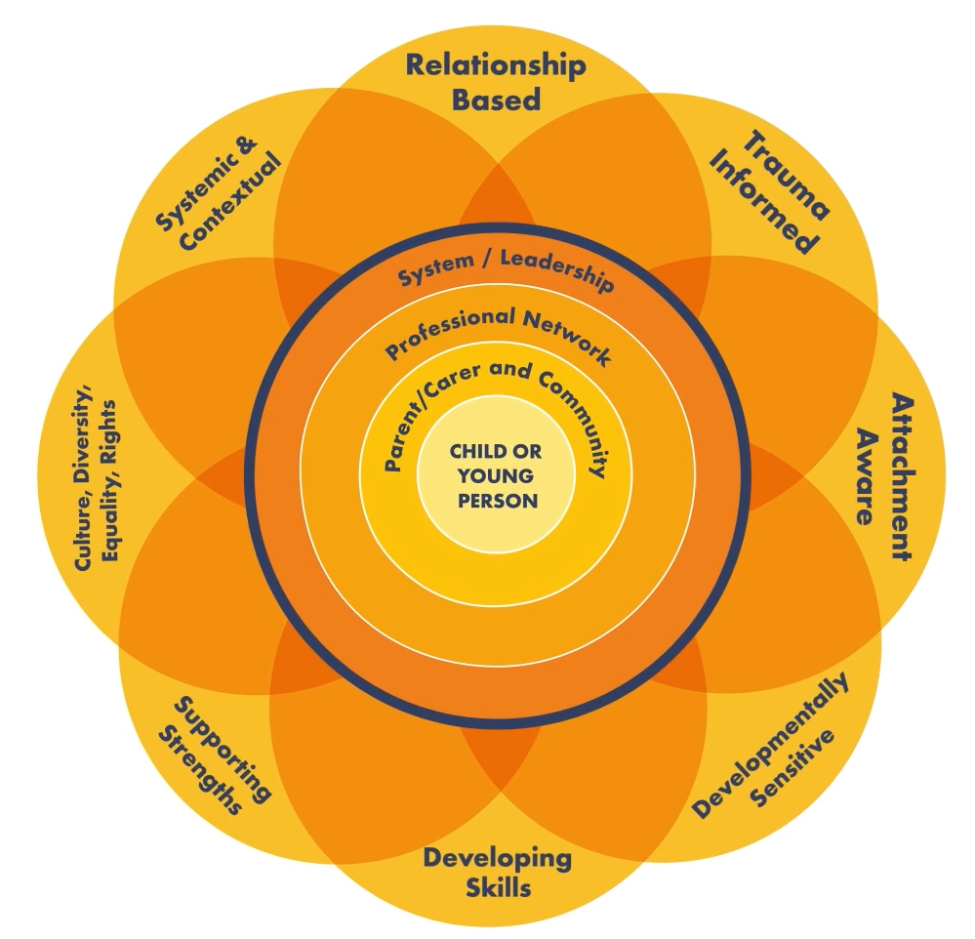

To support discussions working around the supervision cycle four key questions following each heading can be identified:

* Experience – What has happened?
* Reflection – What was it like?
* Analysis – Why? What does it mean?
* Action – What next?

The following resource offers questions that can be used and adapted under each heading to support Supervisors and Supervisees as they move around this cycle: [Questions-around-the-supervision-cycle.pdf (rip.org.uk)](https://practice-supervisors.rip.org.uk/wp-content/uploads/2019/11/Questions-around-the-supervision-cycle.pdf)

The following resource also consider different systemic questions that can be used to consider different perspectives and hypotheses / ideas about what might be happening. Systemic questions in particular explore connections between beliefs, behaviours and relationships to help positive change happen: [Using-systemic-questions-in-supervision.pdf (rip.org.uk)](https://practice-supervisors.rip.org.uk/wp-content/uploads/2019/11/Using-systemic-questions-in-supervision.pdf)

**Chronologies, Cultural Genograms and Social GGRRAAACCCEEESSS**

Chronologies are essential to understanding children’s young people’s and family’s current circumstances and challenges. This information should be regularly considered as part of supervision discussions and practitioners should be asked about how the chronology informs their understanding of what is happening and decision making.

Guidance for completing chronologies is available [here](https://proceduresonline.com/trixcms2/media/10939/chronology-guidance-021118.pdf).

A cultural genogram is also an essential tool in working with a family to understand the network of relationships around a child, young person and their family. A cultural genogram also helps to understand patterns of relationships, individual people’s identity and culture, and who is in the family and wider relationship networks around a child or young person. This then helps to develop ideas and hypotheses about what is happening and what can be done to understand things more, and who can support work being done with the family.

Guidance on cultural genograms is available [here](https://www.researchinpractice.org.uk/children/publications/2021/february/using-genograms-in-practice-practice-tool-2021/).

Understanding individual identities can be supported by the use of the Social GGRRAAACCCEEESSS: Gender, Geography, Race, Religion, Age, Ability, Appearance, Class, Culture, Creed, Ethnicity, Education, Employment, Sexuality, Sexual Orientation and Spirituality. This framework helps to explore individual identity characteristics and the interconnecting aspects of people’s identities. This is also a helpful approach to consider within the supervisory relationship itself as discussing within the Supervision Agreement template above.

Further guidance on the Social GGRRAAACCCEEESSS is available [here](https://vimeo.com/663400290/19c5f09b7c).

**Supervision Frameworks**

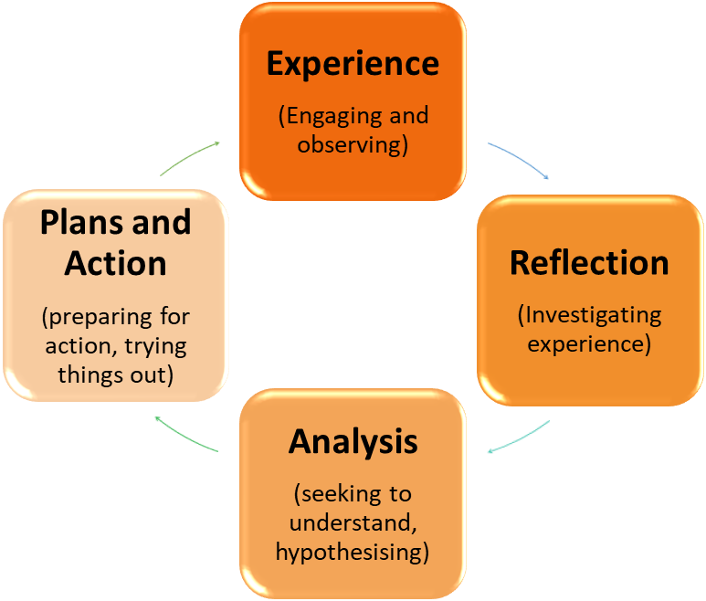With regard to discussions about practitioner’s work with children, young people and families, the following provides structure to support critical thinking, reflection and analysis, leading to purposeful and quality practice. This is taken from the 4x4x4 model, and Morrison and Wonacott’s[1] adaptation of the Kolb learning cycle for Children’s Social Care.

This approach has been further developed by Wallbank and Wonnacott[2] in the model on the following page in respect of restorative supervision for use in safeguarding practice. This develops this model of practice discussion so that it is a reflective and supportive experience for the practitioner where they leave supervision with feeling more contained and clear in purpose. This enables practice discussions to encompass the different functions of supervision identified in the previous section.

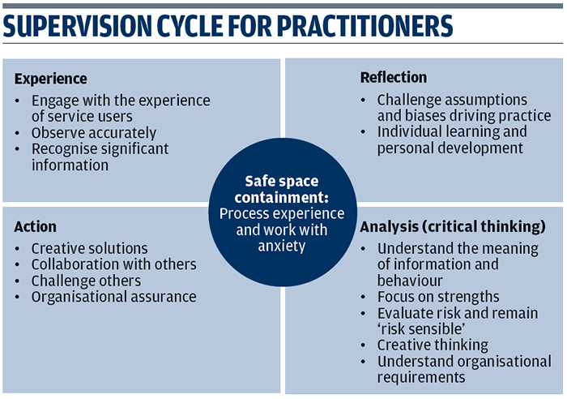

**The Experience:** This is where the supervisor elicits a clear description of the ‘story’, what the worker is experiencing and what they have observed, by asking questions and seeking clarity.

**Reflection:** The supervisee is encouraged to explore the feelings evoked by the story or experience and think about what this might mean for the child, family, victim of crime or themselves. Without this, subtle yet important clues to family functioning (dynamics *within* families) and the dynamics *between* families and professionals might go unrecognised.

**Analysis:** The supervisor and supervisee need to evaluate their perceived knowledge and beliefs about the individual services are delivered to. They need to make judgements and decisions based on observations, evaluation of information, available evidence, wider experience, reflection and consideration to relevant research.

**Plans and Actions:** Where critical thinking and critical reflection have occurred, realistic and safer plans can be developed. Actions can be explained and justified. Timescales and contingency plans should also be considered and agreed.

This framework is embedded in the template for Supervision that has been developed to sit alongside this framework, which can be found in Appendix One at the end of this document.

In addition to this supervision model, managers and practitioners can access the [Reflective Supervision: Resource Pack](https://www.researchinpractice.org.uk/children/publications/2017/april/reflective-supervision-resource-pack-2017/) their account with [Research in Practice](https://www.researchinpractice.org.uk/children/publications/2017/april/reflective-supervision-resource-pack-2017/). The Trust is a member of Research in Practice and as such anyone in the Trust can register for an account.

Similarly, managers may wish utilise resources available via [Community Care Inform Children (ccinform.co.uk)](https://www.ccinform.co.uk/)

1. Supervision: Now or Never Reclaiming Reflective Supervision in Social Work (Morrison & Wonnacott, 2010)
2. The Integrated Model of Restorative Supervision for Use Within Safeguarding (Wallbank and Wonnacott, 2015)