Policy / Procedure

Children in Care
Health Policy &
Guidance

Version 01.0

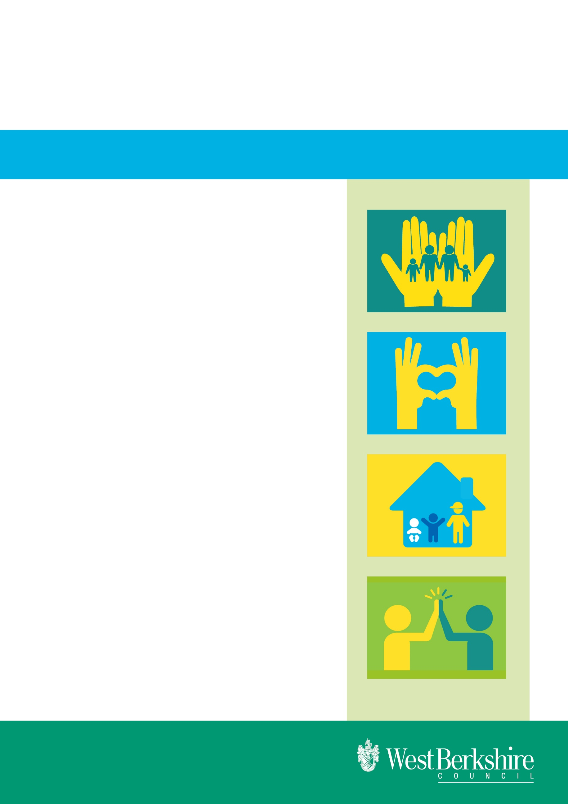

Effective date: April 2024
Review date: October 2024

Issued by: Susan Shepherd
ROLE: Virtual School Business Manager

Children in Care

Health Policy and Guidance

CONTENTS

Page
Number

- Communication 3 - 4
- Procedure to follow for an Initial Health Assessment 5 - 9
for a new child in care
- Procedure to follow to request a Review Health Assessment 10 - 12
- Mental Health and Well-being 13 - 15
- Other health-related subjects 16 - 17
- Contact details 18

COMMUNICATION

- SECURE E-MAIL COMMUNICATION

All communication with the Berkshire West Children and Young People in Care nurse team should be sent securely. In each locality team, there are usually two members of the administrative team who have access to the Health generic e-mail, WBcicHealth@westberks.gov.uk . This account is monitored daily. These contacts are:

Safeguarding West – Yvonne.pinnock@westberks.gov.uk, Ellie.Chapman1@westberks.gov.uk , Gemma.Topping1@westberks.gov.uk

Safeguarding East – Victoria.lee@westberks.gov.uk, Vicky.chalk@westberks.gov.uk

Children in Care and 16+ & Leaving Care – dawn.dawson1@westberks.gov.uk, Jennie.Deeks@westberks.gov.uk

Disabled Children’s – adminDCT@westberk.gov.uk Lisa.Toft1@westberks.gov.uk

Contact Advice & Assessment –Shaughna.keet@westberks.gov.uk

Research & Strategic Support – susan.shephard@westberks.gov.uk

The Berkshire West Children and Young People in Care nurse team consists of 3 full-time nurses and 3 administrators whose remit is to take care of the health and well-being of all children in care across West Berkshire, Wokingham and Reading local authorities.

All communication with the Berkshire West Children and Young People in Care nurse team, for queries or questions to the nurses, and all paperwork should be directed to their generic e-mail account as it is monitored on a regular, daily basis:

CICBerkshireWest@berkshire.nhs.uk

Their telephone number is : 0118 2143253

Their postal address is : Erlegh House
University of Reading
Earley Gate Whiteknights Road
Reading
RG6 6BZ

- Monthly meetings

The Children in Care Service Manager, Team Managers and Life Chances Team Co-Ordinator hold regular monthly meetings with the Service Manager and Named Nurse and other NHS professionals to monitor progress of health assessments and to ensure that every West Berkshire child in care has an up to date health assessment and Health Care Plan.

- Life Chances Team

The Specialist Nurse for Children in Care sits on the Life Chances Team (under 16) and on the 16+ and Leaving Care Life Chances Team.

- Information

The Berkshire West Children and Young People in Care team has access to and regularly provides information in the form of leaflets, etc on a wide variety of health issues such as sexual health, contraception, vaccinations, healthy eating, drug use, childcare etc.

- Change of Placement Notification or Child in Care status end

In order to keep their records up to date, the Berkshire West Children and Young People in Care team has requested a new Part A (or RHA form) for any placement change, with new address, carer and GP details and the same information when a child leaves care.

PROCEDURE TO FOLLOW FOR AN INITIAL HEALTH ASSESSMENT FOR A NEW CHILD IN CARE

There is a statutory obligation on every local authority to ensure that within 28 days of a child being made looked after by a local authority, the child will undergo an Initial Health Assessment and a Summary Health Care Plan produced within that timescale. This is a very short timescale and key to its success is that everyone involved completes their work in a timely manner.

The Initial Health Assessment (IHA) is carried out by a paediatrician, or the child’s GP if placed out of county. West Berkshire’s local NHS trust has established a special clinic, staffed by a paediatricians, which is held at IHA clinic, London Road Campus, University of Reading. If the child has been placed out of West Berkshire, they will be invited to come to this clinic for the IHA but if they decline, it will be carried out by a local paediatrician or the child’s registered GP.

The procedure is as follows:

- A child is taken into care
- Care Director dispatches an automatic LAC Client Notification e-mail
- Life Chances Team Co-Ordinator then e-mails the Berkshire West Children and Young People in Care nurses, requesting they carry out an IHA, giving the child’s details and their allocated social worker contact details: the social worker is requested to complete the paperwork below:
  - Initial Health Assessment form: this is a document on Care Director (go to the child’s record, current Referral, select Forms and Add New) – select CS Initial/Review Health Assessment form. The form will auto-populate if the information is on the child’s record. It is critical that all information is completed on this form. Please ensure that the social worker’s mobile number is included. The child’s care address and carer details do not auto-populate, so should be typed in the free-text box on the form.
  - Consent form: there is a link to this form at the end of the IHA form. This should be signed by parents when the child is first accommodated but if parents refuse to sign or cannot be contacted, this form can be signed by the West Berks Head of Service
  - CoramBAAF Form PH: this should have been completed by parents but if it is not available at this time, the social worker should advise the nurses and aim to have it completed as soon as possible.
The first TWO documents should be sent together, within three working days of the child becoming looked after – irrespective of any pending CP reports or age assessment - to the nurses on CICBerkshireWest@berkshire.nhs.uk
from the WBcicHealth e-mail account. The Berkshire West Children and Young People in Care nurse team will not make an appointment until they have at least the first two documents.

- The Berkshire West Children and Young People in Care nurse team will arrange the appointment for the IHA, either at their paediatric clinic, or with the child’s GP if placed out of county and will e-mail and phone the child’s social worker
- The child’s social worker will be expected to arrange for an interpreter to be present at the appointment, if one is required for either the child, or parents
- The paediatrician will expect the social worker to attend the IHA where possible
- The paediatrician writes an IHA Summary, or Part C and sends it to the generic WBcicHealth e-mail account. (Copies are also sent to the carer, the young person (if age appropriate) and the child’s GP)
- The locality team admin attaches the IHA Summary to the child’s Care Director record, under the Health heading. The date the health assessment is completed appears in the Summary and should be added to the checks tab on the child’s record.

All the above should be completed within 28 days of a child being taken into care. It is therefore crucial that the forms required by the health team are e-mailed to them within 3 working days of the child being accommodated.

Once the health team has sent the paperwork to a health professional, it is their responsibility to ensure that the assessment is completed in a timely manner and they will chase any form that is not returned to them in an appropriate timescale.

If a child has already undergone a medical by a paediatrician just prior to being made looked after, perhaps if CSE is suspected or due to severe disability or hospitalisation, then the report on this medical should be submitted to the CiC nurse team at step 4. The paediatrician will then make an assessment as to whether an IHA is required. In many cases, the paediatrician’s report is sufficient for them to compile the IHA Summary without the need to submit the child to another medical.

=======================

Consent to Share Health Information in Care Director
When to use this form:
- This form should be used as part of the Initial Health Assessment for a looked after child

To print a consent form, do the following:
- Open the relevant client record

- Click Referral in navigation pane (left hand side)
The Referrals area is displayed

- Select the active Referral record and click Mail Merge in the ribbon
The Mail merge window is displayed. The sample screen shot below displays the cloning of a form.
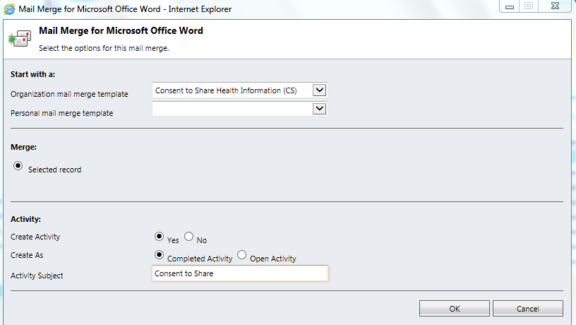

- Select Consent to Share Health Information (CS) from the first drop down box (as above)
This is the form that will be used

- Specify an Activity Subject
This value defines the name of the case note that will be auto-generated when you export this consent form.

- The Create Activity and Create As values should not be changed

- Click the OK button
Care Director displays a dialog box to save or open the form as a word document – see screenshot below
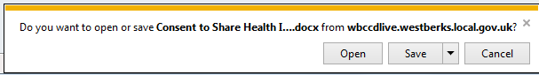

- Save the form and ensure the relevant parties sign.
- You must attach the signed copy of the consent form with the following categories:
  - Document Category = Consent
  - Document Sub-Category = CS Consent to Share

Escalation Process

As there is such a tight timescale in which to comply with the 28 day deadline, an escalation procedure has been developed to try to solve the problem of late delivery of paperwork to the health team.

- The paperwork required for an IHA should be sent to the Berkshire West Children and Young People in Care team within 72 hours of the child being taken into care.

- If paperwork is not received by health within 3 days of a child being taken into care, the request will be escalated to the Specialist Nurse and the locality Team Manager

- If paperwork is not received by health within 5 days of a child being taken into care, the request will be escalated to the Specialist Nurse, the locality Team Manager and both Service Managers.

- If paperwork is not received by health within 7 days of a child being taken into care, the request will be escalated to all of the above, and to both Heads of Service.

PROCEDURE TO REQUEST INITIAL HEALTH ASSESSMENT FOR NEW CIC

Child is taken into care

Care Director dispatches a LAC Client Notification e-mail
Within 72 hours

LCT Co-Ordinator e-mails Berks W C&Yp in Care team requesting IHA and copies details of child from LAC Client Notification, plus social worker contact details

Soc wrkr completes Initial Health Assessment form on Care Director, Consent form & CoramBAAF form PH and sends all 3 documents to Berks W C&Yp in Care team via the generic WBcicHealth e-mail account

If paperwork not received by Health within 7days, request escalated to all previous managers plus both Heads of Service

If paperwork not received by Health within 5 days, request escalated to Specialist Nurse, Team Manager and both Service Managers
If paperwork not received by health within 3 days of child being taken into care, request escalated to Specialist Nurse and locality Team Manager

Within 28 days

Child’s social worker should attend Initial Medical where possible
Berks W C&Yp in Care team arranges appointment at IHA clinic at London Rd campus, Uni of Reading or arrange for GP to carry out medical if child is OOC.

Specialist Children’s Service team writes IHA Summary report and sends to locality admin/soc wrkr/gp/carer/young person (if of appropriate age)

PROCEDURE TO FOLLOW TO REQUEST A REVIEW HEALTH ASSESSMENT
Locality team admin finds date of assessment and adds to child’s Care Director record and attachs IHA Summary to Care Director

Every child in care should have a Review Health Assessment (RHA) carried out every 6 months if aged under 5, or once a year if aged 5 – 18. RHAs are carried out by the following people:
- From birth to age 5 by a Health Visitor
- From 5 to 18 years by a School Nurse
- If placed out of county, it will be carried out by the children in care nurse in the corresponding area, or sometimes by the child’s GP
The procedure to follow to request an RHA is as follows:

- Once a week the Berks W C&Yp in Care team send to the WBcicHealth generic e-mail account, a list of children for whom they require RHA forms (Part A)
- The Health Assessment form is a Care Director document, (go to child’s Care Director record, choose the current Referral, choose Forms and Add New) – select CS Initial/Review Health Assessment Form. The form will auto-populate if the information is on the child’s record. It is critical that all information is completed on this form. The child’s care address and carer details, GP surgery and school do not auto-populate, this should be typed in free text boxes if they do not auto-populate on the form. Once complete the form should be sent to the Berks W C&Yp in Care team from the WBcicHealth e-mail.
- The Berks W C&Yp in Care team sends the RHA form to the appropriate health professional (above) to carry out the medical.
- The health professional returns the completed form to the Berks W C&Yp in Care team.
- The Specialist nurse writes a RHA Summary and sends it to the designated locality team admin via the generic e-mail account. (Copies are also sent to the carer, the young person, if age appropriate, and the child’s GP)
- The locality team admin attachs the RHA summary to the child’s Care Director record, under the Health heading. The date the health assessment is completed appears in the HCP and should be added to the LAC checks tab on the child’s record.

All the above should be completed within the 15 week timescale.

Fifteen weeks may seem like a long time, but school nurses, health visitors and other health professionals need time to plan their appointments and many work term-time only. It is common for other health authorities to prioritise their own children in care over children placed by other local authorities, which causes delay if any WB children in care are placed out of county.

In the case of an Unaccompanied Asylum Seeking child, or parents whose first language may not be English, the allocated social worker may be asked to arrange an interpreter for the assessment.

Once the Berks W C&Yp in Care team has sent the RHA form to a health professional, it is their responsibility to ensure that the assessment is completed in a timely manner and they will chase any form that is not returned to them in an appropriate timescale.

If a child in care has seen the paediatrician for a Pre-Adoption Medical and their next RHA is due within 3 months, the Pre-Adoption Medical report should be e-mailed to the Berks W C&Yp in Care team, and will usually be sufficient for the Specialist Nurse to compile the Summary, thereby obviating the need for another medical examination.

If a child has moved to their adoptive placement, while still remaining in care, and an RHA becomes due, the adoptive parent should be given the choice of having an RHA carried out. If they have no concerns, and the social worker is in agreement, it should be recorded on Care Director as “RHA declined by adoptive parent”. If the adoptive parent wishes the child to have an RHA, this will be carried out as previously.

Escalation

If an RHA (Part A) is not received within two weeks of first being requested, it will be escalated to Team Manager and Service Manager.

PROCEDURE TO REQUEST A REVIEW HEALTH ASSESSMENT

Berks W C&Yp in Care team send request to WB for RHA (Part A) forms on a weekly basis

Soc wrkr completes Health Assessment form on Care Director and sends it to Berks W C&Yp in Care team, via generic WBcicHealth e-mail

Berks W C&Yp in Care team send paperwork to school nurse/health visitor/GP/OOC LAC nurse to carry out medical
Health professional arranges appointment with carer

Within 15 wks

Health professional returns completed form to Berks W C&Yp in Care team

Specialist nurse writes RHA Summary and sends to locality admin/soc wrkr/gp/carer/young person (if of appropriate age)

Locality team admin finds date of assessment and adds to child’s Care Director record and attachs RHA Summary

MENTAL HEALTH AND WELL-BEING

The Berks W C&Yp in Care team has no involvement with mental health issues, but do have contacts with West Berkshire CAMHS. They have no involvement with the completion of SDQs (Strengths and Difficulties Questionnaire) but would like the latest SDQ score in order to inform their Summary Health Care Plan.

Strengths and Difficulties Questionnaire

When a child in care has been in local authority care for more than 12 months, and is aged between 4 and 16, they should have an SDQ completed. This is a double-sided multiple-choice tickbox form in three parts, one to be completed by the main carer, the second by the Designated Teacher for children in care at the school they attend, and the third by the child, if aged between 11 and 16.

These forms are all sent out by the social worker. When the worker receives all 3 completed forms, they can be ‘scored’. This is done using the SDQ website (address below), and when the results are input from each of the forms, the site gives you a summary and an Overall Stress score. This score should then be input to Care Director. Any Overall Stress score over 20 is classed as High Risk.

www.sdqscore.org/

This process is repeated every 12 months.

When a child has been in care for a few years, and several scores recorded, a pattern will emerge as an indication of their emotional well-being.

The Berks W C&Yp in Care nurses have requested they be sent a copy of the SDQ score ‘results’ page, because this score also informs the RHA Summary that the nurses compile. Please send a copy to the CICBerkshireWest@berkshire.nhs.uk
e-mail address.

For other services available to our children in care please refer to another document on Tri-X :

Guidance for social workers on mental health services available to West Berkshire Children in Care

Funded by charities, other options, for specific issues include:

Time to Talk
This is a charity, based in Newbury, who offer 60 individual sessions a week at their offices and also go into schools – Brookfields, The Willink and The Downs. In schools they hold group sessions, largely preventative, around stress and other areas, including self-harming, and negative body image. Their therapists, all volunteers, would come in at the CAMHS equivalent of Tier 2. All counsellors are person-centred and have some knowledge of CBT. They would normally offer several sessions every week over a three month period. The service is free to yp. They cover yp aged 11-25 yrs old in West Berks.
Referrals can be made by a GP, CAMHS, schools or self-referral. It is hoped that an assessment session would be held within 10 days of referral or phone call. Approximate waiting time for therapy to begin is 2 months from referral & assessment.
Contact : Davina Nicholson (Clinical Lead)
e-mail : Clincial.Lead@t2twb.org
Broadway House, 4-8 The Broadway, Newbury RG14 1BA
Tel : 01635 760331
Website : www.t2twb.org

Talking Therapies
This NHS group deliver therapy across Berks, with centres in Reading, Newbury and Wokingham. They take patients from age 17, dealing with problems such as depression, anxiety, post-traumatic stress disorder. The website lists what is on offer, from telephone therapy to a well-being course in a group setting, to a stress control workshop. All therapy is free of charge. They also offer computerised Cognitive Behaviour Therapy and some other therapies, including those for worry and depression, are offered on-line, so can be accessed immediately.
Clients can self-refer, or be referred by professionals, and referrals can be made on-line or by text or phone.
Interventions from therapists can be over the phone or face to face. If higher intensity work is required, the therapist will offer a number of sessions or signpost the client to other services.
Once a referral is made a therapist will phone to carry out a “triage” and once contact has been made there is a wait of between one and two weeks for ‘help’ to start, or if more treatment is needed it can be 4 – 6 wks. The computer package gives immediate access. The service is confidential and social workers would not be notified of outcomes as the minimum age is 18.
Contact : Munya Chigwada (Sen Cognitive Behaviour Therapist)
e-mail : munya.chigwada@berkshire.nhs.uk
Tel : 0300 365 2000
Website : www.talkingtherapies.berkshire.nhs.uk

Daisy’s Dream
This service is aimed at children up to the age of 19, across Berkshire, supporting children/yp living with bereavement or life-limiting illness in the family. Referrals are taken from anyone. If appropriate DD meet the yp or they can meet the foster carer to give advice and support – they don’t always work directly with the yp. DD would first do an assessment, possibly speaking to the social worker, and would then meet the yp. Some assessments are made over the phone.
It is an open-ended service – no fixed number of sessions or time. Each case is reviewed after each visit. Most staff have a background in social work. It is very much about the right time and place: the assessment is key. The yp could be signposted to another service. It is an outreach service with most meetings being held in schools, but sometimes at the yp’s home. The work can include some life-story work.
Social workers can phone the service for advice. DD also offers training throughout the year (more details on the website).
Contact : Gill Stevens
e-mail : info@daisysdream.org.uk
Tel : 0118 934 2604
Website : www.daisysdream.org.uk

Trust House Reading
This is a rape and sexual abuse centre in Reading, which covers the whole of Berkshire, although they are hoping to open a centre in Newbury. They provide counselling, play therapy and individual workshops, and also go into schools with workshops on CSE and relationship building. Age range is not specific: adults and children.
They also offer lots of practical support such as help with housing or benefits. Counselling can be short or long term and is reviewed from time to time.
Referral can be made via the website or can be completed over the phone.
Contact : Namita Prakash
e-mail : support@trusthousereding.org
Tel : 0118 958 4033
Website : www.trusthousereading.org

OTHER HEALTH RELATED ISSUES

- Dental and optician checks

The Berks W C&Yp in Care team has no involvement with dental or optician checks, but may refer to the child’s Care Director record to ensure that regular checks are being carried out. This information is then added to the child’s RHA Summary.

It is the responsibility of the social worker to ensure that the dental check-up dates and optician check dates are input to the child’s Care Director record.

- Pre-Adoption Medicals

The Berks W C&Yp in Care team play no part in organising Pre-Adoption Medicals. If a social worker requires a Pre-Adoption Medical, they must contact the Medical Secretary to the Community Paediatricians, Dr Needham & Dr Vashist, whose contact details are below:-

PAM Service
Royal Berkshire Hospital
3-5 Craven Road
Reading
Berks RG1 5LF

Tel: 0118 322 8774
e-mail: rbb-tr.LACS@nhs.net

Following your enquiry, you will need to complete a Referral Form, one CoramBAAF Consent form from each parent, and also one CoramBAAF form PH from each parent. They will not book the medical appointment until they have received the Referral Form and the two CoramBAAF consent forms. Full details are on Tri-X.

The Pre-Adoption Medical is ‘valid’ for six months, so if matters have not been concluded within 6 months of the date of the medical, a new Pre-Adoption Medical will be required. If in doubt, the social worker should contact the paediatrician who carried out the original Pre-Adoption Medical.

If a Pre-Adoption Medical has been carried out within three months of a Review Health Assessment falling due, the RHA will not be required as the Berks W C&Yp in Care nurses can develop an RHA Summary from the Pre-Adoption Medical report.

- Health Passport

The Health Passport has been produced by the Berks W C&Yp in Care Team and is provided to all children in care aged 16 or over.

The Health Passport is a small A5 folder which contains relevant health information for each young person including all their health history, immunisations and all completed health assessments. The Specialist Nurse completes the Review Health Assessments for all 16+'s within Berkshire and also within a 20 mile radius of Berkshire boundaries. The young people are given their Health Passport at the time of their last Review Health Assessment, and they have the opportunity to go through the information with the Specialist Nurse at this time. The Health Passport is updated at any subsequent health assessments.

For those young people who decline their health assessment, the Health Passport will be sent to the Social Worker to be passed on to the young person.

CONTACT DETAILS FOR MOST QUERIES

E-mail address : CICBerkshireWest@berkshire.nhs.uk

Phone number : 0118 2143253

Postal address :

Erlegh House
University of Reading
Earley Gate Whiteknights Road
Reading
RG6 6BZ

SEShephard
30 April 2024
(to be reviewed 26/10/24)

