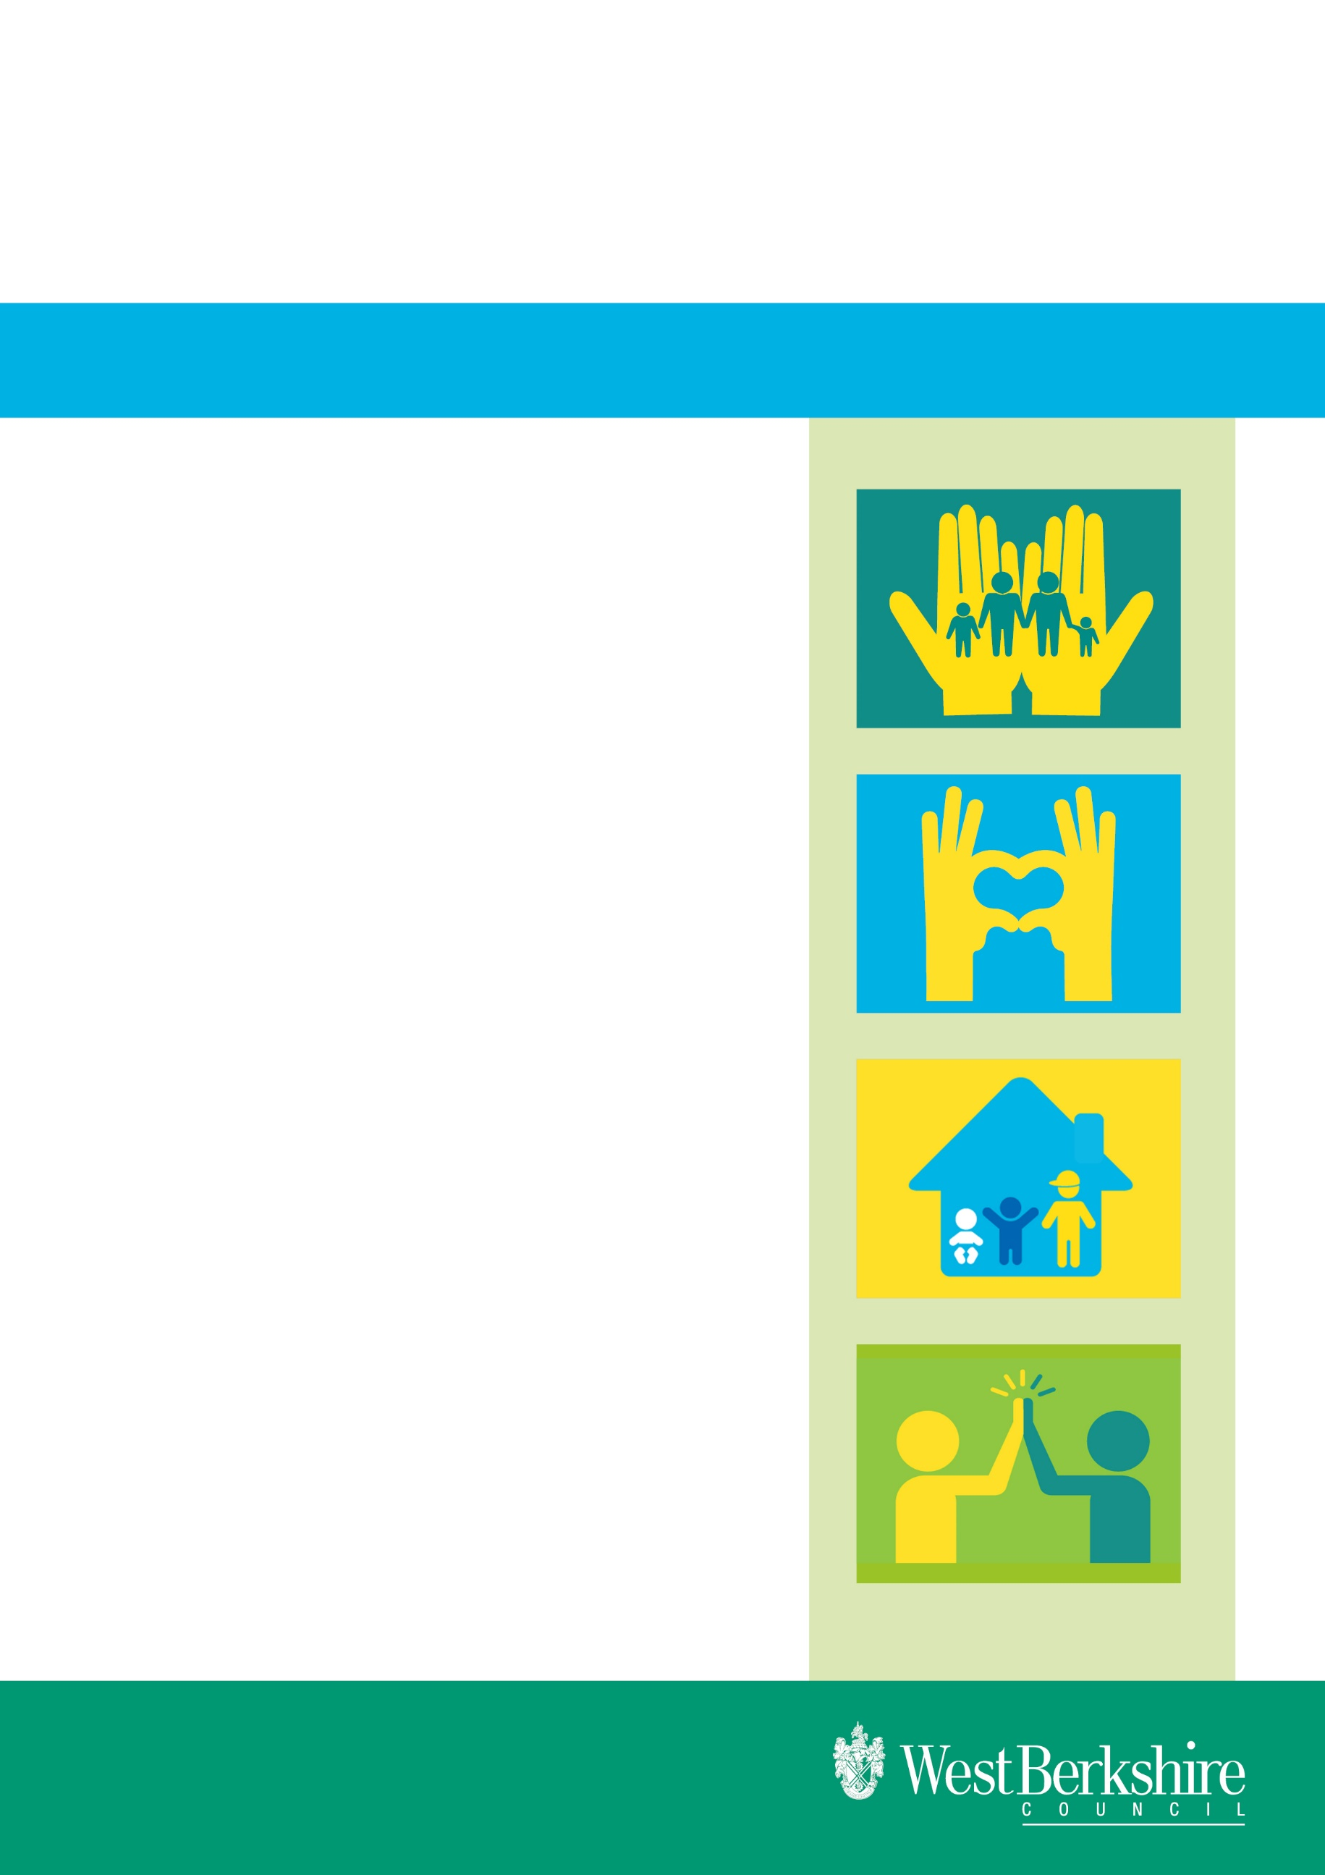
Policy / Procedure

Effective date: May 2025
Review date: May 2028

Issued by : Nicola Robertson
Role: Service Manager
Practice Guidance for Post 18 Children in Care Reviews

Version 1.0

Practice Guidance: undertaking Independent Reviewing of Pathway Plans of relevant and former relevant young people.
Introduction

This guidance applies to Independent Reviewing Officers (IROs), Social workers, Team Managers and Personal Advisors (PAs). The guidance sets out the arrangements for undertaking reviewing of pathway plans for young people aged 18+ who are “Former Relevant” young people, as defined in the Leaving Care Act. i.e. young people who are aged 18 to 25, and have left care having been previously either 'Eligible', 'Relevant' or both.”

The guidance also applies to young people who are “relevant” care leavers i.e.:
Young People aged 16 or 17 who are no longer Looked After, having previously been in the category of Eligible Young Person when in care.

A young person is also 'Relevant' if, having been in care for three months or more, he or she is then detained after their 16th birthday either in a hospital, remand centre, young offenders' institution or secure training centre. There is a duty to support Relevant Young People up to the age of 18, wherever they are living.

The requirement of Local Authorities for this group of young people is:
- to provide the young person with a personal adviser.
- to review and revise the pathway plan regularly and
- to keep in touch.

Role of the Independent Reviewing Officers

The IRO handbook describes the role of Independent Reviewing Officers in relation to care leavers:

“ Where a review concludes that it is appropriate for a looked after young person to make the move to independent living arrangements, and such a move takes place, this does not automatically result in the young person ceasing to be looked after. It is likely that given their vulnerability most young people will benefit from the support that results from being looked after (including having a pathway plan that is kept up to date and reviewed by an IRO) until the age of 18. However, where there is consideration that it might be in a young person’s interests to no longer be looked after and become a ‘relevant child’ then this entirely separate issue must be considered by a properly constituted statutory review of the pathway plan, chaired by the IRO. The proposed pathway plan for the young person concerned must be available for scrutiny at this review. The review should also stipulate how in future the pathway plan is to be reviewed and whether there would be any benefits in these meetings being chaired by an independent person, with an established competence in the provision of leaving care, housing support and other services to care leavers”. (IRO Handbook Paras 5.16 & 5.17)

The offer to relevant and former relevant young people is that, in addition to the current 6 monthly pathway plan reviews undertaken by their PA, they can request a review of their pathway plan by an Independent Reviewing Officer. This will (in most cases) be the same IRO who previously reviewed their looked after care plan, as this ensures continuity in the planning and reviewing process, minimises the number of new professionals the young person needs to deal with, and maintains the relationship between the young person and their IRO.

The IRO will offer to chair a maximum of 3 reviews following the young person ceasing to be looked after at the last review prior to the young person turning 18 years of age. The decision to continue the independent oversight of the Pathway Plan will be led by the young person, who may not want the IRO to continue in this role or may want the IRO to chair only one or two of the maximum 3 further reviews offered.

The IRO will also have discretion, where it is deemed by them to be appropriate and necessary to do so, to offer more than 3 reviews.

The young person may not initially feel that they need this service, but this will remain available to them at any time while they have relevant, or former relevant status under the Leaving Care Act

Outline Process:

Final CIC review:

Every young person looked after will have a final looked after review, usually a few weeks or months before their 18th birthday. If the young person is a relevant young person, the final looked after review may be held at a point before or soon after their 16th birthday.

The final looked after review will be chaired by the IRO. The PA should be allocated well in advance of this final review, and be in attendance at the meeting, along with the outgoing social worker.

The final looked after review will make decisions with regard to the implementation of the young person’s pathway plan. One of these decisions will be regarding the on-going arrangements for the future reviewing of the plan. The young person’s view regarding whether or not they wish the IRO to continue in their role will be the primary determining factor.

A date for the first pathway plan review will be set no later than 6 months from the final looked after review.

The review can take a variety of forms but the consent and active involvement of the young person is essential and the meeting will be organised in partnership with the young person involved.

Ideally the Pathway plan review takes the form of a meeting involving the young person, their PA and reviewing officer. Additional attendees could include the carer or accommodation provider, and any other professionals who are contributing to the pathway plan e.g. College. The young person’s views of who should attend the meeting will be a key determining factor.

Alternatively the Pathway plan review takes the form of the IRO contacting those involved with the young person either in person or by phone/email (dependant on the young person’s consent) to gather information regarding the progress of the pathway plan. IRO leads the discussion involving PA and /or young person.

How would this work?

The IRO will notify the relevant team manager that the young person concerned has requested a post 18 pathway plan review as soon as the request is made.

Where relevant the Transitions Manager will also be notified and they will consider issues relating to DoLS, LPS.

Where a young person is not able to request a review themselves it will be the role of their advocate to consider requesting a review if they felt this was appropriate.

4 weeks prior:
- IRO contacts personal advisor to confirm the time, date and format for the review. The personal advisor provides a verbal update regarding the young person’s circumstances, contact details etc.
- IRO contacts the young person to arrange a time to meet before the review. Ideally this will be in the young person’s home or other venue of their choice.
- If the young person declines to meet their IRO face to face, or this is not practically possible, some other form of contact will be offered e.g. telephone call, e-mail etc. IRO will agree the format of the meeting and who should attend with the young person.
- No less than 3 working days prior to the review: the personal advisor updates the current plan and sends it to the IRO.
- The IRO reads the updated Pathway Plan – this document will be used as the basis for the Pathway Plan review.
- The pathway plan review meeting is not a decision making forum and it will be the role of the relevant team manager to read the recommendations from the pathway plan review and to respond to these within 5 working days.

Pathway Plan review:

Usually the pathway plan review will take the form of a meeting. The attendees will be the young person, their PA, the IRO, their carer or accommodation provider, and any other professionals who are contributing to the pathway plan e.g. College. The young person’s views of who should attend the meeting will be the key determining factor.

The contributors to the meeting will not be required to complete written consultation forms as they do for a looked after review. The contributions and views of review attendees should be captured within the Pathway Plan. It is the responsibility of the PA to determine the views of other agencies and ensure these are accurately recorded within the Pathway Plan.

The Team Manager for the PA will countersign the plan by way of authorisation, before it is seen by the IRO.

The IRO will record a summary of the issues and decisions in the pathway plan, clearly denoting this is part of the pathway plan review.

The review agrees a future date for the second pathway plan review where a need for a further meeting is identified and agreed and this is recorded in the Pathway Plan. Updates will be added to Care Director by the IRO. The pathway plan is finalised by the IRO, adding the updates and recommendations discussed at the review.

A copy of this is then forwarded to all relevant parties and a copy sent to the relevant Team Manager for them to consider and to sign off.

The Team Manager (TM) receives the reviewed plan and it would be expected that they respond to it within 5 working days by either contacting the IRO for discussion if they do not agree with any aspect of the plan, or otherwise the TM indicates their confirmation of the plan, which then becomes the agreed pathway plan.

If the young person wishes the IRO to continue to oversee the subsequent Pathway Plan review/s (second and/or third), these would be conducted in the same way.

Disputes and Challenges:

On occasions, after conducting a review of the Pathway Plan, the Reviewing Officer may identify areas where there is drift, delay or lack of progress with aspects of the plan. E.g. the young person may be in unsuitable accommodation, their health or education needs are not sufficiently met, or there is a safeguarding concern. Decisions or agreed actions from the previous review may not have been followed up, without good reason.

In these circumstances the IRO will challenge the Local Authority by:

- Recording the issue as a dispute on the reviewed pathway plan and
- Logging the dispute on the young person’s record, similar to the existing Dispute Process for Looked After Children.
- The record of the dispute will stipulate the action needed and a clear timescale. The relevant Team Manager and PA will be notified of the issue by the IRO.

Once the timescale has been reached, the IRO and TM will share information as to if and how the issue has been resolved. If the issue is not resolved to the IRO’s satisfaction, the matter is escalated to the Service Manager for Looked After Children.

If this does not resolve the matter to the IROs satisfaction, the matter is escalated to the Service Director who will intervene to address the concern with the Service Manager and Team Manager and agree a resolution.

If this does not resolve the matter to the IROs satisfaction, the issue could be escalated again to the Director for further action.

Administration:

Administrative tasks arising from the undertaking of care leaver reviews will be undertaken by the Quality Assurance & Safeguarding Service.

