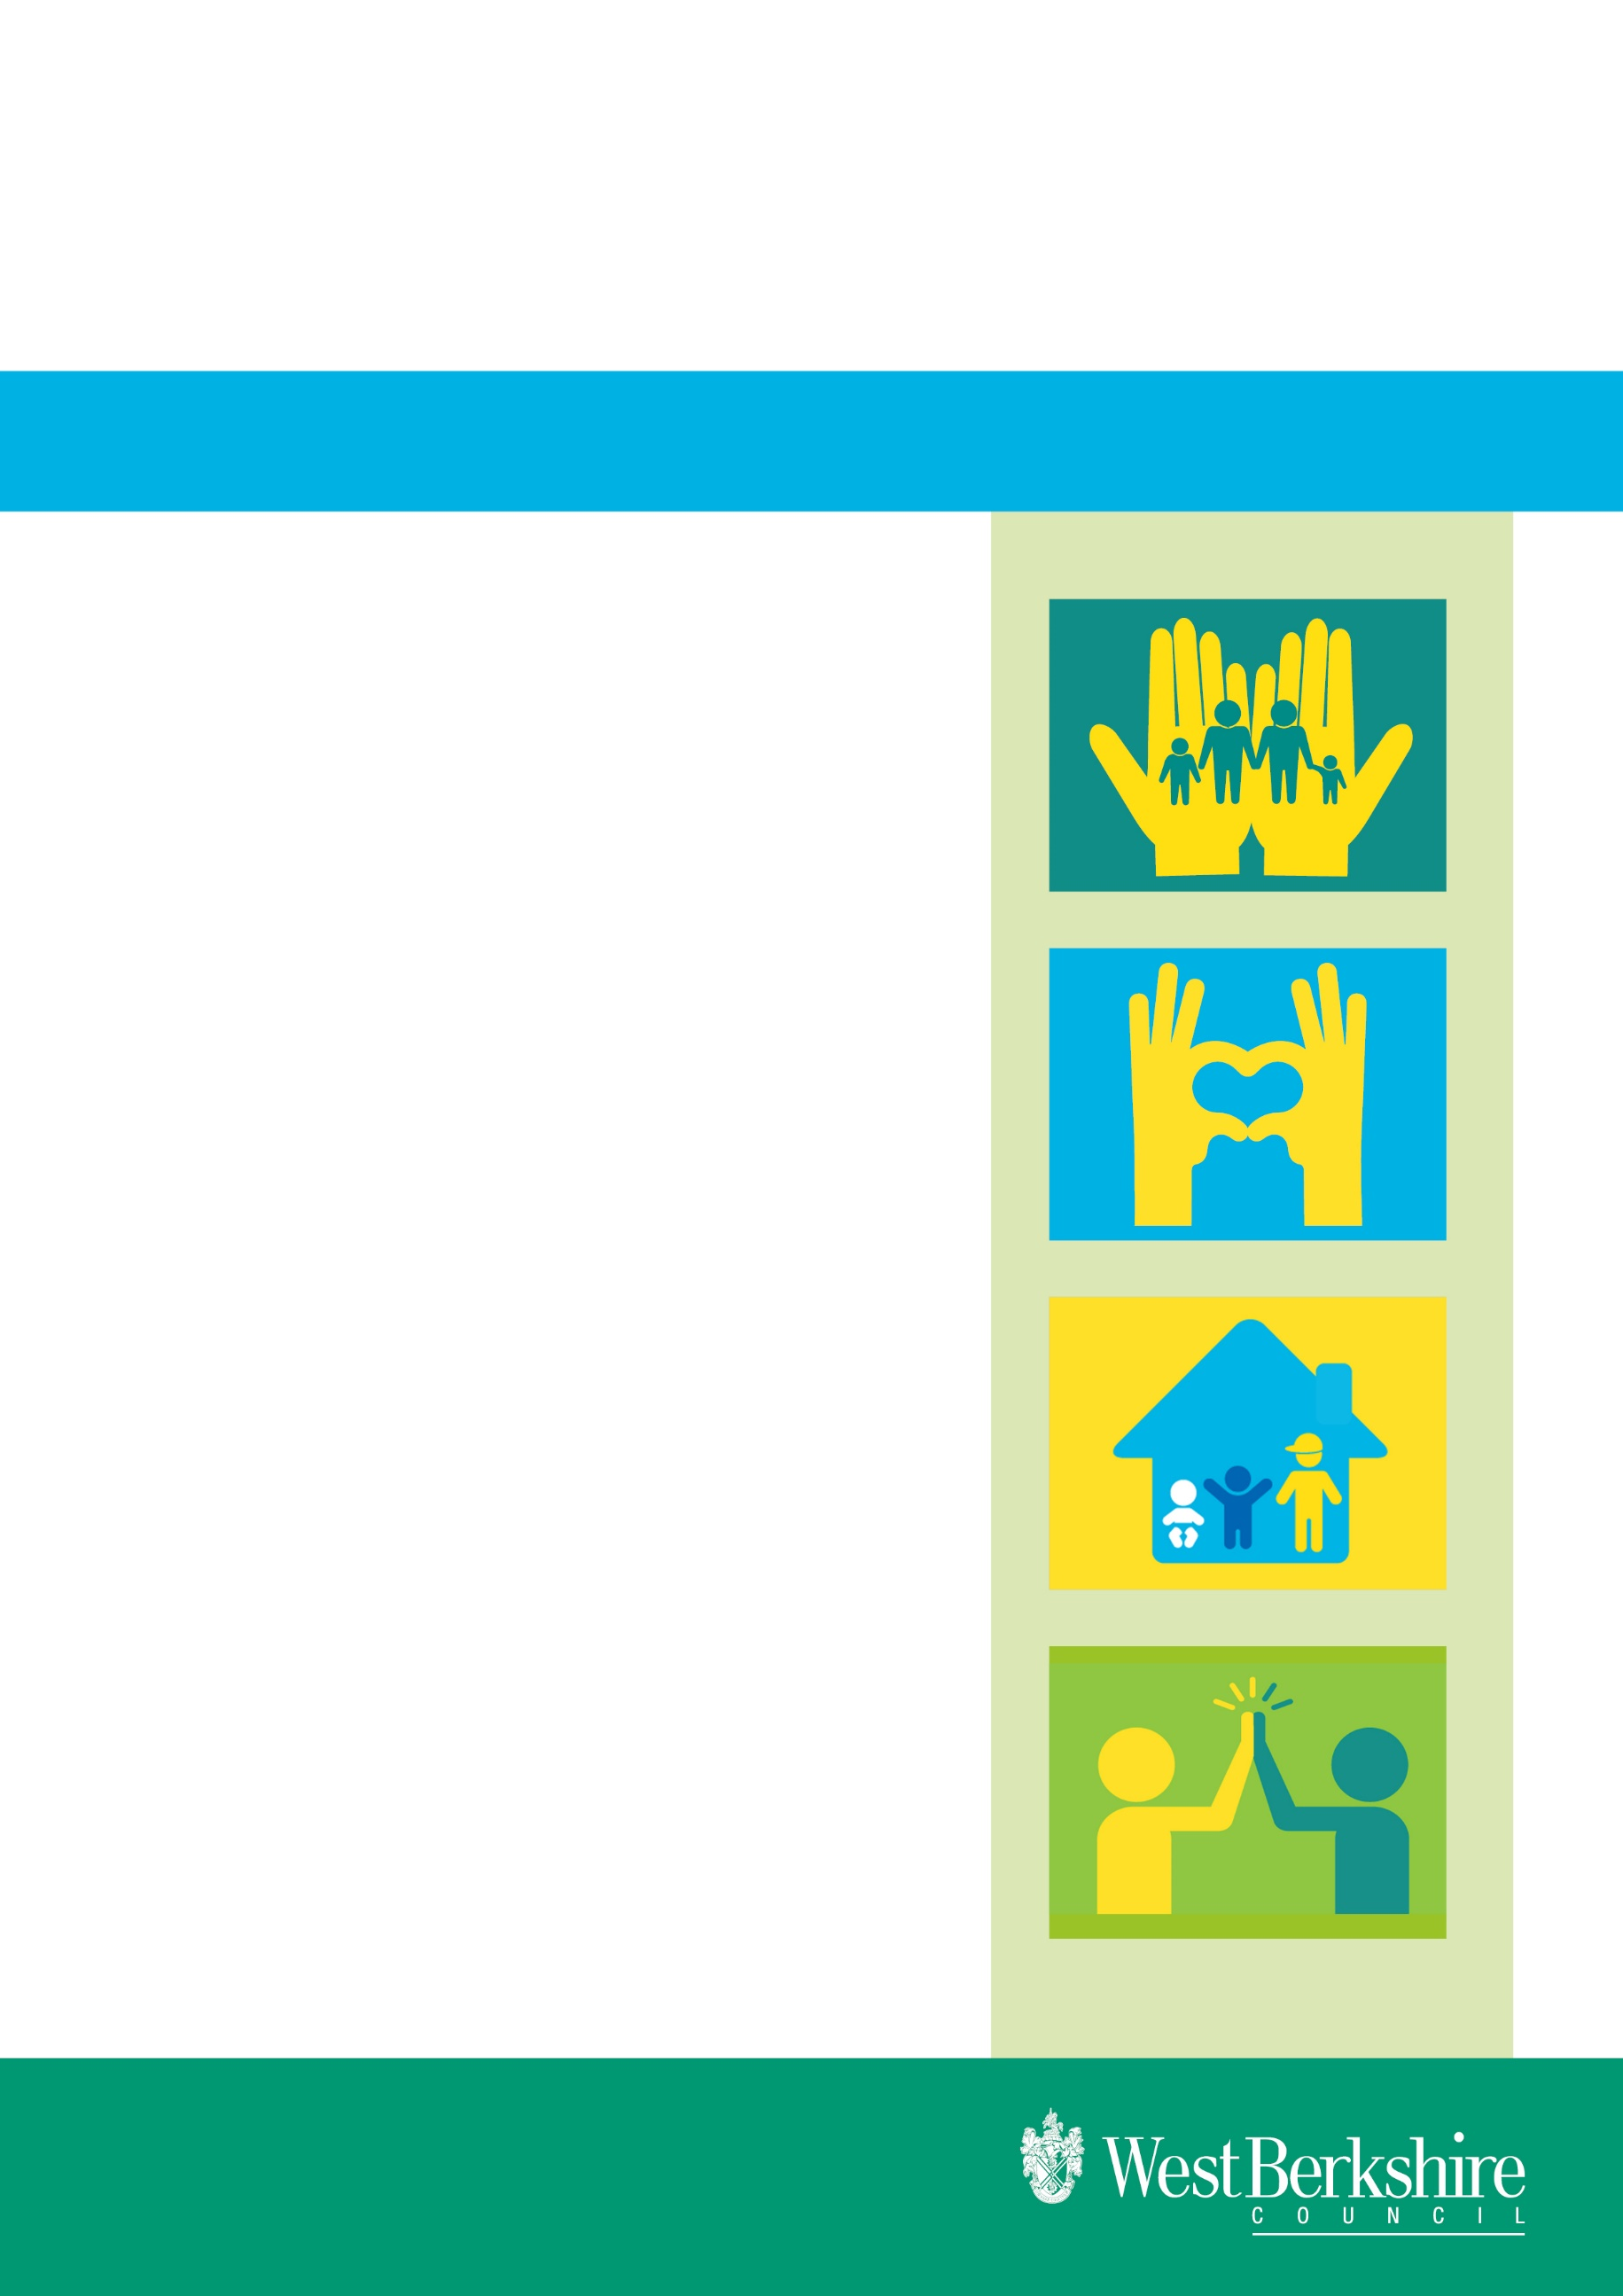
Effective date: March 2024

Issued by: Dora Gouveia Schofield
Role: Principal Social Worker & Academy Lead
Children & Family Services

Practice Standards for Social Workers

West Berkshire Council

Standard 1

Promote and drive lasting outcomes for Children in West Berkshire

Children will see quicker and fairer decisions about where they will live, who will care for them and an opportunity to achieve at school and in the community.

Commitment to children being brought up in their family of origin wherever possible

- When a child or young person becomes looked after we will make sure as far as possible that their Social Worker or known professional places them in care.

- We will explain why such an action became necessary and when they will see their parent and family.

- If children are remaining with birth family or connected persons as Looked After Children we will endeavour to make reports available to HOS for approval of these placements within 48 hours.

- We will hold a placement planning meeting within five days and make sure that we involve them and their birth parents if at all possible.

- We will visit them within seven days and explain what will happen next and provide them with a Looked After Children’s Pack.

- We will arrange for a Looked After Children’s Review within 28 days and make sure that their family and care have sight of their LAC report five days prior to the review meeting.

- We will explain the role of the Independent Reviewing Officer and make sure the child or young person has an opportunity to complete consultation forms prior to the review along with their foster carer and birth family.

- At the first review we will present our Care Plan regarding the work we will do to look at whether the child/young person can return to their birth family or connected person or whether we need to also consider in parallel, placements outside of the family.

- We will make sure we hold a Personal Education Meeting within 20 school days of the Child/Young person becoming looked after.

- We will arrange for a health professional to complete an assessment of health needs within five days to take place no longer than a month after the child/young person comes into care.

- We will make sure that we take legal advice and encourage the birth family to take legal advice so the right for children to family life within their family of origin has external scrutiny and we are held accountable.

- If we decide to follow a legal framework we will make sure members of the birth family have the best support available to make the necessary changes to their parenting to care for their children safely.

- We will hold a Family Group Conference so that the family have an opportunity to come up with their own solutions in a supported way.

- Should the plan be permanence outside of the birth family we will make sure all assessments are completed so that decisions are made in timely way

- If children cannot live within their birth families we will make sure that all reports that are required for the Court to decide on a plan for adoption are completed speedily and within the time periods directed at Court.

- We will gather information about the birth family and the child and young person to support their understanding of their journey in care and we will also mark important milestones so that the memories can be drawn on for children and carers to understand their unique origin and identity.

- We will undertake life journey work, compile life story books, keep memory boxes, write later life letters and support letter box contact where there is no regular face to face contact.

- Wherever possible we will support siblings remaining together and if this is not possible we will promote and support good quality contact.

Commitment to improving our practice
- We will where possible make sure that we have the skills, knowledge and understanding of the children’s origins to enable the culturally competent conversations and decisions necessary to support their identity and promote and celebrate difference.

- If disputes are raised about the quality of our work then we will make every endeavour to provide a plan within five working days to address this.

Commitment to placement stability
- If the settings we place our children and young people in are failing settings, we will advocate on their behalf to move them to settings where standards are high if it is in their interests to move. If this is not possible then we will bring every pressure to bear on providers to provide an individually tailored programme which addresses the identified difficulties.

- If placements are at risk of breakdown we will convene pre-disruption meetings which are independently chaired to enable an improved understanding of the child or younger person’s needs and how best to support them in their placement or if the placement is irretrievable to make sure the information is used to get the best match.

- Where we are concerned about standards of care being offered we will complete reports for fostering panel when foster care reviews are taking place, to make sure that we have named the issues of concern as well as praised good practice so that we can influence the quality of our placements

- If our children or young people are missing whilst in our care we will organise a strategy meeting on day five to make sure we have a co-ordinated response.

- On every occasion our children or young people are missing we will notify the missing person’s co-ordinator so that a return interview can be arranged.

- If the child or young person is at risk of Child Sexual Exploitation we will make sure we complete a screening tool and refer to the CSE panel for multi- agency intelligence sharing and planning.

Our commitment to our children enjoying and achieving

- We will carry out all actions identified in Personal Education Plans and advocate as necessary with professionals in education to get the best possible outcomes for our children and young people.

- We will advocate for both gifted children and those with Special Educational needs to support an environment for them to flourish

- We will track children at risk of exclusion and make sure that Personal Education Plans are reviewed at least every three months to make sure the education of young people is not undermined.

- We will challenge placement providers to make sure the holistic needs of children are met to include out of school activities, membership of clubs, opportunities to develop hobbies and interests and development of life skills.

- Where young people are at risk of exclusion, anti- social behaviour, substance misuse and criminality we will make sure we intervene early as possible to avoid escalation of behaviours.

- Where children are at risk of Child Sexual Exploitation we will make sure that targeted support is included in plans and review how effective this support is with our multi-agency colleagues to make sure that it remains tailored to need and risk.

- Where our children and young people have contact with their birth families which includes siblings we will make sure this is promoted and reviewed so that it remains in the best interest of that individual child or young person.

- We will promote the health of our young people to include timely health assessments, dental appointments and any other identified health need and where there is a gap in resource or provision we will escalate this.

Our commitment to promotion of life skills
- We will make sure Pathway Plans are timely and include input from multi- agency partners and families where appropriate to support preparation for independent living.

- We will encourage an understanding of the young persons’ preparedness for independent living skills, for example cooking, budgeting etc.

- Where young people will require services from adult teams we will alert the relevant teams when the young person is 14 years 6 months old to make sure that transition planning remains at the core of all plans until transfer to adult services.

- We will make sure Housing Plans are in place for all 16 year olds to include staying put arrangements, registration with local Housing providers or return to family.

- Deficits in provision will be identified by us to feed into wider strategic commissioning arrangements for partners.

Our commitment to our UASC

- We will make sure where we do age assessments that they are done in a culturally competent and sensitive manner taking account of the trauma that children have suffered in reaching a place of safety.

- We will make sure that our unaccompanied asylum seeking children have a full understanding of the asylum process and the consequences to their lives if all rights to claim benefits and continue in education are exhausted.

- We will commit to signposting them to the support services in the community which will enable them to make their own connections and networks.

- We will commit to continue wherever possible to advocate, advise and support them to trace birth families and return home if that is their wish.

Standard 2

Children and young people will feel safe in their homes and communities and supported in their journey by trusted adults who they can rely on to provide an unerring focus on their needs.

- We will make sure children and their families have been informed of and understand the concerns of Children and Family Services and have had a fair opportunity to put their view point forward.

- We will strive for SMART outcome focussed plans which prioritise and indentify the key tasks to achieve good outcomes, and which are accessible for children and young families.

- We will evaluate the effectiveness of the plan and escalate practice issues where there is insufficient progress.

- We will review written agreements on a regular basis as part of our commitment to evidence based partnership working that is accountable and restorative in approach.

- Where cases are in pre-proceedings we will comply with the pre-proceedings protocol and escalate issues which impact on timely decision making and outcomes for children.

- We will make sure we update chronologies prior to conference or a Child in Need meeting so that we can show key events and patterns which impact on children and families in an open and transparent way.

- We will visit children and their families and make sure this is recorded as set out in the regulatory framework. If we have not done so we will alert a supervisor.

- We will make sure we will hold core groups or CIN meetings every six weeks and work with families and professional partners to consider progress and where we need to continue to focus our energy to bring about positive change.

- We will highlight complex cases and plan parenting assessments early on to avoid drift and delay.

- We will promote advocacy arrangements for children and young people and vulnerable parents and include this way of working in plans. Where there is a service deficit we will highlight with operational and strategic partners.

Standard 3

Encourage participation and engagement

Children will know that their wishes, feelings and experiences are heard and acted upon in their welfare.

- We will always make sure that the child or young person and family have been consulted and seen information written about them. If necessary we will cancel a meeting and allow for additional time with the agreement of the operational and Service Managers as required.

- We will always check beforehand whether an interpreter/lip reader/signer are available for meetings if required and that they have been booked.

- We will make sure all young persons 10 years upwards have been referred to the West Berks Advocacy Service Here for Me.

- We will always check where there are parents with learning difficulties or mental health difficulties that they have advocates to support them.

- During meetings we will avoid jargon and strive for accessibility and inclusion by taking a straightforward approach to the presentation of information.

- We will explore different and creative ways of consulting with young people and ensure this is recorded, for example, via digital apps, written and verbal forms, using Signs of Safety ‘Three Houses’, or ‘living on a desert island’ to elicit views on how they see their relationships.

- We will plan for extra time for meetings where English is not a first language or where lip readers or signers are required.

- We will plan for breaks to allow families and young people to absorb information.

- If key documents need translation we will advocate for this by getting the necessary financial agreements and make it an expectation of the plan.

- We will encourage participation and engagement from the young people we work with by encouraging them to take part in the Children in Care Council or other forums which are planning to help shape service delivery including exploring a willingness to be part of focus groups, interview panels and Corporate Parenting Panel.

Standard 4
Strive to raise the standards in our practice Children and young people are confident that their Social Workers are always striving to achieve the best possible outcomes for them.

- We will make sure that the regulatory framework for Looked After Children, and children subject to Child Protection and Child in Need Plans is followed and where we identify gaps in practice we challenge this.

- We will make sure that we refer to our online CP procedures as a working tool so that changes in policy and procedure are understood and integrated into our practice to improve outcomes for our children and young people.

- We will strive to understand the structure of good case management and respond to disputes or practice challenges within agreed timeframes.

- We will be clear on thresholds for intervention and challenge colleagues when there is ambiguity in relation to this.

- We will be culturally capable practitioners and have practice qualities that reflect genuineness, empathy and warmth with a personal commitment to address discrimination and disadvantage, and a willingness to work with children and families and workers of different backgrounds.

- We will develop knowledge about the services within our communities and be able to make meaningful connections with these resources and learn how best to use them to the advantage of our children and families.

- Where there is drift and delay in what is promised and what is delivered we will challenge ourselves, our colleagues and professional partners to make sure gaps in practice are dealt with swiftly.

- Whatever the challenge we will make sure we use restorative approaches to resolve disputes.

Standard 5

Commit to professional development and the promotion of social work values

Our children and families will experience professionals who are: Interested Measured Purposeful Accountable Curious Tenacious

- We will commit to and take responsibility for our professional development through a variety of mediums so that we can be the best that we can be as professional Social Workers.

- We will meet the requirements of HCPC registration and any future regulatory body including any arrangements that are put in place for the Approved Child and Family Practitioner status.

- We will continuously aim to improve our skills and knowledge so that we are professional autonomous practitioners who are trusted by children and families and other professional colleagues we work with.

- We will commit to ongoing learning whatever our level of expertise and experience so that we remain current, reflective and committed to supporting children and families in the changing world they live in.

- We will continue to enhance our knowledge and understanding of the developments in information technology and the use of social media and the impact of this on the lives of children and families.

- We will commit to participating and engaging in professional networks to bring new ideas and innovative practice to West Berkshire.

- At all times we will hold at the centre of our practice our social work values of empathy, respect for the individual, promoting the right to self-determination and empowerment with a clear understanding of disadvantage, discrimination and oppression and how it influences the life chances of the children and families we work with.

- In everything we do we will never lose sight of the child whose welfare will remain at the heart of what we do.

