Reunification Support Service

Reunification is when a looked after child or young person (referred to as a child in this document) returns home to live with their birth family. Returning home is the most common outcome for children in care; the Department for Education state that nationally 34% of all children who ceased to be looked after in 2012/2014 returned home. Reunification is the most successful when it is well planned, based on robust assessment of risks considering the child and birth family. If planned well children can return home in a phased way according to their needs with a clear support plan in place as needed.

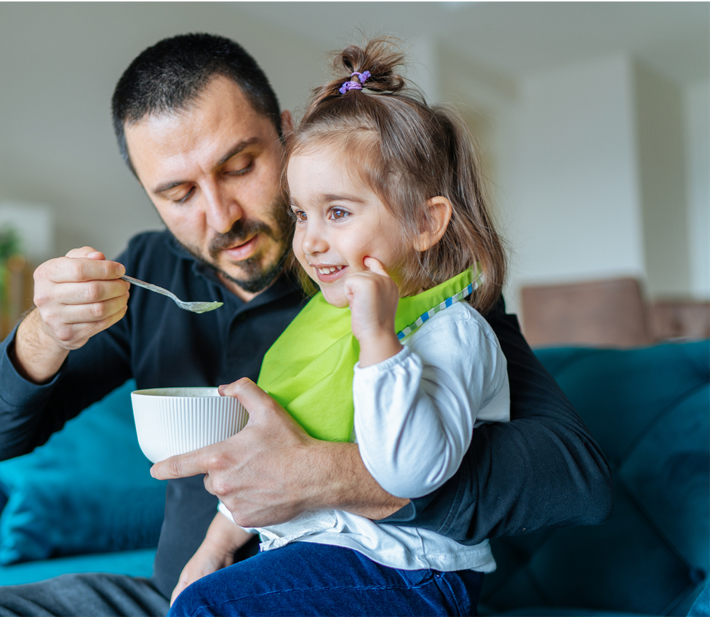

**Why is effective reunification work important?**

When children go home in an unplanned way the return home can often break down and the child/ren would then potentially need to return to care. The reasons for this potential breakdown include lack of (or poor quality) assessment on whether the child should return home; lack of appropriate services and support for child and their family and inadequate planning and preparation for return, monitoring and support post-return. Other reasons can include the parent’s problems not having been sufficiently or which were unresolved or hidden, especially alcohol or drug problems. Effective reunification work is important first and foremost because it is in the best interest of the child that any consideration of the possibility of a return home to their birth family is structured, evidence based, well planned and involves the child, their family and key multi-agency practitioners. In March 2015, the Department for Education made amendments to the Care Planning Regulations. These amendments require local authority consideration when the authority is planning to cease to look after a child. Also, Working Together 2018 provides guidance on reunification stating that “there should be a clear plan for all children who return home”, with a focus on sustainable outcomes including details of services and support required. Supporting reunification can be cost effective when there is a robust plan for the child. The University of Loughborough report that the average annual costs for each child that returns into care is £61,614 compared with an average annual cost of support a child to return home of £5,627

**What are we doing in Surrey?**

Surrey have completed a NSPCC Pilot on reunification but will be providing an in-house slightly adapted evidence-based approach through the newly created Reunification Support Service (RSS). We will invest in the support required once a child returns home, knowing that this is very much an ‘invest to save’ with the costs being recuperated by successful reunification.  In addition, this will be a countywide approach therefore reaching every child at the time that is right for them, rather than a quadrant pilot. The in-house Reunification Support Service will work alongside the allocated social worker and their manager to support a successful reunification for children identified as having a ‘reunification care plan’ by the social worker and their team manager. This service is currently funded for a two year ‘pilot.’

**What do we all need to know?**

Children will be identified for a change of care plan to reunification with their family by their allocated social work team. Social workers, together with others involved with the child and their family, possibly through a family group conference and agreed at their Looked after Child Review meeting. Other practitioners working with the child will become involved at different stages of the process. Case responsibility for the child remains throughout with their allocated social work and team manager.

The reunification framework has five stages:

**Stage 5 Reunification –** Child to be reunified home with their family with Placement with Parents Agreement in place agreed by the AD (where child is subject of a Care Order). The agreement will include clear timescales for revocation of Care Order, a robust monitoring plan and consideration of what future support may be needed post discharge of the order. If the child is S20 then the child ceases to be LAC but may be supported by a CIN plan or Early Help plan as needed.

**Stage 4 Review –** Continued review and assessment of impact of the support plan on the child and their family

**Stage 3 Implementation –** RSS to work directly with the child and their family to implement the agreed support plan alongside allocated team.

**Stage 1 Identification –** Assessment of need with consideration of risk and protective factors and parental capacity to change with the child’s voice being central to this assessment. This is undertaken by the allocated social worker and agreed by their managers.

**Stage 2 Planning –** Professional and Child & Family agreements, goal setting and support plan to be agreed by all parties

**For more info:**

**Elaine Andrews** elaine.andrews@surrey.gov.uk

Service Manager, Northwest Looked After Children’s Service

**Nicola Adesuji** [nicola.adesuji@surreycc.gov.uk](mailto:nicola.adesuji@surreycc.gov.uk)

Team Manager, Reunification Support Service for Children Looked After