

Care Episode Gateway (CEG):

Terms of Reference

Contents

1. Preamble 2
2. Goals and Objectives 2
3. Scope 2
4. Authority & Approach 3
5. Membership 3
6. Process 4
7. Decision Making 4
8. Conduct of the meeting 4
9. Chairing Arrangements 5
10. Frequency of Meetings 5
11. Notice of Meetings 5
12. CEG Proposed Agenda 5
13. Unregistered Placements 6
14. Authorisation of need v Authorisation of Resource/funding 6
15. Approval, review, and variation of Terms of Reference 6

Preamble
BCP Care Episode Gateway is the key forum for oversight and authorisation of resource access, allocation and governance. Its purpose is to provide a structure and process whereby requests for care entry are appropriately considered and where appropriate, professionally challenged. CEG will direct prevention activity and ensure appropriate case and resource progression. Additionally, regulatory, and budgetary aspects will be determined and monitored via the membership of this panel. This panel will provide the primary governance for authorising CLA episodes.

Goals and Objectives
The goals of the CEG are:
- To consider care entry for all such requests and to authorise the commencement of placement search activity
- To authorise any placement and the associated funding for such a placement
- To retrospectively consider and confirm (or otherwise) any emergency placement where limited agreement has been given to meet immediate need
- To determine tasking, activity, and decision review prior to any care entry authorisation
- To receive a review of rehabilitation activity for all s.20 agreements on or before week 12 of any such agreement – the aim of which will be rehabilitation home wherever possible and appropriate
- To review the search profile and/or approach if search activity does not deliver resource options within 20 working days
- To review placement searches that have not delivered viable options after an initial 8-week search period

Scope
CEG is designed as the determinant in access to, and amendment of a placement. It will appropriately challenge s.20 accommodation requests, task Edge of care activity to prevent/divert accommodation by the local authority where it is safe, proportionate, and appropriate so to do. CEG will scrutinise proposed placement type, specific provision and will necessarily apply best value principles through the lens of risk, protection, and proportionality. It is a multi-agency challenge panel and carries the decision-making authority as final arbiter in determining access to resources. For clarity, it is stated that planning for care proceedings is clearly the domain of the LPM / PLO process and not that of the CEG. CEG will however need to consider the resource request.

Authority & Approach
- Placement authorisation is vested in the Care Episode Gateway
- There should be an expectation of professional curiosity & challenge
- Such challenge will provide a balance between best outcome and best value
- Emergency authorisation outside of CEG will be by exception and retrospective authorisation will be considered at the next available CEG
- CEG will be the final arbiter of all regulated placement decisions

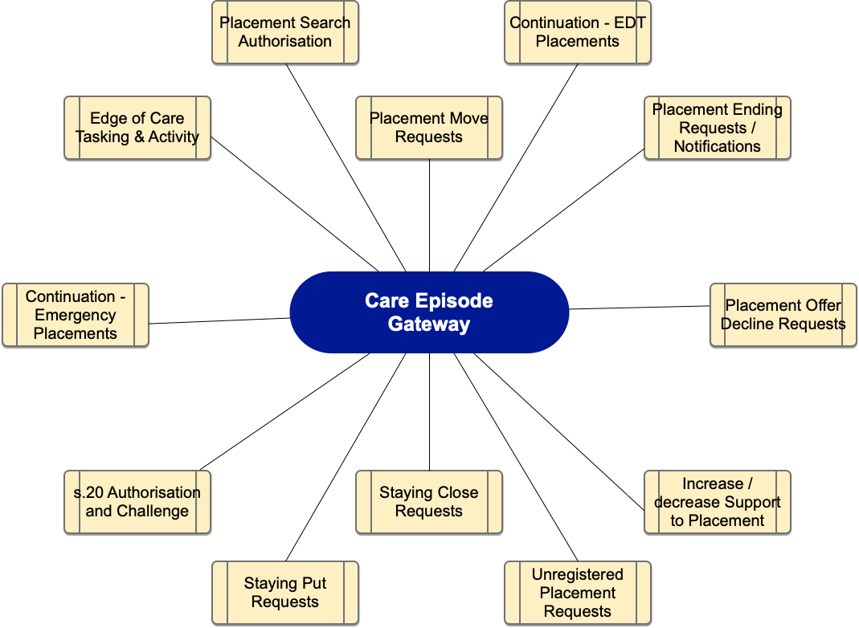

Membership
The membership of the CEG will consist of:
- Director (Corporate Parenting & Permanence) – provides strategic case direction
- Service Manager (Early Help) – provides access to preventative and rehabilitative services (Edge of care)
- Service Manager (IRO service) – Provides Independent view and challenge where appropriate
- Placements Manager – provides access to External placement resource
- HoS Commissioning – Sufficiency, provision, regulatory advisor to the panel & budgetary monitoring lead
- Payments Team Manager
- Service manager (Fostering) – provides access to internal foster placement resource
- Representative from YJS
- Panel coordinator – BSO resource to act as coordinator and to minute the panel (Suggest dedicated resource)
- Head of Virtual School
- CLA Nursing Representative
Where the nominated individual is unable to attend it is expected that they identify a suitable representative to attend in their place.

Process
- CEG will receive notification from the Placements team when a request for a new placement has been made in Mosaic. This will provide all necessary information upon which the request can be appropriately considered.
- The SW and TM will be invited to talk to the request (SM / HoS optional invite)
- Decisions and required actions are recorded using the CEG Decision and Actions Record which is added to a case note in Mosaic
- Placement authorisation will be considered
- Initial S20 rehabilitation outcome will be reported back by week 12 (by IRO)
- CEG aims to both facilitate and challenge and its actions will be professional, appropriate and proportionate

Decision Making
The principles of decision making in CEG:
- Evidenced-based
- Based on a thorough understanding of the circumstances & lived experience of the child or young person and their family
- Made in the best interest of the child/young person
- Determined by collective discussion and professional curiosity
- Guided by regulatory requirements

Conduct of the meeting
- The meetings will require attendance or nominee attendance by all determined as required attendees
- The agenda will be driven by appropriately completed Placement Request forms
- No additional paperwork is required at point of request
- Attendance should be anticipated but attendance requests will be sent 2 working days prior to each panel meeting
- Requests received after meeting invitations have been sent will be at the discretion of the chair and based or urgency of need
- Meetings will be held as a virtual/In-person Hybrid

Chairing Arrangements
CEG will be jointly chaired by Service Director – Corporate Parenting & Permanence & Head of Service – Placements & Resources. This is to reflect the required focus and challenge related to practice and service commissioning. Any member of the group, as nominated by the joint chair, may deputise in the event of the unavailability of the joint chairing arrangements.

Frequency of Meetings
CEG will meet weekly on Thursday afternoons at 13:30 to 16:30. This is to give sufficient time for the consideration of all business in a single meeting.

Notice of Meetings
Unless otherwise agreed, notice of each meeting confirming the venue, time, and date will be agreed in advance and at a minimum of 2 working days before the meeting, with details circulated once agreed.

CEG Proposed Agenda
In order to ensure that all required aspects of the gateway process are met at each gateway meeting, the following agenda is proposed (3 hours duration):

  - Emergency placement requests – retrospective consideration (need & resource related) (15 minutes)

  - New placement requests for consideration (45 minutes)

  - Cases scheduled for review (45 minutes)

  - Review all unregistered placements (30 minutes)

  - Placement search reviews (any search exceeding 20 working days) (30 minutes)

  - Placement Resource authorisation / Placement decline requests (30 minutes)

  - AOB (15 minutes)

Unregistered Placements
- Requests for the creation of any unregistered – unlawful placement will be made in writing to CEG

- CEG will hear any such request and will determine whether the chair will make a request to DCS to consider approval of such

- These placements will be considered on an exceptional need basis and given their unlawful nature, this must ultimately remain a DCS decision

- Reviews of all existing unregistered placements will be a standing agenda item

Authorisation of need v Authorisation of Resource/funding
- A distinction will be made between the above

- This is especially important when considering emergency placements

- The process will therefore distinguish between best outcome and best value with a clear and distinct remit/focus

- Both aspects meet in CEG and the specificity of the focus is considered highly beneficial

Approval, review, and variation of Terms of Reference
The CEG terms of reference will be reviewed, updated as required and approved by group members at least every six months. Any required changes to process or approach will then be communicated as appropriate.

Nicole Mills
Director of Corporate Parenting & Permanence

Jonathan Wade
Head of Service – Placements & Resources
January 2024

