Children’s Social Care Quality

Assurance Framework
Children, Families, Lifelong Learning and Culture

Patricia Denney
Director of Quality and Performance July 2021

1 | P a g e

Introduction
The aim of the quality assurance framework is to improve outcomes by monitoring the quality of practice and service provision. This is achieved in several ways, including:
  - Promoting an understanding that quality of practice and service provision is everybody’s business and everybody’s responsibility
  - Promoting quality consistency across Children’s Services
  - Creating a mechanism for the ongoing monitoring and measuring of performance against required standards and agreed targets
  - Identifying strengths, best practice and areas for improvement
  - Enabling services to learn and benefit from audit findings
  - Identifying substantive or systemic areas of underperformance to inform the work programme of Performance and other services
  - Developing a feedback cycle which drives a learning culture of continuous improvement where problems are addressed openly and honestly
  - Enabling a clear line and method of quality assurance communication between staff members and Practice Leadership Team (PLT)

The Framework outlined here sets out our role and activities in finding out:
  - Are we doing the right things for the child at the right time?
  - Are we keeping children safe?
  - Are we supporting parents?
  - Are we improving outcomes for children?
  - How well are we doing this?
  - How successful is the family safeguarding model of practice?
  - Are we making a difference?
  - Are we engaging well with children and their families and taking account of their views/ wishes?
  - Can we evidence this?
  - What are we doing well?

  - Good quality management
Good quality management is an active pursuit designed to make a difference - rather than simply monitoring quality in a passive way.
Effective quality management is characterised by:
    - A clear understanding of needs achieved through rigorous needs analysis
    - Explicit aims, objectives, priorities and targets for services
    - Clear plans, strategic and operational in nature, informing service delivery
    - Relevant measures enabling judgements to be made on whether services are achieving what is required
    - Reporting at the right levels to enable appropriate decisions and actions to be taken in a timely manner

Effective quality and performance management is predicated on achieving clarity of the differing roles and responsibilities of individuals.

Our approach
Our approach has five steps that are needed to achieve practice assurance: Evidence, Analysis, Action, Learning and Impact.

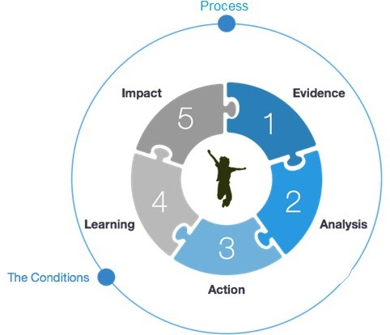

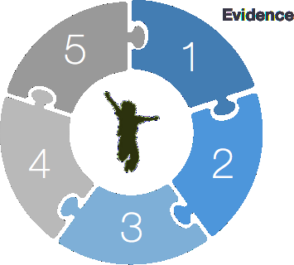
There is a wealth of evidence available for all staff; leaders, managers and practitioners, to use and embed in their work to ensure children are safe, seen and heard. This evidence is captured through for example; our direct work with children; service audits and tableau as well as deep dives and peer reviews. We will use this information to understand what is working well and what we need to improve on and to support informed and accurate quality and performance conversations.

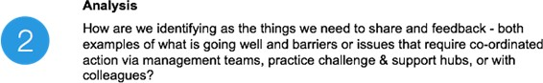

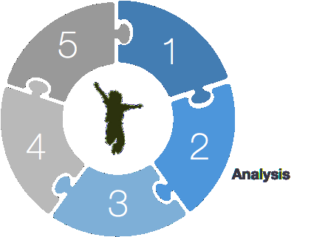
Simply collecting evidence and information is not enough. We need to know and understand at all levels what has gone well, what we need to improve and hat effort or activity is needed to drive that improvement. We will need to know this in the context of the whole system and be alive to the consequences f any adjustment we may make. We are collectively responsible for this. Practitioners, managers, heads of service and the leadership team will all use the evidence available to them, to analyse, challenge and improve quality and performance as well as learning from assurance activity.
a w

o

a

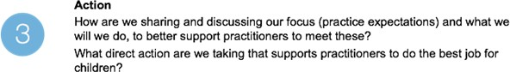

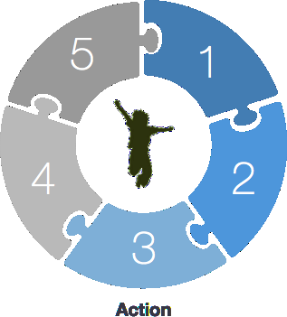
We must have the systems in place to ensure we are able to respond to the intelligence our quality and performance activity is providing us with. We have set out the ways in which we will share our assessment of practice in the products section below. Day to day quality and performance activity is embedded within our teams, which are the checks and balances teams have in place to assure their own work, and include supervision, peer discussions, case debrief and team discussions. We are keen that this activity is captured to ensure experiences in teams leading to improvement in practice is shared at a system level. Quality and performance management routines will be put in place for all managers through service arrangements.

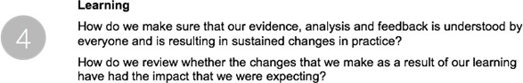

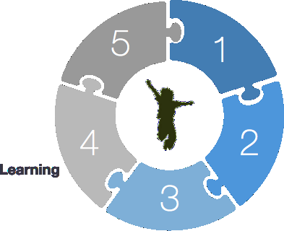
Organisation and whole systems learning is vital to the creation of a culture of improvement. The first three steps in our process support this learning and the identification of the key lessons or issues that the system would need to learn in order to improve is a pre-requisite. Learning is an important step in our assurance process and dependent on the previous steps if it is going to be meaningful and impactful. Learning is of course taking place as the evidence is captured and analysed, and to have systems wide learning a process or programme of learning is needed that effectively reaches out beyond senior leaders to practitioners.

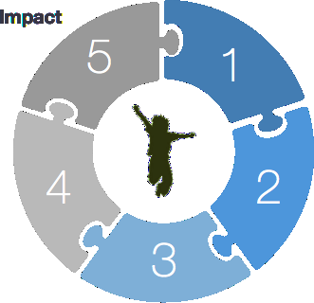
Evidencing the impact of our learning will be central to ensuring our activity makes a difference for children and families. Shared accountability for practice that has an impact on good and improved outcomes for children and families will be upheld through quality supervision discussions, performance and quality meetings and existing protocols. We will invest in the approaches to check the impact of our work. We will set conditions and routines that require us to check we made a difference. Through being curious about the impact of our activity, we will be constantly aware there is more to learn.

Practice standards
We have set out what good practice looks like and expectations of staff and management through our ‘Children’s Social Work Practice Standards’. Understanding and reviewing how well embedded these are into our practice is a key feature of our practice learning framework and programme of activity.
In Summer 2021 a working group has led on refreshing these standards to ensure they are fit for purpose and align with best practice from Outstanding and Good authorities. The revised materials will be available on Tri-X by the Autumn and will be more comprehensive than our current documents.

Practice Learning Framework
Our practice learning framework (see figure below) is the implementation of our approach for understanding and improving the quality of practice. It shows the type of activities that come together for each of the five steps of the learning framework (Understand, Plan, Do, Review, Revise) that will ensure we understand, respond to, measure and improve services and outcomes for children.
Auditing is a crucial part of our practice learning framework and the Quality Assurance Service manages the overall process and programme of work. A monthly, countywide (all four quadrants) audit programme exists which supports our understanding of the quality of practice and helps us to identify remedial actions that apply countywide. The Audit and Practice Standards service is responsible for collating and reporting overall findings from this countywide monthly audit programme, and make recommendations for improving practice that will in turn improve outcomes for children.
A key function of the Audit Programme is to provide practitioners and managers with a consistent and accurate account of expectations around practice, focusing on agreed quality standards and best practice. The audit programme has included practice observations since 2020; the practice observations are additional QA activity which give managers the opportunity to quality assure practice in different ways.
Each individual member of staff is responsible for the quality of their own day to day operational practice. Operational managers will routinely (e.g. through supervision) identify remedial activity and action that is required to improve practice and an individual case by case basis. This is their day to day business.
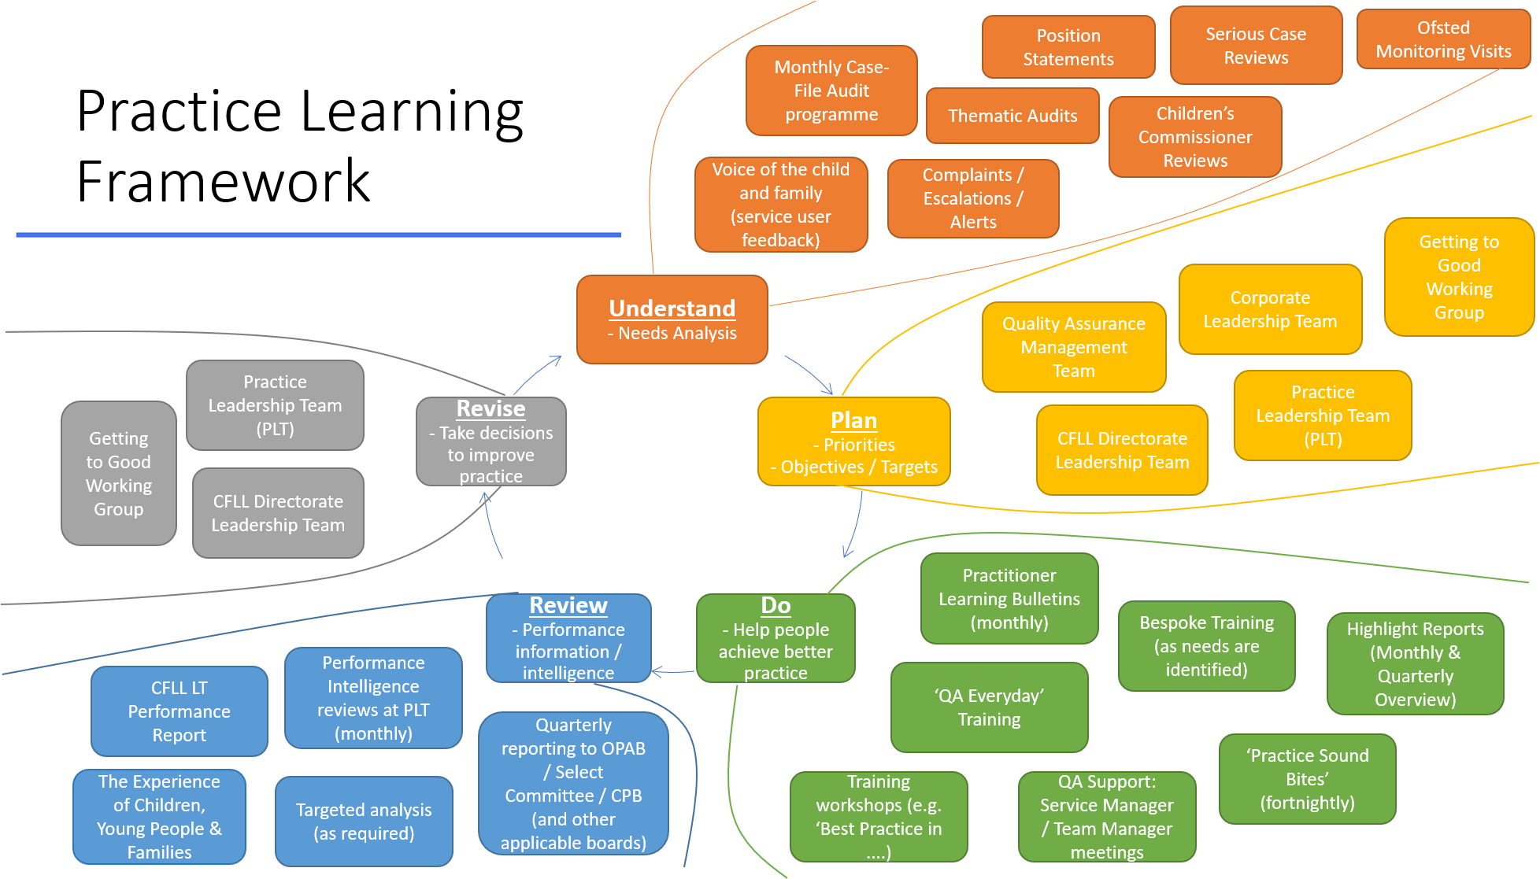

Do – help people achieve better practice

Voice of the child, the family, and their experiences
Listening to and responding to users and particularly the voice of the child, alongside that of their carers is one of the most important ways to understanding how the services we deliver are being received and whether our practice is making the right difference for children and families. Feedback from children, young people and families will be used to build our evidence of users’ experiences, learn from them and in turn improve our support and services. The figure below shows the many ways our young people are involved strategically, operationally, and individually.
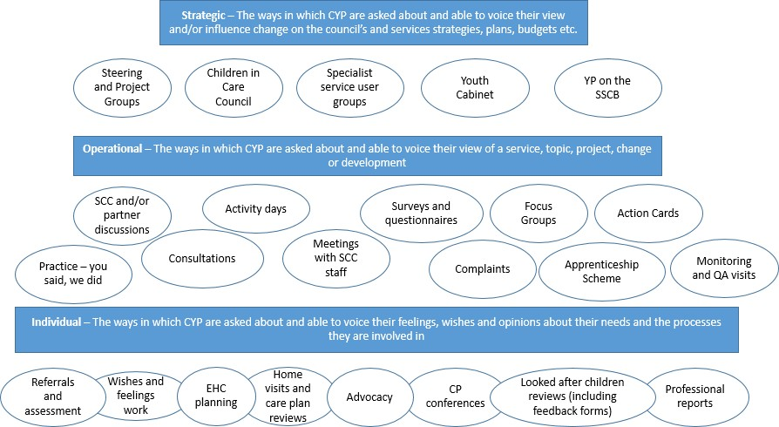

Responsibilities within Children, Families, Lifelong Learning and Culture
In Surrey, performance and quality are everybody’s business and everybody’s responsibility. The council’s Elected Members, managers and staff share overall responsibility for the management, delivery and governance of services and for striving for continuous improvement and excellence. Users of services and residents rightly expect high levels of performance and accountability from the council. The differing but complementary roles and responsibilities of the council’s officers and of the elected members in respect of performance management are summarised in this and the following section.
Departmental Management Teams and Divisional Directors (Executive Director for Children, Families, Lifelong Learning and Culture and his direct management team) are responsible for the day to day performance management of operational and strategic services through:
- Promoting and embedding a strong performance and quality management culture across individual council departments
- Holding Assistant Directors and Service Managers to account for the performance and quality of their areas of responsibility
- Monitoring service performance and quality across all service areas

- Ensuring performance and quality management is integrated into business and service planning and into the performance management processes for individual staff

Assistant Directors (four quadrants), Service and Team Managers are responsible for managing and improving performance and quality effectively within their particular service areas by:
- Promoting the performance and quality management culture within specific service areas
- Ensuring appropriate planning, supervision and performance management processes are in place for specific service areas
- Regularly reviewing and analysing data and intelligence in respect of the performance and quality of specific services and staff
- Identifying performance and quality improvement requirements of services and staff and planning accordingly
- Implementing service improvement plans

The Quality and Performance service have a responsibility to report on service quality and performance to the Lead Member for Children, Members of the County Council, in particular Cabinet Members, and the Select Committees, and, to Departmental Management Teams.

All Practitioners and Staff have their own responsibilities in respect of performance and quality management and service improvement through:
- Having a relentless focus on improving outcomes for children
- Maintaining awareness of relevant council and departmental priorities
- Being aware of their own performance and quality against relevant standards, objectives and targets, including adherence to occupational or professional standards where they exist
- Being committed to meeting personal and service improvement needs through learning and development and involvement in service planning.

Council Governance

Elected Members act in the public interest, working for the benefit of the county as a whole. The Executive and Cabinet Members set the policy context for council services and are responsible for the administration of the council’s affairs. The Leader of the Council directs the Chief Executive who is accountable, with the Corporate Leadership Team (CLT), to the Leader and respective Cabinet Members for the effective delivery of council services.
Cabinet Members and Lead Member for Children in particular have responsibility for:
- Agreeing with senior officers the strategic direction of services and performance improvement priorities
- Progressing policy decisions of the Administration through to implementation
- Providing strategic oversight of the effectiveness of performance and quality management arrangements in council services

- Holding senior managers – The Executive Directors and Departmental Leadership Teams (DLT) – to account for the performance of services for which they are responsible

The Select Committees (the Children, Families, Lifelong Learning & Culture Select Committee in particular)
provide support and challenge to the Executive and Portfolio Holders through:
- Contributing to the development of council plans for services
- Examining whether plans are being implemented effectively
- Receiving reports on performance and quality, asking challenging questions about areas of underperformance and poor quality, and making recommendations accordingly to the Executive

The Chief Executive’s Leadership Team (Chief Executive and Executive Directors) is responsible for ensuring council services perform effectively and achieve objectives set by central government, relevant regulators, and the council’s Executive through:
- Advising Elected Members on the setting of the strategic direction and performance and quality improvement priorities for council services
- Setting appropriate outcome-based targets and performance and quality standards
- Receiving strategic level performance and quality reports and acting on areas of underperformance and poor quality
- Ensuring that there is robust performance and quality management and a strong performance and quality culture embedded across all council services

Document last reviewed: November 2023
Reviewed by: Kasey Senior – Service Manager, Practice Standards
Next review date: September 2024

