 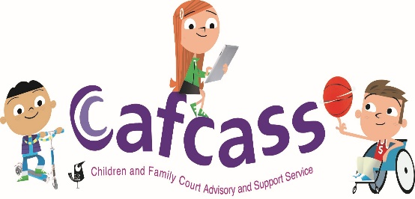 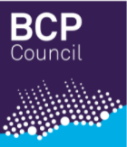

**Pathfinder Good Practice Guidance: Determining whether Cafcass or a Local Authority should prepare a Child Impact Report**

**Current Arrangements**

Under S7 of the Children Act 1989, courts dealing with private law proceedings can direct either Cafcass or a Local Authority to report on the Welfare of a child/ren.

Within the Pathfinder Pilot a Child Impact Report will be filed, replacing the traditional Safeguarding Letter and S7 Reports commonly seen in private law proceedings.

All private law applications received by courts in Dorset will be subject to an initial Gatekeeping process. Within this process the court will decide whether an application should come to Cafcass for Part One of the Child Impact Report to commence. The initial stages of Part One of the Child Impact Report is safeguarding checks with both the Police and the Local Authority.

Within these checks, information from the Local Authority may show that the child/ren are known to the Local Authority and in such cases a decision will need to be made as to whether Cafcass or the Local Authority are best placed to continue with the remainder of the Child Impact Assessment.

There is a Protocol for allocating responsibilities for court reporting in private law children’s proceedings between Cafcass and Local Authority Children’s Services between the ADCS and Cafcass already in existence. This Protocol is clear about the criteria which would need to be met for the responsibility of the Child Impact Report to fall to the Local Authority:

1. **The child has an open case to statutory services.**
   * The child has a Child in Need Plan, Child Protection Plan or is looked after by the Local Authority.
   * There is an ongoing Local Authority investigation following a referral for the child which will result in ongoing work for the Local Authority
   * The child’s case has closed less than 12 weeks before the report is asked for.

b) If none of the above apply, then the court should be advised to order Cafcass to complete the section 7 report. It is important for the court to note that once the local authority completes and files the section 7 report and is awaiting a court date, it will not hold the case open and active.

c) Whether Cafcass or a local authority are directed to prepare the report, each agency is able, pursuant to Rule 12.73 of the Family Procedures Rules 2010, to provide the other agency with all the relevant information they hold to ensure that the court has a complete picture.

d) Where Cafcass is recommending that a local authority prepares a section 7 report, Cafcass should first discuss this with the allocated local authority social worker and/or the first line manager.

This is set out in the agreed policy embedded below.



**Disputes**

In the unusual event there is a dispute between Cafcass and the local authority about responsibility for a Child Impact Report, in the first instance, both agencies will endeavour and expect to resolve this without the need for any further court determination. The Service Manager at Cafcass and the Principal Lawyer at the Local Authority will liaise about any disputes promptly to avoid and minimise any impact on the court timetable.

The agency disputing responsibility will raise this with the other in writing within three working days of receipt of the order. A response will be provided within three working days.

If both agencies agree a transfer of responsibility, the agency seeking transfer will write to the allocated Judge by email to request that the order is amended.

If it is not possible for the agencies to agree responsibility, this will be referred to the court to determine on the basis of written submissions from each agency. Each agency will send a letter by email to the court. This will take place within seven days of service of the order. The court will inform Cafcass and the Local Authority of the outcome within seven working days. The decision of the court will be final and is not open to further challenge from either agency.

The agency named in the court order will remain responsible for compliance with the Child Impact Report direction unless and until the court directs otherwise.

Name: Grant Williams

Head of Practice - Cafcass

Date: 3rd April 2024

Name:

Bournemouth Christchurch and Poole Local Authority

Date:

Name:

Dorset Local Authority

Date: