Guidance for
Fabricated or Induced Illness

January 2022

Anita Hiller

Social Work Standards Officer

This guidance should be read in conjunction with the following procedures and guidance:

Perplexing Presentations (PP) / Fabricated or Induced Illness (FII) in Children - guidance (Royal college of Paediatrics and Child Health, February 2021)
Overview- Fabricated or induced illness (NHS 2019)
Fabricated or Induced Illness (Kent Safeguarding Children Multi-Agency Partnership)

Contents

Subject | Page
Definitions | 3
Impact on the child and harm | 4
Identifying concerns of Fabricated or Induced Illness | 6
Perpetrators of FII | 7
Prevalence of FII | 8
Royal College of Paediatrics and Child Health guidance (Perplexing Presentations (PP) / Fabricated or Induced Illness (FII) in Children February 2021) | 8
Front Door Service | 9
Strategy Discussions | 10
Assessment | 11
Supervision/ Management Oversight | 12
Voice of the Child | 13
Covert Video Surveillance | 13
Flowchart | 15
References | 16
Definitions

Fabricated or Induced Illness (FII) in a child is a condition whereby a child suffers harm through the deliberate action of her/his main carer duplicitously (deceitfully) attributed by the adult to another cause (DfE, 2008). In Working Together (2018) it is also identified within the definition of physical abuse stating ‘a form of abuse which may involve hitting, shaking, throwing, poisoning, burning, or scalding, drowning, suffocating or otherwise causing physical harm to a child. Physical harm may also be caused when a parent or carer fabricates the symptoms of, or deliberately induces, illness in a child’.

In February 2021, the Royal College of Paediatricians and Child Health updated their guidance and introduced the term of ‘Perplexing Presentations’. The guidance details how health professionals can best work with children and their parents when there are concerns of FII and is a helpful document for social workers to be clear about the role of the health professional in these circumstances.

The definition of Perplexing Presentations is:

“…there are alerting signs of possible FII (not yet amounting to likely or actual significant harm), when the actual state of the child’s physical, mental health and neurodevelopment is not yet clear, but there is no perceived risk of immediate serious harm to the child’s physical health or life. The essence of alerting signs is the presence of discrepancies between reports, presentations of the child and independent observations of the child, implausible descriptions and unexplained findings or parental behaviour” (RCPCH 2021).

The table below is taken from the RCPCH guidance (2021) and defines the terms used by health professionals to describe the presentation of children with questionable health issues.

Term | Definition | Synonyms
Medically  Unexplained  Symptoms  (MUS | The child’s symptoms, of which  the child complains and which are  genuinely experienced, are not fully  explained by any known pathology but with likely underlying factors in the child (usually of a psychosocial nature), and the parents acknowledge this to be the case. The health professionals and parents work collaboratively to achieve evidence-based therapeutic work in the best interests of the child or young person. MUS can also be  described as ‘functional disorders’ and are abnormal bodily sensations which cause pain and disability by affecting the normal functioning of the body. | Non-organic symptoms,  Functional illness,  Psychosomatic symptoms.
Perplexing  Presentations  (PP) | Presence of alerting signs when the  actual state of the child’s physical/  mental health is not yet clear but  there is no perceived risk of immediate  serious harm to the child’s physical  health or life.
Fabricated or  Induced Illness  (FII) | FII is a clinical situation in which a child is, or is very likely to be, harmed due to parent(s’) behaviour and action, carried out to convince doctors that the child’s state of physical and/or mental health or neurodevelopment  is impaired (or more impaired than  is actually the case). FII results in  emotional and physical abuse and  neglect including iatrogenic harm. | Munchausen Syndrome by  Proxy; Paediatric Condition  Falsification; Medical Child  Abuse; Parent-Fabricated  Illness in a Child; (Factitious  Disorder Imposed on Another,  when there is explicit  deception).

Impact on the child and harm

Harm caused by fabricated or induced illness can manifest itself in 3 ways:

1. Child’s health and experience of healthcare
- Repeated unnecessary medical appointments, examinations, investigations, invasive procedures, and treatments, which are often experienced by the child as physically and psychologically uncomfortable or distressing and may be dangerous to the child.
- Genuine illness may be overlooked by doctors due to repeated presentations
- Illness may be induced by the parent/carer (e.g., poisoning, suffocation, withholding food or medication) potentially or actually threatening the child’s health or life
- Adoption of dysfunctional health beliefs by the child, with long term consequences for this child and their potential future children.

2. Effects on child’s development and daily life
- Limited / interrupted school attendance and education
- Normal daily life activities are limited and/or social interaction e.g., overprotection, limitation of exploration and learning, prevention from participation in normal social interaction.
- Limitations on development
- Child assumes a sick role
- The child is socially isolated

3. Child’s psychological and health-related wellbeing
- The child may be confused or very anxious about their state of health. Child may be obtaining information from social media and from their own peer group which encourage each other to remain ‘ill’
- The child may develop a false self-view of being sick and vulnerable and adolescents may actively embrace this view and then may become the main driver of their own sickness, getting caught up in sickness roles
- There may be active collusion with the parent’s illness deception or they may be silently trapped in falsification of illness
- The child may later develop one of a number of psychiatric disorders and psychosocial difficulties
- Adoption of dysfunctional health beliefs by the child, with long term consequences in their adulthood and for their potential future children.

The diagram below by Davis et al (2017) shows in pictorial form that not only a parent can cause harm but the ways in which this can be caused and the impact of medical professionals’ actions or procedures which can compound issues for children.

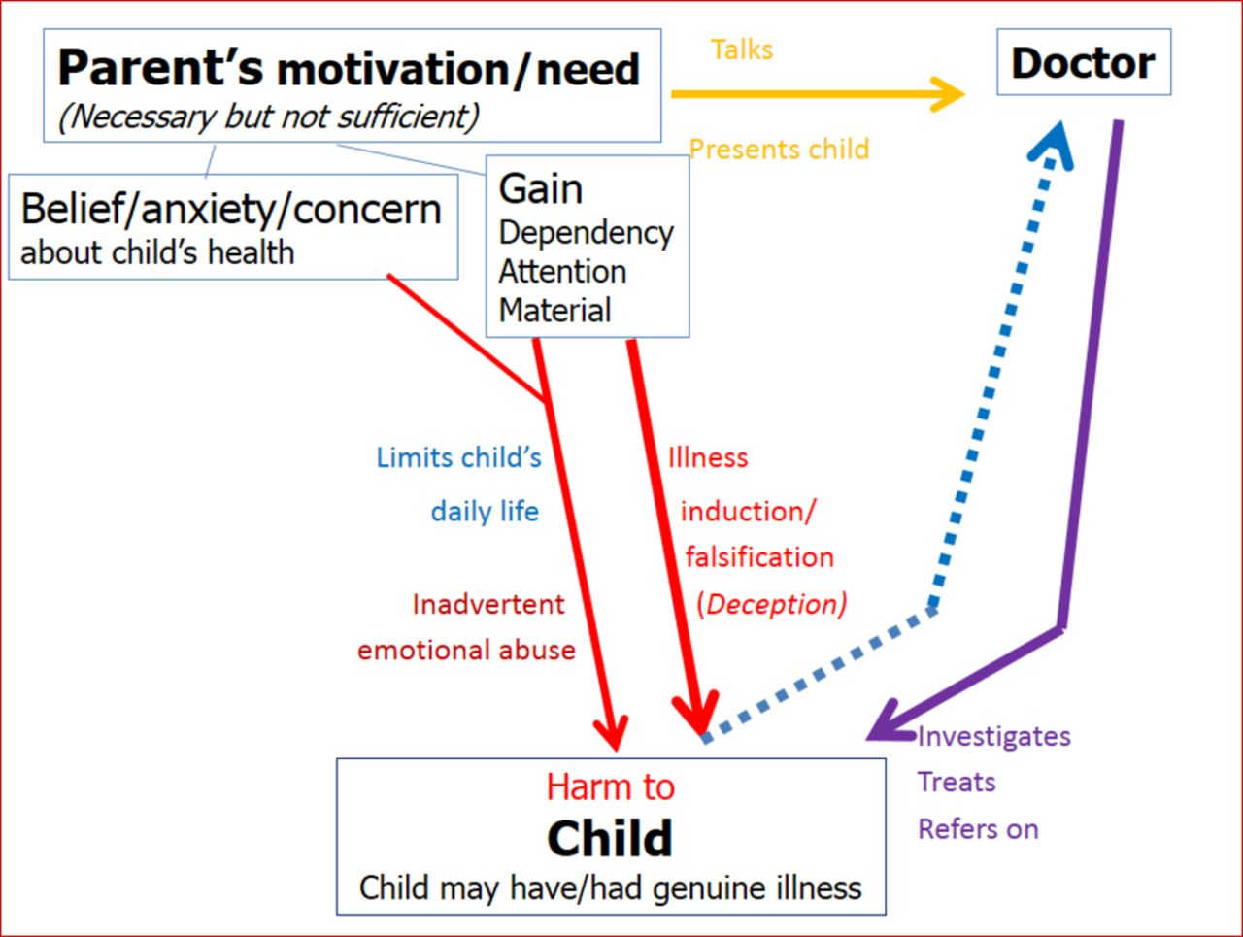
Davis et al 2017

NB. FII was formerly known as Munchausen Syndrome by Proxy in the UK and other terms in the USA include Factitious Disorder by Proxy and Medical Child Abuse.

Identifying concerns of Fabricated or Induced Illness

Practitioners need to be alert to behaviours and indicators of FII. This is not an exhaustive list but some of the indicators can include parents:

- Claiming a child has symptoms which are unverifiable unless observed directly, such as pain, frequency of passing urine, vomiting or fits
- Fabricating a child’s past history
- Alleging that their child has a psychological illness
- Deliberately inducing symptoms in a child by administering medication/other substances
- Interfering with treatment by overdosing or withholding medication
- Tampering with medical equipment or falsifying charts/records/letters/documents/ specimens of bodily fluid
- Attendance at various hospitals, in different geographical areas
- Obtaining specialist treatments or equipment for children who do not require them
- Symptoms and signs found on examination are not explained by any medical condition from which the child may be suffering
- Physical examination and results of medical investigations do not explain reported symptoms and signs
- Poor response to prescribed medication/treatment
- New symptoms are reported on resolution of previous ones
- Missed appointments
- Reported symptoms and found signs are not observed in the absence of the carer
- Child presented with different symptoms in different settings
- Excessive use of medical websites or research

It is important to note that a child may have a genuine illness but additional undiagnosed symptoms or issues which have been fabricated. In cases where the child is not ill, the parent/carer may have a genuine belief that the child is ill.

Practitioners need to be aware that as a result of identifying or challenging a parent about FII, there may be unintended consequences when the parent/carer increases the harmful behaviour in an attempt to be convincing. In addition, a parent/carer who harms their child may appear plausible, convincing and have may have developed a friendly relationship with medical professionals. They may demonstrate sophisticated knowledge of medical procedures and this can make them difficult to challenge. They teach their children to present a picture of ill-health to the outside world.

Sometimes there may be a financial gain through seeking benefits or fundraising.

Perpetrators of FII

Evidence indicates that FII is usually carried out by the child’s mother or female carer (85% of reported cases are the mother, NHS 2019). The diagram below is a simplistic view of the reasons for FII which are often complex and multi-layered.

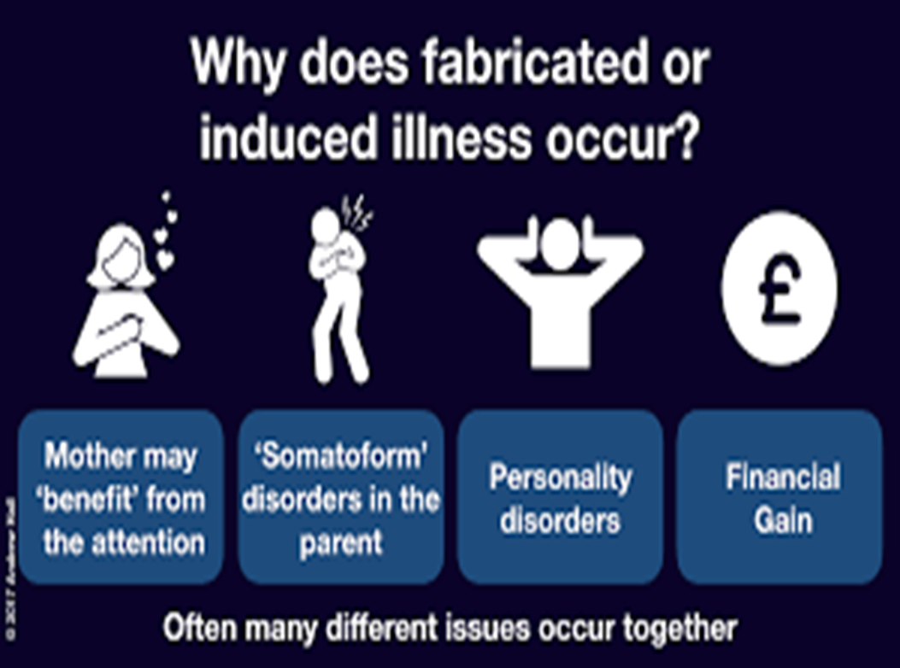
N.B. Somatoform disorders (also known as Somatisation Disorder/ functional symptoms/ psychosomatic symptoms) are where the person experiences physical symptoms with no known medical cause. There could be a range of reasons for this including stress. The cause is not known. It may have something to do with an unconscious desire for help, attention or care and runs in some families. It mainly develops between the ages of 18 years and 30 years, although is seen in younger people, and more women than men are affected. It is difficult for a doctor to diagnose because it is difficult to be sure that there is no physical cause for the symptoms. So, people with this disorder tend to be referred to various specialists and have many tests and investigations. However, no physical disease is found to account for the symptoms (Patient Information, 2020).

In a literature review in the USA in 2017, researchers found 96% of abusers were women and 91% were the mother; 42% had fabricated own illnesses; 25% had been sexually abused as children; and 20% had medical training/experience (Yates and Bass, 2017).

In cases where the mother is the perpetrator, the father is often unaware of the mother’s actions.

Practitioners should also be aware of the possibility of other perpetrators including fathers, grandparents, siblings, other children, and professionals.

Perpetrators of FII may have:
- a history of childhood abuse (physical, emotional, sexual)
- current or previous mental health, especially personality disorders or psychotic illness
- some medical knowledge and use this to try to intimidate professionals.
- made threats of lawsuits
- refused to allow information to be shared amongst professionals, especially medical professionals
- exhibited behaviours of being over-anxious or less attentive than you would expect
- fabricated or induced illness in themselves previously or currently
- financial motivation – benefits, fundraising
- been more vocal/dominant than the other parent/carer

Prevalence of FII

FII is rare in comparison to other forms of child abuse, although it is thought to be widely underestimated. Research in 2000 found 89 cases in 100,000 children in the UK (Lazenblatt and Taylor, 2011). Dr Alison Steele, Officer for Safeguarding at the Royal College of Paediatrics and Child Health, states “it is very rare for parents or carers to deliberately induce illness in a child by, for example, poisoning them or withholding treatment. Most cases are based on incorrect beliefs, misplaced anxiety or verbal deception…” (UCL, 2021).

Fabricated or Induced Illness can happen to children of any age but is most commonly found in younger children (under 5’s). This may be due to children of this age being less able to articulate what is happening or younger children being non-verbal.

Royal College of Paediatrics and Child Health guidance (Perplexing Presentations (PP) / Fabricated or Induced Illness (FII) in Children February 2021)

Please note this section explains what steps health professionals take when Perplexing Presentations are considered or FII is suspected and act as information for social workers. These are not the actions taken by Integrated Children’s Services.

There has been a shift towards earlier recognition of possible FII and intervention without the need for proof of deliberate deception. The guidance for health professionals states that in the absence of clear evidence about risk of immediate serious harm to the child’s health or life, the early recognition of FII is better termed Perplexing Presentations, requiring an active approach by paediatricians and an early collaborative approach with children and families.

Children should not be subjected to unnecessary investigations or medical interventions, always bearing in mind that verified illness and fabrication may both be present. Unless there is significant risk of immediate, serious harm to the child’s life the need for sharing information between different professionals (health providers, education, social care) involved in the child’s life should be discussed by medical professionals with the child/young person and their parents. This should be done in a non-confrontational manner, by discussion of the perplexing nature of some aspects of the child’s presentation, and by explaining the usefulness of gathering information to inform care.

A Health and Education Rehabilitation Plan agreed by professionals and families is an essential feature of management of Perplexing Presentations and FII. This is not dependent on Integrated Children’s Services being involved. It requires a co-ordinated multidisciplinary approach and negotiation with parents. The plan must specify timescales and intended outcomes. Actions could include reducing/stopping unnecessary medication; resuming oral feeding; or offering graded physical mobilisation. There may also be psychological support. The plan will be reviewed regularly by medical professionals.

If the parents disagree with the information and an effective Health and Education Rehabilitation Plan is not agreed, or if parents do not engage with the HERP and the concerning behaviours continue, health professionals will refer to the Front Door Service. The family must be informed of the concerns by medical professionals prior to the referral.

Front Door Service

The Front Door Service will review the information in the Request for Support Form and will use the Support Levels Guidance to consider what, if any, action should be taken at this stage.

Where there is no immediate risk, as part of their ‘further enquiries’ the Front Door Service should enquire whether parents/carers are aware of the medical professionals’ concerns and whether a Health and Education Rehabilitation Plan has been put in place and its progress. A copy of the HERP should be obtained for the child’s electronic file.

The Front Door Service will decide the response required within 1 working day.

Where there is an immediate risk of significant harm or likelihood the child will suffer significant harm, a Strategy Discussion should be convened.

From the point of referral, all professionals involved with the child should work together as follows:

- Lead responsibility for action to safeguard and promote the child’s welfare lies with Children’s Social Work Services
- Any suspected case of FII may involve the commission of a crime and therefore the police should always be involved whenever there is reasonable cause to suspect that a child is suffering or is likely to suffer significant harm
- The paediatric consultant is the lead health professional and therefore has lead responsibility for all decisions pertaining to the child’s health care

All cases of suspected FII need to be assessed by a social worker. However, in cases where the Request for Support suggest that the parent/carer may just need support, the Front Door Service will consider if Early Help, rather than the Children’s Social Work Service would be the most appropriate service. This would be in conjunction with health professionals already working with the family.

Strategy Discussions

A strategy discussion should be held if a possible explanation for the signs and symptoms is that they may have been fabricated or induced by a carer and/or if there is reasonable cause to suspect that a child is suffering or is likely to suffer significant harm.

A strategy discussion regarding FII must be chaired, at a minimum level, by the Team Manager at district level or Senior Practitioner at the Front Door Service. The meeting requires involvement of key senior professionals responsible for the child’s welfare. At a minimum this should include Children’s Services; Central Referral Unit (FDS) / Vulnerable Investigation Team (CSWS), Kent Police; Consultant Paediatrician and the professional who sent the Request for Support. Also:

- Senior ward nurse if the child is an in-patient
- Medical professional with relevant expertise
- GP/health visitor
- Staff from education settings
- Health Safeguarding Practitioner/ Designated Nurse/ Named Nurse
- LADO if appropriate (allegation against a professional)

The Strategy Discussion should:

- Share information and contribute to starting to collate a shared multi agency chronology
- Consider any criminal investigation
- Consider Section 47 enquiries and how this will be undertaken
- Consider health considerations. E.g., what steps will be taken to meet the child’s health needs.
- Consider the impact on any siblings
- Identify any further information required
- Consider how information will be shared with parents/carers and at what stage, if health professionals have not already done this as an identified ‘Perplexing Presentation’
- Clarify the role of professionals

When it is decided there are grounds to initiate a child protection enquiry (section 47, Children Act 1989), decisions should be made about how the enquiry and police investigation, if appropriate) should be carried out.

Follow up strategy discussions may be necessary during the Section 47 enquiry. This is likely when the child’s circumstances are very complex, further information is required, or when professionals are making enquiries with their own agencies.

If at any point there is evidence to indicate the child’s life is at risk or there is likelihood of serious immediate harm, child protection powers should be used to secure the immediate safety of the child. This could take the form of seeking legal advice and/or applying for a Court Order.

Outcome strategy discussion

The outcome may be that concerns are not substantiated, e.g., tests may identify a medical condition which explains the signs and symptoms. It may be that no protective action is required but the family may need support, advice, or help.

Where concerns are substantiated and the child is judged to be suffering or likely to suffer significant harm, an Initial Child Protection Conference must be convened unless the decision is taken to initiate legal proceedings to protect the child(ren), in which case an ICPC may not be required in addition to the safeguards put in place via the court.

NB. Throughout the S47 enquiry, the strategy discussions can be incredibly complex and long as the need to gather and triangulate information from professionals is vital. Due to the nature of FII, there may be numerous medical professionals, hospitals and safeguarding leads involved. Whilst not recommended, it is acknowledged that the S47 enquiry may not be finalised within the statutory timescale due to the complexity of the issues. If this is the case, a clear rationale should be recorded by the Team Manager and Service Manager on the child’s Liberi file.

Chronologies

Multi-agency chronologies are a vital tool in establishing patterns in terms of presentations, illnesses, significant events, impact on education, neglect and historical events. A chronology of health involvement should be prepared by health professionals within 6 weeks of suspicion of FII or for the first strategy discussion, However, any appropriate action by ICS to assess or safeguard a child should not be delayed while a health chronology is being created.

Assessment

Identifying FII is not an easy or quick process. Identifying the parent/carer/perpetrator’s patterns of behaviour needs to be a multi-agency approach, using expertise and observation. As already stated, the person perpetrating the FII can display a range of behaviours and a key task for professionals working with a child, who may be subjected to FII, is to distinguish whether a parent has been
- neglectful of a child’s symptoms
- whether the parent is over-anxious and may be responding in an understandable way to a very sick child
- or whether a parent/carer is exhibiting abnormal behaviour or an unexpected response to diagnosis or care

The diagram below shows behaviours a parent/carer may exhibit. The colours within the diagram are RAG rated, with the green showing a normal range of behaviours, amber showing concerning behaviours and red showing harmful behaviours. Agencies need to determine at what point their concerns or suspicions should be aroused and what, if any, action should be taken.

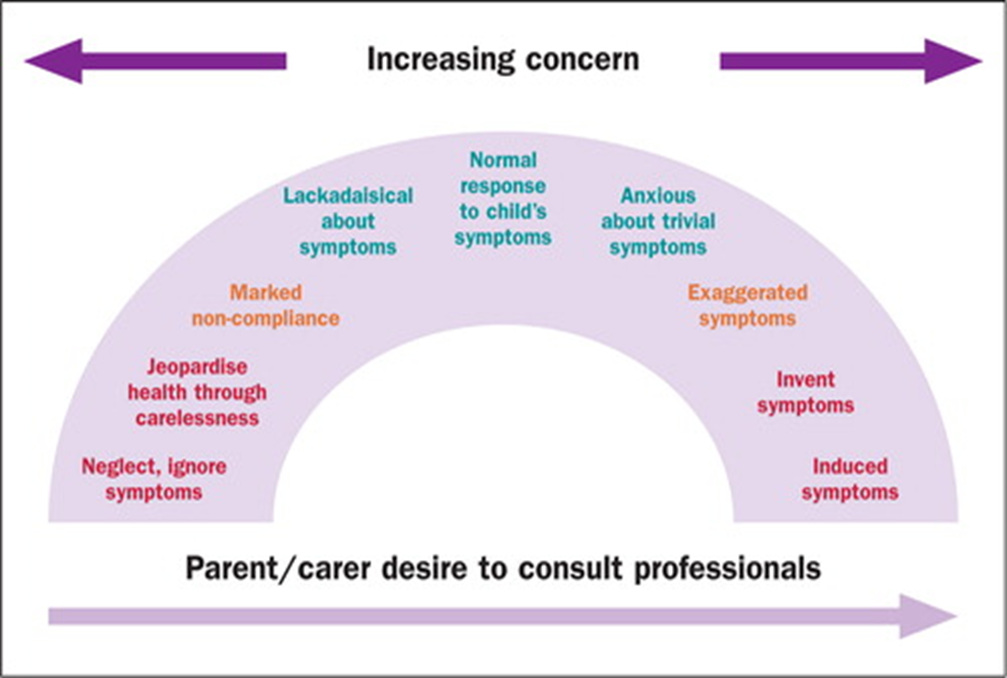

Challenging a parent/carer about their child’s health can be difficult and the practitioner must be sensitive to ensuring further harm is not caused to the child by the parent/carer through escalation of behaviours and/or withdrawal of attendance at medical appointments due to fear of appearing overly anxious. Assessment of FII cases takes patience and requires open dialogue, transparency, and relationship-based work.

Assessment of FII can be challenging, distressing, stressful and time consuming for the practitioner, requiring professional curiosity and triangulation of information, more than any other type of issue.

There can be differences of opinion between professionals but it is important to consider facts, professional judgements, and evidence in the form of a multi-agency chronology. When professional disagreements cannot be resolved through respectful challenge, concerns can be escalated through the Kent ‐ Resolving Professional Disagreements and the Escalation of Professional Concerns process.

Supervision/ Management Oversight

There are two elements to the work with FII. Firstly, there is the practical case direction in respect of what needs to be done and when. As already discussed, this can be challenging and sometimes, the timing and nature of decisions can be a struggle with the available information. There needs to be a clear rationale at every decision-making stage to ensure accountable decisions and a clear record of what was done and why, as the child may access their file in the future.

Secondly, there is the impact on the practitioner. FII can be an emotive area of work, especially if a practitioner has been working with a family for some time and FII has only just been identified. The practitioner can feel a range of emotions, including feeling deceived and betrayed. There can be feelings of helplessness, anger, and frustration due to difficulties obtaining evidence. Feelings of self-doubt and low self-esteem may be evoked. Supervisors will need to support their practitioner’s wellbeing through reflective supervision.

Due to the duplicitous behaviour of the person perpetrating FII, there can also be an element of bias or denial from the practitioner. Supervision should be a safe space to challenge the practitioner’s views and to reflect on their feelings and beliefs.

Voice of the Child

It is important to remember that due to the nature of FII and the abuser’s plausible and convincing manner, the child may wholeheartedly believe that he/she is sick. In addition, they may draw some comfort or benefit from the additional attention being received from the perpetrator, professionals, school staff and doctors. The child may not recognise or be able to say that anything the perpetrator is doing is wrong.

As already stated, FII is most prevalent in the under 5-year-olds so any direct work would need to be age appropriate and for non-verbal children will need to be observational and drawing on the multi-agency partnership for their observations and opinions.

Whilst open questions are recommended when communicating with children about their daily lives, the practitioner may need to be more specific in cases of suspected FII using questions to establish patterns of behaviour; timelines; who does what and when; what medication is given, etc.

The parent/carer/perpetrator may not allow the child to be seen alone and depending on the level of intervention, there may be an issue with consent, but every step should be taken to try to see the child alone.

Research tells us that in the majority of cases this will be the mother, the person who the child relies on and trusts most in the world. The impact on that child when they find out they were harmed, deceived, or manipulated by their mother/carer can be devastating and the child/young person will need support with this.

Covert Video Surveillance

In cases where there is no alternative way of obtaining information to explain the child’s signs and symptoms, the Police can use covert video surveillance (e.g., in a hospital ward). The operation should be controlled by the Police and accountability for it held by the Police. The Police should supply and install any equipment and be responsible for the security of and archiving of recordings.

The primary aim of the surveillance is to identify whether a child is having an illness induced, and the obtaining of criminal evidence is of secondary importance. The safety of the child is the overriding factor.

This form of evidence gathering is used rarely.

Flowchart for use when considering what steps need to be taken when FII is suspected

Concerns raised that child’s illness may be fabricated or induced

Is there a significant risk of harm/likelihood of significant harm?

No
Yes

Consultant Paediatrician follows the pathway for Perplexing Presentations and devises a Health and Education Care Plan with child and parents
If concerns regarding parenting or neglect are identified medical professionals may complete Request for Support
Request for Support to Front Door Service

Is the child’s life at imminent risk?

No
Yes
Parents engage with HECP

Strategy discussion to be convened
Yes
Immediate child protection powers to be considered
E.g., LPM/EPO
No

Medical professionals will continue working with the family unless safeguarding concerns are identified
CSWS to complete C&F assessment
ICPC to be convened

Kent Safeguarding Children Multi-Agency Partnership - Fabricated or Induced Illness
Available at: https://www.proceduresonline.com/kentandmedway/chapters/p_fabricat_ill.html

Further information

Davis, P., Murtagh, U. and Glaser, D. (2017) 40 years of fabricated or induced illness (FII): where next for paediatricians? Paper 1: epidemiology and definition of FII
Available at: https://adc.bmj.com/content/104/2/110

Lazenbatt, A. and Taylor, J. (2011) Fabricated or induced illness in children: A rare form of child abuse? Available at:
https://www.pure.ed.ac.uk/ws/portalfiles/portal/12941026/K201118.pdf

NHS (2019) Overview – Fabricated of induced illness
Available at: https://www.nhs.uk/mental-health/conditions/fabricated-or-induced-illness/overview/

Royal College of Paediatrics and Child Health (2021) Perplexing Presentations (PP)/ Fabricated or Induced Illness (FII) in Children
Available at: https://www.rcpch.ac.uk/news-events/news/new-guidance-perplexing-presentations-fabricated-or-induced-illness-children

University College London (2021) Fabricated of induced ill in children highlighted in new guidance. Available at: https://www.ucl.ac.uk/news/2021/mar/fabricated-or-induced-illness-children-highlighted-new-guidance.

Yates, G. and Bass, C. (2017) The perpetrators of medical child abuse (Munchausen Syndrome by Proxy) – A systematic review of 796 cases. Researchgate [Online]. Available at: file:///C:/Users/HilleA02/Downloads/YatesandBass-2017.pdf

Videos

Community Care (2019) Podcast: Fabricated or induced illness: what it is and what the signs are. Available at:
https://www.communitycare.co.uk/2019/02/25/fabricated-induced-illness-signs/

BBC Scotland (2019) Fabricated or Induced Illness. Available at:
https://bilson.org.uk/home/fabricated-or-induced%20illness/?doing_wp_cron=1619611900.5586841106414794921875

