******Safety planning guidance**

**Name of Author: Jane Caldwell**

**Practice Development Officer**

**Approved by: Hayley Bodiam**

**Interim Service Manager –**

**Professional Standards & Quality Assurance**

**Date of Issue: Jan 2023**

**Date to be Reviewed: Jan 2025**

|  |  |
| --- | --- |
| **Contents** | **Page** |
| Introduction | 3 |
| Understanding the dangers/worries | 4 |
| Principles of Good Safety Planning | 6 |
| Using Safety Circles to Identify Strengths and Safety | 8 |
| ‘One’ Plan - Elements of Safety Planning | 10 |
| Monitoring and Reviewing the Safety Plan | 11 |
| Appendix -A : example safety plans | 12 |
| Appendix B : printable versions of safety circles | 19 |
| Appendix C : tools to use with children for safety planning | 21 |

# **Safety planning guidance**

## Introduction

The safety planning process is a change process, which invites family members, safety and support network members and practitioners to meet, identify the worries/dangers for the children and to work out realistic and meaningful solutions to address these dangers.

Safety planning is about helping people to make the shifts that are required in a change process:

1. Understanding the need for change
2. Visioning a different future
3. Acknowledging that real change requires changes in their own thoughts, attitudes and behaviours.

**‘A safety plan is a specific set of arrangements, that outlines how the family will go about and live their everyday life which shows everyone, the professionals and the family’s own support network, that the children will be safe in the future’ (Signs of Safety Workbook 2012, Page 41).**

Examples of when consideration needs to be given to the safety of the child could be (list not exhaustive):

* When domestic abuse is a worry
* When there are worries about the impact of parent/carers mental health on their ability to care safely for their children
* When there are worries that a parent is misusing alcohol and/or drugs
* When a child/young person is at risk of being exploited and/or has been going missing
* When a young person is self-harming and/or verbalising thoughts around self-harm and/or suicide
* When there are worries that an adult or peer may be a risk to a child sexually, for example sibling sexual abuse or sexual abuse from a parent/grandparent.

The safety planning process involves professionals working collaboratively with parents, children, and an informed family network to develop and implement a detailed safety plan, that leaves everyone confident that children will be safe in the parents’ care in the future. It involves monitoring and reviewing the safety plan over time as part of the child’s regular planning processes, so that everyone is satisfied that the safety plan is working and will continue to work and provide ongoing safety for the children.

## **Understanding the dangers/worries**

For the family and their safety and support network to be meaningfully involved in the safety planning process, they must first be involved in a comprehensive and balanced assessment that focuses on what is happening in the family and what needs to happen in the future. To ensure the safety and wellbeing of the children, this might be a child and family assessment or an early help assessment, for example.

The more the family and their safety and support network are involved in the assessment process, the more likely it is that the family will be able to participate in safety planning and that the detailed safety plan will be achievable and relevant to the family.

An essential first step in the safety planning process is the development of mutually constructed danger/worry statements that describe the dangers/worries for the children that need to be addressed by the safety plan, and mutually constructed well-being goals, that describe what needs to be in place for everyone to be confident that the children will be safe in the future. The danger/worry statements and wellbeing goals should be bought together as part of any assessment process. The views of wider family and friends should be sought, with parental permission by means of a family and friends network meeting or similar.

**The danger/worry statement:** gives the reason we are working with the family in clear terms the family understands. **The safety goal:** addresses the concerns and describes what the child’s life will be like and how the family will be behaving so that we are no longer worried.

**Danger Statements/ Worry Statements**

Danger statements can begin by honouring what the family have already done, safety that is in place, based on evidence of specific actions or behaviours.  They then clarify the risks/worries/danger

1. Who is worried?
2. What are they worried about?
3. What are they worried will happen if nothing changes?

Based on the findings of the Child & Family Assessment/ Early Help Assessment the practitioner will need to consider one or more danger statements (also known as worry statements, where the word danger is not appropriate).

There should be no more than 4 danger statements which focus on the key dangers/worries e.g., neglect, DA, alcohol, or drugs. They should be written directly to the child and note the actual or potential impact of the harm on the child, including the worst-case scenario if this continues.

An example of danger/worry statements could be

*Joseph, your mum and Social Worker, Amy are worried that Callum will continue to ask to see and touch your willy and we know this makes you scared, upset and worried. We are worried that if this continues you may struggle with your confidence and suffer from stress and anxiety now and in the future as well as having an impact on relationships as you get older.*

Or:

*Amy, your Social Worker Bob and your mum are worried about what you see and hear at home when your dad is hurting your mum. You have told Bob that you have often felt frightened, and we are worried you may get caught up in these fights and get badly hurt. We also worry that if you continue to see your mum being hurt by your dad you may be confused as you grow up and struggle to understanding what a healthy relationship looks like.*

## **Safety Goals/ Well-Being goals**

The Safety Goal/Well say what we need to see to end our involvement or to step down. Safety goals/Well-Being goals can be prefaced with best hopes for the situation, followed by a safety goal for each danger/worry statement.  They describe what things will be like at the point that we are ready to end our involvement or step down the service input:

1. What will the parent be doing that is different?
2. What will the child be experiencing?
3. What will professionals see that tells them things are good enough that the child is safe and will continue to be safe?

Whilst safety goals may be devised with the family, it is worth noting with the family that there is the potential that they are adjusted in consultation with the wider family and professionals.

An example of safety goal/well-being goal could be:

*Joseph, for worries to be reduced we need to see and hear that you are no longer at risk of your willy being touched by Callum. The plans in place at home that we have agreed will be working to enable you to be safe and you will be sharing that you feel less stressed and anxious knowing that Callum will not be hurting you now or in the future.*

Or:

*Amy, for us to close our involvement with your family, you will no longer be seeing or hearing your dad hurt your mum (physically or emotionally), you and your mum will be able to describe your safety plan and will be telling Bob that you feel safe at home and no longer worried that dad may come to your house and hurt your mum. You will feel less anxious and have more confidence as well as an understanding of what a healthy relationship looks like.*

**Scaling questions**

A scaling question can be a useful tool to explore views on levels of risk and worry in order to support the safety planning process. The most important thing about scaling is to understand people’s explanations for where they are on the scale including the child/young person).

An example of a Scaling Question could be:

Joseph:

*On a scale of 0-10, when 10 is that you are being kept safe and Callum is no longer touching your willy or making you feel uncomfortable and unsafe, you are clear of the plan in place to keep you safe from anymore sexual behaviours from Callum and are feeling less anxious and able to enjoy yourself without the worry of being hurt, and 0 is that Callum is still touching your willy and you feel unsafe and even though you have told the grown-ups in your life, they are not doing enough to keep you safe.*

*Or:*

Amy:

*On a scale of 0 – 10 when 10 is that you feel safe at home and are not seeing or hearing dad hurting mum, dad is not turning up to the house, shouting and swearing and you feel less worried and anxious that this may happen because you understand the plan to keep you and mum safe, and 0 is that that dad continues to come to the house, uninvited and continues to hurt mum and at times you are involved yourself and have got hurt.*

## **Principles of Good Safety Planning**

There are 7 main principles of safety planning (see diagram below, Figure 1):

1. **The safety plan is formalised**

The safety elements of the plan should within the child’s plan, and its contents are written in collaboration and well understood by all parties, child, family and professionals. The plan should consider risks outside the family as well as inside if appropriate, and clearly consider what needs to happen and how. The plan should be SMART (Specific, Measurable, Achievable, Realistic, Time-Scaled) see the SMART Plans Guidance.

1. **The plan should be collaborative in partnership with families and agencies**

This means developing plans that are understood by the children, family and all agencies working with the family. Expectations for the family need to be clear and realistic, whilst ensuring the family have an awareness of the risks and there is acceptance to implement changes needed. Engagement with the professional network is key to identifying and manging the risk, all those working with the family should be aware of the plan.

1. **The plan must be child centred and holistic and look at ALL of the aspects of the child’s life**

This means developing plans which are written to the child, in a way they understand, whilst taking into consideration their culture, age, capacity, and development and focusing on what they can do as well as any restrictions placed on them. The plan should be strengths based, empowering and must cover all the child’s environments. It is important to remember the child is NOT responsible for the safety plan or the implementation of it.

1. **The plan must be timely and proportionate**

Safety planning needs to be considered from the outset of our involvement and/or where a new risk emerges, developing a plan with the family and professional network that is proportionate to the risk.

1. **You must clarify information**

Information needs to be clarified to ensure it is factual and triangulated by working collaboratively with the family and professional network. Clarity is needed around people’s roles and responsibilities in the implementation of the safety plan.

1. **Holding regular reviews**

This means holding regular reviews in consultation with the family and the network. Plans are not static and by reviewing them regularly you can reflect the evolving levels of risk, including increases or decreases in risk.

1. **Escalation**

This means when there is a collaborative safety plan in place, but the level of risk means that concerns remain about the safety and the well-being of children. In these circumstances practitioners should liaise immediately with their managers and consider whether escalations to Senior Managers via the Need-to-Know notification is necessary.

See **appendix A** for examples of plans where safety planning features.

#### Figure 1:

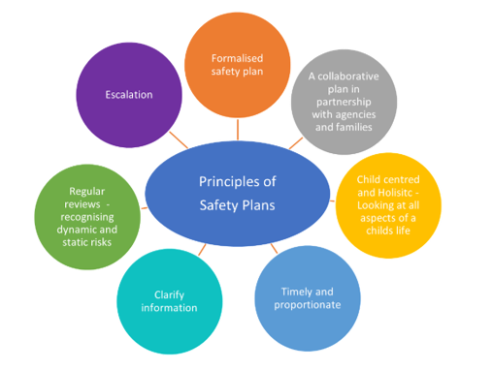

## **Using Safety Circles to Identify Strengths and Safety**

Working with the parents and children and other family members, to identify and involve people in a safety and support network for the family is an essential step in the safety planning process. The safety and support network are made up of people who will support the parents to develop and maintain a safety plan for the children, and who will hopefully continue to provide this support long after professionals have stopped working with the family.

A strong and active safety and support network, provides professionals with confidence that the parents have the support they need to follow the safety plan, and to continue using the safety plan for as long as the children are vulnerable to the identified concerns within the family. The safety and support network provides practical and emotional support to the parents and safety for the children.

Safety circles (Figure 2) can be used from the initial visit with a family as a way to introduce the need for us to work together to build a safety plan to address the concerns and the importance of having a safety and support network, of family and friends and involved professionals, who will work with us to develop the safety plan to ensure that the children will always be safe in the family’s care in the future.

**Figure 2:**

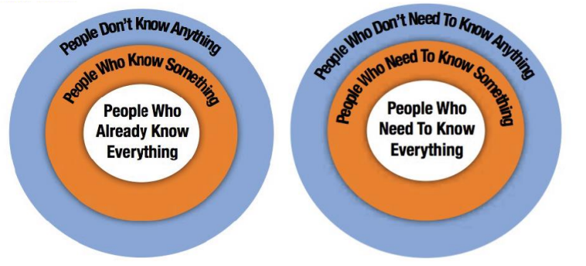

Safety circles is a very simple tool, consisting of three concentric circles drawn around the family (see above). The family members, children and parents/ caregivers are represented in the middle of the tool (in the orange circle), by a quick drawing of the family, by writing the family member’s names or by a photo of the family or children. In a lot of ways, the safety circles are similar to building a genogram with the family. However, its focus is often on the people within the support network who might not be family and importantly on those who could be in the ‘circle’ but are not. (See **appendix B** for printable version).

Another way of using safety circles is to work with a family to enlarge the circle to include friends perhaps who don’t know about their situation, e.g. Domestic Abuse or the fact that they have lost the care of previous children, or have a long standing substance misuse difficulty which is impacting on their parenting. The more ‘safe’ individuals that know the difficulties the family are facing, the more people there are to support them and those they can speak with without having to ‘re-tell’ the story. The development of this work with the family can be enhanced by using systemic questions related to the people within/or not the circle, such as:

“What might X say if you were to discuss your current situation with him?” or If I asked Y, who would she say could be included in your circle?”

When involving the child, using the ‘safety circle’ picture might help you to start these conversations, and also help children to understand who is in their network who makes them feel safe (see **appendix B** for printable child’s version).

## **Involving Children and Young People in Safety Planning**

Research on resilience in children suggest that they do better when they have a sense of control. Children often struggle to articulate when they do not feel safe or to explain why or what needs to happen to feel safe, so it is imperative that they are instrumental in the planning for their safety and given time to understand the plan. Children need to be offered opportunities for meaningful participation, in every part of the safety planning process and this requires more than just eliciting the child’s voice about what is happening in their family and their world.   
  
Involving children in the safety planning process, therefore, focuses on working with the child, their family and their network in ways that enable the child to:

* Understand why services are involved with their family.
* Understand the processes that their family will be involved with.
* Be given the opportunity for their voice to be heard.
* Be provided with clear and developmentally appropriate information about the possible consequences of them speaking up.
* Be given the opportunity to participate in planning and decision-making in safe and developmentally appropriate ways.
* Be supported and helped to understand what is happening at each stage of the safety planning process.

There are various tools and methods you can use to directly involve children and young people including Words and Pictures Explanations, Safety House Tool and Child Relevant Safety Plans – see **appendix C.**

When specific planning tools are used with children and young people the safety plans should be saved on the child’s electronic file, within the document section and the whereabouts clearly noted in the case notes. In addition, a summary of the plan should be included within the case summary. It is imperative that any updates/details should be communicated with all members of the professional and family/friend support network (with parental permission unless s47/child protection) and added as an addition within the child’s main plan within 5 days.

## **‘One’ Plan - Elements of Safety Planning**

Kent County Council is working hard to reduce the number of separate plans children are subject to and bring support together in ‘one’ plan to support children/young people and families be clear about what needs to happen. Therefore, it is vital that consideration of ‘safety’ is explicitly considered within existing planning processes (i.e., Early Help plan, Child in Need plan, Child Protection plan, Care Plan etc) if appropriate.

However, there may be times when an emergency safety plan needs to be agreed and drawn up outside of the usual process of planning for children/young people which may include arrangements such as a safe person moving in, one of the parents moving out, or the children going to stay with other family members etc. In these cases, safety plans should be saved on the child’s electronic file, within the document section and the whereabouts clearly noted in the case notes. In addition, a summary of the plan should be included within the case summary. It is imperative that any updates to children’s plans should be communicated with all members of the professional and family/friend support network (with parental permission unless s47/child protection) and details of the emergency safety plan should be added as an addition within the child’s main plan within 5 days.

Whilst Kent is working hard to bring support together in one plan, we do have a Missing Person Response Plan that is separate to the family plan. When these plans are used, their contents should be included within the child’s existing planning processes (i.e., Early Help plan, Child in Need plan, Child Protection plan, Care Plan etc).

Additionally, other professionals working with our families, such as Independent Domestic Violence Advisors (IDVA’s) may also complete safety plans with families. In these circumstances, these plans should be saved on the child’s electronic file within the document section, and the whereabouts clearly noted in the case notes. In addition, a summary of the plan should be included within the case summary. When these plans are used, their contents should be included within the child’s existing planning processes (i.e: Early Help plan, Child in Need plan, Child Protection plan, Care Plan etc).

## **Monitoring and Reviewing the Safety Plan**

The effectiveness of the child’s plan should be reviewed regularly with children, young people and their friend and family network during home visits and conversations etc in order to ensure they are clear of its contents and to ensure practitioners intervention is linked and focussed on supporting families to make the changes necessary. Its contents should be formally updated and reviewed within child in need meetings, core groups, EH reviews etc) or more regularly if necessary.

## **Appendix A**

1. An example of a safety plan considering a child who has alleged to have been sexually assaulted by his brother (using the Liberi template).

|  |  |  |  |  |  |
| --- | --- | --- | --- | --- | --- |
| **What needs to happen?**  **What is the change we are looking for?** | **What do the child/young person/family/professionals feel might impact on the changes/tasks being successfully achieved** | **How will it happen? What are the Tasks?** | **Who will do this?** | **By when?** | **Wellbeing / Safety Goal**  **What is the expected impact?** |
| Joseph, you need to be kept safe and not feel worried that Callum will ask to see or touch your willy. Therefore, you should not be left alone with Callum. | Joseph we are worried that mummy may find it difficult to make sure that you are not left alone with Callum becauseshe often has to leave the house to go to work and/or go shopping. | Joseph, mummy has agreed with Uncle Bob, Auntie Joan and Ga-Ga that they will take it in turns to be with you and Callum when she needs to work or go shopping. | Mummy, Uncle Bob, Auntie Joan and Ga-Ga. | 23.12.22 | Joseph, you will be safe, and Callum will not sexually touched you. |
| Joseph, you need to be kept safe and not feel worried that Callum will ask to see or touch your willy. Therefore, you should not be left alone with Callum. | Mummy may find this most difficult at certain times of the day, such as dinner time as she may struggle to ensure you and Callum are supervised together. | When mummy is cooking Joseph and Callum will either both be in the kitchen with her (reading or playing on the tablet) or the children will take it in turns to sit in the lounge watching the TV (with the other being with mummy). | Mummy | 23.12.22 | Joseph, you will be safe, and Callum will not sexually touched you. |
| Callum needs some help to understand that it is not okay to touch your willy and to be helped to change his behaviour. | Joseph, we are worried that Callum will find it difficult to understand why his behaviours towards you are harmful and upsetting and why he would need to change these behaviours. | Your Social Worker Amy, and Steve from the Children’s Mental Health Team will support Callum and help him to understand how he has hurt and upset you. Kim will work with Callum to help him make changes to his behaviours so he doesn’t try and touch your willy again or say swear words. | Amy, Social Worker, Kim from CAMHS and Callum | 15.01.23 | Joseph, Callum will have received the support he needs to understand what he has been doing is not right and that his behaviours have hurt and upset you. This means he will no longer do things like touch your willy and you will feel safer with him. |

1. An example of a safety plan where Domestic Abuse is a feature (using the Liberi template).

|  |  |  |  |  |  |
| --- | --- | --- | --- | --- | --- |
| **What needs to happen?**  **What is the change we are looking for?** | **What do the child/young person/family/professionals feel might impact on the changes/tasks being successfully achieved** | **How will it happen? What are the Tasks?** | **Who will do this?** | **By when?** | **Wellbeing / Safety Goal**  **What is the expected impact?** |
| Amy, you need to be kept safe from seeing dad hurting or being nasty to mum. | Amy, we worry your dad may continue to break the Orders that are in place, especially if he has been drinking or using drugs. | Amy your Mum is going to call her friend (and neighbour) Janice, and the Police if your dad turns up or she is worried he is nearby. Janice will come to your house as soon as mum rings and take you to her home if you and mum agree this is necessary. | Your Mum | 09.12.2022 | Amy you will not be worried that you will be hearing or seeing your Mum being hurt or shouted at by your dad. You will feel safer and able to sleep at night, go to school and out with friends because you know your mum is safe. |
| Amy, you need to be kept safe from seeing dad hurting or being nasty to mum | Amy, your Mum is worried that the Police may not arrive in time and dad may break into the home as this has happened before. | The police are putting a red flag on their computer so if your mum calls with worries about dad, they know to help very quickly. | The Police | 9/12/22 | Amy you will not be worried that you will be hearing or seeing your Mum being hurt or shouted at by your dad. You will feel safer and able to sleep at night, go to school and out with friends because you know your mum is safe. |
| Amy, you need to be kept safe from seeing dad hurting or being nasty to mum | Amy, we worry your dad may continue to break the Orders that are in place, especially if he has been drinking or using drugs. | Your Mom is meeting with Sam Smith, your social worker and Annie Gem, the Domestic abuse Adviser, to look at any other things, she or others can do as part of this family safety plan. Any additional points will be added to this plan within 5 days of that meeting. | Your Mum, Sam Smith and Annie Gem | 23.12.2022 | Amy you will not be worried that you will be hearing or seeing your Mum being hurt or shouted at by your dad. You will feel safer and able to sleep at night, go to school and out with friends because you know your mum is safe. |
| Amy, you need to understand why you have a Social Worker, be helped to share how you are feeling and what you think should happen | Amy, we know you can find it hard to talk about how you are feeling especially with the Social Worker who feels like a stranger. | Sam, your Social Worker will meet with you to help you to understand what is happening and what needs to happen | Your mum  Sam Smith  Amy | 30.12.22 | Amy, you will understand why Sam your Social Worker is involved and comes to visit you. With Sam and your mum, you will have put together a words and pictures which has helped you to understand the situation and the plan of support that is in place to keep you and your mum safe. |

1. An example of a safety plan where there are worries that a younger person is going missing (using the EH template).

|  |  |  |  |
| --- | --- | --- | --- |
| **What needs to happen?**  **What is the change we are looking for?** | **How will it happen?**  **What are the tasks?** | **Who will be doing this?** | **By when?** |
| Lauren, we want to ensure that you are safe when out and about in the community, your parents know where you are, and you can remain in contact. | Lauren if you receive a message asking to meet Holly/other friends or associates that you feel unsafe with, you will you’re your mum or dad and they can support you to stay home. | Lauren  Mum  Dad | 10.02.23 |
| Lauren, we want to ensure that you are safe when out and about in the community, your parents know where you are, and you can remain in contact. | Lauren if you feel unsafe when you are out you can send a message with your code word to mum, dad or Auntie Jo, who are your safe people. By doing this Lauren your safe people will know you need support and will come and pick you up/ phone you to support you to come home. | Lauren  Mum  Dad  Auntie Jo | 10.02.23 |
| Lauren, we want to ensure that you are safe when out and about in the community, your parents know where you are, and you can remain in contact. | Lauren, if you feel unable to use your safe people and you do go missing your mum and dad will message or call you to try and make contact. If they cannot get in touch with you, they will call your friends parents and if needed go out and look for you in places they know you might be and use the Find My app.  Lauren, if there is no contact with you and your parents remain worried about your safety, they will call the Police to report you missing. | Lauren  Mum  Dad  Auntie Jo  Police | 10.02.23 |
| Lauren, we want you to remain safe out in the community and have a good understanding of what a healthy relationship looks like now and in the future. | Lauren, Amy Jones your Early Help Worker will complete 4 sessions with you exploring –   1. Safety in the community 2. Healthy relationships 3. Completion of a missing response plan   Understanding the influences that pull you away from home and into activities that are unsafe for you. | Lauren  Amy Jones | 10.02.23 |

1. An example of a review of the safety plan where there are worries that a younger person is going missing (using the EH template).

|  |  |  |  |  |  |  |
| --- | --- | --- | --- | --- | --- | --- |
| **What needs to happen?**  **What is the change we are looking for?** | **How will it happen?**  **What are the tasks?** | **Who will be doing this?** | **By when?** | **Has this been completed?** | **Date Completed** | **Evidence and Impact** |
| Lauren, we want to ensure that you are safe when out and about in the community, your parents know where you are, and you can remain in contact. | Lauren if you receive a message asking to meet Holly/other friends or associates that you feel unsafe with, you will speak with your mum or dad and they can support you to stay home. | Lauren  Mum  Dad | 10.02.23 | Yes | 08.02.23 | Lauren, you have used your safe people when your friend Holly was asking you to meet her, you didn’t feel safe to go and meet her and you asked dad to help you.  Lauren, you now feel more confident to say no to friends/ associates and are spending more time with friends that support you |
| Lauren, we want to ensure that you are safe when out and about in the community, your parents know where you are, and you can remain in contact | Lauren if you feel unsafe when you are out you can send a message with your code word to mum, dad, or Auntie Jo, who are your safe people.  By doing this Lauren your safe people will know you need support and will come and pick you up/ phone you to support you to come home. | Lauren  Mum  Dad  Auntie Jo | 10.02.23 | Yes | 08.02.23 | Lauren, you are now able to ask for support from your safe people. You used your code word and mum supported you to come home when you felt unsafe. |
| Lauren, we want to ensure that you are safe when out and about in the community, your parents know where you are, and you can remain in contact. | Lauren, if you feel unable to use your safe people and you do go missing your mum and dad will message or call you to try and make contact. If they cannot get in touch with you, they will call your friends parents and if needed go out and look for you in places they know you might be and use the Find My app.  Lauren, if there is no contact with you and your parents remain worried about your safety, they will call the Police to report you missing. | Lauren  Mum  Dad  Auntie Jo  Police | 10.02.23 | Yes | 08.02.23 | Lauren, in the last 6 weeks you have been missing once, Auntie Jo contacted your friend’s parent and she came out to look for you in the place you were thought to be. Auntie Jo bought you home and there was no need to call the Police. |
| Lauren, we want you to remain safe out in the community and have a good understanding of what a healthy relationship looks like now and in the future | Lauren, Amy Jones your Early Help Worker will complete 4 sessions with you exploring –  1-Safety in the community  2-Healthy relationships  3-Completion of a missing  response plan  4-Understanding the influences that pull you away from home and into activities that are unsafe for you. | Lauren  Amy Jones | 28.02.23 | Yes | 27.02.23 | Lauren, you met with Amy and have completed all your sessions, you have shared that you now understand the reasons people were worried about you and you have plans in place that keep you safe. |

## Appendix B

## Printable versions Safety Circles

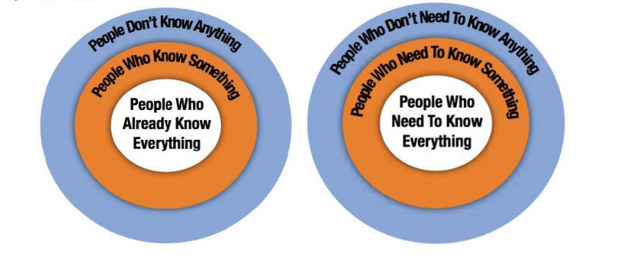

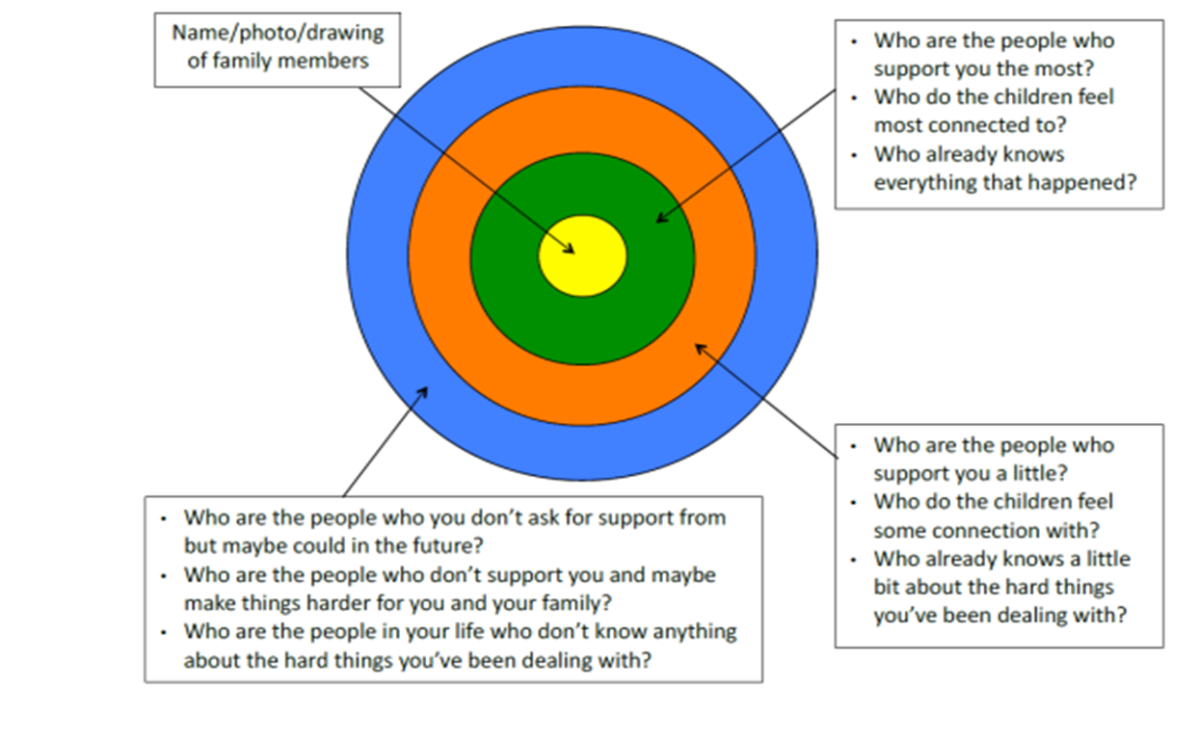

## Appendix C – Resources to use when Safety Planning with children

|  |  |
| --- | --- |
| Resource | Link or helpful document |
| The Signs of Safety workbook.  A helpful resource which holds examples of danger/worry statements, safety/wellbeing goals and scaling questions plus resources for practitioners to use with adults and children to devise plans for safety |  |
| Resources to support safety planning work with children/young people where Domestic Abuse is a worry  The Cedar network in Scotland has produced a short animation called Mikey and Jools keep safe, this supports safety planning where Domestic Abuse is a feature. The film and the accompanying guidance notes can be used with young children when looking at safety planning. | [[Cedar network - Mikey jools animation](https://www.cedarnetwork.org.uk/for-practitioners/mikey-jools-animation/)](https://www.cedarnetwork.org.uk/for-practitioners/mikey-jools-animation/)  [Guidance notes – Cedar Network](https://www.cedarnetwork.org.uk/for-practitioners/mikey-jools-animation/mikey-jools-guidance-notes/)  [Mikey Jools Safety Plan Cedar network](https://www.cedarnetwork.org.uk/wp-content/uploads/2013/09/5.-Mikey-Jools-Safety-Plan.pdf)  [Safety Planning with Children & Youth: Domestic Abuse - Free Social Work Tools and Resources](http://www.socialworkerstoolbox.com/safety-planning-with-children-youth-domestic-abuse/)  [Children's Participation Toolkit for Social Workers (activities & worksheets) - Free Social Work Tools and Resources](http://www.socialworkerstoolbox.com/childrens-participation-toolkit-for-social-workers/) |
| Resources to support safety planning work with children/young people where Sexual Abuse is a worry | [Parents Protect- Create a family safety plan](https://www.parentsprotect.co.uk/create-a-family-safety-plan.htm)  [Parents Protect- Family Safety Pack](https://www.parentsprotect.co.uk/files/Family%20Safety%20Pack%20WEB%20JAN16.pdf)  [Family Safety Pack](https://www.parentsprotect.co.uk/files/Family%20Safety%20Pack%20WEB%20JAN16.pdf) |
| Resources to support safety planning work with children/young people who are at risk of self-harm and/or suicide  These resources encourage the conversation around self-harm and suicide.  This resource is an ‘app’ for children/young people to use to make their own safety plan and to support them in recognising their feelings. | [Creating a 'safety plan' | Samaritans](https://www.samaritans.org/how-we-can-help/if-youre-worried-about-someone-else/supporting-someone-suicidal-thoughts/creating-safety-plan/)  [Suicide and self-harm](https://kidshelpline.com.au/suicide)  [Stay Safe Plan](https://www.papyrus-uk.org/wp-content/uploads/2018/09/Stay-Safe-Plan.pdf)  [Suicide safety planning app: Beyond Now - Free Social Work Tools and Resources](http://www.socialworkerstoolbox.com/suicide-safety-planning-app-beyond-now/) |
| Resources to support safety planning when mothers/fathers/carers have mental health problems.  Resource to support families prepare for mental health crisis | [Planning for a mental health crisis - Mind](https://www.mind.org.uk/information-support/guides-to-support-and-services/crisis-services/planning-for-a-crisis/) |
| Resources to support planning when mothers/fathers/ carers are misusing drugs/alcohol  Resources to support the assessment of risk with the family and safety plans.  Resources linked to strength-based questioning with children/young people | [Making a safety plan | Childline](https://www.childline.org.uk/info-advice/bullying-abuse-safety/abuse-safety/making-a-safety-plan/)  [Safety planning | Child Safety Practice Manual](https://cspm.csyw.qld.gov.au/practice-kits/alcohol-and-other-drugs/safety-assessment-and-safety-planning/responding/developing-an-immediate-safety-plan-when-there-is)  [Partnering with children | Child Safety Practice Manual](https://cspm.csyw.qld.gov.au/practice-kits/alcohol-and-other-drugs/safety-assessment-and-safety-planning/responding/partnering-with-children#Strengths_based_questions_for_children) |
| Resources to support children/young people who are at risk of exploitation and/or going missing | [YP_safetyplan.pdf](https://safelives.org.uk/sites/default/files/resources/YP_safetyplan.pdf) |