Lone Working in Children’s Services
Team Plan
Team Name

It is important that each team has an agreed approach to how they will manage the risks associated with lone working. This plan is a standard template which can be personalised to ensure each team has the appropriate arrangements in place to meet their needs and keep staff safe.
This covers:
- Calendar expectations – knowing where you are.
- Next of Kin – knowing who to contact.
- Planning & Personal safety – keeping ourselves safe.
- Checking in – knowing when and how to check in.
- Calling for help – knowing what to do if something goes wrong.
- Debriefing after – learning from incidents.

All team members should be briefed on the approach for their team which is outlined in this document and sign to confirm this below, showing a commitment and understanding of our expectations and approaches.
Name | Signed | Date
- Calendar Expectations – knowing where you are.
It is an expectation that your outlook calendar will be kept up to date with every visit, meeting and appointment you have during your working day. If there is an emergency this is where your colleagues/manager will go to look at where you are and how to get your help. Appointments should be clearly showing who you are visiting and where.
Share your calendar with your entire team as soon as you start setting up.
How to open someone’s calendar
Go to Calendar in Outlook
Click on ‘+ Add Calendar’
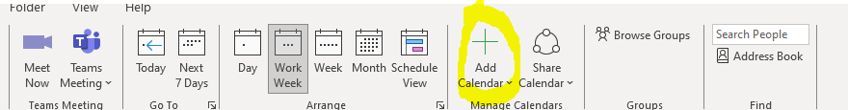
Click on ‘From Address Book…’ (from the drop down)
Add colleagues name in to Search bar and click on name, click OK. Check the detail is visible on appointments, if not they will need to adjust their sharing settings.
How to ensure your calendar is visible
Go to Calendar in Outlook
Click on ‘Share Calendar’
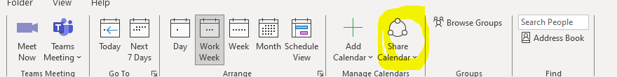
Ensure “my organisation” is set to view detail and not just seeing when busy.
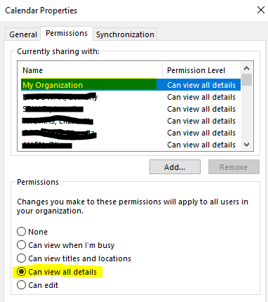

- Next of kin – knowing who to contact.
You will be asked for your Next of Kin details when you start; it is essential for your safety that you keep these up to date with any changes. You must also make any updates to your next of kin on SAP – this is your responsibility. These are essential for your safety.
How to change Next of Kin on SAP –
Go to SAP through the desktop button SAP Portal
Click on Employee Self-Service
Click on Personal Information and then fill in the changes needed on the Personal Details Form.
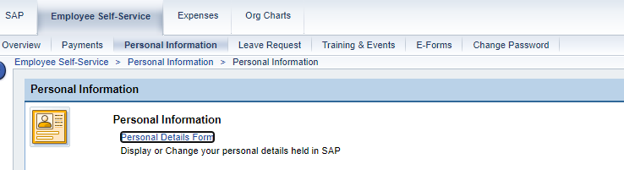
If you are not a SAP user (e.g. agency worker) then you will need to completed a NOK Form and return to your manager.

- Planning & Personal Safety – keeping ourselves safe.
This is a reminder that taking personal accountability for your safety is crucial. As well as ensuring your calendar is up to date, remember to tell someone if you are going on a visit. Be prepared and have a response plan in mind for any risks you may encounter, such as uncooperative or aggressive behaviour, dogs in the home, anyone under the influence of alcohol/drugs, racist or other discriminative behaviour, unexpected family members or visitors at the visit, etc. Make sure you are keeping your phone on you and charged and following the agreed procedures for your team so we know when you are safe and when we should be concerned.
Before any visits you are worried about discuss with your manager and complete a risk assessment on the family. Consider any existing factors you know about the family and the community area you are visiting. As part of this you should discuss if a joint visit is appropriate with a colleague.
If you are taking your own car on a visit then ensure your team knows the details (registration, make, colour).
Any specific agreements for your team should be noted below:
All team members will..

- Checking in.
It is critical that we have an agreed approach to checking in after a visit to confirm you are safe. This may include use of WhatsApp groups or having a named manager or buddy to check in with. The process for your team should be outlined below. This is not a process for tracking staff locations but is for providing a way to keep you safe.
In our team we…

- Calling for help – knowing what to do if something goes wrong.
If at any time you are in a visit and need 999 Emergency help but cannot call to ask for this specifically, your team will have a process for alerting colleagues that you need urgent support.
An example is – if you have an emergency call or text a colleague and ask for Scarlett. Your colleague will know to get you help and support immediately and will call 999 to your location, based on the information you have in your calendar at the time of the call (See Calendar Standards).
If a colleague calls or texts you and asks for Scarlett let them know you will try to find her, keep your colleague on the phone if possible. You can see where your colleague is based on their outlook calendar (see Calendar Standards). Call 999, advise them of the situation and give them the address and family details of the visit. Go back to your colleague and let them know that you have got a message to Scarlett, and she will call back as soon as possible.
If this is different for your team, outline your plan here

- Debriefing after – learning from incidents.
If there is an incident which requires you to call for help, makes you feel like you weren’t safe, or where you think something could be done better, then it is important to debrief with your team manager to look at lessons learned and how we can approach the situation differently next time. Additionally, this should also be recorded as an incident on the SHE Assure portal.
See note below on consideration of Global Majority workers and additional considerations about experiences faced and support available.

Appendices
Global Majority Workers
We wanted to also acknowledge the additional challenges that our Global Majority workers face. "Global majority" is a collective term for people of Indigenous, African, Asian, or Latin American descent, who constitute approximately 85 percent of the global population
Global Majority workers may face additional experiences which are a threat to their safety and wellbeing and it is important that we provide safe spaces for colleagues to discuss them and the impact they have. It is important to set this culture from your very first 1:1 with staff and ensure you’re revisiting it regularly.
There are parts of the county where it may be more likely that Global Majority staff could face racism whilst conducting business. It’s ok to ask staff about whether they feel additionally anxious about certain places and be open to hearing about what they need to feel safe. Ask before and be available to debrief afterwards. There are times when we must work with families who have been known to display racist behaviours, as with locations, talk to staff about what they need. Consider joint working and ensure warnings are visible on the Case Management system if you learn of new incidents.
If a colleague returns from a visit and reports a racist incident, ensure you report it using the Incident at Work process and, if relevant, capture it on the system as a risk. If global Majority staff need additional support, the Black Workers Network can be contacted on bwn@gloucestershire.gov.uk and you can feed into the Anti Racist Ally Group.

Lone Working – Spheres of Support

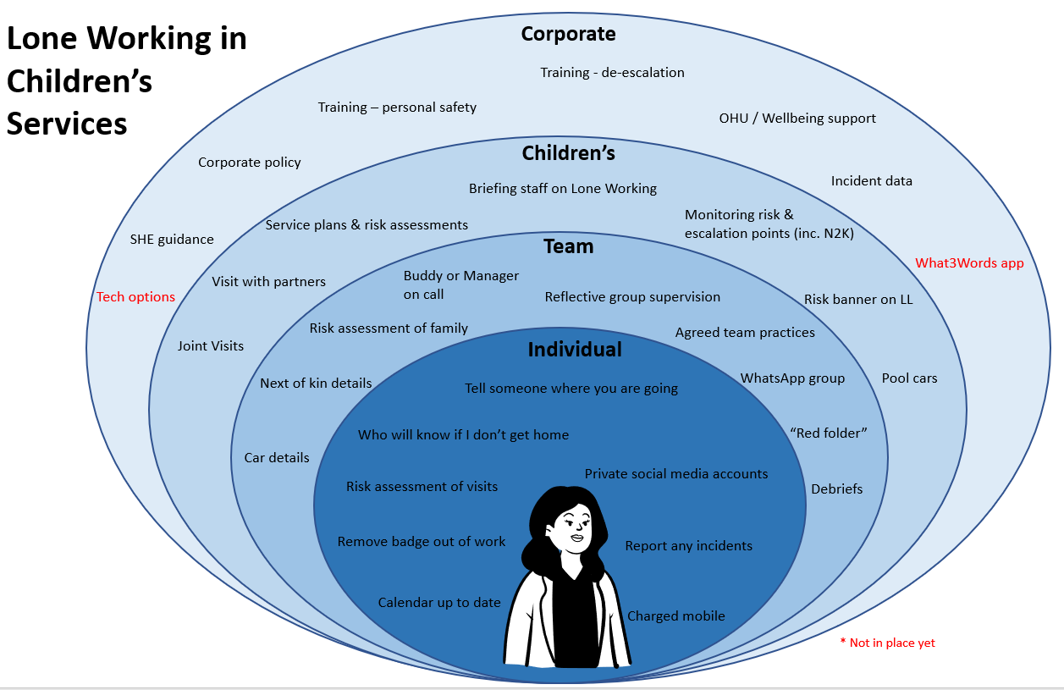

https://en.wikipedia.org/wiki/Global_majority

