Family Network Meeting Best Practice Guidance
June 2024
In Lincolnshire, we strongly believe that children belong within their naturally connected network; with people who they know, who love them and will keep them safe.
What is a Family Network?
A family (inclusive of parents who retain parental responsibility (PR) AND
A group of any other adults closely connected to the child (including wider family members, family friends, neighbours, members of the community e.g. community leader, sports leader etc) who have an ongoing, close, and supportive relationship with the child(ren), young person, and their community.
Professionals (health, education etc) would be part of the professional network.
What is a Family Network Meeting?
A Family Network Meeting is a time when the identified Family Network come together (often with the support of a Lead Professional) to create a family-led plan which is then reviewed, monitored and refined over time.
Family Network Meetings can be part of existing assessment or review meetings and do not need to be a stand alone meeting.
A Family Network Meeting should be explored and facilitated where possible for every child open to a Lead Professional as part of their involvement (TAC, EH,CIN,CP).

How do I identify a Family Network?
As part of TAC/Early Help conversations, a Lead Professional should explore with the family who has an ongoing, close, and supportive relationship with the child(ren), young person, and their community.
Once identified, the names of these adults should be recorded in the Early Help Assessment form in this part of Section 1:
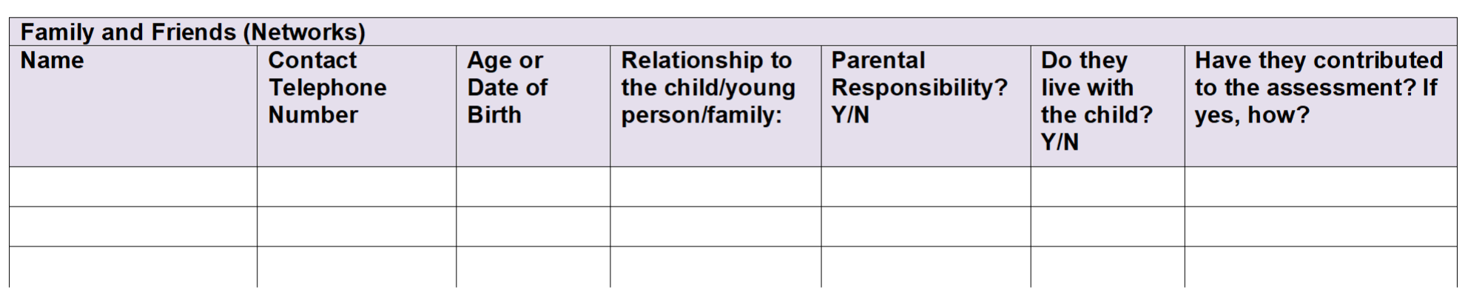
If the assessment has already been completed, please record within the plan and review process.
What to obtain?
- Name, age or DOB and contact details (telephone number) for each identified adult
- The relationship they have with the child and parents, including if they have PR and/or live with the child;
- If and how they have contributed to the assessment at this stage.

How do I involve the Family Network in creating the family plan?
- Once identified in the Early Help Assessment, the family should ask the adults they have identified if they are willing to be involved in the plan moving forward and invite them to attend the next TAC meeting.

- This meeting should take place at a location where the family network feels comfortable, ideally in person but can also be conducted via video calls.

- As part of the TAC meeting, the following should be explored:

- The networks understanding of worries/ concerns/ safety planning;
- What support they can offer to reduce the worries and risk;
- If there are any challenges to them supporting the child/family, and what these are;
- How these challenges could be overcome.

If appropriate, the Family Network and Lead Professional might consider applying for a Family Network Support Package to overcome these challenges. Further information and resources can be found at the bottom of the guidance.

How to record?
The support the Family Network will provide should be recorded in the TAC plan on page 4, so that it can be reviewed at each subsequent meeting.
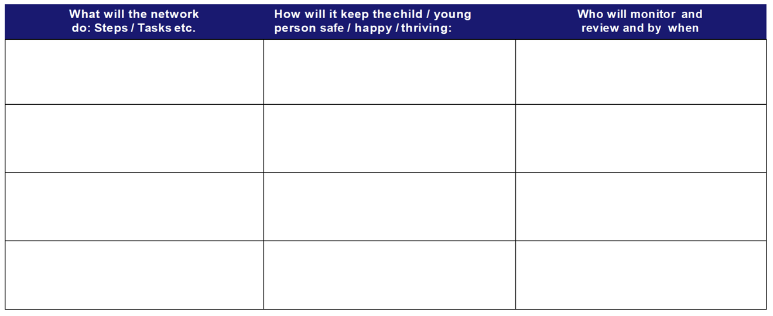
We recognise that Family Networks can be dynamic and we recommend reviewing the people involved in the Family Network at every meeting to ensure the right people are involved.

