### LL

2024-2025 REGULATED TEAMS

**Contents**

**Introduction and Context** 2

**Professional Capabilities Framework** 2

**Career Progression Process NQSW to Level 2 social worker** 4

**Knowledge and Skills Statements** 4

**Support for Social Workers Seeking Career Progression** 7

**Career Panel Application** 9

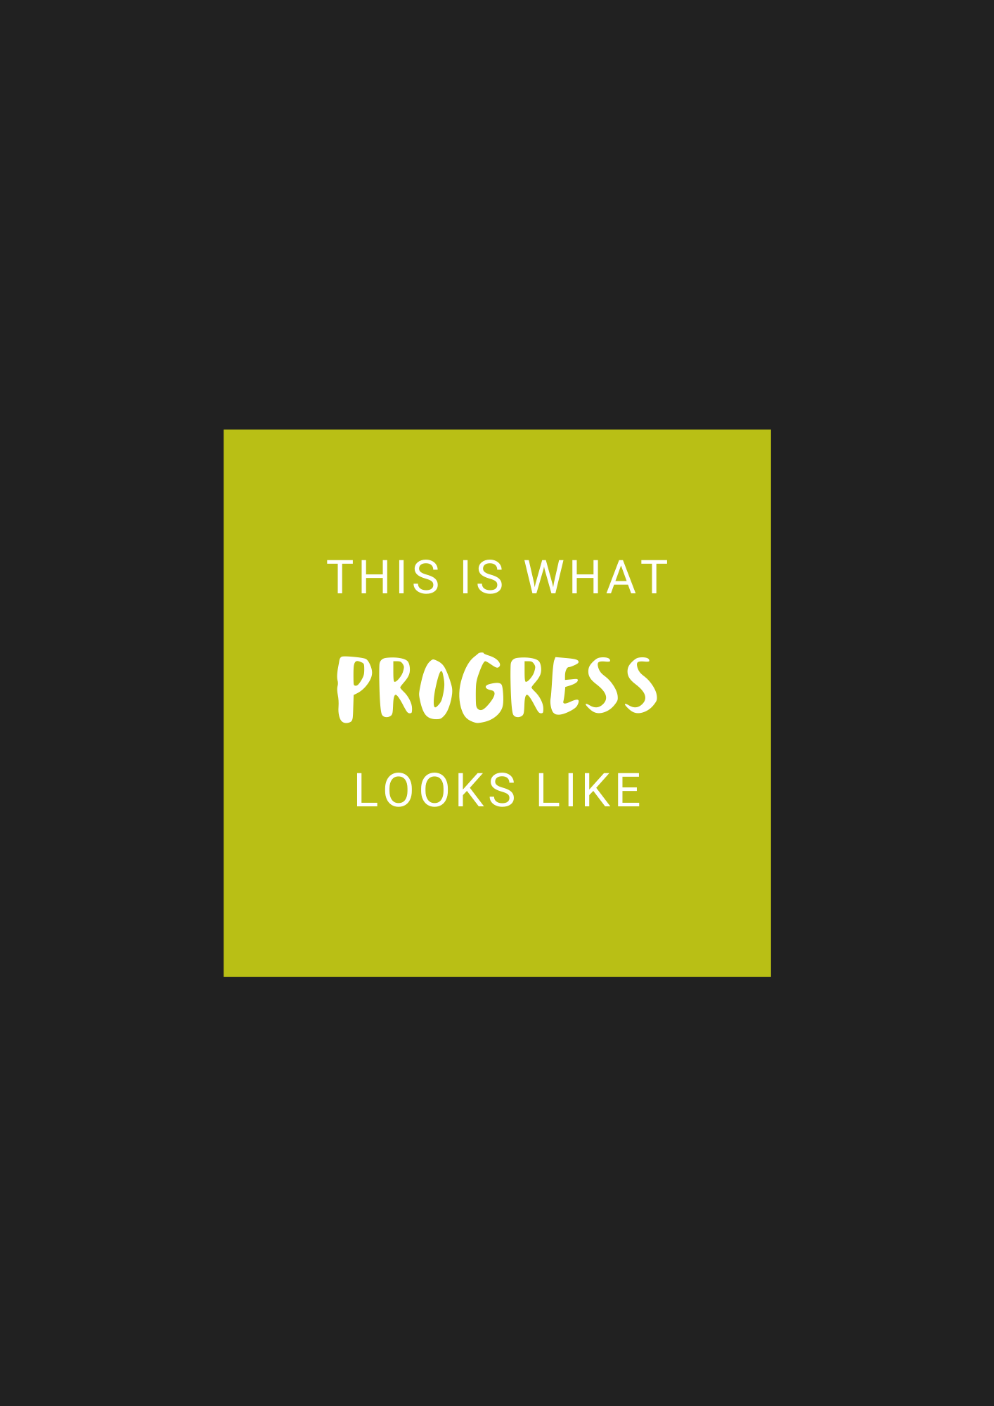

**Introduction and Context**

Lincolnshire County Council is committed to developing the careers of all staff and it recognises the benefits of providing opportunities. For Qualified social workers, this is critical in facilitating career progression and enabling them to take on increased levels of professional responsibility within their role.

This document sets out the pathway for progression for a children’s social worker from a Level 1 Social Worker to Level 2 social worker. A social worker can attend the panel provided that at the time of the panel they have been qualified for two years from date of registration with SWE.

**Professional Capabilities Framework**

The Professional Capabilities Framework (PCF) is an overarching professional standards framework, developed by the Social Work Reform Board and now managed by The British Association of Social Workers.

The PCF:

* Sets out consistent expectations of social workers at every stage in their career.
* Provides a backdrop to both initial social work education and continuing professional development after qualification.
* Informs the design and implementation of the national career structure.
* Gives social workers a framework around which to plan their careers and professional development.

The PCF diagram on the following page (Figure 1) details the current developmental pathways for social workers.



**Figure 1 – Professional Capabilities Framework for Social Workers**

**(Source: www.basw.co.uk)**

The PCF is the underpinning Framework for social work practice in England. It sets out the common capabilities expected of social workers at different levels of practice and stages of career, across all fields of social work. It promotes social work as one profession. The PCF does not define specialist knowledge and skills or lay out learning content that may be needed in particular work contexts. It describes the capabilities that all social workers should aspire to develop throughout their career.

Children's Social Care provides an important role in not only the immediate safeguarding of children and young people who may be at risk of abuse or neglect but also in ensuring that those children and young people that come into contact with Social Care are given the opportunity to thrive and achieve. At Lincolnshire County Council we are proud of our workforce and strive to continually support our social workers to deliver outstanding practice. To achieve both of these it is essential that everybody working within Children's Social Care has the knowledge and skill set to do their job well.

**Career Progression route - NQSW to Level 2 social worker**

**Assessed and Supported Year in Employment to Level 1**

The Assessed and Supported Year in Employment (ASYE) is designed to help Newly Qualified social workers (NQSWs) to develop their skills, knowledge and capability and strengthen their professional confidence. It provides them with access to regular and focused support during their first year of employment.

Assessment is based on the principles of holistic assessment. At the end of the ASYE year, employers complete a final assessment of the NQSW’s knowledge, skills and performance. Evidence is considered from a range of work which demonstrates the NQSW’s performance in relation to the Knowledge and Skills Statement for Child and Family Practitioners (KSS) [Post-qualifying standard: knowledge and skills statement for child and family practitioners (publishing.service.gov.uk)](https://assets.publishing.service.gov.uk/government/uploads/system/uploads/attachment_data/file/708704/Post-qualifying_standard-KSS_for_child_and_family_practitioners.pdf).

The assessment should be completed by a Qualified and Registered social worker. Assessment is not a 'snapshot' of a competence demonstrated at a point in time but is a demonstration of progressive development over the year, culminating in evidence of consistently reaching the standard required. For ASYE this will require assessors to have knowledge of the candidates in order to judge whether that development of overall capability has been evidenced over time.

Lincolnshire County Council will inform all individuals of the assessment outcome. On successful completion of the ASYE programme formal certification will be issued, this includes the Skills for Care aspects and the completion of a post qualifying module.

**Knowledge and Skills Statement**



**Level 1 social worker to Level 2 social worker**

For a Social Worker to progress from Level 1 to Level 2 the Social Worker will need to demonstrate that the knowledge and skills set out in the KSS statements are being consistently met. This evidence will then need to be presented at the Career Progression Panel. The Career Progression Panel will sit three times a year in April, August, and December (if there are a high number of applicants a fourth panel may be convened). Whilst the social worker will be expected to meet all of the 10 KSS's to progress to a Level 2 social work role (and the Practice Supervisor and Team Manager

must verify this) the social worker will only be required to provide evidence within the portfolio in relation to 5 of the 10 KSS's. The social worker will be informed of the 5 KSS's they will be required to provide portfolio evidence for at the time of booking onto panel. There will not be the opportunity to choose from the KSS's or to request that different KSS's are allocated.

**Booking career progression panel**

Once the Team Manager and Practice Supervisor have agreed that the social workers practice is commensurate with the Level Two job description, the social worker will book a place on career progression panel by emailing [swcareerprogressionpanel@lincolnshire.gov.uk](mailto:swcareerprogressionpanel@lincolnshire.gov.uk). At this point, the booking will be confirmed and the social worker will be notified which 5 of the 10 KSS’s they will be required to provide evidence for in their portfolio, and the portfolio submission date.

The completed and endorsed portfolio with accompanying evidence will be submitted digitally on a Microsoft Form by the submission date. The form can be found at:

<https://forms.office.com/e/YgD6s3DbUr>

**Attending career progression panel**

The career progression panel will be held virtually via MS Teams. The core panel membership will consist of two Heads of Service. Additional members may be co-opted as required and could include representatives from Human Resources.

The panel will consider the evidence submitted and presented by the social worker and will determine whether the social worker has effectively demonstrated the knowledge and skills required and if so will 'endorse' the social worker. The panel will reach a decision and notify the social worker of the outcome by letter sent via email within 24 hours of the panel date.

Following a successful progression panel and endorsement, the Chair of the Panel will notify the relevant Children's Services Team Manager so that the social worker progresses into a level 2 social work post at SCP 25 (G9).

The Team Manager will complete the following forms on BWON:

* Amend existing position form
* Contractual change form

The effective implementation date of the progression will be the date the evidence was presented at the panel meeting by the social worker.

Social workers must acknowledge that presenting evidence to the panel does not result in automatic progression to a L2 social worker. The panel will review the evidence provided and may defer the social worker to a future panel and recommend completion of further pieces of work (for example, shadowing or training courses) to evidence that the KSS standards are consistently met.

Should a social worker consider that the Panel failed to follow the proper procedure, they can appeal the outcome of the panel in writing to the Assistant Director of Safeguarding to seek resolution. The appeal should be made within 10 working days. The Assistant Director's decision is final.

**Support for Social Workers Seeking Career Progression**

The Learning and Development Team offers a comprehensive programme to support social workers in continuing their Professional Development which has been redesigned to include additional topics in line with the Knowledge and Skills Statements (KSS). The development of the annual training schedule emanates from on-going evaluation of currently delivered courses and training events, response to national initiatives and emerging local and national themes, feedback from social workers through the annual health check and learning needs identified from QA activity. The programme seeks to support evidence-based practice and encourage learning for the individual and the organisation.



**Guidance on completing your portfolio**

Level 2 social workers are more autonomous in their role. They demonstrate expert and effective practice in complex situations, assessing and managing higher levels of risk, liaising with a wide range of professionals including offering support and guidance to less experienced social workers, they are experts in the field of children’s social work. They model good practice setting expectations for others and start to take responsibility for the development of others, co-working plans with Apprentice Social Workers and students, and mentoring Newly Qualified Social Workers and supervising on pieces of work. Level 2 workers are competent in exercising the Signs of Safety Practice Model and are also expected to participate in specific social work projects or programmes.

To progress to Level 2 you are required to provide evidence in relation to the knowledge and skills set out in the 10 Knowledge and Skills Statement (KSS) for Approved Child and Family Practitioners. ([Click here](https://www.gov.uk/government/publications/knowledge-and-skills-statements-for-child-and-family-social-work) for the KSS document or see above).

Whilst you are expected to meet all of the 10 KSS's to progress to a level 2 social work role, and your Practice Supervisor and Team Manager must verify this, **you are only required to provide evidence within your portfolio in relation to 5 of the 10 KSS's.** **The 5 KSS's you are required to evidence you have met (including written statements) are set out on page 8 and 9 of this document.**

Evidence may be drawn from any point in your working career though it is anticipated most evidence will come from your practice over the past year given that you will be

demonstrating a greater competence in relation to knowledge and skills in social work practice.

It is expected that you will use a **minimum of 2** **case examples for each of the 5 KSS's** you have been allocated in order to demonstrate your knowledge and skill (Mosaic numbers are acceptable and you are not required to give case details about the family. Redaction of case details is not necessary as all progression documents remain in-house.)

For each KSS you write about, please also give one example of a learning event that has supported and assisted you in meeting the specific section (this can include a specific training event, group learning, practice workshop, or research you have undertaken.) An outstanding portfolio will provide multiple examples of user feedback.

The written statements are a summary of your evidence, **you must demonstrate how you have met the standard set out in the KSS**. During the formal progression panel, you will be asked questions and will have the opportunity to expand further on any or all the sections.

It is anticipated you should begin building your evidence for your written statement after completion of the ASYE year during your second year in practice. This should be regularly discussed during supervision including discussion and agreement of work that would provide opportunities to meet learning needs and develop practice competence to meet the required capabilities of an expert safeguarding social worker.

Your Line Manager will be asked to contribute to your written statement and will need to approve the final document prior to electronic submission to the Progression Panel. Your Team Manager will also need to endorse your application by confirming that your practice meets the requirements of the Level 2 social worker role.

Please ensure you include in your portfolio:

* a minimum of two practice observations that demonstrate progression (one from within the last 6 months and one within the last 9 months prior to submitting your portfolio), these should be submitted using the standard practice observation form [app_c_prac_observe.docx (live.com)](https://view.officeapps.live.com/op/view.aspx?src=https%3A%2F%2Flincolnshirechildcare.proceduresonline.com%2Ffiles%2Fapp_c_prac_observe.docx%3Fzoom_highlight%3Dpractice%2Bobservation&wdOrigin=BROWSELINK)
* your most recent appraisal review
* two professional supervision records (one from within the last 6 months and one within the last 9 months prior to submitting your portfolio)
* a minimum of two recent pieces of service user feedback that provide evidence that you have met the 5 KSS's that are being discussed (from within the last 6 months).

**Career Panel Application**

**Progression Document – Level 1 to Level 2 Social Worker**

**A – Personal Details**

|  |  |
| --- | --- |
| Name of Social Worker |  |
| Current Team |  |
| Email |  |
| Practice Supervisor |  |
| Team Manager |  |
| Date of qualification and registration |  |
| ASYE completed | **Yes/no** |
| KSS's | You are required to provide evidence of meeting the 5 KSS's below: |
| KSS 1 | **Y/N** |
| KSS 2 | **Y/N** |
| KSS 3 | **Y/N** |
| KSS 4 | **Y/N** |
| KSS 5 | **Y/N** |
| KSS 6 | **Y/N** |
| KSS 7 | **Y/N** |
| KSS 8 | **Y/N** |
| KSS 9 | **Y/N** |
| KSS 10 | **Y/N** |
| **Date portfolio completed** | **Yes  No** Click here to enter a date. |
| **Signed: Date:** | |

**B. Please give a summary of your current role and responsibilities. Please identify what you consider to be your areas of strength and areas for development. This may link this to your current appraisal objectives (maximum 200 words).**

1. **Knowledge and Skills Statement for Child and Family Practitioners**

For the 5 KSS's only that you have been allocated, please provide evidence below demonstrating how you meet the requirements set out in the knowledge and skills statements (please use N/A for the 5 KSS's you are not presenting evidence in relation to). Please also list any other training that you have attended in the past 12 months. **Remember to include reference to at least two case examples and at least one training or learning event that has supported your development of the KSS.**

|  |
| --- |
| 1. **Relationships and effective work** |
| 1. **Communication** |
| 1. **Child Development** |
| 1. **Adult mental ill health, substance misuse, domestic abuse, physical ill health and disability** |
| 1. **Abuse and Neglect of Children** |
| 1. **Child and Family Assessment** |
| 1. **Analysis, Decision Making, Planning and Review** |
| 1. **The Law and the Family and Youth Justice Systems** |
| 1. **The Role of Supervision**   N/A |
| 1. **Organisational Context**   N/A |

**Other training/learning attended in last 12 months;**

|  |
| --- |
|  |

1. **Report by Line Manager**

|  |  |
| --- | --- |
| Name of applicant |  |
| Practice Supervisor |  |
| Date progression application read and approved | Click here to enter a date. |
| Has the applicant been subject to any informal/formal capability procedure? | **Yes  No** |
| If yes, date and details re issues and outcome |  |
| Has the applicant completed at least 2 years since SWE registration as a children and families social worker? (any extended periods of absence should be factored in as 24 months of practice learning is expected to have gained the depth of knowledge to practice at L2) | **Yes  No** |
| 1. Is your assessment that the applicant is ready to progress to the next level and become a Level 2 social worker? | **Yes  No** |
| 1. Have the knowledge and skills as set out in all 10 of the Knowledge and Skills Statements for Approved Child and Family Practitioners been met by the applicant? | **Yes  No** |
| 1. Is this portfolio and accompanying evidence a good reflection of the applicant’s overall quality and standard of practice?   **Yes  No** |  |
| 4. Please provide a brief overview of the practitioner's strengths and areas for development (500 words max): | |
| **Signed Practice Supervisor** | |
| **Date** | |
|  | |

|  |  |
| --- | --- |
| Team Manager of Applicant |  |
| I confirm that I agree with the assessment of this candidate by the Practice Supervisor and endorse the candidates attendance at Career Progression Panel.  **Signature of Team Manager**: | Click here to enter a date. |