**LA Portal Guidance**

You will receive a notification email into your chosen mailbox. This means that an applicant has completed an Adoption application and the court requires you to enter some supporting details to make the application complete.

**NB: it is important to provide the correct email address directly to the applicant so this notification comes through to continue the application process.**

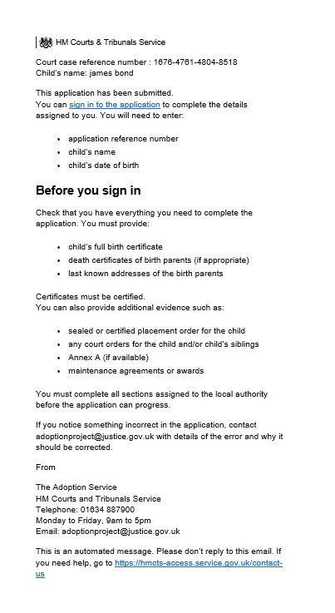

NB: The application data is stored for 30 days

The expectation is for you to complete the birth parents' details on behalf of the applicant(s) and submit birth certificate, placement order details and any other relevant documentation

If your adopter is applying for multiple children please allow them to apply for all children before completing the applications. Each application will have its own reference and email notification.

Follow the link in the top of the email notification and you will see this sign in page.

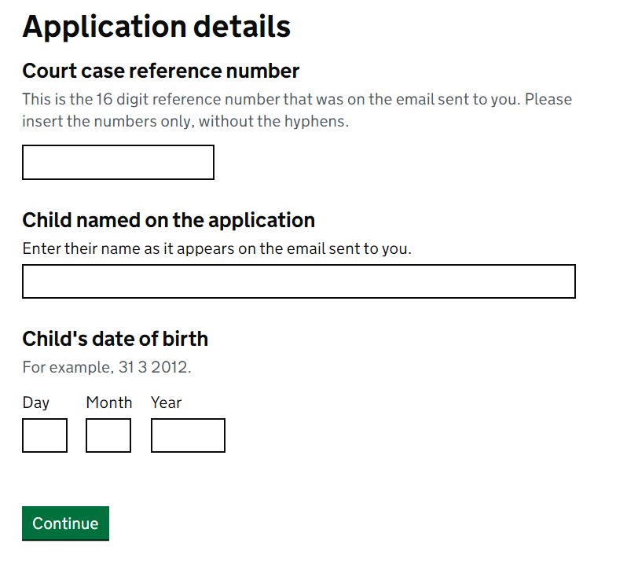

It is important to enter the details on this sign in page as they appear in the email. The 16-digit number needs to have the hyphens removed and the child's name as it appears on the email needs to be entered.

The child's date of birth is not sent due to security reasons, but you should be able to find this on the child's birth certificate or from previous placement/care proceeding information. (single digit format for numbers 1-9)

**NB: If documents are held offsite in your Local Authority then the notification and log in details can be shared with someone who can upload the required documents instead of waiting for post/fax/email**

Once signed in you will see the below page. The 'getting started' page highlights everything you need to complete the application. The time period you should complete the application by and details about dual usage.

There will be an upload facility within this service which will allow you to upload up to 10 documents, with a size limit of 20mb per file. You may need to amend the size of documents. We advise that you save the relevant documents somewhere easy to find on your PC prior to starting the application to avoid delays on the upload section

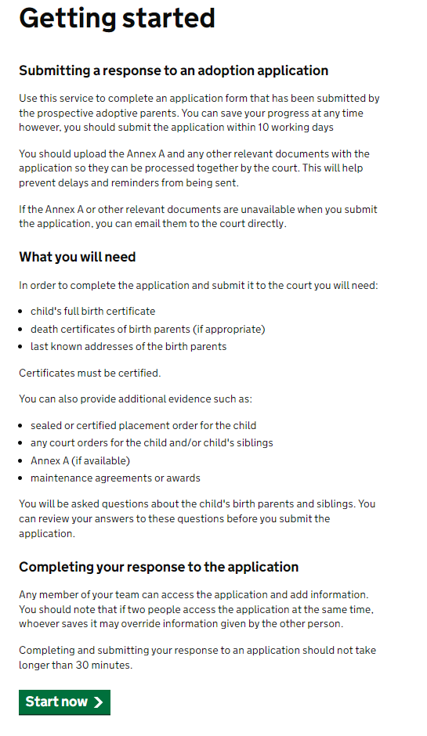

Click ‘Start now’ when you are ready.

You will see this page

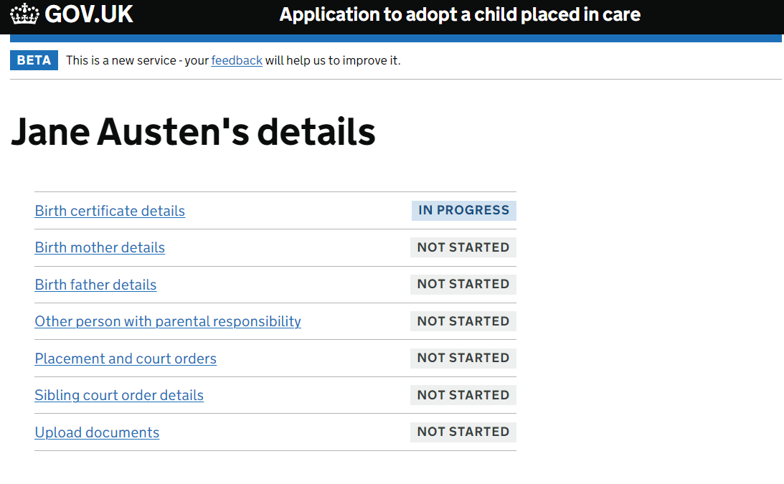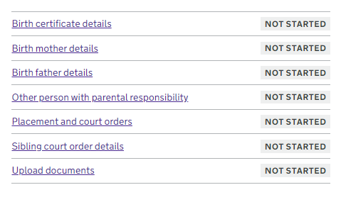

This is the task list screen which allows you to work on certain sections of the application. You will be routed back to this screen every time a section has been completed or you click save as draft.

You can work through this task list in any order. The wording next to each section will highlight what stills needs attention.

When ready click on the option you wish to complete. (For the purpose of this guide we will work through each item in order)

Birth Certificate screens prompt you to answer questions relating to the child. Choose an option and click save and continue. You can choose to save as draft and return to the main menu if you cannot complete a question at this time.

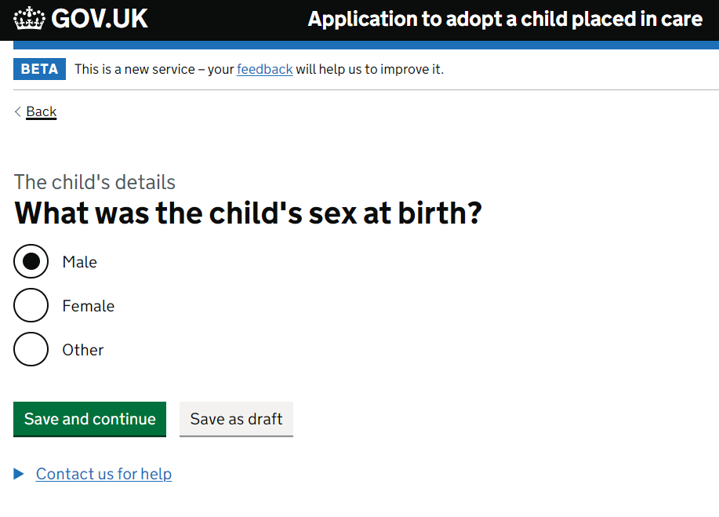

The system guides you through each question until all information for a section is complete.

Choose the relevant option and click save and continue

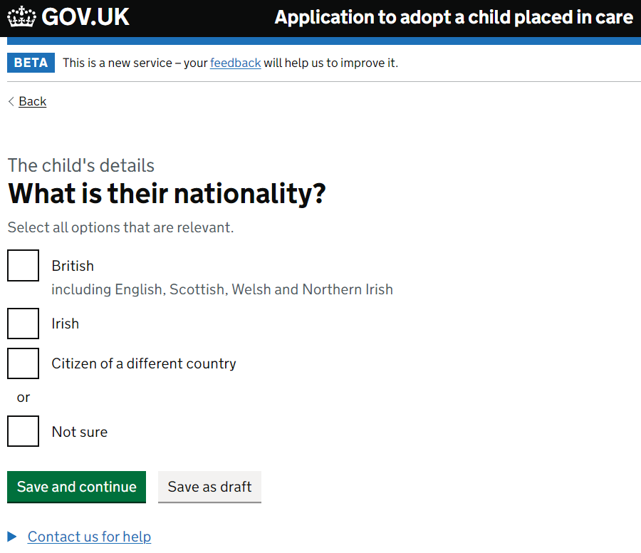

Once a section is completed in full the status changes on the right hand side of the task.

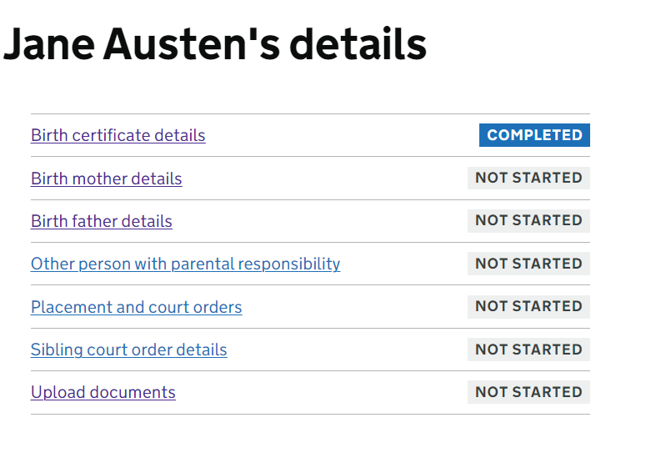

Now click on Birth mother details

Complete section in full relating to the birth mother and click ‘save and continue’ to submit the details or save as draft if you need to double check the details.

Enter the birth mother’s name in full

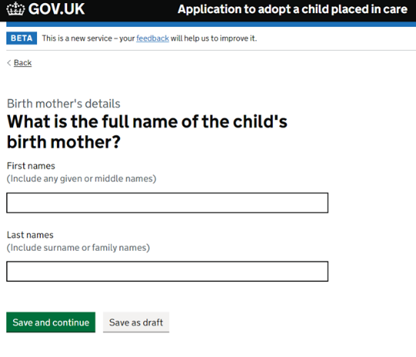

Choose the relevant option and click save and continue. NB: if the birth mother is deceased a copy of the death certificate will be required, and no further questions will be asked.

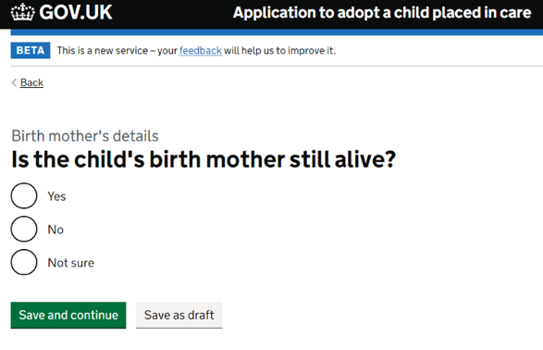

Choose the relevant option and click save and continue.

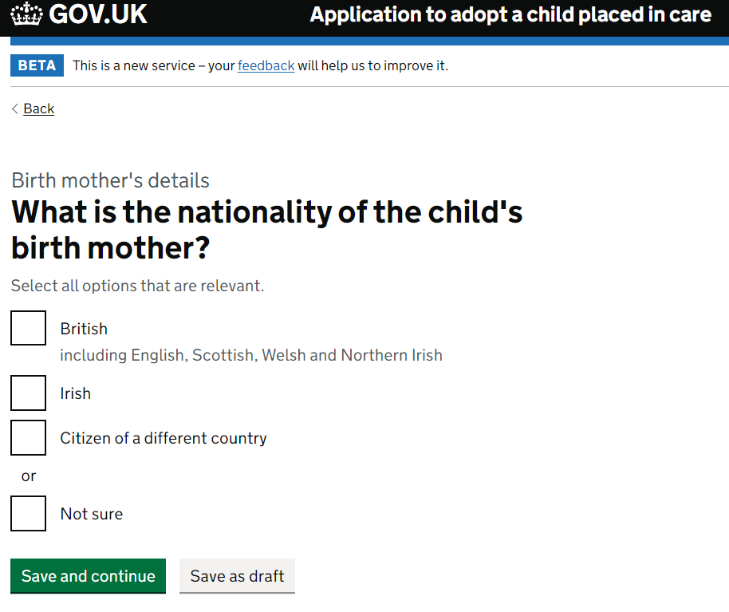

Enter the birth mother’s occupation or state unknown and click save and continue. Click save as draft if you need to go away and check this information.

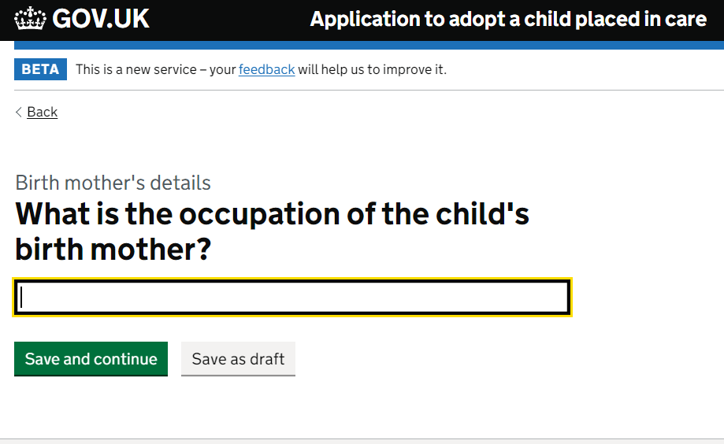

Choose the relevant option and click save and continue

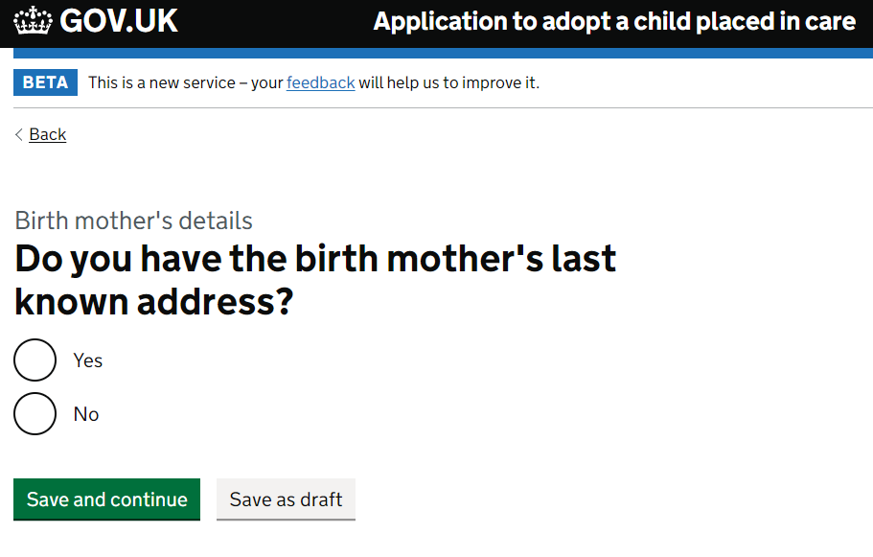

NB if you do not know the address you are prompted to give a reason

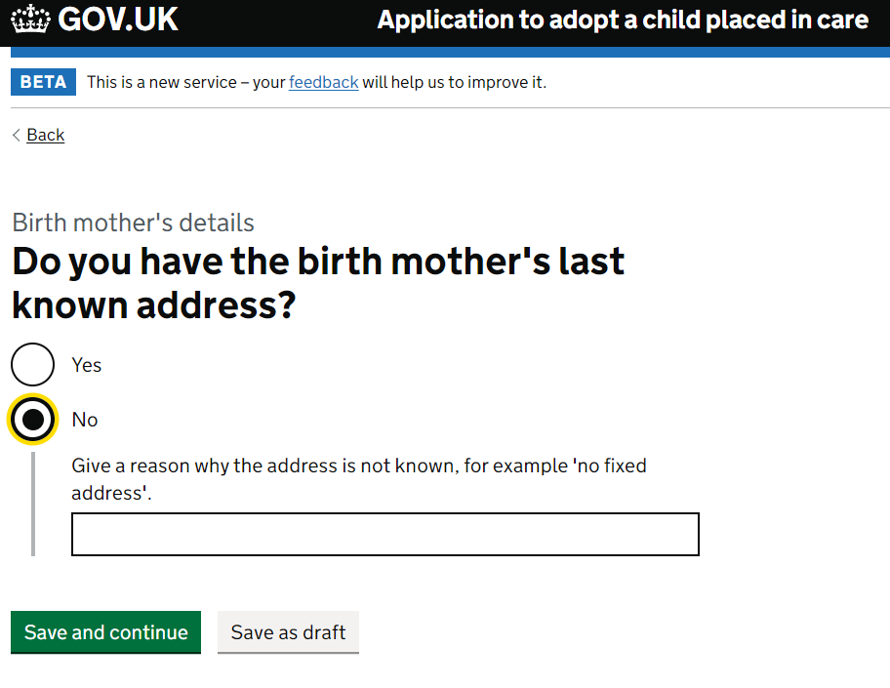

If you know the address, enter the post code for the birth mother and click find address.

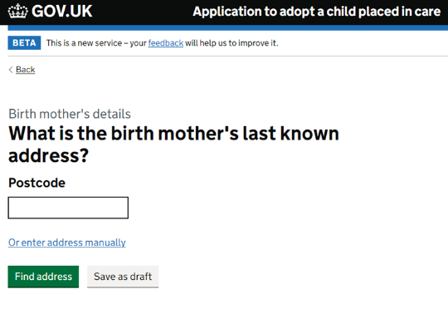

Choose the correct address from the drop down provided and press save and continue. NB: if the address is not in the drop-down list there is the option to enter the address manually.

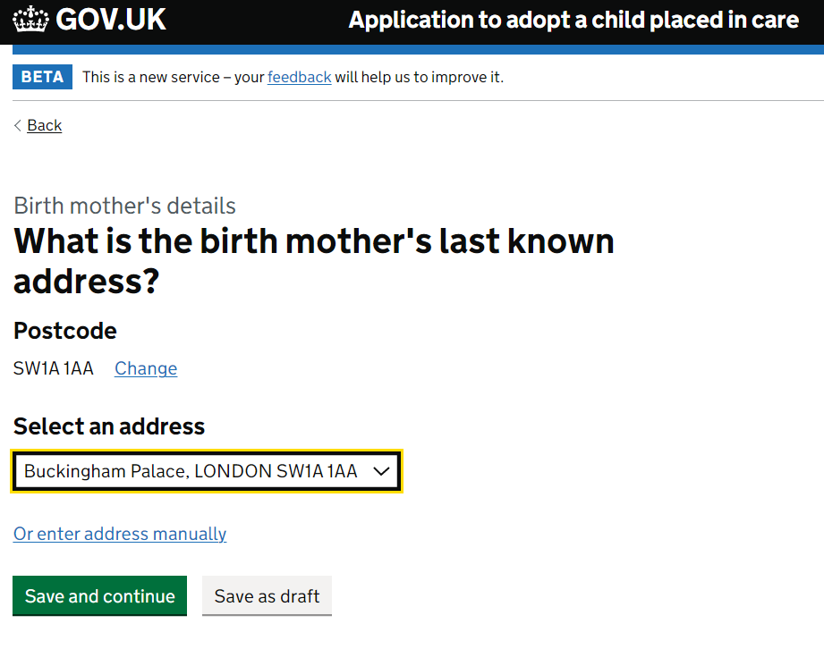

Enter the date the address was last confirmed, and press save and continue (or save as draft if you need to check)

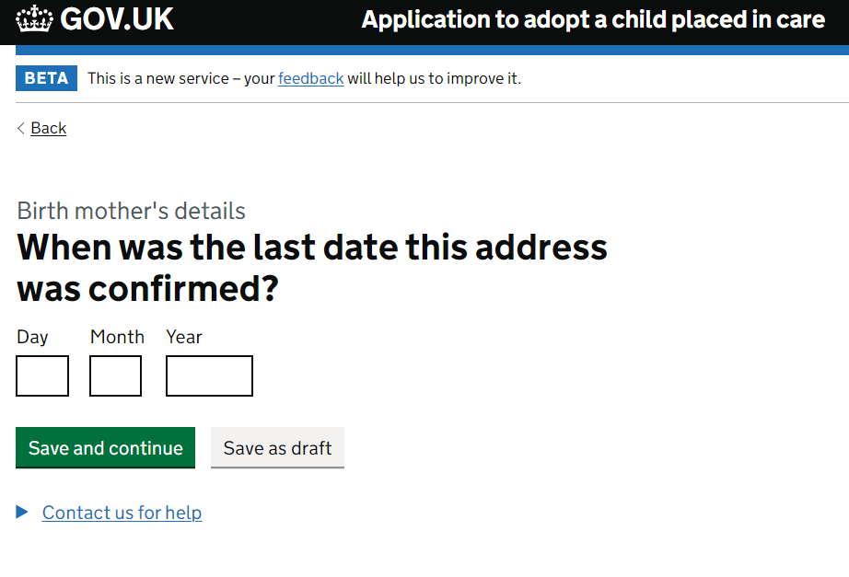

The following question relates to whether the birth mother should be sent court documents relating to the adoption. If the answer is ‘No’ then please give specific reasons for this choice which will be considered by the Judge.

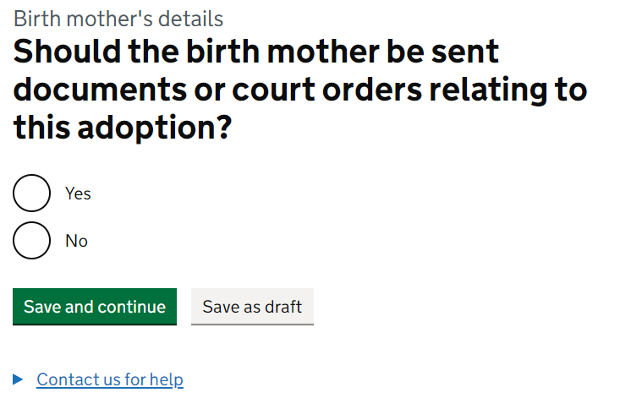

Once you have answered all the questions relating to the birth mother that are required you are directed back to the task list and the status changes to completed (NB: if it says in progress there is something missing, or you have not clarified by pressing ‘save and continue’. You should be able to navigate to the question that needs attention by clicking through the screens again).

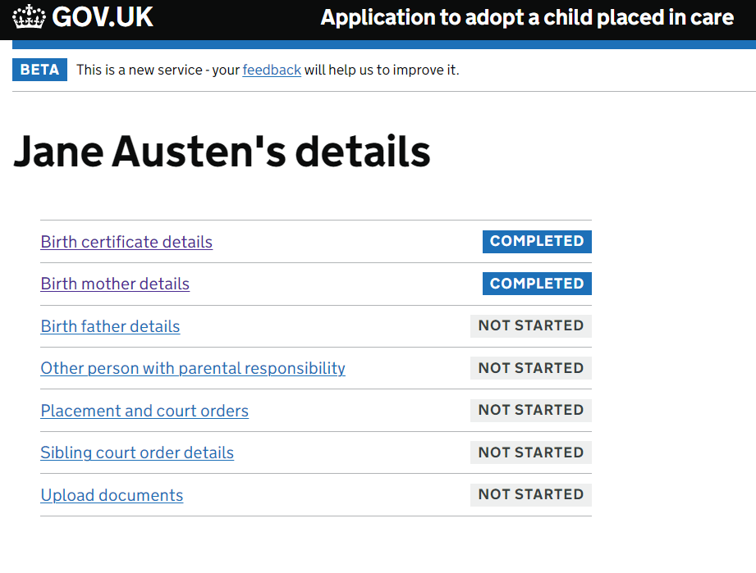

Now complete the Birth father’s details, click on the birth father’s details button in the main menu.

Answer the below question accordingly and click save and continue

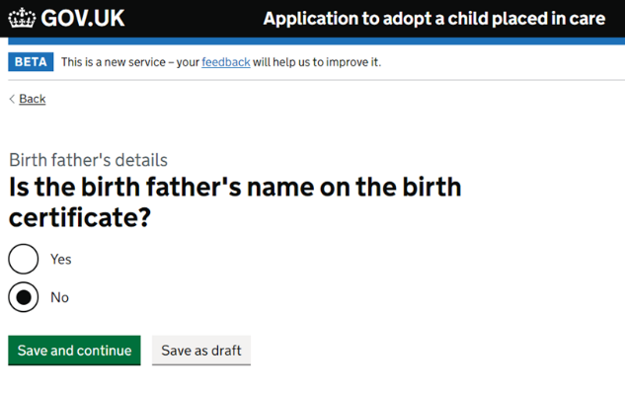

If the birth father is not named on the birth certificate you will be asked the below question

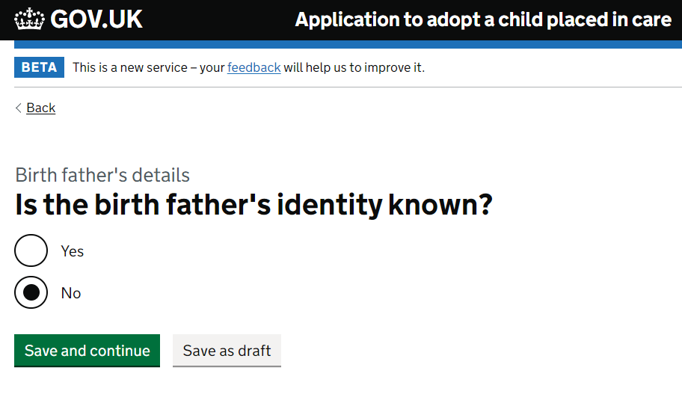

If the birth father’s identity is unknown, then this completes the birth father’s section, and you are returned to the task list.

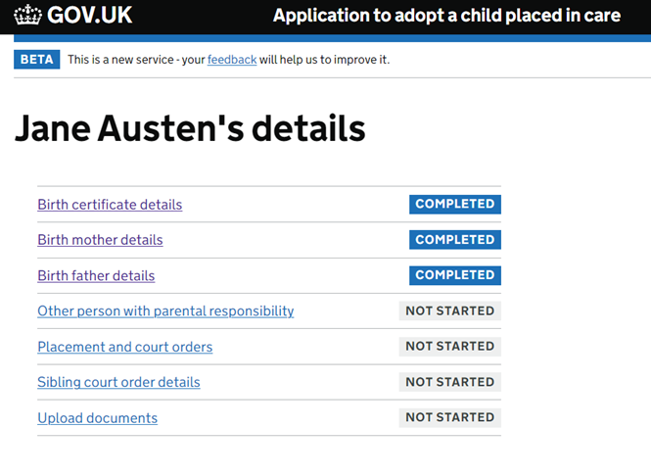

When the birth father’s details are known or listed follow the below process.

Choose the relevant option and click save and continue.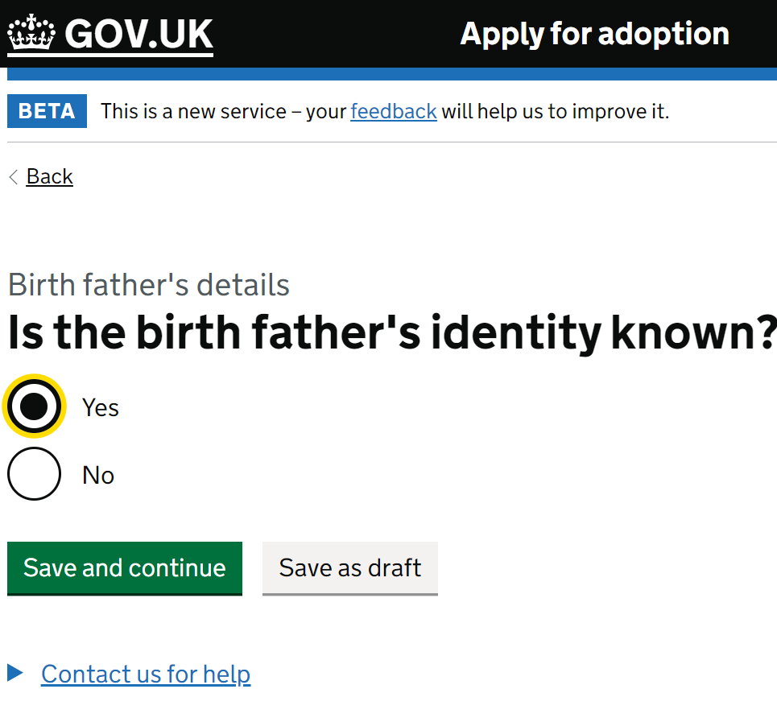

Complete the details accordingly and press save and continue.

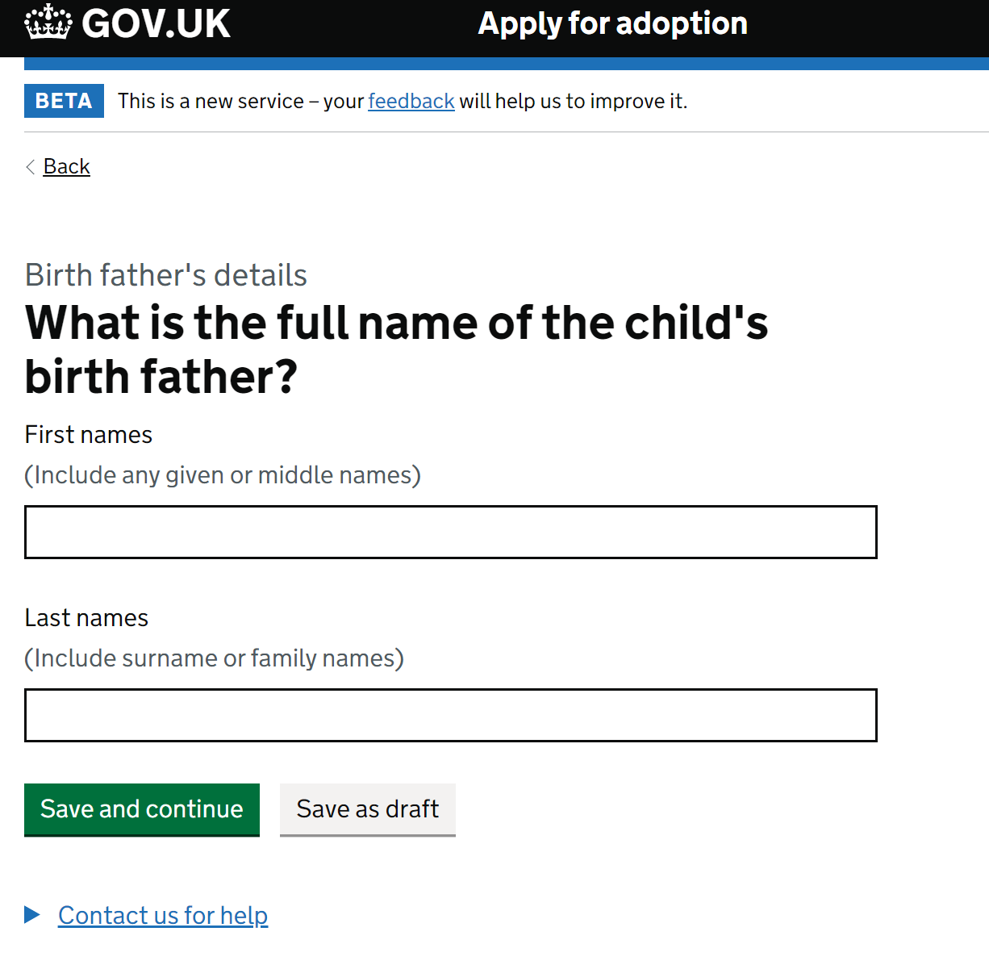

Choose the relevant option and click save and continue. NB: if the birth father is deceased a copy of the death certificate will be required, and no further questions will be asked.

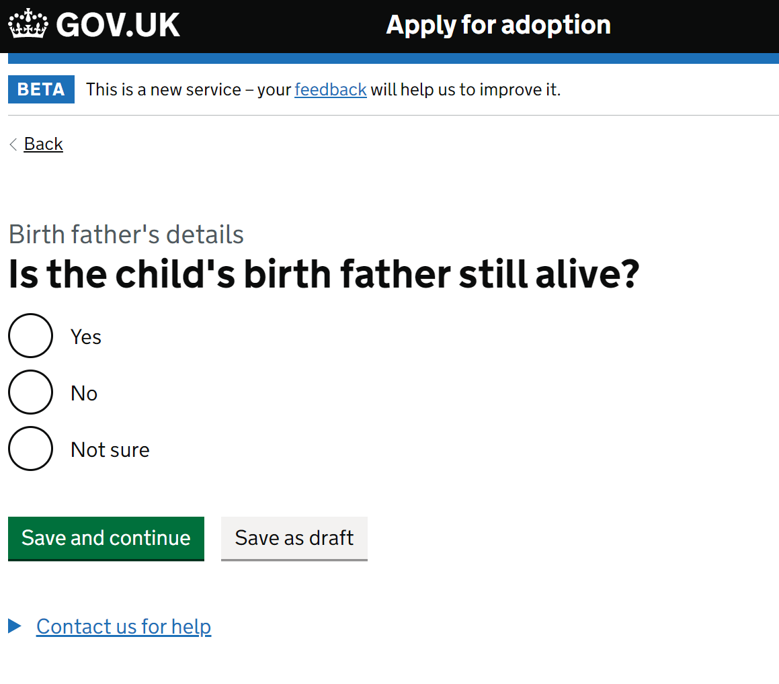

The following questions relate to whether the birth father has parental responsibility and how it was granted or removed.

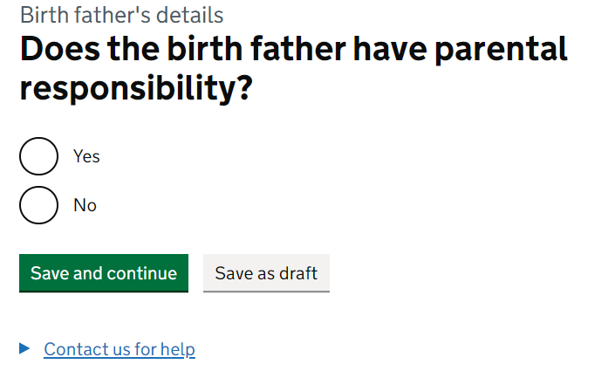 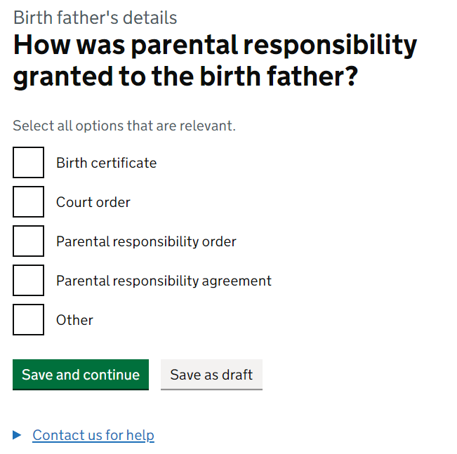 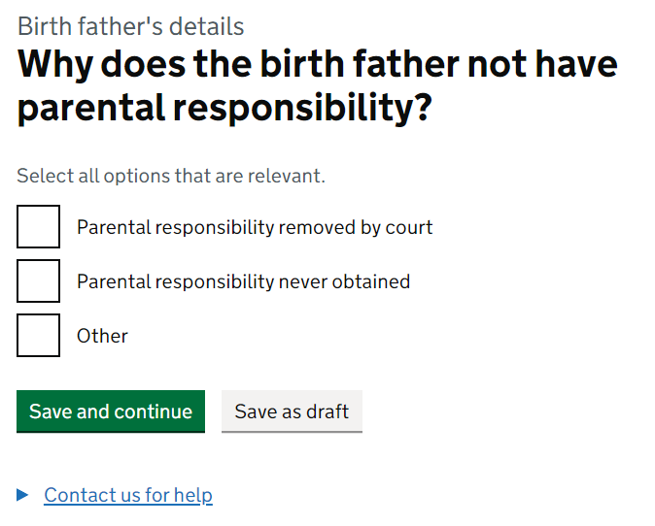

Choose the relevant option and click save and continue.

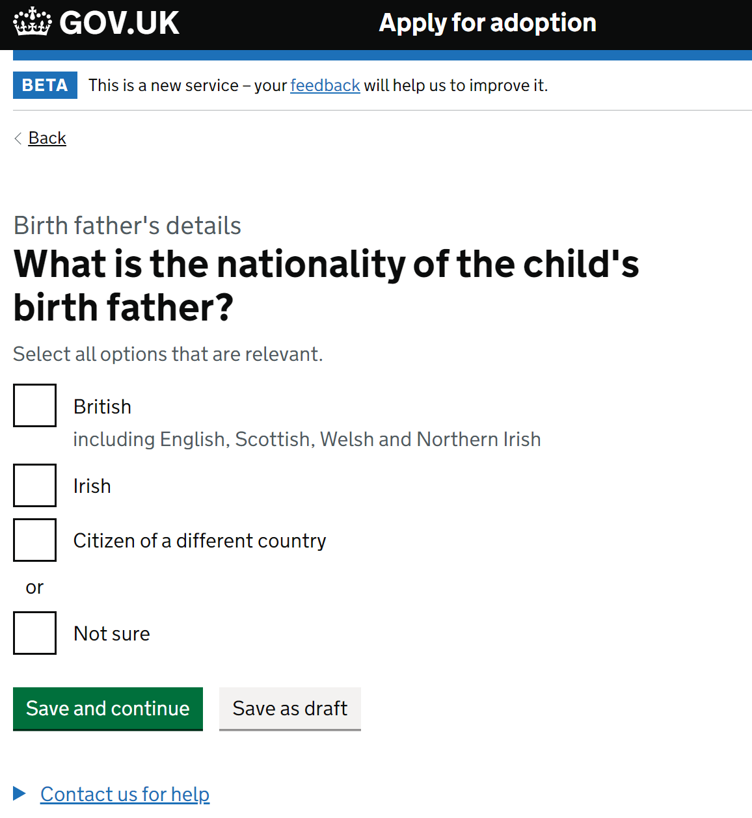

Complete the birth father’s occupation or state if unknown and click save and continue.

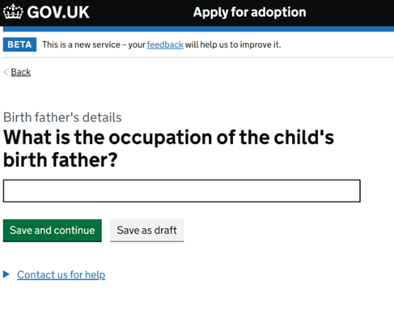

Choose the relevant option and click save and continue.

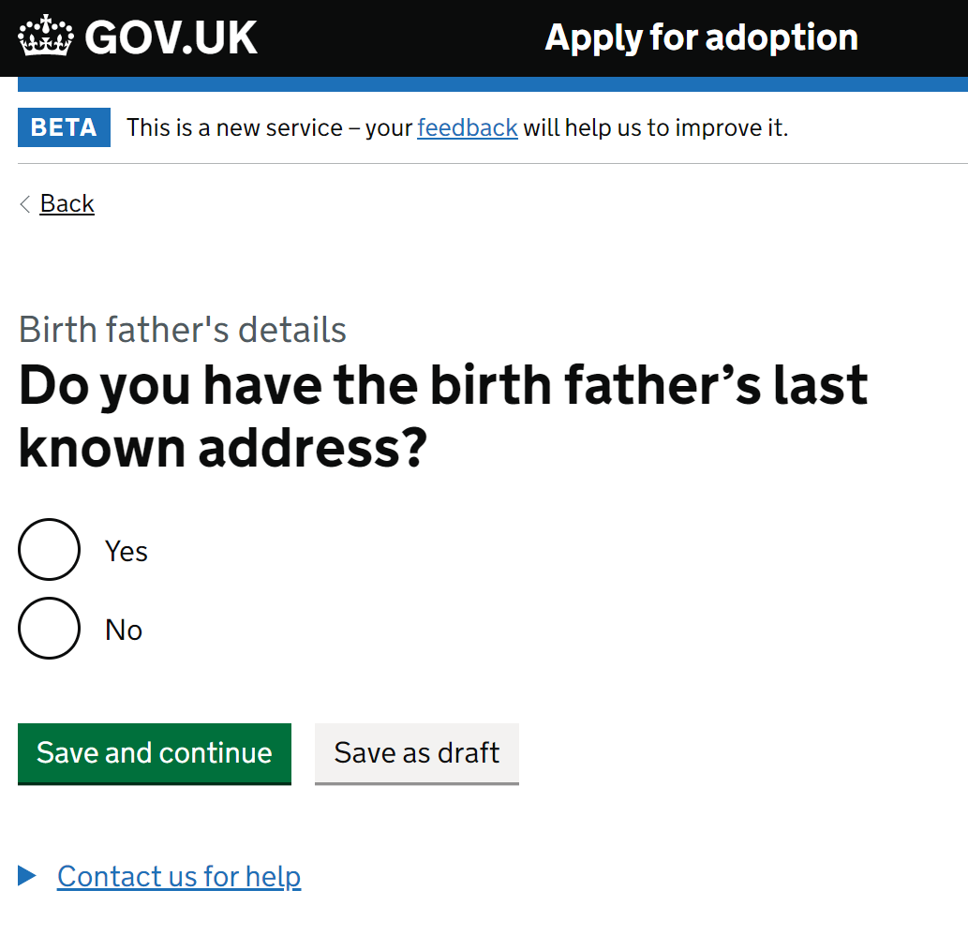

NB: If you do not know the address you will be prompted to provide an explanation. Click save and continue.

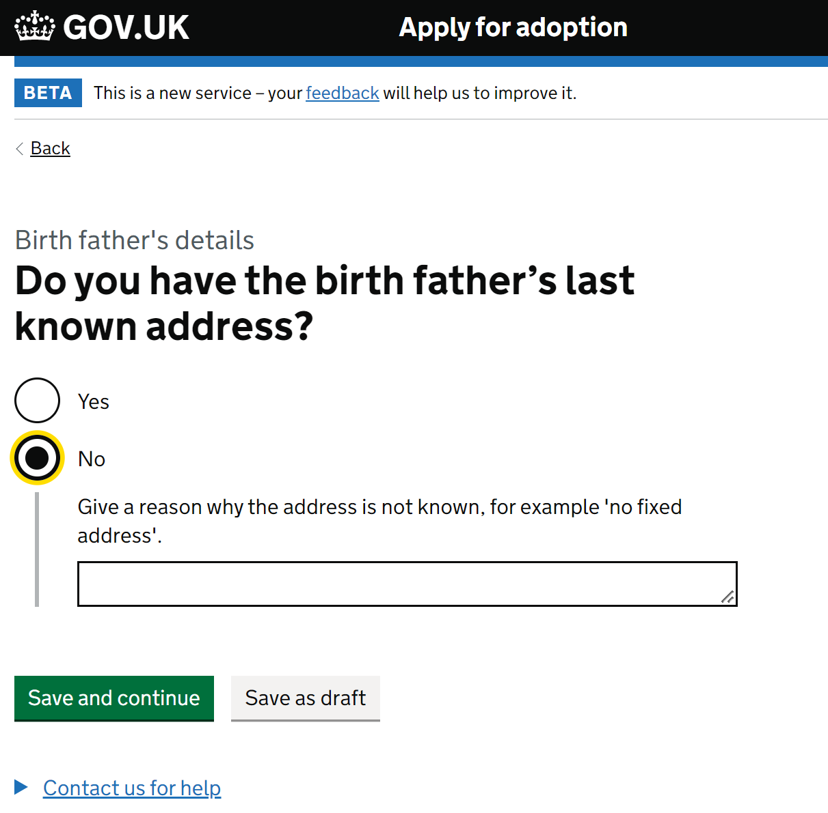

Enter the birth fathers post code in the box provided and click ‘find address’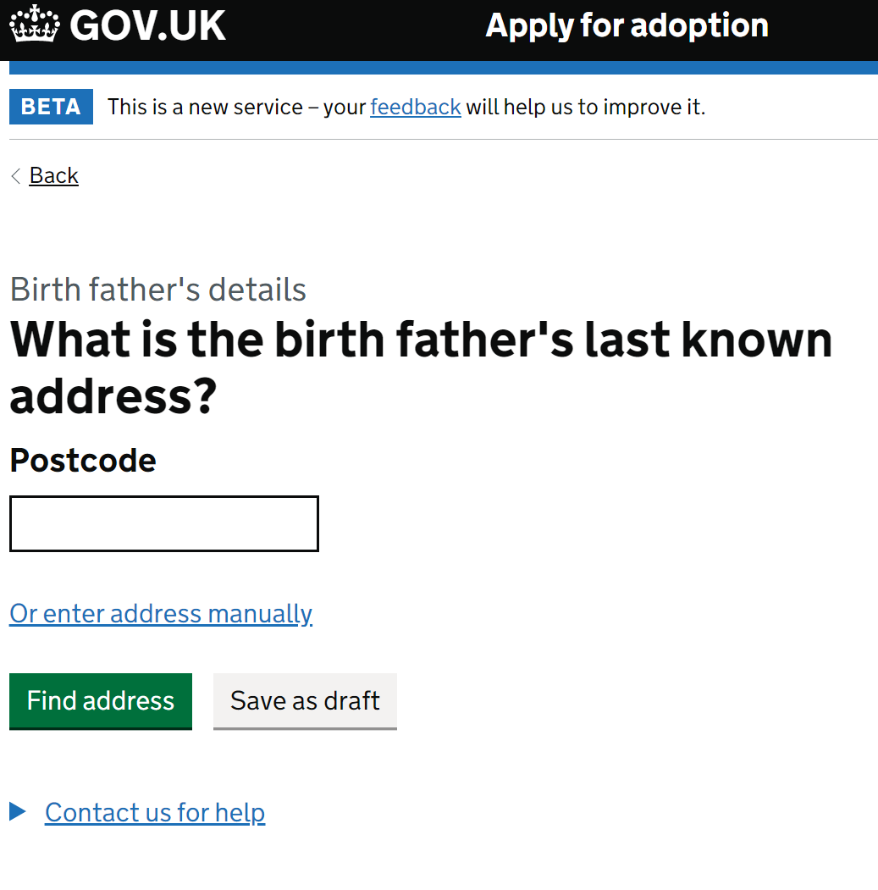

Choose the correct address from the drop-down provided and press save and continue. NB: if the address is not in the drop-down list there is the option to enter the address manually.

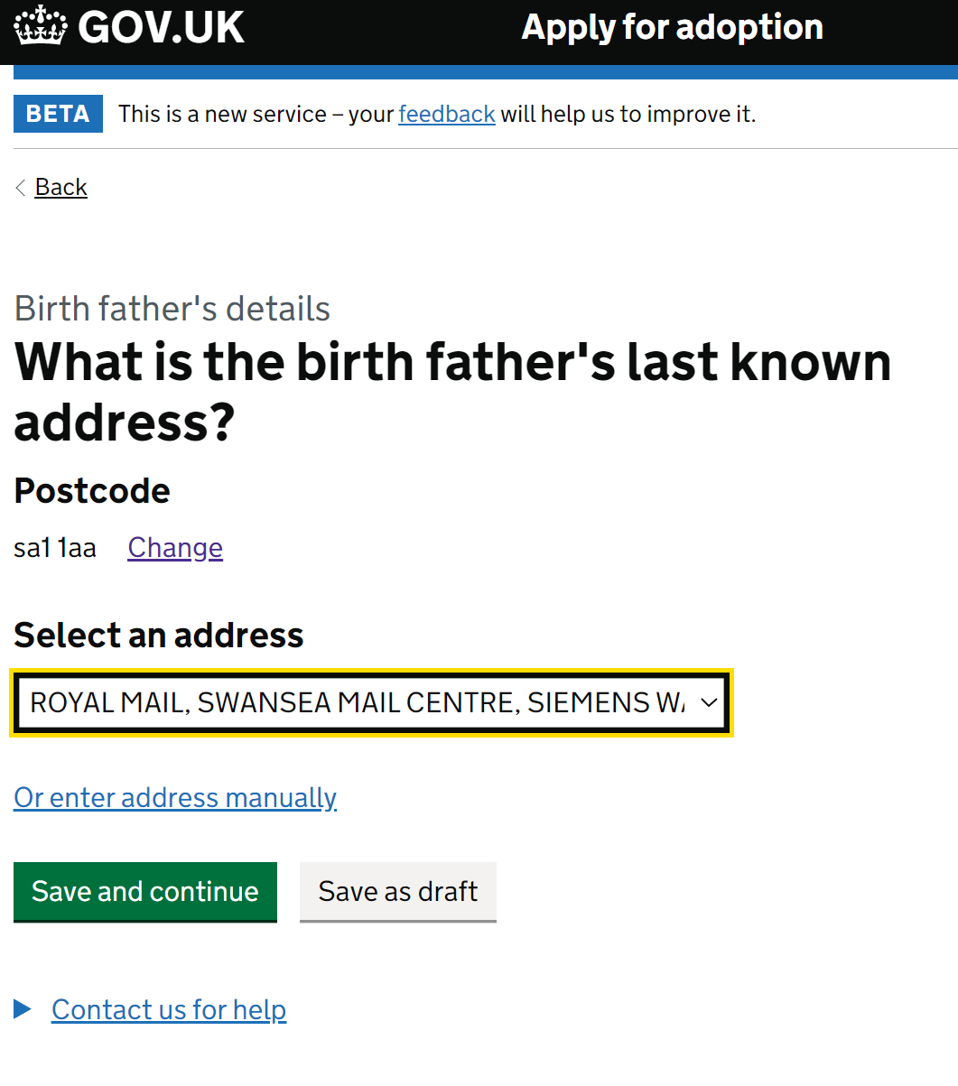

Enter the date the address was last confirmed, and press save and continue (or save as draft if you need to check)

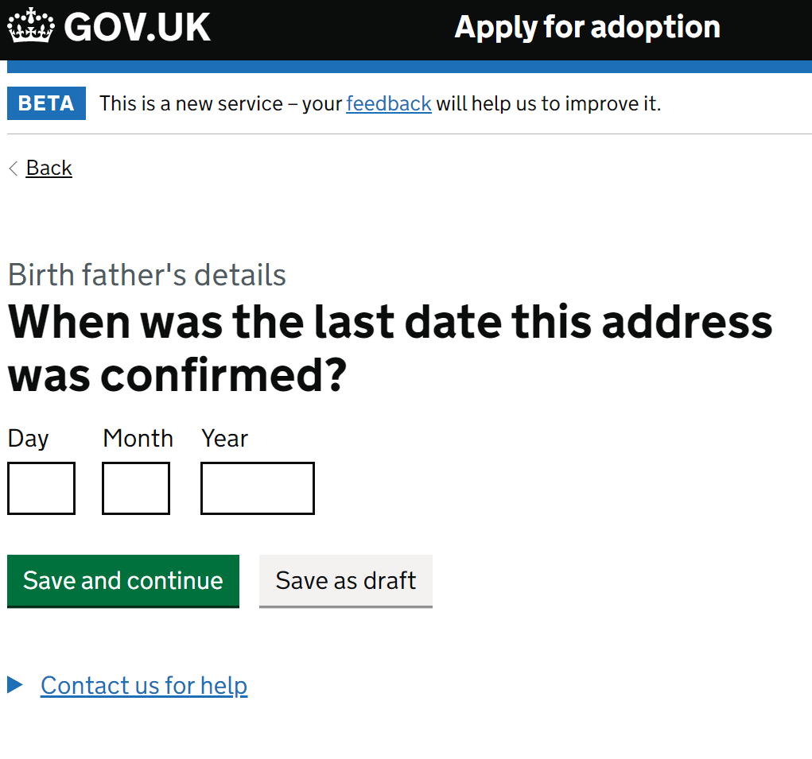

The following question relates to whether the birth father should be sent court documents relating to the adoption. If the answer is ‘No’ then please give specific reasons for this choice which will be considered by the Judge.

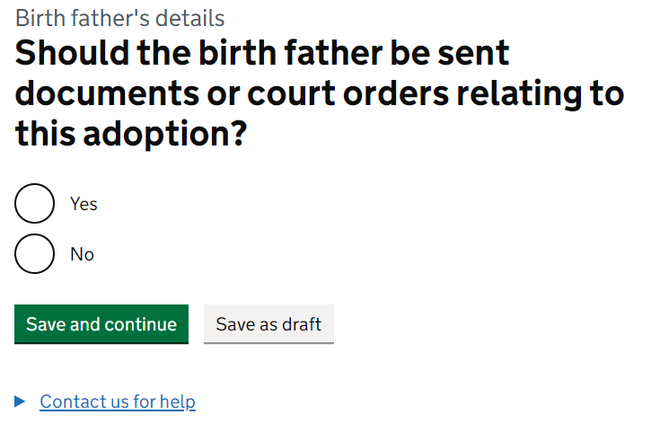

You can see your progress in each section on this task list which shows you how far through an application you are and allows you to complete sections at a convenient time. You can start and stop an application as and when information is available.

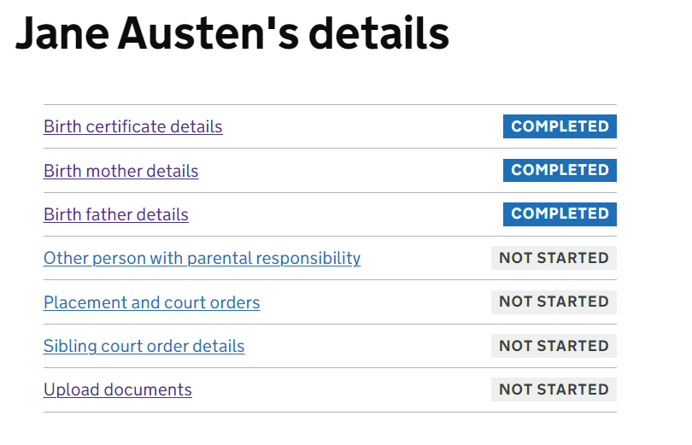

You must click into the ‘Other person with parental responsibility’ task and confirm your answer.

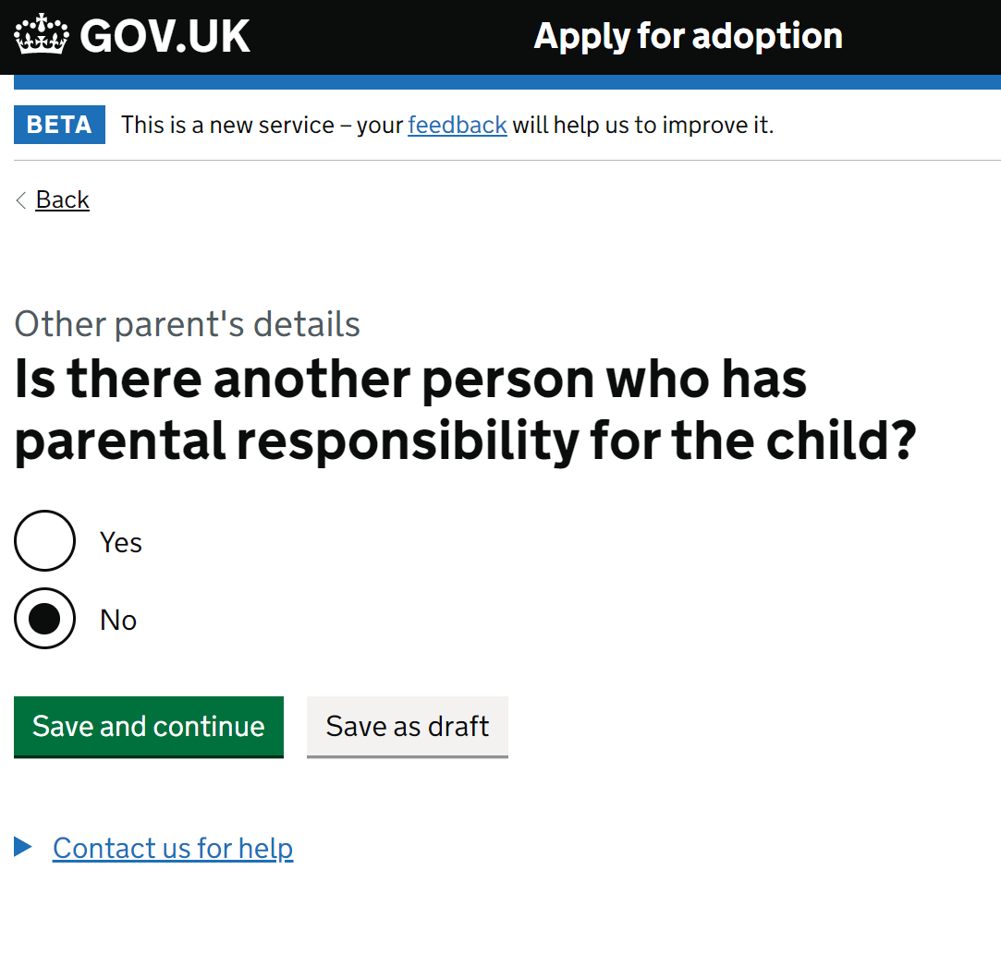 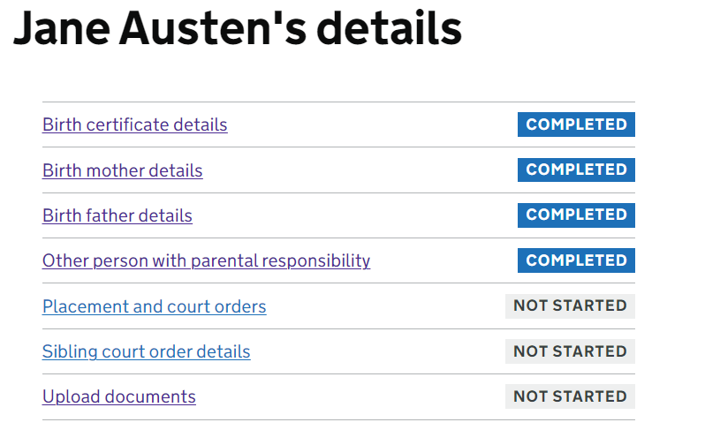

If there are ‘other people with parental responsibility’ you can add them through the below process.

Choose the relevant option and click save and continue.

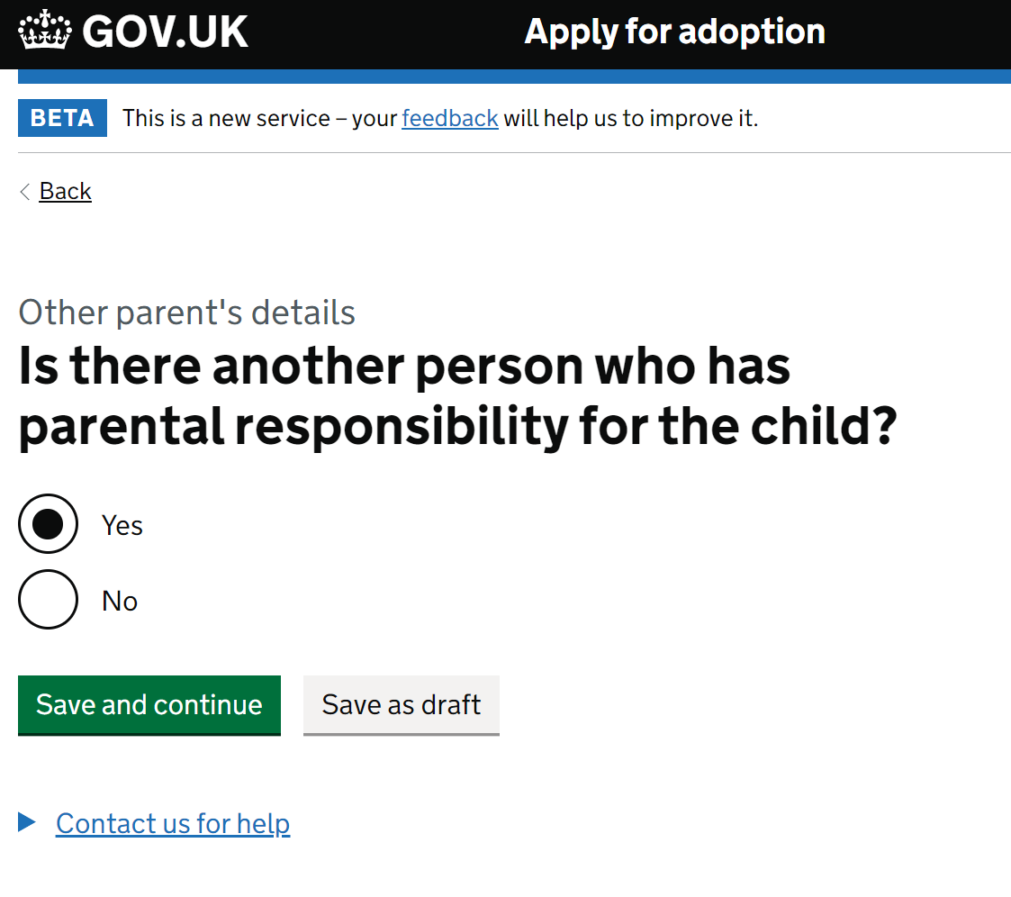

Enter the name of the party with parental responsibility and click save and continue

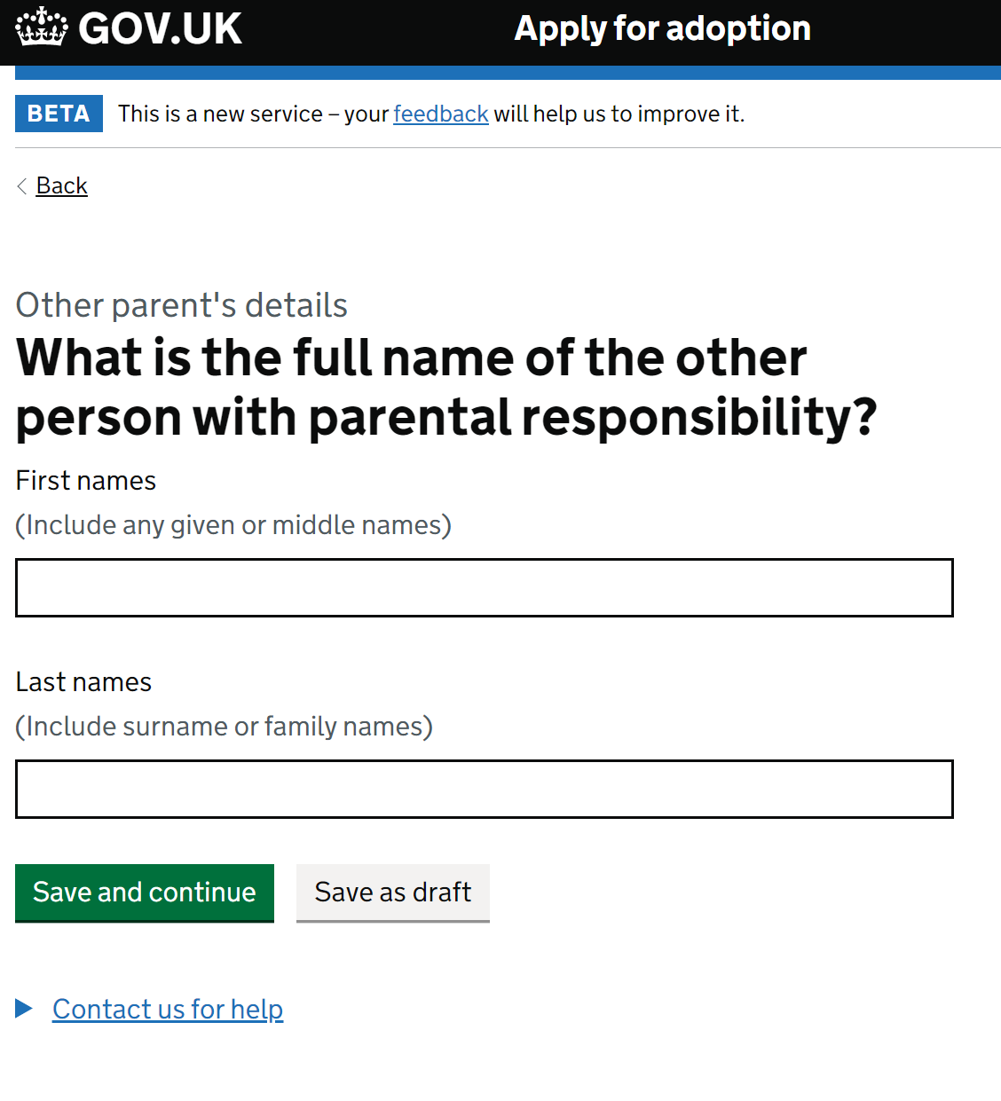

The following question relate to how parental responsibility was granted

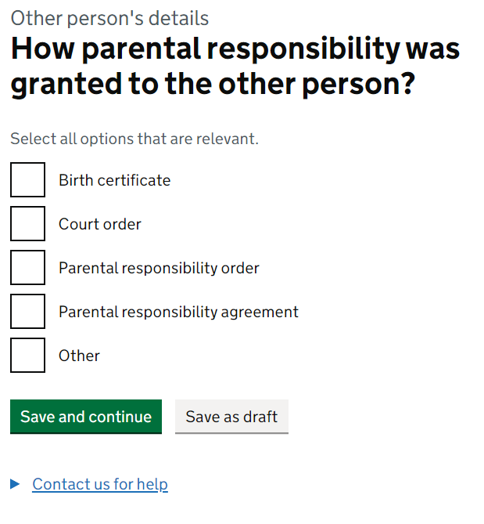

Choose the relevant option and click save and continue.

NB: if you do not know the address, please provide an explanation.

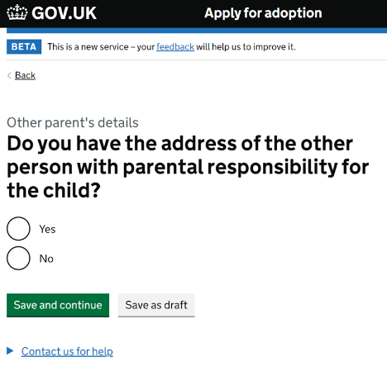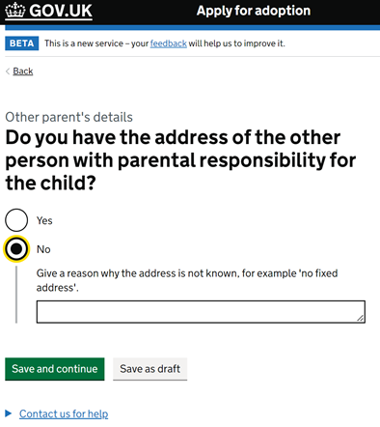

Enter the other parties post code in the box provided and click find address.

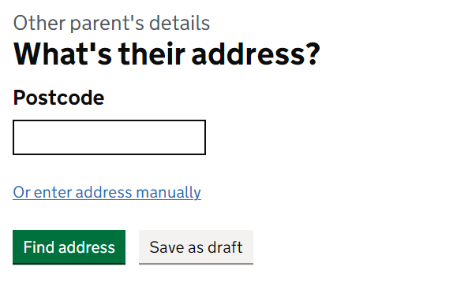

Choose the correct address from the drop-down provided and press save and continue. NB: if the address is not in the drop-down list there is the option to enter the address manually.

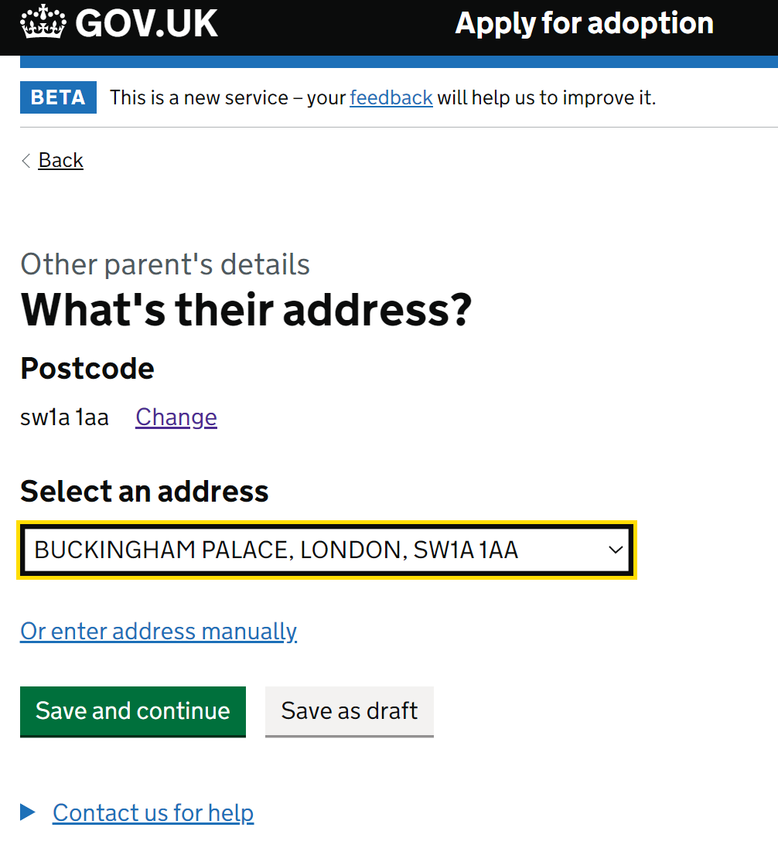

Enter the date the address was last confirmed, and press save and continue (or save as draft if you need to check)

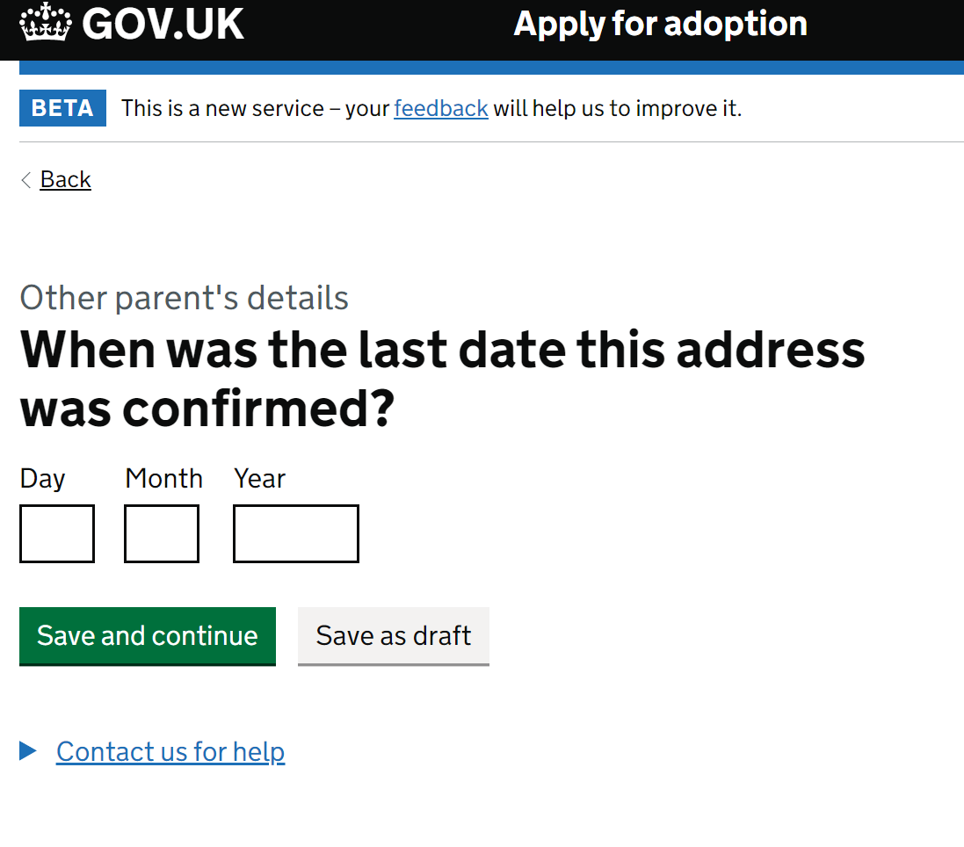

The following question relates to whether the other person should be sent court documents relating to the adoption. If the answer is ‘No’ then please give specific reasons for this choice which will be considered by the Judge.

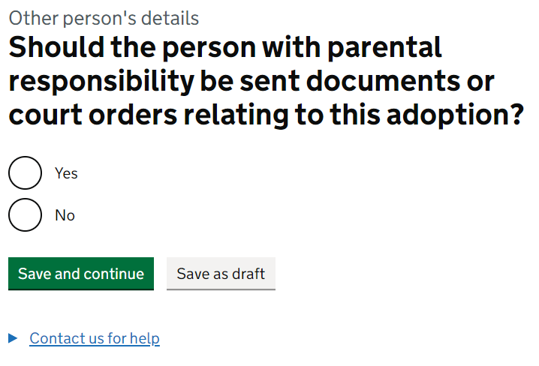

The task list will confirm once a tsk is completed. If it shows ‘In progress’, there are still questions outstanding.

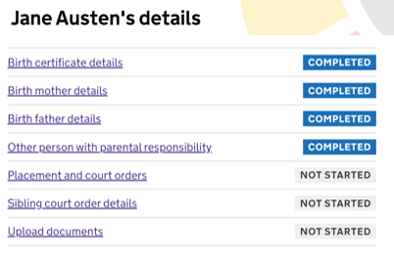

On to placement order details. Enter the serial/case number which is located on the court order previously supplied by the court. Click save and continue.

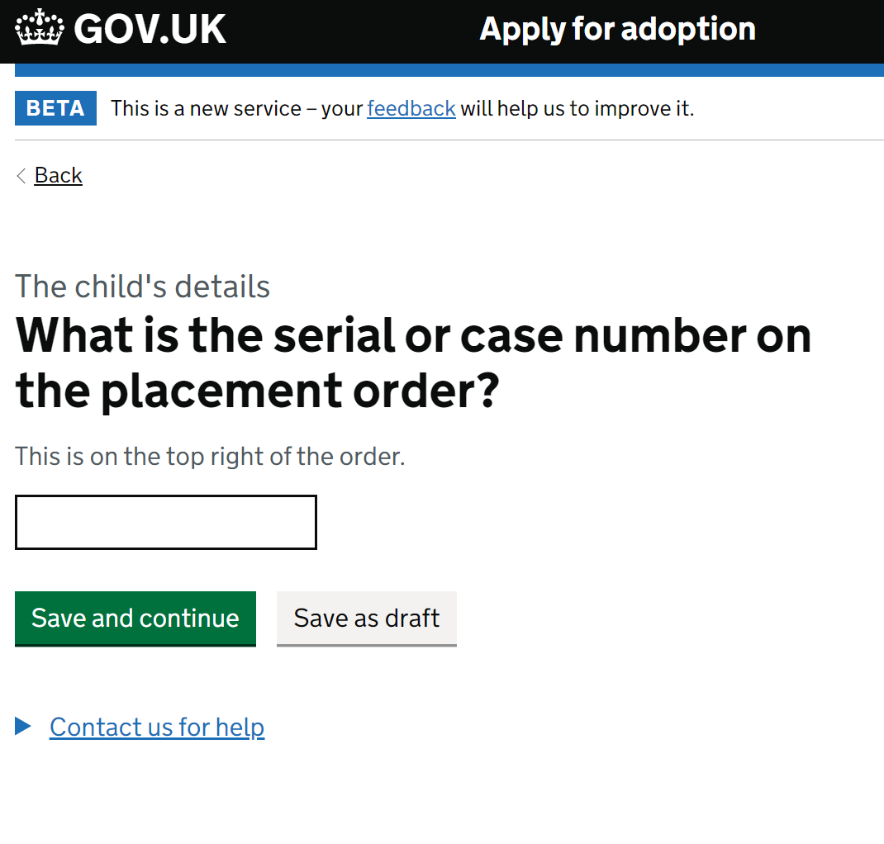

Enter the date from the placement order. Click save and continue. (Or save as draft if you need to check details)

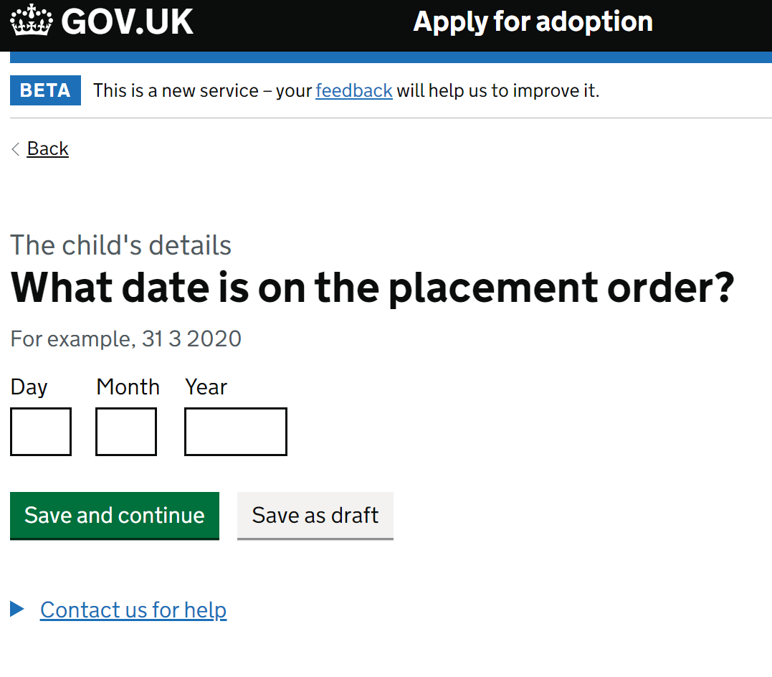

Once the placement order is entered you will see the below screen which allows you to add any other orders relating to the child., view the details already provided or save and continue.

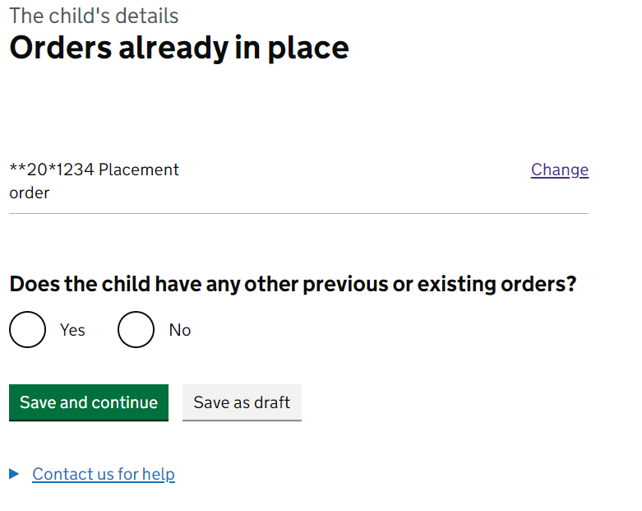

If you select ‘No’ and press save and continue you are sent back to the task list screen.

If you select yes, press save and continue the below page appears which enables you to enter other types of orders relating to the child. This will enable to court to link previous cases to the new application. Enter the serial/case number and start typing the name of the court which will provide a drop down to choose from.

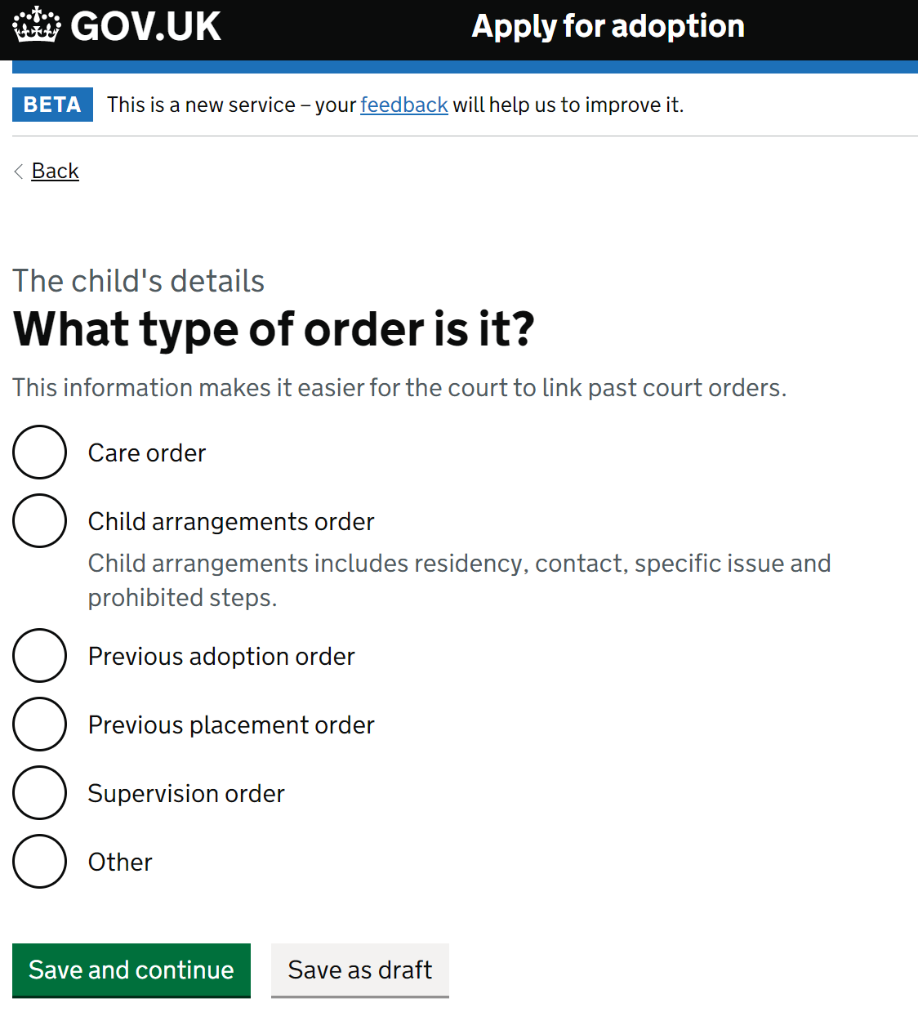 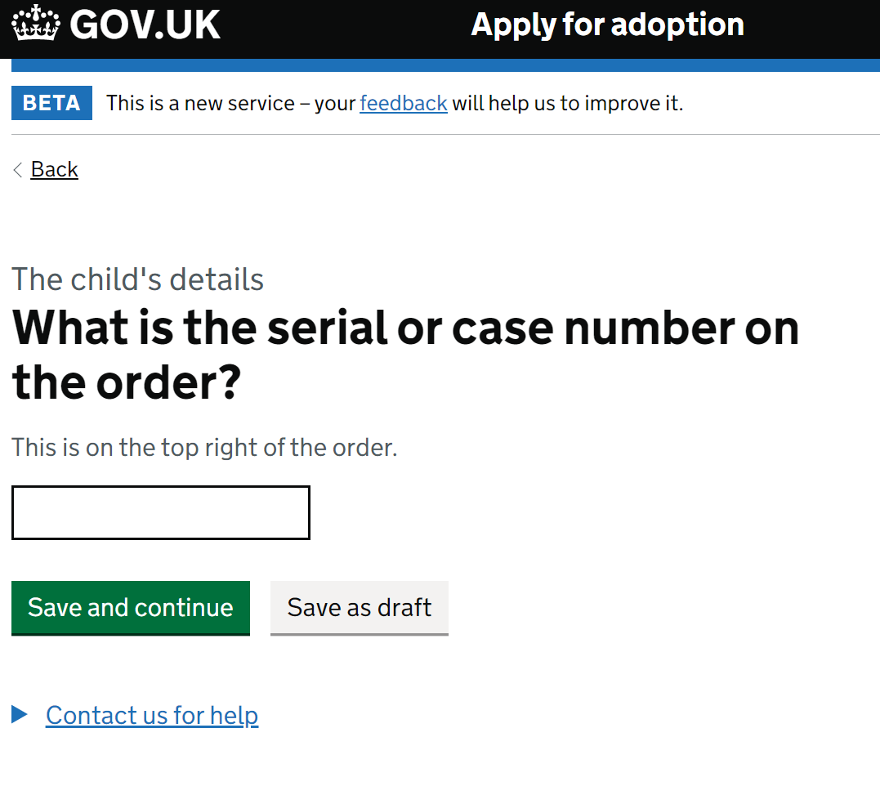 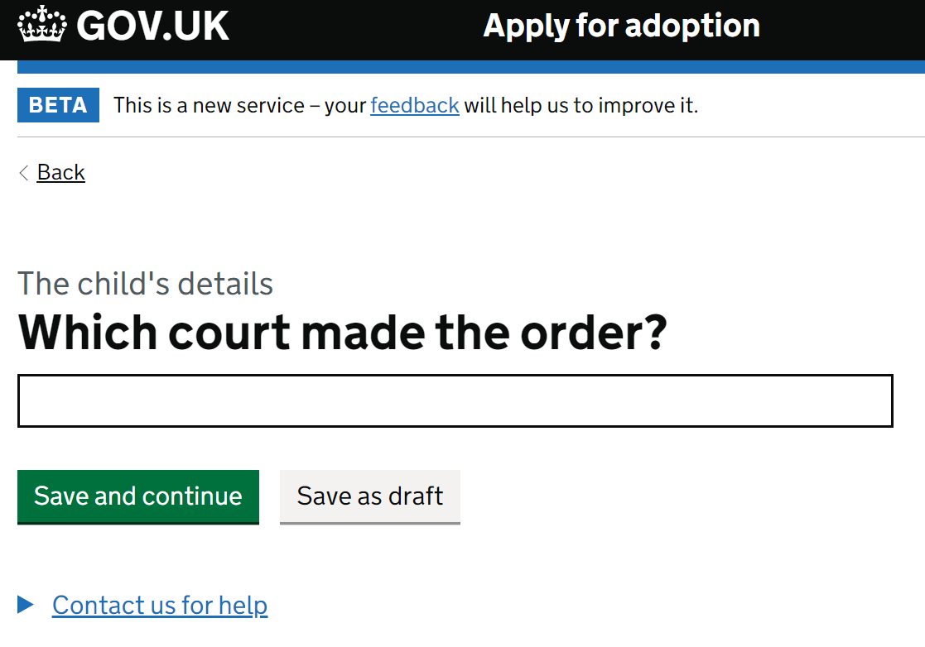 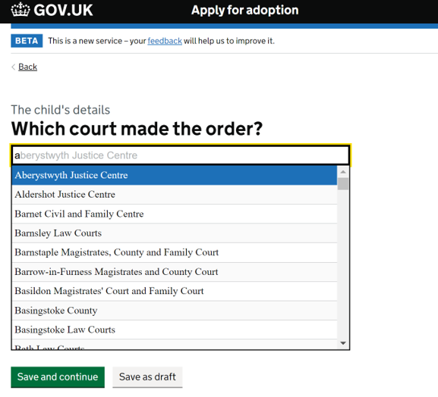

Click save and continue after completing each section relating to the type of order.

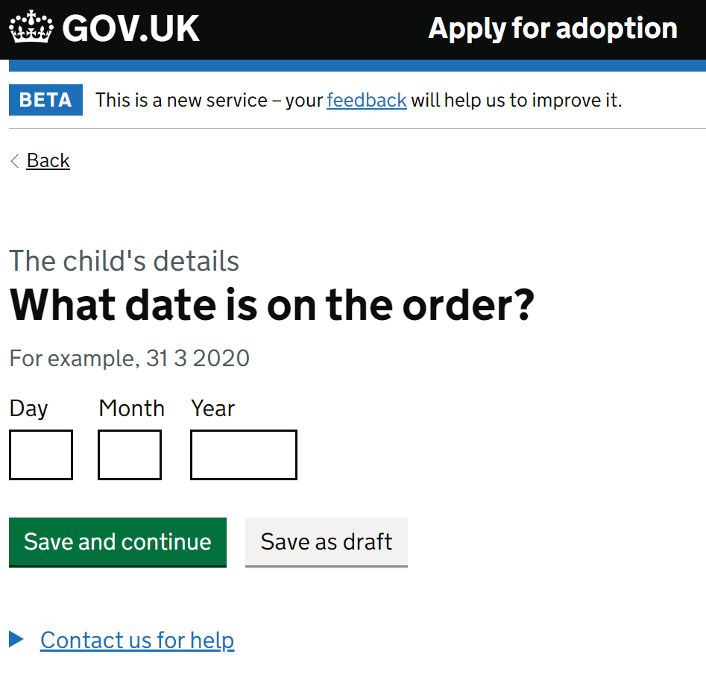

NB: use the ‘save as draft’ button at any point if you need to clarify the information.

You can add as many orders that are relevant from this screen by selecting ‘yes’

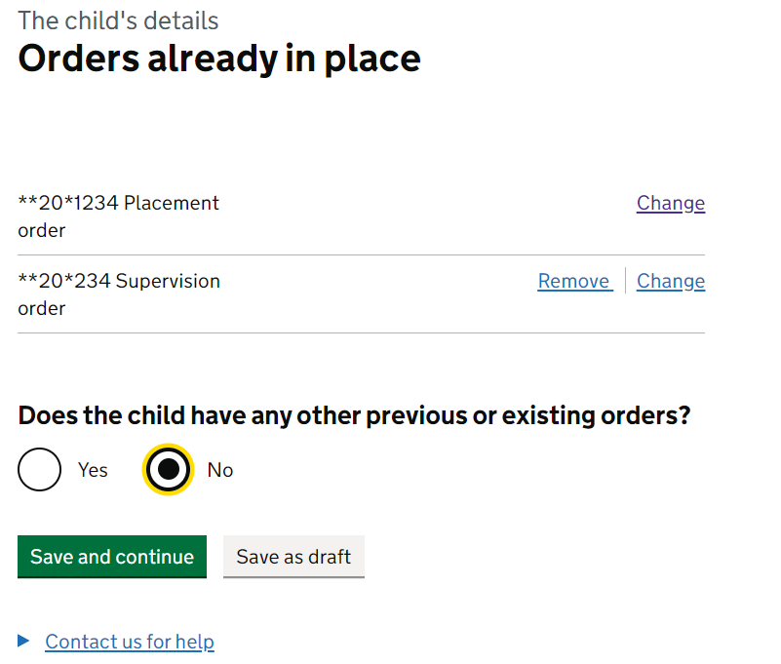

Select ‘no’ and then save and continue to complete this section.

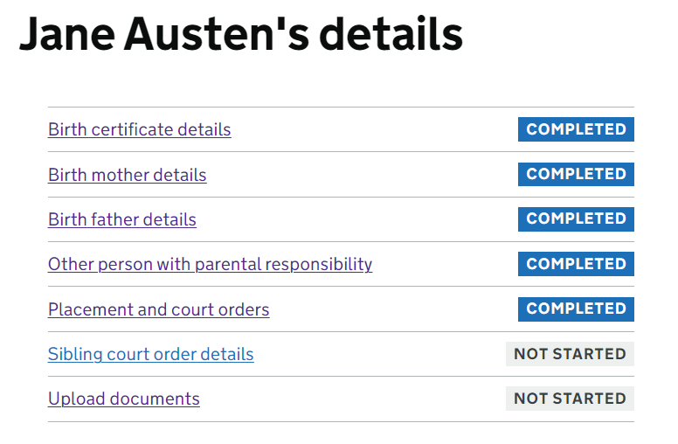

Click on the next link relating to ‘sibling court details’ which will show you this page.

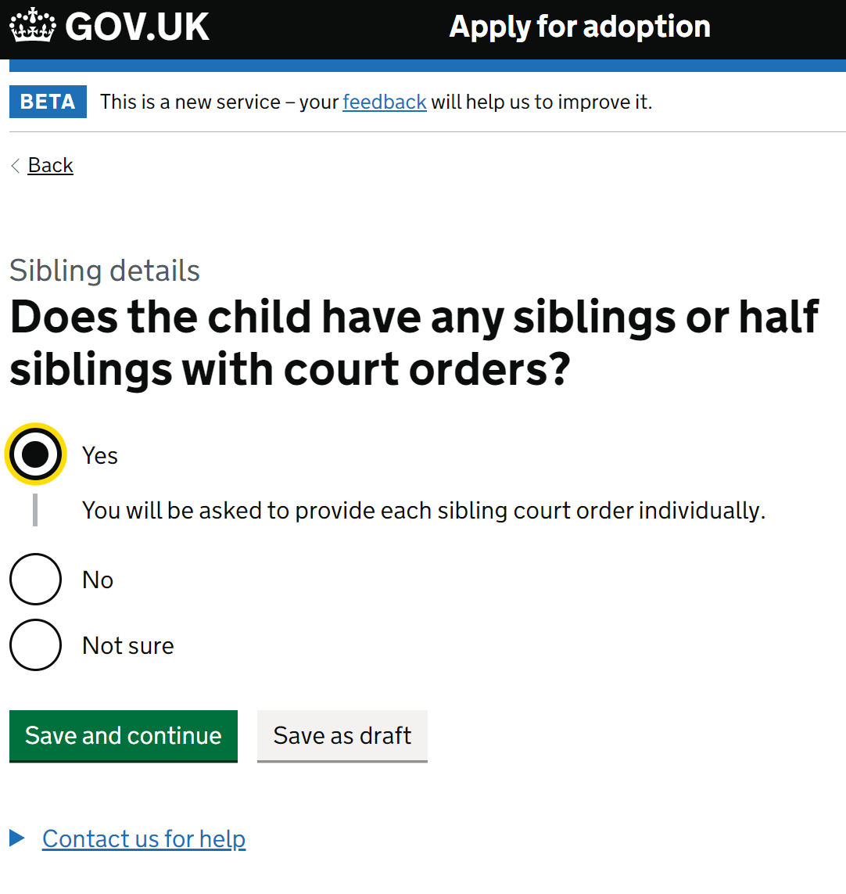

NB: if you choose ‘No’ or ‘Not sure’ and click save and continue you are returned to the task list.

If you choose ‘yes’ and click save and continue you are moved to this screen. Choose the relevant option and click save and continue. If the reference/case number is unknown please state ‘Unknown’

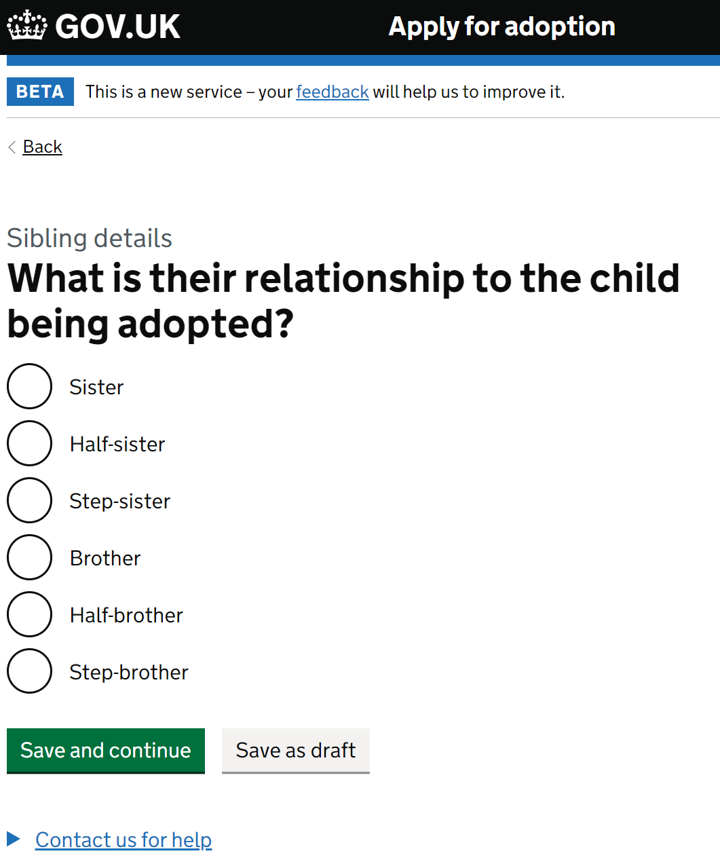 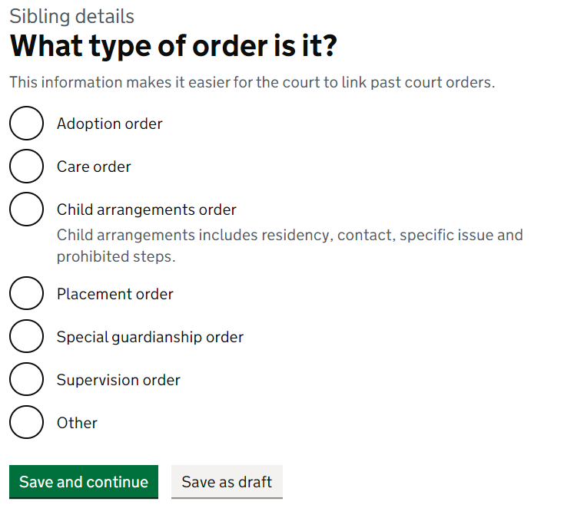 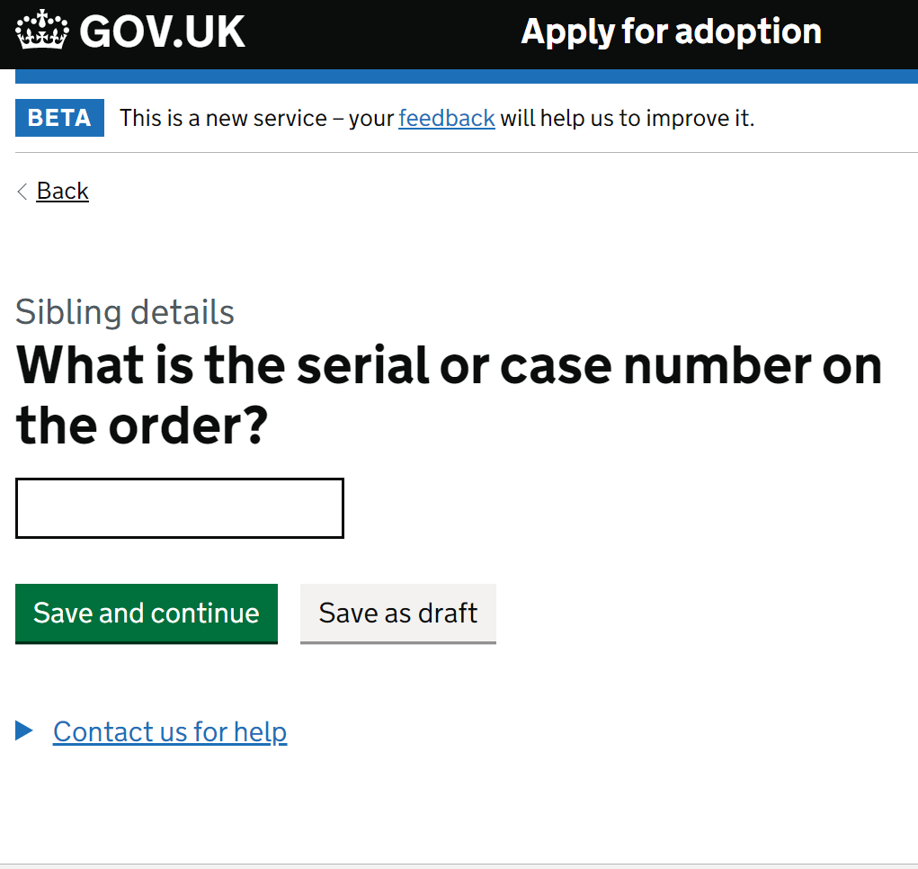

NB: if there are multiple siblings you can add them by repeating the screens above. When you are finished adding sibling orders choose no on the below screen and you will be navigated back to the task list.

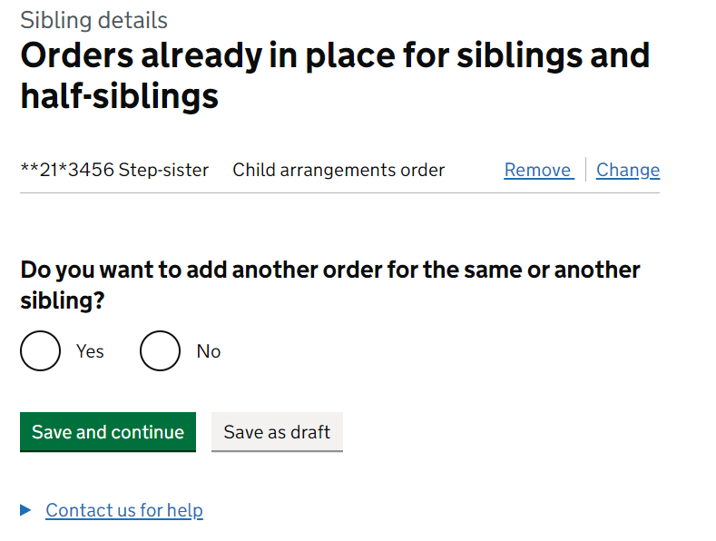

The task list should now look like this.

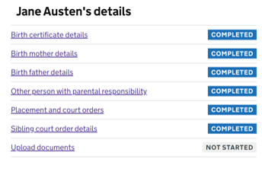

The next link takes you to an upload page where you can upload the birth certificate and all relevant documents relating to the adoption application. If you have already completed the annex A this can also be submitted at this point.

Click on the blue word ‘Choose’ under the grey arrow. This will open a dialogue box which will enable you to choose a file to upload to the service. There is a size limitation of 20MB. Handy tip – Have all documents compressed, saved, and named in advance to make it easy to locate within the file explorer.

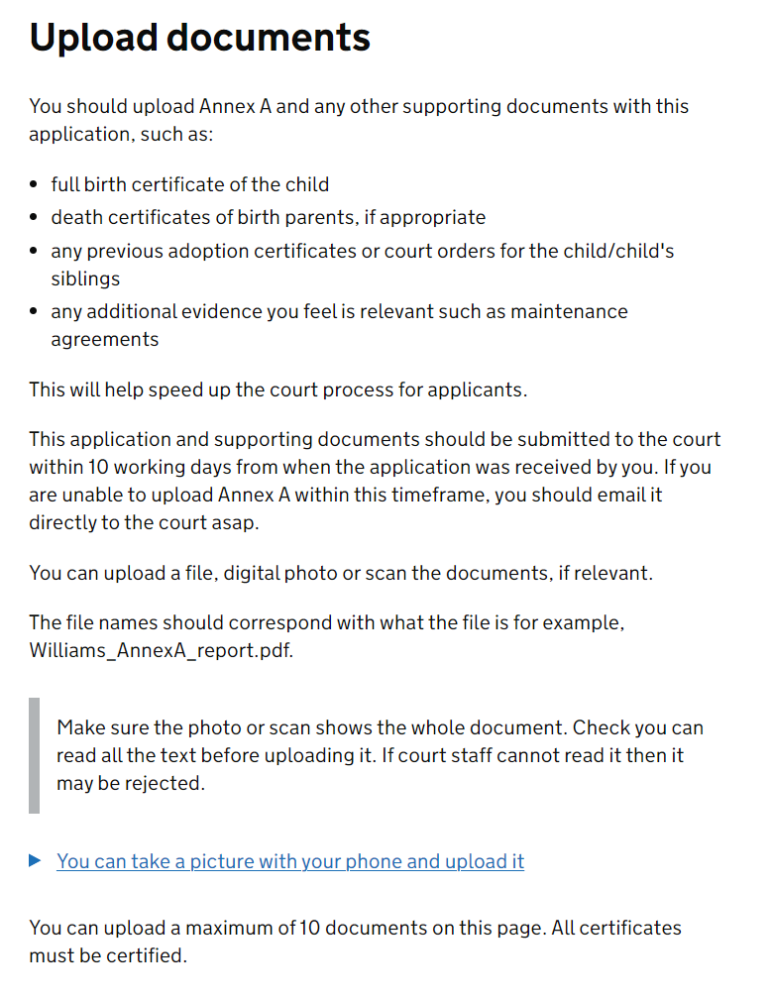 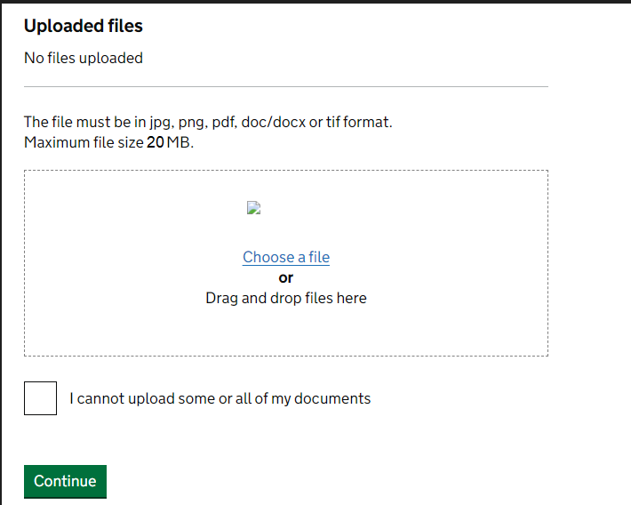

If you are unable to upload documents for any reason these should be sent directly to the court via email quoting the 16-digit reference. There is a 35MB size limit for emails.

Once you have uploaded all the documents or ticked the ‘I cannot upload some or all of my documents’ box click save and continue.

Once the task list looks like the below you can then click the review and submit button. 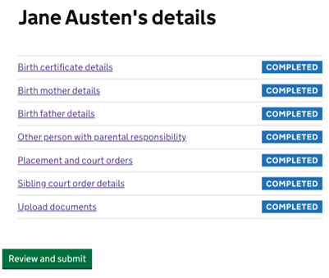

The check your answers page includes all details you have entered throughout the application. If there are any mistake, use the ‘change’ button which directs you directly to that section of the application.

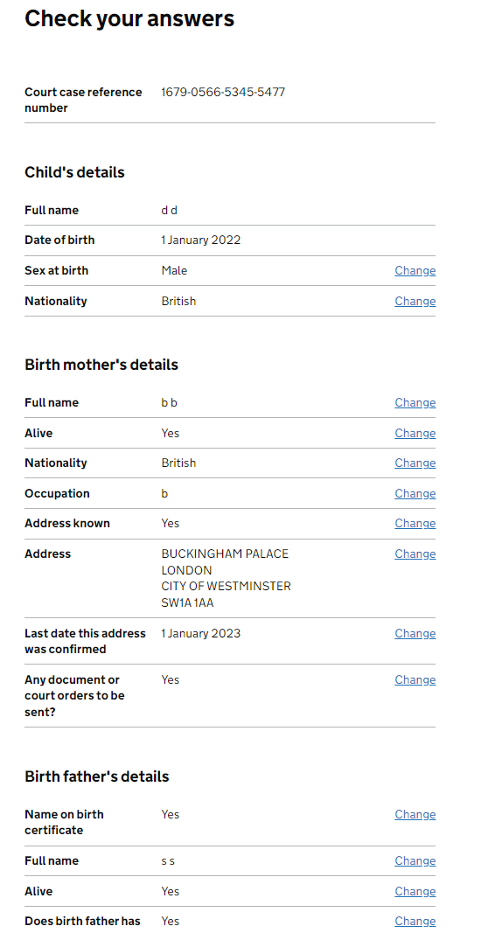

Once you are happy with all your answers you can click ‘Continue’ which will submit the application to the court. You have the option to save as draft if you are not 100% happy with your answers or need clarity.

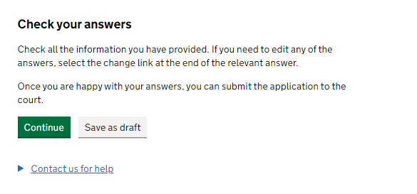

You are then taken to the statement of truth page. You must complete this page in full before clicking ‘Confirm’ which will submit the application to the court.

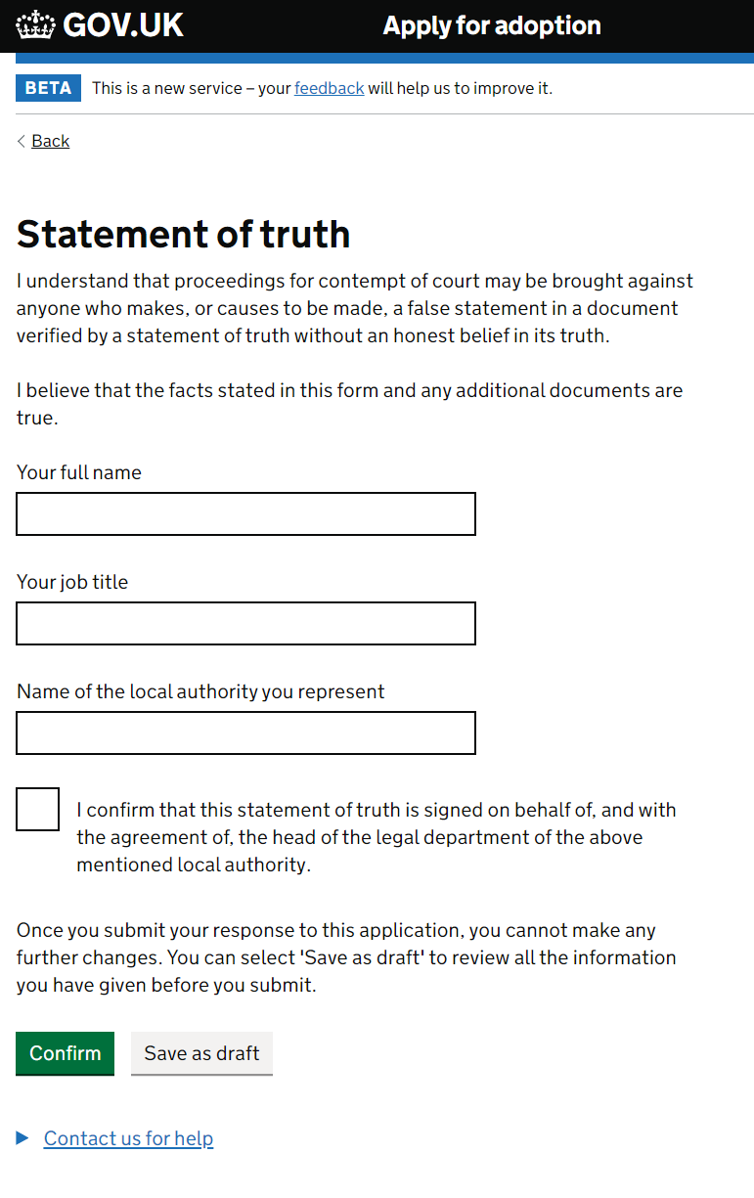

You will then see this information page. Please make a record of the 16-digit reference number on any local documents relating to this application for ease of reference in future.

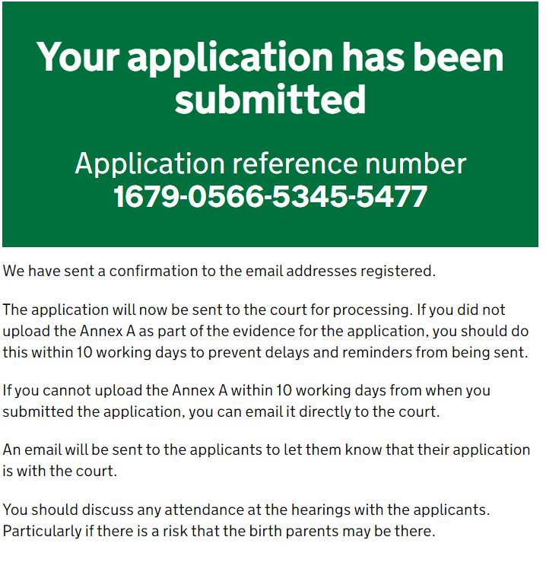

Feedback can be given throughout the application process by **following the link in the application**.

Accessibility Issues can be raised as outlined in the accessibility statement found in the cookie banner on the online application.

**Further information**

If you have any questions, please contact The Adoptions Project Team at: [Adoptionproject@justice.gov.uk](mailto:Adoptionproject@justice.gov.uk)