|  |  |
| --- | --- |
| Northamptonshire Childrens Trust  Leaving Care Service   |  | | --- | |  | |
|  |



Parenting Support Strategy 2024



|  |  |
| --- | --- |
| Introduction – Parenting support for our young peopleBecoming & being a parentParenting StrategyEvaluation of impactAppendices | Page 3Page 4Page 6Page 13Page 15 |

# Parenting support for our young people

|  |  |  |  |  |  |  |  |  |  |  |  |  |  |  |  |  |  |  |  |  |  |  |  |  |  |  |  |  |  |  |  |  |  |  |  |  |  |  |  |  |  |  |  |  |  |  |  |  |  |  |  |  |  |  |  |  |  |  |  |  |  |  |  |
| --- | --- | --- | --- | --- | --- | --- | --- | --- | --- | --- | --- | --- | --- | --- | --- | --- | --- | --- | --- | --- | --- | --- | --- | --- | --- | --- | --- | --- | --- | --- | --- | --- | --- | --- | --- | --- | --- | --- | --- | --- | --- | --- | --- | --- | --- | --- | --- | --- | --- | --- | --- | --- | --- | --- | --- | --- | --- | --- | --- | --- | --- | --- | --- |
| “Every parent needs a little help from time to time”  In Northamptonshire at the time of writing this strategy 1207 children were reported to be in care, all will have the opportunity to become a parent. This table shows for all care leavers under 25 (both open and those who no longer require services or over age of 21) whether they had S47, CIN, CP or  CiC involvement ever for their children.   |  |  |  |  |  |  |  | | --- | --- | --- | --- | --- | --- | --- | |  | Care leavers who are parents | CL who had any involvement (s47, C, CP or CiC) | S47 | CIN Plan | CP | CiC | | Young person open to services | 91 | 55 | 39 | 51 | 30 | 20 | | Young person no longer requires services due to age (over 21) | 136 | 79 | 46 | 65 | 38 | 19 | | Grand Total | 227 | 134 | 85 | 116 | 68 | 39 | |  |  |  |  |  |  |  |   (NB some young people count in multiple types of involvement in the list, the "any item" column gives a count where they only count once if they have had any of the above social care involvements.  There remains an unhealthy automatic assumption that a care leaver cannot be a good parent, this is not acceptable. There can be a lack of continuity from service providers with young people having to move home because they are becoming a parent. Care-experienced parents may face discrimination, and many have a negative experience of previous support leading to barriers to collaborating with professionals and services. Many care-experienced parents have significant resilience, positive qualities, strong values, and aspirations for outcomes that far outreach their own subjective experiences of parenting.  Often care-experienced parents are not afforded the luxury of mistakes and testing boundaries like those who are not care-experienced. We are all too aware of the stigma, discrimination and scrutiny that surround those that have received significant observational evaluations and assessments. The feelings of care-experienced parents can vary but most often include fear of the unknown, shame, embarrassment, rejection, isolation, loneliness, and hopelessness. These types of feelings are not unusual in any way and are shared amongst thousands of children placed into care every year.  Corporate parents should focus on providing stability, compassion, and continuity so that care-experienced parents feel respected and empowered. We will seek to evidence this through improved integration and considered strength-based support to both our young parents, ensure safeguarding of children, but also supporting agencies in Northamptonshire to have confidence in the support available to reduce professional anxiety.  Becoming a parent  Care leavers who are to become parents will have a additional responsibility. They will need to ensure their baby receives good enough parenting when that might not have been the case for them. They will also have to show a stable home life and independence skills in order to be in the best place to care for their baby.  We have a responsibility to consider if a young person will need additional support for the baby and consider if there is a degree of risk that would merit a referral through the Multi Agency Safeguarding Hub (MASH). Such a consideration of risk will be recorded in the care leaver’s case record. It should not be assumed that a care leaver would not be able to provide a good enough level of care to their child. We will continue to provide support to care leavers emotionally and practically if a referral through MASH is deemed necessary..  Being a parent  Being a parent is a big step for any young person, but it is particularly so for a care leaver who is transitioning to independence at the same time. Care experienced parents have shared their fear of their children being taken from them because they were in care.  We understand that supporting parents means better outcomes for the child. We've seen the difference this support can make. That’s why we offer help and guidance in person by our trained Personal Advisors within the Leaving Care Service.  Our parenting strategy will aim to support our care experienced young people to help parents and children bond, learn or overcome any challenges: We provide a selection of services to meet the needs of our young people in a supportive and nurturing way.    Utilizing the Solihull approach and trauma informed “Responding to your child program” (MBAM – Managing behaviour with attachment in mind); we will focus on both individuals and small group work sessions, where we will provide guidance on preparing them for parenting, learning skills and tools to support them and with the aim of helping parents understand their child’s behaviors in the context of the developing the parent—child relationship and building confidence.  The Solihull Approach brings together three core psychological constructs of containment, reciprocity, and behaviour management. The aim is to help parents understand their child's behaviour in the context of their development and the parent-child relationship.  MBAM – “Responding to your child” program focusing on individual and small group intervention which draws on attachment theory and was developed to help adoptive parents and foster carers understand and manage their child's behavior, by promoting an environment of greater empathy and attunement between adult and child. The support provided by the Leaving Care Service will adapt to our parents who have needs which impact on their parenting capacity, for example those who are affected by:  • Learning disabilities  • Mental health needs  • Substance misuse issues  • As well as supporting:  • First time mums who have increased vulnerabilities  • First time fathers  • Care experienced young people moving into their own accommodation  Extra support  Every parent needs a little help from time to time and our local offer to young care leavers enables some limited financial support. Northamptonshire Children’s Trust will ensure that the young parent has a hospital bag with required items for labor and birth. In addition, a gift for new baby, flowers, and clothing will be provided. Opportunities will be offered to engage with the Leaving Care Parenting group to engage in pre-birth guidance and parenting programs.    Parenting Strategy  Our parenting strategy will aim to support our care experienced young people, help parents and children bond, learn, or overcome difficulties. We know that supporting parents means better outcomes for the child. The strategy being employed allows us to empower parents at all stages to traverse the supporting options available, through regular scaling we will be able to monitor and work on strengths and their commitment to achieve. We've seen the difference this support can make. That’s why we offer help and guidance in person. This will include:  • Undertaking direct work with the young person and their support network   * Pre birth support   • Advocating for the young person  • Ensure that a crisis contingency plans are in place  • Expectations and roles of each person in the “family” or support network.  • Parenting programmes  • Freedom to deliver a service based on the need of the family   * Cross county provisions   To achieve this, we will employ a fluid model of intervention focusing on three interconnected strands:  Our promise:    It is our mission to ensure every care experienced young person reaches their full potential and be:   * Happy and thriving * Safe, secure, and healthy * Valued and respected * Seen and listened to   Prevention (of escalation)  Opportunity to work with dedicated support staff from WAVE - for young people who are not quite ready to be a parent, or who are at risk of losing a child  Ongoing support  Parenting guidance and programs within own homes, or other locations, working to individual strengths, supporting, and encouraging each person to help reach goals and aspirations for themselves and their children  Guidance  Helping to improve on things such as self – confidence in themselves and their parenting as well as supporting on other issues such as support with goal setting, housing, education, and employment   |  |  | | --- | --- | | Prevention:  Our parents will have the opportunity to work with dedicated support staff from WAVE – a project provided by Catch 22. This service will initially prioritise those who have experience of, or are at risk of, a child not remaining in their care. Whilst also addressing the needs of young females at risk of sexual exploitation, pregnancy. Key aims are to support young people to build resilience, improve relationships and increase wellbeing.  Whilst we will work hard to assist to prevent the removal of a child through empowering educational support, it is acknowledged that a child may be removed. The impact of not being able to care for their child on mothers is evident and includes grief, substance use, depression. For women coping with the aftermath of child separation therefore, there is a need for meaningful support, and we will continue to guide our parents through this difficult process. The service will focus on supporting females, to develop and maintain positive, healthy relationships as well as working alongside other partners using a trauma informed approach to improve access to other services. | The Wave referral | | Everyone has the right to be treated fairly and with dignity and respect. We are committed to promoting positive, inclusive and innovative learning environments for our care experienced young people. | |     Referrals will be collated by Leaving Care Senior PA, Ann-Marie Prendiville [Ann-Marie.Prendiville@nctrust.co.uk](mailto:Ann-Marie.Prendiville@nctrust.co.uk).     |  |  | | --- | --- | |  | Ongoing support:  Parenting guidance and programs within own homes, or other community locations, working to individual strengths, supporting, and encouraging each person to help reach goals and aspirations for themselves and their children with parents to be and parents receiving a co allocation of Solihull trained PA or senior PA. |   Using the “responding to your child” Program either in small groups or individually, this intervention based on attachment theory, social learning theory and the principles of empathy, attunement and PACE (playfulness, acceptance, curiosity and empathy) can help to create an environment where adult-child relationships are perceived as more positive and problem behaviours are observed to be less severe. Our parents can gain a sense of confidence in their ability to manage child problem behaviours through gaining knowledge and the support of meeting others in a similar position.  The Leaving Care Parenting group made up of experienced PA’s who have been trained in this new program will champion and lead the delivery and the learning throughout the service.     |  |  | | --- | --- | | Guidance:  Helping to improve on things such as self – confidence in themselves and their parenting as well as supporting on other issues such as support with goal setting, housing, education, and employment sign posting to supporting services and online resources. Through the Mini & Me parent and baby group. |  |   “Mini & Me” Parent and baby group, Northampton  Parent and child “Mini & Me group for care experienced young parents seeks to enable our young people to spend time socialising, meeting other parents with similar experiences. Some care experienced parents can struggle to integrate with others because of their own life experiences or even having low self-esteem. Being a parent for anyone is hard and especially for some of our care experienced young parents, this can be even more difficult. They do not always have the confidence to attend baby groups and can feel out of place or uncomfortable. Most baby groups are available for all ages so this will be tailored for care experienced parents from the ages of 16-25. This allows young people to feel a sense of security and surround themselves in an environment where their situations may be similar.  The Senior PA will approach the allocated worker of any care leaver identified as being a parent with information regarding the group to seek young person views of attendance. Clear guidance in what the group will offer will be undertaken during visits with potential young people.  3 staff will be in attendance on rota basis, every week, with a focus on two seniors and an additional PA or supporting service worker to enable a maximum number of 15 children to attend, with the age group being 0-4.  In addition, we will be supporting a young parent who is undertaking health and social care qualification at college, to support with the group on a voluntary basis. This young person is a care experienced young parent with a child under 5. This model will be continuously monitored and further exploration for engagement with local colleges to secure placement opportunities for students.  The purpose  The purpose of this group is to allow parents to feel comfortable and to focus on building positive relationships not just for themselves but for their children. The family centre is a welcoming building and is child friendly. It has amazing facilities for parents to access for their children. There are indoor playing facilities as well as outdoor. This is also an opportunity for professionals to observe interactions because it is a safe place, and the parent will not feel judged because they already have the relationship with Leaving Care Personal Advisors.    We will we be evaluating the outcomes for parents by utilising the LCT Parenting scale assessment tool (see appendix) being completed prior to start and then every 3 months. This will enable Leaving Care to analyse both progression of young people but also service delivery model.  Support from the Leaving Care service will also entail identifying additional support to parents or carers who have needs which impact on their parenting capacity, for example those who are affected by:   * learning disabilities * mental health needs * substance misuse issues   As well as supporting:   * first time mums who have increased vulnerabilities * First time fathers (service offer currently under development)   We have a responsibility to consider if a young person will need additional support for the baby and consider if there is a degree of risk that would merit a referral through the Multi Agency Safeguarding Hub (MASH). Such a consideration of risk will be recorded in the care leavers file. We will continue to provide support to care leavers if a child has to be referred through to MASH with further referrals being undertaken to more specialist supporting services, such as The Wave, Family Nurse partnership, health visitors, Midwives and Early Help practitioners.  Sessions will initially focus on relationship building and confidence, leading to implementation of Solihull approaches to focus on baby development and development of confidence of parent. We will seek to create confidence and encouragement to engage in more robust parenting programs if needs are identified.  Utilising trauma informed approaches we will aim to assist with parenting skills and socialisation. Sessions will progress to planned themed sessions, including nutrition, teething patterns, sleeping, parent support networks. This will be led by the voice of the parents.  Partnership working will be a priority to ensure that our parents are receiving the right support through engagement universal early help services as well as with Family Nurse partnership, health visitors, social workers, Moving On up placement provider, Baby basics and Faraway Charity.  In addition, Jolly Tots, a group sharing the same venue, is a larger parenting support group available for the community. We will be supporting our care experienced young people to progress to engage with this group to develop their confidence and independence.  Cost and funding  The community centre will be available to hire for a cost of £45 per hour and an additional £10 fee for insurance. As part of the Local Offer Sarah Bugless from (Moving on up) has kindly agreed to fund all the costs for this.  MOU have agreed to pay for an hour and a half a week (@£16.50/hr) plus insurance (@£10 per session), for 6 months, reviewing after a maximum of 3 months, to evaluate how effective support is and to ensure that young parents’ feedback is sought.    Young people will be required to make their own travel arrangements to attend the group, no additional funding is available.  Refreshments will be available but will be limited to basics with young people required to pay £1 per sessions towards costs.  Days and Times  This group will occur every Wednesday for 1.5hours 10.30am -12 noon at Abington Avenue United Reform Church, 157 Abington Ave, Northampton NN1 4QA. It is important that the group sessions are run on a regular basis because this gives consistency for the parents and their children. This can offer structure and routine to their life especially if they are not socialising enough for the parents’ own wellbeing but also the wellbeing and skill development of the child.  This project will begin on the 17th January 2024, with a review being conducted in March, June and December 2024. With further exploration of additional venues in the North of the county.  [Mini & Me parenting and tots’ referral](https://forms.office.com/e/s2hEszPU13?origin=lprLink)      Evaluation of impact   |  |  |  |  | | --- | --- | --- | --- | | **Measure** | **Evaluation description** | **Methods** | **Utilization** | | **Reaction** | Understanding how young people felt about the service | * Staff evaluations * Records of attendance to Mini & Me * Numbers of Programs delivered * Voice of the young person recorded | * At end of day or after sessions * to be recorded on observations | | **learning** | Measure increases in confidence and knowledge before and after | * Parenting scales to be completed by young people * Feedback by supporting services/staff | * Before and after all intervention programs * 3 months of attendance at Mini & Me parenting project | | **Behavior** | Measure the extent to which young people apply knowledge and skills | * Parenting scales, to be completed by young people. * staff evaluations and observations | * Before and after all intervention programs * 3 months of attendance at Mini & Me parenting project * Interaction and discussion with other supporting agencies. | | **Result** | Measure effect on reduction of professional concerns and MASH referrals | * NCT Social care Data set analysis | * 3-6 and 12 months. |   **Reaction & Learning**  To ensure that practice delivery is meeting the immediate and long term needs of young people in a trauma informed manner, clear register of attendance of parentswill be kept and numbers and consistency reviewed. Self-assessment forms/ parenting scale forms will be used throughout the three differing strands of intervention, to monitor change. Further case discussion with PA/s and supporting services will be completed in March 2024 and June 2024 with final review December 2023. Staff will complete discussions on young parents’ views and ideas at parents group meetings will enable staff discussion and reflection during Monthly parenting group meetings.  **Behavior & Result**  It is envisaged that the three strands of the parenting strategy will enable fluid transitioning of our parents through the levels of support. As relationships build with workers and confidence grows  Reduction of need or increase in wish of further self-learning will take place.  This will be evidenced in the parenting scaling and register of attendance at various sessions.  It is recognized that data in 12 months’ time may not evidentially present a reduction of care experienced parent or parents involved in Section 47 assessments, child in need, CP, PLO and child removal processes’, as this is a long-term vision.  The data review of attendance and outcome of scaling will enable further discussion on suitability of having a smaller trained cohort of PA’s or whether full-service training is required.  Further consideration will take place to evaluate the effectiveness of staff within Leaving Care or whether additional specialist intervention is required. |
|  |

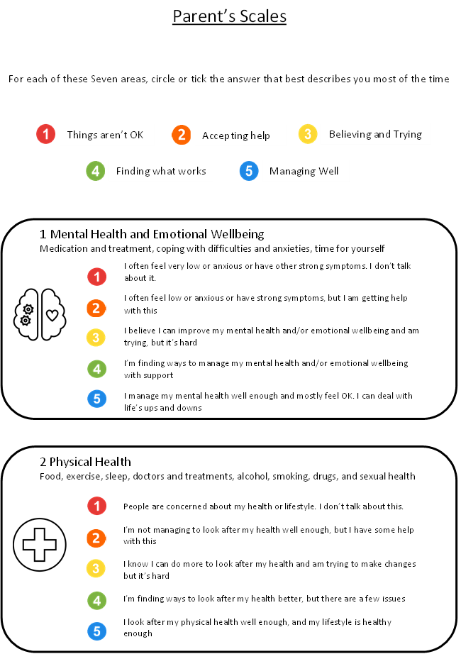

Appendices:

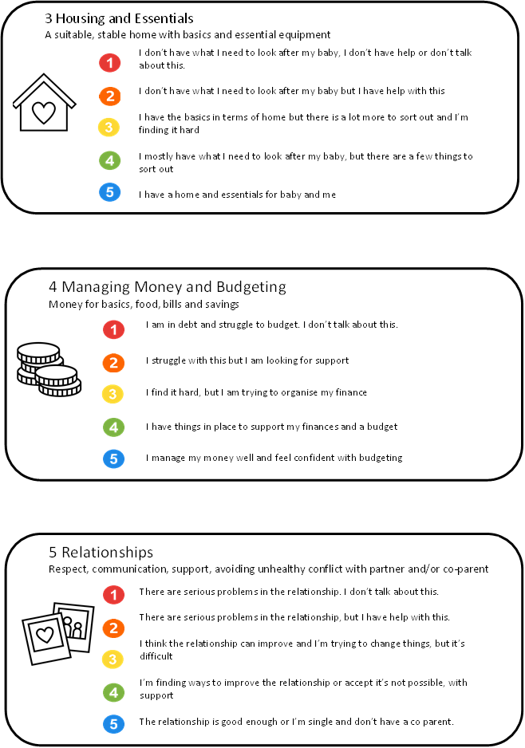

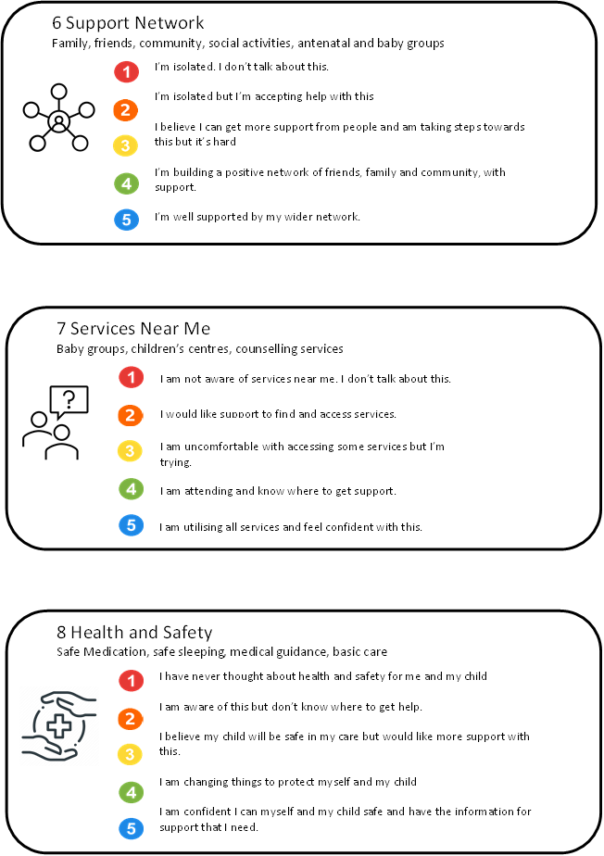

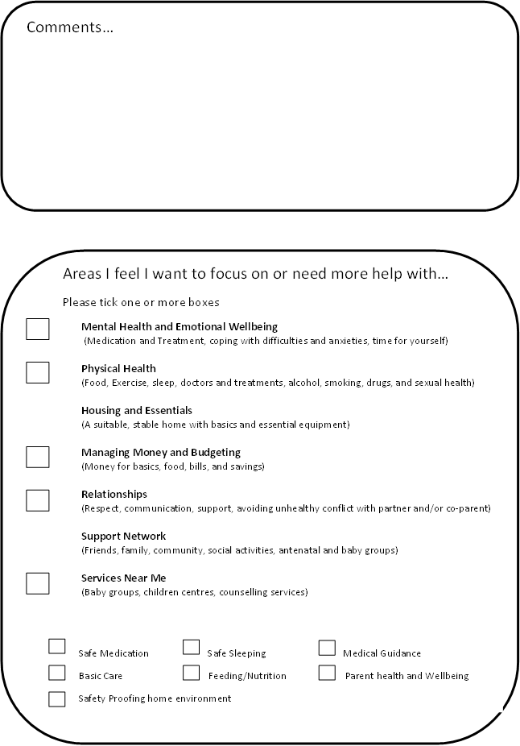





Consent to Share Information

In accordance with the UK General Data Protection Regulation and the Data Protection Act 2018, The Wave requires your consent to share all relevant and appropriate information to support your needs identified.

|  |  |  |  |  |
| --- | --- | --- | --- | --- |
| Agency/service | Reason for sharing information | Information to be Shared | Signature | Date of Signature |
|  |  |  |  |  |
|  |  |  |  |  |
|  |  |  |  |  |
|  |  |  |  |  |
|  |  |  |  |  |
|  |  |  |  |  |

I understand that:

I have agreed that information can be shared as stated above with a view to ensuring and assisting my continuity of care and support. YES □ NO □

Service user signature: _________________________________________________ Service user name: ________________________________________

Caseworker name: _____________________________________________________ Date: _____________________________

Anonymised case studies, evaluation & feedback

We do like to provide anonymised case studies, as well as your evaluation and feedback, so that we can improve the service that we deliver, and we will always seek your explicit consent before doing this. You can request to remove your consent at any time and we can discuss this with you. However, if your case study has already been used in a report or a published article it may not be possible to remove the case study from the public domain.

I give my consent for The Wave to use my anonymised case study □ I give my consent for The Wave to use my evaluation & feedback □

I do not give my consent for The Wave to use my anonymised case study □ I do not give my consent for The Wave to use my evaluation & feedback □

Activities & Outings

While working with Catch22, we may invite you to take part in activities or outings as part of your support. Please sign below to show your consent to this:

I confirm that:

* I consent to taking part in sessions including travel, events and/or trips supervised by Catch22 volunteers or staff. YES □ NO □
* I understand of the need for appropriate behaviour during outings/activities and I will keep to the relevant safety rules. YES □ NO □

Name ………………………………………………………………………………………. Signature ……………………………………………………………………

Case Workers Name ……………………………………………………………………. Signature ………………………………..…………………………… ……..

Date ……………..………………………..