**Uploading children and young people’s photographs to Liquid Logic**

**August 2024**

**Purpose**

Ensuring we have an updated profile photo of children and young people on their Liquid Logic file provides those of us who do not meet with children often an opportunity to connect to children as opposed to an ID number. It supports all of us to be as child centred as we can and keep children and young people in mind as we work on their behalf. In emergency situations it also provides us with an up-to-date picture should we need to utilise this for any purpose.

The responsibility of ensuring the picture is up to date and a true likeness is that of their practitioner who sees them regularly and will judge if the image needs updating.

**Consent**

Uploading a profile photo to Liquid Logic is crucial. For children and young people who are in our care, and we share parental responsibility, this is a task of liaising with parents and highlighting the benefits of an up-to-date photo being on the file. If we do not share parental responsibility parent’s must provide consent for a photo to be added and a case note added to evidence this consent. It is also important to discuss this directly with children and young people who may want to provide their preferred picture.

**3. Process to upload**

**Step 1. Personal drop down, click – “Photos”**



**Step 2. Upload from your desktop**

**Step 3. Locate the picture**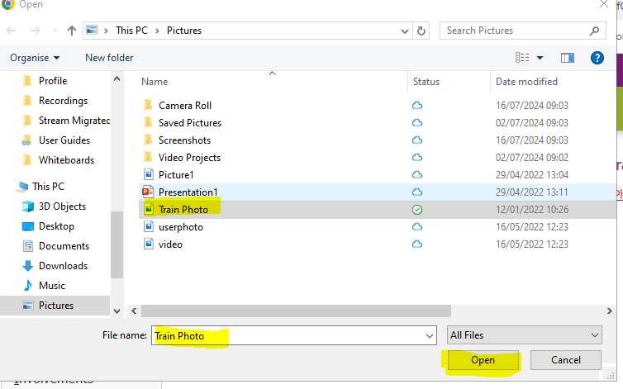

**Step 4. Import new image file**

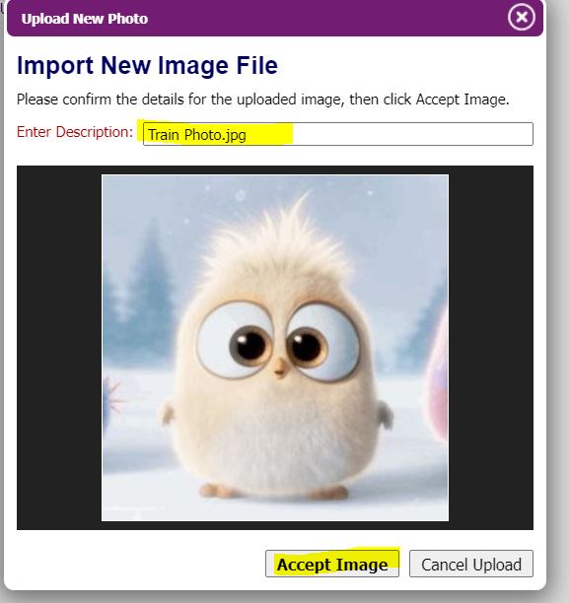

**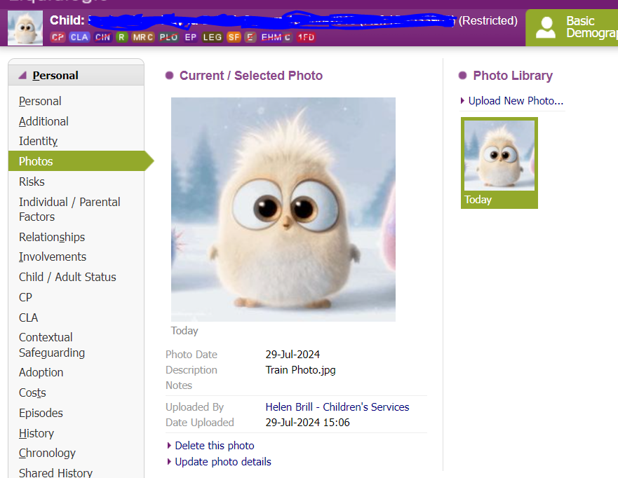*Step 5.***  **Accept image and your child’s profile picture should now be changed**