

**CHILDREN MISSING FROM HOME AND CARE PROTOCOL July 2024**

Responsible Officer: Zoe King

Author: Multi-Agency Working Party

Coverage: Partnership

Effective date: June 2024

Review: June 2027

Status: Version 1.4

|  |  |  |
| --- | --- | --- |
| **Contents** | | |
| 1 | Introduction | 3 |
| 2 | Purpose | 3 |
| 3 | Strategic Oversight | 3 |
| 4 | Scope | 5 |
| 5 | Definitions | 5 |
| 6 | Missing Operational Processes for all Children who go missing | 5 |
| 7 | Missing from Our Care | 7 |
| 8 | Children Missing from Home | 9 |
| 9 | Children Missing from Education | 9 |
| 10 | Missing Children from Other Local Authorities | 10 |
| 11 | Philomena Plans and Missing Prevention Plans | 10 |
| 12 | Missing Vulnerable Risk Management | 11 |
| 13 | Strategy Discussions | 13 |
| 14 | Children Subject to Child Protection Plans or S47 Enquiries | 14 |
| 15 | Missing Process Map | 16 |
| 16 | Police Response When a Child Goes Missing | 17 |
| 17 | Children at Risk of Extremism | 19 |
| 18 | Children who may have been trafficked or are at risk of trafficking | 20 |
| 19 | Children Who Repeatedly go missing or away without authorisation | 20 |
| 20 | 16- & 17-Year Olds | 20 |
| 21 | Children Leaving Care or Care Leavers | 21 |
| 22 | When a Child is found | 22 |
| 23 | Transporting a child home / placement | 22 |
| 24 | Return Interviews | 22 |
| 25 | Return to placement | 24 |
| 26 | Responding to abduction | 24 |
| 27 | Harbouring Notice | 24 |
| 28 | Recovery Order | 24 |
| 29 | Collection Orders | 24 |
| Appendix 1 – Useful Links  Appendix 2 – Missing From Care Framework  Appendix 3 - Approved addresses form to establish ‘missing’ or ‘absent’  Appendix 4 - Appendix 4 - Out of Area Return Home Interview Flowchart  Appendix 5 – Glossary of abbreviations  Appendix 6 – EDT Flow Chart | | |

**Introduction**

This procedure is written in accordance with the West Yorkshire Police Missing Protocol and Statutory Guidance on ‘Children Who Run Away and Go Missing from Home or Care. This procedure should be read in conjunction with the Child Exploitation Protocol.

For any child who goes missing there is a range of safeguarding risks depending upon their age and stage of development and what we understand about the child’s lived experience. There is a duty to ensure that appropriate risk assessments are undertaken for an individual child and that if a child repeatedly goes missing, to measure risks situationally each time.

**Every** “child missing episode” should trigger proper responses from professionals involved with the child and information gathered during return home interviews should be analysed to inform planning for the child. It should be noted that there are proven links between child missing episodes and child exploitation, particularly for children in our care.

**Each** instance of a child going missing should be taken seriously, both for issues that may have led to it and issues that may arise from it. Further each episode must be recorded to give a true picture of the child’s missing episodes.

**Purpose**

To provide an agreed inter-agency framework for:

1. Assessing and classifying the level of risk when a child goes missing from home or care. Or when a missing child comes to our attention.
2. When a child is absent without authorisation following their individual missing reporting strategy and/or trigger plan
3. To provide guidance on what responses different agencies will offer in relation to each level of risk.
4. To ensure that Police National College of Policing, ‘missing’ definitions are aligned to Children Services interpretation of vulnerability of a child with due consideration given to their age, vulnerability and development factors.

**Strategic Oversight**

**Strategic Managers / Team Managers** - Daily reports are produced to provide thepartnership with up-to-date data reports on children who are missing, including being missing from their home, from education and from all care settings including supported living providers. A dashboard of data is also provided by the police and EDT where missing episodes go into ‘out of office hours.

**Integrated Front Door (IFD)** - The IFD will receive missing notifications from policeforces across the UK during office hours. These are to be progressed to the Child Exploitation/Missing Hub [**missingchildren@bradfordcft.org.uk**](mailto:missingchildren@bradfordcft.org.uk) , allowing for the Child Exploitation/Missing Hub to take forward all strategic oversight of all missing children.

**The Child Exploitation / Missing Hub** - support children who are actively being exploited and / or are vulnerable to exploitation, oversee children who are missing and undertake return home interviews. The Child Exploitation / Missing Hub screens all children identified as being at risk of exploitation. Children who are assessed and screened are measured against the Continuum of Need in the same way as the Integrated Front Door would all referrals for children. The information gathering incorporates health, police and education checks. Gathering information around the child on what is required to support them and their families.

Children who go missing and have an allocated social worker will be notified by the Child Exploitation / Missing Hub about significant concerns/worries, further to the missing episode being recorded onto LCS, and will support all work linked to the missing episode and return home. Children who are persistently going missing or where there is a common theme the relevant practitioners will be contacted by the missing senior support worker.

Children in Care that are placed within our area from other local authorities are also reviewed within the Child Exploitation/Missing Hub daily. If the missing episode is received within ‘out of office hours’ this is reviewed by our EDT and when needed joint work takes place between the relevant placing Local Authority both during office hours by locality teams and via our EDT service, out of hours.

**Missing Worker** – are located within the Child Exploitation / Missing Hub and undertake ‘ReturnInterviews’ with children upon their return. For Children in our Care who go missing, return interviews are undertaken by an independent, service in line with statutory duty.

**CE RAM** (child exploitation Risk Assessment Meetings) - are specific forums that frontline practitioners willpresent risk profiling of children to a multi-agency panel. The panel members will consider allocation to an appropriate service, provide advisories on safety planning and clear steer on disruption planning. Children who go missing will be discussed at this panel on the basis their missing episodes are increasing their vulnerability to harm, further to a child’s exploitation risk profile assessment being completed. Practitioners will continue to present to RAM whilst a child’s risk grading is moderate or significant risk of exploitation, until such a time the risks have been reduced to a safer level (emerging risk). Locality and Early Help will lead on children grading as Emerging Risk exploitation, independent of the RAM process.

**MACE (multi agency child exploitation) board** - meet on a minimum six weekly basis for review and strategic oversight for thehigh risk and most vulnerable children. They also hold responsibility of wider strategic mapping and prevention of exploitation. The partnerships will work together to ensure children, and their families receive the help and support they require, such as services coordinated in this board. MACE support the most complex exploited children in our district and will work together to expedite support and remove barriers to the right help being provided. Children who are at chronic risk when missing and where support planning is not improving the safety of a child, may be invited to be discussed at MACE.

**Emergency Duty Team (EDT)** - Dashboard data of missing children is to be collatedand reviewed by the emergency duty team over the weekend and bank holiday periods. EDT when needed will support work to locate and recover children during out of hours, with a view to progressing children to daytime services, aligned to procedures already in place. The Child Exploitation/Missing Hub and or locality teams will take forward during daytime hours all work to locate and return children.

**Scope**

This procedure provides a framework for missing children or children absent without authorisation in following categories:

1. Children in our care
2. Children in need / in need of protection
3. Children not previously known to Children’s Social Care or closed cases.
4. Children placed in our area from Other Local Authorities
5. 18 years and still vulnerable (children previously in our care)

**Definitions**

**Missing child:**

Children whose whereabouts are unknown to statutory agencies including:

* Children whose whereabouts cannot be confirmed or confirmation they are safe with an appropriate/ safe adult.
* Children in families who have to go into hiding suddenly.
* Children in families who have disappeared without leaving a forwarding address.
* Children in families who have gone on extended leave and have failed to return when due to do so.
* Children who have been abducted/ trafficked.

The College of Policing defines missing as:

*“Anyone whose whereabouts cannot be established will be considered as missing until located and their well-being or otherwise confirmed.”* This will be in line with the Children in care framework and levels of intervention model.

**First steps if a child goes Missing**

**Children Missing from Home**

A child or young person under the age of 18 who has gone missing from home or feels they have been forced or coerced or controlled in some way to leave, or whose whereabouts is unknown. Subsequent Missing episodes requires the practitioner to formulate a missing prevention plan for the child, this is recorded as part of their Philomena Plan.

First time missing episodes are reported to the police and assessed used the framework on page 17. Children who are not open to the trust will be reviewed and support/guidance offered in the form a missing return home interview.

**Missing Operational Processes for All Children Who Go Missing**

Exploitation, Missing Risk Assessment and MVRM -

* An exploitation and missing Risk (Profiling) Assessment
* Missing prevention plan
* Philomena Plan

The exploitation and missing Risk Profiling Assessment, the missing prevention plan and the Philomena Plan are key documents to enable rapid information sharing when it is required, seeking to reduce future harms. Risk Profiling Assessments should be completed for every child we are working with as part of the Children and Family Assessment, where such risks are assessed. Philomena Plan is a live document as it provides vital information and intelligence about the child. These plans must be evaluated for their effectiveness / updated every time a child goes missing. Plans that are not working will need to be reviewed and updated.

The above assessments and plans must be made available to parents / carers, so they are clear what their child’s plans are, where Parental responsibility is shared, or they hold Parental Responsibility.

Children should form an integral part of their missing risk assessment, safety planning and be aware of what plan will be triggered upon a risk being posed. Where appropriate children be given a copy of their assessment and plans.

Children and parents / carers should be specifically asked about key factors below as part of this assessment and missing prevention activity, including when a child is in our care wherever possible under CO / Under Sec 20. For details of the factors that should be considered as part of the risk assessment, please refer to CE & Missing Risk Assessment plan.

* Child’s view on current placement / stability or of their relationships at home
* Level of supervision & support that parents / carers proposes to provide for the child.
* The degree of risk to the child if they go missing.
* The views of parents / carers, on the child’s needs and the action that needs to be taken if the child is missing.
* Consideration of any external influences which may result in a child going missing (family / known associates / persons of concern)

**Contact with children when missing.**

If a missing child is maintaining / or making contact the opportunity should be taken to understand if they are safe and what support, they need to return home/ to placement.

**Children Missing from Education**

Children missing from education are children of compulsory school age who are not registered pupils at a school and are not receiving suitable education otherwise than at a school. Children missing education are at significant risk of underachieving, being victims of harm, exploitation or radicalisation, and becoming NEET (not in education, employment or training) later in life. Effective information sharing between parents, schools and local authorities is critical to ensuring that all children of compulsory school age are safe and receiving suitable education.

Practitioners must recognise that absenteeism from school has to be addressed. For more information - [Children Missing Education](https://bso.bradford.gov.uk/content/children-missing-education#:~:text=Referrals%20must%20be%20made%20within,completeness%20before%20action%20is%20taken.)

**Vulnerable Learners/ Not in Receipt of Full-time Education**

Vulnerable learners are defined as children at greater risk of poor educational outcomes. This covers several categories of children including those formally recognised to be receiving programmes of alternative provision.

* Children who are looked after.
* Young carers and those affected by circumstances.
* Children from a Gypsy, Roma or Traveller background
* Children who are disabled and have special educational needs.
* Children who have missed education i.e. poor attendance.
* Children known to Childrens services and or on a protection plan.
* Children with medical needs
* Children where English is an additional language.
* Disadvantaged child.
* Children in danger of radicalisation and extremism
* Children of asylum-seeking families/ or unaccompanied children
* Children who attend unregulated schools.
* Children who have been or at risk of exclusion Very young children
* Children with mental and emotional health conditions Children who qualify for 2 years funding.

**Children subject to CP Plans or S47 enquiries**

Children who have a Child Protection Plan or who are subject to a Section 47 enquiry need additional action to that required for other children. This includes reviewing their child Protection Plan/ CIN plan and consideration of legal advice during a Section 47 enquiry. The exploitation Risk Profiling assessment must be completed or updated and submitted to the Child Exploitation / Missing Hub.

For families who abscond with their child / children who are subject to Child Protection Plan, without notification of change address/area will be deemed as missing. The Police and Child Protection coordinator/ Education and Health must be notified, and a strategy meeting convened, and consideration given to national alerts via Health, Police and or Local Authority alert channels.

**Missing from Our Care**

**Missing –** A child who is in our care (Child in Care) who is not at their placement or theplace they are expected to be (e.g., school) and their whereabouts is not known will be classed as missing. Until they are located, and they have been determined as safe and well with an appropriate adult. Practitioners, foster carers and or Provider staff are expected to trigger the Philomena actions in the child’s plan and make every attempt to locate and make the child safe, prior to seeking police assistance. Missing episodes require the practitioner to formulate a missing prevent plan for the child, as per the Missing Vulnerable Risk Management Process. This is recorded on their Philomena protocol plan. Should a child be referred to police as missing, staff will have to demonstrate what reasonable actions have been undertaken. **If a risk is deemed life threatening, then contacting Police must not be delayed. Professionals and Police would jointly plan actions where risks are extreme and life threatening**.

**Absent without Authorisation (AWA) -** When a child has been located and remains with asafe and appropriate adult, this will be recorded as AWA, until they return to placement or the place, they are supposed to be i.e. school.

Children who have an AWA episode require the practitioner to formulate a missing prevent plan for the child. **If the young person is consistently and persistently AWA, the allocated Social Worker is to consider following the MVRM Plan.** This is recorded on their Philomena protocol plan. To ensure any adult is appropriate agency checks must be undertaken. Consideration to the child’s family time plan with significant others should be taken into account and updated if appropriate/approved.

Children who are accommodated in Trust residential homes will be offered a return home interview after each AWA episode.

* If there is no confirmation the child is with a safe adult, the AWA process **must not** be used, and the child is reported as missing.
* AWA **must not** be used if the child is absent for longer than **72 hours** as per the flow chart below

**Missing Children from other Local Authorities placed in Bradford**

When a child is reported missing the responsible Local Authority is notified, an episode recording is used to help locate children aged 18 or younger who have gone missing from the district. Once they have been found, the responsible Local Authority is notified including any relevant information. Missing episodes will be tracked by the CE/Missing Hub. Bradford Children and Families Trust hold responsibility to use LCS for tracking, recording and monitoring missing children.

**EDT - Out of hours**

As children generally go missing out of hours where a child is missing from the family home, parents, shouldbe advised to take the steps set out above, if they have not done so already. The allocated social worker or EDT will support the evaluation of risk and consider any known history of the child’s circumstances and key events and risks. EDT will inform the allocated team as their out of hours’ work activity ends, allowing for the day service to continue supporting the child / family.

**Missing From Our Care Framework**

For the full framework please see appendix

**Leadership Oversight**

The locality Service Manager for the missing child must be notified by the locality Team Manager. The Service Manager should maintain strategic oversight until a child is found. Service Managers should place direction and oversight case notes on LCS for all children missing over 24 hours and again at 3 days. Service Managers must notify their Head of Service, Assistant Director & Executive Director of The Bradford Children and Families Trust via a Serious Incident Notification report based on the child’s vulnerabilities and risk factors, discretion should be used. **On the 5th day Missing** the Head of Service, Assistant Director & Executive Director of The Bradford Children and Families Trust must be notified when a child is found.

Top 10 Missing reports will be sent to all service managers by the CE Hub to consider where risks do not appear to be reducing as a child continues to regularly go missing despite multi-agency planning and safeguarding activity.

**Philomena Plans and Missing Prevention Plans**

The Philomena Protocol is a Police initiative to help locate and safely return a child as quickly as possible when they are missing, Bradford Children and Families Trust are fully signed up to using the Philomena Protocol.

The basis of the scheme is for vital information about the young person to be recorded on a form so that this can be used to help locate them safely and quickly. The form should then be stored safely within the child files on LCS. It may need to be located quickly, at any time of day or night, by the person who needs the information to begin the initial searches. When the form is complete, it will contain confidential information and need to be regularly reviewed and updated.

Philomena Plan/ Missing prevention plansmust be placed on the child’s LCS fileunder the heading Missing Prevention and Philomena Plan. This is a form on LCS thus ensuring the Child Exploitation / Missing Hub, EDT and Police can quickly retrieve this plan. Practitioners circled around the child must complete the missing prevention planning elements. This must be reviewed regularly if deemed to not be working.

Philomena Plans are fluid documents that need to be reviewed at least **3 monthly *or after every missing episode\*** and at any RCPC/ CIC Review meetings for the child. These are useful forums to ensure all agencies and parents/ carers can assist in Philomena Plans being up to date, therefore effective in their purpose. Audits will be undertaken regularly by the CE Hub Missing Senior and guidance and support offered to staff accordingly.

**MVRM Missing Vulnerable Risk Management Process**

In the event a child has had three missing episodes in a four-week period a **Missing Vulnerable Risk Management Meeting (MVRM)**needs to be convened by the Missing Senior Support Worker/Police Missing Co-ordinator and include: the allocated social worker; missing support workers; parent/carer and child; and other relevant multi-agency professionals involved in the support plan. In the event concerns are raised before this time, a meeting can be held subject to professional judgement upon the level of risk associated with that child. This risk management meeting should address the following:

* Push/ Pull factors of the missing from home episodes.
* Exploitation risks and matters relating to contextual safeguarding
* Any other safeguarding concerns and interventions required.
* Any hotspots of concern.
* Information from return interviews and what we can do to prevent that child going missing again.
* The child's voice and their wishes and feelings.
* Creation/updating of (Philomena) trigger plan.
* When the plan needs to be reviewed.

Through this multi-agency forum, a support plan will be created in partnership and a decision should be made at this meeting about the needs of the child and risk management. Timescales should be agreed for reviewing the plan within the meeting. If there is an escalation of concerns prior to this meeting this meeting can be brought forward.

The Missing Vulnerable Risk Management meetings are stand alone in response to the missing and must not replace any other professional meeting (i.e. Strategy discussion/ care planning/mapping meeting/CIN etc). Information shared at this meeting can contribute to the child’s ongoing care and support plan in the wider context

.

Ensuring the child's participation in these risk management meetings are key and therefore children should be invited where possible however in the event they do not wish to or its not appropriate for them to attend, creative solutions on seeking the child's voice should be considered by the chair of the meeting. Professionals should ensure that sensitive information and intelligence is not discussed in the presence of the child or parent/carer.

If risks continue to escalate or a significant incident happens consideration needs to be made for a Team Manager or a Senior/Service Manager should be invited to attend the next missing risk management meeting for management oversight.

A Strategy discussion could be called consequently or if there is reasonable cause to suspect that a child is suffering, or is likely to suffer, significant harm if this information is shared during the MVRM. Strategy meetings for missing children should be held after a period of 24 hours. MVRM meetings will be held to consider the child’s ongoing risk factors and safety planning these will replace a follow up strategy meeting.

The following points relate to when to organise a missing vulnerable risk management meeting in response to the child’s missing episodes and is also linked to the blue flow chart on page16

1. **To be identified locally based on carer, young person and social worker judgement**.
   * The parents and child should be included wherever possible and appropriate and as a minimum their views should be sought and considered in discussing the issues and strategy. The Chair must ensure the outcome of the meeting is fed back to the young person and where appropriate their parents.
   * The purpose of the meetings is to identify any push/pull factors that need tackling, decide jointly on an action plan and identify any services that could provide support. In the case of 'pull factors' it may be necessary to target those in the community who harbour the missing child or exploit them with regards to crime, sex or drugs.
2. **When there are persistent concerns after the first MVRM or strategy meetings consideration should be given to leadership oversight including chair and attendees.** 
   * Independent Reviewing Officer or nominated Senior Manager to Chair.
   * Attendees: Team manager from Children's Services, Police Divisional Supervisor, Children's Home manager/ family placement manager (as appropriate), representative from health and /or education.
   * Meetings at this level should only be required for a small number of children. In addition to seeking to reduce future missing episodes and reduce any apparent risks to the child.
   * It is recognised that there will be some children who go missing repeatedly within a short period of time where this level of intervention will immediately apply.

If the child/young person continues to be reported missing beyond this level the senior management team for Children's Trust and Police should discuss how best to proceed.

Other risk factors demanding escalation (a strategy meeting/SIN) include:

* Any case where the risks involved in even a single future missing episode is very high.
* Cases where it has been identified that immediate action is necessary to ensure the wellbeing of the child.

**Strategy Discussion**

*A strategy meeting should be called at when there are 3 missing episodes in four weeks or as soon as there are serious concerns about the child, in any event, whenever a child is missing for 24hrs a strategy meeting should be held.* This will be arranged by Bradford Children and Families Trust, West Yorkshire Police Missing Person Investigators to be invited (01274 376611), and as well as any other agencies who may have important information including Youth Justice, Youth Service, Early Help Health and Education, External providers or any other relevant professional should also be invited to attend.

The strategy meeting should be chaired by the allocated social worker’s team manager or delegated officer at the same level. The purpose of this meeting is to ensure sharing of information between all relevant agencies, to confirm what action has been taken to locate the child and to agree what further action is possible or necessary. Missing Prevention planning should also be considered at the strategy meeting as well as determining if a Missing Vulnerable Risk Management Meeting is needed.

If **two or more children have gone missing together** from their home or placement(s), the responsible social workers for all the children should liaise with the placement provider/s and consider whether to arrange a **Complex Strategy Meeting**. To minimise duplication and ensure a plan of action is timely co-ordinated. Careful consideration should be given to the issue of confidentiality. A separate individual record of the meeting and a separate action plan must be drawn up for each child.

**Missing Process Map**

|  |  |
| --- | --- |
| **Children Missing from home, not Looked After** | |
| Stage 1 | Children who are not looked after that go missing 3 x in a    4-week period, or 1 significant (over 24 hours with high  risk indicators/perpetrators). A Strategy Meeting should  be convened within 24 hours to be chaired by the  appropriate Team Manager.  The Police to be invited along with all involved partner agencies.  CP chair to be notified if a CP plan in place. |
| Stage 2 | Children In Our Care who go missing more than 5 times up to 10 times within a 3-month period or have had previous significant missing episodes, it is unclear whether the child is under duress to go missing or there are concerns the child may be groomed or exploited, or other influences/locations that are dangerous and are  impacting the child with subsequent significant incidents, a MVRM should be convened within 24 hours and weekly thereafter until the missing has reduced chaired by the Missing Coordinator  The Police to be invited along with all involved partner agencies.  IRO to be notified- kept informed. |
| Stage 3 | Any Children in Our Care who continue to go missing post stage 1 and 2 and are at continued risk of exploitation a Complex Strategy Meeting must be convened within 24 hours to be chaired by the locality Service Manager.  The Police to be invited along with all involved partner agencies as above.  IRO to be notified and invited to the strategy meeting/informed and the placement reviewed of its ability to keep child safe.  Head of Service, ADCSC & EDCS to be updated. |
| **Young people in semi-independent living who go missing from their placement (16- & 17-year-old)** | |
| Stage 1 | If you know where the young person is, and you are satisfied that they are not at risk of significant harm, and you are in contact with a young person they are not defined as missing but absent without authorisation. Children assessed as in need via the housing protocol are entitled to 3 nights away - missing to be reported from day 4.  Children in care should have an up-to-date pathway plan and care plan that defines the agreement for overnight stays elsewhere and this should be linked to the Philomena (missing trigger plan).  Social worker establishes where they are staying, and risk assess and undertake checks. Records of nominated approved place to visit must be recorded on LCS.  Report to the police if the young person’s whereabouts is unknown or thought child deemed to be at significant risk.  During the 3 days’ absence if any professional has concerns for young person’s safety this could trigger a Stage 1 Missing from Home Strategy Meeting. Chaired by a Team Manager.  3 x 4-week period, or 1 significant (over 24 hours with high-risk indicators/perpetrators).  MVRM Process is followed, and the IRO notified / kept informed. |
| Stage 2 | Any young person who continues to go missing over 10 times and been subject to Step 1, a Complex Strategy Meeting must be convened within 24 hours to be chaired by the locality Service Manager.  The Police to be invited along with all involved partner agencies.  IRO notified / kept informed. |

The flowchart below sets out the procedure for responding to children under 18 years who are ‘missing’ from home or care. It outlines the required safeguarding processes for every allocated child.

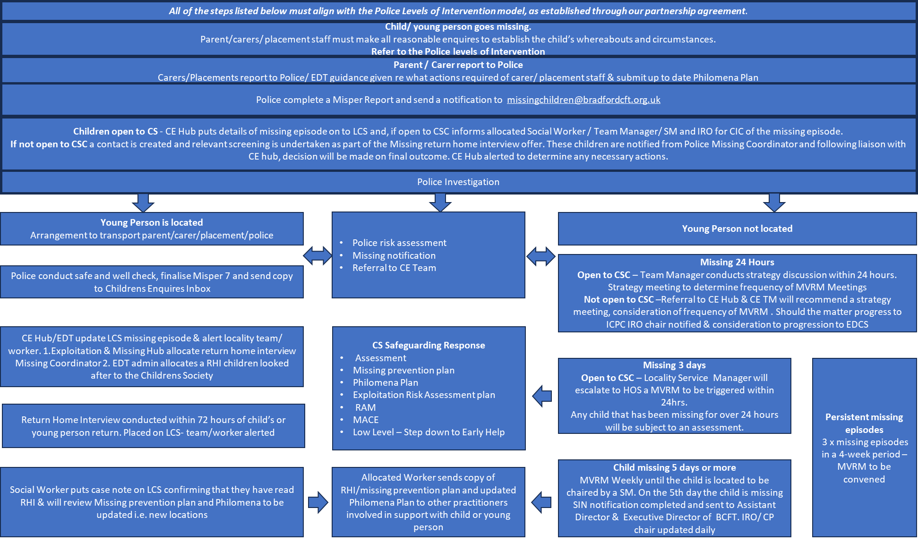

* ***MVRM frequency can be increased / decreased with supporting management rationale. 3 working days to organise MVRM***
* ***Enhanced specific supervisions for Social Worker should be considered by Line Manager***

**Police response when a child goes missing.**

**Police risk gradings**

The definition below is for all age groups, therefore Children under the age of 18 years and who may have additional needs or vulnerabilities would likely fall into the latter 3 grading. This is a guide for professionals to consider risk levels and responses.

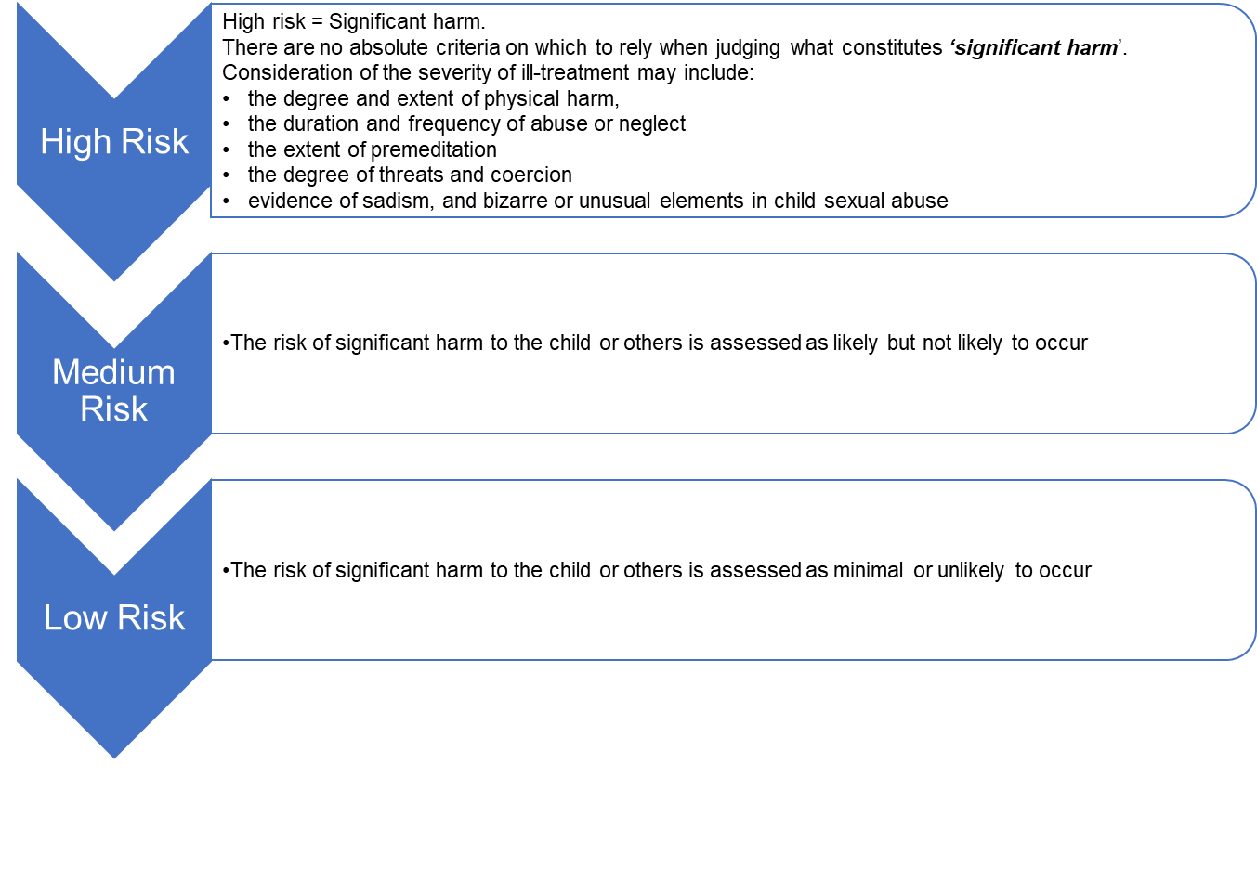

*Based upon West Yorkshire Police grading; children at risk of CE regardless of degree of risk, are not automatically high risk.

**Police Levels of Intervention**

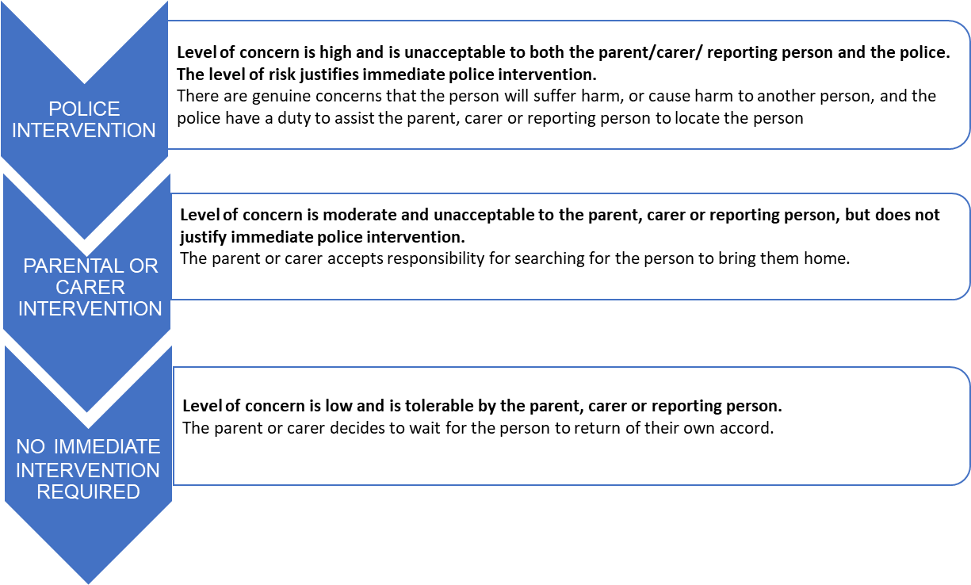

**Reporting a Missing Child to the Police**

When a child is reported as missing, the Police will request a high level of information to aid their own agency assessment level of risk (if any) the child is likely to face. The fact that a vulnerable child has a history of going missing (including any occurrences of absence) does not mitigate risk, and each report of missing will be considered. Risks will be quantified each time. Police have their own agency triaging processes and may take a decision to ‘pause’ before activating any investigation. This risk being owned and managed by a senior officer who will be required to review risks as the missing episode progresses. Other professionals/parents/carers/non-police staff must continue efforts to locate and return a child to their care.

The Philomena form provides the level of information to be shared and the police need to have specific risk information from any previous CP/CIN/Exploitation Risk Assessment and plans. Upon the police receiving this information and carrying out their risk analysis, investigations may commence, as noted above.

**Children not previously known to Police**

Where a child is not known to the police or there is limited information available, a joint assessment should be undertaken with multi-agency partners at the earliest opportunity to inform the risk level. **Extreme caution should be exercised before** **planning about low risk for a child for whom there is limited information and / or to go missing, is out of character**.

Risk levels can be reduced following new information, but should they have been inappropriately deemed low risk the first instance valuable time may have been lost to safely locate a child. This risk grading will be continuously reviewed during the missing episode.

Once a child is located safeguarding procedures will be followed.

**Attending officer**

If the Police assess a child as missing and there are concerns for the child and/or others, they will attend to take a missing person report and investigate in accordance with the assessed level of risk and vulnerability.

The police officer attending will:

* Take details of all the enquiries conducted so far.
* Request a photograph of the missing child.
* Make all necessary enquiries at the scene to locate the missing child, including undertaking a thorough search of the premises.
* Ensure during any search of premises that they also search for items which will assist subsequent enquiries or inform the Risk Assessment, e.g. suicide notes, diaries, and mobile phones.
* Gather information relating to any Police flags, reporting strategies, Missing Action Plans, and /or Risk Assessments to help determine whether the child is at risk of Child Sexual and/or Criminal Exploitation, Trafficking / Modern Day Slavery, Forced Marriage, So Called Honour Based Violence, or Female Genital Mutilation and to establish if an immediate investigation is required
* Provide the reporting person and other significant individuals with details on who to contact should they require an update from the Police.

**Police Investigation**

If a child is not located because of the initial enquiries, the police officer will create a missing person occurrence record on the Police computer system and a formal investigation will commence. The police will continuously review any missing from home report in line with the West Yorkshire Police Missing Person’s policy.

Parents / carers, practitioners and all relevant agencies will be expected to continue to help the Police to find the child and to work co-operatively with the Police during any investigation. No one agency holds sole responsibility and there is a shared objective to locate and make children safe.

**Cross Border Investigations**

When a child is reported as missing to West Yorkshire Police, the responsibility for the report and enquires to locate the missing child will ordinarily lie with the Police district in which the report was originally received. However, where it becomes apparent that the missing child has left that area and is now likely to be in a different force or district area, then the ‘ownership’ of the report and enquiries may be transferred from one district area to another within West Yorkshire Police or to another Police force.

In respect of children in our care, the home / responsible local authority retains legal responsibility for the child and therefore the Police force responsible for any enquiries to locate the child, should liaise with both the child’s home / responsible local authority Children’s Social Care Services, as well as the update the host local authority.

**Media Alerts**

The Police have responsibility for any missing person investigation and will decide whether media involvement will assist or hamper the enquiry. A decision to use the media will only be made after consultation between the Police and Bradford Children and Families Trust, the parents / Carers or those who hold Parental Responsibility (PR) and family should also be informed and involved. The usual mechanism for this action will be through a strategy meeting/ discussion. Where media publicity is required, any statement made must be agreed through press officers. Where a child is to be publicised through the media, every effort will be made to include the parents/carers beforehand.

The relevant Head of Service for a child in our care must be notified of any proposal to publicise a child’s information. They then must advise the Assistant Director and Executive Director Children’s social Care and practice.

Where agreement over publicity cannot be reached between the Police and the local authority, the ultimate decision rests with the police.

**Children at risk of extremism**

Where a child has left the country, and where there is some evidence to suggest that this might be linked to extremism, that child should be deemed ‘missing’. The situation should be considered at a strategy meeting, chaired by the Service Manager and in line with the Prevent Strategy, at the earliest opportunity, within 24 hours.

Where there is a strong suggestion that a child is a flight risk linked to extremism but has not yet left the country; that young person will not be considered ‘missing’. However, a strategy meeting will need be held as a matter of urgency chaired by the service manager and in line with the District Wide [Prevent Strategy](http://www.gov.uk/government/publications/prevent-duty-guidance) at the earliest opportunity within 24 hours. Consideration of legal routes to prevent a child leaving the country must be given.

**Children who may have been trafficked or at risk of being trafficked.**

Separated Migrant Children, other migrant children or children who are being exploited are at greater risk of being trafficked. Some may have been trafficked into the UK and may remain under the influence of their traffickers even while they are looked after.

Separated Migrant Children or asylum-seeking children who go missing immediately after becoming looked after should be treated as children who may be victims of trafficking.

Child Exploitation Risk Profiling Assessment will be critical in these circumstances and should be completed immediately as the window for intervention is very narrow. The assessment must seek to establish:

* Age of Child – Age Assessment may be required – do we still do these? Clarification?
* Relevant details about the child’s background before they came to the UK.
* An understanding of the reasons why the child came to the UK.
* An analysis of the child’s vulnerability to remaining under the influence of traffickers.

Following the assessment, close co-operation with the UK Human Trafficking Centre (UKTC) and immigration staff will be necessary. Notification to be made in consultation with the Service Manager for the Integrated Front Door. Immigration staff will be able to advice on whether the assessment indicates that the child fits the profile of a trafficked child.

The location of the child should not be divulged to any enquirers until their identity and relationship with the child has been established. Proportionate safety measures that keep the child safe and take into account their best interests should be put in place to safeguard the child from going missing from care or from being re-trafficked.

‘Safeguarding Children Who May Have Been Trafficked’ contains practical guidance for agencies which are likely to encounter, or have referred to them, children who may have been trafficked. Where it is suspected that a child has been trafficked, they should be referred into the UK’s victim identification framework, the National Referral Mechanism (NRM). – put a link in or links in appendix?

NSPCC Child Trafficking Advice Centre (CTAC) provides specialist advice and information to professionals who have concerns that a child may have been trafficked. Phone **0808 800 5000** or visit the [CTAC website.](https://www.nspcc.org.uk/services-and-resources/services-for-children-and-families/child-trafficking-advice-centre-ctac/)

**Children who repeatedly go missing or absent without authorisation.**

Missing can be linked to exploitation but not always. Repeat episodes of a child going missing can indicate Child exploitation, repeatedly going missing should not be viewed as a normal pattern of behaviour. The social worker must complete a CE risk assessment and review this after each missing episode, alongside updating a Philomena Plan

If a child goes missing **three times or more**, Children’s Trust should ensure the child is discussed at a CE RAM meeting. Information (where deemed appropriate) should be shared with the child, their family / carers or both, to offer further support and guidance to prevent missing. Actions following earlier incidents should be reviewed and alternative strategies considered.

If a child is repeatedly absent without authorisation from a residential care home or foster care there is a need to understand this pattern of behaviour, every effort must be taken to assess and understand the pressures and reasons (push and pull factors) for this behaviour and consideration should be given to reclassification to a missing status should risks warrant, reunification efforts should be taken into consideration, where appropriate. All children who have been absent without leave will receive the same return home interviews.

**16- and 17-year-olds**

Whilst children aged 16 and 17 have a greater degree of independence and self-determination than younger children**, they are not adults and are subject to safeguarding procedures**. It should be noted that for some children; particularly care leavers, those transitioning to adulthood may increase their level of vulnerability including risks such as trafficking, sexual exploitation or gang activity.

**Age should not** be used as an indicator of lower risk when a 16 or 17-year-old child cannot be located, and protective action should be as swift and decisive for vulnerable 16- and 17-year-olds to determine their location and return them to a place of safety. This policy applies in its entirety to 16- and 17-year-olds who go missing, absent without authorisation or are made homeless put the youth homelessness protocol in here. Recognition must be made of a 16- or 17-year-old operates in line with their biological age, e.g. previous EHCP plans outline developmental delays.

**Children in Our Care and relevant / eligible care leavers aged 16+**

Local authorities have the very same duties and responsibilities towards 16 and 17-year-old looked after children and care leavers as they do towards younger children in care and for the purposes of this guidance, the response to a missing care leaver age 16 and 17 should be the same. Children’s Social Care continues to have a range of responsibilities towards children leaving care until the young person’s 25th Birthday. Pathway plans should reflect any risks to the child from abuse or exploitation and missing episodes and actions to reduce the risk. Police continue to have a duty to investigate missing adults; particularly if they remain vulnerable or at risk.

16 and 17-year-olds who are S.20 Accommodated and have ‘capacity’ can withdraw their consent to be accommodated. Therefore, in such circumstances a Child in Care Review chaired by an IRO should be held to explore this decision with the young person and their support network, with the aim of ensuring suitable accommodation and support can be put in place. If the child withdraws consent to S20 this will need oversight and sign off from the deputy director.

Semi-independent living arrangements are classed as ‘unregulated’ and not covered by the regulations that apply to fostering and residential placements. This is to enable semi-independent provision to realistically prepare young people for their transition to adulthood. Most semi-independent arrangements allow for care leavers to have periods of time, including overnight, away from their accommodation. This will be included in the placement plan, placement information record; and a clear agreement reached between the provider, the care leaver and the allocated social worker. This can mitigate missing episodes being reported. However young people at risk of exploitation must follow the exploitation policies and procedures. If a young person at risk of exploitation is going missing, and exploitation remains a concern, the placements suitability must be reviewed.

Guide to the Supported accommodation regulations including Quality Standards Reg 21, March 2023:

*Missing Child Policy (Regulation 21) Young people aged 16 and 17 are still children and can face risks, particularly of extra familial harm, sexual exploitation, criminal exploitation or involvement with gangs. Staff should maintain good and consistent communication with young people and be familiar with the young person’s patterns, routines and mental health needs. Staff should be alerted to concerning situations and take swift action if they cannot locate or make contact with a young person if that young person hasn’t returned to the setting as expected. We expect that it would not be appropriate for young people who are known to be at risk of going missing or frequently go missing to be placed in supported accommodation as their needs are such that they would likely require a greater level of care and supervision. As a result of developing strong and trusting relationships and effective communication with young people, staff should encourage young people to keep staff informed of their whereabouts, where appropriate, and maintain good communication about their wellbeing. Where there is a possibility that a young person will go missing from a supported accommodation setting, their care/pathway plan (arranged by their accommodating authority) should include a strategy to minimise this risk.*

For further information please refer to the Statutory Guidance on Children who run away or go missing in appendix 1.

**When A Child Is Found**

If a child returns of their own volition parents/ carers and placement staff must inform both Childrens Services and police immediately. If one of the partners locate a child, they must inform the other key agencies and police immediately.

Once the police have been informed that the child has returned from a missing episode, welfare checks are carried out by the police as soon as possible after the child reported as missing has been found. Their purpose is to check for any indications that the child has suffered harm, where and with whom they have been, and to give them an opportunity to disclose any offending by or against them.

A police officer, PCSO or Investigation Officer must always conduct a prevention check of any child who was categorised as missing when they are found or return no matter how many times they have been missing before. Unless the police district missing person, co-ordinator has agreed a prevention check strategy with the local authority. That it is in the best interests of the child, that it would not be beneficial or appropriate for a prevention check to be completed by a police officer. Agreement is that a comprehensive return interview can be conducted by a professional from another agency.

The Child Exploitation / Missing Hub will coordinate a Missing Coordinator/support worker or Independent Service (for children in our care) to undertake and submit the **‘Return Home Interview’.** Once these are completed, they will be uploaded onto the child’s file on LCS. An alert will be sent to the social worker / team manager and IRO / CP chair. The Child Exploitation / Missing Hub may provide clear advisories, such as complete risk profiling assessment, missing prevention plan and or update Philomena plan.

For children from other areas placed in Bradford the CE Hub will coordinate the same activity and ensure LCS files held are kept up to date.

**Transporting a child home/ placement**

Once a child is located and their wellbeingconfirmed, it is the responsibility of the child’s parent/ carers or the responsible local authority to arrange for the return of the child back to their address or approved safe place.

Police assistance to return a child home should only be sought if:

* Access to the child is being denied.
* There is evidence to suggest the child is at risk of harm; or
* It is necessary to prevent a breach of the peace.

Placed out of area, Social Workers are to follow Appendix 2 – see attached.

**Return to placement**

When a child has been located, it must be decided whether the child’s placement remains appropriate. The decision should be informed by discussions with the child and carers where appropriate parents who retain PR (shared). The decision will also be informed by discussion held while the child is missing in strategy meetings.

Placement Plans must be kept up to date and Missing Prevention Plans and Philomena Plans updated.

The IRO must be notified.

**Return Interviews**

When a child is found, they must be offered a return interview. Return interviews provide an opportunity to uncover information that can help protect children from the risk of going missing again and from risks they may have been exposed to while missing or from risk factors in their home. If there is any suggestion or information from the IRHI that the child or another child has been subject of a crime or any other incident of note, this should be reported to Police through the appropriate channels immediately.

An independent commissioned service willsupport children in ourcare and will make arrangements to contact the Child / children who are in our care with the aim of conducting a return interview within 72 hours of the child returning to their home or care setting. Once completed, the service will submit the form back to the designated Business Support in the CE/Missing Hub who will ensure the document is uploaded to LCS and relevant social worker and team manager is alerted and circulated to other professionals as appropriate.

Missing support workers,support children who are not living in our care. Theywill make arrangements to contact the child / children who are in our care with the aim of conducting a return interview within 72 hours of the child returning to their home.

Once completed, Missing Coordinators will ensure the document is uploaded to LCS and relevant social worker and team manager will be alerted, and the social worker will be required to circulate to other professionals as appropriate.

A child or young person should be given the opportunity to talk before they return to their home/ placement. The interview should be held in a neutral place where the child feels safe.

|  |
| --- |
| * Identify and deal with any harm the child has suffered – including harm that might not have already been disclosed as part of the ‘Safe and Well check’. * Understand and address the reasons why the child went missing. * Help the child feel they are cared for and to prevent repeat instances of them going missing (missing prevention planning with them directly) * Provide them with information on how to stay safe if they go missing again, including helpline numbers. * and cover how they will keep in touch at a distance and with whom during this period. |

The interview and actions that follow from it should:

Assess whether a child might go missing again should be based on analysis of previous and current risk assessments. Provide information to professionals who would want to update Safety Plans, Missing Prevention Plans and Philomena Plans where required.

Following the Welfare Check and Independent Return Interview, Bradford Children and Families Trust, police, health, education and voluntary services should work together:

* To build up a comprehensive picture of why the child went missing.
* To understand what happened while they were missing.
* To understand who they were missing with and where they were found; and,
* To understand what support they require upon returning home or to their care placement in accordance with the ‘Working Together’ guidance.

Consideration of the above risks being monitored in the RAM or MACE meetings further to submitting an Exploitation Risk Profiling Assessment and any Children in Care review/ CIN or Core group forums.

Where children refuse to engage with the interviewer, parents and carers should be offered the opportunity to provide any relevant information and intelligence they may be aware of.

**Responding To the Abduction of Children in Our Care**

When a child for whom Bradford Children and Families Trust has parental responsibility is missing from placement or abducted, and the child’s location is unknown, consideration should first be given to recovering the child by negotiation. However, in an emergency situation, the Police can be requested to take appropriate action. There are also a number of legal options that can be accessed by Bradford Children and Families Trust and the Police to allow for the recovery or collection of a missing child and future prevention activity.

**Harbouring Notice**

If Bradford Children and Families Trust or the police have reason to believe that an adult is adversely involved with a child who is missing from home, they may consider making a witness statement via the Children’s Social Care Team Manager specifically prohibiting that adult from having any contact with the named child, without exceptions. The Police would intervene and serve upon that adult a Child Warning Abduction Notice.

Explaining that any breach would be dealt with by arrest under section 2 Child Abduction Act 1984.

**Recovery Order**

Where Bradford Children and Families Trust has parental responsibility for the child, when there is no immediate risk that the child will be harmed or moved elsewhere, the person holding or harbouring the child should be notified by letter of the Department’s intention to apply for a Recovery Order.

If there continues to be no agreement following this, a Recovery Order should be applied for. Legal Services should be consulted and will provide the necessary court form for completion by the social worker. Recovery Orders may be served on persons who are thought to be withholding information about the whereabouts of the missing child. A Recovery Order empowers the Police to enter the premises to search for the missing child.

**Collection Orders**

If Bradford Children and Families Trust social work team are unsure of the whereabouts of a child and have cause to believe the child to be at risk of harm, a Collection order can be applied for at the High Court. Collection Orders can be applied for out of hours but must only be sought following consultation with Legal Services and the agreement of the EDCS and/or the Out of Hours Duty Head of Service.

**Appendix 1 - Useful Links**

* This procedure should be used in conjunction with the West Yorkshire Consortium Joint Missing Protocol
* The procedure follows [Statutory Guidance on Children Who Run Away or Go Missing](https://www.gov.uk/government/publications/children-who-run-away-or-go-missing-from-home-or-care) [from Home or Care](https://www.gov.uk/government/publications/children-who-run-away-or-go-missing-from-home-or-care) (January 2014). It also draws on the [Children’s Homes Regulations 2001.](https://www.gov.uk/government/publications/children-act-1989-childrens-homes)
* For guidance on children M*issing from Education*, please refer to the Bradford Guidance on [Children Missing from Education](https://bso.bradford.gov.uk/content/children-missing-education) or [Children missing education - GOV.UK (www.gov.uk)](https://www.gov.uk/government/publications/children-missing-education)
* For guidance on PREVENT - [1.4.43 Safeguarding Children and Young people against Radicalisation and Violent Extremism (proceduresonline.com)](https://westyorkscb.proceduresonline.com/p_violent_extreme.html?zoom_highlight=prevent#-6.-further-information-)

For further guidance - [Practice Guidance (proceduresonline.com)](https://bradfordchildcare.proceduresonline.com/local_resources.html)

[**https://assets.publishing.service.gov.uk/media/5a7c51d2e5274a2041cf3350/Flowchart_when_a_child_goes_missing_from_care.pdf**](https://assets.publishing.service.gov.uk/media/5a7c51d2e5274a2041cf3350/Flowchart_when_a_child_goes_missing_from_care.pdf)

**Appendix 2 – Missing from Care framework**



**Appendix 3 – Approved addresses form to establish ‘missing’ or ‘absent’.**

**(To be filled out and agreed by the allocated social worker)**

In order to assist us in ensuring we only report young people missing when there is a cause for concern, we ask that you fill out the following outlining which situations would warrant a “missing person” or “absent” call to 101.

|  |  |  |  |  |  |  |
| --- | --- | --- | --- | --- | --- | --- |
| **PLACES DEEMED SAFE FOR YOUNG PERSON TO SPEND THE NIGHT** | | | | | Staff to confirm YP is safe with… | |
| Name | Relation to young person | Contact details | Phone | Conditions of stay | YP only | YP and contact |
|  |  |  |  |  |  |  |
|  |  |  |  |  |  |  |
|  |  |  |  |  |  |  |
|  |  |  |  |  |  |  |
|  |  |  |  |  |  |  |
| Situation | | | | | Yes | No |
| If young person is in contact and confirms that they are safe but cannot / will not evidence where they are, do they need to be reported missing? | | | | |  |  |
| Other Comments | | | | | | |
| Is a MVRM required? | | | | | | |
|
|  | | | | | | |

**Appendix 4 - Out of Area Return Home Interview Flowchart** 

**Appendix 5 – Glossary**

|  |  |
| --- | --- |
| **Glossary of Acronyms** | |
| AWA | Away Without Authorisation |
| CE | Child Exploitation |
| CE TM | Child Exploitation Team Manager |
| CIC | Child in Care |
| CIN | Child In Need |
| CME | Child Missing from Education |
| CO | Care Order |
| CO/Under Sec 20 | Section 20 is used to accommodate children who cannot live with their families |
| CP | Child Protection |
| CSC | Children’s Social Care |
| CTAC | NSPCC Child Trafficking Advice Centre |
| EDCS | Executive Director Children’s Services |
| EDT | Emergency Duty Team |
| EHCP | Education Health & Care Plan |
| EHM | Early Help Module |
| HA | Hosting Authority |
| HOS | Head of Service |
| ICPC | Initial Child Protection Conference |
| IFD | Integrated Front Door |
| IRO | Independent Reviewing Officer |
| LA | Local Authority |
| LCS | Liquidlogic Children's System |
| MACE | Multi agency Child Exploitation |
| MISPER | Missing Person |
| MVRM | Missing Vulnerable Risk Management |
| NEET | Not in Education, Employment or Training |
| NRM | National Referral Mechanism |
| PCSO | Police Community Support Officer |
| PR | Parental Responsibility |
| RAM | Risk Assessment Meeting |
| RCPC | Review Child Protection Conference |
| RHI | Return Home Interview |
| SIN | Serious Incident Notifications |
| SM | Service Manager |
| SW | Social Worker |
| TM | Team Manager |
| UKTC | UK Human Trafficking Centre |

**Appendix 6 – EDT Flow Chart**

