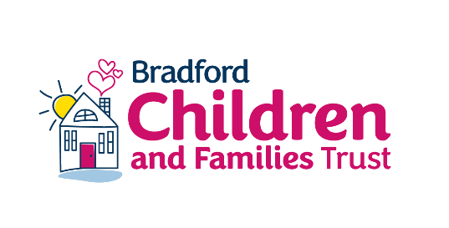

How to use Mind Of My Own

A short guide for
CHILD PROTECTION

Contents

All about Mind Of My Own | 3
One App  - Preparing for meetings  - Understand the child’s wellbeing  - Sharing good news  - Sorting problems | 4  5  6  6
Express  - All about me & My Education  - My Health & My Life | 10  11

Why should I use Mind Of My Own?
- Mind Of My Own apps will save you time. You’ll receive a pdf of the child’s views, wishes and feelings which you can upload to their file

- Receiving Mind Of My Own statements from children and young people ensures you have evidenced the voice of the child

How do I sign up or log in to my worker account?
Open your web browser (Google Chrome or Internet Explorer) and go to workers.mindofmyown.org.uk
- Choose the Organisation you’re working with from the drop down list
- Fill out your First Name, Last Name, and Email Address
- Click On ‘Sign Up’
Why do I need a worker account?
- To use Mind Of My Own with young people you work with
- To familiarise yourself with the apps (using the ‘Test Profile’)
- To create an Express account for a child or young person

When should I use Mind Of My Own?
- Preparing for meetings  - Child Protection Conferences  - Statutory Visits  - Assessments  - Any other meeting or review | - Direct Work  - Understanding lived experience  - Journey mapping through care  - Understanding risk & resilience  - Identifying safeguarding risks
Who can I use Mind Of My Own with?
Any child or young person you work with, any time you work with them

Preparing for meetings

 | What is this for? | When is this used?
 | - Prepares every young person for their child protection conference  - Gives you a clear understanding of what the child wants to talk about during the meeting, allowing you to focus on what matters to them | - Child Protection Conferences  - Direct work sessions
 | - Gives young people the opportunity to feedback on how the meeting went from their perspective | - After all meetings

Understand the child’s wellbeing

 | What is this for? | When is this used?
 | - Allows young people to reflect on their current life situation  - Gives the worker an opportunity to see into the corners of their life you may not see otherwise | - Encourage individual use anytime  - Social work visits  - Assessments & investigations  - Meetings & reviews
 | - Understanding the child’s lived experience, allowing you to mitigate against risks  - Identify key risk and resilience indicators, giving a unique insight into the child’s wellbeing | - Encourage individual use anytime  - Social work visits  - Assessments & investigations  - Meetings & reviews

Sharing good news and sorting problems

 | What is this for? | When is this used?
 | - Can be used as part of life story work to capture events in the child’s own words  - Young people asked us to put this in the app. They wanted a specific place to talk about things that are going well. | - Encourage individual use anytime  - After planned events
 | - Solve issues at the earliest stage possible  - Often the change is small and easy for the worker to action, but the effect for the child can be huge | - Encourage individual use anytime  - Formal complaints  - Raising concerns
Using Express in direct work
FOR CHILDREN AND YOUNG PEOPLE WITH ADDITIONAL NEEDS

 | What is this for? | When is this used?
 | - Gives an overview of a young person’s likes and dislikes  - Develops a one page profile so the child does not keep having to tell their story over and over again | - One page profiles  - Before health checks  - Assessments  - Statutory visits  - All other meetings and reviews
 | - Understanding the child’s learning preferences and the academic support they need  - Understanding how they feel at school and to embed the child’s voice into education planning | - Education, health and care plans  - Education planning  - Assessments  - Statutory visits  - All other meetings and reviews

Using Express in direct work

 | What is this for? | When is this used?
 | - Understanding how the child feels about their health and visits to health care professionals  - Explore any worries the child has about their health and understand their behaviours better | - Before health checks  - Assessments  - Statutory visits  - All other meetings and reviews
 | - Exploring different aspects of a child’s life and the relationships they have  - Identifying safe-guarding concerns including where they feel safe or not and whether they have a trusted adult | - Before health checks  - Assessments  - Statutory visits  - All other meetings and reviews

