Early Help Assessment: Practitioner Guidance

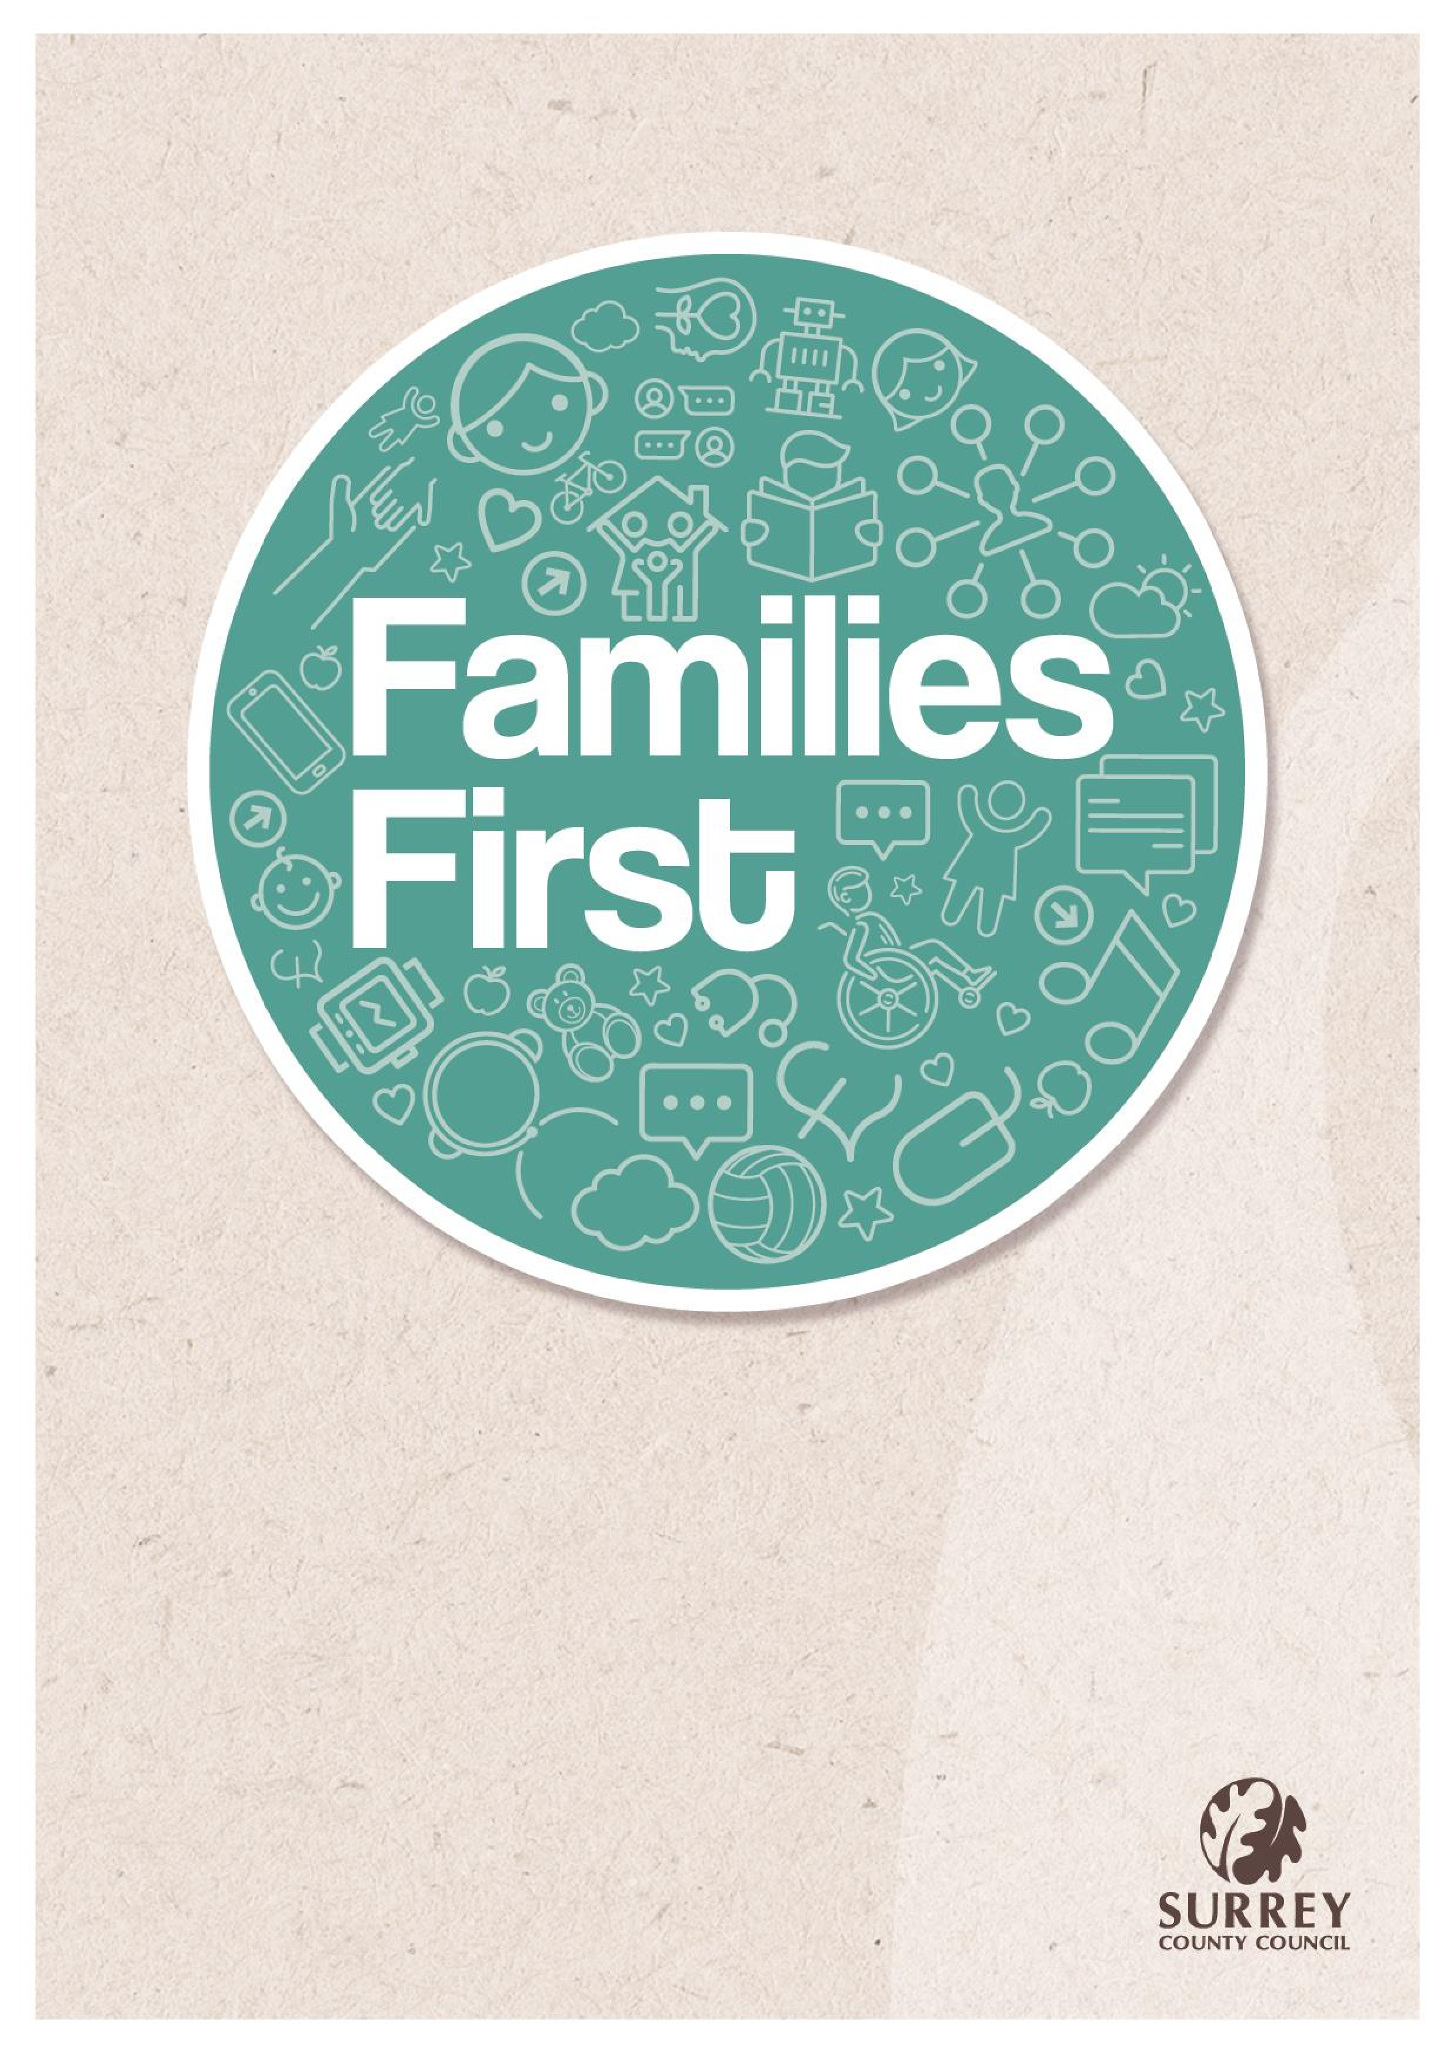

**Early Help Assessment**

**Practitioner Guidance**

# Introduction

Underpinning effective Early Help are our Families First principles. These six principles enable everyone in the partnership to adopt a consistent approach. They encourage holistic support for families, to always prioritise the needs of children, and to engage families in a way that will best meet their needs.

As a partnership, we all:

* Prioritise a child’s wellbeing, wishes and feelings
* Include everyone, supporting whole families, in their communities
* Empower families in their choices, never assume or judge
* Promote family strengths and value the family’s experience
* Communicate simply and clearly, with no surprises
* Respect families and be reliable and trustworthy

The Early Help Assessment (EHA)/Family Plan has been designed to ensure it does not act as a barrier to engagement and recognises the importance of capturing the voices of children and families, their strengths and the areas they want support in to improve in their lives. When completing an Early Help Assessment (EHA)/Family Plan practitioners should consider Surrey’s Families First principles.

# Assessment Best Practice

The assessment process should engage the family and children and is an important part of establishing the relationship that will support the change the family wants to make. Where the change the family wants to make has been described as part of the initial request for support/contact, the practitioner must use this as the starting point. A holistic assessment should be undertaken.

A holistic family assessment:

* Provides a sense of what is going on in their life, using the holistic person-centered framework offers a base for conversation
* Gives a sense of what is going well and where they don’t need help
* Is child/ person centred – allows the parent or child to take the lead and be an active participant in their own support, capturing what is important to them
* Is holistic and outcomes focused – providing a consistent framework for exploring and reflecting on someone’s life today and their goals for the future
* Is collaborative and empowering – information is collected through collaboration
* Is simple and clear – and has accessible design and language for parents and children themselves.

The EHA is supported using a range of additional practitioner assessment tools. An example of a holistic assessment tool is The Outcome Star used by many services in Surrey. Other assessments used by different professionals can be used to inform the early help assessment and should be seen as contributing to the holistic picture. Examples of these are Health Needs Assessment, NSPCC Graded Care Profile 2, 2-year progress checks and development matters. The assessment should be owned by the family and should use language accessible for the family, child/young person.

# Completing the Early Help Assessment and Family Plan

The EHA should be undertaken with the agreement of the child and their parents or carers, involving the child and family and all the practitioners working with them (Working Together to Safeguard Children 2023). The assessment and goals will be discussed and agreed with the child, young person, and their family. They should be written in a language that all understand.

**How are things for you and your family? How does this affect the children?**

Capture the voice of the child and family. The assessment should tell the story with the child and family’s own words. Records should be non-judgemental and not label children and families. Remember that all records could be read by the child and family in the future. The child should be able to see that their needs were considered as part of the assessment and their voice heard.

# What is going well? What are the strengths/positives in your family life? This should include the child’s view

Tell the story using the child and family’s own words. Think about the family strengths, the Continuum of Support has a list of resilience factors that might help you identify what these are with the family. If you are using an Outcome Star Identify the areas of the Star that the family has marked themselves as high on the scales. All strengths should be covered under these boxes, clearly evidence who said what and the reason for their views under this section.

**What would you like to be different?**

Focus on what the family would like to be different, use their own words from what they have told you. If you are using an Outcome Star the areas which the family identified as low in the scales can be used. Use the family’s identified goals and clearly evidence, who has said what and the reason for their views under this section.

**What support do you have now? What support have you had previously?**

Here evidence what support the child and family has had from the family’s networks; include school, health and positive activities/clubs, and family and friend network.

You need to include:

* Who?
* When? (dates when ended)
* What did/does support look like? What is being offered?
* What is the goal/was the outcome of support?

A range of assessments tools (as discussed above) can be used to complete the assessment and are useful to frame discussions with the child and family.

Where possible always use the words used by children and families to record their voice and all questions/discussion should use open ended questions/reflect back/affirm what the child/family has said and be confident in being professionally curious.

**Practitioner summary and analysis:**

The practitioner should provide a summary assessment. Your professional opinion about the completed assessment is included here, as are the views of the parents and children. Here you draw together the information you’ve entered elsewhere in the assessment. Including what is going well and what the family would like to be different.

Drawing on the information gained through any assessment tools used, practitioners should briefly summarise the relevant strengths and areas of focus for the family plan.

Practitioner comments should be based on evidence, not opinion. Indicate what your evidence is. When the assessment has been supported using specific tools such as the GCP2 for example, the findings of these tools should be summarised here.

The analysis should clearly set out:

* How will you know things have improved?
* How will the family know things have improved? • What are the main worries that the family have?
* As a practitioner what are your concerns, or the concerns of other professionals?
* What is the impact on the children? Have you already spoken to the family about these concerns?

Remember to use language that is respectful to the child and family.

A good analysis will take into consideration all the facts, evidence, differing opinions, and impact of these on the child and their development.

# Family Plans

The family plan identifies objectives and goals and details the actions to be taken. It should identify the roles and responsibilities of the child and family as well as each of the organisations providing services to the family.

It should include:

* what is needed
* the overall outcome for the action
* who will help with this and how – the actions need to be specific, measurable, achievable, realistic and timely (SMART)?

Family plans should be family centered and focused on actions that improve the outcomes for children. Some actions such as ‘making a referral to…’. or ‘Chasing another professional’, should not be included in the family plan; these are professional’s actions for case recording.

Family plans are working documents that should either be reviewed as/when things change or at the Team around the Family meeting (TAF).

# stages to family plans

## Engagement

Plans at this stage are likely to be short and include small steps and will include actions for the practitioner to prove trust and quick wins. The family plan should reflect the individual’s personal and family-related needs, their barriers, and the stage they are at in overcoming them for the plan to work.

## Direct Work

These plans are after engagement and once a family are open to change. The family plan should chart the progress made by the individual and should give the individual a framework to help focus on what they need to do. It should be agreed on by the individual and reviewed regularly. The family plan is an important way of evidencing the progress made, so it is important that all family activities undertaken are recorded on it.

## Exit Plans

The timing of exit plans is crucial as this empowers and enables children and families to identify their journey and the changes they have made, then use this as a resource to remind them if things begin to become difficult later. Good effective exit plans can prevent early rereferrals**.**

# Consent and data privacy statement

The data consent statement on the EHA/Family Plan is a guideline provided by Surrey County Council; practitioners and agencies using the form should refer families to their own privacy statements and ensure consent to share is gained from the family.

# Appendix A

## ‘Top Tips’ to help identify child and family strengths and needs when completing an Early Help Assessment and Family Plan

Completing an EHA/Family plan should be a comfortable and positive experience for children and Families. Remember: ‘Every interaction is an intervention.

**Have a conversation:**

* You will gain more information from a conversation than from asking a set of questions
* When talking with children and families think about how you are introducing the assessment – what language are you using? Avoid jargon and frequently check the family have understood what you have said
* Think about how you are presenting to the family – your body language / unconscious bias etc
* Sit side by side and allow the child/family to talk
* Explain you may need to take some notes. Check this is ok – have your notepad visible so they can see what you are writing
* Be an active listener giving full attention. Try not to comment verbally or start

‘fixing’.

**Phrases to help open up a conversation**:

* “How are things now /since you asked for support?
* I have read why you would like some support. Can you tell me yourself?

**Phrases to help gain a greater understanding:**

* “It sounds like there’s a lot going on, what worries you the most/what you’d like to talk more about?”
* “Can I check that I’ve got this right….?”

**Linking feelings with facts:**

* “Let me check …. you feel angry/frustrated/sad because…….”

**Affirming/empathy:**

* “I can see that things are difficult at the moment” This validates their story
* “that sounds really hard for you, however you managed to…..” This acknowledges

their strength and encourages and isn’t just focusing on negatives.

**Summarising:**

* “You’ve shared/talked about a lot of things today. So let’s recap/see where we’ve got to……” this provides another opportunity to check for accuracy and understanding and to clarify priorities.

Using the headings from a holistic assessment tool such as Outcome /Family star will also help to remind you of any areas of Family life that may need exploring.

# My children’s health

General health and development of the child.Thinking about birthing experience; physical development; conditions and impairments; access to and keeping appointments for dentist/GP/optician; immunisations; developmental checks; nutrition; communications development; hospital admissions and accidents. Medications. Impact of poor child health in accessing education/ friendships/ family life.

# My children’s learning

Additional needs impacting learning. Speech & Language development; access to, attendance and participation in education/employment; achievement and attainment in education/employment. Access to pre-school (FEET /early years funding options). Child’s voice:

what are the child’s feelings about school/learning (likes, dislikes aspirations.): what do they perceive as the barrier’s to learning.

# My children’s emotions

Emotional development of the child. Include mental health; early attachments; risking/actual self-harm; phobias; coping with stress; motivation; self-confidence; feeling isolated/solitary; sense of belonging; can they understand/manage their feelings in an age-appropriate way. Child’s voice:Friendships/feelings/fears confidence- what makes them happy/sad angry – observation of child with care givers and responses of care giver.

# Keeping my children safe

What does the Family do to minimize the impact on the children of Parental conflict/domestic abuse/ poor mental health /substance misuse. Think about basic care, ensuring safety and protection: Provision of food, drink, warmth, shelter and appropriate clothing; age-appropriate daily routines in place; engagement with services; safe and healthy environment: online use and managing child’s safety around this. Emotional warmth and stability form caregiver.Completion of a Graded care 2 profile may be appropriate at this point if there are many concerns in this area.

# My children’s behaviour

Explore with parents’ child’s self-control; reckless or impulsive activity; behaviour with peers; substance misuse; anti-social behaviour; sexual/sexualised behaviour; offending, violence and aggression; restless and overactive, easily distracted, attention span/concentration; becoming independent; reaction to boundaries and rules; self-care skills, hygiene. Child’s voice:How does the child see their behaviour? Why do they react I the way they do. What/who helps them?

# Friends and Community

Building stable relationships with family, peers and wider community and how those relationships impact on the child/young person; helping others; friendships; experiences of discrimination due to race, religion, age, gender, sexuality and disability; experience of being a Young Carer. Wider family: Extended family relationships; help and support from extended family, friends & neighbours; potential positive role models; other significant adults that have, or could have, impact on the child’s life. What is it like living in the Community? Access to and involvement in local Social and Recreational Activities and networks; Local levels of harassment, anti-social behaviour, crime/hate crime/fear of crime; (un)employment; social isolation and impact on family.



|  |  |
| --- | --- |
| **Title** | Early Help Assessment Practitioner Guide |
| **Purpose** | Practice guidance for completing an EH assessment on EHM |
| **Updated by** | Sue Turton |
| **Approved by** | Jackie Clementson |
| **Date** | January 2025 |
| **Version** | V2 |
| **Status** | Final |
| **Frequency** | 12 months |
| **Next review date** | January 2026 |