Children’s Single Point of Access (CSPA)  
and Multi-Agency Partnership (MAP)

**Operational Guidance**

January 2025

**Our vision**

**In Surrey, we all believe that every child should have the opportunity to fulfil their potential and that children are best supported to grow and achieve within their own families.**

**By working together, we strive to provide a more consistent, timely and unified multi-agency response to individual situations relating to welfare and safeguarding concerns for children and adults in the county.**

Table of Contents

1. Document Overview 1

1.1 Document Purpose 1

1.2 Version Control 1

1.3 Intended audience 1

2. Children’s Single Point of Access (CSPA) 2

2.1 Definition and Model 2

2.1.1 Service Description 2

2.1.2 Family Safeguarding Model 3

2.1.3 Working Together to Safeguard Children 2023 3

2.1.4 Continuum of Support 3

2.2 Membership 5

2.3 CSPA Process 6

2.3.1 Process overview 6

2.3.2 Process for urgent safeguarding concern 7

2.3.3 Step up guidance for Family Centres for children who may need statutory intervention 7

2.4 Service Level Agreements 7

2.4.1 Timescales 7

2.5 Governance 8

2.5.1 Key meetings 8

2.6 Key Protocols 9

2.6.1 CSPA Child Protection Consultation Line 9

2.6.2 Working together with Surrey’s education services, partners and alternative provision 10

3. Multi-Agency Partnership (MAP) Team 10

3.1 Key Definitions 10

3.2 Purpose 10

3.3 Partners 12

3.3.1 Co-located Members 12

3.3.2 Virtual Members 12

3.3.3 Roles and responsibilities 12

3.3.4 Management, Supervision and Training 14

3.3.5 Resolving Disagreements 14

3.4 Multi-Agency Partnership Enquiry (MAPE) process overview 15

4. Information sharing and consent 16

4.1 Information sharing 16

4.1.2 IT systems and security 16

4.2 Consent 17

5. Quality Assurance 19

5.1 Quality Assurance Arrangements for the MAP 19

6. Appendices 19

6.1 Best Practice Guidance 19

6.1.1 What makes a good request for support? 19

6.1.2 Recording Contact Information and Activity 20

6.2 Legal Advice 20

# Document Overview

## 1.1 Document Purpose

The purpose of this document is to provide a reference guide for Managers, staff and professionals involved in and working in conjunction with the CSPA. This document outlines established procedures for managing safeguarding activities, ensuring all parties understand their shared and individual roles and responsibilities.

## 1.2 Version Control

| **Date issued** | **Version** | **Summary of changes** | **Author** | **Approved by** |
| --- | --- | --- | --- | --- |
| May 2019 | Final v1 | First issued | Neena Koshla | Jackie Clementson |
| November 2022 | Final v1.1 | Reviewed and reissued | Paul Cooke | Jackie Clementson |
| January 2025 | Final v2 | Reviewed and reissued | Fardowsa Ga’al | Matt Ansell |

Document Location: The Surrey County Council Children’s Services Procedures Manual

Formal review will take place on an annual basis with partners.

## 1.3 Intended audience

This document has been issued to the following for Review (R) Information (I) and Sign off (S).

| **Name** | **Position** | **S/R/I** |
| --- | --- | --- |
| Matt Ansell | Director of Family Resilience and Safeguarding | S |
| Nicole Miller | CSPA Assistant Director | RS |
| Fardowsa Ga’al | CSPA Service Manager | RS |
| CSPA Staff & Partners |  | I |

This document is designed for Managers, staff, and professionals involved in and working in conjunction with the CSPA.

# Children’s Single Point of Access (CSPA)

## 2.1 Definition and Model

### 2.1.1 Service Description

The Surrey Children’s Single Point of Access (CSPA) is the ‘front door’ to children’s services, responsible for managing and responding to all safeguarding concerns regarding children and young people who live in Surrey.

Our primary goal is to ensure that children and families receive the right support the first time. We achieve this by efficiently triaging requests, signposting to relevant information and services, allocating to appropriate support, and collaborating with partners to share information and make joint decisions on the support needed.

Members of the public and professionals can submit a request for support into the CSPA service via phone or email. Professionals working with children and young people in Surrey play an important role in keeping them safe by referring into the CSPA where appropriate.

The team is made up of customer service specialists, Social Workers, early help practitioners, and community partners. We work together to safeguard children and young people, improving outcomes for families by ensuring they receive the services they need without unnecessary delays.

The CSPA service is made up of three main teams:

| Team​ | Description​ |
| --- | --- |
| Request for Support Team (RFST) ​ | The team are customer service specialists, consisting of Supervisors, Officers, and Assistants. Their role is to triage and process all initial requests for support and information from both professionals and members of the public. The team are part of the Customer Services Directorate. |
| Multi-Agency Partnership Team (MAP) ​ | The MAP is a partnership of agencies, physically and virtually co-located with a duty to safeguard children, young people and families. This includes qualified Social Workers practioners,Team Managers and specialist workers in Education, Health, and Police. The team work together to improve information sharing and decision-making. The team is supported by MAP Officers (MAPOs) and Administrators. The MAP team screen and undertake agency checks in order to make an informed decision on the support required for each child and family. |
| Early Help Hub (EHH)​ | A small team screening requests where intensive/targeted support or universal or community support is required. The team undertake further checks, speak to the family and relevant professionals. Allocate to the most appropriate Early Help locality team and/or signpost to relevant support. The team are supported by a Team Manager and Advanced Practitioner who are qualified Social Workers ensuring that there remains Social Work oversight. |

### 2.1.2 Family Safeguarding Model

In Surrey, our chosen model of practice for Statutory Social work is Family Safeguarding, this is a partnership approach to working with families which promotes keeping families together where it is safe to do so. We collaborate with professionals to identify the changes needed within families to facilitate positive outcomes. This approach helps build resilience within families, enabling them to overcome future difficulties independently.

Key principles

* Promotes the upbringing of children in their families, by identifying, supporting, and meeting the needs of the children and parents to make a difference for the child or young person.
* Strengths-based, needs-led, and seeks to work in partnership with families to facilitate sustained change.
* Adopts motivational interviewing approach to find out and draw out people's own motivation for positive change.
* Includes multi-disciplinary teams providing services to CIN (Children in Need) & those in need of protection and their families. Working to create change for children, not monitoring their circumstances / enforcing compliance.
* Aims to support more families to create sustained change that supports capacity to parent at the earliest opportunity.

### 2.1.3 Working Together to Safeguard Children 2023

The statutory guidance outlines how the Local Authority, Police, and Health services work together to safeguard and promote the welfare of children. It covers key areas such as multi-agency collaboration, roles and responsibilities of safeguarding partners, information-sharing protocols, and champions a child-centred approach to ensure the needs of children are prioritised. This document and our practice align closely with this statutory guidance.

### 2.1.4 Continuum of Support

In Surrey, the approach for helping families early is embedded within the [Continuum of Support](https://surreyscp.trixonline.co.uk/chapter/continuum-of-support-for-children-and-families-living-in-surrey) and the Social Work practice model ‘Family Safeguarding’.

The Continuum of Support is a partnership document developed on behalf of the Surrey Safeguarding Children’s Partnership (SSCP). The continuum focuses on the needs of children and how they can be supported through Early help.

The aim of this document is to support the wider workforce to understand how to best meet the needs of children as they emerge, connecting them to community resources and services that can help improve the outcomes of children. This will help prevent families being unnecessarily referred into the CSPA service and ensures that families receive the support they need.

The model identifies five types of support:

* Universal and community
* Emerging Needs
* Targeted Support
* Intensive Support
* Statutory services

The diagram below provides a reference to understand how the continuum of need aligns with [The Thrive Framework for System Change](https://implementingthrive.org/wp-content/uploads/2019/03/THRIVE-Framework-for-system-change-2019.pdf) needs-based groupings. Showing how as a continuum of support which different responses across the system are used according to what works and will make a difference.

The Early Help Booklet assists colleagues in making appropriate allocations to targeted services and identifying other available resources that might be suitable for families with emerging needs. It provides an overview of targeted services that can be accessed through CSPA, Mindworks, and the Family Information Service. This booklet can be accessed by Surrey County Council (SCC) practitioners via SharePoint: [Early Help Booklet.docx](https://orbispartnerships.sharepoint.com/:w:/r/sites/family_resilience_and_safeguarding/Documents/04.%20Early%20Help/Early%20Help%20Booklet.docx?d=w8fa119a68ba24f4cb2fd6f21d7d9faa1&csf=1&web=1&e=2sQeOr)

## 2.2 Membership

The visual below highlights the key partners and services who form part of the CSPA alongside their roles and responsibilities which enable the service to effectively safeguard children, young people and families in Surrey.

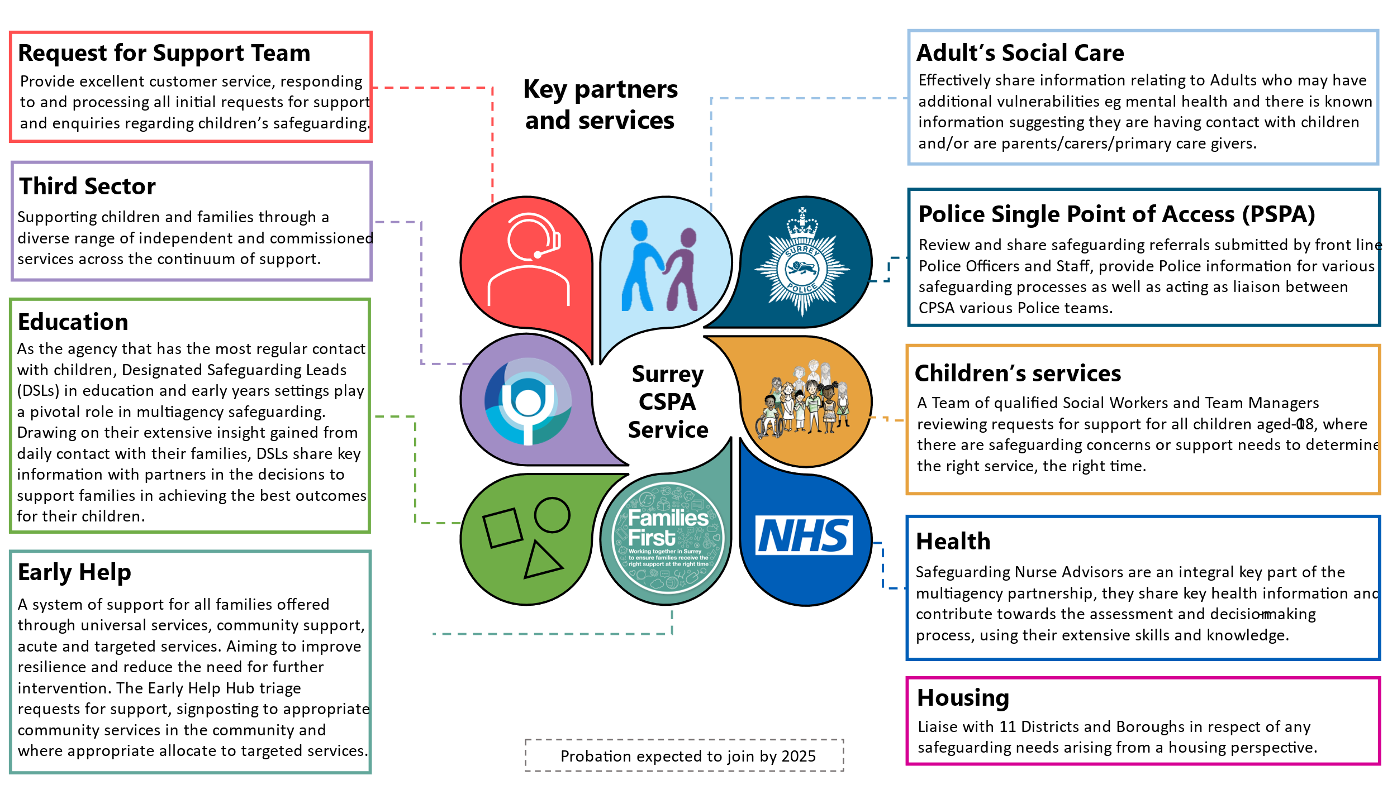

## 2.3 CSPA Process

### 2.3.1 Process overview

For more information on how to make a referral visit our external webpage: [Report a concern about a child or young person - Surrey County Council](https://www.surreycc.gov.uk/children/contact-childrens-services)

Detailed process workflow can be accessed by SCC staff on [SharePoint.](https://orbispartnerships.sharepoint.com/:w:/r/sites/family_resilience_and_safeguarding/Documents/05.%20CSPA/CSPA%20Operational%20Guidance/Live%20versions/Request%20for%20Support%20Workflow%20-%20live.docx?d=w39e3ebfd70494d5380e545d478ebd0e0&csf=1&web=1&e=vaKEYo)

### 2.3.2 Process for urgent safeguarding concern

If the Request for Support Officers identifies an urgent safeguarding concern this is progressed immediately and allocated to the Assessment Team for review by an Assessment Social Worker.

It is the responsibility of the area teams to then hold any relevant safeguarding meetings and or strategy discussions with partner agencies to determine the most appropriate course of action to ensure the ongoing safety and wellbeing of the child(ren) referred in.

Where the contact is with the MAP and information ascertained heightens the level of risk to a child, the MAP Social Worker will inform the relevant area Team Manager and ensure the contact is transferred to the area assessment team without delay and alert the Assessment Team Manager.

### 2.3.3 Step up guidance for Family Centres for children who may need statutory intervention

From January 2024, all requests from Family Centres to Step up a child for consideration for social care intervention should be made via SCC’s children’s social care case management system, Early Help Module (EHM) following the process detailed process.

SCC professionals can access this guidance via SharePoint: [Step-up process January 2024](https://orbispartnerships.sharepoint.com/:b:/r/sites/family_resilience_and_safeguarding/Documents/04.%20Early%20Help/step-Up%20-process%20%20January%202024.pdf?csf=1&web=1&e=3jfUwD)

## 2.4 Service Level Agreements

### 2.4.1 Timescales

The overall target for CSPA is to complete contacts within 2 working days. However, we aim to progress contacts as quickly as possible, with the following targets serving as a guide that we strive to meet.

|  |  |  |  |  |
| --- | --- | --- | --- | --- |
| **BRAG** | **Nature of request** | **Pathway** | **Timescale for decision** | **Timescale for completion** |
| **Blue** | Information Requests  Universal Services/Community Support | Multi-Agency Partnership Team (MAP) /  No further action | All contacts must be decisioned within 24 hours | 5 working days |
| **Green** | Emerging Needs/Targeted | Early Help Hub | 5 working days |
| MAP | 24 hours |
| **Amber** | Targeted/Intensive | MAP | 24 hours |
| **Red** | Statutory | MAP/Assessment | 4 hours* |

*‘RED’ contacts are sent immediately to the Assessment team without delay, in line with the 'Process for Urgent Safeguarding Concern 2.3.3'. These children and families are progressed as soon as possible.

If further agency checks are required to determine need the Multi-Agency Partnership (MAP) team will have 24 hours to undertake and complete a Multi-Agency Partnership enquiry (MAPE).

The onus will be on CSPA to ensure timely progression of MAPE's to Partner agencies to ensure children and families are adequately researched by partners. MAPE numbers vary according to daily operational demand and the partnership aims to work as quickly as possible in accordance to need to meet or exceed the timescales outlined below.

|  |  |
| --- | --- |
| **RAG rating** | **Timescale for completion** |
| **Green** | * Information from MAP partners expected to be available within 7 working hours. * Contacts will be referred on to the Early Help Hub to identify the appropriate service for the family to ensure they start to get the help they need. |
| **Amber** | * Information from MAP partners expected to be available within 7 working hours. This includes information sharing by MAP partners and referral on to a relevant resource, including the Early Help Hub. |
| **Red** | * Information from MAP partners expected to be available within 4 working hours. * Early warnings will need to be given to the relevant Assessment Team as they may need to go and visit the child in parallel with the MAP gathering information. |

All attempts will be made to complete the information gathering and/or to alert the Out of Hours team for any children or families who may need support out of hours.

## 2.5 Governance

### 2.5.1 Key meetings

| **Meeting** | **Frequency** | **Purpose** |
| --- | --- | --- |
| CSPA Strategic Board | Bi-monthly | * Provide strategic direction on the function of the CSAP and MAP, in terms of future development and/or changes. * Review performance of the CSPA and MAP. * Review resourcing and make recommendations. * Ensure Partnership engagement and arrangements are sufficient. * Make financial and budgetary decisions. * Hold operational practice to account. |
| MAP Operational Board | Monthly | * Opportunity for partners to provide updates to ensure smooth multi-agency operations and reviewing of individual service needs. * Enables communication about effective multi-agency sharing of information. * Share Partnership pressures and plans to reduce these. * Discuss Performance data and explore areas for improvement. * Discuss ongoing development of the MAP and identification of workstreams that may be required. * Plan/explore multi-agency training opportunities. |
| Daily Partnership Meetings | Daily at 9am | * Notify partners of any urgent safeguarding concerns received that require immediate prioritisation in gathering information from relevant partners. * Agency updates on significant incidents that may impact on partners. * Discuss operational, staffing or IT issues. * Review actions identified at previous meeting. |
| Missing Discussions | Daily | * Ensure that all children reported missing in Surrey (along with other children relevant to the missing episode) are screened as quickly as possible, with the best possible information being shared at the earliest stage. |
| Daily Domestic Abuse Discussions | Daily | * Review Domestic Abuse victims and perpetrators where an increased risk to a child/children has been identified by partner agencies. * Consider the level of risk and the needs of the family presented within the referral information and collectively identify next steps / outcome to ensure the safety and welfare of the child(ren) going forward. * Ensure information is shared in a timely and effective way to enable clear multi-agency decisions to be made at the earliest point and to identify the relevant services to meet any identified need. |
| SABP (Mindworks) & CSPA Daily Discussions (MWDD) | Daily | * Enhance partnership working and sharing of information to inform decision-making and support provided to children, young people and their families in respect of mental health and emotional wellbeing. * Ensure children are supported at the earliest opportunity by the right service. |
| CSPA Reflective Practice Meetings | Fortnightly | * Review of multi-agency decision by CSPA and application of continuum of support. * Aim to improve application of continuum of support, understanding of need and our response across the partnership. |

The CSPA service holds terms of reference for each meeting, which are shared with members to ensure clarity and alignment on objectives.

## 2.6 Key Protocols

### 2.6.1 CSPA Child Protection Consultation Line

The CSPA Child Protection Consultation Line is available to all professionals working with children and families in Surrey. Professionals can call this dedicated line to talk to a Social Worker about any safeguarding concerns they have about a child or family. The Social Worker will offer advice, support, and information on relevant services to meet the family's needs. The consultation line does not replace the current safeguarding process and Professionals do not need parental consent to have an anonymous consultation. The protocol below outlines the arrangements for the use and operation of the [consultation line](https://proceduresonline.com/trixcms2/media/24049/cspa-consultation-line-v2-october-2024.docx).

### 2.6.2 Working together with Surrey’s education services, partners and alternative provision

The procedure intends to ensure effective information sharing between CSPA and all education services, partners and alternative provision working with children and families in Surrey. This agreement aims to strengthen safeguarding and support for children and families who come to the attention of the CSPA. This guidance can be accessed by SCC staff on SharePoint: [CSPA Education procedure - live.docx](https://orbispartnerships.sharepoint.com/:w:/r/sites/family_resilience_and_safeguarding/Documents/05.%20CSPA/CSPA%20Operational%20Guidance/Live%20versions/CSPA%20Education%20procedure%20-%20live.docx?d=wd988e73cea97437dbb2bcf45c5d524b3&csf=1&web=1&e=7dqh5a)

# Multi-Agency Partnership (MAP) Team

## 3.1 Key Definitions

The Multi-Agency Partnership (MAP) is a partnership of agencies, physically and virtually co-located and others via virtual links, that have a duty to safeguard children and who have agreed to work within an integrated team to improve decision making whenever there are concerns about a child.

The MAP team shares and analyses information from their agencies database in a safe, managed environment so that social work decisions on intervention can be made quickly and are based on the most accurate information available. The MAP co-locates safeguarding agencies and their data into a research and referral unit for notifications and referrals on vulnerable children. By doing this, the MAP aims to identify and quantify risk and need by building a full picture on the child and their family.

The original Multi-Agency Partnership Hub (MAP) concept for children’s safeguarding intends to:

Provide the highest level of knowledge and analysis of all known intelligence and information across the safeguarding partnership to ensure all safeguarding activity and intervention is timely, proportionate and necessary.

A Multi-Agency Partnership Enquiry (MAPE) is an enhanced information sharing process which enables agencies within the MAP Team to share information they hold about a child and their family. Information is gathered by children’s services within the MAP team and is held within SCC’s children’s social care case management system on the Early Help Module (EHM). This information can be shared with other Children’s Social care teams but will only be shared with other external agencies if it is deemed necessary, relevant and proportionate to safeguard the child.

## 3.2 Purpose

The purpose of the Multi-Agency Partnership (MAP) is to safeguard children through effective multi-agency collaboration, ensuring timely and proportionate intervention.

Information sharing is central to this collaboration, enabling professionals to make informed decisions based on accurate, up to date information. This ensures families are referred to the most appropriate services and receive help at the earliest opportunity. Information sharing within the MAP is governed by relevant protocols, while sharing outside of the MAP follows each agency's policies and agreements.

One of the key purposes of a Multi-Agency Partnership (MAP) is to ensure a coordinated response to safeguarding children through inter-agency cooperation and effective information sharing. This approach enables the creation of an accurate and comprehensive picture of a child’s life, helping to identify risks of harm.

MAP’s objective is to work collaboratively to safeguard children, in line with the legal duty set out in the Children Act 1989, which places a responsibility on services to support children in need or at risk of harm:

* Section 17 defines children in need as those who require services to maintain health and development, or whose health or development would be significantly impaired without such services, including disabled children.
* Section 47 requires agencies to cooperate with children’s social care to investigate concerns of significant harm.

Section 17 defines children in need as:

* (10a) those children who will need services in order to achieve and maintain a reasonable standard of health and development.
* (10b) those children whose health or development is likely to be significantly impaired or further impaired, without the provision for of such services.
* (10c) disabled children.
* Section 47 places a duty on Surrey County Council to carry out enquiries where there are concerns that a child is at risk of significant harm. Organisations such as the police, health, education, probation services and housing have a duty to assist children’s social care with these enquiries.

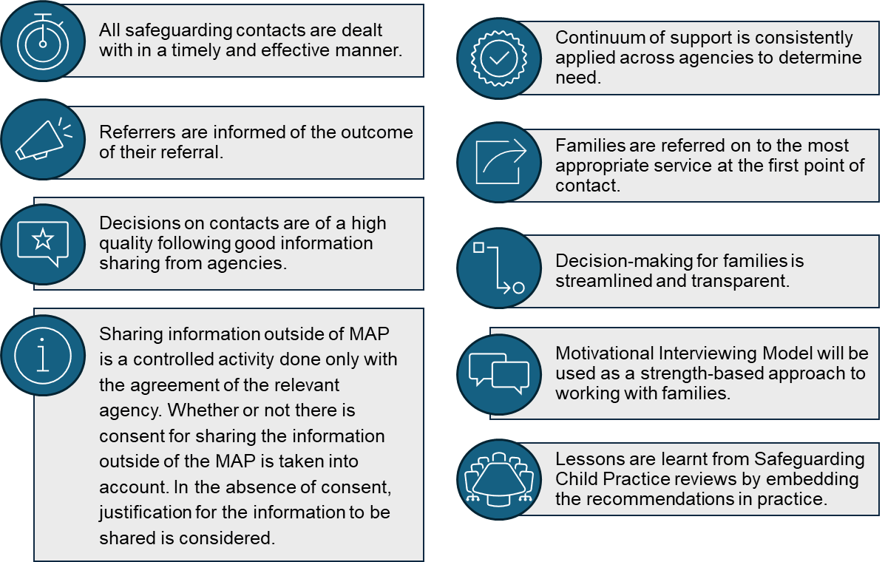Key aims

## 3.3 Partners

### 3.3.1 Co-located Members

The following partners are physically based within the MAP team in Woking:

* Surrey Children’s Services
* Health Services
* Surrey Police
* Education
* Adult’s Social Care

### 3.3.2 Virtual Members

These partners are not physically co-located but work alongside and support the MAP Team:

* Third Sector
* Probation
* Housing

These members provide information from their agency at the request of the MAP subject to having consent to share that information or being satisfied that there are grounds to share the information without consent.

### 3.3.3 Roles and responsibilities

All MAP members, regardless of their originating agency, will have:

* The relevant professional qualifications, experience and levels of access to agency databases needed to carry out their MAP role effectively.
* An up-to-date enhanced DBS check in place, or suitable vetting.
* Received safeguarding and child protection training at a level that is relevant to their role.
* Access to regular and effective supervision from their line manager that meets their needs as MAP members.
* An understanding of key roles and responsibilities of all partners.
* Commitment to put the needs of children and families first.

| **Role** | **Key responsibilities** |
| --- | --- |
| CSPA Service Manager | * Oversee and manage MAP daily operations. * Maintain strong working relationships with partners. * Develop operational policies and procedures. * Oversee the quality assurance of all activity within the CSPA. * Ensure there is effective inter-agency working and information sharing. |
| Children’s Services Team Manager | * Oversee decision making within the MAP. * Work collaboratively with partners to identify risk and needs and agree the way forward. * Clearly define ownership of activities and roles. * Ensure management oversight and through flow of work allocated to MAP Social Workers and MAP Officers respectively. |
| Advanced Social Worker | * Sign off contacts with support from Team Managers * Responsibilities include that of Social Worker as listed below. |
| Social Worker | * Responsible for gathering information from a range of professionals and family members. * Collate the history as contained in LCS and EHM electronic records referred to the MAP. * Provide advice and support to all MAP staff where required. * Assist Team Managers to monitor timescales. * Support MAP Officers to analyse information in order to make informed decisions. * Respond to queries on the CSPA Child Protection Consultation Line as required. |
| Business Support Administrators | * Provide support with administrative tasks. * Provide feedback to Referrer via letters and email. |
| Multi-Agency Partnership Officers (MAPOs) | * Carry out information gathering and history taking as directed by the Team Manager for information requests. * Support with data tidying and creation of contacts when required. * Assist with supporting Social Workers in administrative tasks. |
| Police Staff | * Carry out checks on police systems and provide analysis of this information, including intelligence, identification of patterns, trends and relationships in order to inform MAP decision making. |
| Health Practitioners | * Undertake checks on health data base for information and liaise with other partners in the health service as appropriate to gather all relevant health information on the child and family. * Support timely information sharing and influence effective decision making to safeguard, improve outcomes and reduce risk for children and young people. * Manage health information and analyse risks with MAP partners through established processes. * Liaise with other relevant health practitioners across the local health economy to gather and share information. |
| Education Safeguarding Advisors | * Liaise and gather information from Schools and other education providers as directed by MAP Team Managers to help inform decision making within the MAP. * Share information with named staff in other SCC departments, (for example EHE, CME, SEND) on direction of Social Worker/team manager if deemed appropriate and proportionate. * Provide feedback to schools following MAP enquiries/speak with schools about providing additional support for students. * Help schools navigate their way to the appropriate department in SCC. * Share information with police that will help them carry out OP ENCOMPASS. * Support partner agencies with Education information where needed. * Attend relevant education meetings and forums. |

### 3.3.4 Management, Supervision and Training

The CSPA Service Manager oversees MAP operations, ensuring team members fulfil their roles to achieve MAP objectives effectively. Any concerns regarding individual MAP team members from partner agencies should be addressed with their respective Line Managers.

Each agency remains responsibility for the line management, supervision, and training of their MAP team members in accordance with their own policies. This includes ensuring staff have received suitable training to enable them to carry out their MAP role.

Core training should include:

* Operating Procedures.
* Confidentiality, Information Sharing & Recording.
* Continuum of Support.
* Safeguarding and child protection training at a level that is relevant to their role.
* Data Protection/GDPR.

Police resources in the MAP will be supervised by an Inspector. The Supervisor will take an overview of information shared and will decide on further action by Police if criminal offences are established.

Health staff in the MAP will be supervised by Line Managers within the various health providers they are employed with.

Education Safeguarding Advisors will be supervised day to day by the CSPA Service Manager.

### 3.3.5 Resolving Disagreements

In the event of any disagreements arising between partner agencies relating to MAP operations or decision-making, the matter will initially be resolved at the local level through discussion with partner team members.

The CSPA Service Manager will have discussions with partners around the rationale of the final decision making and if this is not sufficient a meeting between partners and Children’s Services will take place, which will be written up and a final decision will be recorded and shared with the representatives present at the meeting. If this does not resolve the disagreement; the matter will be escalated to the Service Manager who may raise the issue with senior staff/line managers from relevant partner agencies in order to find a resolution.

The CSPA and MAP service applies and where appropriate uses the [Surrey FaST (Finding Solutions Together) Resolution Process](https://surreyscp.trixonline.co.uk/chapter/surrey-escalation-policy). The escalation policy has been agreed with all our partners, as a mechanism for seeking solutions that places the needs of the child and the family at its centre. The primary aim of the Surrey FaST resolution process is that professional disagreements are resolved at the lowest possible level, by those working directly with children and families.

## 3.4 Multi-Agency Partnership Enquiry (MAPE) process overview

Detailed guidance can be accessed by SCC staff and CSPA partners on SharePoint: [Multi-Agency Partnership Enquiry process - live.docx](https://orbispartnerships.sharepoint.com/:w:/r/sites/family_resilience_and_safeguarding/Documents/05.%20CSPA/CSPA%20Operational%20Guidance/Live%20versions/Multi-Agency%20Partnership%20Enquiry%20process%20-%20live.docx?d=wc83080692823497eaef365b138d424da&csf=1&web=1&e=hPbSQZ)

# Information sharing and consent

## 4.1 Information sharing

* Information sharing will take place on request via a Qualified Social Worker.
* Each individual agency will take responsibility for deciding what information they are able to share from their own databases and include a RAG rating for prioritisation.
* All agencies will comply with relevant information sharing procedures.

The Surrey Multi-Agency Information Sharing Protocol (MAISP) Tier 3 - Agreement for data sharing for Children’s Multi-Agency Partnership, builds upon our existing social care information sharing agreement which key partners are committed to through the Tier 1 and Tier 2 Agreement which covers data sharing for social care related activity (see below).

The Tier 3 agreement is specific to the MAP team, detailing processes and procedures to provide transparency, accountability and consistency on how we manage and process information as a partnership. The protocol upholds the requirement that any information shared must be necessary, relevant and proportionate and must have a lawful basis.

Links to relevant Multi-Agency Information Sharing Protocols

* [Surrey Multi-Agency Information Sharing Protocol (MAISP) - Tier 1](https://www.surreycc.gov.uk/council-and-democracy/your-privacy/protocol-for-multi-agency-staff/surrey-multi-agency-information-sharing-protocol)
* [Surrey Multi-Agency Information Sharing Protocol (MAISP) - Tier 2](https://www.surreycc.gov.uk/__data/assets/pdf_file/0009/348417/MAISP-Tier-2-Social-Care-v-1.2.pdf)
* [MAISP Tier 3 Multi-Agency Partnership](https://proceduresonline.com/trixcms2/media/24050/maisp-tier-3-multi-agency-partnership-v1-24022025.docx)

### 4.1.2 IT systems and security

Co-located partners will access their agency database(s) separately from the council IT infrastructure to ensure the integrity and security of the system and data. Agencies undertaking and supporting the MAPE process will have limited access to children’s services EHM system to enable them to provide information.

Staff from all agencies will be expected to comply with their respective agency’s data protection policies in terms of not sharing passwords, locking computers when away from desks etc.

The Early Help Module (EHM) is a secure system and all workers will be fully trained to use this.

The following systems are used by the partner agencies:

| **Partner** | **Systems** |
| --- | --- |
| Police | NCHE  PNC  PND  EHM (limited access) |
| Health Practitioners | EMIS  NHS Spine  EHM (limited access) |
| Children’s Services/Education | Liquidlogic Children’s System (LCS & EHM)  EYES |

## 4.2 Consent

Requests for Support for Children’s Services MUST be made with the knowledge and agreement of the family members being referred, exempting in exceptional circumstances (see below).

Parents MUST be made aware that Children’s services may need to share information with, and to seek information from other agencies to help them decide if additional services are needed.

Members of the Public

It is not an expectation that members of the public will have gained consent from the child/parent, or at least one person with parental responsibility (PR), to make contact with the Request for Support Team.

Professionals

Best practice dictates that when professionals submit a Request for Support, they will have already gained explicit consent of the child/parent, or at least one person with parental responsibility to do so.

Basic Screening Checks

Consent from child/parent or person with PR is not required for screening checks, because no sensitive information about the child or family is being shared in these circumstances.

The purpose of screening checks is to identify which Services are or have been working with the family, to prevent any duplication of activity.

Accepting Contacts without Consent

Obtaining consent for information sharing is best practice, and professionals should always attempt to obtain explicit consent from the child/parent or at least one person with PR, before making a request for service to Surrey Children’s Services, unless specific criteria apply as below.

There are some circumstances where sharing information without consent will be justified in the public interest. These are:

1. When there is evidence of reasonable cause to believe that a child is suffering, or at risk of suffering significant harm; or
2. To prevent significant harm to a child, including through prevention, detection and prosecution of serious crime.

When there is justifiable public interest, there are some circumstances where consent can be overridden, furthermore there may also be times when it is also NOT appropriate to inform the child/parent or person with PR that the information will be shared. If to do so would:

1. Place a person at increased risk of significant harm; or
2. Prejudice the prevention, detection or prosecution of a serious crime; or
3. Lead to an unjustifiable delay in making enquiries about allegations of significant harm to a child

MAPEs

Obtaining consent for information sharing is best practice. MAP should always attempt to obtain the explicit consent (where this has not been obtained by RFST) from the child/parent or at least one person with PR, to share information with other agencies when conducting MAP checks. Unless specific criteria apply (see below).

Circumstances where consent can be overridden to share information during MAPEs.

|  |
| --- |
| “The key factors in deciding whether or not to share confidential information are necessity and proportionality, i.e whether the proposed sharing is likely to make an effective contribution to preventing the risk and whether the public interest in sharing information overrides the interest in maintaining confidentiality”  *Information Sharing: Guidance for practitioners and managers. DCSF p21* |

There are some circumstances where sharing information without consent will be justified in the public interest. These are:

1. When there is evidence of reasonable cause to believe that a child is suffering, or at risk of suffering significant harm; or
2. To prevent significant harm to a child, including through prevention, detection and prosecution of serious crime.

When there is justifiable public interest, there are some circumstances where consent can be overridden, furthermore there may also be times when it is also NOT appropriate to inform the child/parent or person with PR that the information will be shared. If do so would:

1. Place a person at increased risk of significant harm; or
2. Prejudice the prevention, detection or prosecution of a serious crime; or
3. Lead to an unjustifiable delay in making enquiries about allegations of significant harm to a child

A decision to override consent in these circumstances will need to be agreed between the requesting MAP Team Manager and the agency who owns the information. The rationale and decision will be clearly recorded on the Contact record.

Where a MAP Team Manager makes a decision to step down a request to targeted support, consent MUSTbe gained for a referral for these provisions. If consent cannot be gained, a referral cannot be made to Early Help/Targeted Support, and a decision will have to be to either step up or close, dependent on the level of risk.

During contact with parents, Social Workers can discuss that a C&F or a step down to Early Help service might be an outcome. The parental view should be clearly documented. If parents do not consent for a C&F Assessment but Social Worker and team manager’s view is that an assessment is still needed; the analysis and management oversight must evidence the rationale and outline the need for further efforts to be made to engage with the parents by the Assessment Team.

If we have spoken to parents during our MAP information gathering, it is essential they are informed of the MAP decision.

# Quality Assurance

The CSPA Quality Assurance (QA) Framework details the range of audit activities taking place within the CSPA and MAP to ensure practice is in line with key service standards and achieve good or outstanding outcomes for children and their families. This document sits within Surrey’s broader QA framework, as a service specific review of the effectiveness of the CSPA process.

The QA Framework can be accessed by SCC staff on SharePoint: [CSPA Quality Assurance Framework - live.docx](https://orbispartnerships.sharepoint.com/:w:/r/sites/family_resilience_and_safeguarding/Documents/05.%20CSPA/CSPA%20Operational%20Guidance/Live%20versions/CSPA%20Quality%20Assurance%20Framework%20-%20%20live.docx?d=w40946c9108794ad79c8c5d5d3a13117f&csf=1&web=1&e=83UlTR)

## 5.1 Quality Assurance Arrangements for the MAP

* Each agency will be responsible for ensuring the quality and accuracy of information provided.
* Agencies remain responsible for the professional conduct and quality of work of their staff working within the MAP and should take action to address any capability or disciplinary matters.
* The operation of the MAP will be evaluated on a quarterly basis by the MAP Operational Board using management information provided by the MAP team.
* Feedback will be compiled within the MAP from Service users and virtual partners, to provide an opportunity for service development.
* The CSPA Quality Assurance Framework details partnership audit activity used to jointly review practice.

# Appendices

## 6.1 Best Practice Guidance

### 6.1.1 What makes a good request for support?

* Full personal details​ for those living within the family home and those with parental responsibility; other professionals or services involved and all relevant contact details (phone number/address/demographics etc).
* Clear outline of consent – gain consent and/or inform parents/carers of the completion of the request for support form.
* Include a clear chronology with details of previous interventions and outcomes.
* Detail any strengths of the family and your concerns including any existing support in place.​
* Concentrate on the impact on children, capturing their voice and addressing their health needs.
* If children have raised worries about a particular incident, please document this using the children's own words. Include when / where / how / who / what.
* Ensure that all your concerns are documented in the children’s health record and included in the request for support form with parents/carers being made aware that a referral has been completed.

### 6.1.2 Recording Contact Information and Activity

Good practice in information gathering will be evidenced by:

Family Seeing – there is a clear picture of the family network that shows the child in the context of their immediate family but also shows the support network of key family and friends that are currently supporting the family or could be included in any plans to increase support in the future.

Strengths based – the information recorded provides a clear picture of the concerns for the child and family life but also the strengths that are present in the current situation that prevent things getting worse or have helped improve in the recent past.

Evidence based – the information provides evidence that supports the reported concerns and strengths. This requires skilful use of questioning that helps those seeking help to think of an example of the last time, first time, worst time the things they are reporting occurred.

Succinct - The record is succinct including all relevant information and analysis but avoiding lengthy descriptions or story telling that does not add value to the information or outcome.

Accountable – Every contact must include outcome focused actions informed by analysis that are clearly recorded and show what action will be taken by whom and a timescale for action. There is evidence that the outcome of the contact in terms of next steps is communicated to the referrer and family appropriate

## 6.2 Legal Advice

For information on how to access legal advice including urgent duty line please refer to the procedure manual: [How to Arrange a Legal Gateway Meeting and Accessing Legal Advice including Urgent Duty Line](https://www.proceduresonline.com/surrey/cs/p_legal_planning_meetings.html#:~:text=The%20LGM%20request%20will%20be,in%20consultation%20with%20Legal%20Services.)