1. ***Note****: Before starting your Independent Chair Alert Template form in LCS, if you have previously completed a form prior to this you will have the ability to copy forward the answers. Select each of the Assessments you wish to include answers from and click Copy Forward.*

*If you do not wish to copy forward or have not created a form previous to this you will only have the option to* ***Start Blank****.*



How to use the Independent Chair Alert Template

form in LCS Help Guide

**Please note:**

This

Alert form

is

**done in 3 parts**

, please see details below:

**Part 1**

–

Completed by the

**Independent Chair**

(

please follow steps 1

-

6

)

**Part 2**

–

Completed by

**Relevant Operational Manager**

(

please follow steps

7

-

9

)

**Part 3**

–

Completed by the

**Independent Chair**

(

please follow steps

10

-

1

2

)

1)

Navigate to the child’s demographics & Click on the

**F**

**orms**

tab on the left hand side of

the screen,

click on the drop down to view the list

Click

**Independent Chair Alert Template**

& click

**Start**

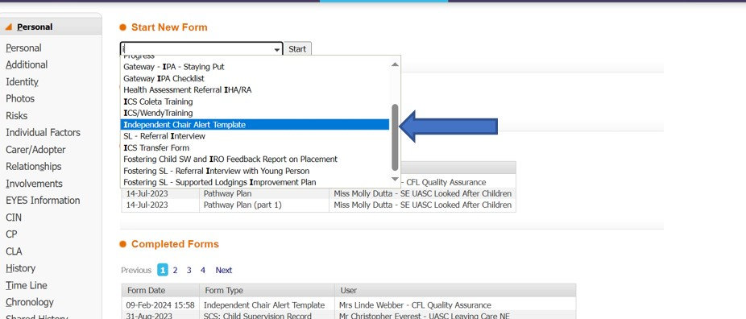



1. Click **PART 1: FOR COMPLETION OF INDEPENDENT CHAIR** tab within the form
2. Please complete all the relevant fields within **PART 1**
3. Please select the **‘person to complete part 2’** below the ‘Stage of alert’.(Look up for relevant operational manager in address book if needed) **.**

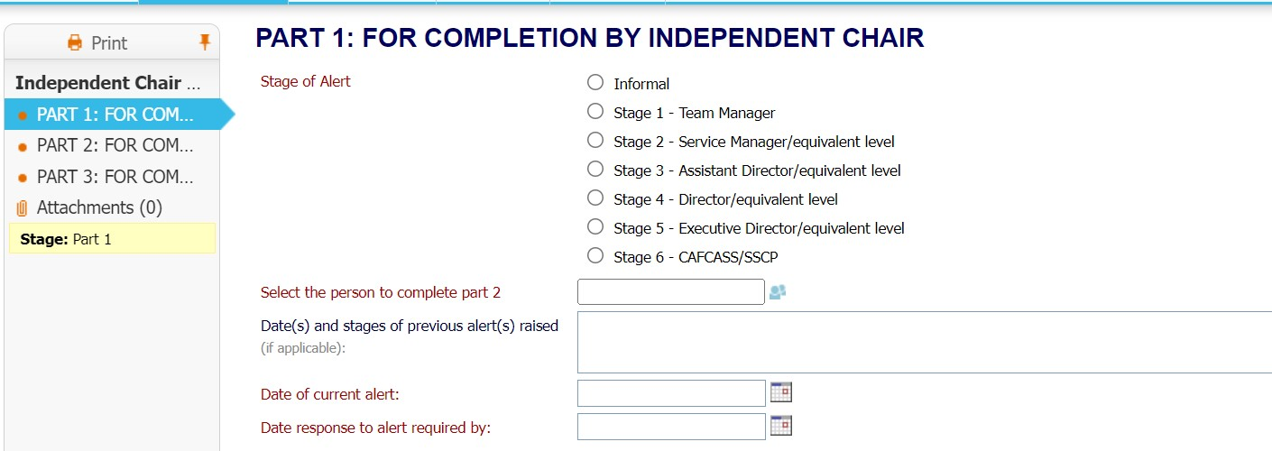

1. Click **Save** & **Send to Manager** to relevant operational manager to complete Part 2

Example of

completed

Part 1

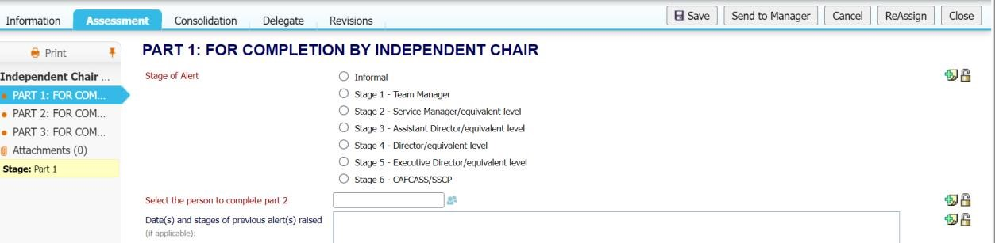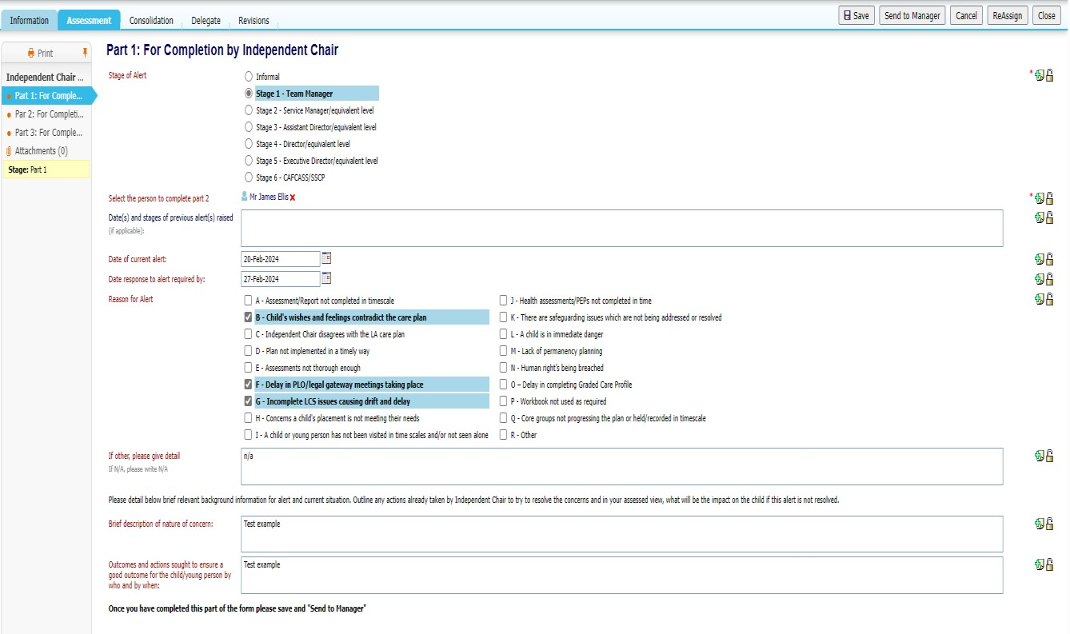

***Note****: The alert will now appear in the Team Manager’s tray where they can pick up the task and complete P2, please follow steps 6-8 below to see* ***Manager’s process****.*

7) Select **Independent Chair Alert Template** task from tray



1. Click **PART 2: FOR COMPLETION BY RELEVANT OPERATIONAL MANAGER** tab within the form

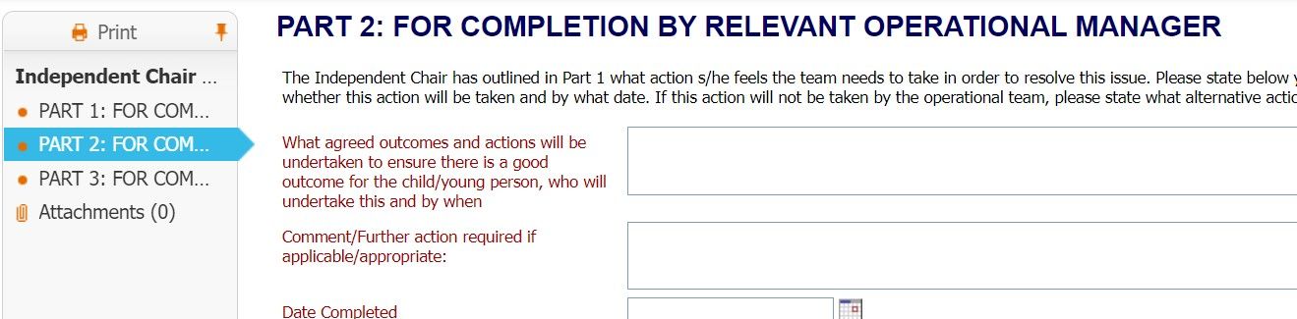

1. Complete all the relevant fields within **PART 2** and Click **Save** & **Send to Ind Chair** to Independent Chair to complete part 3.

The name of the manager who completes Part 2 will automatically populate in ‘Current User Name Signature’.

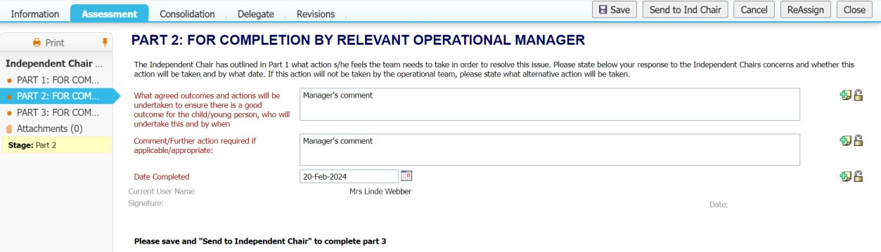

1. Select **Independent Chair Alert Template** task from tray



1. Click **PART 3: FOR COMPLETION BY INDEPENDENT CHAIR (P3)**

12)

Complete all relevant fields within

**PART 3**

and click

**Save**

&

**Finalise**

