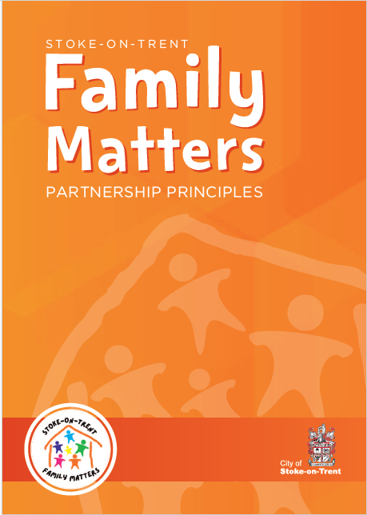
Appendix 3 Supervision Agreement
Tri x 1_1_9 (May 2025)
Review September 2025

City of Stoke on Trent Children’s and Families Services

SUPERVISION AGREEMENT
Between
and
Minimum frequency
Usual location
Anticipated duration

1. General
1.1 The main purpose of a Supervision Agreement is to establish a shared understanding and expectations regarding the arrangements between the people involved.
1.2 Supervision agreements are particularly useful at the start of any working relationship. The contents of any agreement should be drawn up in line with the Children’s Services Supervision Policy and Procedures -Supervision of Staff.

2. Commitment
2.1 The main purpose of supervision is to provide support in such a way to ensure that supervisees have the appropriate knowledge, skills, and experience to carry out their duties effectively and efficiently.
2.2 Each service area makes its own contribution to achieving Children’s Services objectives as laid out in Childrens Vision Room to Grow. Therefore, commitment to arrangements that have been agreed should be a responsibility shared between Supervisor and Supervisee and should form an agenda item in supervision from time to time.
2.4 Supervision sessions should be regarded as high priority and should be rearranged rather than cancelled except in those exceptional circumstances where they cannot go ahead as planned.
2.5 Colleagues should be aware that supervision sessions are not to be interrupted without good cause.

3. Agenda
3.1 Both Supervisor and Supervisee will agree an agenda at least at the beginning of each session.
3.2 Standard agenda items may include issues specific to the Supervisee.
3.3 For specific items requiring thought prior to supervision, a realistic period should be given by each party to consider these.
3.4 As well as job related issues, regular attention should be given to professional development and personal matters which may be discussed where appropriate and necessary.
3.5 Standard agenda items to include:
- Well-being
- Time off in lieu, annual leave, sickness
- Training and development
- Equality & Diversity
- Health and safety
- Caseload Discussion
- Workload Management.

4. Preparation for Supervision
4.1 Both parties have the right to expect that each person will come to the session prepared for the topics on the agenda.

5. Disclosure of personal matters
5.1 For example health concerns or those having a significant bearing on the supervisees capacity to work normally are likely to require discussion with the Supervisor’s Line Manager. Such discussions, wherever possible, should be had with the knowledge and agreement of the supervisee.

6. Supervision Record
6.1 A supervision record will be kept for each session. This will be written by _________________ and distributed within __________ working days. Both Supervisor and Supervisee should retain a copy of these records in a personal file.
6.2 Each party is asked to sign and date the record. Supervision records other than casework decisions will not normally be shared with a third party without the agreement of both parties.
6.3 Supervision records are the property of the City of Stoke on Trent Children and Families Services and in exceptional circumstances disclosure can be required if a performance or disciplinary issue arises concerning either party.
(Include arrangements to ensure minimum frequency level of supervision occurs while Manager is on annual leave or off sick).

7. Disagreements
7.1 Areas of disagreement between Supervisor and Supervisee will be recorded on the supervision records.
7.2 Areas of disagreement that cannot be resolved, including failure for supervision to occur at prescribed intervals, will be referred to the Principal or Strategic Manager.
Date of Agreement:
Signed
(Supervisor)
Date of Agreement:
Signed
(Supervisee)

