Freedom of Information Request Process
Children’s Social Care
June 2025
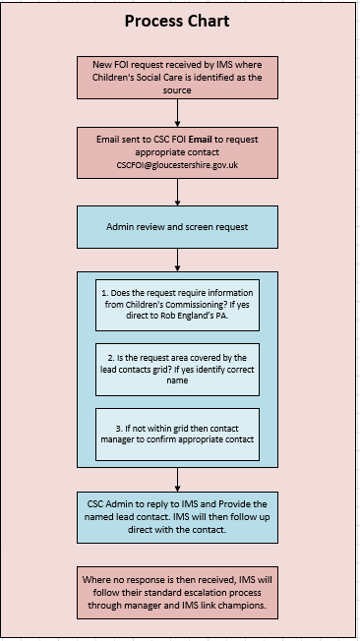

Lead Contact Grid
Service Area | Lead Contact | Second Contact
Fostering | Lisa Long | Tammy Wheatley
Children in Care | Jess Roberts | Deb Owen
Care Leavers | Mark Bone | David Stewart
Adoption | Jess Roberts | Tammy Wheatley
No recourse to public funds | Hannah Gregory | Gemma Main
Disabled Children | Nicky Wilson | Rhian Evans (Head of Disabled Children)
Unaccompanied asylum-seeking children | Mark Bone | David Stewart
Child Protection or Child in Need | Finbar Breeze | Rachel Townsend
Front Door | Claire Connolly | Charmaine Shaw
Youth Justice & Youth Service | Fiona Walker | Lynne Speak
Early Help | Emma Trigwell | TBC
Training & Academy | Eve McCarthy | Sally Dobson
Staffing | Tom Underwood | TBC
Finance | Suzanne Hall & Tom Underwood | Nic Westley & Michelle Evans
Residential | Dan Jones | TBC
Allegations Management | Eve McCarthy | Anna Gravelle (HoQ)

Document Control
This process went live April 2025 and will be reviewed initially monthly for 3 months and there after quarterly between IMS and Business Support.
Document information
Owner: | Head of Business & Resource (Children’s Services)
Author: | Tom Underwood
Last Reviewer: | Policy Governance Group
Date Created: | 01/04/2025
Next Review Date: | 19/09/2025
Approval: | Policy Governance Group May 2025
Version: | 2

Version | Version Date | Summary of Changes
1 | April 2025 | New Document
2 | June 2025 | Updated Lead Contact Grid

