Gloucestershire Children’s Social Care  Supervision Policy | 2025

- Our vision
Our vision is to work together to support families and communities to give every child the best chance of a happy and rewarding life, especially those who need more help. We are committed to working with the right children and offering the right support, at the right time, every time.
Our vision is underpinned by our practice standards and practice framework and our commitment to systemic practice principles, building on strengths and developing nurturing relationships with children, families and carers. Our expectation is that effective management oversight and supervision will drive forward and sustain high-quality practice.
- Supervision
We recognise the critical importance that good quality supervision plays in ensuring that all aspects of practice are good or outstanding. Managers at all levels of our service are responsible for creating the conditions that support good practice to flourish. Supervision has an integral role in supporting social workers and social care staff to recognise and respond to risk, develop confident practice and to access necessary challenge, direction and support.
Supervision has a number of different benefits for the child, family, practitioner, manager and the organisation, connecting management, development, mediation and support as set out in the 4 x 4 x 4 model:

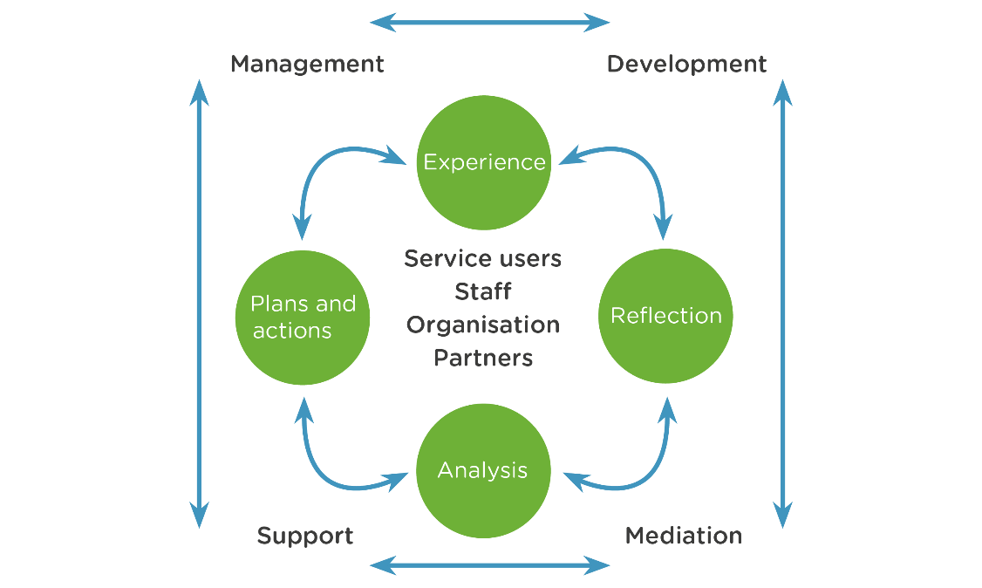

For children and families, these benefits include:

- Providing a safe space to reflect on what work has been done with a family, consider what impact this has had and plan next steps.
- Providing a safe, thoughtful and intentional space to focus on the child, explore the child’s life, their feelings, experiences, voice and barriers to progress.
- Drawing on shared knowledge and skills to agree plans to improve lives and sustain positive change.
- Reflecting on the needs of other members of the family such as parents or carers and how they impact on the child.
- Promoting anti-oppressive practice by safely offering challenge, exploring dilemmas, hypotheses and discussing bias through attention to multiple perspectives and experiences within family and professional networks.
- Ensuring that partners work together effectively and creatively to meet the needs of the child.

For the practitioner, supervision gives an opportunity for:

- Exploration of the practitioner’s experiences, skills, workload, capacity and resources.
- Exploration of risks, hazards and perceptions to help practitioners stay safe.
- Learning from successes and mistakes through giving and receiving constructive feedback.
- Encouragement to be curious and to try something new.
- Support for career development.
- Reflection on how they are working with partners to support children and families.
. For leaders and managers, supervision should:
- Provide an opportunity to develop supportive relationships with practitioners that promote clarity and a shared understanding of expectations.
- Provide opportunities for challenge, exploration of difference and different perspectives towards agreed and effective aims and actions.
- Provide an opportunity to monitor the welfare and development of their staff.
- Enable risks to be identified, explored and addressed.
- Ensure that staff work safely and that hazards are addressed.
- Ensure that we consider proportionality and that our intervention is purposeful and making a difference.
- Ensure that everyone is accountable for their work and supported to make and sustain improvements where necessary.

For the organisation, supervision should:
- Contribute to workforce stability by making sure that practitioners feel happy, motivated, supported and valued.
- Provide an opportunity for exploration and development of the culture of the organisation and the team
- Provide space to share and discuss key organisational issues and message

- Our Supervision Model
The 4x4x4 supervision model, developed by Tony Morrison, integrates the four objectives of supervision with the four functions of supervision. It emphasises and prioritises the holistic functions of supervision, including managerial, supportive, and developmental aspects.
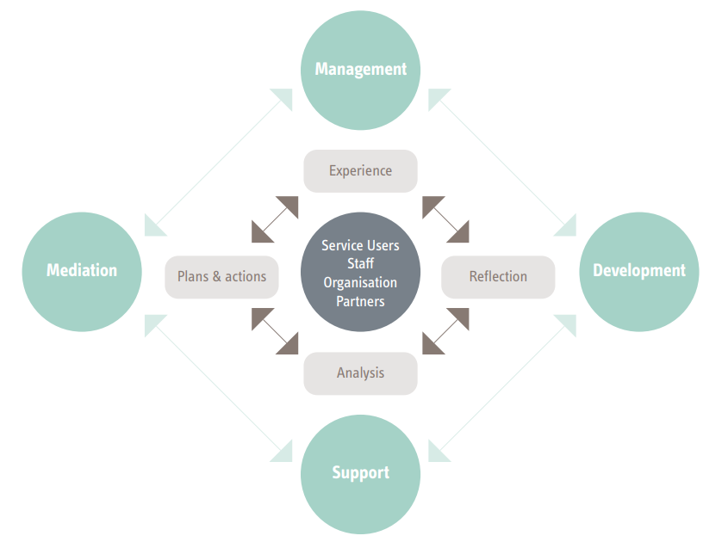
Morrison’s model provides a helpful structure for understanding and connecting the different roles and functions of supervision. It keeps children and their families at the centre of the model whilst encouraging us to consider wider stakeholders, including staff, the organisation and partners. Morrison’s model incorporates a reflective cycle and considers the range of interconnected and complementary functions that supervision should fulfil.
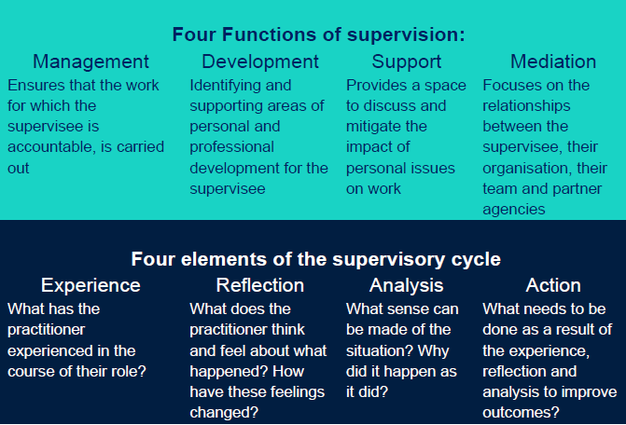

- Systemic practice and supervision
Our commitment to systemic social work and social care practice is reflected in our practice framework and standards. Supervision has a critical role to play in how systemic practice is implemented across the authority, and we expect supervision to reflect systemic principles and ideas.
Systemic practice privileges relationships, and how the relationship between a practitioner and their manager is of central importance in promoting and sustaining good practice. We want supervisors to reflect the importance we place on these relationships by prioritising and protecting time for regular, uninterrupted supervision with all practitioners.

Completion of the systemic supervision agreement:
- Managers approach to supervision should be underpinned by systemic ideas, including relational reflexivity, the social graces model and the importance of considering multiple perspectives. Our commitment to these ideas and the importance of them underpinning quality supervision is reflected in our supervision agreement. This agreement introduces and privileges systemic ideas at the outset of the supervisory relationship and provides the foundation for the use of systemic ideas throughout supervision.The agreement should always be completed collaboratively at the start of the supervisory relationship.
Encouraging and promoting systemic practice:
- Managers and practitioners should be supported to understand systemic ideas and how these can underpin good practice and support positive outcomes for children and families. We want managers to hold clear expectations of practitioners as reflected in our practice standards and framework. Some key ideas include the importance of relationships, first and second order change, social Graces, first and second order positioning, reflexivity, safe uncertainty, hypothesizing, multiple perspectives and curiosity. They can be accessed through this link Systemic Practice. Additional resources, advice and support can be accessed via the Social Work Academy
- These ideas should be used in practice to help us develop nurturing relationships that build on strengths and help us create positive change in partnership with children and families.
- Supervisory discussions will reflect these ideas and are an opportunity to ensure that practitioners are working with families, colleagues and partner agencies in ways that reflect our practice standards and framework.

- Group supervision sessions
Group supervision involves the use of a group setting to enable members to reflect on their work and develop a shared understanding of practice. By pooling skills, experience and knowledge, the aim of the session is to improve the skills and capability of both individuals and the group. The goal of the session may be to solve problems, plan work and set priorities, learn from others or make decisions.
Effective group supervision can result in rapid, more effective problem solving by drawing on the expertise of a group of people. It allows for learning from the diverse backgrounds and experiences of different social services workers, practitioners and partners, who may provide different perspectives on situations.
Group supervision presents an opportunity to address the concerns and issues of individuals and also an opportunity to develop teams.
Group Supervision
All teams will hold monthly group reflective supervision sessions. As a minimum this will align with team leaders’ (team manager and advanced practitioner) responsibility, under the QA Framework, to review the team’s audits from the previous month, through a thorough and reflective lens such that it builds shared learning.
Team leaders will add to this minimum in line with their self-evaluation and improvement planning for their teams. In this respect, the 3 Ofsted ILACS prompts (paraphrased) can prove particularly useful:
- How are we doing?
- How do we know this?
- What are we doing to improve?
Whilst group supervision offers a tremendous learning opportunity, it must be differentiated from other forms of quality improvement work delivered within/between teams.
More on group supervision, including models and tools can be found here.
Sharing in a group setting:

- Can give supervisees an increased sense of support by realising others have similar concerns
- Allows supervisees to find new and better ways of dealing with their own situations by listening to others
- Can allow supervisees to explore different ideas about how they will solve problems by obtaining a range of feedback from others about issues or concerns
- Provides a safe environment where individuals can discuss their limitations and problems without criticism – some individuals may find that they are more confident about opening up in a group situation than in a one-to-one situation
All teams will hold monthly group reflective supervision facilitated by an Advanced Practitioner. This session can take number of formats and may include reflection on work with a particular family, reflection on findings from quality assurance activity or another activity rooted in systemic ideas.

- Observation of practice
Each year all practitioners should have at least one practice observation completed by their supervisor. The observation will depend on the role of the practitioner but should reflect their day-to-day work and could incorporate a home visit, presentation at conference/meeting, attendance at Court or direct work with families. Supervisors/managers should ensure that the date of observation, as well as feedback and learning from this using the observation template (see resources below).
- Preparing for Supervision
For supervision to be effective, both the supervisee and the supervisor need to be prepared.
For the supervisor, preparation should include:
- Ensuring sufficient time and suitable physical space is available for supervision.
- Identifying which children need to be discussed.
- Familiarising yourself with up-to-date information about the quality of the practitioner’s work, so you can give feedback about strengths and areas for development.
For the supervisee, preparation should include:
- Reflecting on your work with each family and identifying any children that need to be discussed as a priority outside the usual schedule.
- Preparing updates for each child to be discussed - this should include progress of the work being completed as well as key dates such as when the child was last seen, plan last updated, PEP completed etc.
- Identifying any work that is at risk of being completed outside statutory timescales.
- Reviewing actions agreed at the last supervision session and preparing an update on completion.
- Reflecting on your performance and identifying any areas of development/learning.
- Frequency of Supervision
Expectations of supervision frequency vary according to the needs of the child and are laid out in our practice standards. The following minimum frequencies apply.
N.B It is important to emphasise that these standards represent the MINIMUM expectations. Social workers and other case holders have responsibility for continuously assessing risk and need for the children they support, and if they identify a situation which needs an early or urgent discussion, then they should not wait for a scheduled supervision, but should talk to their manager straight away, and this should be recorded as supervision or management oversight on the child’s record. Additional advice and support is also accessible from the Advanced Practitioner.
This approach has two key aims:
(i) to ensure that allocated case workers take responsibility for the continuous and dynamic assessment of risk to children they are working with.
(ii) to support practitioners to develop autonomy and confidence in their practice, seeking management oversight support and direction where needed to reflect on practice or validate decision making.
Area of service | Minimum frequency
Children open to Families First Early Help | 3 monthly
Children open for assessment | Assessments should be reviewed at day 8 and day 20 by the worker and their manager
Children in need | 3 monthly
Children subject of a child protection plan | 2 monthly
Children subject of care proceedings | 2 monthly
Children in care | 2 monthly/3 monthly when long term matched
Children receiving short breaks | 3 monthly
Care leavers | 3 monthly
Children receiving adoption support | As per children in need, 3 monthly

Social work students and apprentices:
Social work students and apprentices are offered supervision on a weekly basis, for a minimum of 90 minutes per week. Week 1 is with their Placement Supervisor with a focus on their practice with children and families and week 2 is with their Practice Educator, which has a focus on learning and development. Supervision agreements should be completed with both the supervisor and educator in line with this policy as well as the relevant university. Students are also offered and encouraged to attend a peer-reflective group once a month, facilitated by the Social Work Academy.

Newly Qualified Social Workers:
During the Assessed and Supported Year of Employment (ASYE), newly qualified social workers will have increased supervision for the first 6 months.
0-6 weeks | 6 weeks – 6 months | 6 months onwards
Weekly | Fortnightly | Monthly

- Supervision Recording

Discussions about children and young people need to be recorded on the child’s record. The supervisor is responsible for recording supervision sessions, updating the child’s record and sharing supervision notes with the practitioner. The practitioner should check the accuracy of the records and raise any discrepancies with their supervisor.
Supervision notes should be completed and shared with the practitioner and added to the child’s record within 5 working days. In some situations, it is important to ensure that decisions are recorded on a child’s record sooner than 5 days. Managers should use their professional judgement to identify where information needs to be recorded sooner and ensure that this is added to the child’s record.
Discussions about learning, development and performance are an important part of supervision. Confidential information about practitioners could form part of this discussion and so should be stored on the OneDrive of the manager. Names of personal details of children and their families will not be recorded in professional supervision notes. However ID numbers may be used. Disagreements should be recorded together with proposed activities to resolve or escalate as required.
- Personal or Wellbeing Supervision Recording:
The capacity of professionals to remain resilient within their role depends on effective supportive systems being in place to enhance the emotional wellbeing, practice skills and confidence of the practitioner.
Personal supervision should be person-centred, an opportunity for supervisee and supervisor to spend time together in a safe space to build a trusting relationship to discuss how things are going in relation to the supervisee’s personal wellbeing (both at work and home), their personal development and progress and role and responsibilities. The relationship should focus on good communication, openness, transparency and flexibility between supervisor and supervisee.
This form of supervision should provide restorative and reflective, supportive opportunities to address the emotional demands on staff and support them to build resilience levels, reducing stress and burnout. This means that supervision should be a safe place for workers to reflect on their practice and the impact this has on their feelings and perspectives. It should also help workers to explore their thoughts and experiences in a non-judgmental environment. This will help provide opportunities for professional growth and help strengthen decision making,
Sessions should be pre-arranged, regular and take place in a confidential space. They should be prioritised and only moved or cancelled in exceptional circumstances.

- Confidentiality and Retention
There are circumstances where it may be necessary for supervisors to discuss information gained from supervision with senior managers. Supervision records may be released for the purpose of monitoring the quality of supervision or used as documentation in disciplinary or legal proceedings. Supervision records are the property of Children's Services. Where issues of a sensitive nature are contained within a supervision record, the confidentiality of such material should be protected in line with the Data Protection Act (2018).

- Resources

Children’s Services Supervision Agreement

Supervisee:
Line Manager/Supervisor:
Team:
General Principles

- Supervision can be face to face or as a virtual meeting as agreed between both parties
- Supervision should take place at least once every calendar month
- Cancellation or interruption should only occur in the event of an operational or personal emergency. If supervision is cancelled it should be rearranged as soon as possible
- Supervision should take place in a private confidential space
- Any disagreements or disputes should be openly discussed between the practitioner and supervisor. If they cannot be resolved, then the supervisor’s line manager, should be asked to assist in resolving the differences between both parties
- Previous supervision notes should be brought to each supervision.
- Where supervision records are typed by someone other than supervisor, this needs to be discussed and agreed

What I would find helpful from you as my supervisor and what I will
contribute as a practitioner:
What I would find helpful from you as the practitioner and what I will contribute as a supervisor:
Anything either the practitioner or supervisor should try to avoid:
Signature of practitioner:
Signature of Line Supervisor:
Date agreement completed:
Review date (to be reviewed annually):

Direct Observation of Practice Record

Name of Practitioner:
Name of Observer:
LCS Number:
Date, venue and nature of observation:
What worked well, including any good practice observed:
What could have been done differently:
Service user feedback: (If possible, seek feedback from the service user about how they experienced the observation and their relationship with the practitioner)
Practitioners reflections on how the observation went:
Learning points and actions: (To be discussed in subsequent supervision session)
Signature of Supervisee:
Observer’s Signature:

Personal Supervision Record

Name of Supervisee:
Name of Line Manager/Supervisor:
Team/Area:
Support
(Personal safety, wellbeing, sickness absence and leave)
Things that have gone well since the last supervision session (Positive feedback, good examples of practice, workplace relationships that are supportive etc)
Reflection (Dilemmas, practice issues and workload)
Learning and development (What are the priorities to further develop skills and knowledge? What progress has been made on the actions agreed at appraisal? What feedback has been obtained from service users or via direct observation recently?)
Review of actions from previous session:
Action |  | Progress made
Actions to take forwards:
Action | Person responsible |  | Timeframe
Signature of practitioner:
Signature of Line Manager/Supervisor:
Date supervision completed:
Date of next supervision:

Group Supervision Record

Date of session:
Team:
Names of people involved in the group supervision:
Lead person for this session:
General terms of reference for the group supervision:
Focus of discussion:
Any dilemmas or practice issues discussed:
Review of any actions from previous session:
Action |  | Progress made
Actions to take forwards:
Action | Person responsible |  | Timeframe

Document control:

Title of document | Supervision policy
Author’s job title | Service Director – Safeguarding and Care (PS)  Head of Quality (AG/CW) and Principal Social Worker (RT)
Document version | Version 2 (May 2025)
Supersedes | Version 1 (October 2022)
Date of adoption
Review due date
To be stored on | Online procedures/local resources/

Version control:

Version | Date | Reviewer | Changes made
2 | 04/07/2025 | Policy Governance Group May 2025 | Amended authors

