July 2025
GLOUCESTERSHIRE COUNTY COUNCIL
SINGLE ASSESSESSMENTS PRACTICE NOTE
SINGLE ASSESSESSMENTS PRACTICE NOTE
Our practice with children and families is rooted in the principles of relational and systemic practice. For those families who are involved with an assessment the Anchor Principles the Risk Review Principles and the Management Oversight Principles underpin our work. These set out the recording and practice detail in relation to expectations within single assessments.
Agreement to cancel an assessment following referral
Assessments may be cancelled in the following circumstances with oversight from the Team and Group Manager.
- Young Person over sixteen not consenting to an assessment for themselves.
- Family have moved out of county.
- Unborn baby where birth mother has experienced a termination, miscarriage or still birth.
- System problem (assessment opened in error).
- Consent Gained and Withdrawn without a visit.
If MASH obtain consent, and the family subsequently change their mind or feel that this is not required, prior to a visit having been undertaken, the team will record conversations within case notes and record management oversight on the file. This will contain rationale for not considering a strategy discussion and which services the family have been advised to contact for support. This will be reviewed by the group manager who will record their own oversight on the file.
Completion of an assessment following a visit
If, following the initial visit or subsequent visits, the family withdraw their agreement to an assessment the information gathered so far should be recorded on a single assessment format. The assessment should clearly record the fact that the assessment is ‘partially complete’ and the rationale for not considering a strategy discussion and which services the family have been advised to contact for support. Management oversight should be added to Case Notes to ensure the rationale is clearly recorded. The Single Assessment should be sent to the family for their record of our involvement.
When consent is not gained by the MASH
When MASH receive a referral and identify Level 4 indicators but are not able to establish contact with parents to discuss the concerns or to explore consent, they will send this to the locality teams clearly indicating that parental consent has not been gained. The locality team will undertake to establish parental consent. Should the parents/carers decline support the Team Manager will review the Level 4 indicators and determine whether a strategy needs to be convened or close the referral with signposting and advice to the family of what support services are reccomended. The management oversight should be clearly recorded in case notes.

Single Assessments opened in other circumstances:
In the scenario that an assessment is triggered as part of a section 47 enquiry, but this is felt to be not required by the team manager, this will be cancelled by the team manager who will record their rationale in a case note using the management oversight principles. This should be in exceptional circumstances such as an assessment was concluded within the past month and there has not been any significant change in circumstances.

Specific Privacy Notice
Our lawful basis for collecting your information is Public Task under the Children & Families Act 2014. This means that we have a number of statutory responsibilities, powers and duties which require us to carry out tasks and deliver services. We will ask for your agreement to this assessment, if you withdraw your wishes at any point we will cease the assessment immediately. Any information collected as part of the assessment from that point will be able to be requested and a copy from our records will be shared with you.
We recognise that you may not always agree with what is written and we will review your request and rectify any facts that are not accurate and include your views if you disagree with the assessment.
Proposed wording for social workers undertaking a single assessment prior to the assessment beginning.
In order to understand the best way to help and support your family children’s social care will work with you to complete an assessment. This involves visiting you in your home and speaking to you and your children, it will also include with your agreement for your social worker to have conversations with other professionals involved with you family. The written assessment will be completed within forty-five workdays, which is around nine weeks. Before the assessment is finalised you will have the opportunity to comment on what your social worker has said.
Your assessment will begin with an initial visit from your allocated social worker who will talk to you about the assessment and what it will cover. You will get a written leaflet that has more information about the process, but your social worker can answer any questions you might have. The best assessments are those that include the views of you, your family and support network so we will work to establish a collaborative relationship with you all so that we achieve this together. If following this initial visit, you decide not to participate in the assessment your child or children’s casefile will be updated to reflect this decision. The social worker will let you know what might happen next. If you agree to the assessment following this initial visit, we will arrange to meet with you and your child/children to continue and finish the assessment. If, once the assessment is started, you decide that you do not want to complete the assessment then the social worker will write up the information that they have already gathered within a single assessment format and share this with you. The assessment will clearly record that this is not a completed assessment and that you have decided to withdraw your agreement to the assessment. This partial assessment will be shared with you for your comments and agreement.

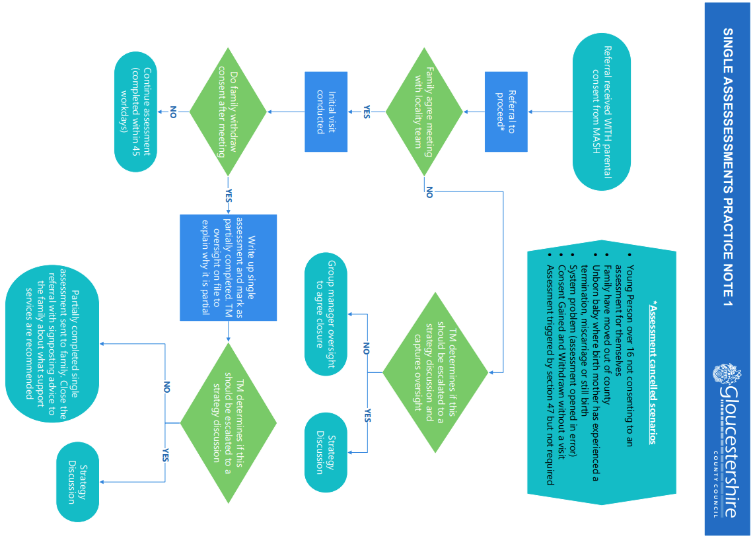

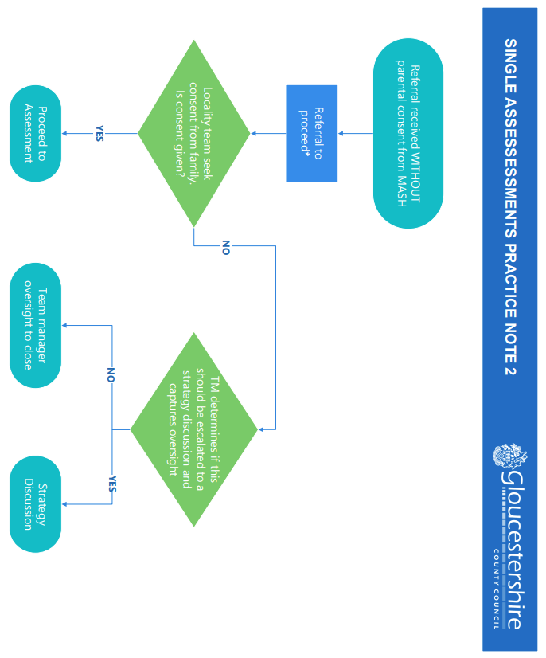
Document Control
Document information
Owner: | Naomi Adams – Assistant Director North Gloucestershire Cheltenham, Tewkesbury and the Disabled Children’s Service
Author: | Naomi Adams & Miranda Rigley
Last Reviewer: | Policy Governance Group
Date Created: | 01/07/2025
Next Review Date: | 01/07/2026
Approval: | Leadership Meeting 01/07/2025
Version: | 1-1

Version | Version Date | Summary of Changes
1 - 1 | July 2025 | Document reviewed and flow diagram created

