



Allegations and Standard of Care Policy

Guidance for Foster Carers and
Children’s Services Staff



Contents

1. Allegations and Standard of Care Process – Flow Charts

2. Introduction

3. Jargon Explained

4. Understanding an ‘Allegation’ versus a ‘Standard of Care concern’.

5. Allegation and Standard of Care concern process FAQs

6. Advice and support for Gloucestershire Foster Carers during the allegation process

Appendix

Allegations Toolkit

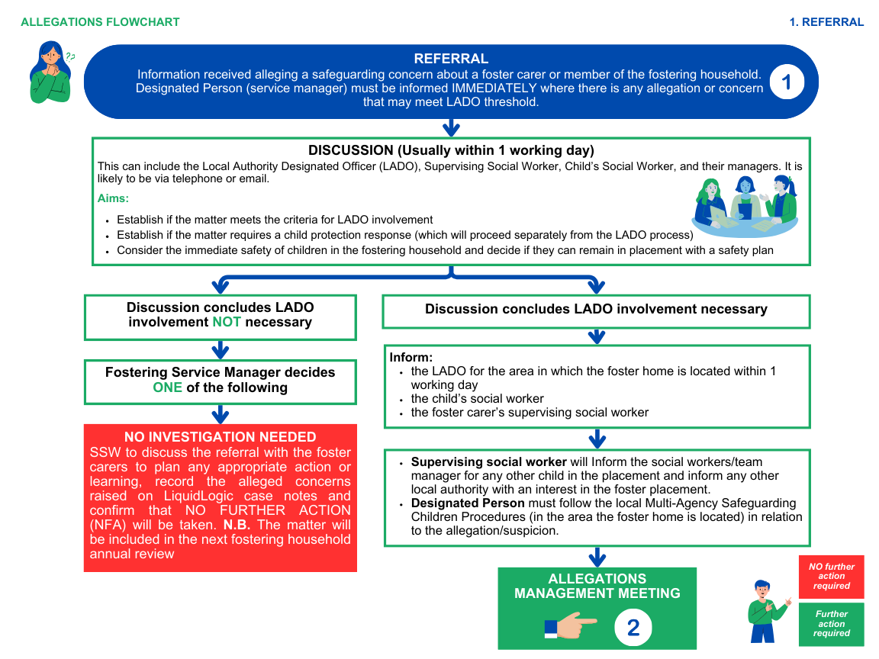
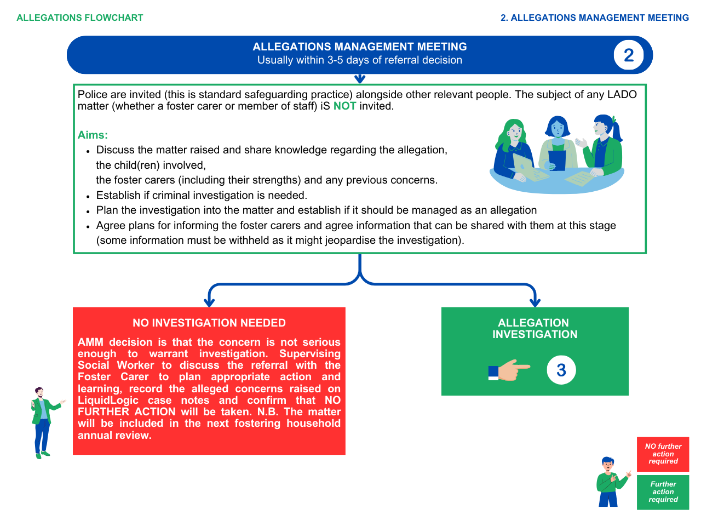
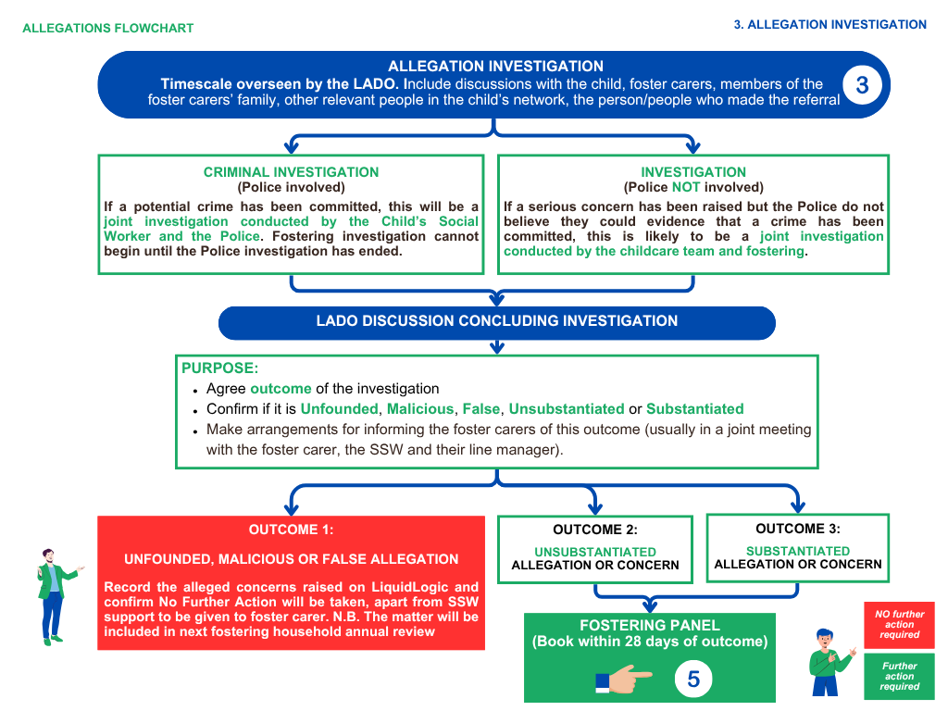
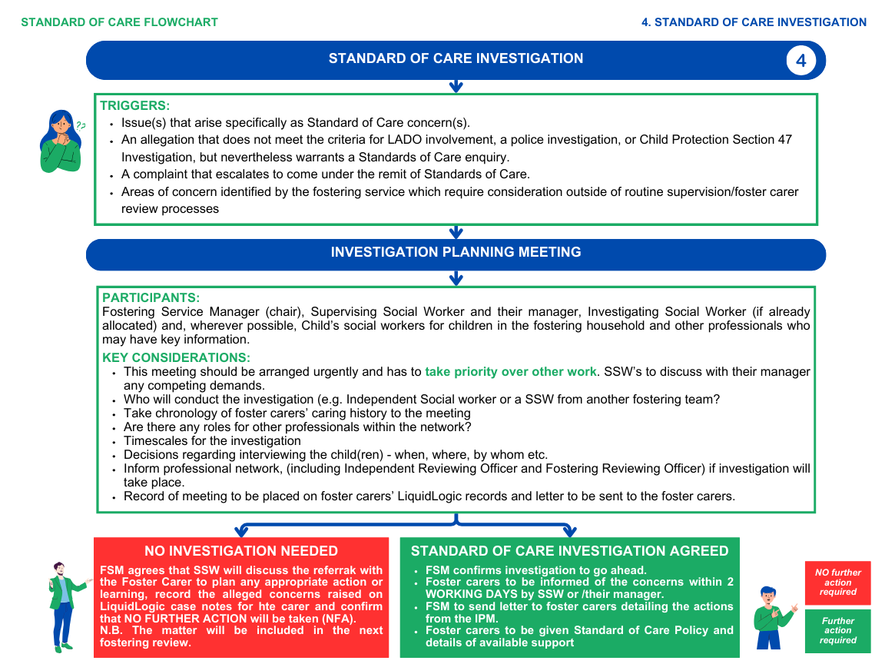
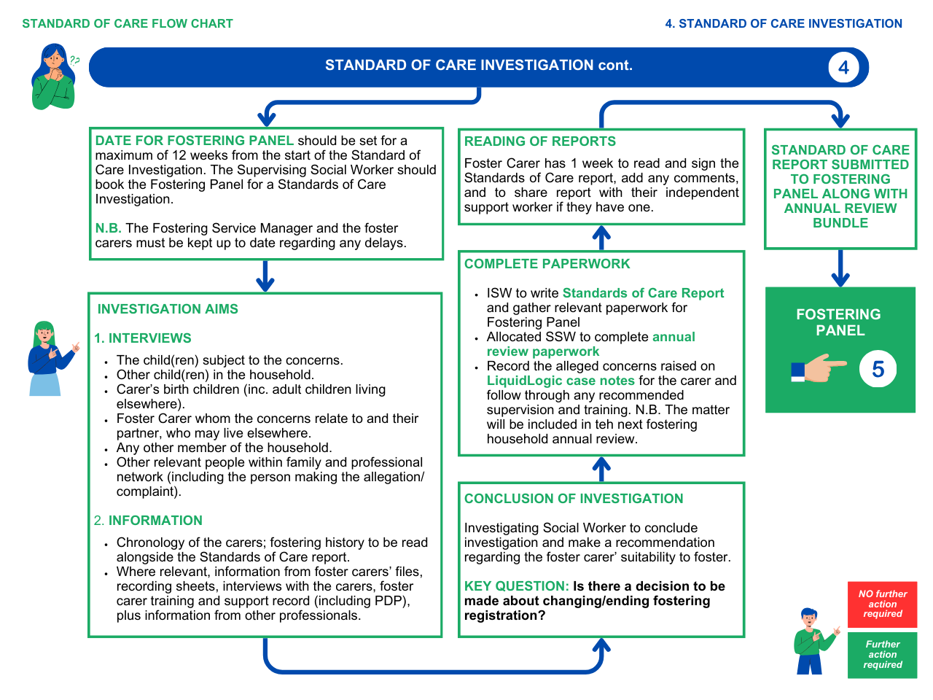
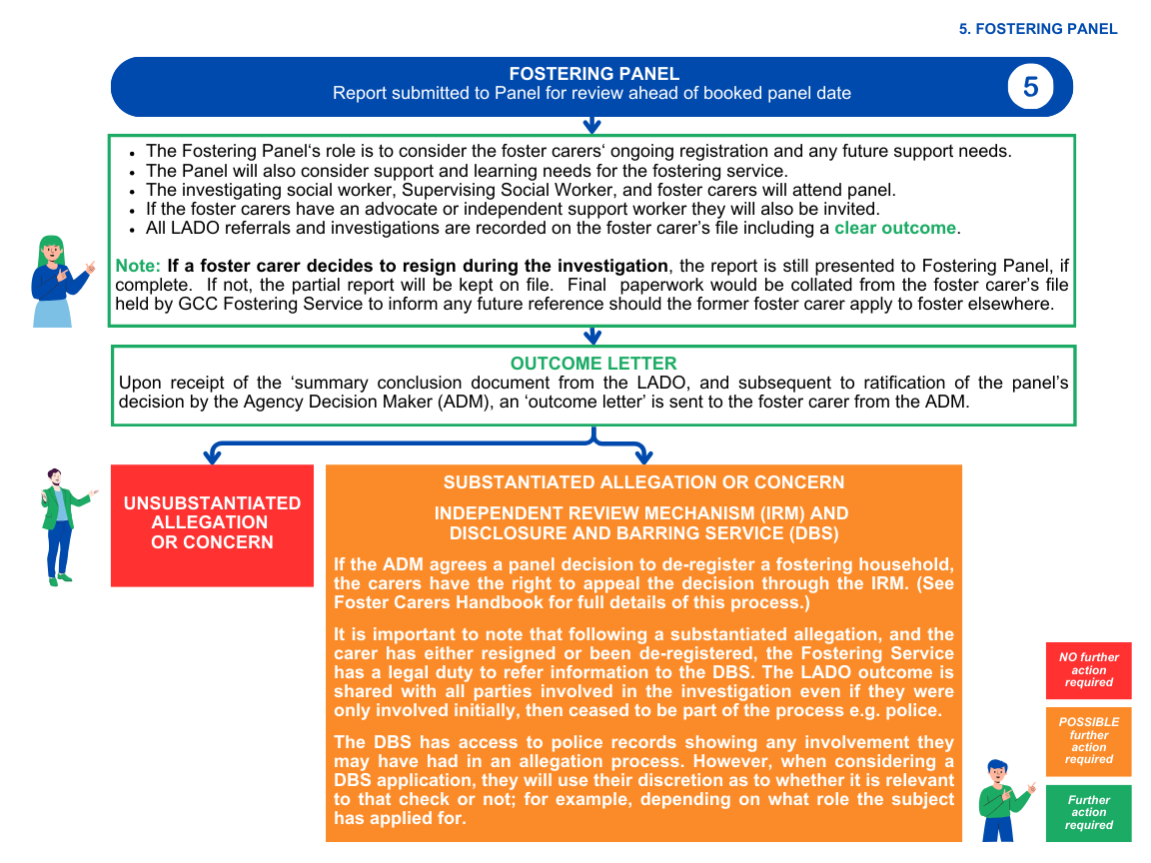

2. Introduction
Foster carers provide vulnerable children and young people with emotional and physical warmth in the privacy of their own homes. Whilst this is an essential part of this unique and invaluable role, it does leave foster carers or members of the fostering household particularly vulnerable to allegations. Indeed, foster carers are unlikely to have a fostering career without facing the challenge of an allegation or standard of care concern at some point in time. The welfare of the child should always be the paramount concern, and it is vital that children’s needs remain at the centre of thinking and decision-making throughout. All children are entitled to the same level and standard of protection from harm, including those receiving services from statutory or other agencies. For this reason, enquiries and investigations relating to allegations against foster carers must be dealt with under the local Gloucestershire Safeguarding Children Procedures.
Anyone working with children is vulnerable to having allegations made against them. Many children who come into care have been abused or neglected prior to entering care which may increase the risk of them making allegations. They may also be more vulnerable to abuse.
It must also be acknowledged that children in care may have been abused by people in positions of trust, such as their caregivers and this can include their foster carers. Allegations may also be made against other members of the fostering household/family; in these cases, the foster carer(s) may still be subject to investigation. When an allegation is made against a person in a position of trust, the local authority has a legal duty to investigate and to ensure that children are safe. Although this is a necessary process, we fully understand that it puts the foster carer and their family under emotional strain.
We understand that the impact for foster carers or members of the fostering household, even when an allegation is ‘unfounded’ can be profound. It is recognised that a perceived lack of information about the allegation itself, the investigation process, and the support which carers or members of the fostering household are entitled to, can lead to frustration and distress for the fostering family.
This guidance aims to provide the information Gloucestershire County Council staff and foster carers need to understand what will happen if an allegation is made against a foster carer, but also details what support is available to foster carers when an allegation or ‘standard of care concern’ is made.
This policy document has been written in an easy-to-read format to aid understanding; but at times, due to regulatory requirements, is technical.

3. Jargon Explained
LADO | Local Authority Designated Officer. This is a safeguarding officer who is responsible for managing all allegations against people working with children in trusted positions; e.g., teachers, nursery workers, social workers, foster carers etc. The LADO will oversee all allegations against foster carers.
Section 47 | Child Protection Enquiry carried out under Section 47 Children Act 1989
Strategy Discussion | A strategy discussion is a decision-making process to establish if an allegation needs to be referred for a S.47 Enquiry. It will usually involve the police, the local authority, and the fostering service. It is standard procedure not to invite a foster carer if an allegation is about them, but they will be informed about the outcome.  Child Protection Enquiries (Section 47) (proceduresonline.com)
LADO  Discussion/ Allegations Management Meeting | This is a multi-agency meeting to share information and make recommendations following an allegation being made against a person in a position of trust.
ADM | Agency Decision Maker. The ADM Is the person in the Local Authority who is responsible for making decisions about the registration of foster carers. All decisions about registration must be ‘ratified’ by the ADM.
IRM | Independent Review Mechanism. A service that considers appeals about registrations if foster carers disagree with the ADM decision.
NMS | National Minimum Standards e.g. for Fostering, created by the Department for Education.  https://www.gov.uk/government/publications/fostering-services-national-minimum-standards
Regs | Fostering Regulations  https://www.legislation.gov.uk/uksi/2011/581/made

4. Understanding an ‘Allegation’ versus a ‘Standard of Care concern’.
The fostering service must make a clear distinction between an investigation into allegations of harm and discussions over standards of care. Investigations which find no evidence of harm will not become procedures looking into poor standards of care - these will be treated separately.
The Children Act 1989 Guidance and Regulations Volume 4: Fostering Services

4.1 Allegation
Any allegation made by a child must be taken seriously and investigated, since it is of the utmost importance to keep children and young people safe.
However, foster carers do face a risk of being the subject of false allegations and this can be extremely traumatic for those involved and their families. Allegations may result in the removal of the child who made the allegation and potentially other foster children in the household. Unfounded allegations therefore affect not just of the fostering household but also the placement stability of foster children.
The Children Act 1989 Guidance and Regulations Volume 4: Fostering Services
Allegations or suspicions that a foster carer has caused harm to a child will be shared with the appropriate agencies, investigated thoroughly, speedily and sensitively under those procedures and in accordance with the relevant statutory guidance such as Working Together to Safeguard Children, and will involve open and honest communication with and support for all those affected.
The threshold for an allegation that is considered by the LADO is wider than those in which there is reasonable cause to suspect a child is suffering, or likely to suffer, harm.
The LADO threshold is where people are working (NB in fostering this includes members of the fostering household) or volunteering with children in a position of trust, and have:
- Behaved in a way that has harmed a child or may have harmed a child;
- Possibly committed a criminal offence against, or related to, a child;
- Behaved towards a child or children in a way that indicates they may pose a risk of harm to children;
- Behaved or may have behaved in a way that indicates they may not be suitable to work with children.
Whilst some behaviours may not constitute a criminal offence, and some may not reach the threshold of ‘harm’, consideration will need to be given as to whether they may indicate unsuitability to work with children.
The Fostering National Minimum Standards require:
22.6) Allegations against people that work with children or members of the fostering household are reported by the fostering service to the LADO. This includes allegations that on the face of it may appear relatively insignificant or that have also been reported directly to the police or Children and Family Services.
Given the high threshold of allegations (versus standards of care concerns) in exceptional cases where immediate action may be necessary to safeguard the welfare of the child, the child's social worker and their manager may decide a new placement should be identified for the child in question and other children placed in the household (Note: this may be with an alternative fostering agency).
Concerns may arise due to the person’s behaviour as a carer or outside of this role.
If concerns arise about the behaviour of a carer the police and/or Children’s Services will need to consider if there is any further action required, including the possibility that a Child Protection Conference may be convened in relation to their own children.
The police and/or Children’s Services will also consider what implications there may be for fostered children in the household. Anyone in a foster family or their extended network may be accused of harming a child, including the foster carer’s own children.
When an allegation has been made against a foster carer, they should be given the opportunity to respond to the allegations before any final decision is made about necessary action to protect the child and other children in the household. Such protective action may include asking the person against whom the allegation has been made to leave the household while the investigation is conducted.
A strategy meeting or an Allegations Management meeting may be held where this is the best vehicle for sharing information and making recommendations. Typically, those invited to this meeting would be police, the Fostering Supervising Social Worker and manager, the Child’s Social worker and manager, though others relevant may also be invited. There will always be a representative from the Fostering Service present.
Please note: Foster carers sometimes have a dual role; they could be employed in a school, nursery, run a child-minding business, have a voluntary position within a children’s sports club or some other occupation working with children, young people or vulnerable adults, as well as being a foster carer for the local authority. Foster carers should ensure that they advise other employers or organisations they are working with that they are also foster carers. They should also advise their Supervising Social Worker if they are working or volunteering with children, young people or vulnerable adults in any other capacity.
If a foster carer is the subject of an allegation or a concern is raised about them in another capacity, it is their responsibility to notify their Supervising Social Worker straight away; in some circumstances but not all, this may affect their ability to foster children and young people and could lead to a parallel investigation by the Fostering Service.

4.2 Why are allegations made?
Allegations can be made when:
- a child has been abused or harmed by their foster carer or by a member of the household.
- there has been conflict or a confrontation between carer and child, including where it has been instigated by the child.
- a child makes links between abuse that has taken place in the past and their current care giver.
- a child may feel the need to gain control, initiate a move to another foster home or a return home.
- the child’s birth family may wish to gain control or disrupt the placement.
- a child misinterprets actions of the foster carer, such as an arm around their shoulder to stop them from running into the road or to prevent them having some form of accident.

4.3 Standard of Care concern
A ‘Standard of Care concern’ is a matter , not of a child protection nature, that the care provided to a child does not meet the standards expected of a registered foster carer (National Minimum Fostering Standards 2011, Standard 22). Concerns can relate to apparently small incidents that may be explained as mistakes or temporary lapses in standards. However, if they are severe or persistent, the fostering service would work with the carer to address the concerns, and where necessary review their suitability to foster. A ‘Standard of Care’ concern/s will usually be investigated by Gloucestershire’s Fostering Service as an internal fact-finding investigation.
A Standard of Care concern may be made by the child, or by someone acting on their behalf, such as a birth parent, teacher, or social worker.
Every local authority has a duty to investigate ‘allegations of harm’ as well as a duty to investigate any alleged ‘Standard of Care concerns’. Allegations are managed through our safeguarding procedures and are overseen by a Gloucestershire Local Authority Designated Officer (LADO). Standard of Care Investigations are overseen by the Fostering Service Manager.

4.4 The differences between an Allegation and a Concern / Why are Standard of Care concerns made?
It might not be clear whether an incident constitutes an 'allegation'. It is important to remember that to be an allegation the alleged incident has to be sufficiently serious as to suggest that harm has or may have been caused to a child/ren or that the alleged behaviour indicates the individual may pose a risk of harm to children (or otherwise meet the criteria above).
Concerns that do not meet this threshold may constitute conduct or disciplinary issues and should be addressed using the appropriate organisational procedures via routine supervision and support; or can be considered as a full Standard of Care investigation depending upon the nature of the concern / concerns.
Incidents which fall short of the threshold could include an accusation that is made second or third hand and the facts are not clear, or the individual alleged to have done this was not there at the time; or there is confusion about the account.
Concerns may be raised when:
- when a foster carer has not provided a child with the standard of care expected of a registered foster carer under fostering regulations and GCC’s guidance.
- when there are different standards and expectations of care between fostering households.
- when others in the child’s network e.g. birth family, social workers, child’s school do not agree with aspects of the care provided by the foster carer.
- when a child does not agree with aspects of parenting provided by the foster carer.
- Does the child or family want to report the incident to the police or would they prefer the matter to be dealt with by the employer?
- when a foster carer behaves in a way that contravenes what is expected of a registered foster carer, as set out in the Foster Carer Agreement.
- During an incident was a disproportionate or inappropriate response provided by the foster carers in the context of a challenging situation?
- Where the incident involved an inappropriate response to challenging behaviour, had the carer had training in managing this; but not used the training?
- Does the carer understand that their behaviour was inappropriate and express a wish to behave differently in the future? For example, are they willing to undergo training?
- Poor environmental standards in the fostering home.
- Concerns about the presentation of children in the fostering home e.g. diet, clothing, hair care etc.
- Inappropriate use of language.
- Financial mismanagement.
- Ongoing disagreements, arguments, conflict etc. This could be with family members, the fostering service or in respect of the foster children or their birth family.
- Concerns that despite support and training, the foster carer is unable to demonstrate emotional warmth.
- Thoughts on something to do with behaviour, parenting etc.?
- The foster carer has failed on multiple occasions, despite support and advice to follow the missing from care process and report when a child is missing in their care.
- The foster carer routinely misses foster carer supervision, will miss appointments for the children in their care, does not maintain foster carer recording and or does not attend expected foster carer training.
Sometimes concerns fall very clearly in to one of the above categories. At other times, especially if the issue(s) is complex, it is not immediately clear whether the matter falls under Allegations or ‘Standard of Care concerns. It should be noted that the above is not an exhaustive list but reflective of matters which may need to be considered as part of the Standards of Care process.
As part of good practice, it is expected that the fostering service will have first attempted to support the foster carer to address the concerns; this could be via supervision or in the format of a more formal action plan. If following these actions concerns are still present, then this is when progression to consideration of an Investigation planning meeting would take place.

4.5 Complaints
A third, lower-level type of concern is a ‘Complaint’, defined as ‘an expression of dissatisfaction or disquiet in relation to an individual child or young person, which requires a response.’ Complaints could be made about foster carers’ behaviour, actions or inactions in relation to a child.
The Complaints policy, can be found here Complaints and Representations (proceduresonline.com)

5. Frequently asked questions about the Allegation and Standard of Care concern process
The allegations investigation process from referral and discussions, through LADO process to a conclusion, and what happens next, is described in the ‘Allegations flow chart’ on page 4 of this document.
The ‘Standard of Care Flow Chart’ can be found on pages 5 and 6 of this document.
Below are some questions which often arise during the allegations and / or standard of care process.

5.1 In the event of an allegation, what will I be told and when?
Unless there are circumstances when the details or nature of the allegation cannot be shared immediately, you will be advised of the allegation as agreed at the Allegations Management Meeting. If an allegation is made against you or a member of your family, you will be notified both verbally and you will receive this in writing as well.

5.2 Will the police be involved?
The fundamental objective of safeguarding procedures is to ensure the welfare of the child is protected. The initial strategy meeting/discussion is convened by the children’s social work team with the police to decide whether the police will undertake a criminal investigation. Generally, the police will only investigate if they believe a criminal offence has or is likely to have been committed.
It is important to note that, although there may be insufficient evidence to support a Police prosecution, this does not mean that action cannot be taken to protect a child nor that the termination of a foster carer's approval cannot be considered.

5.3 Who will be interviewed as part of the investigation?
Whether it is an Allegations or a Standard of Care Investigation it is good practice for the child who raised the concern, or who the concern is about, to be interviewed as soon as possible. This would usually be arranged via the child’s social work team.
It is also good practice for the person(s) to whom the allegation or concerns relate to also be interviewed, whether they are foster carers, or members of the foster carers’ family.
This gives everyone chance to give their account and the investigating worker an opportunity to gain a full picture of what has occurred. This will be discussed at the start of the investigation. If the foster carers have an advocate (see Advice and Support for GCC Foster carers during allegations), they may choose to have their advocate present for interviews.
Please note: if an allegation is being investigated by the police, then it is usual practice for the police to request that details of the allegation are not shared with the foster carers until the police have interviewed them.

5.4 Will elements of diversity be discussed?
It may be that the child, or the person whom the allegation/concerns have been made against, has disabilities or communication needs. There may also be relevant factors relating to ethnicity, culture, religion, or sexuality that need to be taken into consideration. This will be considered at the start of the investigation.

5.5 How long does it take to resolve an allegation or ‘Standard of Care concern’?
It is difficult to specify timescales as much will depend on whether the police are involved in the investigation. Some allegations are resolved within days, some take several weeks, and unfortunately some can take many months to reach a conclusion; for example, where a complex police investigation is involved. It should be noted that a fostering investigation will not begin until any police investigation (or other employer investigation) has fully concluded.
Gloucestershire’s LADOs and the Fostering service strive to resolve the issue as soon as possible and will advocate on your behalf to encourage other agencies to manage the matter in a timely way. The LADO can also formally escalate concerns regarding delays. Wherever possible you will be advised of the approximate or likely timeframe for resolution.

5.6 Will the child be moved when an allegation has been made or ‘standard of care concern’ raised?
Most allegations do not require the child to be moved from the placement and can be investigated whilst the child and any other child placed remains in your care.
When the Fostering Service first receives notice of an allegation, we will consider carefully with colleagues from Children’s Services whether any child in the household is at immediate risk of harm. It is the duty of Gloucestershire County Council Children’s Services to make the decision based on the information at that moment in time; the child’s welfare is paramount.
If a child is at immediate risk of harm, we will move them to an alternative foster home. In some circumstances, the person who is the subject of the allegation e.g. the carer or other member of the household, may be asked, or prefer, to leave the home in order that the child remains in the foster home. There are other circumstances where the child may wish to move, or the carer feels that it is untenable for them to remain for the duration of the investigation.

5.7 Am I allowed contact with a child who has been removed from my care?
If a child does move from your care, you may have questions about how the child is getting on, and whether it is possible for you to have any direct communication with them. Please ask your Supervising Social Worker, Team Manager or the social worker conducting the investigation, to take this up on your behalf, with the child’s Social Worker.
The decision on what information is shared and whether direct communication can take place will be based on what is right at the time for that individual child, what confidentiality allows and this will be explained to you by your Supervising Social Worker or the Investigating Social Worker.

5.8 Will I receive payments if a child is moved from my care?
In some circumstances the allegations are of such a nature that it is necessary to remove the children, or young person, from the foster home whilst the allegation is being investigated and a decision is made about the carer’s continuing suitability to be a foster carer.
Payments relating to each child removed will be the fostering skill fee and will be on a sliding scale decreasing over a 3-month period, or until the outcome of the investigation, whichever is sooner. Carers will only be paid for the actual children removed not the potential number of children in terms of the carer’s approval.
The payment structure is as follows for fee paid carers:
• Full skill fee for each child removed for the first month
• 75% of the foster carer’s skill fee fees for each child removed for second month
• 50% of the foster carer’s skill fee for each child removed for the third month
If at the point of three months the investigation has not been concluded, the Fostering Service will consider the current circumstances of the foster carer, the investigation, and its progress, and whether the carer should receive further payments. Any recommendation for further payments will be considered by the Head of Service for Permanence.
Gloucestershire County Council has the authority to cease these payments at any point, for example where a foster carer has been formally charged by the police.

5.9 How will I find out about the LADO outcome?
Your Supervising Social Worker or their Team Manager will update you with the outcome of the initial Allegations Management Meeting and any further review meetings. When the matter has concluded foster carers will receive a letter from the Fostering Agency Decision Maker (ADM) clearly detailing the outcome of the LADO matter.
(Note: If the matter is presented to the Fostering Panel the letter from the ADM will follow Fostering Panel).
The Allegations Management Meeting minutes and relevant decision-making actions will also be detailed in the investigation report that foster carers have sight of and can comment on prior to appearing at Fostering Panel.
There are 5 possible outcomes (as described in government guidance*):
- Substantiated – where there is enough identifiable evidence to prove the allegation.
- Unsubstantiated – where there is insufficient evidence to prove or disprove the allegation. The term, therefore, does not imply guilt or innocence.
- Unfounded – where there is no evidence or proper basis which supports the allegation being made. It might also indicate that the person making the allegation misinterpreted the incident or was mistaken about what they saw. Alternatively, they may not have been aware of all the circumstances.
- Malicious – where there is clear evidence to prove there has been a deliberate act to deceive and the allegation is entirely false.
- False – there is enough evidence to disprove the allegation.
*Handling Allegations of Abuse against Adults who work with Children and Young People – Practice Guidance 2009, adapted in Keeping Children Safe in Education, 2020

5.10 Will the Disclosure and Barring Service (DBS) be told about the allegation or Standard of Care concern?
If, following a ‘substantiated’ allegation or concern, the Fostering Panel recommend deregistration, and this is agreed by the Agency Decision Maker, the Fostering Service has a legal duty to make a referral to the DBS, as a regulated agency. This would mean that the DBS will consider whether you should be barred from working with children or vulnerable adults again in the future or the information added to your DBS record.
The Fostering Network would be your most appropriate source of support in this instance. For more information on this see Tool Kit below and Appendix 1 – Flowchart (IRM and DBS).

5.11 Will I be able to continue to foster?
Whilst there is an active investigation into an allegation or a standard of care concern, it may be the case that Gloucestershire Fostering Service will not place any additional children with you; any decision to suspend making further placements will be communicated in writing. Any vacant placements may be put ‘on hold’ until the investigation is concluded.
If the matter is concluded as ‘unfounded’, ‘malicious’ or ‘false’ you will be able to resume fostering immediately.
If the matter is concluded as ‘unsubstantiated’ the fostering service may consider that you are able to resume fostering, but you will need to discuss this with your Supervising Social Worker there may be requirements necessary first to consider such as any actions or learning needed in response to the allegation.
If the matter is concluded as ‘substantiated’ you will not be able to care for children in care until the Fostering Panel have considered if continued registration is appropriate and, if it is, have confirmed that your support and learning needs are being met appropriately by the Fostering Service.
Regardless of the outcome, some foster carers choose to take a break from fostering for a while and this option can be discussed with your Supervising Social Worker.

5.12 How will an allegation affect my own children?
When carrying out an investigation into allegations of abuse against a child you are fostering, Gloucestershire County Council has a legal duty to consider the welfare of any other children in the household, including the foster carer’s birth children, adopted children or children on Special Guardianship Orders.
In very serious circumstances when these children are deemed to be at risk, they would be subject to the same safeguarding procedures as any other child in the community.
It is also important to note that the subject of the allegation may include your own children. The fostering service will ensure where applicable and requested appropriate support (with agreement) is provided for your own children.

Keeping Parents Informed
The Fostering Service would usually inform the parents of the child/ren involved of the allegation and the process that is being followed unless this will be detrimental to the welfare of the child (where the council holds parental responsibility) or impede the disciplinary or investigative processes.
However, in some circumstances, the parent/s may need to be told straight away (e.g. if a child is injured and requires medical treatment), or is moving from the current foster home.
The parent/s and the child, if sufficiently mature, should be helped to understand the processes involved and be kept informed about the progress of the investigation and of the outcome where there is no criminal prosecution. This will include the outcome of any disciplinary process, but not the deliberations of or the information used.

5.13 Will I have to return to the Fostering Panel?
If the outcome of the allegation is ‘unfounded’, ‘malicious’ or ‘false’ and this outcome is known prior to an investigation being undertaken, details of the allegation will be noted at your next annual review and a decision made whether to return to Fostering Panel or have a chaired review meeting with a Fostering Reviewing Officer. The Fostering Service may decide to bring forward the date of your next scheduled annual review to reconsider your fostering approval terms and ensure that support is in place for you, your family and any foster children living with you. It is expected that you and your Supervising Social Worker will have explored the impact of the allegation and any possible learning and reflections for you and the service. This will be recorded in the Supervising Social Worker annual review report.
However, if an investigation report is completed and this is the outcome of a fostering investigation it is expected that a panel date is booked within 28 days of the matter concluding. The aim being for your foster carer approval to be reconsidered as soon as possible and decision made on implementing recommendations in the investigation report. Fostering Panel members may make further recommendations and provide advice to ensure that your fostering approval terms any support and learning needs have been considered fully
If the outcome of the allegation is ‘unsubstantiated’ it is expected that a panel date is booked within 28 days of the matter concluding. The aim being for your foster carer approval to be reviewed as soon as possible. Fostering Panel members will review your registration and ensure that any support and learning needs have been considered appropriately by the Fostering Service, for you and the service itself.
If the outcome of the allegation is ‘substantiated’ it is expected that a panel date is booked within 28 working days of the matter concluding. The aim being for your foster carer approval to be as soon as possible. Fostering Panel members will review your registration and ensure that any support and learning needs have been considered appropriately by the service. If the allegation is serious and substantiated it could result in the panel recommending de-registration (an end of your foster carer approval) or a change of approval terms, but this will depend on the individual circumstances of each case.
For a Standard of Care investigation, it is expected that a panel date is booked for a maximum of 12 weeks from the start of the investigation.
The paperwork presented to the Fostering panel for each of the three situations above will be as follows:
- Allegation/Standard of Care Report for Fostering Panel completed by the Investigating Social Worker
- An updated annual review report (in all cases)
As with any other Fostering Panel review, you will be invited to attend with your Supervising Social Worker and one other person you may wish to bring for support. The Investigating Social Worker will also attend. Panel members will ask you about the circumstances around the allegation and will want to consider if any learning has occurred as a result, either from you as a foster carer, from the Fostering Service or wider Children’s Services.
Prior to the Fostering Panel, the foster carers and their independent support should have seen and had time (10 working days) to comment on the report being presented to panel.

5.14 Can I appeal in the event of de-registration?
Fostering panels make a recommendation regarding the foster carer’s suitability to continue to foster, which then goes to the Agency Decision Maker (ADM). Occasionally a decision is made that the foster carer will be de-registered.
Where, as a result of a review/investigation, the termination of a foster carer's approval is proposed, written notice of the proposal and the reasons must be sent to the foster carer within 7 days of the decision and he or she must be advised that if they wish to challenge the decision, they have the opportunity to make representations to the Agency Decision Maker or to request a review by an Independent Review Panel under the Independent Review Mechanism.
Notification/representations will need to be received by the Panel Administrator within 28 days of the date of the notice of the decision being sent. The Panel Administrator will then notify the foster carer within 7 working days of the date when the Panel will reconsider the matter. If no written representations or notification of a request for a review are received within the period, a final decision to terminate can be made by The Agency Decision Maker.
The foster carer will not have the right to request a review by an Independent Review Panel if they are regarded as disqualified as a result of a conviction or caution for a specified offence.
If written representations are received within the period, the matter must be referred to the Fostering Panel for further consideration. Foster carers wishing to make representations in person to the Panel may be accompanied by a friend or supporter. Where a foster carer wishes to make representations in person, the Panel Chair may consider the Panel meeting as a smaller quorate sub-group.
The Panel will make a new recommendation in relation to the foster carer and a final decision will be made by the Agency Decision Maker taking into account any fresh recommendation made by the Panel. Written notice of the final decision, together with reasons, must then be sent to the foster carer within 7 working days of the decision. Where the termination of the approval of a foster carer is being considered, plans for the termination of any current placement will also be required and made as appropriate.

6. Advice and support for Gloucestershire Foster Carers during the investigation process
Whether it is an allegation or a standard of care investigation, the process and resulting report will be completed by a qualified Social Worker. This will either be a member of staff from the Fostering Service (from a different team) or it could be an Independent Social Worker. Gloucestershire Fostering Service will continue to provide you with access to advice and support throughout the process. Your allocated Supervising Social Worker may be the best person to support you or you may wish to access independent help that is available.

6.1 Supervision
In most cases, your allocated Supervising Social Worker will continue to meet you, carry out supervision visits and should remain a source of emotional support for you and your household.
The Investigating Social Worker will be responsible for liaison with all professionals involved in the investigation and will provide you with all information that they are able to share throughout the process.
Occasionally, whilst there is an open police investigation into an allegation, your Supervising Social Worker may not be able to give you specific details about the allegation as this could interfere with the police investigation. This can cause frustration and confusion. Indeed, foster carers have described feeling that they are ‘guilty until proven innocent’ or have no way to defend themselves if they are not allowed details of the allegations.
Your Supervising Social Worker and the Investigating Social Worker will be empathetic and mindful of these frustrations. They must also be open minded to the possibility that something has happened, at the same time as being open to the possibility that it hasn’t. This is sometimes a very challenging balance to strike. You will hopefully feel less ‘judged’ personally if you focus on the fact the local authority has a legal duty to ensure that all concerns raised about children and young people are listened to and dealt with appropriately. As a foster carer, the information will be shared with you as soon as we are able to do so.

6.2 Support
In the event of any investigation you will receive a letter which confirms support arrangements (including arrangements for payments). Under the Fostering Service Regulations (2011), foster carers have a right to independent support and supervision during an investigation. This will be discussed with you when you are first made aware of the allegation or concern; you have the right to decline the offer of independent support.
The support, which is independent of the fostering service, will be made available to the person subject to the allegation and, where this is a foster carer, to their household. This support is to provide:
a. information and advice about the process;
b. emotional support; and,
c. if needed, mediation between the foster carer and the fostering service and/or advocacy (including attendance at meetings and panel hearings).
The independent support offered worker may be provided via The Fostering Network, a freelance worker, or another independent organisation.
All Gloucestershire County Council foster carers are members of The Fostering Network as GCC pays your membership fees. This support includes a telephone helpline in the event of an allegation, as well as legal assistance (contacting a solicitor) should the allegation become a criminal matter. (For contact details, please see the Allegations and Standards of Care Toolkit below.) GCC will fund a worker from The Fostering Network, or a freelance support worker (allocated by GCC), to support you.
If you choose to access support through another organisation, then this will need to be funded by yourself. The independent worker will offer guidance and you may ask them to be present for interviews and Fostering Panel.
You may have someone who you know, who you prefer to act as your support. In this case, you are free to make whatever arrangements you wish, however all foster carers should remember that third party information about children and young people is highly confidential so sensitive information cannot be shared with others without permission from Gloucestershire County Council. It is helpful for your Supervising Social Worker to know that you are getting this additional support and who is providing it.
The letter sent will also confirm the contents of this procedure and the relevant local Multi-Agency Safeguarding Children Procedures and details of the Independent Review Mechanism. In addition, this letter will contain details of the senior manager responsible for managing allegations, this person will be able and has the responsibility of keeping you informed of the progress during and after the investigation.

6.3 Learning from allegations and standard of care investigations
All foster carers who have experienced an allegation against them, or Standard of Care concerns resulting in attendance at Fostering Panel, will be offered the opportunity to meet with a Team Manager from the GCC Fostering Service. Reflecting on the experience provides learning from the allegations and standard of care investigations and allows the Fostering Service to evaluate the process and impact on foster carers, children and young people. This is not to repeat the investigation process, but a chance for foster carers to share their views and experience of the investigation process.
If it has been decided not to return to Fostering Panel your next annual review of foster carer approval will be a chaired review meeting chaired by a Fostering Reviewing Officer. The Fostering Reviewing Officer may make recommendations which may include the opportunity to meet with a Team Manager from the GCC Fostering Service for reflection on the experience and to evaluate the process and impact on foster carers, children and young people. Again, this is not to repeat the investigation process, but a chance for foster carers to share their views and experience of the investigation process.



ALLEGATIONS

Preventing and mitigating the risk of an allegation
The simple truth is that it is impossible to fully protect yourself against the risk of an allegation whilst fostering. However, you can work towards avoiding this eventuality by taking preventative and mitigating measures which reduce your risk and susceptibility and allow you to minimise the impact of an allegation.
Having an allegation made against you can be an enormous shock, and even the most experienced foster carers can find it devastating. Research has found that foster carers who are prepared for this eventuality often cope better, so we have created this Allegations Toolkit designed to help you both prevent and mitigate the risk of allegations.
- Have an up-to-date Safe Care Policy and regularly add in any significant changes, in consultation with your Supervising Social Worker (SSW).
- Talk to your own children and extended family members about allegations and safer caring.
- Take part in all training courses that cover allegations including Allegations training, Safer Care, Child Protection and Safeguarding, Therapeutic Parenting, Record Keeping and De-escalation training.
- Keep detailed foster carer diary recordings, especially regarding any incidents of concern or significant events. Ensure these are read by your SSW and shared with the child’s social worker too.
- Ensure any accidents, marks or bruises on a child are always recorded (consider use of body map picture) and reported to your SSW on a Serious Incident Notification form.
- Immediately report (by phone, not just email), any serious incidents, missing incidents, arguments, or altercations with, or about, a child in your care. If this happens outside of normal office hours, then you should inform the Emergency Duty Team (see below) and follow up with your Supervising Social Worker on the next working day.
- Ensure you have a risk assessment for each child in placement and make sure it’s updated when necessary.
- When considering caring for another child in your home, check whether any previous allegations have been made by the child, if this issue has not been raised.
- Build a good local support network which includes other foster carers and close family members and friends.
- Join one of GCC’s foster carer support groups and attend regularly.
- It is recommended that all GCC foster carers complete the document ‘Allegations Prevention – Self Audit’ at least once a year with their Supervising Social Worker.
- Make a note of important contact details and a note of the name and number of the Social Worker of any child in care that stays with you. Make sure all the adult members of your household know where these details are kept.
- Communicate with your Supervising Social Worker, Children’s Social Worker and/or their managers. There will also be a Duty Social Worker you can phone/email.
- Read your supervision visit records to ensure they reflect any concerns that you/others may have and that support is being put in place and meets needs.
- Gloucestershire County Council has an Emergency Duty Team which offers out of hours support to foster carers. Call 01452 614758 if you need to report an incident or are experiencing serious difficulties with a child’s behaviour and need urgent advice out of hours.


Allegations prevention: Self-audit
Taking time regularly to review how you are doing your best to prevent allegations is a positive action all foster carers can take. Every six months, ask yourself the following questions, grade yourself as to how well you think you are doing in the area concerned, and record any resulting actions. Please discuss these with your Supervising Social Worker during a supervisory visit.
1 is low and probably means there will be an action to increase your knowledge or practice; 5 is high and means you are confident you are doing everything possible in that area.

Question | Grade  (1-5) | Actions to mitigate allegations
Am I attending relevant training (e.g. allegations, safer care, recording)?
Am I attending local support groups regularly? Do I find them helpful?
Is the safer care agreement written, communicated, applied and reviewed?
Am I on top of my record keeping? How could I improve it?
Am I valuing the child. Including their identity, culture and family?
Do I have a good knowledge of GCC’s fostering policies and procedures?
Do I have full information about the child, e.g. past traumatic experiences or allegations against other foster carers that were substantiated or unsubstantiated?
Am I having reflective supervision discussions, identifying my learning or support needs, changing needs of a child / young person in my care?
Do I model healthy communication with the child, school, SSW, family?
Have I agreed and recorded any therapeutic parenting strategies?
What support resources do I have in place should there be an allegation?
Do I take time for myself and my family to maintain morale?
What other strategies do I use to mitigate allegations?

In the event of an allegation
Sometimes, despite good training and preparation, facing an allegation is something that you might have to experience whilst you are a foster carer. This is inevitably a distressing time for everyone involved, and Gloucestershire County Council fostering service will support you through this time.
If you are subject to an allegation or standard of care investigation, you have a right to an independent support worker. Ask your supervising social worker for details and make a note of them below.
In addition to support from GCC, you can access guidance and advice from other impartial sources.
The Fostering Network has resources, helplines, and mediation services and training to help foster carers and their families if an allegation is made. Keep your membership details, and helpline number to hand.
Fosterline is a free, confidential, impartial, and supportive service. In the event of an allegation, you can contact them for support and advice, as well as guidance on all relevant legislation.

Useful contact details
Role/Organisation | Name | Telephone
Allocated Supervising Social Worker
Fostering Support Team Manager
Independent Support Worker
 | Member Helpline | 020 7401 9582
 | 24-Hour Legal Helpline | 01384 885734
 | 24-Hour Emotional Support Helpline | 01384 889549
 | Free, independent, fostering advice service that offers support to foster carers to help them in their vital role transforming children’s lives. | 0800 040 7675  enquiries@fosterline.info
Other useful contacts:
Independent Review Mechanism | irm@irm@org.uk | 0113 202 2080  9.30am – 12.30pm  Monday - Friday

Document Control
Document information
Owner: | Head of Service: Corporate Parenting
Author: | Tammy Wheatley
Last Reviewer: | Policy Governance Group
Date Created: | 08/11/2024
Next Review Date: | 08/11/2025
Approval: | Policy Governance Group March 2025
Version:

Version | Version Date | Summary of Changes
1 | 08/11/2024 | New policy and guidance document
2 | 31/07/2025 | Process update to investigation flow chart

