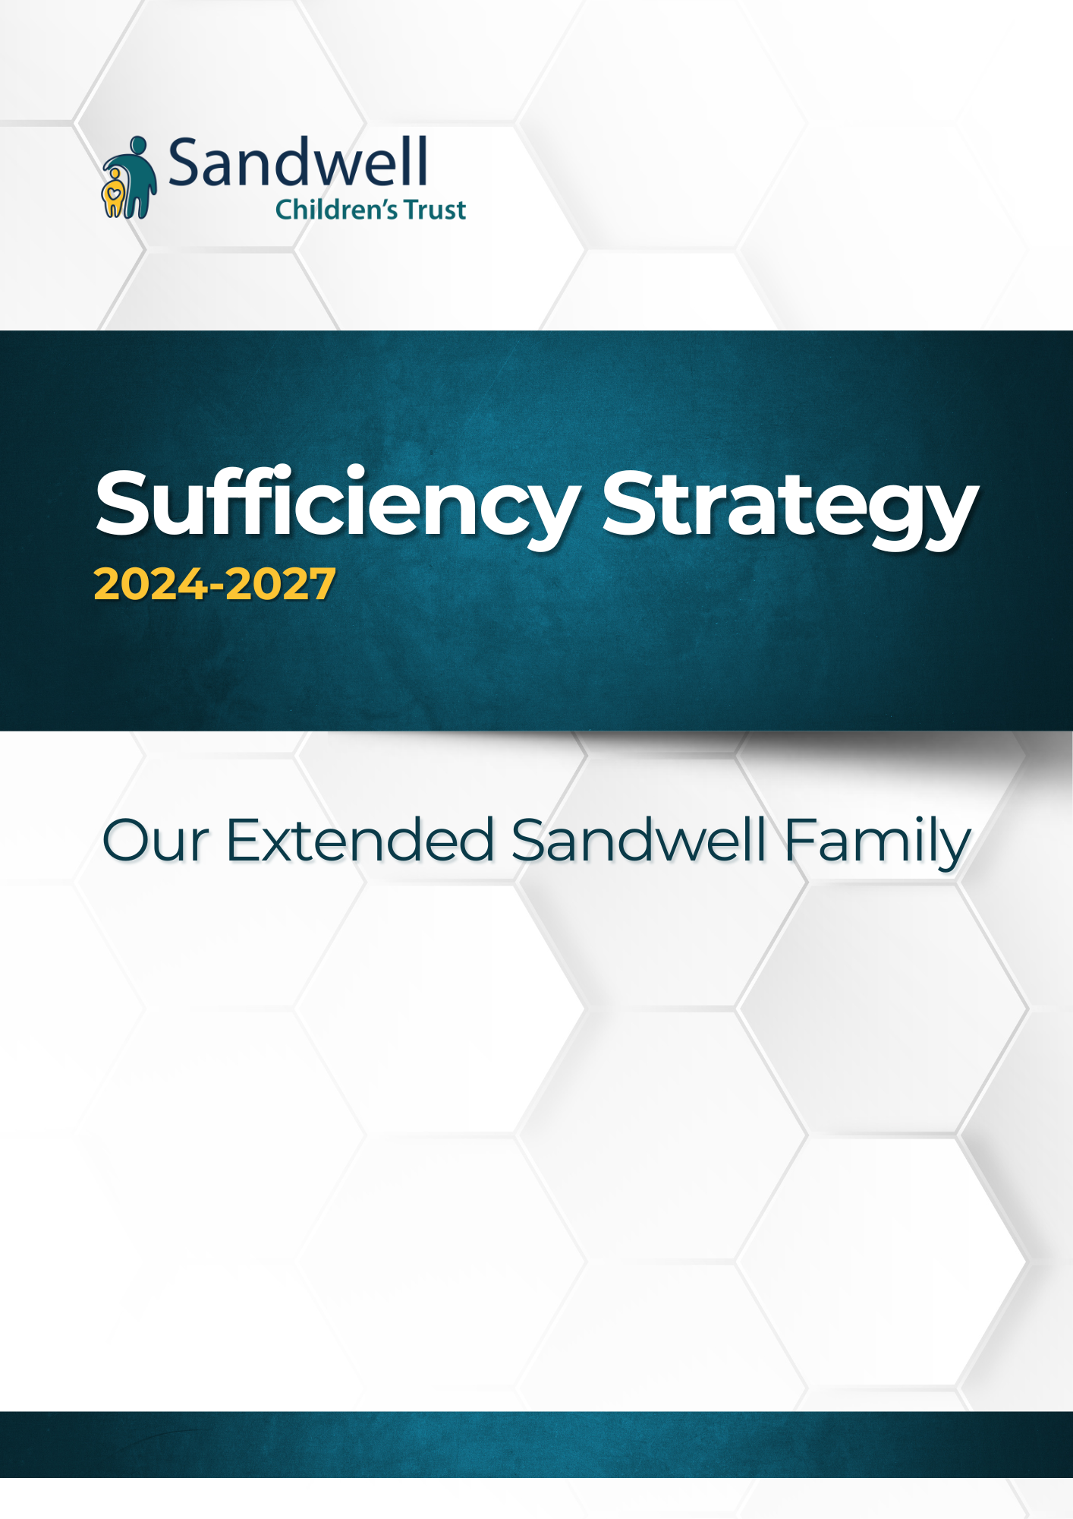
Foreword
From Jevon and Maddie
Chairs of the Forum for Independent Young Adults and Voices of Sandwell
What our children and young people said
No one knows as much as us how it feels to not have a normal home like everybody else. We see our friends who live with their mums and dads, who have their own bedrooms and their things around them and all we want is to feel as safe and as happy as them.
As children and young people in care in Sandwell, we have had lots of different experiences. Some of us have had great carers who we have been with for a long time, and we will never forget them, some of us have moved around a lot more than we would have liked to. Can you imagine what it’s like to be young and not really know if you will be at the same house or with the same people for long? It makes it hard to relax and concentrate on things like school or hobbies. It also makes us sad when we have to move around a lot, it’s hard to get used to different places and different rules.
What we all want is a home that we can be comfortable in and not have to worry about being told we have to pack our things up and move.
A group of us who are care experienced or working with the youth justice people got together to talk about what we wanted from this sufficiency strategy. We shared our stories and experiences with each other, and someone came along who listened to what we said and drew it out on some big boards. (see Appendix 1)
We also did some work with Sandwell Children’s Trust to explain how we wanted to be treated by the people that are there to support us, all of the things we thought were important were written down and put into a document called the ‘Guide to Working Together’. We have used the headings in this guide to tell you about what we want from this sufficiency strategy and what matters to us when you are looking for a home for us.
 | 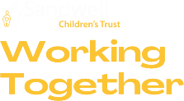
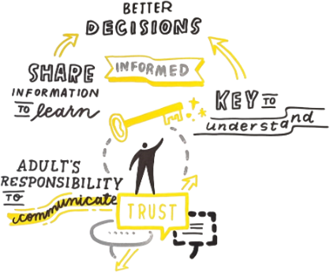
When you are looking for somewhere for us to live, it’s important that you share information with us so we can let you know how we feel. It’s always better if we understand what’s going on.
The more you let me know about our right to have a say about where we live and who we live with, the better it will be for everyone.
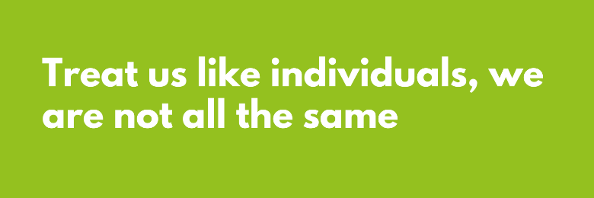
If we have brothers or sisters, please try and remember that we are not the same!
Sometimes people just think we act the same or want the same things. Don’t just copy the same information about us when you are trying to find us somewhere to live.
When you are writing about us on our profiles or any of the forms you have to fill in, we can help you make sure that what you write really does reflect who I am as a person.


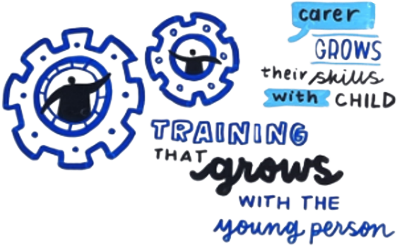
It’s important that we can be included when decisions are being made about where we live and the people that we will be living with.
You can help us to do this by talking to us whenever you can, by asking us what we think and by helping us to be part of meetings where things will be decided.


Training us and helping us get ready for our next steps is also important, the more we know about things, the more we can get involved.
Another thing that is really important to us is the way that you can help us to remember things about our lives.
The best carers are the ones that make memories with us, this helps us think about the good times as well as helping us understand what has been happening in our life.

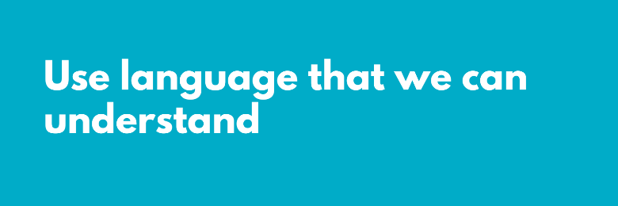
The way that you speak to us and write about us can make such a difference to the way we feel. It’s hard to understand some of the words that you use, even when you explain them to us.
This is important when talking to us about where we are going to be living, or when you are writing stuff about us to people that might want to let them live with us.
We should be able to look at the forms and the information that you have written about us and be able to understand them without having to ask many questions.


When you are looking for a home for us you should try your hardest to make people want to let us live with them. The words that you write on a form about us or the things you say in meetings about us could make people decide they don’t like us before they have even met us.
When we spoke about this in our groups, we could all remember times that something was said that made us look bad. We know that you have to tell the truth, but when you ask us, we can always tell you that there are reasons why we acted like we did, or did things we shouldn’t have done.

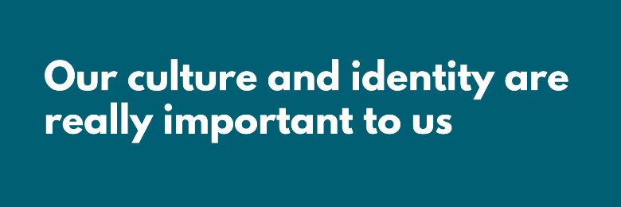
When you talk to us about what matters to us, we will be able to tell you about the most important things. For some of us, it means a lot that we are in a home and with carers that share our faith or are from the same cultural background as us. It helps us learn about ourselves and can help us carry on speaking the language that the rest of our family speaks.
The important thing is to talk to us and understand what matters, as we are all different.

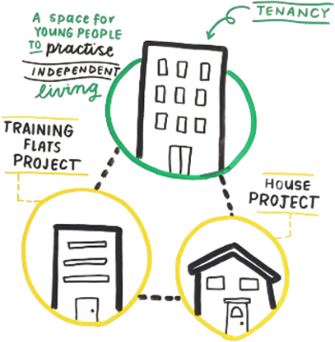
The most important place we will ever go is our home, it’s the place where we should feel safe and comfortable. We understand that we are not going to get all the things we ask for in our home, but we think we should work together to try and make it a place where we can feel like we belong.

Another thing to think about is where our home is. It’s hard being a child in care, and if we have to move to different towns where we don’t know anyone and we don’t know where anything is it makes it feel worse.
It is also important that there are lots of options for us when we are ready to become more independent. This could mean spaces that we can practice our life skills, homes that we can be supported by adults and options to stay with carers that we have built a strong relationship with.


All of us that helped write this section have had lots of positive and negative experiences with the homes that we have lived in and the families that we have lived with. The thing we all agreed on was that when you take the time to understand how we feel, we feel more confident in sharing our views and more confident that you are doing all you can to keep us in a safe and loving home.
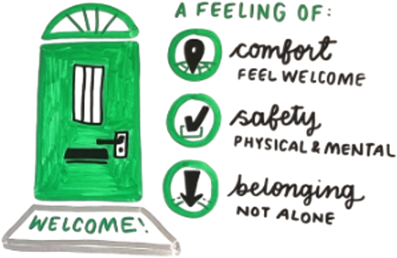
Some of the things are obvious. Keep talking to us if there are delays with things, can you imagine how it feels when you don’t know where you will be living next week? Think about how you can support us to get ready for when we turn 18. We all know young people that are a bit older than us, and we are scared that we are going to be left on our own.
Work with us to figure out what people we need in our lives to help us through the difficult times, tell us that things are going to be OK if we have to move homes at short notice, or say goodbye to carers that we love.
Above all, when you are looking at the options for us and where we are going to live, please try to understand what’s it like for us.
Table of Contents
Introduction 7
Context and Background 8
Current trends and challenges 8
National context and direction of travel 8
Care Leavers National Movement Peer Evaluation 8
Regional and local context 9
What we know about our children and families 9
Sandwell Children’ and Families Strategic Partnership 12
Prevention 13
Personal Approach 15
Keeping it Local 19
Preparing for Adulthood 26
Market Position Statement 29
Conclusion 30
Appendices 31

Introduction
Our purpose is to improve children’s lives and to achieve this, we must offer the best possible help to meet families’ needs and enable them to stay together.
When this is not possible, and children need to live elsewhere, we must offer the same high-quality help to make sure they have safe, stable, loving homes where they can form trusting relationships, and their needs can be met. This Sufficiency Strategy outlines our ambition to achieve this over the next 3 years, it aims to address current challenges, anticipate future needs and provide a framework for delivering effective and sustainable homes for children who are unable to live within their own families.
Like many other areas, Sandwell can find it difficult at times to find suitable homes for its children, especially those with more complex needs. This can be for several reasons, for example: the number of children cared for nationally increased by 30.1% between 2010 and 2023; a shortage of suitable homes; and while the number of children’s homes has increased they are not evenly distributed across the country, with only a limited number providing specialised care.
The shortage of suitable homes appears to contribute to several issues including: too many children being placed outside their home area or a long way from home; high costs of homes; and increasing numbers of children deprived of their liberty placed in unregistered settings, with no regulatory oversight.
It is within this challenging context that the Trust sets out its new approach to achieving its strategic ambitions:
To safely prevent children needing to be in our care and prepare them well for adulthood when it is needed

To understand our children’s needs and increase the number of local homes that can meet them

To reduce the number of children we care for living outside of Sandwell
To increase the number of fostering households in Sandwell
The Children Act 1989 requires Local Authorities to provide or procure homes for children we care for. This duty requires us to “take steps that secure, so far as reasonably practicable sufficient accommodation within the authority’s area which meets the needs of children that the local authority care for, and whose circumstances are such that it would be consistent with their welfare for them to be provided with homes within the local authority’s area (‘the Sufficiency Duty’).”
To meet our Sufficiency Duty, Sandwell must ensure that, through either direct provision or commissioned services, a range of homes sufficient to meet the needs of all children we care for are available where possible and appropriate to be locally within the region. Where this has not been achieved, the duty requires a plan to rectify the sufficiency shortfall.
The focus of this strategy is the three largest placement types: foster care, residential care (excluding residential schools), and supported accommodation and Independent Living Services (SaILs). These areas are where the critical sufficiency challenges lie.

Context and Background
The landscape of children's homes is shaped by a range of legislation, policies and practice. This strategy has therefore been developed with an understanding the broader national trends, challenges, and legislative framework needed to make sure our local approach is aligned with best practice as well as our statutory requirements.

Current trends and challenges
Increasing Demand: Nationally there has been a steady increase in the number of children entering the care system, driven by factors such as family breakdown, neglect, and abuse.
Placement Shortages: Local authorities face challenges in securing sufficient placements, particularly for children with complex needs, leading to a reliance on out-of-area and sometimes unregulated placements.
Quality and Stability: Ensuring high-quality, stable placements remains a priority, with efforts to reduce the number of home moves and improve the overall experience for children in care.
Financial Pressures: Local authorities are under significant financial pressure, impacting their ability to invest, develop homes and support for carers.
Workforce Challenges: Recruiting and retaining skilled social workers and carers is an ongoing challenge, affecting the capacity and quality of care provided.
Impact of COVID-19: The Pandemic has exacerbated existing challenges in the care system, leading to increased demand for placements, disruptions to education and support services, and additional pressures on carers and social workers.

National context and direction of travel
Analysis shows that there are not enough suitable homes for the children we care for across the country and at a reasonable cost. Research including the CMA Market Review, the Independent Review of Children’s Social Care and the subsequent Stable Homes Built on Love strategy and implementation plan, all highlight the issues we are facing. These include:
A lack of homes of the ‘right kind’ in the ‘right places’ – often resulting in siblings being separated and poor options for more complex or older children.
- The largest providers charge inflated and unreasonable prices.
- The system is ‘skewed’ towards crisis intervention rather than preventative help
- The system tries to replace ‘organic bonds and relationships’ with professional services
- A failure to recognise the ‘strengths of families’

Care Leavers National Movement Peer Evaluation
Whilst the peer evaluation focused on the House project the recommendations hold a relevance to the wider work with young people:
No Conversation About Me Without Me: This recommendation related specifically to formulations and safety plans. The evaluation found that whilst many young people contributed to their formulation and safety plan, this wasn’t consistent
Good Mental Health for All: Whilst most young people agreed that being part of a House Project had improved their mental health, improving access to different levels of support would provide an even better offer to young people.
A Community Beyond Moving In: Young people would like support to maintain the friendships and connections they made as part of the House Project.
Local Opportunities for House Project participants: As well as being part of the House Project community young people would like more support to become part of their local community, once they have moved into their home.

Regional and local context
West Midlands Regional Framework
Sandwell works with 13 Local Authorities and Children’s Trusts across along with the West Midlands Commissioning Hub for joint commissioning arrangements including: West Midlands Fostering Framework; Residential Flexible Contract Arrangement (FCA); and the Supported Accommodation Framework. The West Midlands Commissioning Hub supports and facilitates regional arrangements, including the Strategic Commissioning Network (SCN) and Operational Commissioning and Contract Group (OCCG), along with annual regional data collections, used to inform future commissioning intentions. This is an important part of our regional work.
Over the next few years, new Regional Commissioning Consortia will be developed, and these are being piloted within two regions and their findings will influence this strategy.

What we know about our children and families
Sandwell Children’s Trust places a strong emphasis on maintaining high-quality data to drive performance and inform service development. The Trust regularly collects, monitors, and analyzes data across various areas including service delivery, outcomes for children and families, and resource allocation. By employing robust data management systems and performance indicators, Sandwell Children’s Trust can track trends, identify areas for improvement, and assess the effectiveness of interventions. This data-driven approach not only supports continuous service refinement but also ensures that decision-making is based on evidence, helping to shape and adapt the sufficiency strategy to meet the evolving needs of the local population. Regular data reviews, performance monitoring, and stakeholder engagement help the Trust anticipate challenges, adapt services, and ensure that resources are aligned with demand, ultimately driving better outcomes for children and families.

Sandwell Sufficiency Infographic
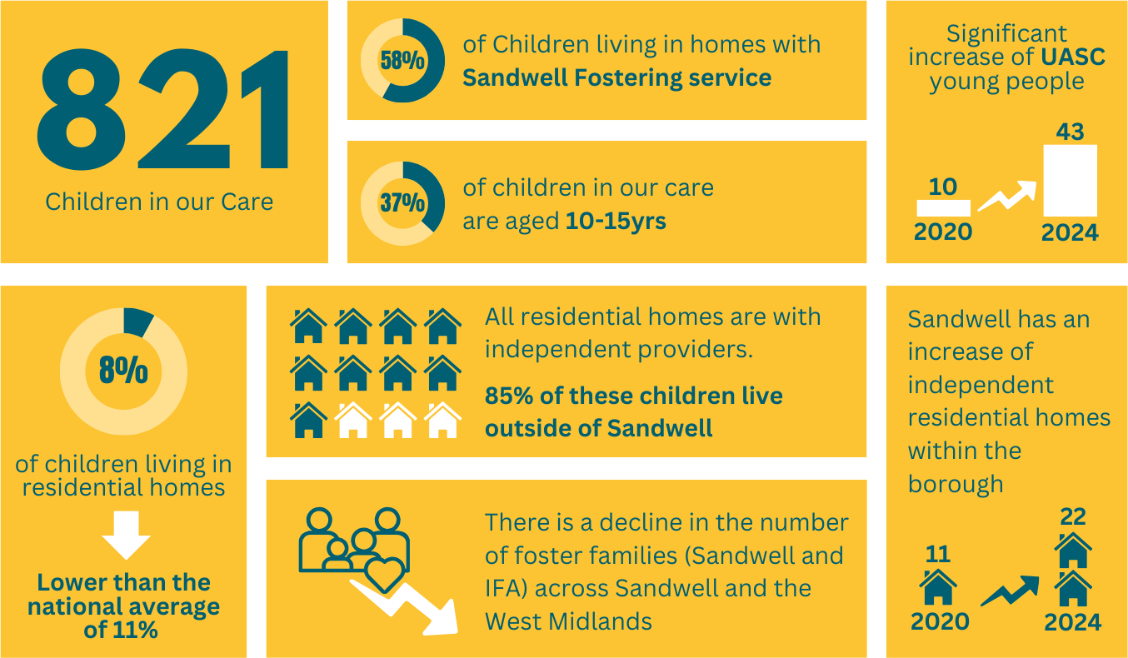
Early Help
- There are 1160 young people open to Early Help services in Sandwell (683 within Strengthening Families and 442 Universal Services).
- 48% Female and 51% Male, the remaining 1% consists of Agender, Cisgender or indeterminate young people.
Children in Need
- March 2024 had 658 young people subject to Child in Need, this is a rate of 76.7 per 10,000.
- 47% Female, 50% Male with the remaining 3% Unborn.
- 54% from a White background, 15% from a Mixed background, 14% from an Asian/Asian British background, 12% from a Black/Black British background and the remaining 5% from Other backgrounds.
- 2% of young people subject to Child in Need are Unborn, with 21% being aged New-born – 4 years, 26% between the ages 5 years – 9 years, 38% between 10 years and 15 years with 12% of young people aged 16+ years old.
Child Protection
- March 2024 there were 473 young people subject to Child Protection Plans, this is a rate of 55.1 per 10,000 (SN Average 62.0 per 10,000).
- 43% Female, 54% Male, with the remaining Unborn (3%).
- 61.5% from a White background, 15% Mixed background, 12% Asian/Asian British background, 6% Black/Black British background and the remaining 4% from Other backgrounds.
- 3% of young people subject to CPP are Unborn, New-born to 4 years old represent 27% of the cohort, with 5 years – 9 years a further 28%. 34% are between the ages of 10 years – 15 years and there are around 7% which are aged 16+ years old.
- Around 69% of young people subject to CPP have been so for less than 9 months. A further 12% between 9 months and a year, 16% between a year and two years and just 3% for longer than 2 years.
- 34% of young people subject to CPP are on their second or subsequent plan.
Children We Care For
- March 2024 there were 808 young people We Care For, this is a rate of 94.1 per 10,000 (SN Average 98.7 per 10,000.
- 44% Female and 55% Male, with the remaining young people Agender or Indeterminate.
- 49% from a White background, 24% Mixed background, 10% Asian/Asian British background, 13% Black/Black British background with the remaining 4% from Other backgrounds.
- 4% of young people We Care For are under 1 years old, with 14% 1 years – 4 years, 24% 5 years – 9 years, 36% 10 years – 15 years and 22% 16+ years.
- 66% of young people are on a Care Order, with a further 17% on Interim Care Orders. 10% of young people are subject to Section 20 and 6% are on Placement Orders awaiting adoption.
- Young people are predominantly in external foster placements (37%) with 15% placed with internal foster carers. 20% of the young people We Care For are placed with a connected carer. 10% are placed at home with parents and 8% in external residential placements. 5% are in independent living arrangements and the remaining 3% are in various other placement types.
- 521 of our young people are placed out of borough, with 84 of those placed further than 20 miles away from their home address.
Further demographic information at Sandwell’s six town level is shown in Appendix 2

Sandwell Children’ and Families Strategic Partnership
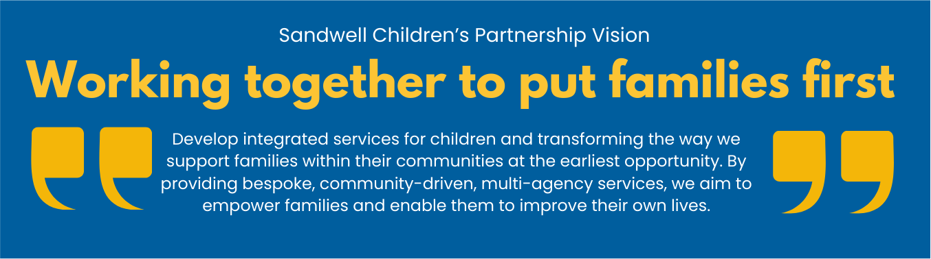
Our Strategic Partnership’s vision applies to all children, including those we care for. Where children are unable to live safely with their families, we want them to be cared for in their local communities, in homes where they are loved; and their individual needs are met by bespoke, wraparound support; so, they can thrive when they become adults.
To achieve this vision, our Sufficiency Strategy has four strategic themes:
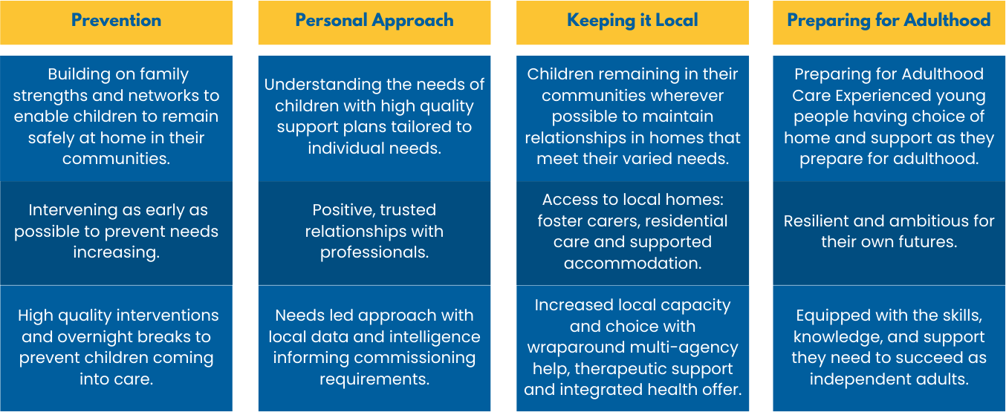

Prevention
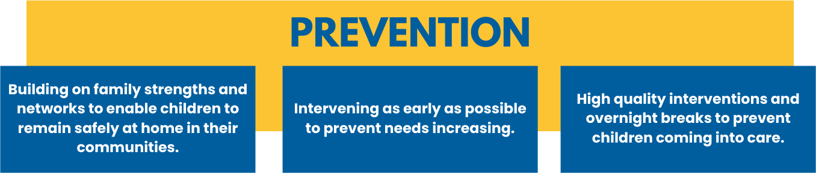
Prevention is key to supporting families at the earliest point and enabling them to remain together in their communities. This approach underpins Sandwell's Early Help strategy, and the key principles moving forward of ‘Family Help’, the impact of which can be seen in the sustained reduction in referrals over the past five years. Close working with partners is crucial; progress continues although there is much more to do.
Whilst Early Help is crucial for helping families stay together, for some feedback has shown that sometimes they need some time and space for problems to settle and talk things through with other family members. This need is reflected in a small number of children who come into our care at a point of crisis but return home after a short period.
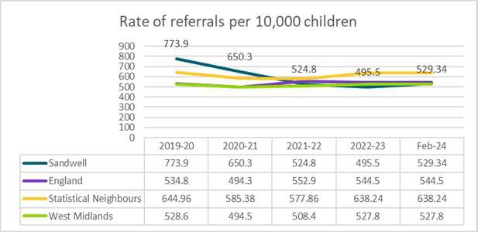
Rate of referrals per 10,000 children
Over the past three years, the rate of referrals per 10,000 children has been decreasing. However, as of February 2024, there has been a slight upturn compared to the 2022/2023 figures. Currently, Sandwell’s referral rate remains below the England and statistical Neighbour average, although slightly above the West Midlands average.
% Referrals which: Were within 12 months of a previous referral
The percentage of children re-referred to Sandwell Children’s Trust within 12 months of a previous referral has declined from 24.8% in 2019/2020 to 22.9% in 2022/2023. As of February 2024, this rate decreased to 21.3%. Currently, the rate is below the England average, although slightly above West Midlands and Statistical Neighbours (2022/23).

Rate of completed assessments per 10,000 of children aged under 18 years
Since 2019/2020, the rate of completed assessments per 10,000 in Sandwell has steadily decreased each year. Despite a slight increase in February 2024, the assessment rate per 10,000 remains below England, West Midlands, and Statistical Neighbour averages.
Where we are now
Underpinned by our partnership Early Help strategy, significant progress has been made in our approach to supporting families without the need for intrusive statutory services. The Trust’s approach led to the development of our shared vision across the Children’s Partnership, along with a set of shared principles, all of which resulted in a bid to be part of the national Pathfinder Programme in early 2024. Whilst this was not successful, it laid the groundwork for a set of proposals for the partnership to take forward, all of which reflect the aims and objectives of Stable Homes, Built on Love.
The Partnership shares a clear plan to build on our Family Hubs model and develop integrated multi-agency teams designed to help families in their communities. With detailed data on each of our 6 unique towns, we are now better equipped to understand and address the needs of our children and families at local level.
Where we want to be
Our goal is to use our town-level data to inform service design and delivery, offering the right support in the right places at the right time. We want to develop these alongside our children and communities, developing tailored help, reflective of the needs of individual towns. We want to make best use of our specialised intervention services, where children are on the edge of care; and we want families to benefit from short breaks where this will help preserve relationships.
What we will do
- Through our Community Network Groups, we will use detailed town level data to inform service design and delivery based on specific local needs
- Engage with our children, families and communities in designing and developing our approach, with our Participation Team involved in gathering input and ideas
- Collect feedback from families and communities to continually improve services.
- Through our new Family Help Board, support and empower more families within our Family Help system by intervening and enabling access to Early Help services
- Extend Family Group Conferencing so children benefit from family decision making at the earliest possible opportunity
- Develop a stronger support system for families that need our help, where children are at risk of coming into our care. This includes the option of overnight short break accommodation with intensive multi-agency wraparound support (maximum 28 days)
- Consider accommodation options including a possible collaboration with “Night Stop”, that allows time and space for reflection with the intention of preventing care and the potential role of: designated foster families; registered residential provision (for example, 2 or 3 separate flats in the same building, managed by a single registered home manager);
- Develop across the partnership the skills to deliver effective “family networking meetings”
- Expand the range of accommodation options for young people as they prepare for adulthood
- Creation of a multi-agency accommodation hub to offer 16-25 years support

Personal Approach
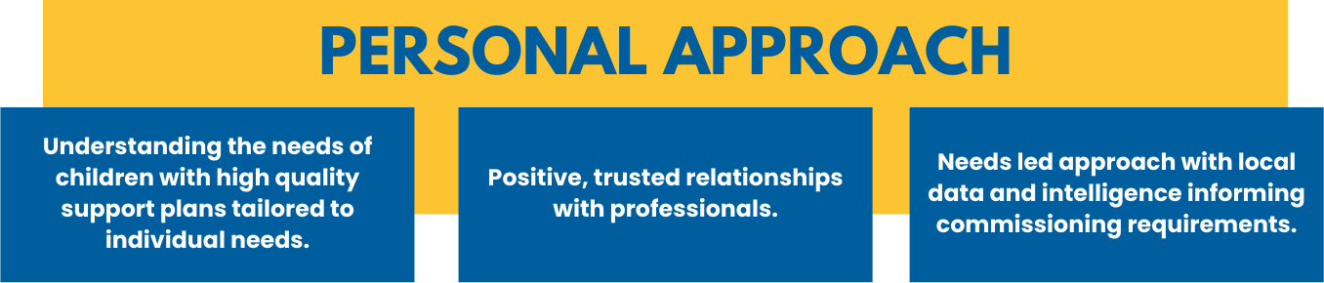
Nationally, in 2015, there were 69,470 children in care. By 2020, this number had risen to 80,080. Analysis conducted through this programme forecasts that this figure could further increase to between 86,000 and 95,000 by 2025.
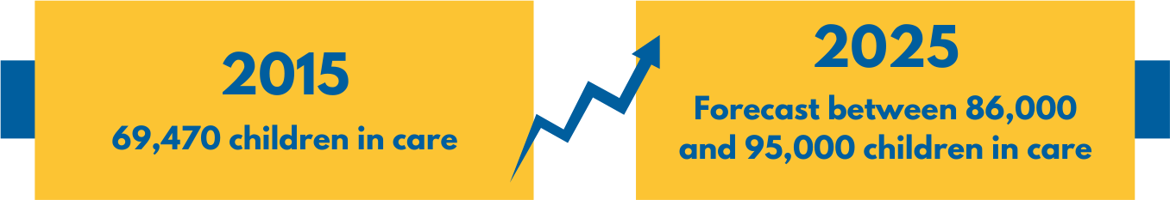
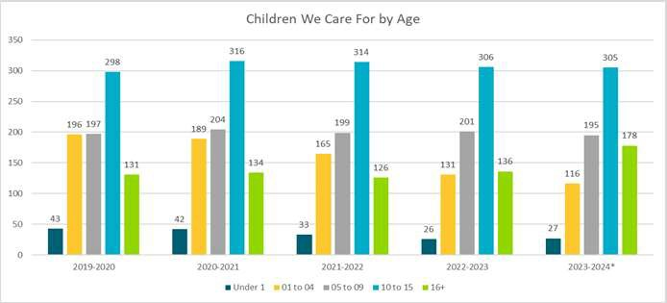
Children we care for
The ONS mid-year population estimates 85,824 children living in Sandwell. As of 30 April 2024, there were 808 children in our care, a rate of 94.1 per 10,000, lower than our statistical neighbours.
Overall numbers of children we care for have decreased over the past four years, although it has fluctuated.
When compared with other areas, Sandwell has a lower rate (93.0) compared to our Statistical Neighbours (97.4), but remains higher than the West Midlands (90.0) and England averages (71.0).
Age & gender of children we care for
The age distribution of children we care for has remained fairly consistent over the past five years. As of February 2024, the majority (37%) of the children were aged between 10 to 15 years old, similar to our comparators. Notably, there has been an increase in the number of children aged 16 and above, rising to 22% from 17% at the end of 2022/2023, bringing us more in line with our comparators.
Gender distribution has also remained consistent, with a higher proportion of male children (56%) compared to female (44%), again similar to our comparators.
Ethnicity of Children We Care For
In Sandwell, 51% of the children in our care are from a white background, while 49% are from a minoritised background. Over the past five years, the proportion of children from minoritised backgrounds has increased steadily each year. | 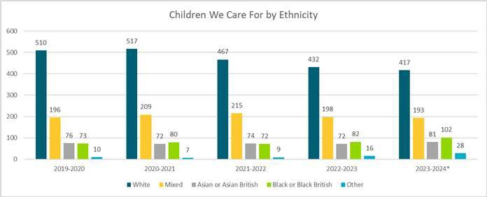
Unaccompanied asylum-seeking children
There has been a significant increase in the number of unaccompanied asylum-seeking children (UASC) in our care in Sandwell. As of February 2024, 16 of the 43 UASC children transferred through the National Transfer Scheme (NTS).
The NTS operates under a national allocation model, which stipulates that the number of unaccompanied asylum-seeking children (UASC) each local authority (LA) should care for is 0.1% of the total child population under 18 years old. For Sandwell, this equates to 85 UASC children under the age of 18.
The increase in UASC this year has already put significant pressure on our services. Further increases in these numbers will challenge our capacity and add additional pressures as we strive to meet this growing demand, this is key pressure and priority for the trust.
The creation of a UASC hub within the Children we Care for Service aims to offer a responsive service at the point of referral into the Trust, as well as a specialised approach post 18 years, in partnership with Housing to create Sandwell accommodation options; specialist Human Rights Training and emotional wellbeing support to assist in preparing for adulthood whilst waiting asylum application outcomes. Working in partnership with the NTS enables preparation to accept additional children, and opportunities for grant allocation which equally offers the opportunity to develop and enhance service provision to separated children. The ambition would be to enable this area of work to be developed as part of a multi-agency hub and partnership engagement.
Step-Aside Project
There is a lack of capacity amongst providers to meet our community’s needs. In 2022, only 35% of residential homes operated through regional frameworks, leaving a substantial 57% under spot contract arrangements. For Sandwell, this figure is higher, with 72% of residential placements sourced from spot contract providers. | 

It is within this context that Sandwell changed its approach when engaging with providers, moving away from a cost-centric model to a needs-led commissioning approach.
Consequently, in 2024, the Step-Aside project launched which saw a greater focus on the individual and unique needs of our children we care for, primarily those in residential homes. The project uses the BERRI tool to gain insight into each child's needs, ensuring they can be placed in a home that best supports their development and well-being.
Step-Aside implements the BERRI tool collaboratively to review and understand the needs of children we care for, including the social worker, the home where the child lives, plus potential homes. Children can complete a BERRI assessment themselves, with support from someone who knows them well; and in some situations, parents can attend sessions. | 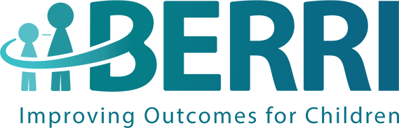
The project goes beyond the ‘cost management’ aspect of care, aiming to adopt a strengths-based approach to ensure that children's needs are accurately understood. This approach has led to the development of new Placement Request forms that are strengths-based, examining children's lived experiences and aligning these with BERRI tool reports for information sharing.
Through these efforts, the Step-Aside project is driving meaningful change, with the aim that children can be placed in the right home that can meet their needs in a nurturing environment. It also enhances the overall quality of care, ensuring that our commissioning intentions are always aligned with the best interests of our children.
Where are we now
Our Data and Intelligence is responsive to new requests and developments and there is regional data available through the West Midlands framework; however, this data has a time lapse and may not always reflect the most current information.
Our participation team is well-developed, fostering positive relationships with our children and young people. Our young people help to lead and facilitate Trust-wide and partnership events; they are well respected and influential in Trust developments.
The Step-Aside project has initiated a new way of commissioning for our children, with home finding becoming more strengths-based, needs-led, and outcome-focused rather than resource-led.
However, some areas require more attention. Although our understanding of our children is improving, the lack of integrated commissioning means that this knowledge is not shared across the partnership routinely. To have a greater impact on children, a more integrated approach to commissioning is required, with clear intentions established across the partnership.

Where we want to be
We want to transform the commissioning landscape for Sandwell's children. Our intentions should be led alongside all our partners, with a collective understanding of children's needs; culturally, we want to be relationship-focused, which means a change in our approach, language and practice so children benefit from a personalised, strengths-based approach in line with the ST*R Practice Model. We want to see the Step-Aside project permanently embedded in practice and across the Trust, driving best practice and relationship-based commissioning, where the right homes can be secured in a planned way wherever possible.
What we will do
- Continue to develop our local and regional intelligence, informed by our data
- Embed the Step-Aside project as a permanent offer within the commissioning and home finding service.
- Continue to embed our new Home Finding Service and rebranded placement service to the Home Finding team, to enable more a focused and specialised approach in finding the right homes for children.
- Develop a ‘How to Guide’ for the home finding process within commissioning and across operational teams.
- Embed the new Strengths-Based Home Finding Request approach that reflects children’s strengths and needs.
- Record all home searching on the child’s electronic file
- Embed "One Page Profiles" for all children – written from their perspective, and train staff.
- Ensure children are routinely consulted and are central in the home finding process.
- Adopt a relationship-based approach with providers, with guidelines and training.
- Strengthen relationships with providers, leading to more children living in the borough with better outcomes.
- Establish joint commissioning arrangements with key partners. Integrate the fostering home finding function.
- Streamline home finding processes and improved coordination.
- Ensure Care Experienced Young People are part of a new quality assurance approach and train them alongside commissioning.
- Strengthen provider engagement and service improvement from a child's perspective.

Keeping it Local
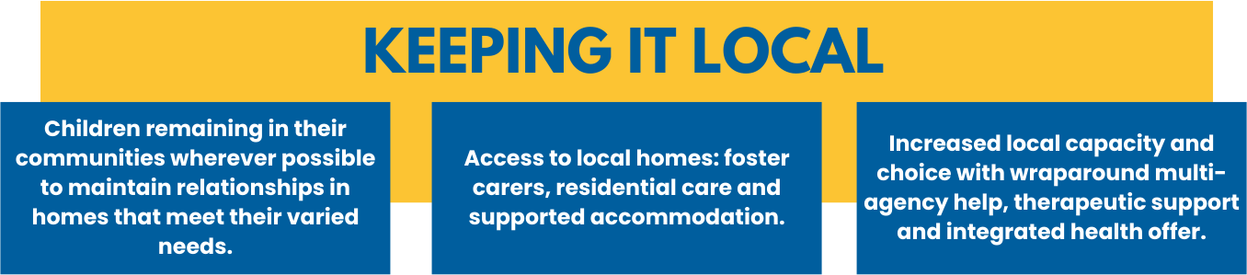
Our Sandwell Family approach should be applied whenever a child cannot live within their own family. This means they should live locally, in their own communities, with the wraparound help and support they are familiar with, wherever it is safe and possible to do so. Everyone plays a part in this - local communities, our partners and families. Importantly, it’s about our local communities coming forward to provide homes for our children.
To achieve this, we need a skilled and well-trained workforce across the Trust and wider partnership, equipped to deliver the interventions within our communities, alongside children and those caring for them. Consequently, children’s needs can be met more effectively in local homes, whether these are foster homes, residential homes or supported accommodation.
We also need a clear, positive narrative to enable our communities to understand that caring for our children locally, wherever possible, can increase their sense of belonging and feeling valued. This can improve their stability and security, meaning that everyone has a part to play in Sandwell’s extended family, creating supportive environments for our children.
This approach is underpinned by our ST*R Practice Model which promotes a relationship- based, strength-based, and trauma-informed approach to how we work with children and families. With the aim of working consistently with children, it should ensure that every child and family receive the highest quality of care and support in a responsive system that, keeping them connected to the people and places that matter most.
Children We Care For
Where they live & home stability
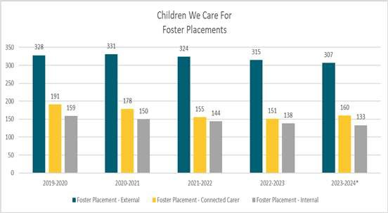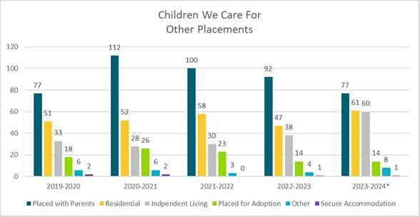
73% of children we care for are currently in foster homes. Of these, 37% of are living in external foster homes, 19% are living with connected carers and 16% live with internal foster homes. Children living in other homes have remained similar to previous years, however there are more children living in residential and independent accommodation and fewer living with parents in comparison to year end 2022/2023.
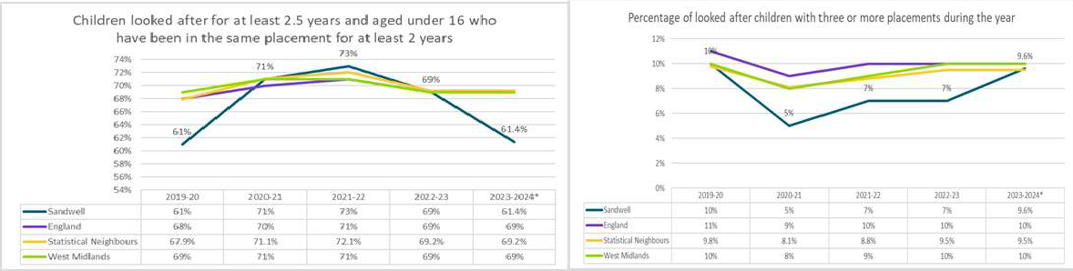
Children who have remained in the same home for 2+ years is currently at 61.4%, a decrease compared to year end 2022/2023 when it was 69%. This is below our comparators.
As of February 2024, children who had experienced 3+ home moves during the year increased to 9.6% compared to 7% year ending 2022/2023. This remains below the England and West Midlands average and is slightly (0.1%) higher than our Statistical Neighbours.
Out of Borough homes
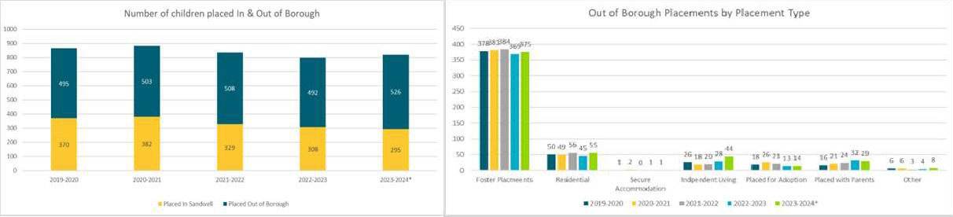
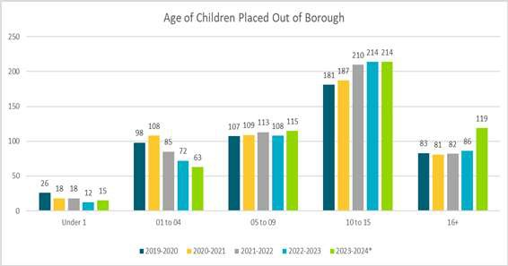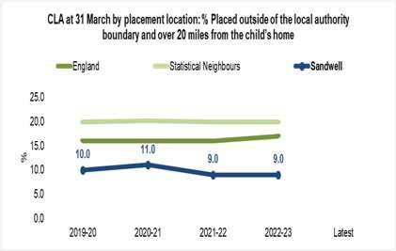
Out-of-Borough homes in Sandwell
64% of the children we care for are not living in Sandwell. This is a 2% increase compared to year ending 2022/2023 year and higher than our comparators (England: 44%, West Midlands: 45%, Statistical Neighbours: 53.1%).
Among the children living out of the Borough, 71.3% are in foster homes, 10.5% are in residential homes, 8.4% are in independent living arrangements, and 5.5% are with parents.
Of those living out of borough, 40.7% are aged 10 to 15 years, 22.6% are aged 16 and older, and 21.9% are aged between 5 and 9 years.
There are more male children (57%) living out of borough compared to female (43%).
Whilst there has been a slight increase (2.1%) in the number of children living more than 20 miles from their home address compared to last year, Sandwell still has significantly fewer children placed over 20 miles away than our comparators.
Building trusted relationships: Lifelong Links
We know that children we care for often face the disruption of personal relationships as they move within or enter the care system. According to Freedom of Information (FOI) requests conducted last year by Become, it was found that on average, children in England are placed more than 18 miles from their homes, roughly equivalent to the distance between Birmingham and Coventry, with some children over 500 miles away.
Children who experience multiple home moves are more likely to be placed over 20 miles from home. On average, children with only one home are situated 15.8 miles away from home, while those with three or more home moves are placed 22.4 miles away.
The 2022 Independent Review of Children's Social Care recommended that by 2024, all local authorities should implement "skilled family finding support equivalent to, or exceeding, the work of Lifelong Links," ensuring that no young person leaves care without at least two loving relationships.
It is recognised that lifelong links is a specialist area of work that sits alongside family group conferencing. There is an aspiration in Sandwell to develop the skills and knowledge within the Intervention Hub to enable all 16+ children we care for to have a lifelong links meeting and for this to be followed up by the allocation of a Personal Advisor at the age of 16 years. Pathway Planning for 16 years + needs to include progression of lifelong links connections and this should be monitored through the Child we Care for reviews.

Fostering
We want all our children to have the opportunity of living in a family home, either through family connections or foster families. Over the past four years, this has become increasingly challenging due to a local and national decline in registered foster families.
In 2019/20, Sandwell had 220 registered fostering households within the borough. This number has significantly decreased over the past four years, with just 100 registered fostering households in 2023. While independent fostering agencies within the West Midlands have seen a more positive trendgrowing from 2,115 fostering households in 2019/20 to 2,400 in 2023/24this increase of 285 households is not enough to compensate for the total reduction of 1,155 local authority fostering households across the West Midlands during the same period. This pattern mirrors the national profile, where many fostering households are deciding to stop fostering rather than move to an independent fostering agency.
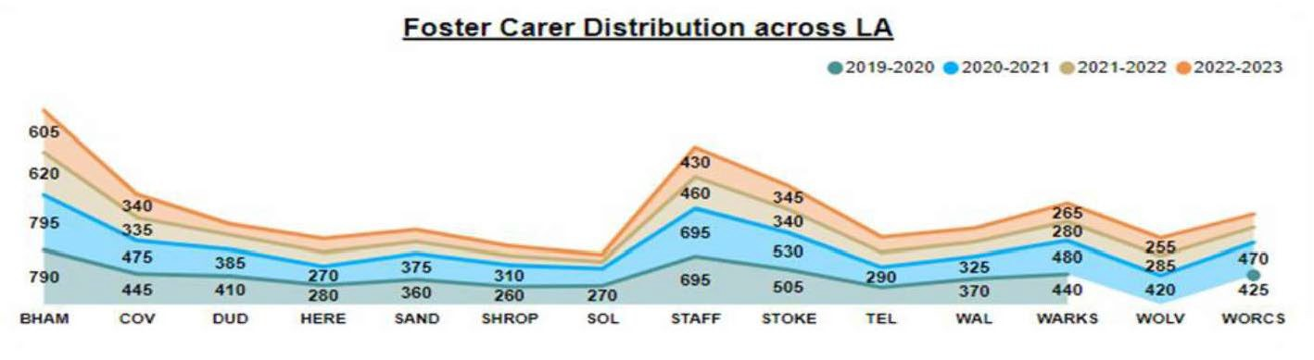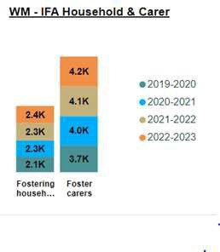
Where we are now
Expanding our current fostering offer is key, not just in terms of the number of foster households, but also in the skills and support they offer. These need to be developed at pace to meet the needs of our children, particularly teenagers, who are the largest age group coming into our care.
Sandwell Children’s Trust have received Foster Friendly Employer status with the Fostering Network and have supported Sandwell Council to achieve the same. There is an established working group to promote Sandwell as a Foster Friendly borough, and this is a key focus for the Strategic Corporate Parenting Group (multi agency sub-group of the Corporate Parenting Board).
The Training and Support offer for foster carers, also provided to our connected carers, has been expanded and incorporates mandatory modules, focusing on trauma informed training and attachment as examples. The promotion of TSDs for foster carers enables tracking of their training and the individual support needed. Whilst the programme of hybrid training is promoted, there are also times when 1:1 bespoke training is provided, and also specialist training if the needs of a child require this. The new Trust ST*R practice model is also being embedded as part of the practice framework for fostering alongside the premise of secure base training.
Our most recent Fostering Inspection, in October 2024, recognised the skills, knowledge and experience of our foster carers and the positive impact and outcomes for our children. It noted that managers and leaders are aspirational for staff and carers, they promote their development and support to carers is consistently provided. It also noted that whist fostering annual reviews had improved and are 100% compliant, we need to be able to close the loop on areas of improvement identified in them.
It is recognised that despite the work undertaken to promote our internal provisions there continues to be a reliance on external provisions to ensure that there are sufficient homes to suitably match our children.
As of September 2024, the new regional Fostering framework is operational, which is our main resource for Independent Foster Agencies. Noticeable is that some IFAs have chosen not to join the framework, leading to an increase in spot purchasing arrangements.
Where we want to be
We want to embed a culture and practice that reflect our guiding principle of our Sandwell Family. We also aim to embed our ST*R practice model to recognise the professional approach of our carers. This means having a clear narrative that our community is strongest when we come together and work together to support our most vulnerable children and young people. We want every child in Sandwell to be able to grow up locally, or in areas they want to live in, in a supportive and loving family environment, whenever it is safe to do so. Therefore, this strategy needs to drive to expansion of our in-house fostering capacity so that 70-75% of our children and young people in fostering homes have safety, stability and care within their own community.
By focusing on those areas where there are identified gaps, we want a dedicated offer for teenagers, recognising the unique challenges they face; and by expanding our fostering capacity, we want to reduce the unnecessary use of residential homes, ensuring that they can thrive in family settings with the wraparound support they need.
We want to strengthen our fostering service and attract more carers, so more of our children can live in the Sandwell community.
We wish to enable our carers to consider longer-term arrangements with our young people, supporting their transition into adulthood supported by staying put initiatives, home programme and House Project or into their own tenancies, where appropriate.
The first strand of keeping it local means working with our partners and communities to expand in-house fostering, building a responsive, resilient system, with efficient processes, good wraparound support and carers capable of meeting our children’s diverse needs.
What we will do
Continue to invest in media campaigns to generate a strong public narrative around what it means to be part of our Sandwell Family, where community values and local homes for our own children are emphasised alongside real stories, testimonials, and the positive impact fostering has on both children and foster carers.
Work closely with schools as part of our strategy to raise the profile of fostering across Sandwell
- Improve our enquiry handling so all enquiries from prospective foster carers are responded to promptly and the full scope of different fostering options are communicated clearly.
- Promote fostering as a career option so it is seen as a viable and rewarding career path, with development and training opportunities, for those who are attracted to it.
- Supporting partners to achieve Foster Friendly employee accreditation and supporting the ethos and ambition of becoming a Foster Friendly Borough
- Ensure assessments and approvals processes are timely, thorough and efficient to reduce the risk of potential foster carers withdrawing from the application process.
- Engage with the Independent Fostering Agency market and consider specialist block or mini tender contracts whilst we expand our in-house offer, with particular attention to same day foster homes, PACE (remand) homes, and homes for teenagers.
- Learn from national pilots and their emerging best practice to inform our own developments.
- Support the primacy of kinship care with the development of a Kinship Strategy
Residential Care
With significant changes over the past four years, demand for appropriate residential homes now far outweighs capacity. Although the market has developed during this period, it does not appear to have kept pace with increasing needs. Our most complex children and young people are often placed in residential homes, which is reflected in the increasing number of smaller and solo, bed homes. Many of these children are placed at a distance from their communities, which heightens their risks of going missing or being exploited.
Difficulties and prices increase often occur when ‘matching’ our young people with potential homes. Providers will need to ensure that they are a good ‘match’ with other children already living there; and whether there is the capacity and ability to meet their needs. In many situations placements include conditions, for example:
additional staffing due to the providers due to the provider’s assessment of how they need to support the child and mitigate risk. In some instances, the provider’s assessment does not match the Trusts’ and can be more to do with staff experience in managing complex needs.
pay to ‘block’ a bed, in effect the paying for 2 beds. Again, this can be linked to staff experience in supporting a child with complex needs.
Where we are now
The demand for residential care in Sandwell has risen due to a small group of young people with complex needs and increase in new entrants to care, while foster care availability has decreased, making placements more challenging even when fostering is the preferred option. An increasing need to use DOLs has added further complexity. To address this, all children in residential care have been reassessed to identify those who might transition to foster care, supported by tools like the BERRI-based Step-Aside project. Currently, 7.7% of Sandwell's children are in residential care, lower than the national average of 11%. As of March 2024, 62 children resided in residential homes, with older children more frequently placed in such care. Notably, 12 children began their care journey in residential placements, often due to failed foster care searches.
Sandwell has 21 registered independent children’s homes, providing up to 59 beds, over half of which were established within the last three years by new, inexperienced providers. Despite this, 58 children are placed outside the borough due to limited local provision. Most homes accommodate three or four children, with only two offering solo placements. Matching children to homes considers compatibility with current residents and the home’s capacity to meet specific needs. Complex care often involves additional staffing or securing vacant beds to manage risks, although discrepancies in care assessments between providers and the Trust highlight challenges in aligning expertise and expectations.
Where we want to be
We want to shift the focus so we our children and young people can remain local, regardless of the complexity of their needs. By ensuring that appropriate homes are in Sandwell, it reduces the risk of unregulated provision becoming the only option.
We want to be confident that there is access to high-quality residential homes in or near Sandwell, so our children remain connected to their local communities. This means working closely with local providers to develop the right local provision to meet our children’s needs.
We want our commissioning activity to be needs-led, shaped by better understanding of needs through our Step-Aside project BERRI assessments. It means having the right resources in place to conduct high-level quality assurance activities, including thorough building inspections. This approach will enable us to have a deep understanding of our children’s needs and the quality of the providers we partner with, ultimately ensuring that we deliver the best possible care for our children and young people. We also want our new regional residential framework (operational from April 2024) to enable greater efficiency within the residential market.
What we will do
Using a whole system approach, and partnership with Sandwell Council, develop an internal residential offer that focuses on 3 strands: the prevention of full time care; suitable in-house provision; and smooth moving plans that include ‘Staying Put’ and ‘Staying Close‘ options.
- Complete an options appraisal regarding phase one of our residential provision and finalise the most suitable operating model based on most recent analysis.
- Expand our provider information website and integrate this work within the Step-Aside project, ensuring a local in-borough protocol enables residential homes to share vacancies with Sandwell first, so Sandwell children can live locally wherever possible.
- Take an active role in the regional work surrounding the new residential framework, ensuring that Sandwell helps to inform commissioning activities.
- Embed the Step-Aside project within the Home Finding team, with dedicated resources allocated to understanding the needs of children currently in, or entering, residential care, ensuring commissioning decisions are driven by the specific needs of children.
- Work with Council Planning colleagues, to engage with providers who have submitted applications, to ensure that local children's needs are prioritised.

Preparing for Adulthood
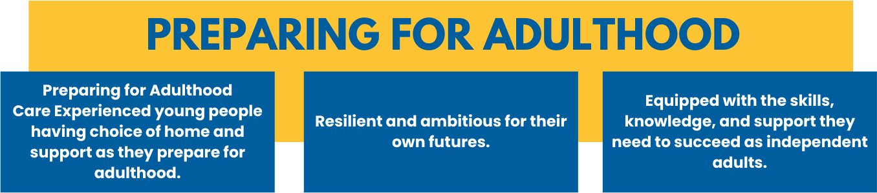
Legislation emphasises the rights and entitlements of care experienced young people and the requirement for them to have access to continuing advice, assistance, and support. More recently, the Independent Review of Children's Social Care made several recommendations for care-experienced young people, including increasing the leaving care allowance and providing a threefold increase in the bursary for care leavers undertaking apprenticeships.
All our young people should benefit from a smooth transition into adulthood, avoiding the "Care Cliff Edge." Our aim is for them to have good, stable, sustainable accommodation options so they can decide what is right for them. They also need to feel confident that they have the independence skills needed to enjoy adulthood and fulfil their potential, knowing that help is available to help them succeed.
Our Care Experienced Young People
The number of care leavers aged 16-24 has increased over the last two years, with 40 more open to the service as at the end of February 2024 compared to March 2023.
The highest proportion of children entering care were aged 16+, including 31 unaccompanied asylum- seeking children. The largest proportion of care leavers are living in independent (20%), or semi-independent living (17%) with a high proportion of care leavers also living with Foster Carers (13%) and parents/relatives (14%). | 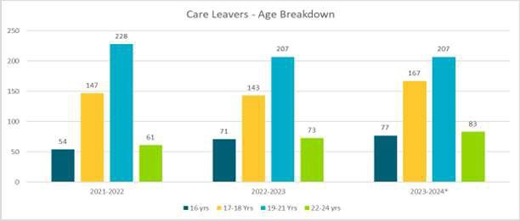
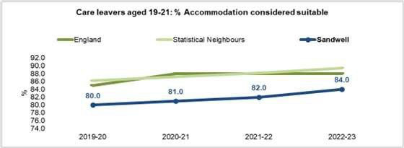
Suitable Accommodation
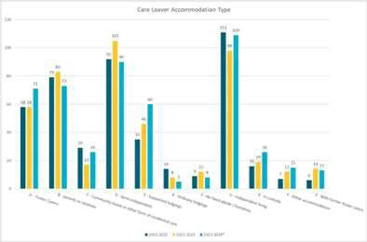 | 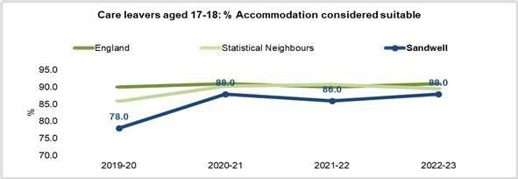
Care leavers aged 17/18 in suitable accommodation is currently at 89%, a slight improvement compared to the end of last year and more in line with our comparators.
Care leavers aged 19/21 in suitable accommodation is currently 88%, an improvement of 4% compared to the end of last year and in line with our comparators.  Our care leavers living in supported accommodation, unlike residential homes are living within Sandwell or the wider West Midlands which does allow them to maintain their community connections. | 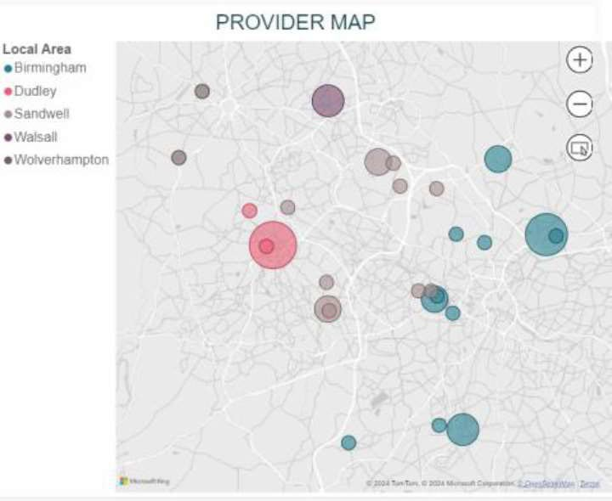
Where we are now
As part of our Transformation Programme Priority 4 focuses on an Integrated Approach to Care and several workstreams are helping to achieve our ambition of care experienced young people living locally and thriving as adults. Work including a redesign of our Children We Care for Service that should help to address increased demands, such as the higher numbers of Unaccompanied Asylum-Seeking Children (UASC). The redesign also means that young people will be able to develop trusted relationships with their Personal Advisors at 16.
The Trust offers 25 properties, rented from the Council, as supported accommodation for our young people to support them to be tenancy ready. In addition, the Trust is working in partnership with the National House Project, which will support up to 20 young people in gaining their own tenancy and support as they transition into adulthood. As a national programme, there is a strong evidence base demonstrating success for many young people securing their own homes with wraparound support. The Trust is also registering training flats as part of our Supported Lodgings programme, which will allow young people aged 16+ to continue accessing this type of accommodation where it meets their needs.

There is a strong West Midlands Regional Framework for Supported Accommodation, although there is still a high demand for spot purchase arrangements. It appears the new registration requirements are leading some providers to withdraw from accommodating young people 16+yrs; plus there are regional pressures, particularly due to the National Transfer Programme and the opening of asylum hotels within the West Midlands.
Relationships and processes with our partners in both adult services and housing are positive. However, not all young people transition swiftly and smoothly; and whilst our appropriate accommodation figures are positive, the choice offer remains limited.
Where we want to be
We want all care-experienced young people to have a choice of accommodation and support options, reflective of their individual needs; and for these choices to be local ones where practicable. With our partners, we want to develop a range of options through a Young People’s Accommodation Pathway. This will not only show the options for care- experienced young people but will include agreed processes for other vulnerable young people, such as those leaving youth justice and secure welfare settings.
The Young People Accommodation Pathway would include a Homeless Prevention pathway to ensure that care-experienced young people who might be at risk of homelessness have an agreed joint protocol to prevent this, above and beyond the standard homeless pathway.
We also want to build on the current Care Leavers Panel, working with our partners in housing and vulnerable adults, so we commission and provide the right homes for care experienced young people, which will help address the lack of accommodation capacity.
What we will do
- Achieve protected characteristic status for care experienced young people with Cabinet support
- Work with Adult Social Care colleagues and wider adult-facing services to agree a set of key principles for how we support vulnerable young adults who may not be eligible for Social Care services
- Expand our Supported Lodgings offer by determining whether it should integrate with the fostering improvement plan or be commissioned externally.
- Continue to improve use of Home Programme Training Flats following Ofsted registration, streamlining the model and its processes
- Consult Housing colleagues to refurbish and sustain a standard number of flats.
- Expand our Staying Put offer, both with in-house and external foster carers.
- Develop and implement a Staying Close model for Sandwell, particularly for young people in residential provision, integrating it as part of the Step-Aside work.
- Establish a process for the Trust to act as a guarantor for young people's tenancies, which is essential for some as they transition into adult services.
- Develop a clear understanding of the needs of care-experienced young people and work closely with council colleagues to expand our offer.
- Improve the timeliness of transition planning accompanied by effective support
- Facilitate sessions with care experienced young people to assess the suitability and effectiveness of our accommodation and involve them in developing the best possible range of options.

Market Position Statement
Sandwell Children’s Trust is committed to working closely and collaboratively with the provider market to meet the diverse needs of the Sandwell community and drive improved outcomes for children and young people. We believe that by building strong, transparent partnerships with providers, we can ensure that the services offered are not only tailored to the unique needs of local children but also focus on keeping children within the borough whenever possible.
The following points outline Sandwell Children's Trust’s requirements for providers to ensure there is sufficient and suitable accommodation for the children we care for and our care leavers.
- Residential provision in Sandwell should primarily support Sandwell children, not those from other areas. Which will mean they can continue their education, maintain friendship groups and easily access family time.
- Independent fostering agencies should offer placements for children aged 12 to 16 years, as this is the age group we have the most difficulty to find homes
- Independent fostering placements should allow brothers and sisters to stay together, whenever it is safe and in their best interest.
- Supported accommodation providers must be registered (or actively working towards) and meet Ofsted standard requirements.
- Short break options for children with disabilities meet families’ requirements and reduce the need for residential care.
- Providers should stay committed to working with young people, managing risks together, and avoid ending placements suddenly, which can lead to feelings of rejection and instability for vulnerable young people.
- Foster carers, residential workers, and supported accommodation staff should be skilled, experienced professionals, receiving the support they need to care for children dealing with emotional distress and related risks.
Governance, Quality Assurance
Delivery of the actions within each of our strategic themes will be through the Transformation Programme, Priority 4 Task Group.
Quality assurance is also an important part of our activity as we need to make sure that the effectiveness of this strategy is evaluated thoroughly. Success means that children and young people are being impacted positively- through suitable homes, with their needs met locally, and they are ready to become successful adults. Therefore, as part of Priority 4, we will be considering how best to quality assure the strategy and its implementation plan.

Conclusion
This strategy outlines the Trust’s ambitions for preventing the need for children coming into our care; but when they do need to be in our care, they can live in homes that best meet their needs in their local communities; and become confident, resilient adults, able to fulfil their full potential.
The strategy also highlights the strategic themes that will drive the activity for this to be a success.
There is much to do, especially given the current challenges in a complex and demanding market; however, by working closely with our partners, providers, and the local community, we believe we can create a strong, supportive extended Sandwell Family where our children can thrive in homes that meet their individual needs.

Appendices
