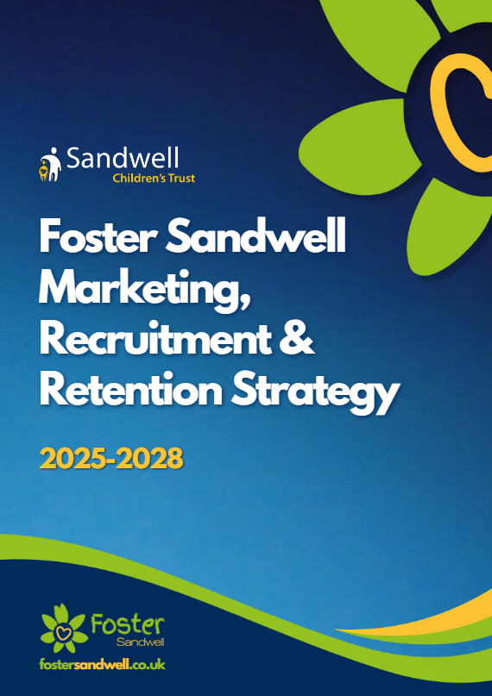
Table of Contents
Foreword by Young People 3
Introduction 4
Attracting - Pre-application 5
What do we want to achieve? 5
How will we achieve it? 5
Welcoming - From initial enquiry to approval 8
What do we want to achieve? 8
How will we achieve it? 8
Developing - The first two years following approval 12
What do we want to achieve? 12
How will we achieve it? 12
Thriving - A rewarding career with Foster Sandwell 14
What do we want to achieve? 14
How will we achieve it? 14
Evaluation, Monitoring & Review 16


Foreword by Jevon & Maddie

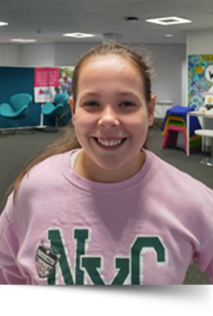
No one knows as much as us how it feels to not have a normal home like everybody else. We see our friends who live with their mums and dads, who have their own bedrooms and their things around them and all we want is to feel as safe and as happy as them.
As children and young people in care in Sandwell, we have had lots of different experiences. Some of us have had great carers who we have been with for a long time, and we will never forget them, some of us have moved around a lot more than we would have liked to. Can you imagine what it’s like to be young and not really know if you will be at the same house or with the same people for long? It makes it hard to relax and concentrate on things like school or hobbies. It also makes us sad when we have to move around a lot, it’s hard to get used to different places and different rules.
What we all want is a home that we can be comfortable in and not have to worry about being told we have to pack our things up and move. We hope that by having more foster carers, all children and young people like us will be able to live in happy homes.
Jevon – Chair of Forum for Independent Young Adults
Maddie – Chair of Voices of Sandwell


Introduction
According to a study carried out by Children & Young People Now ‘since 2015 the number of approved foster carers has decreased by more than a third. If we continue to lose foster carers at this rate, we will have none left by 2046. This, coupled with the fact that the number of children coming into care is at a record high and rising, is creating a crisis in foster care.’
The West Midlands is one of the most competitive fostering marketplaces in the country. Not only are we surrounded by larger local authorities (with therefore larger marketing budgets) there are between 15-19 Independent Fostering Agencies (IFA) active at any one time. The average for the rest of the UK is between 6-8 active IFAs.
To address this, it is critical that we not only position ourselves as the fostering agency of choice in Sandwell, but that we attract, recruit and retain quality foster carers to provide loving and stable homes for the children and young people that we care for.
Alongside workshops with Foster Sandwell and a review of regional and national best practice, this strategy has been developed in conjunction with:
- The Trust’s Ethos and Purpose
- The Trust’s Sufficiency Strategy 2024
- Foster Sandwell Statement of Purpose 2024/2025
- Fosterlink Diagnostic Report 2024
- Feedback from Newton Review 2024
The strategy sets out the Foster Sandwell approach to recruitment and retention across four key stages:


Attracting
Pre-application

The West Midlands is one of the most competitive fostering marketplaces in the country. As well as our neighbouring Local Authorities there are between 15-19 Independent Fostering Agencies (IFA) active at any one time. The average for the rest of the UK is between 6-8 active IFAs.
This means that we must be clear about what our message is, focus on the uniqueness of Sandwell and our people, and target our marketing spend in a measurable way.

What do we want to achieve?
- An increase in the number of approved foster carers who can care for our children.
- A raised profile of Foster Sandwell in a competitive and challenging marketplace, articulating the uniqueness of Foster Sandwell and our role in caring for our children.
- An increase in engagement with our digital and in person marketing campaigns.
- An increase in enquiries from potential carers who could meet the needs of the children we care for. The needs will change over time but will include sibling groups of 2 or more children, children over 11 years old, young parents and their children, children with additional or complex needs, young people that are leaving custody, children stepping down from residential, children that need a home in an emergency.
- Carer led campaigns, showcasing the difference they make to our children.

How will we achieve it?
By knowing and telling our story
- Develop marketing material that showcases our progress, reflecting our Foster Friendly status and good rating from Ofsted.
- Articulate and promote the ‘Deal’ for our foster carers.
- Continue to benchmark ourselves against regional and national best practice.

By adopting a ‘digital first’ approach to marketing
Consumers in all sectors are increasingly making their decisions by conducting their research online, in the majority of cases using a Google browser. Research indicates that people are promiscuous with online transactions, they will click the first or easiest link. With this in mind, we will:
- Increase our Google Ad spend to achieve a 60-80% ad impression share.
- Undertake daily search term and traffic analysis to ensure our adverts are served to the right people.
- Implement a landing page to return search specific results - for example a search for fees related information will land on a page that clearly outlines the maximum pay they could earn, broken down in an easy-to-understand format.
- Use our data to target advertising to postcode level, for example under-represented areas or where we have children placed with IFAs.
- In conjunction with the Sufficiency Strategy, analyse the needs of our children to develop specific campaigns to target those that could care for targeted cohorts of children.
- Increase our social media activity by creating a Foster Sandwell Facebook page, TikTok and Instagram account.
- Further develop the Foster Sandwell website with online chat facility, payment calculator, ‘are you ready to foster?’ quiz and information about the application process.
By developing relationships with our partners and community leaders to promote Foster Sandwell.
- Capitalise on Foster Friendly accreditation and explore opportunities to promote and develop with council and Trust.
- Attend partnership leadership and staff events, team meetings, away days & roadshows to showcase the benefits of fostering as a career.
- Become an integral part of partner organisation retirement planning activity, working with organisational HR teams to articulate the benefits of fostering.
- Spread our message on the benefits of fostering as a career using partnership communication distribution channels, including newsletters, school bulletins and email campaigns.
- Explore other cost-effective ways of promoting Foster Sandwell utilising partner buildings, fleet and ICT systems.
- Refresh our suite of printed material to support our message.

- Make best use of our relationships with our local MPs and Elected Members to enable them to promote Foster Sandwell in their respective constituencies and wards.
- Host face to face fostering information events across Sandwell and maintain a presence at local & regional events with partners.
- Open our refreshed refer a friend scheme to Trust and council staff and partners.
By showcasing the difference our carers make
- Identify carers who are willing to become the ‘face’ of our marketing activity, work with them to develop stories, testimonies, videos and images that can used alongside the Foster Sandwell branding in a move away from stock imagery and generic statements to resonate with the wider public.
- Link the experiences of our children and carers to national cultural events, such as the John Lewis Christmas advert.
- Develop our carers into ambassadors to help deliver our message.
By developing a fast-track transfer process for IFA carers
- Emphasise the benefits of being a Sandwell foster carer through our own staff and our partnership arrangements.
- Provide information about our deal for carers and the fast-track transfer process, particularly to those carers that are long term matched with our children.
- Improve systems and statutory processes to reduce transfer times to 6-8 weeks.
By exploring opportunities with the regional recruitment hub
- Explore opportunities to work more collaboratively on foster carer recruitment with our regional colleagues in other local authority areas, especially across the Black Country.
- Consider all feasible options that could enable more effective and efficient fostering activity through a centralised regional model.

Welcoming
From initial enquiry to approval

Our refreshed approach to attracting will yield more initial enquiries, so it is vital that we are able to respond efficiently and professionally to all enquires regardless of their status and current ability to progress their application. Considering the ‘first impressions last’ rule in a customer focused digital age, we must ensure we are resourced to provide a consistent and timely response to all contact from initial enquiry through to approval.

What do we want to achieve?
- Potential foster carers to be able to make an initial enquiry via the channel of their choice.
- Clearly defined timescales between all stages of the ‘enquiry to approval’ process.
- Each stage of the process is as accessible and easy as possible for potential foster carers.
- Foster Sandwell to provide an efficient, timely and professional service, with a named point of contact for applicants throughout the stages.
- Understanding of the motivation and experience of enquirers and applicants.
- Potential foster carers feeling valued, informed and excited throughout the process.

How will we achieve it?
By being accessible and available
- Answer calls to the 0800 358 0899 Foster Sandwell freephone number within 6 rings with a standard greeting during office hours and configure handsets and call routing to enable this; and set up a recorded message voiced by a child to advise callers to leave their details for a callback on the next working day.
- Route emails to hello@fostersandwell.co.uk to a shared mailbox which will be monitored in real time. Introduce an automatic acknowledgement and respond to emails as soon as possible but always within 1 working day.
- Configure the online contact webform to only request essential information at the initial enquiry stage; name, email address, telephone number and ‘how would you like us to contact you?’ Introduce an automatic acknowledgement and respond to webforms as soon as possible but always within 1 working day.
- Introduce an online chat facility to the Foster Sandwell website which will be monitored real time during office hours and when outside office hours, enquirers will have the facility to request a callback, email or details of our next information event.
- Action enquiries made to Foster Sandwell staff at face-to-face events immediately, taking enquirer details and providing relevant information.
By setting out clear timescales between each stage of the process
- Complete initial stages of the welcoming process in line with defined timescales, set out in the diagram to the below.
- Work towards assessments to be completed and presented to Panel within 16 weeks of allocation to assessing social worker. Use the data from initial stages of application process to forward plan Panel capacity.
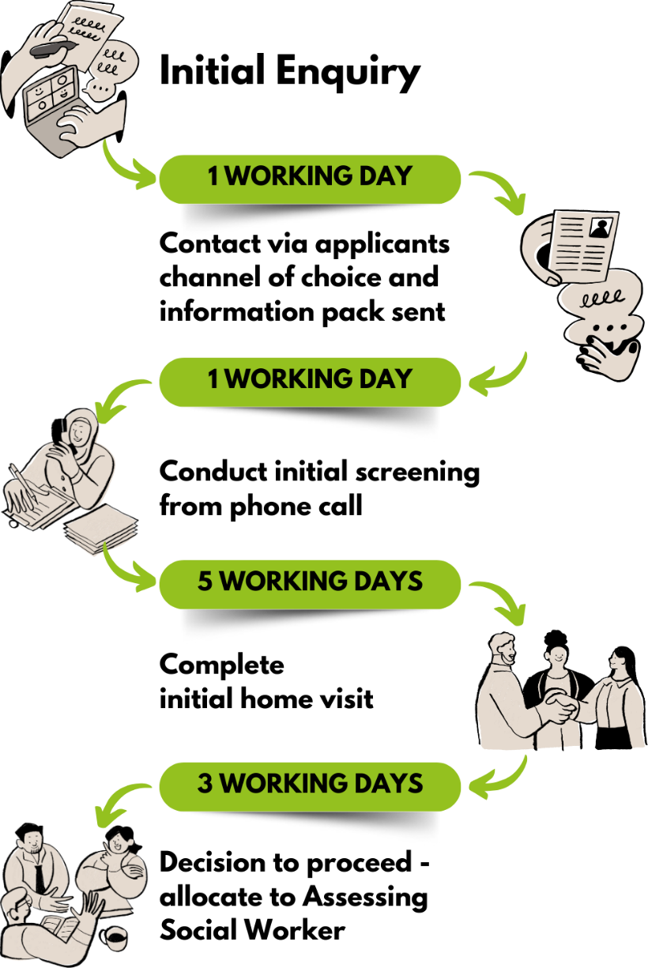
By ensuring the right resource is in the right place within the service
- Remove single points of dependency from the process to ensure enquiries are responded to efficiently during office hours, whichever channel they come through.
- Ensure the Recruitment Team supports individuals from initial enquiry through to allocation to assessing social worker. A dedicated point of contact will support them through the initial screening call, home visit and starting the process of statutory checks.
- Create two distinct assessment teams to separately manage the assessments of potential foster carers and connected carers following a positive Initial Viability for Connected Carers or successful home visit for Mainstream Carers.
- Upon allocation, ensure the assessing social worker supports potential foster carers through the process through the first 6 months following approval, maintaining a minimum of 6 weekly foster care supervision weekly contact and guidance.
- Through the Recruitment Team, coordinate the Skills to Foster training sessions, supported by social workers, experienced carers, young people, Trust leadership and other staff where necessary.
- Run Skills to Foster training sessions every four weeks, delivered via a blend of weekday, weekends and evenings.
By consolidating our approach to statutory checks
- Take a strengths-based approach to screening, underpinned by our ST*R practice model and Secure Based Training.
- Adopt a more consistent, professional and efficient ‘digital by default’ approach to statutory checks.
    - Create PDF versions of all in house forms will and update with current Foster Sandwell branding (Covering letter, consent forms, DBS guidance & checklist)
    - Use the PDF version of the CoramBaaf Form AH.
    - Work with The Integrated Care Board to move to an electronic version of the Medical Fee Claim form.
- Refresh and rebrand hard copies of forms for those applicants that cannot progress electronically.
- Address delays in process between Foster Sandwell and third parties (Local Authority checks, medical checks) at a strategic level.

By tracking and capturing data at every stage
- Continually review the data we are recording, and develop a tracker (hosted on shared Microsoft Team channel with access to relevant team members) to capture data including:
    - Number of hits, likes and engagements to web & social media
    - Number of initial enquiries
    - Date of initial enquiry and response
    - Date of screening call
    - Date of Home Visit
    - Date of handover to Team Manager for decision to proceed
    - Preferred contact method
    - What prompted you to contact? (to be captured at screening call)
    - Consent to keep in touch if application does not proceed (to be captured at screening call)
- Create a record on LCS upon completion of screening call to monitor potential foster carers through to panel approval.
- Introduce reverse interviews to establish where our process can be improved, targeting those that did not complete the application process, newly approved carers and existing carers.
By developing our applicant carers throughout the assessment process
- Encourage potential foster carers to complete mandatory training throughout the assessment process, including Skills to Foster, Paediatric First Aid Module 1, Safeguarding Level 2, Equality, Diversity & Cultural Competence, Risk Management & Safer Caring, Managing Allegations.
- Offer training courses across a mix of channels – face to face, virtual and self-guided where appropriate.
By keeping in touch with potential carers throughout the process
- Distributing monthly newsletters with content pulled from regular foster carer newsletter.
- Hosting monthly informal coffee mornings providing the opportunity for applicants to meet other applicants, existing carers and Foster Sandwell staff.
- Sending regular ‘you are here’ emails to individuals with updates on their progress.
- Retargeting those people that have made an initial enquiry but have decided that fostering is not for them at the moment. This can be with less regularity than our progressing applicants and should include a quarterly newsletter with selected stories and details about upcoming information events.

Developing
The first two years following approval
A survey conducted by the Fostering Network in 2024 identified the most common reasons for foster carers leaving the profession was:
- Lack of support from their fostering service.
- Lack of respect from other professionals.

- Burnout and poor wellbeing.
Supporting foster carers in the first two years is crucial to ensure they feel equipped, valued, and confident in their role. This support not only helps reduce turnover but also promotes better outcomes for the children we care for.

What do we want to achieve?
- No deregistrations for newly approved carers within first two years.
- Stability for our children that are living with newly approved carers.
- Newly approved carers to feel supported and valued.
- Newly approved carers to develop their skills.

How will we achieve it?
By providing ongoing support, whatever the time of day
- Conduct regular visits from supervising social worker to offer support and guidance.
- Provide timely access to emotional support through Barnardo’s programme.
- Consider opportunities to develop our offer around psychological support and fast track access to CAMHS.
- Promote the 24/7 telephone support available through our Emergency Duty Service.
- Develop and promote a Family Solutions Team led carer support hub, bringing services from across the Trust and partnership together monthly in community-based venues.

- Access to planned respite care through patch-based peer support system, developing relationships between cohorts of carers.
By appropriately matching new carers with children
- Consider the needs of the child.
- Ensure that where children have more complex or additional needs, they benefit from more experienced foster carers.
By offering a clearly defined training programme and progression route
- Support carers to undertake training offer requirements, including mandatory and core training as well as specialist development programmes.
- Undertake targeted training for carers around the ST*R Practice Model, Working Together and the role of the Voice Team
- Work with our experienced foster carers to support new carers with the completion of the Training Support & Development (TSD) training.
By developing relationships between new and existing carers
- Build on ‘patch-based support’ model with supervising social workers linking carers in geographical areas to develop the relationships through local support groups, informal coffee mornings and catch ups at local venues.
- Create a ‘new carer’ forum to nurture relationships and build peer to peer support.
By celebrating and saying thank you to our carers
- Continue to recognise newly approved carers at our annual foster carer celebration event.
- Provide certificates when a carer completes training to help them track their professional development.


Thriving
A rewarding career with Foster Sandwell
Retaining experienced foster carers is crucial for providing stability and continuity for the children we care for.

What do we want to achieve?
- Foster carers only de-registering due to usual personal circumstances.
- Stability for our children, especially when they are with their long-term carers.
- A competitive and aspirational deal for our foster carers.
- Foster carers that are skilled and supported to progress in their career if they wish.
- An increase in conversions from connected to mainstream carers.
- All our carers and children telling us that their voice is heard and informs service improvements.

How will we achieve it?
By demonstrating that fostering with Sandwell is a rewarding career
- Regularly review fees and rates for skills payments to ensure competitive with regional counterparts and local IFA’s.
- Define and communicate a clear progression pathway for carers to develop skills and experience, supported by an accessible training offer.
- Regularly review training offer to meet needs of our carers, ensuring a blend of online and face to face courses covering mandatory and development modules.
- Review expenses process to ensure clear policy and prompt payments.
- Host regular celebration events and recognition for long service.


By providing first class support to our carers
- Continue to ensure regular visits from dedicated supervising social worker.
- Establish local buddy support network coordinated by supervising social worker using ‘patch based’ model.
- Define and promote specialist support offer from Trust and partners, including Family Solutions Team, Exploitation, Voice, Virtual School, Health, placement stability, therapeutic and clinical supervision.
By hearing the voices of our carers and children
- Host monthly Support Groups for mainstream and connected carers with planned programme of visiting speakers and subject matter experts.
- Host monthly informal coffee mornings for all carers to network, provide peer support and get to know members of Trust staff.
- Support carers to establish an independent and self-governed Foster Carer Forum to formally discuss and escalate matters relating to their experience.
- Undertake annual carer survey to seek feedback on their experience as a carer.
- Raise awareness of Voice Team and activities, including Voices Heard, Voice Fest, Voices of Sandwell child in care council, Forum for Independent Young Adults, holiday programmes, celebration events and parties.
- Track the age profile of our carers to forward plan for deregistrations related to retirement.
- Recognise the role of carer’s birth children by hosting dedicated sessions and inviting extended families to engagement events.
By clearly defining, promoting and extending the benefits of fostering with Sandwell
- As part of the Foster Friendly initiative, work with council and partners to further develop the benefits of package available to foster carers.
- Promote benefits available to foster carers through the Sodexo employee scheme, Blue Light membership, Foster Talk membership and Sandwell Leisure Trust.
- Benchmark benefits and align with regional counterparts and local IFA’s, including considering a ‘council tax equivalent’ payment scheme for our foster carers.
- Consider provision of laptop and data package to digitally excluded carers to ensure they can access online training opportunities and other benefits.

Evaluation
Data related to the evaluation of this strategy will be collated and used to monitor effectiveness. In addition to data captured as part of the recruitment process, key metrics will include:
- Number of approvals and deregistrations
- Number of carers transferring from IFA’s
- Number of carers attracted via the Refer a Friend scheme
- Carer Satisfaction
- Training attendance and satisfaction
- Number of carers progressing through skill levels
- Number of ‘specialist’ foster care placements
- Number of children we care for in our internal provision
The marketing budget will also be tracked on a monthly basis.

Monitoring and Review
Effectiveness of this strategy will be tracked though an action plan, based on the four stages of Attracting, Welcoming, Developing and Thriving. Regular reviews will help identify successes, challenges, and any areas for adjustment. This will be achieved through:

- Monthly review and monitoring through the Trust’s Transformation Programme Board and operational workstreams
- Quarterly updates to the Executive Management Team
- Reporting to the Corporate Parenting Board

