Practice Note for all SCT Practitioners, Managers and Staff;
Private Fostering

A privately fostered child is a child under 16 (or 18 if disabled) who is cared for by an adult who is not a parent, grandparent, aunt, uncle, stepparent (including civil partnerships), sister or brother where the child is to be cared for in that person's home for 28 days or more.

In the definition provided by The Children Act 1989 (Section 66 Privately Fostered Children);

A privately fostered child means a child, under the age of 16, or 18 in the case of a child who is disabled, who is cared for, and provided with accommodation by someone other than:

• A parent of his/hers
• A person who is not a parent of his/hers but who has parental responsibility for him/her
• A relative of his/hers (a relative is defined as brothers and sisters, aunts and uncles, grandparents, whether of the full or half blood or by marriage or a stepparent.

ST*R Partnership Practice Model
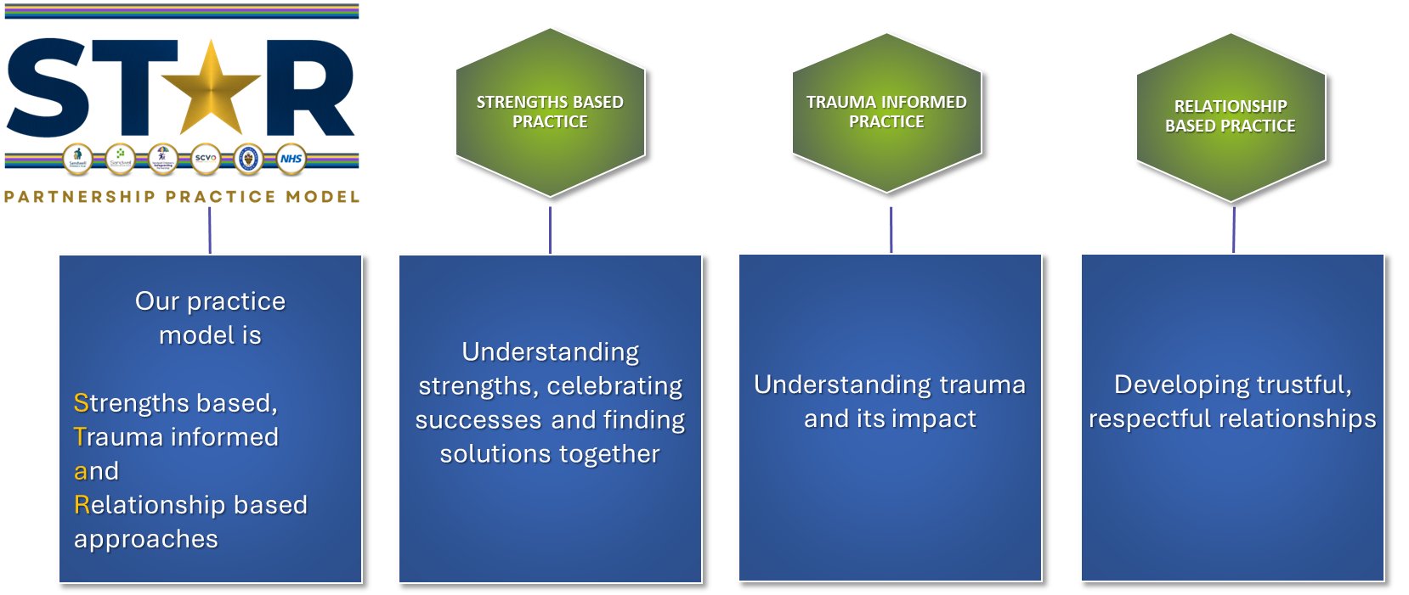
The ST*R Partnership Practice Model is our shared practice framework. It provides directions in how we engage, communicate and work with children and families in Sandwell providing a common language and consistent approach. There are 3 key principles, Strength based Practice, Trauma Informed Practice, Relationship based Practice- all of which make up a whole system of working across the partnership, to help children and families as well as our workforce. When working with privately fostered children it is important to incorporate the 3 key principles in our approach.
Private Fostering
The first legislation governing private fostering came into force following the death of Victoria Climbie in 2000. Victoria was privately fostered by her great aunt. Many private fostering arrangements are ‘hidden’ and rarely brought to the attention of Local Authorities. Private fostering arrangements are made directly between the parent and the private carer, NOT Sandwell Children’s Trust. Private Fostering includes children who are 16 years and younger, or 18 years old or younger if the child is disabled.
Process and Practice Guidance
- When a child is privately fostered, the parents, the private foster carer and anyone else in the knowledge of the arrangement, must tell Sandwell Children's Trust about the arrangement as soon as possible.
- A social worker will visit the child(ren), private carer, and the parents to complete a Private Fostering Assessment, complete DBS checks on all adults in the home, and determine if the arrangements are satisfactory. The private fostering single assessment should assess the needs of both the child and the suitability of the private foster carer in meeting the child’s needs.
- A social worker should provide the child(ren), Private Foster carer and parents or persons with PR, copies of the relevant leaflets for information around Private Fostering.
- Ensure that the purpose and likely duration of the private fostering arrangement is understood by and agreed between the parents and the private foster carers. Encourage the parents to draw up a written agreement with the private foster carers as to their respective expectations and responsibilities.
- Once it has been established that this is a Private Fostering arrangement, the social worker will visit the child(ren)at least every 6 weeks, for the first 12 months of the arrangement, and at least every twelve weeks in the second and subsequent year. Visits should be recorded as Private Fostering Reg 8 visits not child in need.
- The social worker will visit and speak with the child(ren) alone.
- The overall purpose of all visits is to encourage the maintenance and improvement of care of the child(ren) and check that the child's needs are met within the private fostering arrangement.
- Once the child(ren) is allocated to a Social Worker for an assessment they have up to 45 days to complete a private fostering assessment on the suitability of the arrangement.
- This will involve speaking to all members of the household, DBS checks for everyone over 16 as well as assessing the suitability of the accommodation and private fostering carers parenting capacity.
- Establish the plans for family time between the child and their parents.
- Sandwell Children’s Trust will support the Private carer and the child under the Child in Need process - Including providing support within the auspices of CIN meetings. Ensuring the parents are also involved, where possible, in planning for the child.
- Notify all relevant health and education agencies of the Private Fostering Arrangement. Ensure the child is registered with a GP, dentist and if necessary, an optician local to the private foster carers home. Ensure that a school place has also been arranged where necessary.
- There is no support specifically available for private foster carers. However, once the Trust is aware of the arrangement, they have a duty to safeguard and promote the welfare of children who are ‘in need’ by providing services under Section 17 of the children Act 1989. This can include financial support.
- Where a decision is made to prohibit a private foster carer from caring for a child, reasons for the decision must be recorded. Written notice of the decision, together with the reasons, must be sent by hand or recorded delivery post to the private foster carer and to the parent by the social worker responsible for the assessment.
System (LCS) process – Non negotiables
- Social worker (or lead professional) should open a Single assessment and select Private fostering assessment from the drop down.
- The child must be identified through adding the case status from the drop down in the Cin tab on LCS (see guidance below)
- Social worker (or lead professional) must ensure that they record in the assessment, the dates that DBS was sent off, and the result of the DBS – for all people age 16 or over in the home.
- Social worker must ensure they record the proposed duration of the private fostering arrangement.
- Social worker (or lead professional) must ensure they record the parents views within the assessment, including the reasons for the private fostering arrangement.
- Record the Private Foster Carers parenting capacity for the child(ren) within the assessment, in the same way we would assess a birth parents parenting capacity.
- If on concluding the assessment, the arrangement is deemed to be private fostering – the child(ren) should remain open on Child in need plans, even in the absence of any other chid in need factors.
- Social worker (or lead professional) must record visits as REG 8 visits – NOT CHILD IN NEED VISITS.
- Social worker (or lead professional) should consider from the beginning, the permanency for the child, this includes where the arrangement is predicted to be a long term arrangement, supporting the private foster carer to make arrangement for their own private law application.
- Team Manager must ensure that the drop down for Private fostering assessment is selected in the assessment, that the Private Fostering CIN status is added to the child’s file, that all visits are recorded as REG 8 Visits, and that DBS checks are received for all people age 16 or over in the home.

Important Practice Notes
- Sandwell Children’s Trust can prevent someone from privately fostering on the basis of the assessment & non-compliance with specific requirements.
- Private foster carers do not have parental responsibility for a privately fostered child.
- Parents should delegate day-to-day decision making to the private foster carer but maintain their Parental Rights, and will have to consent to major decisions such as medical treatment, travel abroad and schooling. The parent will need to continue to provide general consent to cover any necessary medical treatment and a written copy of this should be provided to the relevant professionals, if necessary.
- Private foster carer should be advised regarding recording the child’s development, particularly around:- child’s medical history, retaining school reports, dates of contact with parents and significant others, maintaining a financial record, however this is not a a necessity. Keeping a photograph album (life and memory work) is particularly important if the child is to remain in the arrangement for a period of time, to assist the child(ren) in understanding their journey.
- A parent can end a private fostering arrangement at any time and without notice. However, should notify the Local Authority. The social worker should ascertain the name and address of the person now caring for the child and their relationship with the child.
- Where a private fostering arrangement is likely to be long term, the carers should be supported to consider seeking a Private Law Order which will give them parental responsibility and provide the child with greater security and stability, for example, a Child Arrangements Order or a Special Guardianship Order. The social worker should make this a focus of the planning for the child.
- Private foster carers can claim many of the same benefits and financial support that a parent is entitled to. This includes Child Benefit and Child Tax Credits. Parents should not be claiming these benefits if the child is no longer residing with them.
- Parents remain financially responsible for the child’s needs being met and should make appropriate arrangements with carers.
- The maximum number of children privately fostered in any one household must not exceed 3 unless there are exceptional circumstances.
- Should the private foster carer move to live in the area of another local authority, the social worker must immediately notify the new local authority, the name and address of the private foster carer, the name of the child being privately fostered, the name and address of the child's parents. If that move is a permanent move, transfer of the CIN planning should be completed to ensure the new Local Authority have oversight of the child (ren) in their area who is in the privately fostered arrangement.

LCS
Private Fostered children must be marked as such on the LCS file.
Within the CIN Tab you are able to add a case status- Private Fostering can be selected within the drop down.


Further information and reading
- How to complete DBS checks
- https://proceduresonline.com/trixcms1/media/6561/tx49-dbs-checks-v14-130919.pdf
- Child in Need Plans and Reviews
- https://sandwellcs.trixonline.co.uk/chapter/child-in-need-plans-and-reviews
- Assessments
- https://sandwellcs.trixonline.co.uk/chapter/assessments
- Further information regarding Private Fostering https://sandwellcs.trixonline.co.uk/chapter/private-fostering

