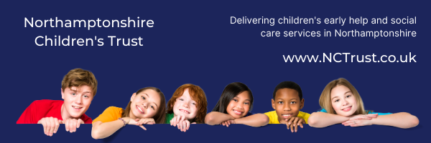
Learning from Audits
6 Step Briefing
Title of audit - date completed

Supporting children in a timely way (drift)
Nov/Dec 2020

Context / reason for audit

This audit is in line with our Improvement Plan and priorities for action

Working well

- In this audit, the overall experience of 2 young people was considered good
- Almost every child had a good genogram on their record – this is a significant improvement
- Although only half of the children’s records looked at held an up-to-date chronology indicating further is improvement required; however, there is significant improvement from last month
- The large majority of young people’s records saw evidence of multi-agency involvement in the work with the child and their family
- Almost all of the audits were completed side-by-side and, for those which were not side-by-side, most saw consultation with the SW.
- Improved outcomes were evidenced for children in the majority of cases

Worries

- High caseloads are identified as a significant concern and this is seen to have a negative impact on the quality of our work
- Formal supervision was not in line with policy in all but 3 of the records seen - in terms of quality and timeliness, or both
- For 3 children, change of SW contributed to delays in plans progressing – high caseloads sometimes led to reallocation
- A few children were not supported in a timely way and this had a negative impact on outcomes; caseloads seem to have an impact
- In 3 children’s records, an absence of contact with father was of note; there was little evidence of a pro-active approach by SW’s to engage with father. We seem to place full responsibility for engagement with the father, rather than being pro-active in seeking this ourselves

What needs to happen – agreed actions

- Continue the good work to ensure all children and young people’s records have an up-to-date chronology, in line with the Brilliant Basics Action Plan
- Bring case supervision in line with NCT policy to ensure every child / young person’s record has an up-to-date supervision which is SoS compliant
- Caseload levels need to be reviewed; there is a link to recruitment and retention
- Recent “Undertaking High Quality Audits” training delivered on the Managers’ Development Programme to be made available to all managers to support confidence in “side-by-side” auditing
- Thematic audit to explore our current position regarding work to engage fathers

Good practice

- Three audits completed by managers were good and showed real practice improvement; this good practice will be highlighted and used to support the learning of colleagues who also complete audits
- Lots more audits were completed side-by-side offering “real time” learning experiences to the SW and the auditor

