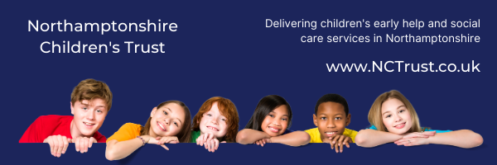
Learning from Audits – Feb 2021
6 Step Briefing
Title of audit - date completed
There were two themes for audit in February; Placement Matching and Decision Making and Children with Disabilities who are Children in Care. The questions for audit were designed with the support of our Corporate Parenting Service

Context / reason for audit
In follow up from Practice Week and in preparation for Ofsted Monitoring Visit

What’s working well?
Placement and Decision Making:
- Almost all of the children considered went straight into their permanent placement; one child had one previous placement, and one child had two previous placements
- In almost every case there was evidence of child and family involvement in placement matching
- For the large majority of children considered, specific support was made available when any difficulties arose around stability of placement
- In all cases bar one there was evidence of meaningful multi agency work to support placement

Children with Disabilities who are Children in Care:
- In almost every case the Voice of the Child was heard in a meaningful way and influenced the plan for the child.
- Most cases saw IRO activity outside of Review processes
- The one young person over 16 considered in the audit had a Pathway Plan with consideration of preparation for adulthood.

Across both cohorts:
- Many of the audits saw the auditor liaising well with the SW
- Many of the audits saw the auditor talk with the IRO which will have allowed some triangulation of information
- Management oversight had a positive impact in approx. 1/3 of cases reviewed

Worries
Over both cohorts:
- Life Story Work planning could start earlier
- One case saw the Health Assessments missing from the record and on some records this assessment was difficult to find
- Several Children’s records saw the chronology requiring an update
- It seems that PEPs are not accessible to auditors – there is now an ePEP system; if this is not available across the workforce then this part of the record cannot be considered; in side by side audits the SW may be able to access and share with auditor
- The direct work we complete with Children and Young People is not always captured on the record
- Management oversight can be more consistently robust to provide greater rationale and reference to the child’s plan.

What needs to happen? Agreed actions
- Focussed effort to update chronologies in order that they can fully inform practice
- Consider the timing or preparation and planning for Life Story work
- Encourage practitioners to ensure the direct work they complete with children and young people can be seen on the record. Maybe make it an area for discussion/sharing at a team meeting.
- ePEP system to be available to the workforce if this is the only way to access PEP
- Improve consistency of robust management oversight to provide greater rationale and reference to the child’s plan

Good practice

- Two cases evidenced that SOS was used well.
- The good practice we see highlights that our best work is relationship based. In these examples of our best work we:
  - build relationships with children and families
  - we help YP engage with support
  - we work alongside families
  - we listen to children and young people and their voice influences what we do
  - we advocate for children
  - we gain the trust of children and families, even in the most complex circumstances, by being empathic, respectful and understanding but by also facing up to the challenges and having those difficult conversations.

