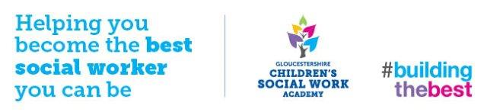 The impact of…

Everyone is different and will respond differently to difficult experiences. Research\* shows us though that children and young people whose parents have significant struggles with alcohol and/or drugs can be effected with the following if they do not have enough protections in their lives:

Body

* As an unborn baby, my mother’s use of alcohol/drugs could damage my brain and body development
* I could be born too early and have a low birth weight
* I could have difficulty sleeping
* I could be hit, hurt or mistreated
* I might not have my needs met when mum or dad is struggling
* I could become very unwell if I have any alcohol or drugs in my body

Thoughts & Feelings

* I feel irritable and grumpy
* I’m scared and worried about my mum or dad
* I feel unhappy, sad, low, flat
* I feel worried about how mum or dad is acting or what they’re doing
* I feel embarrassed or ashamed of my mum or dad
* I’m not getting as much stimulation as I need to grow
* I find it hard to concentrate and focus
* I think I’m to blame for mum or dad’s struggles
* I’m not always sure about my relationship with mum or dad

Behaviours & Relationships

* I’m learning unhealthy ways of coping and how to look after my own children one day
* I find it difficult to connect to mum and/or dad (attachment - which effects my social, physical, emotional and intellectual development)
* I’m being teased or bullied by others
* My behaviour is sometimes muddled or difficult for others
* I have problems in my relationships with others
* I don’t have a good routine
* I am at risk of accidents in the home if mum or dad isn’t able to look after me
* I take on too much of a caring role in the family. This can mean I have fewer friends, or me playing less, or it sometimes gets in the way of my school work
* When mum or dad is struggling, we sometimes don’t have enough money to make ends meet
* I am being exposed to harmful substances, drugs equipment, criminal activity and unsuitable people
* I don’t see as much of my mum or dad as I would like
* I struggle with school
* I might start (or already have started) using alcohol or drugs
* I’m getting into trouble too often at home or in my community
* I don’t expect much from my mum or dad
* I can be too physically aggressive
* I prefer to keep to myself and be on my own
* I find it hard to talk about what’s happening

It’s important to remember that when children and young people have parents who are significantly struggling with alcohol and/or drugs, on top of other difficulties (like aggression and violence in the home, parents struggling with thoughts and feelings, criminal behaviours in the family, poverty) the impact can be much greater.

\* Research from: ‘Parental drug and alcohol misuse’ (Joseph Rowntree Foundation); ‘Parental alcohol misuse and children’ (Parliamentary Office of Science and Technology); ‘Preventing child abuse and neglect: Parental substance misuse’ (NSPCC); ‘The impact of parental substance misue on child development’ (RiP); ‘The impacy of parental substance misuse’ (The Children’s Society).