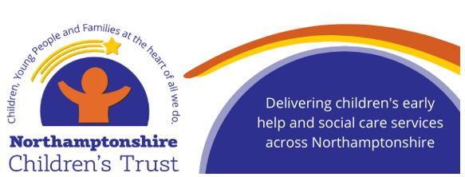[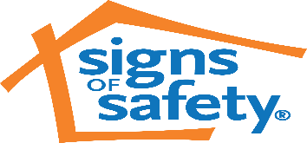](https://www.google.com/url?sa=i&url=https://www.signsofsafety.net/&psig=AOvVaw0Ox13SL4rVi9GyZ9_9h_ZY&ust=1594886211726000&source=images&cd=vfe&ved=0CAIQjRxqFwoTCKiW1qLkzuoCFQAAAAAdAAAAABAE)

**Guide for Safety Planning with parents / carers to ensure ‘safe sleeping’**

Contributing parental themes in infants being harmed by co-sleeping / unsafe sleeping

* Parental alcohol use
* Parental illicit substance misuse
* Parental stress
* Parental mental health
* Parental sleep deprivation
* Young parents
* Presence of pets
* Cluttered environment

Pre-Birth Assessments

All good pre-birth or Children & Families assessments will identify strengths, weaknesses and complicating factors in families. Themes, including those listed above, may feature in the assessment, with actions and plans, agreed with the family, to mitigate potential risks to the baby and they may co-exist with a range of other risk factors. All complicating factors (or ‘unknowns’) should be assessed further, as they may have a significant impact on the final assessment and subsequent planning.

Preparing Danger Statements – Safety Goals

Danger Statements form the analysis of an assessment. They are created from the case mapping and should be developed with the family themselves. The Danger Statement will explain to the parents / carers what might happen to the children, should the parents or carers behaviours continue to put the child at risk of harm (worst case scenario). The parents or carers need to be able to understand the Danger Statement and acknowledge any potential risks to the child. There are times when simplistic, to-the-point language is hard-hitting and difficult for parents to process; however, this is needed, in some cases, for parents to be made aware what might happen if things don’t change. For example – *“Social Worker and Health Visitor can see that both Mum and Dad really do care for their baby; however, when they drink too much alcohol, they can become drowsy and forgetful (like the time they forgot to turn the oven off and went to bed). When adults drink too much alcohol, their brains are less focussed and their behaviours can change. Should Mum or Dad get so drunk, they might forget to put baby in the cot, and baby will end up sleeping with Mum and Dad in their bed. This might end up with baby being squashed, suffocated or really hurt by Mum and Dad when they’re asleep. There are, tragically, times when babies die in these circumstances. ”*

Safety Goals are agreed targets, set by parents / carers and professionals. Safety Goals are achieved by agreeing SMART actions which are realistic, achievable and relevant to the concerns. To reach the Safety Goal, a trajectory of work, timescales, reviews and responsibilities should be developed. Each Danger Statement should have a Safety Goal - for example – *“Social Worker and Health Visitor would like baby to be healthy, happy, sleeping, eating well and have a loving, caring relationship with both Mum and Dad. For this to happen, Mum and Dad need to work with professionals to create a ‘Safety Plan’ to ensure that, when they both drink too much alcohol, they can make sure baby is safe, sleeping in the cot and not in the same bed as Mum and Dad.”* As with the Danger Statement, parents and carers need to understand the Safety Goal and commit to working towards this.

Safety Planning:

***A Safety Plan is NOT a working agreement. No-one signs Safety Plans. There should be no reference to taking legal action should the parents not comply.***

In order for parents / carers to keep baby safe when sleeping, Safety Planning with the family is paramount. Social Workers or other professionals can’t forcibly make adults abstain from alcohol or drugs, especially if there are long-standing addiction issues. Similarly, adults who experience mental health difficulties or have learning difficulties cannot suddenly change overnight. As such, Safety Planning should be realistic and meaningful, not tokenistic. Below is an example of a Safety Plan.

**‘Danger Statement’ -** *“Social Worker is worried that ……………………*”

**‘Safety Goal’ -** *“Social Worker would like baby to…………….”*

**‘Safety Plan’**

This Safety Plan has been created by the Social Worker, ***insert other professionals involved and parents’ / carers’ names*** and the close family network who the parents / carers trust. All members of the Safety Network are committed to make sure the Safety Plan works and correct actions are taken at all times. All members will share each other’s contact details.

Members:

***Insert names and contact numbers for professionals and family / networks.***

We are aware that both Mum and Dad have ***insert relevant risk factors****.* This could lead to baby sleeping with Mum and Dad, rather than in the cot. As the Danger Statement outlines, safe-sleeping for baby needs to be practiced all of the time and, for this to happen: -

***Worker to list points of protective measures to be put in place - for example:***

1. ***Social Worker will visit at least once a week, but will have regular phone calls to the support network as well***
2. ***Social Worker and Midwife or Health Visitor will work with Mum and Dad to go over safe-sleeping arrangements***
3. ***Mum and Dad will call on [named support network] to ask for help if they feel unwell or can’t cop***
4. ***Further points can be added that are specifically tailored to the family’s situation***

