**Direct work with ***** and *****.**

**Slime making**

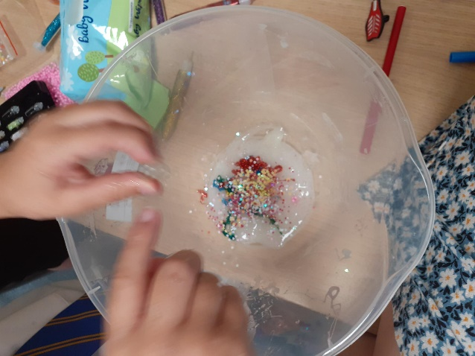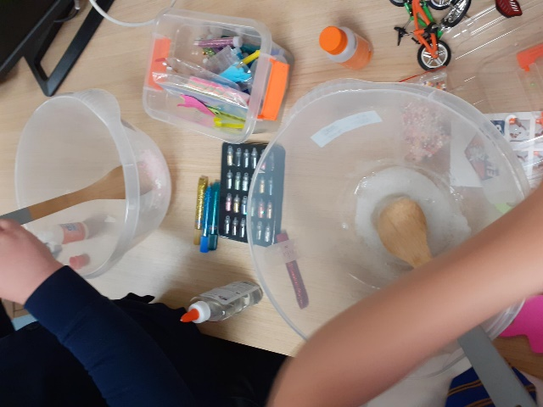

This session was designed to undertake 1:1 work with ***** and ****** around what was working well for them currently and what they were worried about. I was mindful that currently they were also undertaking work with FIP so I made the session very relaxed and fun for the children providing them the opportunity to share with me their worries and what was working well for them at home and in school.

During this session ****** and ****** were able to share how things were at home for them currently and shared that they had been enjoying 1:1 time with their mum. ***** shared that if they was behaving better then they would be on green and he could pick the movie of his choice. ***** shared that they had really been trying to stay clam at home and not shout and swear. ***** added that they were able to see an improvement in ***** behaviour and that they were not as scared of them anymore.

During the direct work ***** and ****** appeared to have a good relationship and bond as siblings and it was evident that ****** took on the caring role asking ****** if they needed help or sharing with ideas of how they could improve their slime by adding more activator.

When looking at the current worries I asked ***** and ***** about their father and what their views/feelings were on having contact with him. ****** shared that they were not sure about seeing his father because he used to kick them and hurt them which made them sad. ***** shared that when ***** used to see dad that they was always coming back home angry at him and mum and this is what they did not like.

I asked ***** about this and tried to unpick this a little more. ***** shared that he could remember all the arguing that happened when mum and dad lived together and they were worried this would happen again. I asked ***** if they felt that by seeing dad did they feel mum and dad may get back together. ***** said yes and this sometimes makes me think it will all start again and I don’t want it to.

Shortly after this ***** changed the conversation and we spoke about their favourite music and they asked me if I knew the song they were singing. ***** shared that they were so proud that they could now bike to school by themselves and was clearly excited and happy with this.

Both ***** and ***** shared that they really enjoyed the slime making and commented on how they preferred this way of undertaking activities with me as we got to speak and share things however it was such fun.

**What’s working well:**

* ***** and ***** both engaged very well and enjoyed working with me.
* ***** and ***** appear to have a good relationship with each other. ****** was very caring towards ***** and took on this caring role offering to help them with this activity.
* ***** recognised that swearing and hitting his sibling and mum was not good behaviour and shared that they were trying to stop this and change.

**What we are worried about:**

* ***** and ***** clearly have been affected emotionally around their parent’s separation and the ongoing parental conflicts that have taken place.
* ****** challenging behaviours at home and how this is managed by mum.